**Arrays**

**Theory**

* They store Similar types of data types. [int, char, string, bool]
* They are mutable
* They are stored in contiguous memory locations
* The values stored in arrays can be accessed used index locations.
* An array of size ‘n’ has indexes in the range [0 – (n-1)]
* If we initialize an array with a value, the rest of the indexes will be populated with 0 as the value
* We can use the formula: sizeof(array) / sizeof(data type) to find the length of the array.

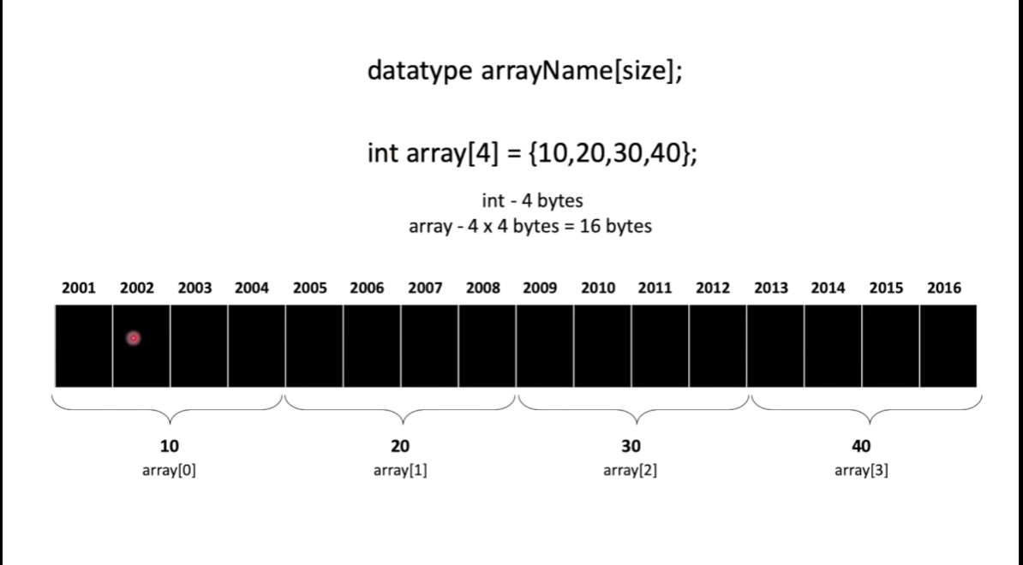

**Working of Indexes:**

* int arr[3]
* arr represents the address of the starting memory location
* to access the any element we can use the formula
* address + [index x sizeof(data type)]

**Initialization:**