Primary Source Process

**Education**

1. If the rules allows for PSV Yes, then you must check the license State and match it to the State Board.
2. You will check the School State Verified Yes or No field, if Yes then the School Verification Date must be within the last year. <https://192.168.0.139:4433/LicenceCertfIssuerDept/Main?LicenceCertfIssuerCode=129>

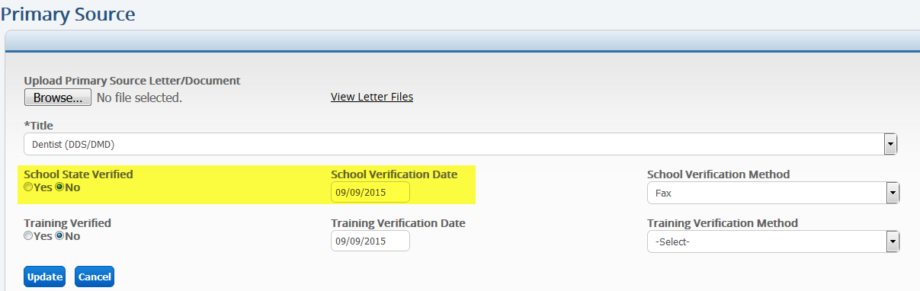

1. Then you will verify the education with the school verification date and method of “Primary Source (CA)”. In ( ) put the State used.
2. If the provider has multiple licenses, you can use any State Board however the license must be verified by VerifPoint once before you can use it. If the license was verified for another client that is fine as well.

**Post Graduate**

1. If the rules allows for PSV Yes, then you must check the license State and match it to the State Board.
2. You will check the Training Verified Yes or No field, if Yes then the Training Verification Date must be within the last year.

<https://192.168.0.139:4433/LicenceCertfIssuerDept/Main?LicenceCertfIssuerCode=129>

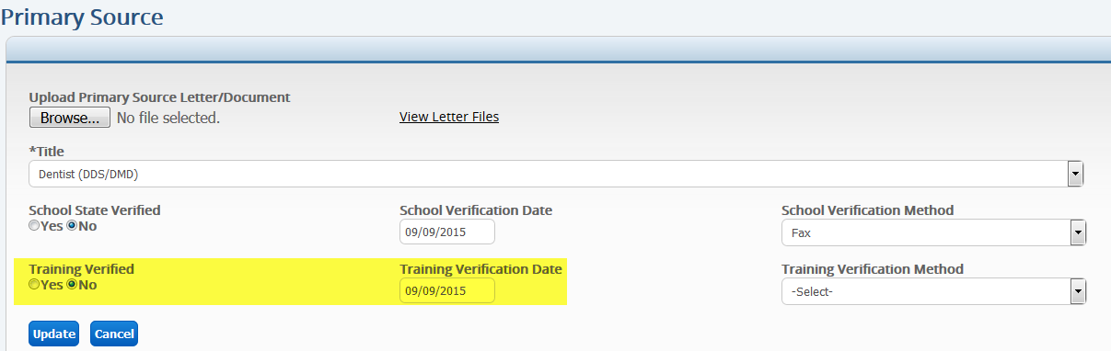

1. The provider’s Post Graduate Training (Internship, Residency or Fellowship) the To Date must be before the issue date of licensure.

<https://192.168.0.139:4433/Provider/Application?ProviderCode=108759&ApplicationTrackingCode=0&PlanCode=38&ProviderPlanCode=112733>

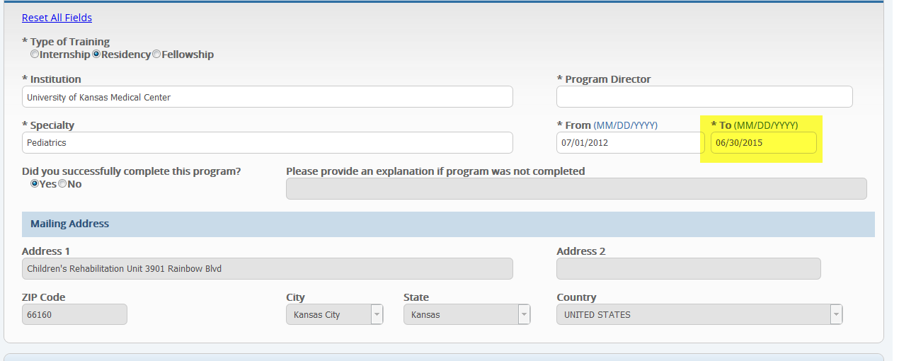

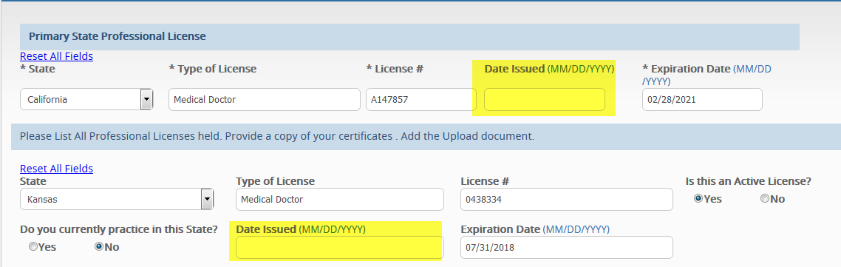

1. Then you will verify the post graduate training with the Training verification date and method of “Primary Source (CA)”. In ( ) put the State used.
2. If the provider has multiple licenses, you can use any State Board however the license must be verified by VerifPoint once before you can use it. If the license was verified for another client that is fine as well.

I think the specialty board PSV process might need to wait until Phase 2. See below

**Specialty Board**

1. If the rules allows for PSV Yes, and the provider is Board Certified Yes and this has been verified, then you will find the Specialty Board from <https://192.168.0.139:4433/SpecialityLicenseIssuerDept/search>

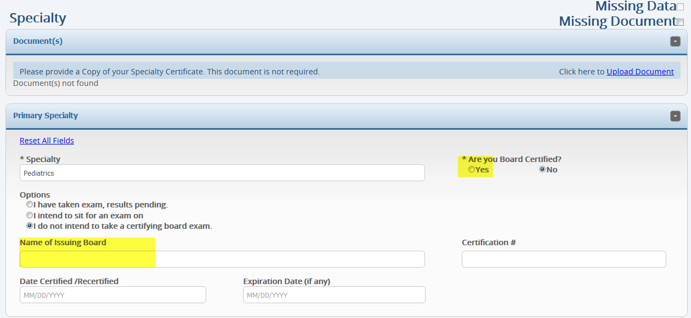

1. You will check the School Verified Yes or No field, if Yes then the School Verified Date must be within the last year. Then you can verify education with the date of the School Verified Date and the method is “Primary Source (ABOMS)”. In ( ) put the abbreviation for the specialty board. We need to add a new field in the Specialty Board table for the Abbreviation. If this cannot be done for Phase 1 then we can wait for the PSV process regarding specialty for Phase 2 as well <https://192.168.0.139:4433/LicenceCertfIssuerDept/Main?LicenceCertfIssuerCode=129>

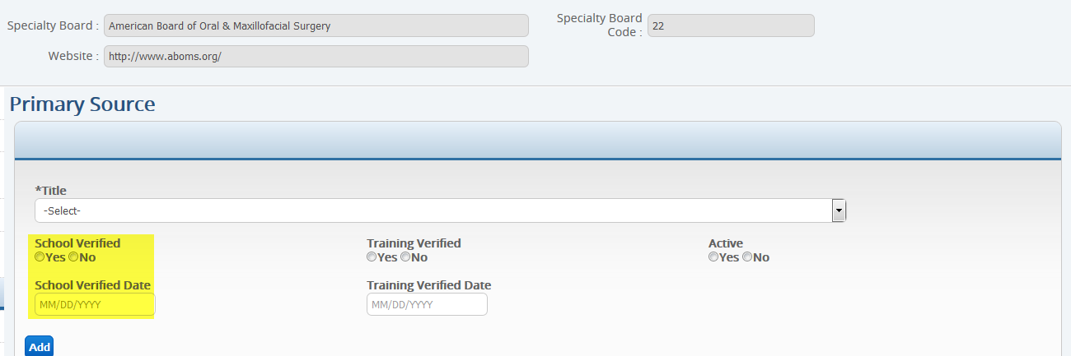

1. You will check the Training Verified Yes or No field, if Yes then the Training Verified Date must be within the last year. <https://192.168.0.139:4433/LicenceCertfIssuerDept/Main?LicenceCertfIssuerCode=129>

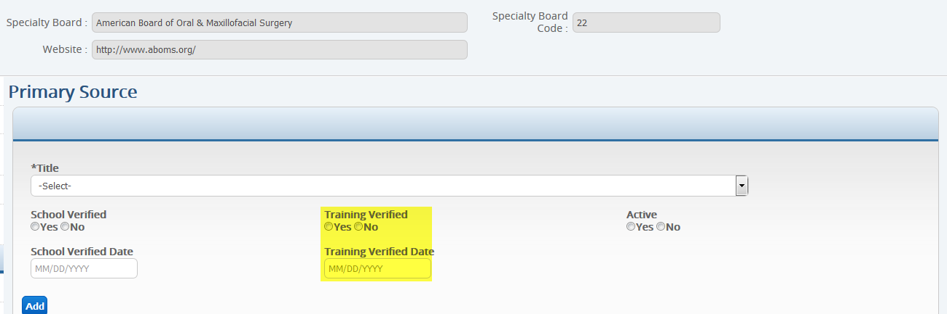

1. Then you can verify Training that has the same specialty, see below, with the date of the Training Verified Date and the method is “Primary Source (ABOMS)”. In ( ) put the abbreviation for the specialty board. We need to add a new field in the Specialty Board table for the Abbreviation. If this cannot be done for Phase 1 then we can wait for the PSV process regarding specialty for Phase 2 as well

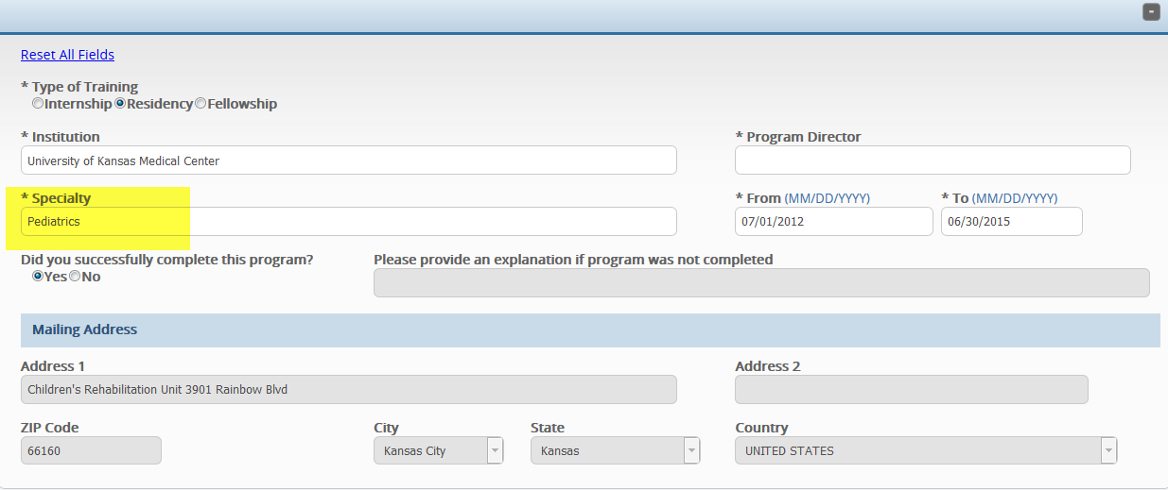

<https://192.168.0.139:4433/SpecialityLicenseIssuerDept/Main?SpecialtyLicenseIssuerCode=22>

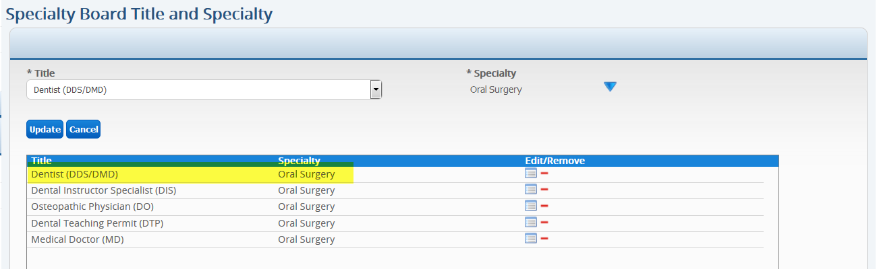

If the provider has two post graduate training records, one internship with a specialty of rotating and a residency with a specialty of Oral Surgery. Then only the Residency is verified because the specialty matches with the specialty board.