**INSURANCE**

1. Department and Contact Person Information>without filling form, if delete button is clicked> the heading of the page got deleted.

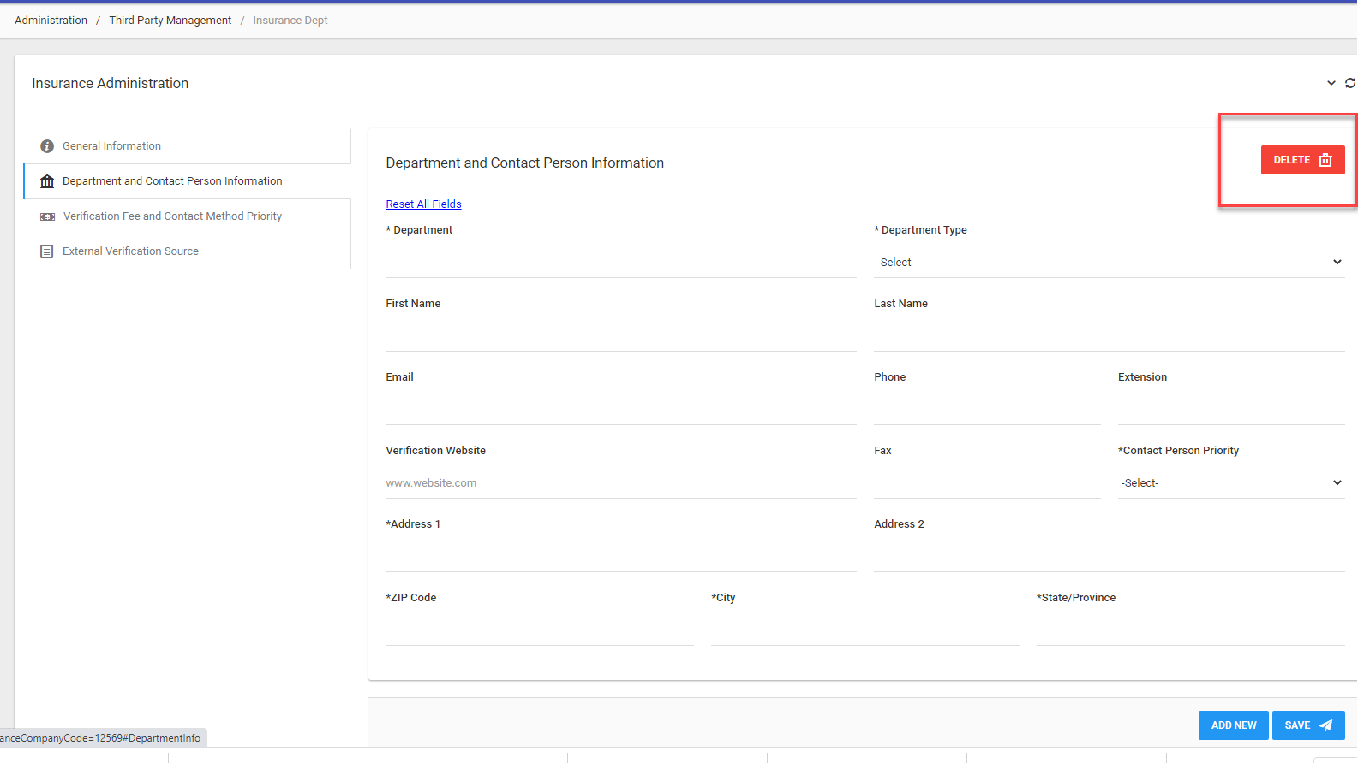

2.Department and Contact Person Information>if only department is entered and click on save>It gives message “ Select Category in Panel 1” instead of “Select Department in Panel 1”.



3. Added and saved only general information > Search company from Country and Insurance Company fields>it gives no result but when country is not selected (searching on the basis of insurance company > it shows results.

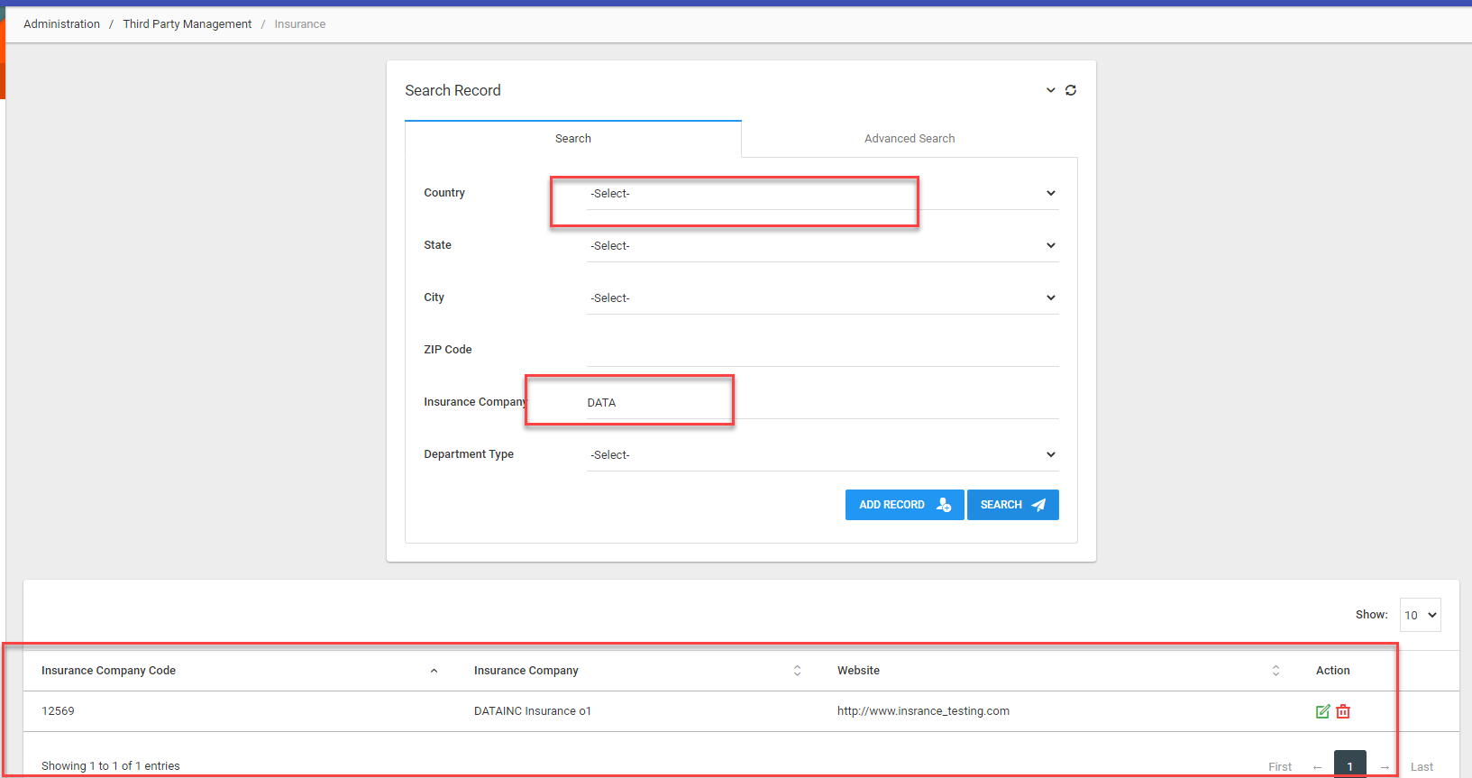

4. Department and Contact Person Information> It should accept full stop in first name because some people write their names like M.Arsalan etc.

5. Department and Contact Person Information > edit > save button is disabled.

##### 6. Verification Fee and Contact Method Priority> Amount 0.00 can be saved (It gives no error that amount cannot be zero). GENERIC ISSUE

##### 

7. Verification Fee and Contact Method Priority> without filling form, if delete button is clicked> the heading of the page got deleted. (Generic Issue)

8. External Verification Source > There are two different external verification sources are added and priority for both is same, then it should not give error.

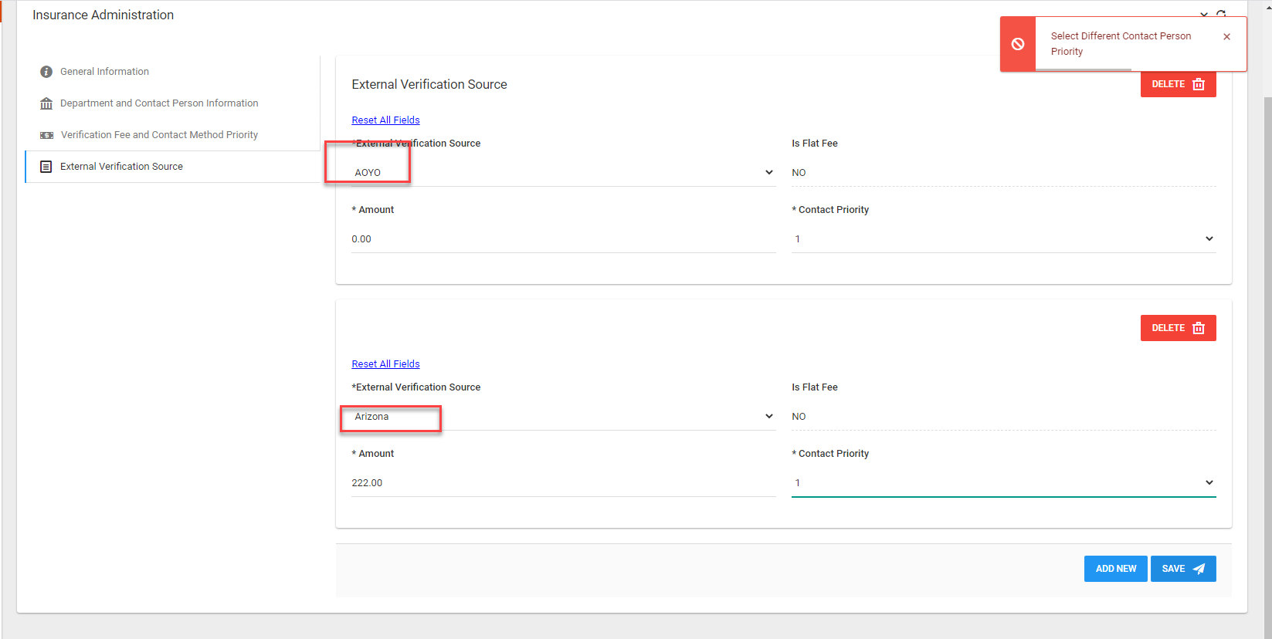

9.