KTown Rooms – Booking Module

The flow of Booking Module is as follows:

# Bookings Table

The Homepage of Booking Module shows a table with current booking records

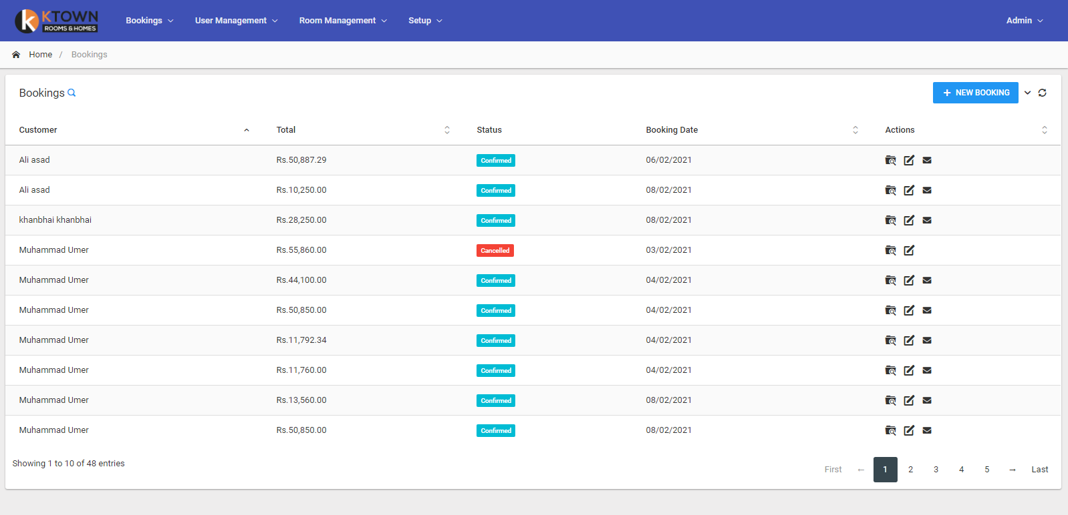

Each row shows one booking and can be

1. Viewed
2. Edited
3. Resend Invoice (when booking is ‘Confirmed’)

## Viewing a Booking ()

A window will open that shows details of the booking. There, booking can be Edited / Cancelled also.

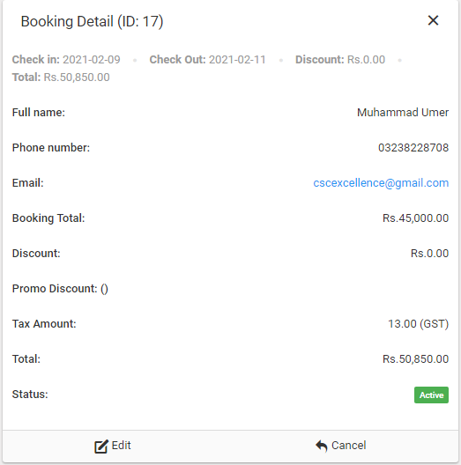

## Cancelling a Booking

Upon cancellation, the reason for cancellation is required.

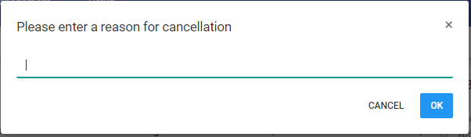

## Editing a Booking

Upon clicking Edit, (from table or the detailed window), another window will be opened. That shows the rooms and other details of the booking along with option to edit them.

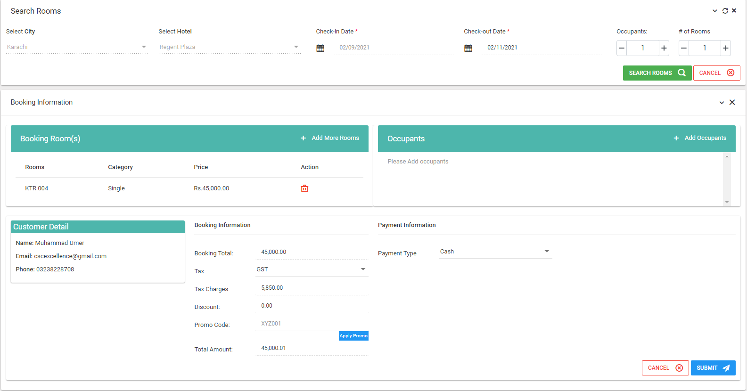

Hotel, and City are disabled and cannot be changed. To change hotel one has to cancel the current booking and ask for a new one.

Check-in date is also disabled. However, checkout date can be changed and new rooms can be added. Selecting checkout date and clicking search reveals another window showing the available rooms

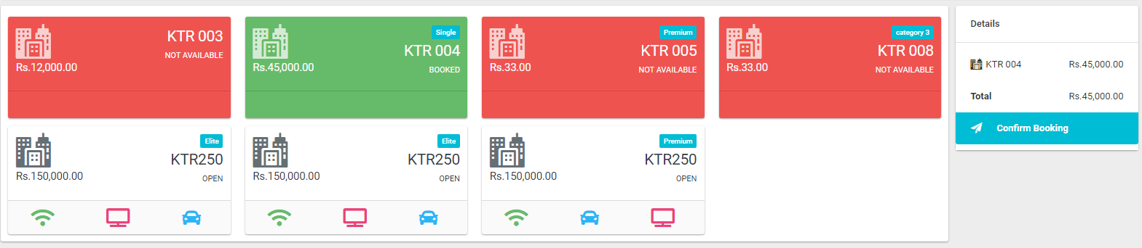

* Red color shows ‘Not Available’ rooms which have booked in another booking for the selected date.
* Green Color Shows the current booking’s rooms. And White colored rooms are available to be booked.
* Current Booking’s room cannot be deleted from this window, instead it can be deleted from the table’s delete button .
* Upon adding new rooms, right window will show the amount of booking.

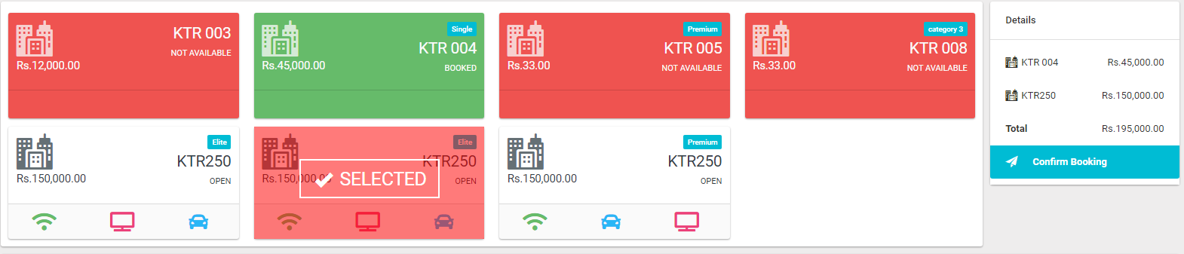

The customer window shows the customer details and is fixed in edit mode. To change customer, one needs a new booking.

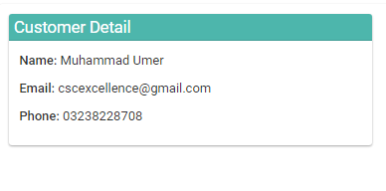

Booking amount details are shown in next window.

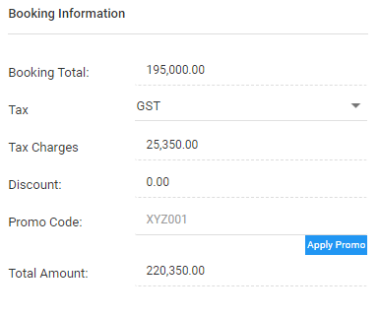

Promos and taxes can be selected here.

The occupants details is shown in Occupants window. One can add the occupants here

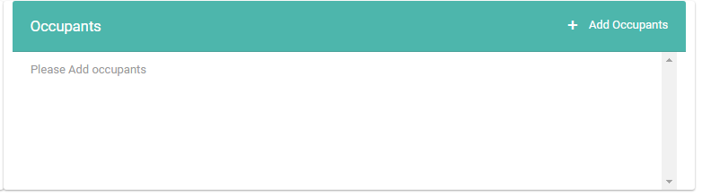

Clicking on Add Occupants button reveals a window asking for occupants’ details.

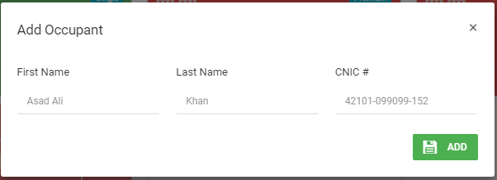

After submitting the details one can see the occupants in the list.

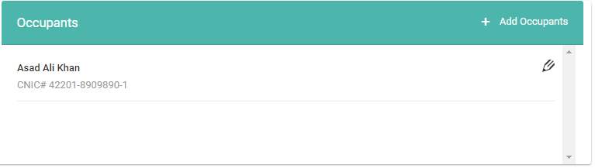

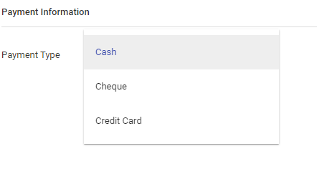

Payment type can be selected from the dropdown. Currently, the system does not have debit card / credit card facility. Cash and Cheque can be used. After clicking the submit button an invoice is shown. This shows all the details of the booking.

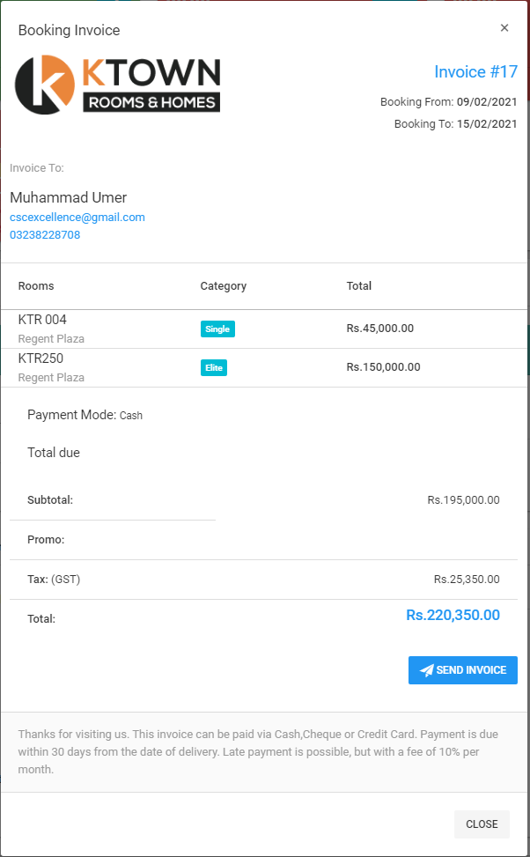

On clicking the ‘Send Invoice’ button, an invoice will be sent the customer’s email address. (if the email is valid, the invoice will be received).

## Creating a new booking

Booking can be created using the bookings table by clicking on the ‘New Booking’ Button. The window will be shown to select the city, hotel, checkin date, checkout date, no. of rooms, etc.

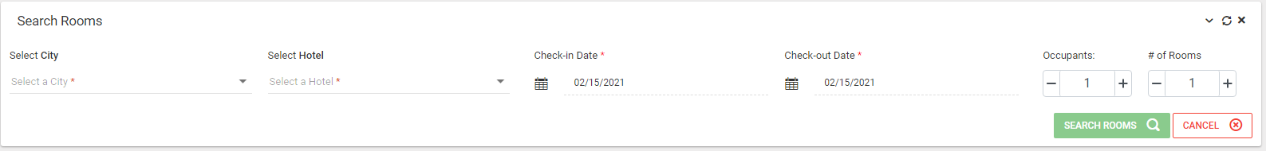

Upon selecting the details, available rooms will be shown.

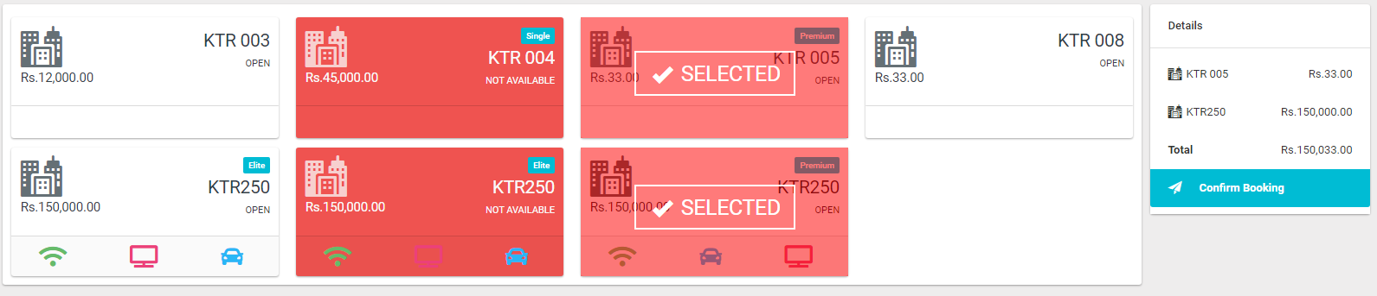

Admin can select rooms, and confirm the booking.

A new window will show booking details.

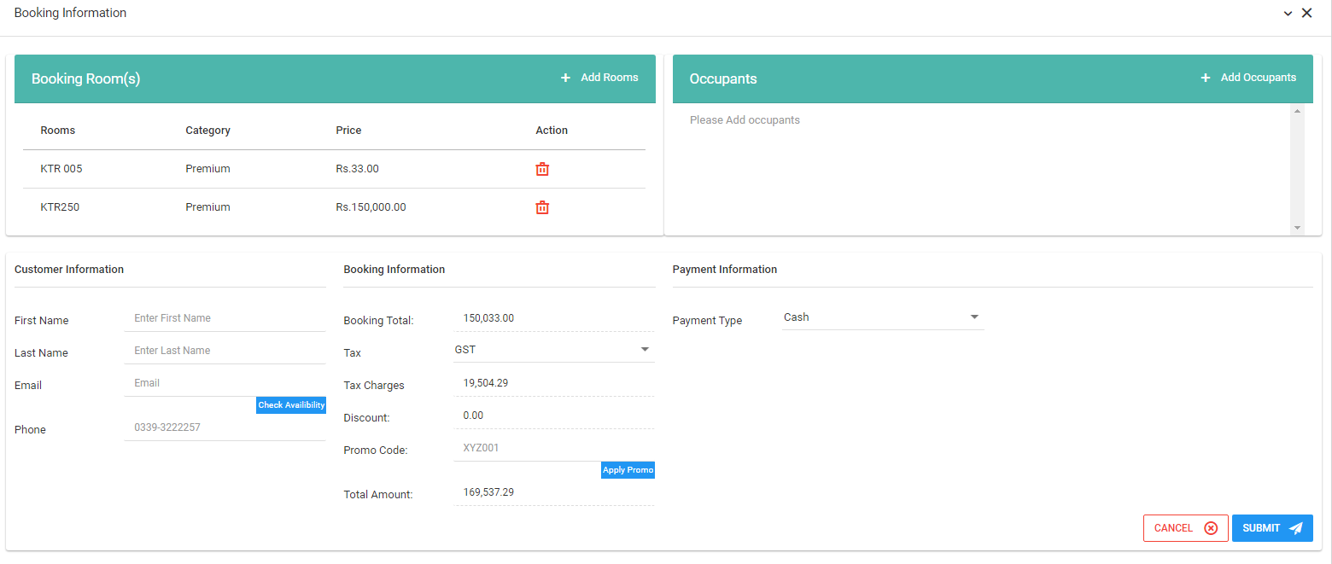

Ideally, the admin will enter the email address of the customer and click on ‘check availability’ button. If the user is present, the details will be filled.

Then the occupants, payment type, Tax type, Promo discount, etc need to be selected.

Similar to edit, after clicking the submit button and invoice will be shown.