**RESTAURANT SIGNUP:**

1. Restaurant Signup>Can register with wrong email and wrong Address format.
2. When clicking on submit without filling any info > It is only showing error for restaurant name although other fields are also compulsory.(Deferred)
3. There is no place holder for Contact number.
4. On registration, it is accepting 0 as contact number.
5. No restaurants found on search for Karachi.

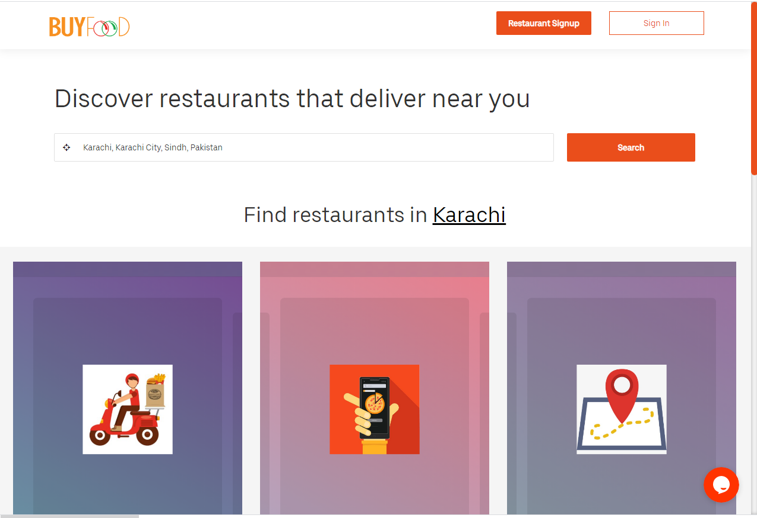

6. Send message option>Accepting alphabets in name field.

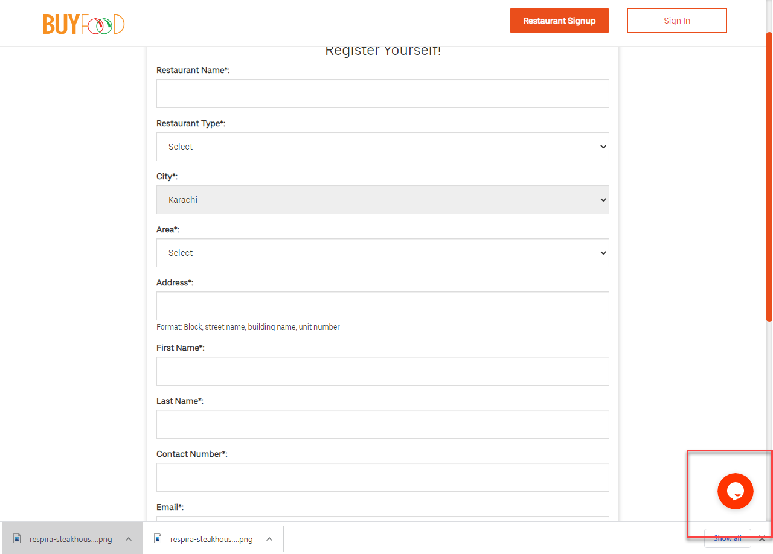

1. Message email pre-filled with data which was entered before.

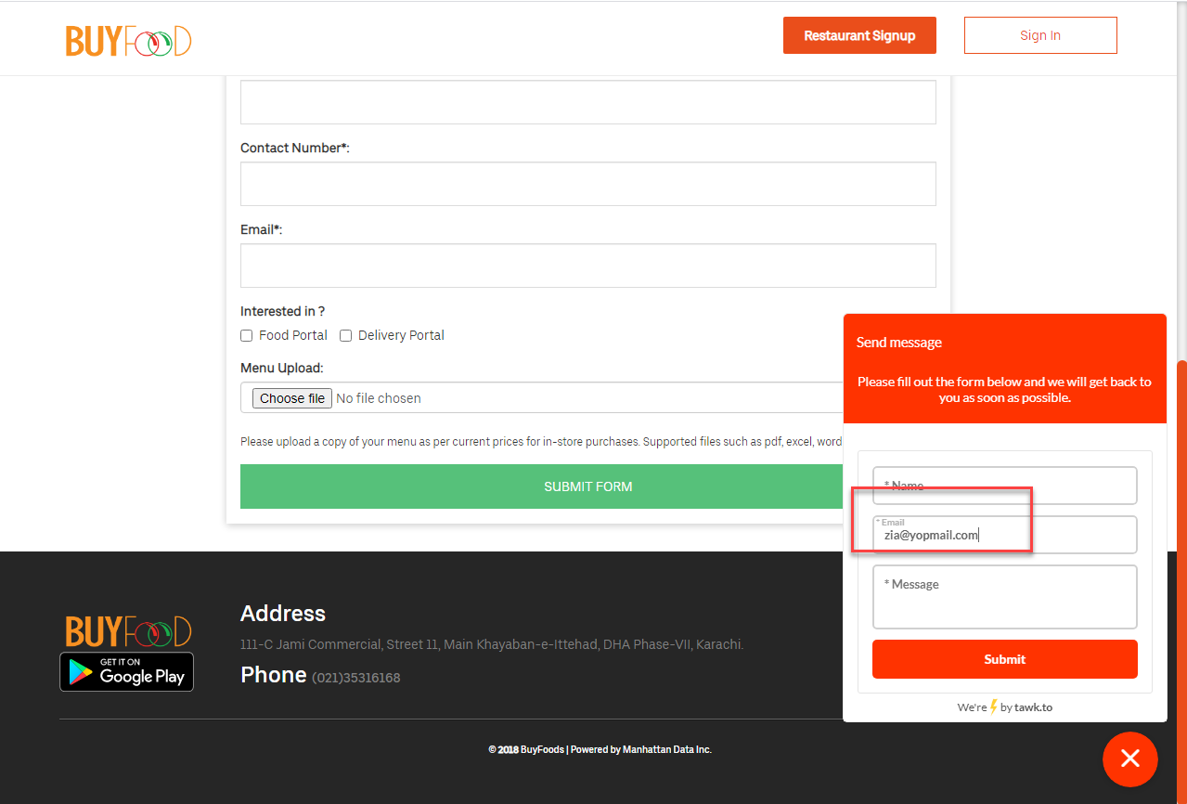

1. Restaurant name> click> navigate to restaurant page> if no selection is made how come checkout option is enabled.
2. If checks out without selecting any item> navigating to this page <https://buyfood.com.pk/>.(Deffered)
3. Checkout> if an item's quantity is 1, the decrement arrows should get disabled.(Deferred)

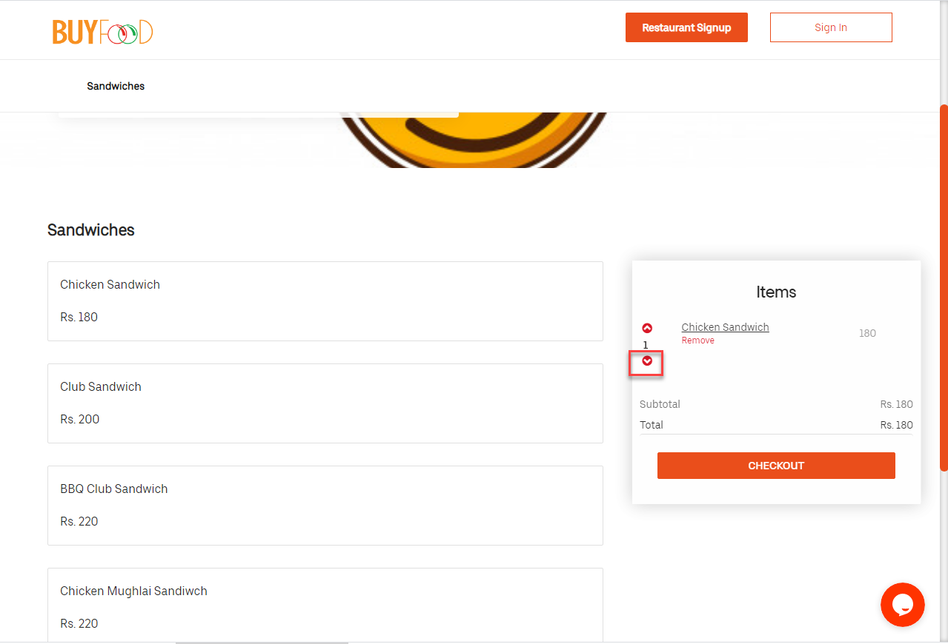

1. After checks out> in checkout details> address: fetches current location and pre fills the address and city but not the area.
2. Select items> checks out> open the restaurant's page again> same items are in cart.(Deferred)
3. Accepting numbers in First name/Last name and accepting incomplete numbers.

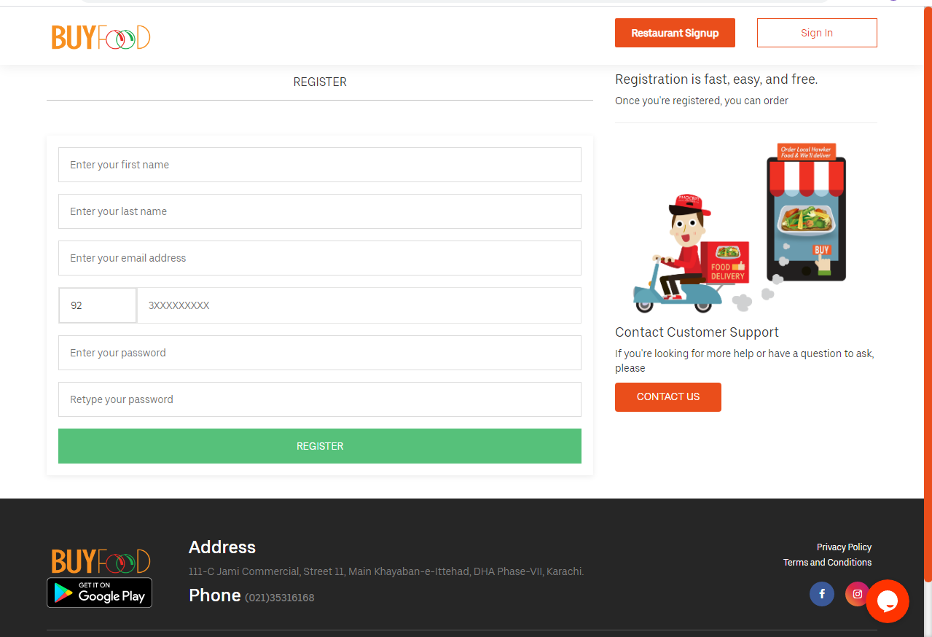

13. No email received on contact us.

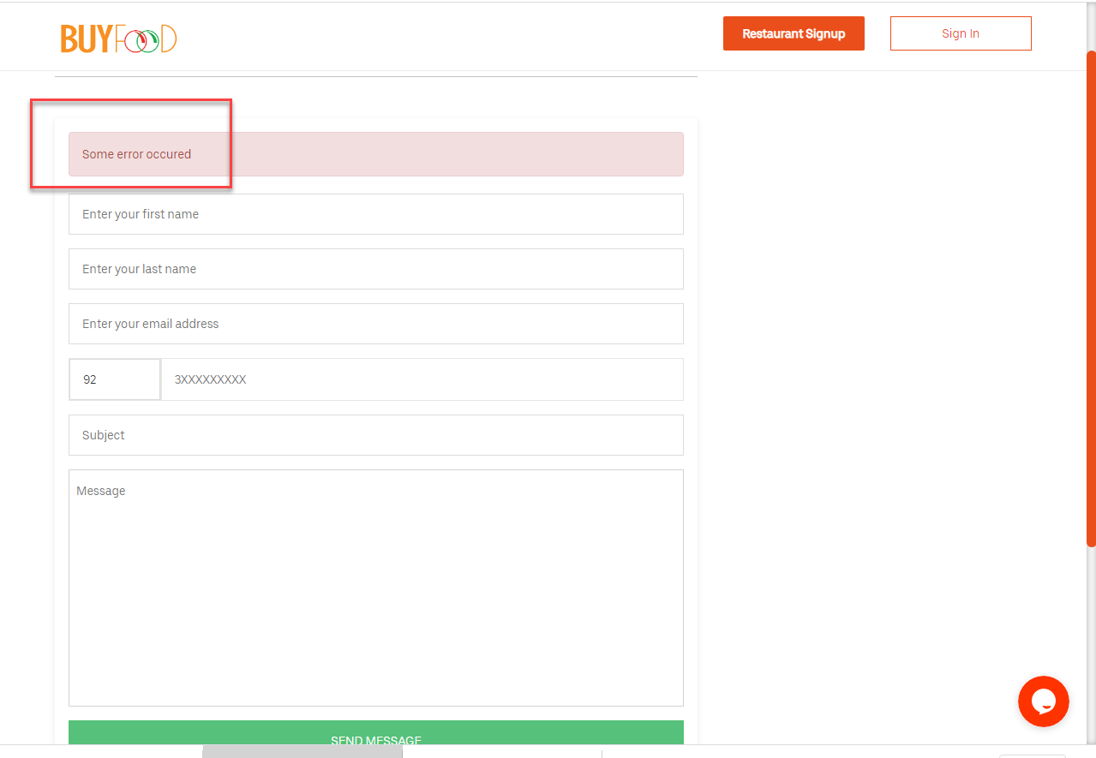

14. Register> verification link sent to email> click on verification link> navigated to the buy food portal>after verification message display 404 error.

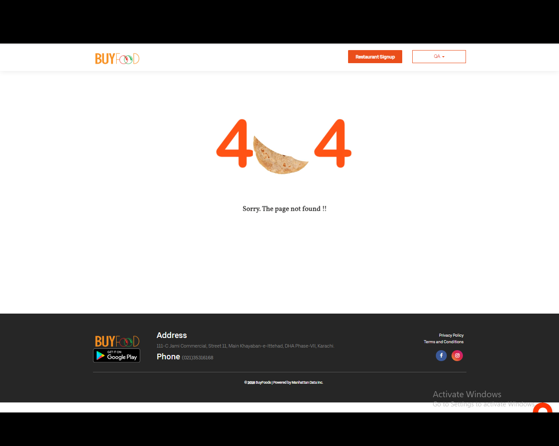

15. After checks out> in checkout details> proceeds to complete order even if the area and address fields have two different location.

16. After checks out> in checkout details>not able to check out if account is not activated. It shouldn’t sign in.

17. When email is received for activation. The link should be expired after it is verified once.

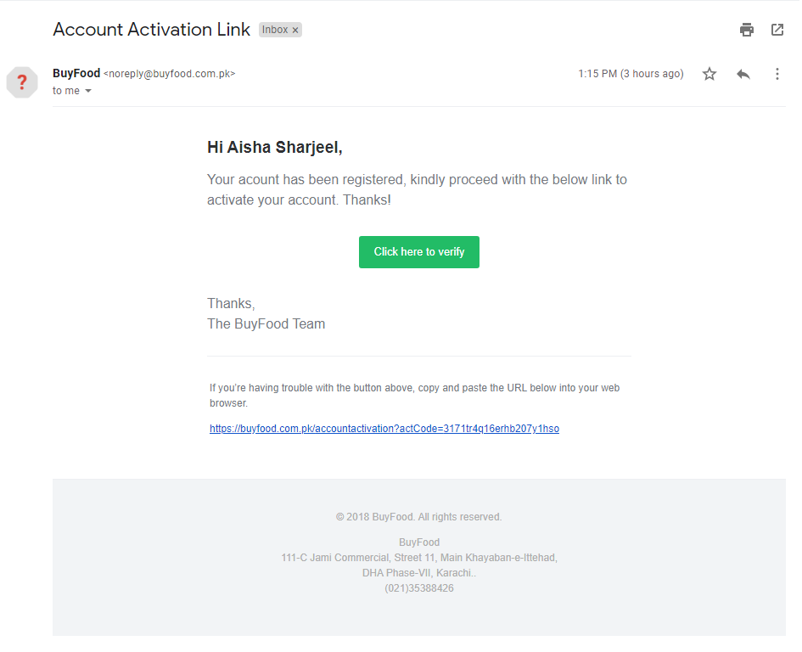

18. Customer login>forgot password>the module remains open and after the submit button should be disabled and email should be removed.

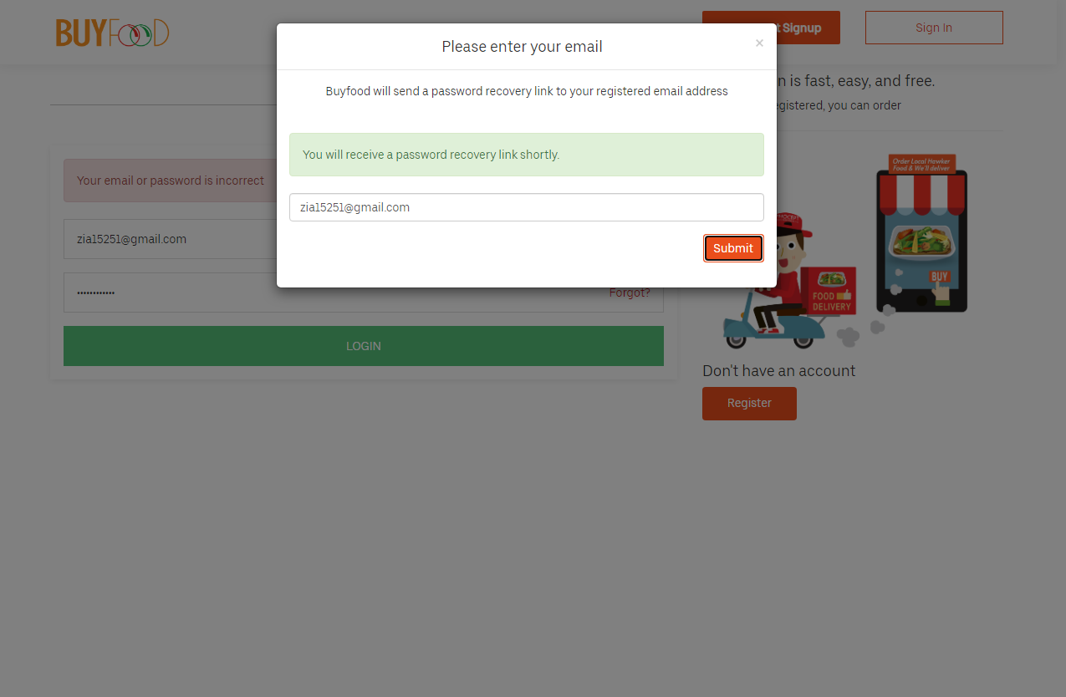

19. No email received on the email.

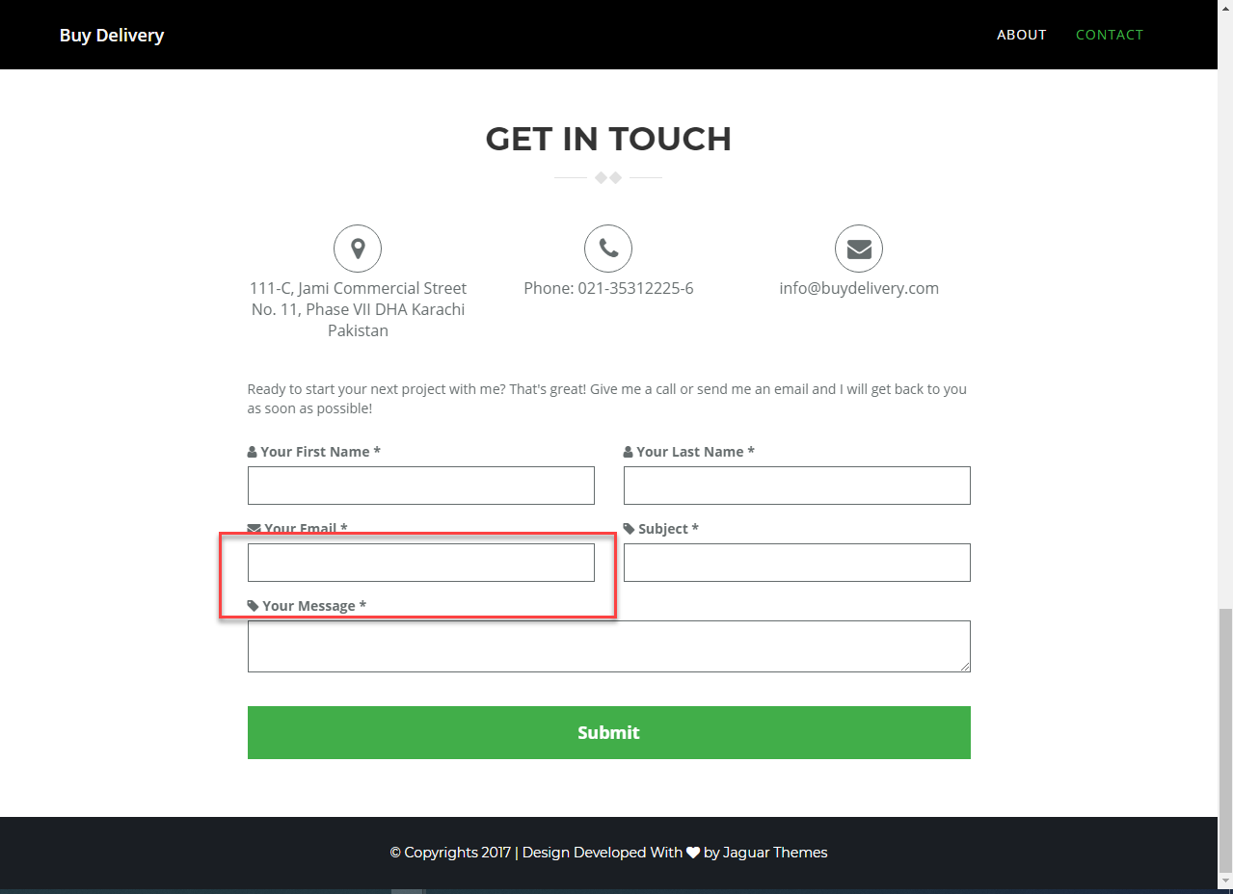

20. Register yourself button> form> if from is submitted unfilled, system shows error (to fill the fields) for the first field in the form, similarly if only first field is filled and form is submitted the systems shows error to fill the second field only.(Deferred)

21. Register form: name fields accepts digits/special character (+, = etc).

22. Contact number needs validation.

23. Register yourself> accepts same data to register multiple times.

24. Buy food>Checkout>Select area text on field is missing.

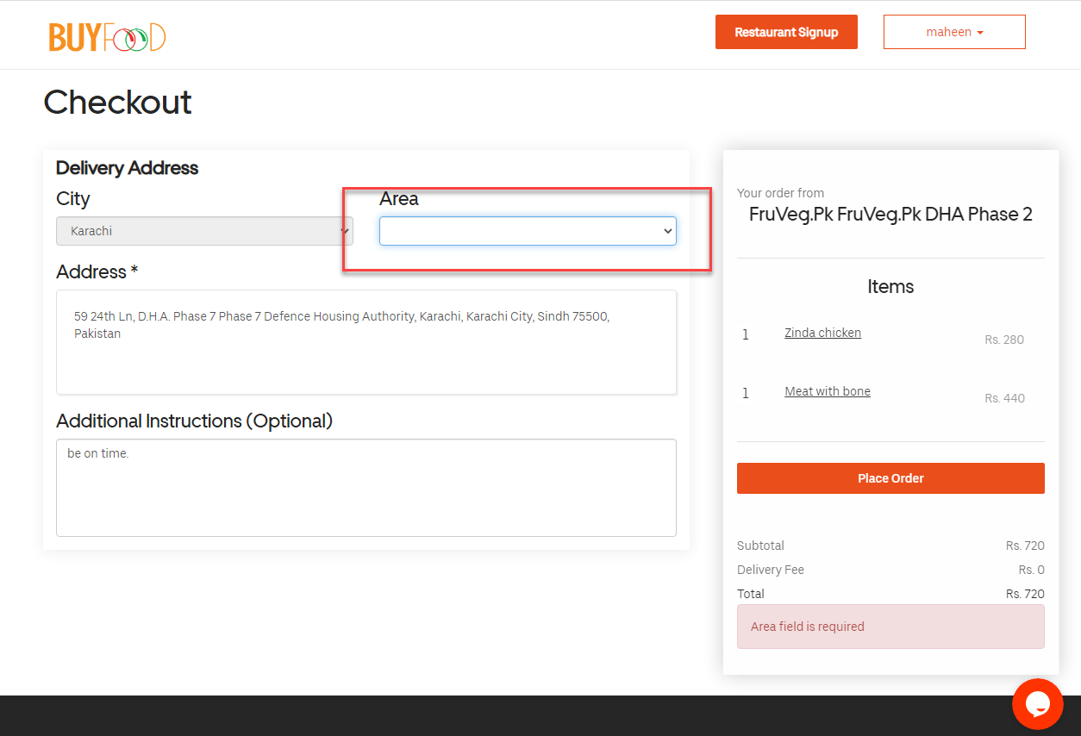

**DELIVERY FOOD BUGS:**

1. Latest orders> form> why the page loads on entering any data.
2. Order created time is different in all the screens.

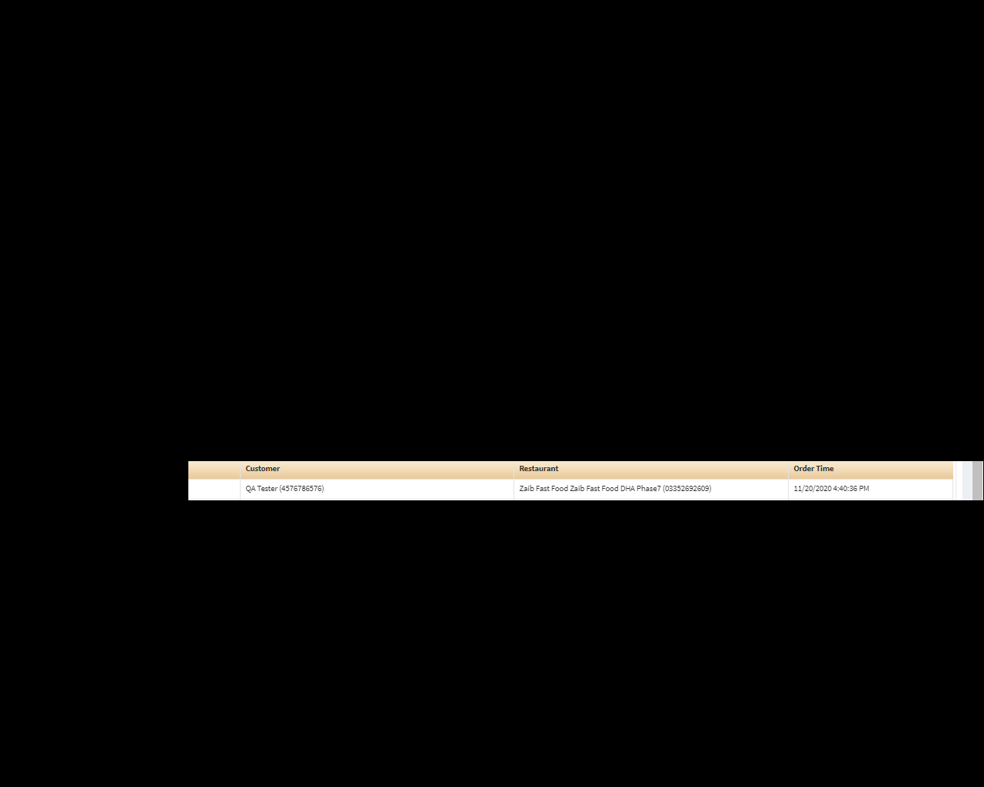

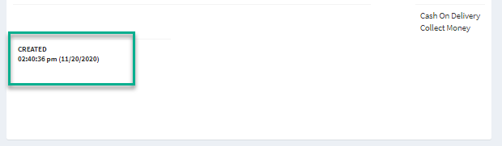

3. Pending restaurants> restaurants select> form> opening/ closing time arrows: increment and decrement labels does not go away (which hides the time).

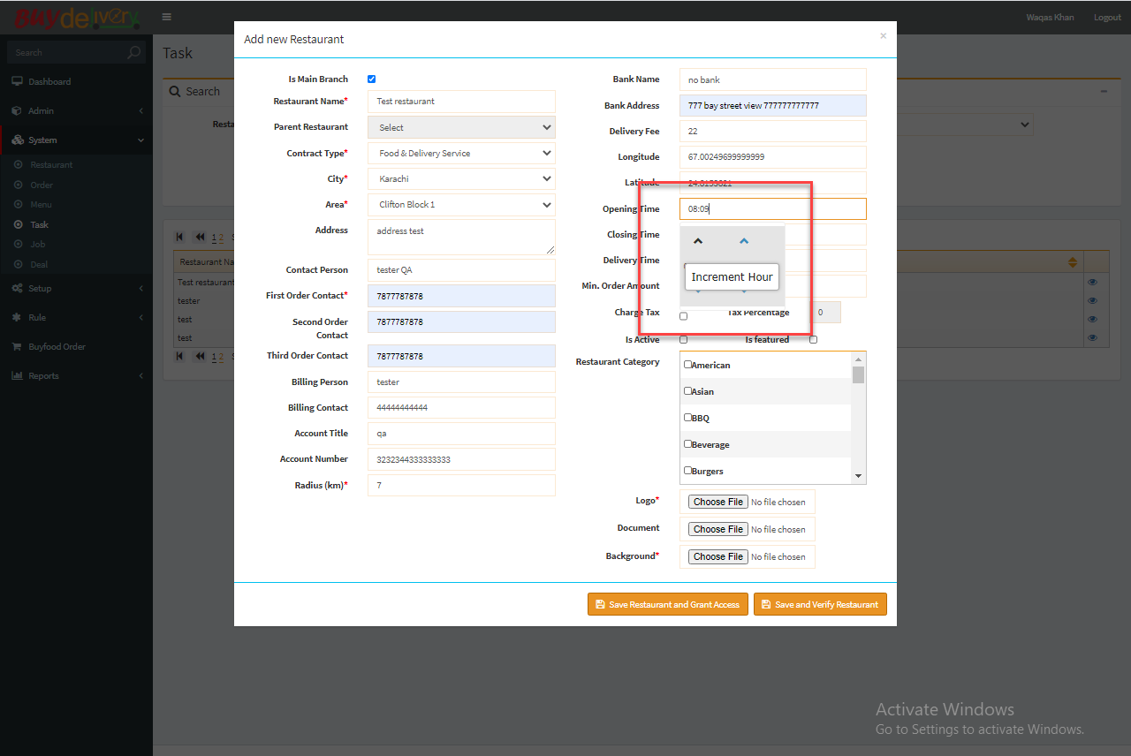

4. Pending restaurants > Restaurants select> form>restaurants category> should be able to select a category on clicking the word too.

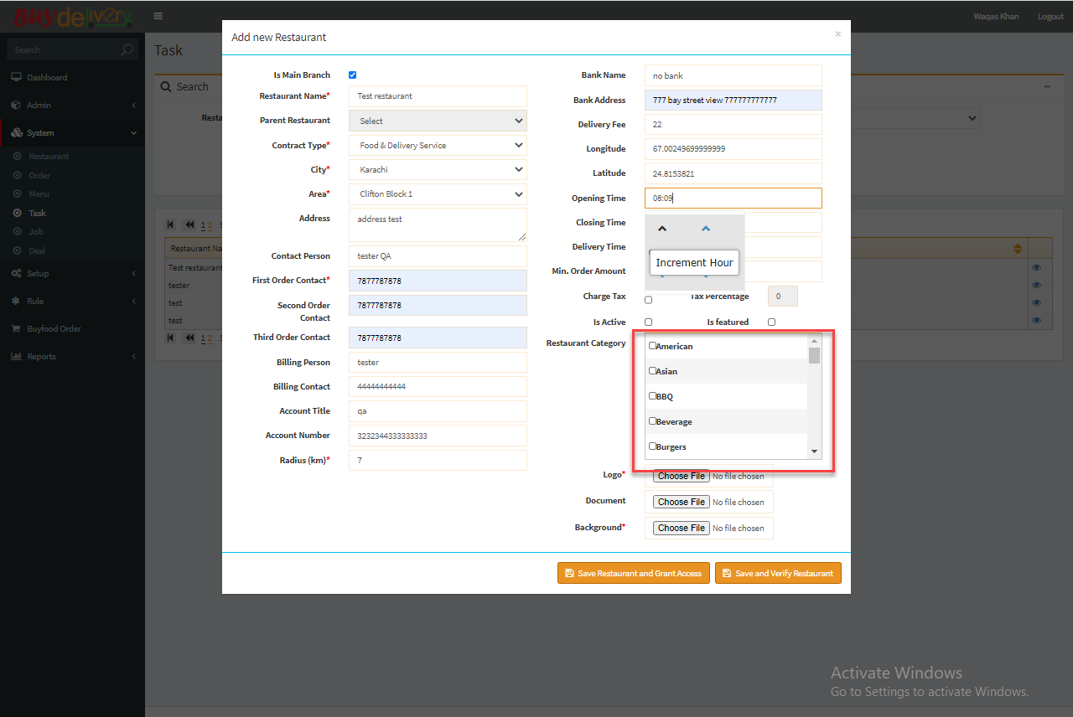

5. Restaurant verification email> should show buy food's icon.

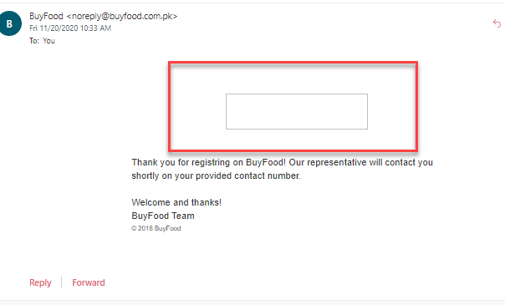

6. Link at the bottom left hand side" powered by MDI solutions" navigates to the buy delivery dashboard.

**DASHBOARD>RESTAURANT’S STATUS>VIEW ALL PENDING STATUSES**

1. If you put one space by mistake at the start of the restaurant’s name filter> It will fetch no data.

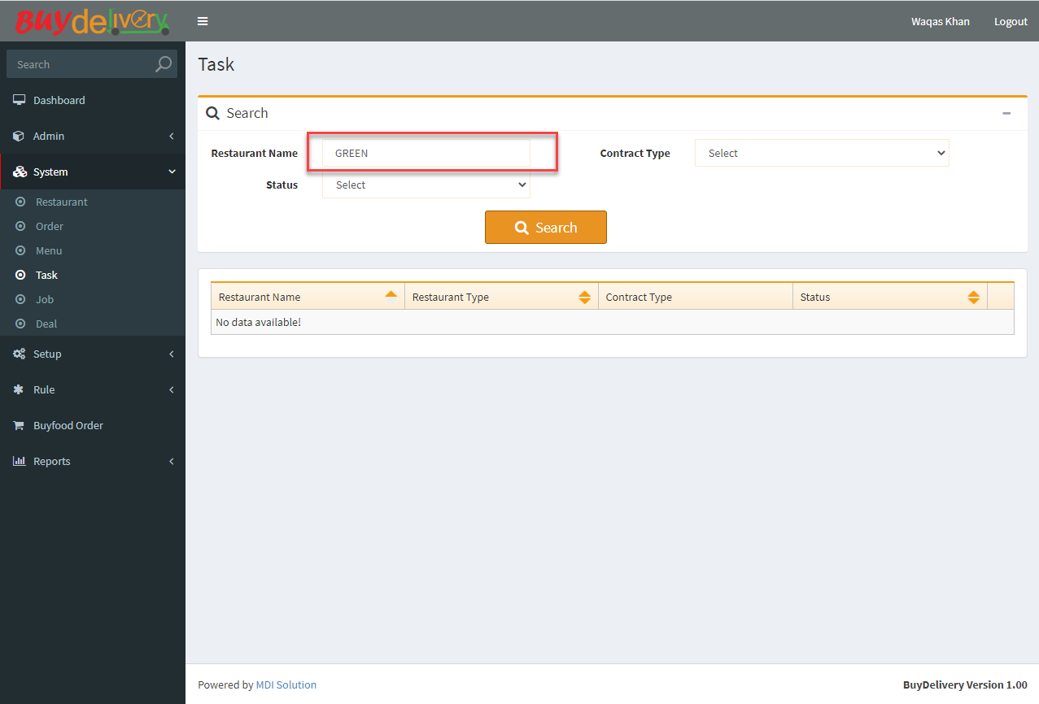

2. Increment/Decrement arrows and time should be aligned.(Low Priority).

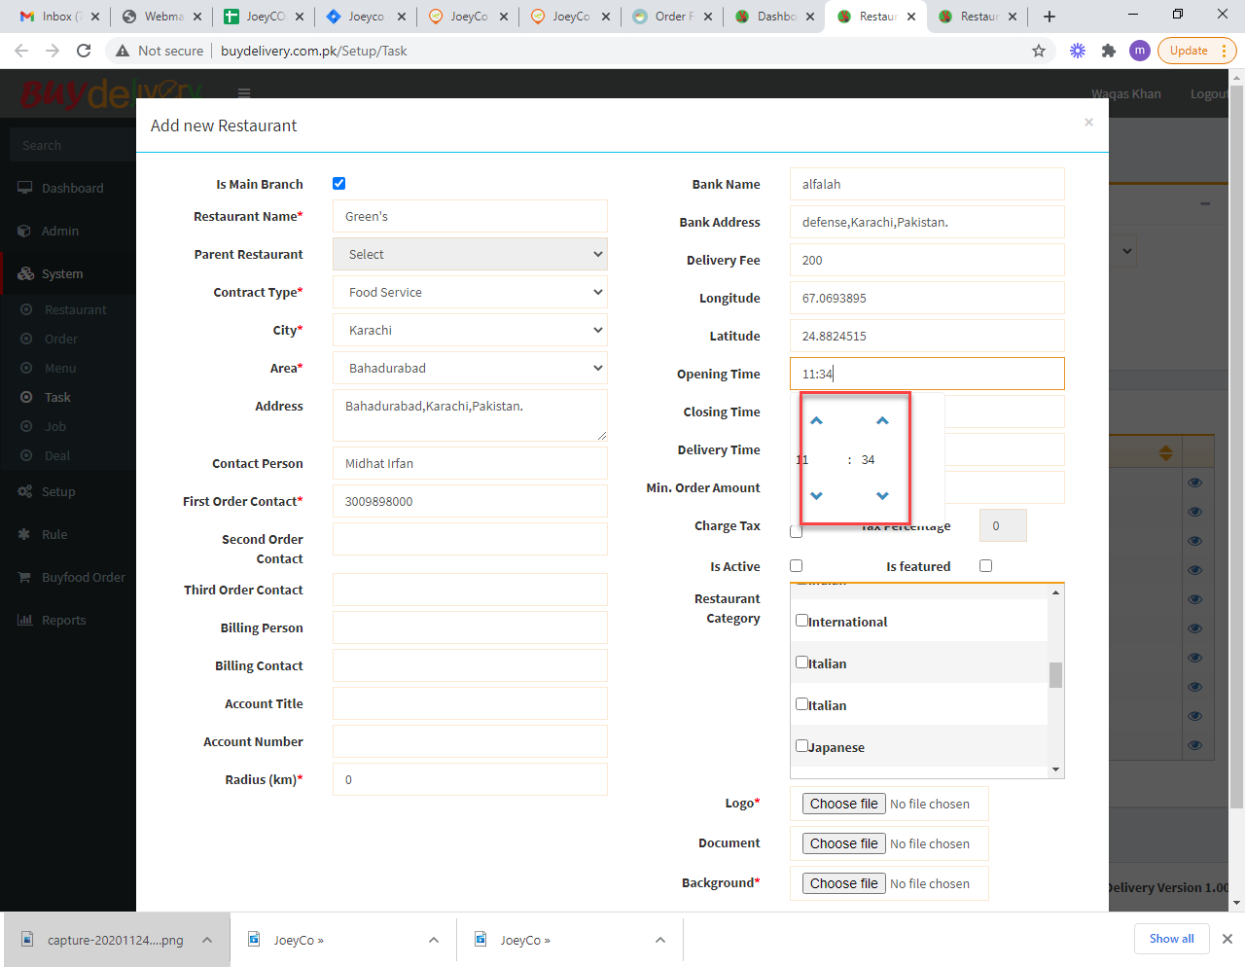

3. No time selection options opens on delivery time field.(See closing and opening time field).

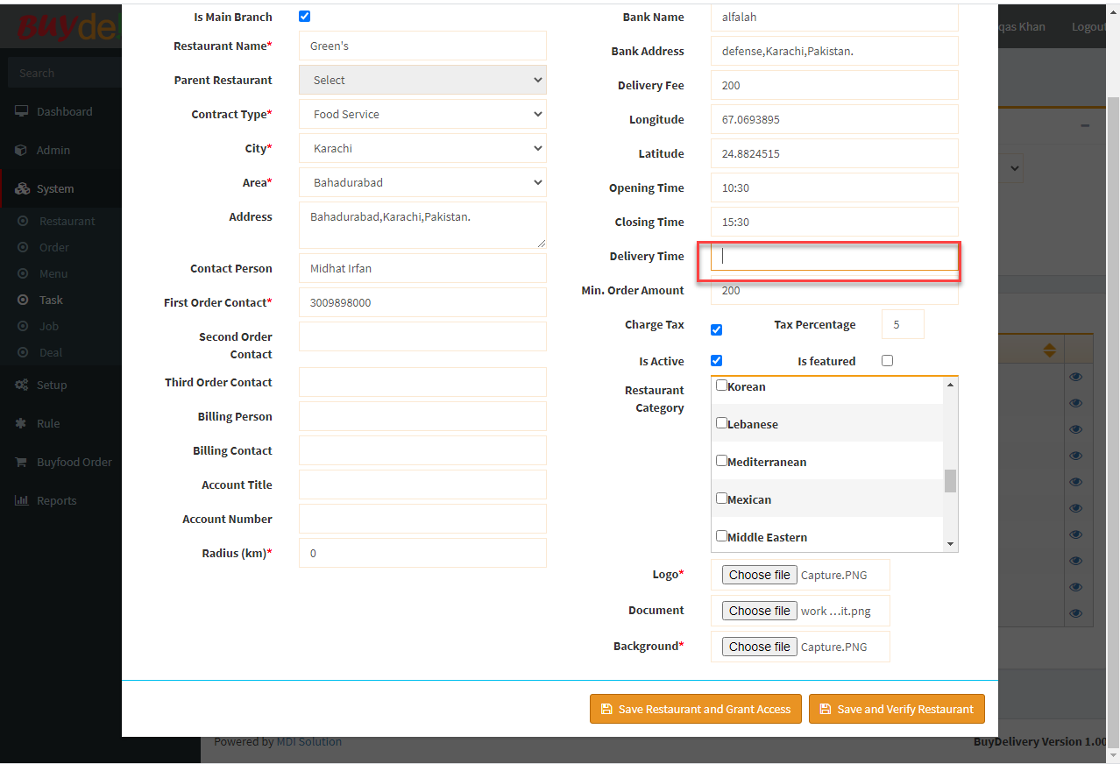

4. There is no option to remove logo, document and background>Can only replace it.

5. View pending restaurants>fill out few details and submit>cannot proceed further.

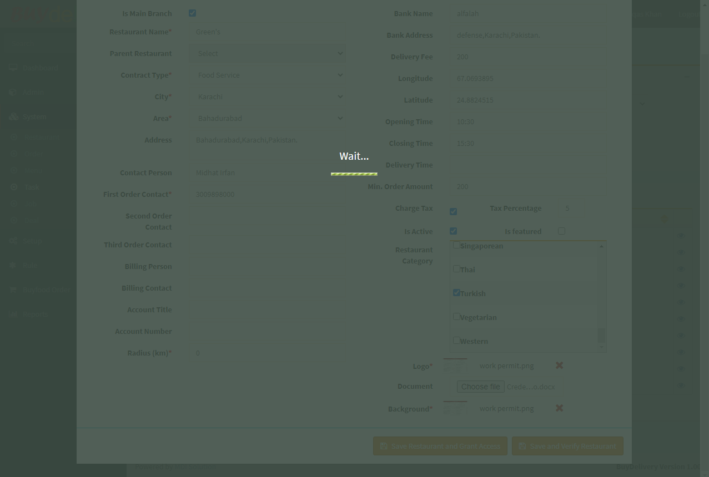

6. When login>There is an option view pending restaurants>although pending, approved and declined restaurants all can be seen.

7. Once the restaurant’s details are added and it is approved>there is no option to view restaurant’s details.

8. Time was fixed from 10:30-5:30>Appearing wrong here.

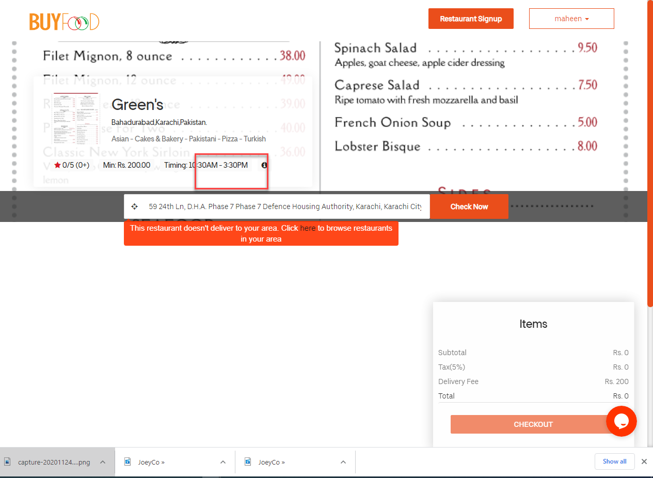

**ADMIN DASHBOARD>PENDING ORDERS:**

1. Wrong date. This order is placed on 24th Nov, 20.

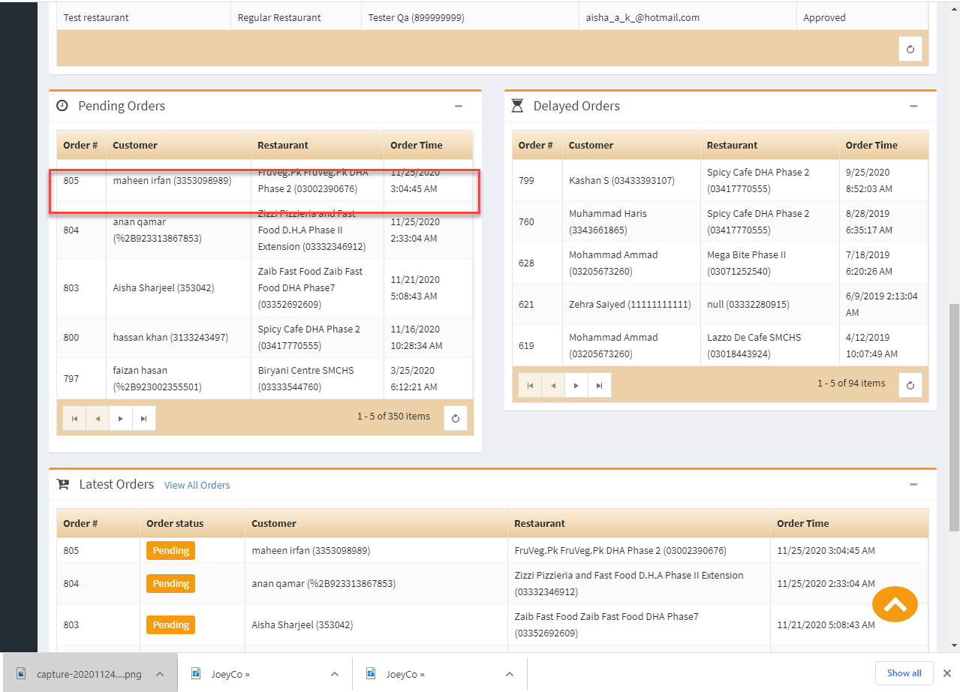

1. View all orders>add new option>All the restaurants are disabled.

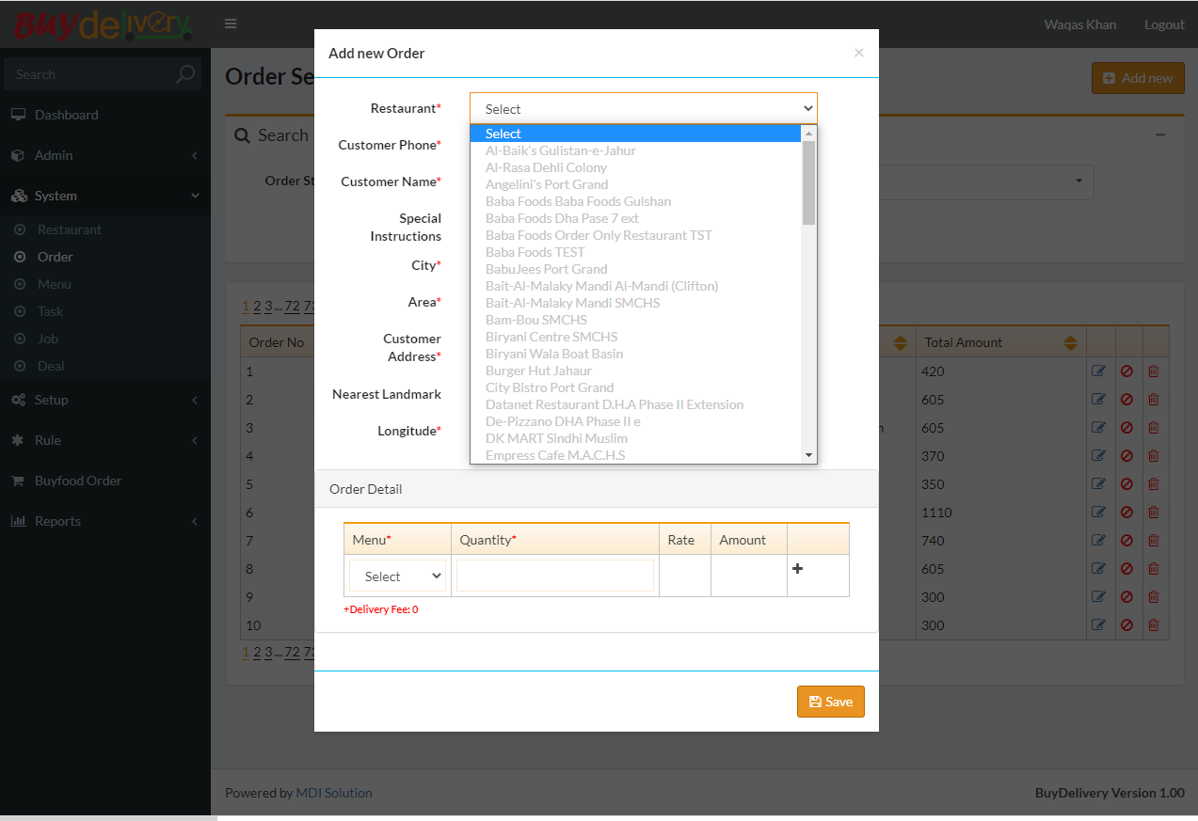

**ISSUEST LATEST (13/1/21)**

1. Can signup restaurant while logged in as customer at the same time.

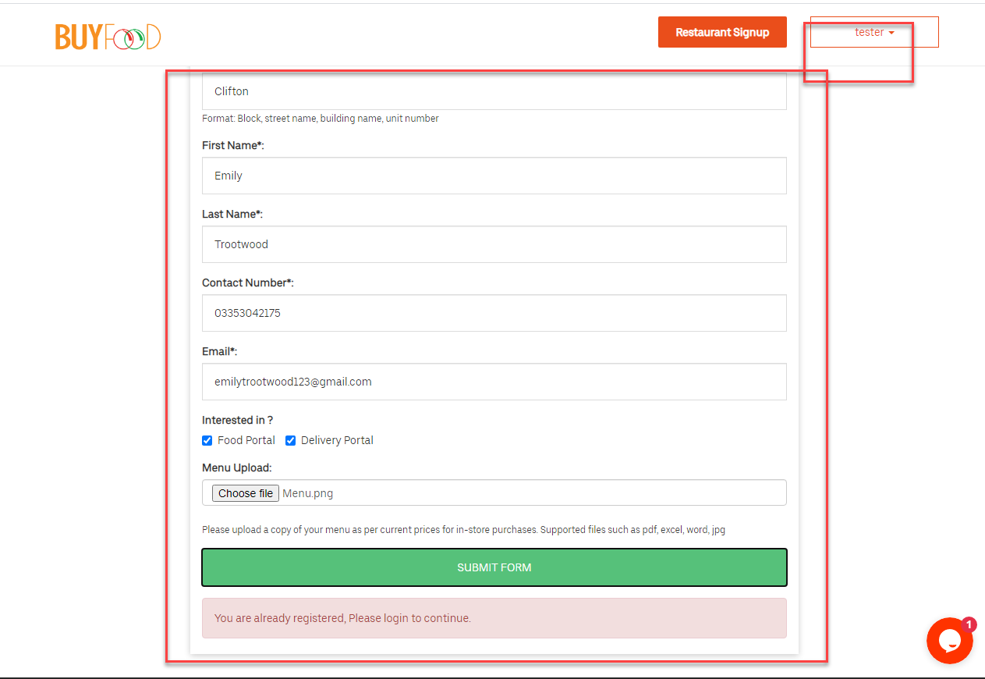

**FOOD AND DELIVERY CONTRACT:**

1. New restaurant (Food and delivery contract) >test food restaurant is made but on buy food > unable to select any item.

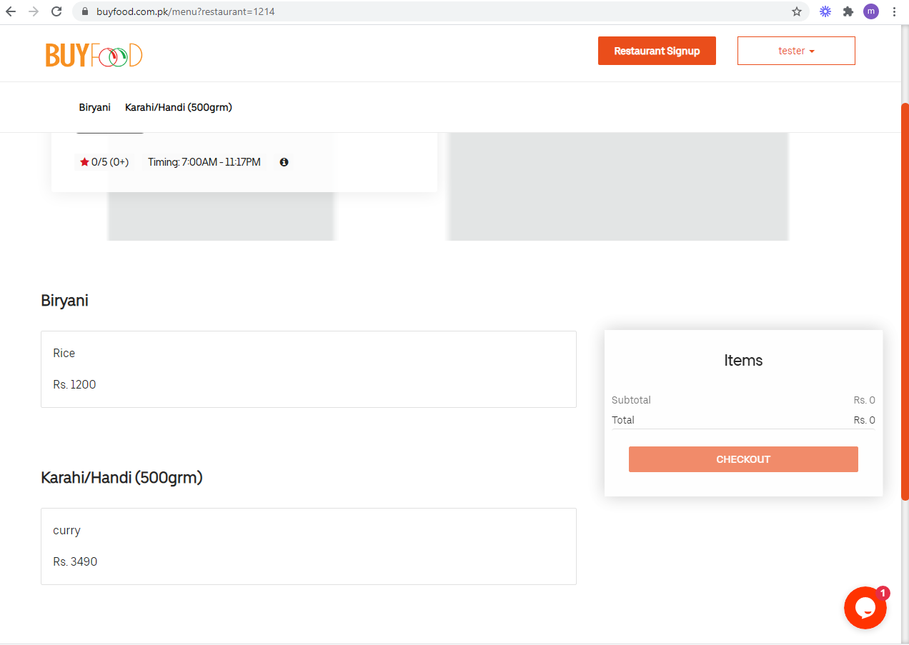

2.