*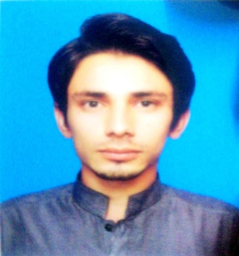CURRICULUM VITAE*

# Personal Information;

**Name:** Muhammad Umar Farooq

**Father’s name:** Muhammad Farooq

**Cell:** 0332-1122316

**Email:** [omrfaruk316@gmail.com](mailto:omrfaruk316@gmail.com)

**Date of Birth:** 04-Apr-1997

**Marital status:** Single

**Nationality:** Pakistani

**Address:** District & Tehsil, Toba Tek Singh, Chak# 316 GB, Qadirabad

# Objective;

To secure a position in an organization that would fully employ my personal skills, my experience as well as my academic training in a rewarding career that affords professional and personal growth.

# Personal Strength;

* I am an adaptable person.
* I can acquire new skills quickly.
* I have a special interest in Management
* Hobbies include traveling, gaming, badminton and photography.

# Academic Qualification;

## 1: BBA Honors (Bachelor of Business Administration):

Department of Business Administration

Specialization in HRM

Government College, University Faisalabad

Presently in 7th semester with CGPA 3.58 (Grade B), will be complete in August 2019

## 2: HSSC (Higher Secondary School Certificate):

Inter in Science,

Misali Zakria Higher Secondary School

Completed in July 2015, (Grade A)

## 3: SSC (Secondary School Certificate):

Matriculation in Science

Misali Zakria Higher Secondary School

Completed in June 2012 (Grade A)

# Skills and Expertise:

* Microsoft word and PowerPoint
* Leadership Skills
* Team Work skills
* Interpersonal skills

# Projects:

**Marketing Project: (2016)**

Create a new product named “Virasat Masala” and advertised it by arranging a stall.

**HRM Project: (2018)**

Solve the cases in management of Shakar Ganj Sugar Mill.

**HRD Project: (2018)**

Make a Model of Trainee & Development of employees of Shakar Ganj Mill. .

**Operational/Production Management Project: (2019)**

Make a model of operations management of Atlas Honda.

# Language Proficiency:

1. Urdu Fluency
2. Punjabi Fluency
3. English Lightly

# References:

Will be provided on request