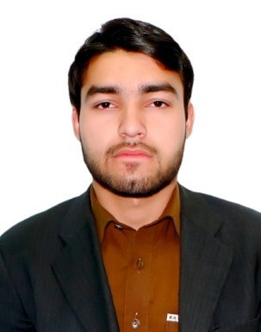

**CURRICULUM VITAE**

**ZULQARNIAN HAIDER**

**Contact # (+92) 03339131946**

**POSTAL ADDRESS:-**

**Mohallah Zakaryakhel Village Kaddi & P.O Kaddi**

**Thesil & District Swabi, Khyber Pakhtunkhwa, Pakistan.**

**Email Address;-**

**zulqarnainhaiderswb@gmail.com _________________________________________________________**

**OBJECTIVE;- To secure a position in an organization that would fully employ my potential including persistence a positive disposition and academic preparation in a rewarding career that would afford me professional**

**as well as personal growth. I am graduated university level fresh student .**

**________________________________________________________ ­­­­­­­­­­­­­PERSONAL INFORMATION:- _ _**

**Father Name : MUKHTAR HUSSAIN**

**Date of Birth : 26-11-1994**

**Domicile : Sawabi ( Khyber Pakhtunkhwa)**

**NIC # : 16202-5086201-5**

**Religion : Islam**

**Marital status : SINGLE**

**Nationality : Pakistani**

**_______________________________________________________________________ ACADEMIC QUALIFICATION:- __**

**Matric:- (2011) Marks : 805/1050**

**From Board of intermediate & Education Mardan.**

**Intermediat: (2013)_________ marks _____________725/1100**

**_____________________ OTHER QUALIFICATION:- _ _**

**English language course 3th Month Certificat (2012)**

**currently doing software engineering from COMSATS universaty (2015-2019) Marks: 2.55/4.00 ____________________________________________________ HOBBIES & INTRESTS;- _ _**

**• Social Work, Sport, Reading Books etc.**

**writting + typing.**

**LANGUAGES:- __**

|  |  |  |  |
| --- | --- | --- | --- |
| **LANGUAGES** | **SPEAKING** | **READING** | **WRITING** |
| **English** | **very Good** | **Excellent** | **Excellent** |
| **Urdu** | **very good** | **Excellent** | **Excellent** |
| **Pashto** | **Excellent** | **Excellent** | **Excellent** |
| **Arabic** | poor | Excellent | Excellent |

**________________________________________________________________________ REFREANCE:-**

**Could be furnishing upon request.**