**DRUG VERTIFICATE**

1. Add drug certificate > taking a lot of time to save.

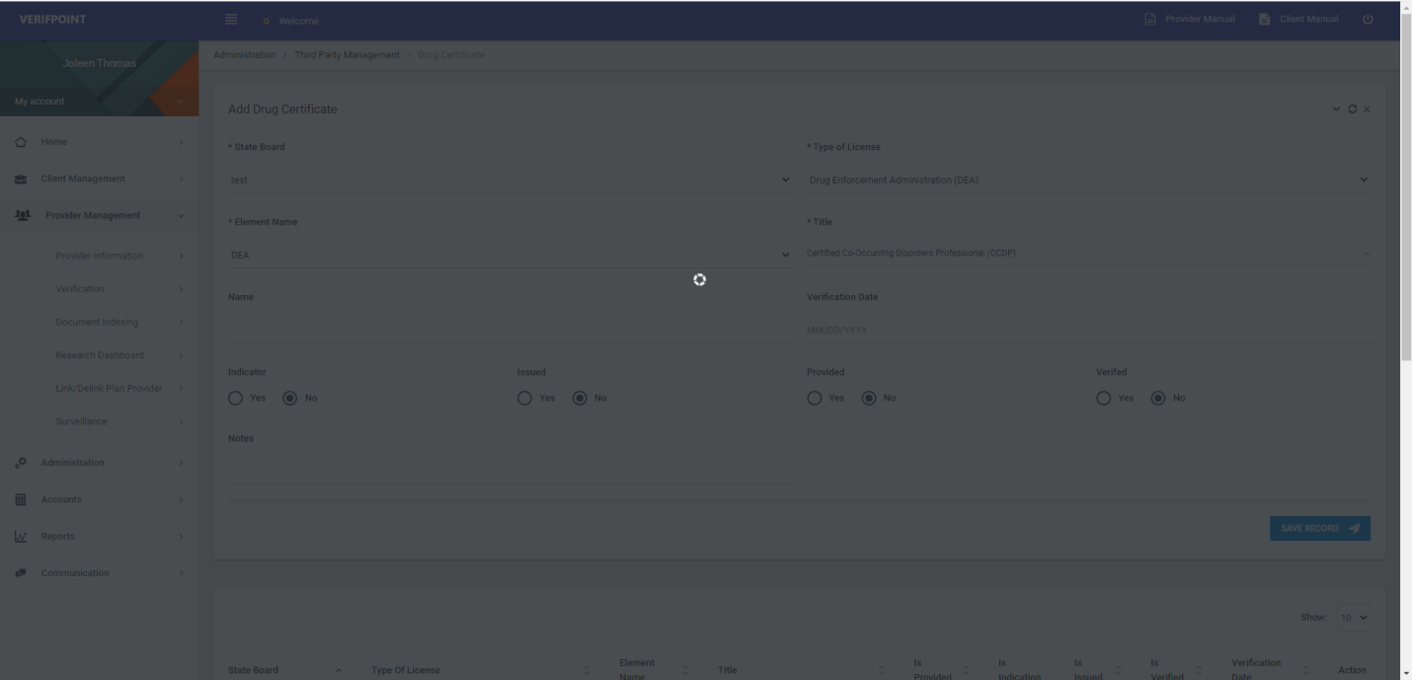

2. Calender widget > should have option to jump on different years/months.

