

LAB REPORT

Submitted By:
Fahad Khan (23-SE-64)

Lab Tasks
Task 1: PrintNumbers.java
CODE:
package lab06;
public class Task1_PrintNumbers {
public static void printNumbers(int n) {
// Base case: if n is 0 or less, stop
if (n <= 0) {
return;
}

// Recursive case: first print numbers from 1 to n-1
printNumbers(n - 1);

// Then print current number
System.out.print(n + " ");
}

public static void main(String[] args) {
System.out.println("=== TASK 1: Print Numbers from 1 to n ===");

int n = 5;
System.out.print("Numbers from 1 to " + n + ": ");
printNumbers(n);

// Test with different values
System.out.println("\n");
int n2 = 10;
System.out.print("Numbers from 1 to " + n2 + ": ");
printNumbers(n2);

System.out.println("\n");
System.out.println(" Explanation: The function calls itself with n-1");
System.out.println(" until it reaches base case (n <= 0), then prints");
System.out.println(" as it returns (backtracking).");
}
}
OUTPUT:
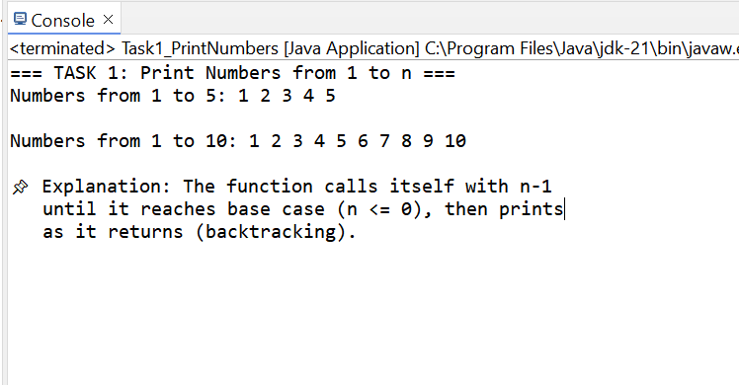

Task 2: PowerCalculator.java

CODE:
package lab06;
public class Task2_PowerCalculator {
public static int power(int base, int power) {
// Base case 1: Any number to power 0 is 1
if (power == 0) {
return 1;
}

// Base case 2: Any number to power 1 is itself
if (power == 1) {
return base;
}

// Recursive case: base^power = base * base^(power-1)
return base * power(base, power - 1);
}
public static void main(String[] args) {
System.out.println("=== TASK 2: Calculate Power of a Number ===");

// Test case 1
int base1 = 2, power1 = 4;
int result1 = power(base1, power1);
System.out.println(base1 + "^" + power1 + " = " + result1);

// Test case 2
int base2 = 3, power2 = 3;
int result2 = power(base2, power2);
System.out.println(base2 + "^" + power2 + " = " + result2);

// Test case 3 - edge case
int base3 = 5, power3 = 0;
int result3 = power(base3, power3);
System.out.println(base3 + "^" + power3 + " = " + result3);

// Test case 4
int base4 = 10, power4 = 2;
int result4 = power(base4, power4);
System.out.println(base4 + "^" + power4 + " = " + result4);
System.out.println("\n Explanation: " + base1 + "^" + power1 + " = " +
base1 + " × " + base1 + "^" + (power1-1) + " = ...");
}
}

OUTPUT:
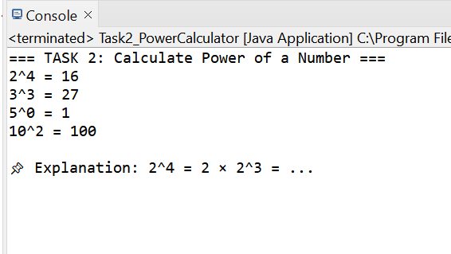

Task 3: Fibonacci.java
CODE:

package lab06;
public class Task3_Fibonacci {
public static int fibonacci(int n) {
// Base cases
if (n == 0) {
return 0;
}
if (n == 1) {
return 1;
}

// Recursive case: F(n) = F(n-1) + F(n-2)
return fibonacci(n - 1) + fibonacci(n - 2);
}
public static void printFibonacciSequence(int terms) {
for (int i = 0; i < terms; i++) {
System.out.print(fibonacci(i) + " ");
}
}

public static void main(String[] args) {
System.out.println("=== TASK 3: Fibonacci Sequence ===");
int terms = 8;
System.out.print("First " + terms + " Fibonacci numbers: ");
printFibonacciSequence(terms);
System.out.println("\n");
// Show individual calculations
System.out.println("Individual Fibonacci numbers:");
for (int i = 0; i <= 7; i++) {
System.out.println("F(" + i + ") = " + fibonacci(i));
}

System.out.println("\n Explanation: Each number is sum of two previous numbers");
System.out.println(" F(5) = F(4) + F(3) = 3 + 2 = 5");

// Show recursion tree for F(5)
System.out.println("\n Recursion Tree for F(5):");
System.out.println(" F(5)");
System.out.println(" / \\");
System.out.println(" F(4) F(3)");
System.out.println(" / \\ / \\");
System.out.println(" F(3) F(2) F(2) F(1)");
System.out.println(" / \\ / \\ / \\");
System.out.println("F(2)F(1)F(1)F(0)F(1)F(0)");
}
}

OUTPUT:
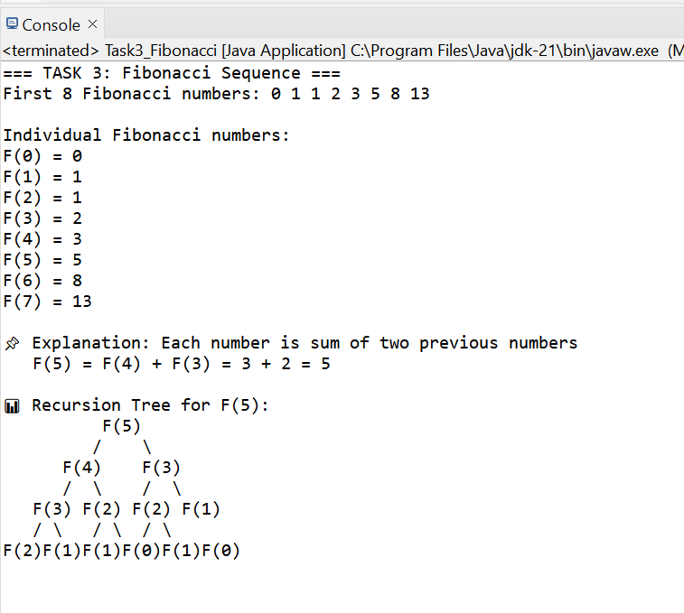

Task 4: SumOfDigits.java
CODE:
package lab06;
public class Task4_SumOfDigits {
public static int sumOfDigits(int number) {
// Take absolute value to handle negative numbers
number = Math.abs(number);

// Base case: if number is 0, sum is 0
if (number == 0) {
return 0;
}

// Recursive case: last digit + sum of remaining digits
// number % 10 gives last digit
// number / 10 removes last digit
return (number % 10) + sumOfDigits(number / 10);
}
public static int sumOfDigitsTraced(int number, String indent) {
number = Math.abs(number);

if (number == 0) {
System.out.println(indent + "sumOfDigits(0) = 0 (base case)");
return 0;
}

int lastDigit = number % 10;
int remaining = number / 10;

System.out.println(indent + "sumOfDigits(" + number + ") = " +
lastDigit + " + sumOfDigits(" + remaining + ")");

int result = lastDigit + sumOfDigitsTraced(remaining, indent + " ");

System.out.println(indent + "→ Returns: " + result);
return result;
}

public static void main(String[] args) {
System.out.println("=== TASK 4: Sum of Digits ===");

// Test case 1
int num1 = 1234;
int result1 = sumOfDigits(num1);
System.out.println("Sum of digits of " + num1 + " = " + result1);

// Test case 2
int num2 = 9876;
int result2 = sumOfDigits(num2);
System.out.println("Sum of digits of " + num2 + " = " + result2);

// Test case 3 - single digit
int num3 = 5;
int result3 = sumOfDigits(num3);
System.out.println("Sum of digits of " + num3 + " = " + result3);

// Test case 4 - negative number
int num4 = -567;
int result4 = sumOfDigits(num4);
System.out.println("Sum of digits of " + num4 + " = " + result4);

System.out.println("\n=== TRACING EXECUTION for 1234 ===");
sumOfDigitsTraced(1234, "");

System.out.println("\n Formula: sumOfDigits(n) = (n % 10) + sumOfDigits(n/10)");
}
}
OUTPUT:
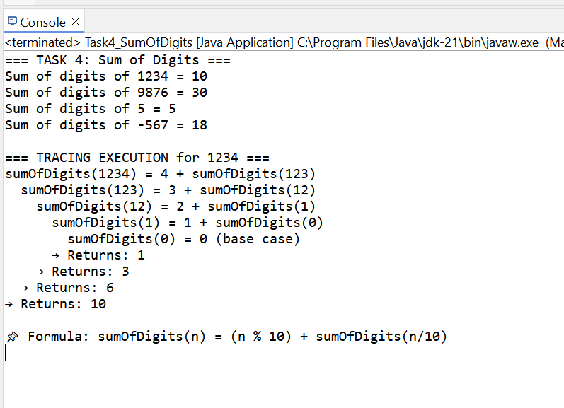

Task 5: ReverseString.java

CODE:
package lab06;

public class Task5_ReverseString {
public static String reverse(String str) {
// Base case: if string is empty or has 1 character, it's already reversed
if (str == null || str.length() <= 1) {
return str;
}

// Recursive case:
// reverse("hello") = reverse("ello") + "h"
return reverse(str.substring(1)) + str.charAt(0);
}

/**
* Alternative method with explicit tracing
*/
public static String reverseTraced(String str, String indent) {
if (str == null || str.length() <= 1) {
System.out.println(indent + "reverse(\"" + str + "\") = \"" + str + "\" (base case)");
return str;
}

String firstChar = String.valueOf(str.charAt(0));
String remaining = str.substring(1);

System.out.println(indent + "reverse(\"" + str + "\") = reverse(\"" +
remaining + "\") + \"" + firstChar + "\"");

String result = reverseTraced(remaining, indent + " ") + firstChar;

System.out.println(indent + "→ Returns: \"" + result + "\"");
return result;
}

public static void main(String[] args) {
System.out.println("=== TASK 5: Reverse a String ===");

// Test case 1
String str1 = "HELLO";
String reversed1 = reverse(str1);
System.out.println("Original: \"" + str1 + "\"");
System.out.println("Reversed: \"" + reversed1 + "\"");

// Test case 2
String str2 = "JAVA";
String reversed2 = reverse(str2);
System.out.println("\nOriginal: \"" + str2 + "\"");
System.out.println("Reversed: \"" + reversed2 + "\"");

// Test case 3 - palindrome
String str3 = "RACECAR";
String reversed3 = reverse(str3);
System.out.println("\nOriginal: \"" + str3 + "\"");
System.out.println("Reversed: \"" + reversed3 + "\"");
System.out.println("Is palindrome? " + str3.equals(reversed3));

// Test case 4 - single character
String str4 = "A";
String reversed4 = reverse(str4);
System.out.println("\nOriginal: \"" + str4 + "\"");
System.out.println("Reversed: \"" + reversed4 + "\"");

System.out.println("\n=== TRACING EXECUTION for \"HELLO\" ===");
reverseTraced("HELLO", "");

System.out.println("\n Formula: reverse(str) = reverse(str[1:]) + str[0]");
System.out.println(" where str[1:] is string without first character");
}
}

OUTPUT:

