Contents
Introduction 3
World Setting and Narrative 3
Player Experience 4
Objectives 5
Procedures (Gameplay Flow) 5
Resources and Environmental Storytelling. 6
2D Map Explanation 7
Conclusion 7

Introduction
This project is the design and development of a 3D adventure game level, which is a single-player game, and the project was designed and developed entirely in Blender by white-box modeling. The purpose of the assignment was to have a game environment that can be explored, delivering the impression of progression through space layout, well-defined routes, environmental risks, and interactive features like puzzles and fights. The game is to be played in the third person view, which will enable the gamer to be able to visually interact with the character and the environment.
The setting is in an ancient volcanic ruin and the game offers the player a combination of environmental exploration, choice, a bit of light puzzle solving and fighting. This design has focused on the risk/reward factor by making the player have the choice of taking a longer but a safer route or a shorter route but more hazardous one. The option encourages agency of players and introduces replay value, because other players can make updated choices depending on their favorite play styles. The idea of flow is also facilitated by the branching path design that enables the player to feel challenged and not overwhelmed.
White-boxing is the construction of the level environment with the help of modular geometric shapes. White-boxing enables designers not to be distracted by textures or visual detail in order to work on navigation, readability, and spatial rhythm. When the layout is functionally sound, surface materials and light are used to support atmosphere and draw attention. The lighting is placed purposefully to focus on interactive or story-important elements, especially the glowing lava, the puzzle platforms and the last artifact room. The visual and design help uphold a narrative theme of lost explorers, lost relics and lost rituals, developing interest and involvement.

World Setting and Narrative
The setting of the level is a volcanic shrine which is buried deep into the jungle somewhere remote. The lore goes on to say that the shrine was constructed by a people that had a mythical flame god, who was thought to live in the core of the volcano. The shrine contains a mighty device, which could direct life energy and fire of the elements. This artifact acted as a religious relic and a fear object since it was only accessible to people who were spiritually strong enough to get into its proximity.
Through the centuries, there has been an effort by people to access the artifact by explorers, treasure hunters and scholars. Nonetheless the mix up of natural volcanic threats with the artificial defenses that were in place made the majority of these endeavors unsuccessful.
This profound historical experience and abandonment is manifested via environmental narrative, as shown by:
The bones and leftovers were found close to dangerous areas, which presupposed the way earlier explorers died.
The collapsed tracks and shattered bridges, which depict geological erosion and old decay.
The burnt torches and the tools scattered around that point to some attempts of struggle and survival or escape.
The player character is the newcomer but not a selfish man. They want to take back the artifact before it fails and the journey the player goes on becomes connected to a moral and narrative goal. The tone is also augmented by the atmosphere at the level, the warm glow of lava is dramatic in contrast with dark stone surfaces, shadows are used to create a sense of depth and danger. There is no dialogue necessary to pass narrative, the surrounding tells the story itself.

Player Experience
The level is structured in such a way that it would lead the player through the emotional flow with the help of strictly regulated rhythm and space sequence. The initial area is non-hazardous, large, and safe, allowing the player time to familiarize. The initial significant choice is given shortly afterwards- should the player go on the longer and safer path or opt to make the shortcut, which is easier, but perilous. This ruling instantly strengthens the autonomy of the players.
The non hazardous upper path stimulates exploration and brings about vertical climbing which creates spatial awareness. The lower path is also a dangerous one and involves tensioning spike traps and has to move precisely, which attracts the attention of the players who enjoy playing high-risk levels.
The lava crossing sequence also requires the player to use his or her timing and spatial skills and thus is a transition between exploration and skill execution. This is then succeeded by the Puzzle Chamber which is designed in such a way that it makes it slow down and demands brain interaction. The Enemy Zone then presents the strategy of combat by having multiple levels of enemies. Lastly, the experience ends with the Artifact Chamber, which is a reward-based and visually serene setting.
The player’s emotional arc follows:
Curiosity → Caution → Challenge → Danger → Strategy → Triumph → Reward
This controlled arc strengthens the player's sense of accomplishment and narrative closure.

Objectives
Primary Objective:
Take the artifact that is in the last chamber.
Secondary Objectives:
Go along the safe or hazardous road.
Complete the puzzle of environmental statue in the puzzle room.
Either defeat or evade opponents at the field.
Past platforming and environmental challenges.
The level system is also specifically developed to allow every goal to be based on the previously acquired skills, allowing mastering the gameplay progressively.
Rules
Rule Type | Description
Movement Rules | The player may walk, run, jump, climb, and drop from ledges.
Combat Rules | The player can engage enemies or avoid fights through movement and positioning.
Navigation Rules | Falling into lava or spikes results in failure and a return to checkpoint.
Puzzle Rules | The puzzle is solved by interpreting statue positions and spatial arrangement.
The rules are intuitive and consistent, ensuring the player can predict outcomes and learn through experience.

Procedures (Gameplay Flow)
Start Area : The player starts and looks around.
Branching Path Choice
Upper Path: Slice of time - Puzzle Room - Enemy Zone.
Lower Path: Spike damage risks - Enemy Zone straight.
Lava Platforming : This needs to be moved safely.
Puzzle Room : Multistory set-up forms critical thinking.
Enemy Zone : The player has to respond to positions and space of the enemy.
Artifact Chamber : The end of the level and the reward.
This developmental process is rhythmic as thoughts, space, and battle activities are alternated.
Conflict and Challenge Types
Conflict Type | Example in Level
Environmental Conflict | Lava pits, unstable platforms, spike traps
Navigational Conflict | Climbing and descending elevation changes
Puzzle Conflict | Interpreting statue layout and platform levels
Combat Conflict | Enemy formations and positional strategy
The interplay of these conflicts keeps the experience engaging and non-repetitive.
Resources and Environmental Storytelling.

The significance of the environment supports narrative:
Bones on the verge of dangers - demise of the earlier adventurers.
Broken bridges - the sign of instability and danger.
Rubbish and flares - old oppression and defeat.
Such hints add to the immersion without the need to have a dialogue.

2D Map Explanation
START
│
├── Safe Long Route → Climbing → PUZZLE ROOM → ENEMY ZONE → END (Artifact)
│
└── Dangerous Short Route → Spikes → ENEMY ZONE → END (Artifact)
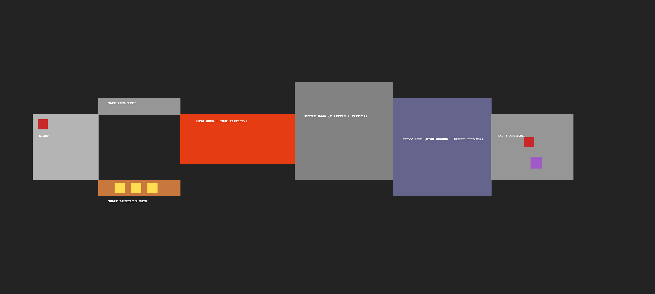

Conclusion
The last tier manages to meet all the criteria of the design of an adventure game, such as exploration, progression, interactive challenge, and narrative coherence. The design encourages player agency, the gameplay gives the experience of tension and reward, and the visual narrative adds to the atmosphere and meaning. Structurally and conceptually, it is already prepared to be implemented to the full extent in a playable game engine.

