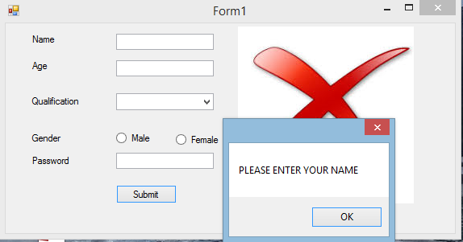

using System;

using System.Collections.Generic;

using System.ComponentModel;

using System.Data;

using System.Drawing;

using System.Linq;

using System.Text;

using System.Windows.Forms;

namespace validation

{

public partial class Form1 : Form

{

public Form1()

{

InitializeComponent();

}

private void Form1_Load(object sender, EventArgs e)

{

}

private void button1_Click(object sender, EventArgs e)

{

if (textBox1.Text == String.Empty)

{

MessageBox.Show("PLEASE ENTER YOUR NAME");

label1.ForeColor = Color.Red;

pictureBox2.Image = Properties.Resources.False;

}

else{

pictureBox2.Image = Properties.Resources.download;

}

if (textBox2.Text == String.Empty)

{

MessageBox.Show("PLEASE ENTER YOUR AGE");

label2.ForeColor = Color.Red;

// pictureBox3.Image = Properties.Resources.False;

}

else{

// pictureBox3.Image = Properties.Resources.download;

}/*

if (comboBox1.SelectedIndex == -1)

{

MessageBox.Show("PLEASE ENTER YOUR Qualification");

comboBox1.ForeColor = Color.Red;

///pictureBox3.Image = Properties.Resources.False;

}

else

{

//pictureBox3.Image = Properties.Resources.download;

}*/

if (!radioButton1.Checked && !radioButton2.Checked)

{

MessageBox.Show("PLEASE ENTER YOUR Gender");

}

if (textBox3.TextLength<4) {

MessageBox.Show("Please enter the password atleats 8 characters");

label5.ForeColor = Color.Red;

}

}

private void textBox3_TextChanged(object sender, EventArgs e)

{

}

}

}