LABORATORY EXERCISE 9

SEARCH AND FILTERING SYSTEM

Learning Objectives
By the end of this laboratory exercise, students should be able to:
- Implement client-side search filtering using jQuery for dynamic user experience.
- Develop server-side search functionality using CodeIgniter's database queries.
- Create a responsive search interface using Bootstrap components.
- Integrate AJAX techniques to display search results without page reload.
- Understand the differences between client-side and server-side search approaches.

Prerequisite student experiences and knowledge
Before starting this exercise, students should have:
- Completed Laboratory Exercise 8 (Real-time Notifications with jQuery).
- Solid understanding of CodeIgniter's MVC architecture and database operations.
- Proficiency in writing jQuery and JavaScript code for DOM manipulation.
- Experience with AJAX requests and handling JSON responses.
- Familiarity with Bootstrap form components and grid system.
- Knowledge of SQL queries, particularly LIKE operators for search functionality.

Background
An effective search system is crucial for any Learning Management System (LMS) to help users quickly find relevant courses and content. This exercise focuses on implementing a dual-approach search system: client-side filtering for immediate feedback and server-side searching for comprehensive results. jQuery provides the tools for dynamic client-side filtering, while CodeIgniter's database class enables efficient server-side search using SQL LIKE queries. The combination creates a seamless user experience where search results update in real-time without page refreshes, enhancing the overall usability of the application.

Materials/Resources
- Personal Computer with Internet Access
- XAMPP/WAMP/LAMP server installed
- CodeIgniter Framework
- Visual Studio Code or any code editor
- Git and GitHub Account
- Web Browser (Chrome, Firefox, etc.)
Laboratory Activity
Step 1: Project Setup
- Open your existing ITE311-LASTNAME CodeIgniter project.
- Ensure your database has a courses table with sample data for testing search functionality.
- Verify that your course listing page is functional from previous exercises.

Step 2: Create Search Controller Method
- Navigate to your Course.php controller in app/Controllers/.
- Add a new method named search():
  - This method should accept GET or POST requests with a search term parameter.
  - Use CodeIgniter's Query Builder to search the courses table using LIKE queries.
  - Return the results as JSON for AJAX requests or render a view for regular requests.
- Implement the search logic
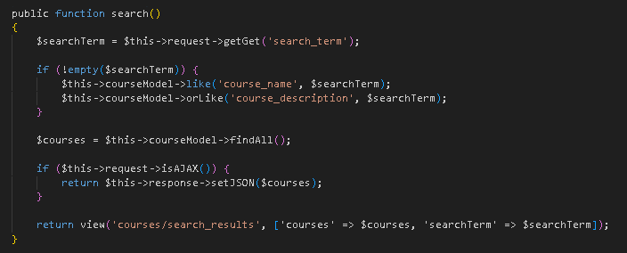

Step 3: Add Search Route
- Open app/Config/Routes.php.
- Add routes for the search functionality:
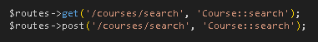

Step 4: Create Search Interface
- Modify your courses view file (app/Views/courses/index.php).
- Add a search form with Bootstrap styling
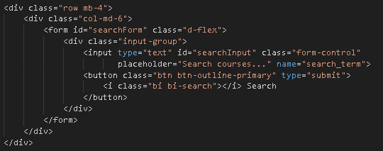

Step 5: Implement Client-Side Filtering with jQuery
- Add jQuery script for instant client-side filtering
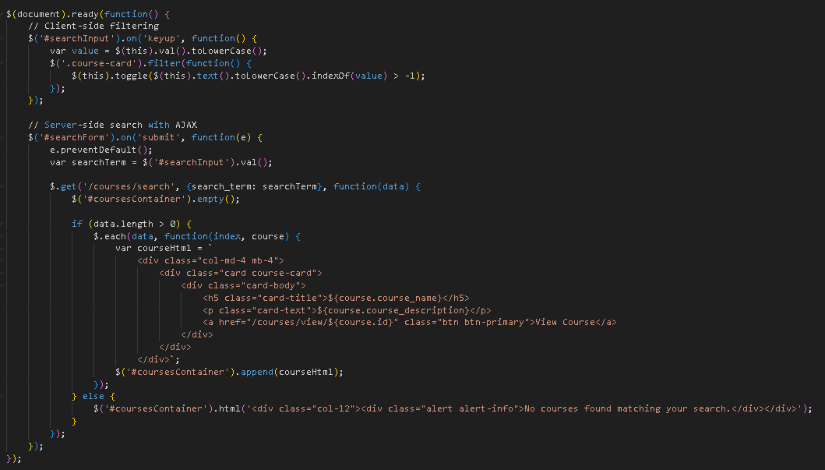

Step 6: Update Courses View Structure
- Modify your courses listing to work with the search functionality
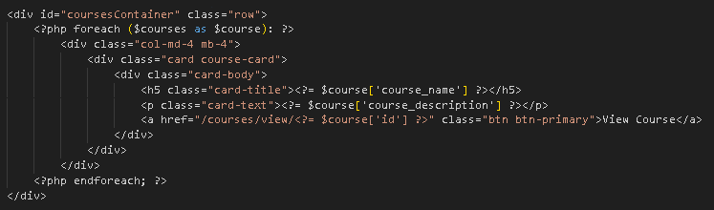
- To simulate real-time updates, you can set an interval to fetch notifications every 60 seconds (optional advanced task).

Step 7: Test the Search Functionality
- Load the courses page in your browser.
- Test the client-side filtering by typing in the search box courses should filter instantly.
- Test the server-side search by submitting the form results should load via AJAX without page refresh.
- Verify that both empty search results and successful searches display appropriate messages.

Step 9: Push to GitHub
- Stage and commit your search functionality
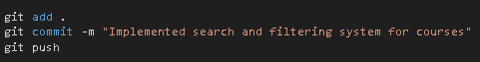

Output / Results
- Screenshot of the courses page with the search interface implemented.
- Screenshot showing filtered courses during client-side search.
- Screenshot of browser Developer Tools Network tab showing AJAX request to server-side search.
- Screenshot of search results displaying when no courses match the search term.
- Screenshot of GitHub repository with the latest commit.

QUESTIONS:
- What are the advantages and limitations of client-side filtering compared to server-side search?
Client-side filtering refers to searching or filtering data directly within the user's browser, using JavaScript to display or hide results without reloading the page. One major advantage of client-side filtering is its speed. Because all necessary data is already loaded, results appear instantly as the user types—ideal for small datasets such as product lists, category filters, or dashboards. It also reduces server load because no repeated requests are sent to the server.
- How does using AJAX for search improve the user experience compared to traditional form submission?
AJAX-based search dramatically enhances user experience by eliminating full page reloads. Instead of submitting a form and refreshing the entire page, AJAX sends the search query in the background and updates only the relevant part of the interface. This results in a smoother and more responsive experience, similar to real-time search.
- What security considerations should be taken when implementing search functionality with user input?Any feature that accepts user input—including search bars—must be secured carefully. The first key concern is SQL Injection, a common attack where malicious users insert harmful SQL code into search queries. To prevent this, developers should always use prepared statements or query builders, never raw concatenated SQL.

- Output / Results
Screenshot of the courses page with the search interface implemented.

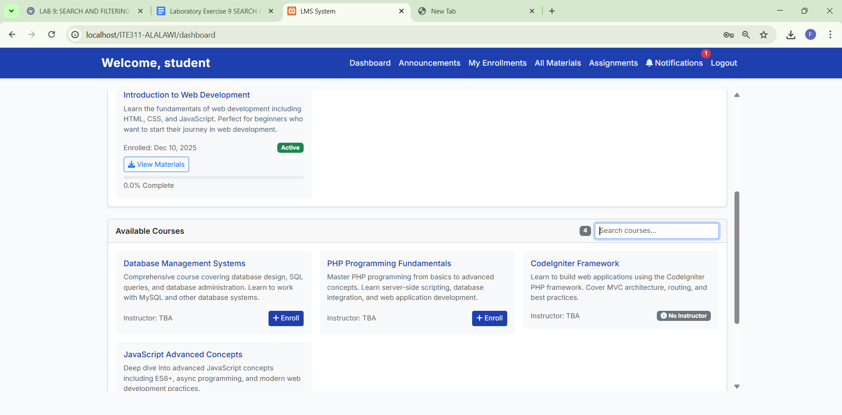

- Screenshot showing filtered courses during client-side search.
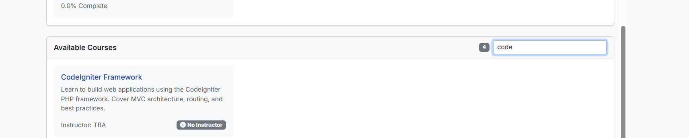

- Screenshot of browser Developer Tools Network tab showing AJAX request to server-side search.
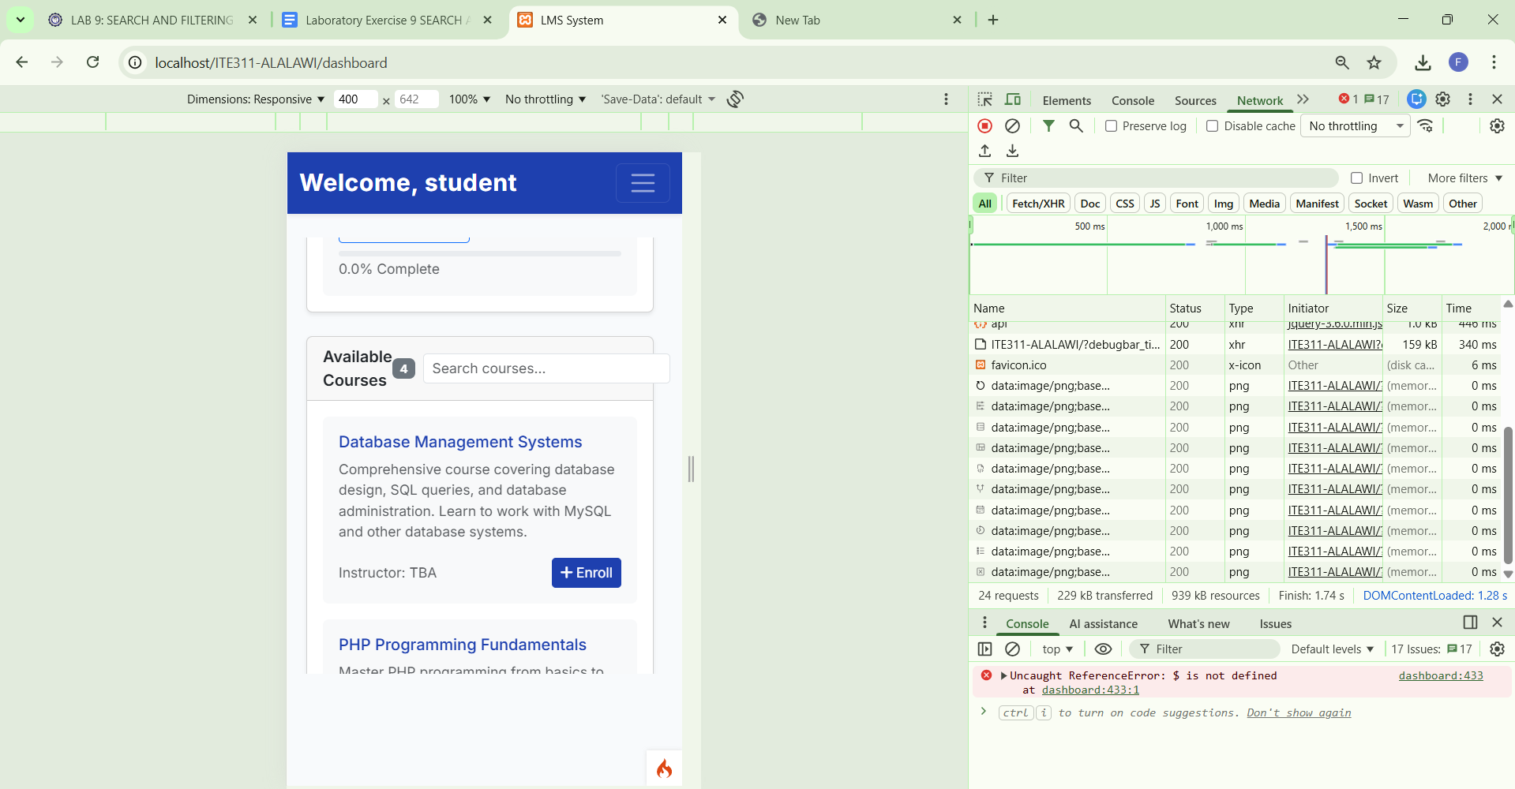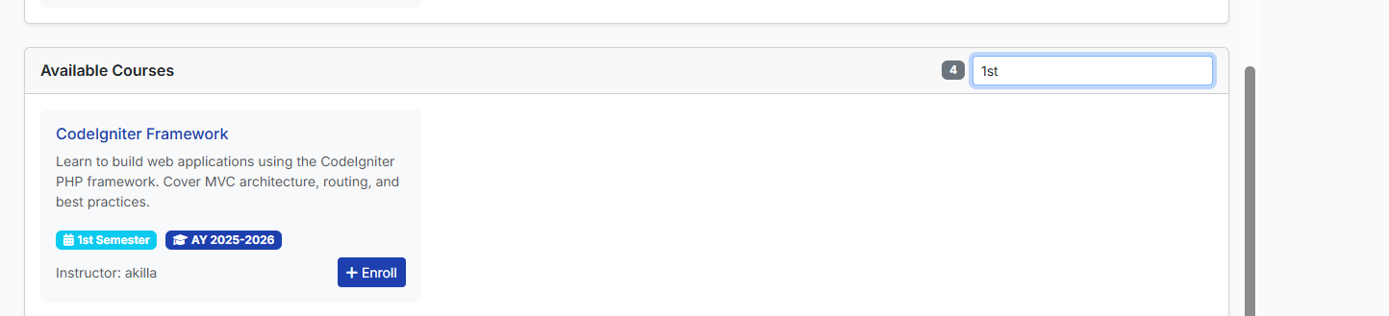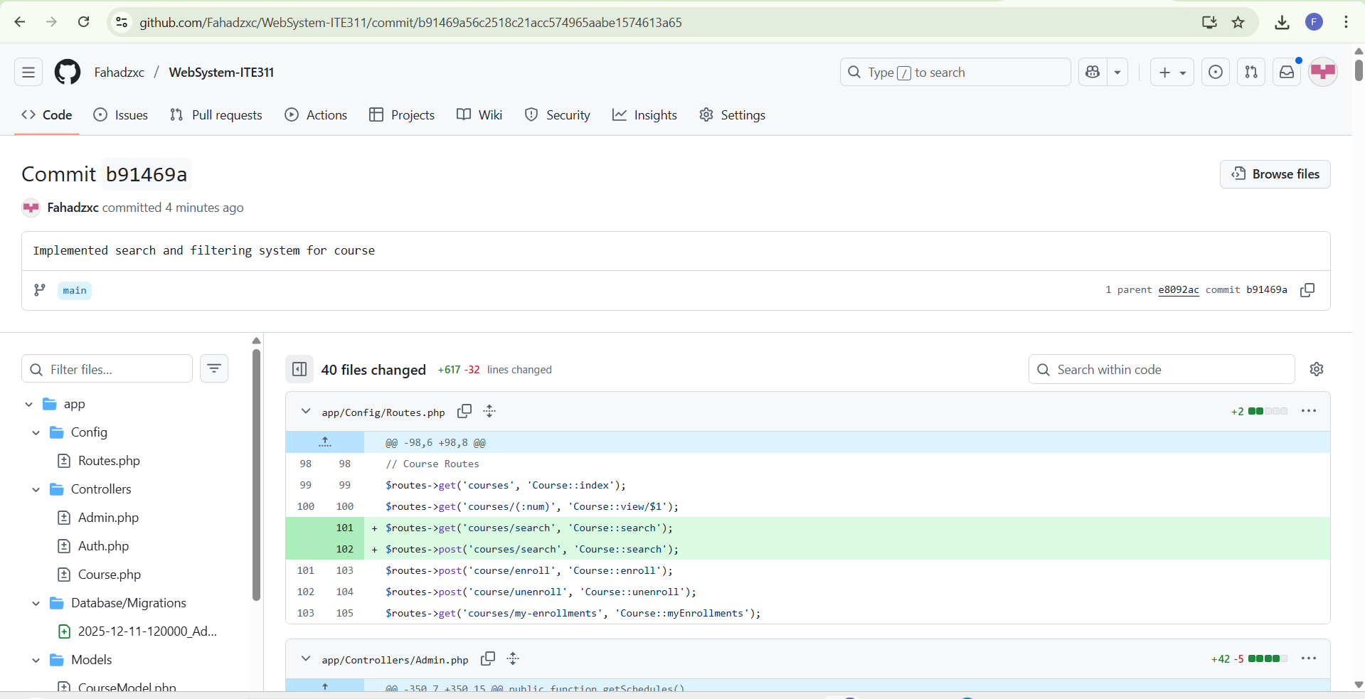

Conclusion
Client-side filtering and server-side search each provide distinct advantages, and the best choice depends on data size, security needs, and performance goals. AJAX enhances the search experience by making interactions smoother and faster, creating a modern and interactive interface. However, no matter how search is implemented, security must remain a priority. Protecting against SQL injection, XSS, excessive requests, and data exposure ensures both safety and reliability. By combining efficient search techniques with strong security practices, developers can deliver applications that are both user-friendly and secure.
窗体顶端

