**LABORATORY EXERCISE 1**

**INTRODUCTION TO HUMAN-COMPUTER INTERACTION**

# Learning Objectives

* Understand fundamental principles of usability and recognize common issues in user experience.
* Gain hands-on experience with usability testing tools for evaluating website or app user-friendliness.
* Enhance analytical skills to identify and assess usability issues systematically.
* Learn to use screenshots or recordings effectively as visual documentation in usability testing.
* Practice writing concise reports summarizing usability issues and proposing solutions professionally.

# Prerequisite student experiences and knowledge

Students should possess basic computer literacy, including familiarity with web browsers and application navigation. Internet navigation skills and a foundational understanding of critical thinking are crucial for analyzing and identifying usability issues during the navigation process. Documenting and reporting skills are advantageous, requiring students to articulate their observations clearly and concisely in a brief report. While prior knowledge of usability concepts and testing methodologies is beneficial, it is not mandatory. Additionally, a basic familiarity with computer screen capture tools for capturing screenshots or recording interactions and proficiency in written communication will enhance the student's ability to document and communicate their findings effectively.

# Background

The students must have basic knowledge of using digital devices and applications. The exercise aims to enhance their understanding of usability principles by having them navigate through a popular website or application. Using a usability testing tool for the first time, students will record their interactions and provide visual documentation through screenshots or screen recordings. The goal is for students to identify three usability issues, propose solutions, and summarize their findings in a brief report. This hands-on approach introduces them to practical evaluation techniques, setting the groundwork for further exploration in HCI.

# Materials/Resources

* PC/Internet
* Pen
* Usability Testing Online Tools ([Lyssna](https://app.lyssna.com/users/sign_up), [QUALARO](https://qualaroo.com/), Etc.)
* Web Browser (Internet Explorer, Mozilla, Google Chrome, Etc.) ➢ Word-processing program

# Laboratory Activity

**Task**

Navigate through a popular website or application and identify three usability issues. Document these issues and propose potential solutions.

**Instruction:**

* Use a usability testing tool to record your interactions.
* Provide screenshots or screen recordings to support your findings.
* Write a brief report summarizing the identified issues and proposed solutions.

# Question

1. How do usability testing tools contribute to identifying and recording usability issues in websites or applications? Discuss their advantages and limitations in the context of Human-Computer Interaction (HCI).
2. Explain the role of visual documentation (screenshots, recordings) in HCI when identifying usability issues. Provide examples of how visual elements enhance the communication of findings in usability analysis.
3. Explore practical strategies for proposing solutions to usability issues in HCI. Discuss considerations for balancing user satisfaction and technical feasibility. Provide real-world examples of successful usability issue resolutions.

ANSWER

1. Usability testing tools play a crucial role in making sure websites and applications are user-friendly and intuitive. Imagine you're building a bridge. Before you let people drive across it, you don’t want to make sure it's safe and easy to use, right? Well, usability testing tools are like the inspectors who check every inch of that bridge to ensure it's sturdy and easy to navigate. And that’s it based on my research.

2.Visual documentation, like screenshots and recordings, is the superhero tool in the toolkit of Human-Computer Interaction (HCI) professionals. Imagine you're trying to tell a friend about a hilarious moment from a movie. You could try to describe it, but wouldn't it be so much better to whip out your phone and show them the scene? That's exactly what visual documentation does in HCI – it turns abstract experiences into tangible evidence, helping us to understand exactly where things might be going off track. And that’s it I think.

3.User centered design Begin by understanding the user’s need preferences conduct tohrought reseacrh including surveys and interviews obsevre how user’s navigate throught and identify it.

**Output / Results**

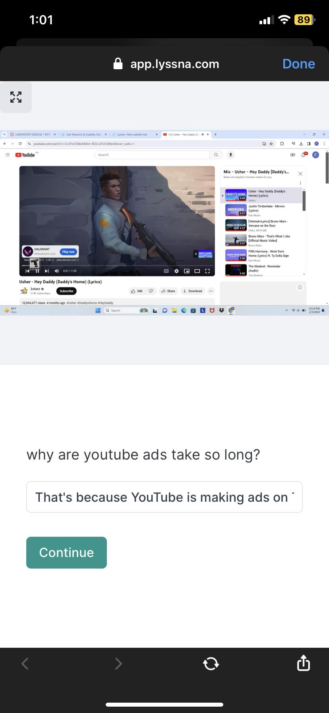

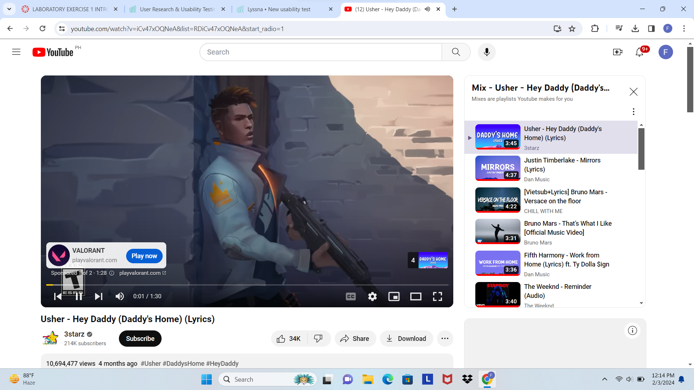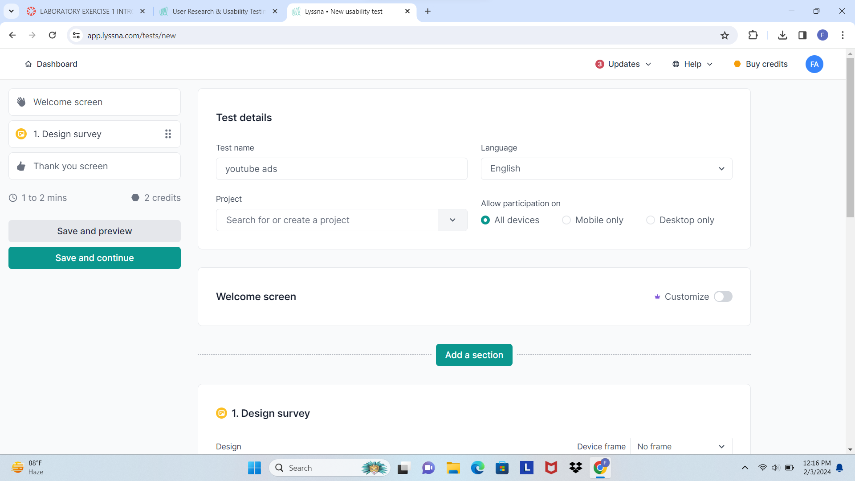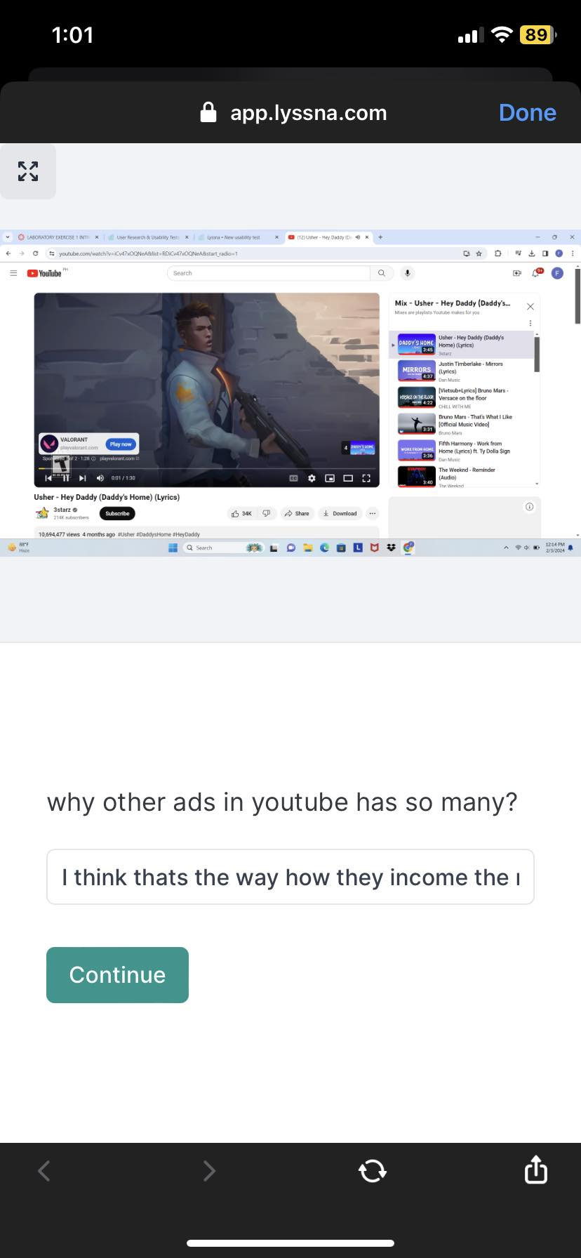

The is the result

**Conclusion**

**What I did is I share the link to my friend to answer it and I send the screentshot in the result and they answer it**