Using Affective State to Adapt Characters, NPCs, and the Environment in a First-Person Shooter Game

Authors Name/s per 1st Affiliation (Author)
line 1 (of Affiliation): dept. name of organization
line 2-name of organization, acronyms acceptable
line 3-City, Country
Authors Name/s per 2nd Affiliation (Author)
line 1 (of Affiliation): dept. name of organization
line 2-name of organization, acronyms acceptable
line 3-City, Country

Abstract — Innovations in computer game interfaces continue to enhance the experience of players. Affective games –those that adapt or incorporate a player’s emotional state – have shown promise in creating exciting and engaging user experiences. However, a dearth of systematic exploration into what types of game elements should adapt to affective state leaves game designers with little guidance on how to incorporate affect into their games. We created an affective game engine, using it to deploy a design probe into how adapting the player’s abilities, the enemy’s abilities, or variables in the environment affects player performance and experience. Our results suggest that affectively adapting games can increase player arousal. Furthermore, we suggest that reducing challenge by adapting non-player characters is a worse design choice than giving players the tools that they need (through enhancing player abilities or a supportive environment) to master greater challenges.
Keywords — affective gaming, dynamic difficulty adjustement, galvanic skin response, FPS, challenge, player experience.

Introduction
Computer games are widely adopted as a form of entertainment. In 2014, an average of two Americans per household reported that they play video games, with each household owning at least one dedicated console [12]. There have been technical advances that have driven game innovation over the past few decades, including advances to computer graphics, system performance, and human-computer interfaces. Novel input devices change what types of games can be built and what types of games people are inspired to play. Recently, researchers have been interested in how the affective (i.e., emotional) state of a game player can be brought into computer and video game experiences [14]. Augmenting traditional game controls with affective controls can increase a player’s engagement with a system [23], whereas adapting games based on a player’s affective state (e.g., [8][19]) could optimize the play experience by keeping players engaged.
Although there is evidence that adapting games based on a player’s affective state shows promise as a novel interaction technique to enhance player experience, there is no guidance for game designers on which aspects of games should be changed. Researchers have investigated one-off approaches in the context of different games, and have adapted game elements including game graphics, screen shaking, and enemy spawn points (the number of locations in which enemies are put into the game world) [8]; character walking and turning speed, aiming direction, recoil amount, and firing rate [19]; and flamethrower length, density of snow, enemy size, and enemy speed [23]. These different game elements can be loosely characterized into player abilities, enemy abilities, and the properties of the environment. Although these initial investigations have been absolutely fundamental for advancing the state of the art in affective game design, we still lack systematic studies on which types of game elements should be adapted (e.g., player abilities versus environmental variables) and how these design choices affect player performance and ultimately play experience.
To systematically explore affectively-adapting game elements, we created a system with which to deploy a design probe in affective game design. Our primary contribution is not the mapping of physiological variables to game state, but an understanding of how design decisions affect player experience. We created a custom zombie survival level for Half-Life 2 – a popular first person shooter (FPS) – as a test bed, and interfaced it with a system that inferred arousal from galvanic skin response (GSR) signals. Arousal state was then fed back to the player through changing aspects of the game. Our design probe investigated three ways in which games can adapt. First, we increased or decreased the strength of the player’s avatar (through speed and access to weapons). Second, we manipulated the strength of the zombie opponents (through their speed and number). Third, we varied the surrounding environment to increase or decrease support for the player (through varying the spawning of health packs and the visibility of the environment due to fog). We had sixteen participants play each approach along with a non-adapting control condition, and collected data on adaptation amount, player performance, and player experience.
The results of our design probe suggest that affectively-adapting games increases a player’s arousal during play; however, there were differences between the three approaches. Results suggest that decreasing the challenge by adapting the number and strength of the NPC enemies is not as effective as giving the players the tools needed to overcome greater challenges, as we did when adapting the strengths of the player or the supportiveness of the environment. These results are in line with recent work that suggests that thwarting the need for competence within the context of a game affects player experience [27]. Game designers can use our results to inform their decisions on how to support players to experience competence while still optimizing player engagement.
In the remainder of this paper, we first describe the state of affective games, and then explain our system that adapts game play based on a user’s affective state. We follow this with an account of our design probe with sixteen participants, and the results that we found in terms of adaptation, performance, and player experience. Finally, we discuss our findings and present opportunities for future work.

Background
Using emotional responses to adapt interaction with a real-time play technology requires a method of identifying specific emotion states within an emotional space. Methods of describing emotions in the psychology literature include: basic emotion theory [10][11], which uses a series of semantic labels (e.g., joy, fear) to identify emotion discrete categories; and dimensional emotion theory [28][20], which argues that emotions reside in a two-dimensional space defined by arousal and valence. Regardless of how we characterize emotional response in a person, our goal is to sense the emotional state of a user and use that information in a real-time manner to adapt gameplay. Thus, we refer to a player having an affective state and we aim to adapt to a player’s affect – the use of ‘affect’ reflects that we are less concerned with advancing the theories of emotion and more concerned with using emotionally-relevant player states to drive gameplay.

Recognizing Affect
There are multiple ways that researchers have created to recognize affect in people. For example, researchers have used facial expressions [25], typing rhythms [9], and voice signal analysis [26] to characterize a user’s affective state. However, the most common approach is to gather physiological signals and use mathematical modeling approaches to characterize affective state reflected by the physiological measurements [21]. For example, heart rate (HR), blood pressure, respiration, galvanic skin response (GSR), and facial EMG (Electromyography) are physiological variables that have been shown to correlate with with various affective states [22]. Interpreting physiological measures can be difficult, due to noisy signals and difficulties with inference; however, recent progress in this area has been promising. In addition, there has been work to apply physiological affect recognition approaches to video game evaluation. Mandryk and Atkins presented a method of continuously identifying affective states of a user playing a computer game [21]. Using the dimensional emotion model and a fuzzy logic approach on a set of physiological measures, the authors transform GSR, HR, and facial EMG (for frowning and smiling) into arousal and valence variables and then transform arousal and valence variables into five player-centric affective states including: boredom, challenge, excitement, frustration and fun. The advantage of continuously and quantitatively assessing user's affective state during an entire play session using their fuzzy logic model is what makes their model appropriate for real-time play technologies.

Challenge and Flow
Although there are many components that go into a great player experience, games at their core motivate players by giving them the opportunity to demonstrate mastery over game challenges [31]. To feel accomplishment over mastering game challenges, designers change many parameters to create gameplay that resides somewhere between too easy to be boring and too hard to be frustrating [18].
Csikszentmihalyi, in studies of happiness, introduced the concept of flow – or the feeling of complete and energized focus while engaged in an activity [7]. As applied to player experience in games, flow has been used to describe how designers should balance the inherent challenge of the activity and the player's ability to address and overcome it [6]. Thus challenges should not be far beyond a player's ability, which would generate anxiety and frustration; and should also not fail to engage the player by being so easy that players become bored. To ensure that players stay in the zone of flow, game designers first introduced static difficulty balancing approaches, such as offering multiple difficulty setting choices in a game [1]. To improve the challenge-skill balance, designers have also introduced dynamic difficulty adjustments (DDA), which vary the challenge according to the player’s performance [17]. Finally, researchers have recently started to explore how accessing the affect signals directly can be used to adapt game challenges, which we present next.

Advances in Dynamically Adapting Game Challenge
To dynamically adjust the difficulty of games, researchers have explored the use of facial expression as a decision input [38] and have controlled NPC behaviors by reinforced learning algorithms [3][33]. Hunicke used the Hamlet system to predict when the player is repeatedly entering an undesirable loop, and to help them get out of it they explored computational and design requirements for a DDA system using probabilistic methods within the Half-Life game engine [17]. Westra et al. [37] proposed an adaptation approach that uses expert knowledge for the adaptation; they used a game adaption model and organized agents to choose the most optimal task for the trainee, given the user model, the game flow and the capabilities of the agents. Hom [16] used AI techniques to design balanced board games like checkers and Go by modifying the rules of the game, not just the rule parameters. Olesen has explored neuro-evolution methods to generate intelligent opponents in Real-Time Strategy (RTS) games and tried to adapt the challenge generated by the game opponents to match the skill of a player in real-time [24].

Affect-driven Gameplay
Our goal is to adapt gameplay based on a player’s affective state. Although there have not been studies investigating our particular question of how player experience is impacted by applying different mechanisms for affect-driven adjustments in games, there has been related work that can inform our research. Affective gaming has been defined by Gilleade et al. as an activity where “the player’s current emotional state is used to manipulate gameplay.” [14]. Researchers have created and studied games that replace traditional game controls with affective game controls (e.g., the GSR-controlled dragons racing in ‘Relax-to-win’ [5] or the Electroencephalography-controlled balls rolling in ‘BrainBall’ [15]). Researchers have also investigating augmenting traditional game controls with affective game controls. For example, the Death Trigger side-scrolling shooter was played with a traditional gamepad and control scheme, but also adapted game elements (e.g., length of the flamethrower, size of the enemies, and the density of snowfall) using different physiological signals [23]. Finally, researchers have investigated adapting games using affective input. In work closest to ours, Dekker et al. [8] developed a game modification using the Source SDK and Half-Life 2, in which GSR and HR were used to control game shader graphics, screen shaking, and enemy spawn points (the number of locations in which enemies are put into the game world). Kuikanniemi et al. [19] studied how awareness of the manipulation affected player experience in a first-person shooter (FPS), where affective input modulated character walking and turning speed, aiming direction, recoil amount, and firing rate. Their works revealed that players preferred to be aware of the adaptation.
Although researchers have started to explore how affective signals can be used to augment control or adapt gameplay, there is still little systematic research to guide developers on how players respond to changes to different aspects of a game, such as the character, the enemies, or the environment.

System Implementation
The purpose of this paper was to evaluate the effects of design choices for affect-generated game adaptation on player experience. To compare different in-game adaptation appraoches, we needed to implement three components:
Affect sensing: An affect-detecting middleware engine (AME) to translate between physiological indicators of affect and actionable game input.
Game Environment: A game system with parameters suitable for adaptation via output from the sensed affect.
Experience Evaluator: A series of validated instruments integrated with the game environment to determine user experience during the experiment.
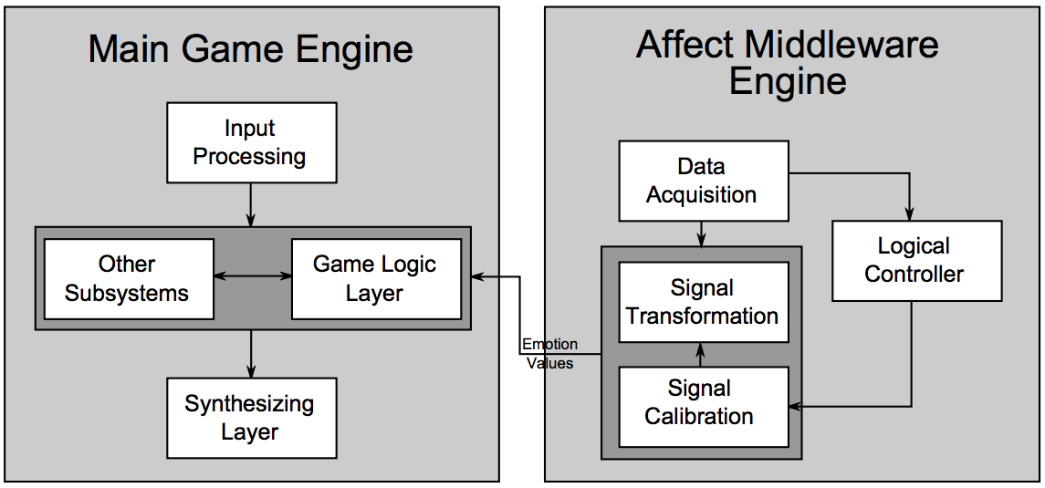
- System design.
Fig. 1 shows a schematic flow diagram for the first two components, where an affect detection system depicted on the right feeds data to a typical game engine depicted on the left-hand side of the diagram.

Affect Middleware Engine
The Affect Middleware Engine is the software system developed to transform collected physiological data into usable emotional state in real-time. While it is generally agreed that emotions can be inferred from three sources (i.e., subjective experience (e.g. feeling joyous), expressive behavior (e.g. smiling), and physiological activation (e.g. arousal) [32], our affect engine provides a framework for the transformation of physiological activations and some expressive behaviors. Fig. 2 is a schematic view of the signal transformation pipeline.
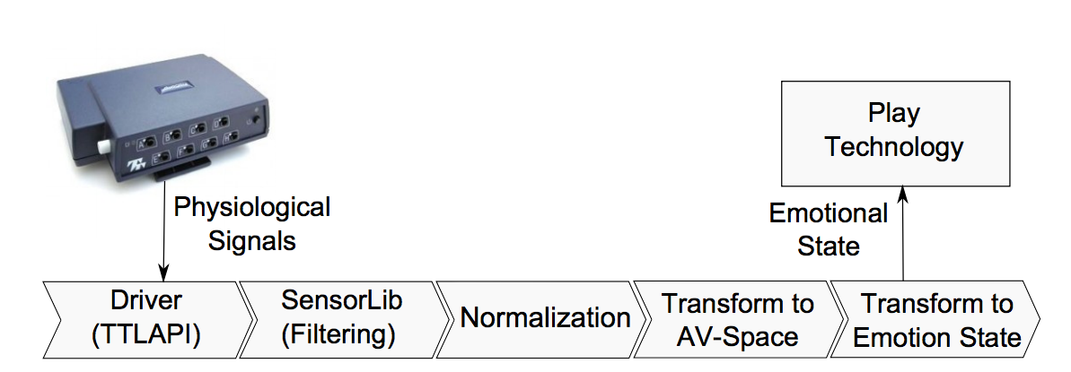
- A schematic of the affective engine modules.
Applications such as games can easily integrate the affect engine where emotion recognition can offer adaptive control to maintain user interest and engagement. Once connected via sensors to the emotion recognition system, the affective state of the user can be captured continuously and in real-time, and used as a secondary input for an enhanced interaction experience. The AME runs in two states, calibration and adaptation. When calibrating, the system waits for user input, attempting to discern sensible boundaries for physiological normalization according to the process described in [21]. After a set period of time, the system enters adaptation mode, where data is fed into the signal transformation stage, and from there into the game engine. For longer play sessions, the system will periodically re-enter the calibration state to compensate for drift in the physiological signals. In this manner the system compensates for the difficulty of globally bounding physiological signals by approximating a series of local temporal bounds.
While the affect engine is capable of interpreting multiple physiological signals and performing a full fuzzy logic-based emotion inference according to the approach described in [21], we constrained ourselves to a simpler linear mapping for this experiment. Specifically, GSR signals were measured using a Thought Technology ProComp Infinity, connected to PC through a USB cable. Through the SensorLib API [23], raw physiological inputs were received and basic filtering operations were performed. After the calibration period described above, the AME system began reporting normalized GSR signals to the game engine as a measure of player excitement or arousal [2][34].

Game Environment
To evaluate the impact of feedback on player experience, it was also necessary to implement a game environment that could be linked to the output of the AME. We chose to implement a straightforward zombie survival game based on the Half Life 2 engine in the genre of first-person shooters (FPS). A custom map (shown in Fig. 3) was implemented. Using the Source Software Development Kit (Source SDK). The map was composed of a small outdoor area and three buildings. Zombies spawned in waves from one of 10 points, and would undertake standard Half Life 2 zombie AI behavior, looking for the player and attacking with either thrown objects when distant (weakly damaging the player) or a melee attack when close (heavily damaging the player). A good default strategy for the player was to keep the zombies at a distance, eliminating them with their moderately powerful machine gun, and not allowing them to close to melee range. The player is tasked with surviving as many waves of zombies as possible, and accrues a score based on the number of zombies killed. The player is equipped with a machine gun with unlimited ammunition and a limited number of grenades. Health packs, which restore players from received damage, and additional grenades are available at defined locations. If a player presses a button at that location, a health pack will dispense and the button will be disabled until a cool down timer has expired.
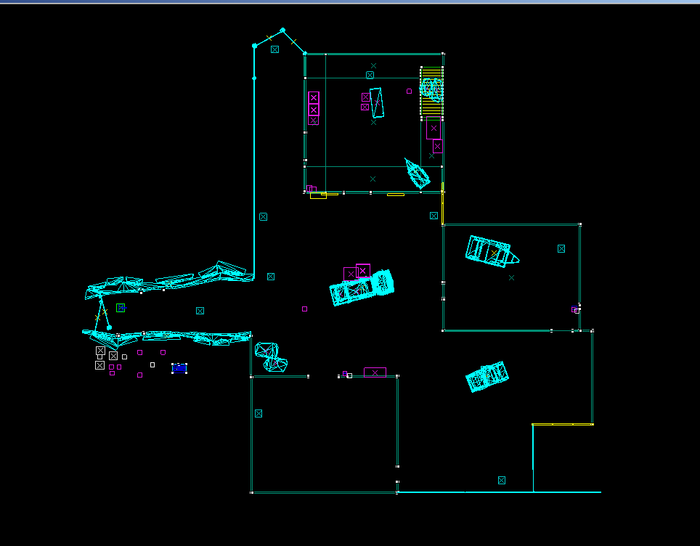
- Our custom map level created using the Source SDK and Half-Life 2.
Aspects of the game can be adjusted in real time based on the output of the AME system. In the implementation used in our study, the system could be in one of three states based on the normalized GSR value supplied from the AME. If players fell below a threshold of excitement as indicated by normalized GSR, then the system inferred that they were bored and increased the difficulty of the game. If players were above a threshold of normalized GSR, the system inferred that they were over-stimulated and made the game easier. If neither of these states were true, then the system assumed that they were playing normally and no adjustment occurred. The equations by which the game parameters were adjusted are also shown in Table I. While no action was taken unless normalized GSR was in the excited or bored band, once in that band, the game parameters adjusted continuously with the value of the GSR. Constants in the equations and the threshold values for excited and bored were adjusted manually, based on design experience and play testing prior to the experiment.

Game Adaptation
The game can be adapted in numerous ways based on the output of the AME. Our research interest is in how different in-game adaptation mechanisms affect resulting player experience. To explore in-game adaptation, we adapt either the player's abilities, the zombies' abilities or the environment. Table I shows the types of adjustments that can occur, which we describe next.
Player: Player modifications are any modifications that directly affected player state, even if the environment mediated those modifications. Specifically, to adapt the player’s abilities, we vary the player’s speed (at which they can move around the environment) and the rate of grenade respawn in the player’s weapon. Higher player speeds enabled the player to more easily escape the zombie melee attacks. The respawn rate of grenades impacted the player’s ability to inflict damage by essentially giving them more powerful weapons.
NPC: To adapt the non-player character zombies (NPCs), we can vary the speed at which the zombies move and the number of zombies (the size of the attacking crowd). The number of zombies spawned per unit time obviously increases the difficulty of the game. Increasing the speed of the zombie with respect to the player made it more difficult for the player to evade the zombie melee attacks. This manipulation is interesting as it is similar to the player speed adjustment from the perspective of game balance (i.e., the relative speed of the player and the enemy varies using both approaches), but applying the adaptation to the player or the NPC could result in very different game experiences.
Environment: To adapt the environment, we vary the density of fog displayed, which was proportionate to the distance that the player could see. By constraining the players’ viewing distance with increasing fog, zombies could approach closer, leaving the player with less time to target them before they closed to within melee range. We also varied the rate at which health packs respawned in the environment. Giving players the ability to find more health packs affected their ability to take damage; however, this required player interaction with the environment (i.e., picking up the health pack) as opposed to better equipping the player directly (e.g., giving the player more powerful weapons or shields).

Evaluation System
Evaluation of the system was carried out in three ways. First, all physiological signals were logged to ensure that the system was working correctly and as a basis for comparison.

- Adaptation Strategy
 | Player | NPC | Environment
Excited | Increase player speed  Increase grenade sate | Decrease zombie speed  Decrease number of zombies spawned | Decrease fog density  Increase health-pack spawn rate
Not Excited | Decrase player speed  Decrease grenade spawn rate | Increase zombie speed  Increase number of zombies spawned | Increase fog density  Decrease dealth-pack spawn rate
Adaption Equation | P_{speed} = 0.65 + 1.35 * Arousal  G_{delay} = 40 – 20 * Arousal | Z_{speed} = 1 / (0.30 + Arousal)  Z_{number} = 3.75 – 2.5 * Arousal | F_{start} = 70 + 380 * Arousal  F_{end} = 500 + 1000 * Arousal  H_{delay} = 100 – 60 * Arousal

Second, game events were logged to track how the player reacted to adaptive game mechanics. Finally, players were given experience surveys after the completion of each level. In this analysis, the player experience surveys are the primary evaluation method because they directly link the resulting experience to the in-game adaptation manipulation.

Design Probe Description
We performed a design probe to determine the effects of different game adaptation mechanisms on player experience.

Participants
After filling in consent forms consistent with our institutional ethics approval, data were recorded from 16 University students (15 male), aged between 18 and 32 years old. All participants felt that they had at least intermediate computing skills. All participants have played games on a computer before and 76% also have played using a console. All of participants had at least some experience with 3D FPS games, with 41% describing themselves as experts in 3D FPS games. Another 47% have played 3D FPS games many times, and the final 12% had limited or intermediate experience with 3D FPS games.

Task and Conditions
There were four experiment conditions (Control, Player adapted, NPC adapted, Environment adapted), as previously described. We balanced the order of presentation of conditions using a Latin Square. Each game condition lasted 5 minutes. Players were told to kill as many zombies as possible, and to die as few times as possible. After each condition, participants were asked to write their comments about particular changes they noticed under that condition and its effect on their gameplay. Then they were asked to fill out the questionnaires related to player experience during the first part of the seven minutes of resting time before the next condition began. The resting time was meant to help restore players’ baseline GSR levels; however, because we normalize GSR (see next section), a full resting GSR was not required prior to the next gameplay session. GSR sensors were recording signals during both the play and the resting sessions from the beginning of the first condition to the end of the last condition.

Apparatus
Participants played our games (described previously) on a Computer running Windows 7. GSR data was collected using the Biograph Infinity sensor and encoder. To diminish noisy GSR signals and make participants feel comfortable, the GSR sensors were attached to the participant's ring and index finger on their mouse hand, because mouse fingers tend to move much less than the keyboard hand in FPS gameplay.

Dependent Measures
We group our dependent measures into amount of adaptation, player performance, and player experience.
- Adaptation: GSR Range is a measure of the span of the normalized GSR signal, giving an idea of how much range there was in GSR over the condition. Proportion is the proportion of time spent adapting the game positively (increasing difficulty) to the time spent adapting the game negatively (decreasing difficulty).
- Performance: Deaths is the number of times that a player’s health became so low that they died and respawned within a condition. Kills are the number of zombies that a player killed in a condition.
- Experience: Mean GSR is a normalized measure of the galvanic skin response of a player over a whole condition. It is normalized by subtracting the pre-condition GSR value from each recorded GSR value (to essentially zero the signal prior to each condition). We also measured player experience using three subscales from two standardized scales. Competence is measured using the Player experience of Needs Satisfaction (PENS) scale [31] and reflects how much mastery a player feels they have over challenges in the game. Enjoyment is measured using the Intrinsic Motivation Inventory (IMI) scale [29] and reflects how much interest or enjoyment the game produced in the player.

Data Analysis
We conducted a RM-ANOVA with condition (Control, Player, NPC, Environment) as a within-subjects factor on all dependent measures (see previous section). Comparisons of main effects used planned contrasts [13] with Control as the reference condition to show how each manipulation compared to the condition with no manipulation. Order of presentation of conditions showed no systematic effects in a one-way ANOVA, thus order is not considered in our main analysis. All comparisons of main effects and contrasts used α=0.05.

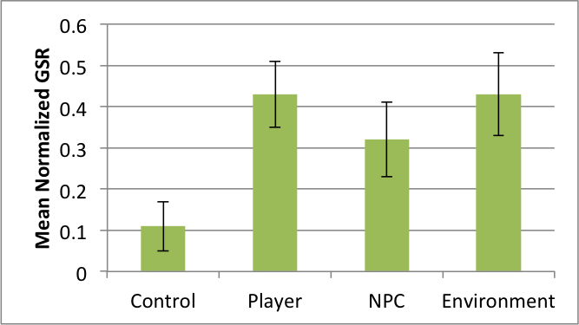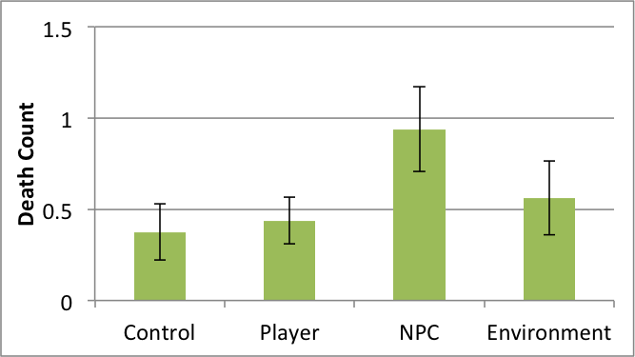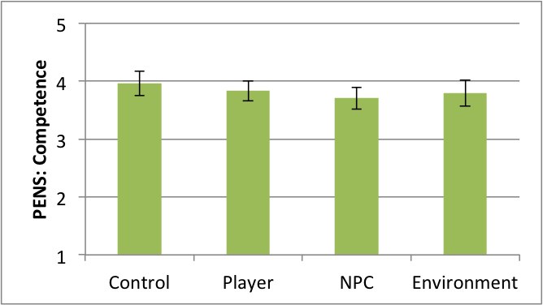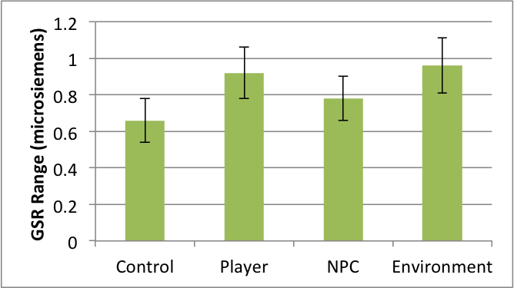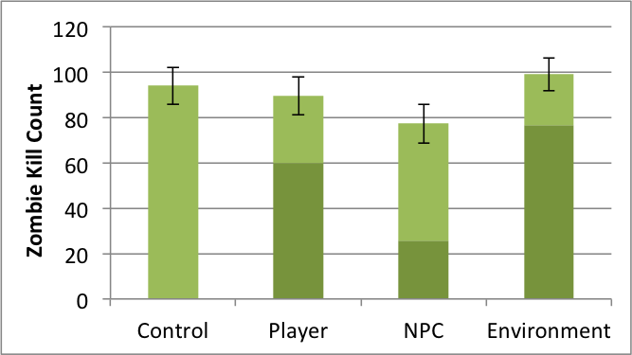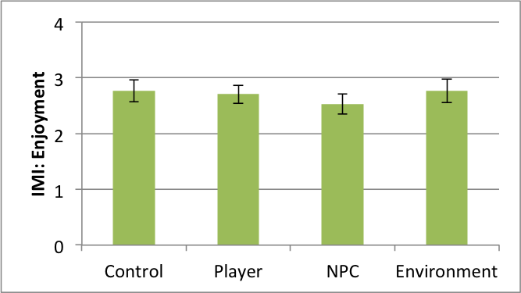
- Top Row (left to right): Mean (±SD) of GSR, player deaths, and ratings of perceived competence. Bottom row (left to right): Mean ratings (±SD) of GSR Range, number of zombies killed (dark bar shows proportion of kills during positive adaptation), and and Enjoyment on a scale of 0-4 (higher is better).

Design Probe Results
We first present the results of adaptation, followed by performance and player experience. See Fig. 4.

How much adaptation occurred in the game?
We adapted the game difficulty using galvanic skin response. So although GSR could indicate player arousal, in our case, it is the source of the adaptation. Thus GSR Range can tell us how much span there was in the player’s experience of the game. There was a main effect of condition on GSR Range (F_{3,45}=4.20, p=.011, η²=.22). Contrasts showed that the Player and Environment conditions yielded a greater range than the control condition (p=.007 and p=.028 respectively), whereas the NPC condition did not (p=.199).
When looking at only the adapted conditions, there was no difference in the proportion of time spent in positive versus negative adaption (F_{2,24}=1.48, p=.248).

How did adaptation affect performance in the game?
Player performance was measured using the number of zombies killed by players (kills) and the number of times the player was killed by the zombies (deaths). There was a no effect of condition on kills (F_{3,45}=3.2, p=.032) or deaths (F_{3,45}=3.0, p=.042). However, planned contrasts revealed that the NPC condition resulted in marginally fewer kills (p=.081) and more deaths (p=.023) than the control condition. In addition, when examining each adaptation direction individually, we see a main effect of condition on number of kills during positive adaptation (F_{2,30}=9.43, p=.001, η²=.39), in which NPC adaption had fewer kills than Player (p=.007) or Environment (p=.001). This is expected as the NPC condition presents fewer zombies spawning as its adaptive mechanism, giving fewer zombies for players to kill.

How did adaptation affect player experience?
Although GSR was used to adapt the game, and is thus expected to vary both with the player’s response to the game and with their response to the adaptation, it can be used as a general estimate of player arousal during play. There was a main effect of condition on mean GSR (F_{3,45}=13.59, p≈.000, η²=.48); contrasts showed that GSR was higher in each condition than in Control (all p≈.000).
Player experience was also measured using the PENS scales for competence and autonomy and the IMI scale for interest/enjoyment. There were no main effects of condition on experienced competence (F_{3,45}=1.47, p=.235), or enjoyment (F_{3,45}=2.24, p=.097); however, contrasts showed that there was lower experienced competence and enjoyment in the NPC condition than in Control (p=.041 and p=.006 respectively). There were no significant contrasts for Player or Enjoyment as compared to Control (all p>0.1).

Did participants notice the adaptations?
We asked players after each condition to comments on the game and their performance. Although not asked specifically about adaptation, players often made comments about how the game was changing. When adapting the player, 50% commented that they noticed changed to their player; when adapting the NPCs, 31% of participants commented that they noticed changes to the zombies’ behaviours; when adapting the environment, only 13% of players declared that they noticed environmental changes.

Summary of Results
Our results showed that GSR was higher when we adapted the game. In addition, the Range of GSR was higher in the Environment and Player conditions. Adapting the NPC resulted in fewer kills (particularly during positive adaptation) more deaths, and reduced competence and enjoyment. Finally, the environmental manipulations were least noticed, whereas adaptations made to the player were most noticed.

Discussion
The results of our design probe show that adapting the game resulted in higher arousal, but that not all methods were equally effective. In this section, we discuss how game developers and designers can apply our results, consider the limitations of our work, and present the opportunities for future research in this area.

Applying the results
Our work suggests that adapting games based on a user’s affective state can increase player arousal (excitement) and can potentially automate balancing the difficulty of the game with the affective state of the player. By increasing the challenge of the game when players are not aroused, we can personalize the game experience, drawing the player in. Conversely, by decreasing the challenge when players feel overwhelmed (too aroused), we can keep the game difficulty manageable and maintain player engagement.
Our work aims to investigate how to adapt games based on a player’s affective state – with the goal of keeping players optimally engaged with the system. Previous work has examined dynamic difficulty adjustment (DDA) for the purposes of balancing multiplayer game play (e.g., [4]). Previous research has shown that when multiplayer games are unbalanced (i.e., one player is much stronger than another), players do not have as much fun [35], and thus there is a need to provide assistance to one player (or hindrance to another) to better balance play. Different approaches have been used to adjust difficulty for player balancing (see [4] and [35]); however, research has not systematically examined whether adjusting the abilities of the player, enemy, or environment affects game enjoyment or player perception. Our work suggests that these different approaches change player experience and thus there is an opportunity to extend our work into the domain of DDA for balancing multiplayer games.

Why adapting the NPC enemy reduced enjoyment
Our results suggest that helping the player or changing the environment to better support the player are better adaptation approaches than adapting the strength of the NPC enemies. Although a common approach in many games, reducing the difficulty by making the enemies easier to beat resulted in fewer zombie kills (as there were fewer zombies available to kill). This reduction in challenge may have resulted in lower ratings of perceived competence, which in turn reduced players’ enjoyment in the NPC condition.
Self-determination theory [30] suggests that we strive to master challenges, and that this mastery over challenges creates a perception of competence – which is one of our basic needs that must be satisfied for well-being (along with the need for autonomy and need for relatedness). In the context of games, mastering challenges leads to competence, which ultimately leads to game enjoyment [31]. By adapting the NPC enemies, we give the player less of an opportunity to conquer a challenge, and thus less opportunity to experience competence (and as a result enjoyment). This approach thwarts players from satisfying their needs. Conversely, giving the player enhanced abilities or adapting the environment to support the player in their quest does not seem to negatively affect perceived competence. Adapting the spawn rate or value of helpful items (such as the grenade in our Player condition or the health pack in our Environment condition) does not seem to reduce experienced competence, but allows players to feel like they are achieving in the context of the game.
Recent research in violent imagery in games and the resulting aggression that players experience has suggested that impeding competence in video games fosters aggressive thoughts, regardless of the presence or absence of violent imagery [27]. The authors show how manipulating competence (through manipulating frustrating and complex control schemes, levels of player experience, or game challenges) thwarts need satisfaction amongst players, and increases their access to aggressive thoughts. Although the domain of evaluation (aggressive thoughts) is distinct from our goals, the hypothesis that impeding competence in games thwarts satisfaction of this basic need helps to explain why giving players less challenge to master (as in the NPC condition) does not work as well as giving players the tools and support needed to master greater challenges, as in the Player and Environment conditions.

Limitations and future work
This design probe represents preliminary work into the domain of affectively-adapting games. There are several limitations in our work that present opportunities for future research. First, the number of participants that we included in our design probe is low (n=16). Conducting a large-scale experiment would increase the power of our experiment and could reveal differences between the approaches or strengthen existing differences (e.g., the planned contrasts). Second, we investigated the adaptation in a single game genre (FPS game) with specific approaches (e.g., manipulating speed and weapons). Investigating whether our results hold in a different genre or with different adaptation choices would help to generalize our findings. Third, we only adapted based on a player’s galvanic skin response. Using a more sophisticated model that included signals to access player valence (e.g., [21]) would qualify the player’s arousal as either positive or negative in nature. Finally, as noted previously in the discussion, we could consider applying our approach of adaptation based on performance variables, rather than player affect, to examine DDA for the purpose of balancing multiplayer games.

Conclusions
Drawing a player into an optimally-engaging play experience is a goal of many game designers and developers. We investigated various approaches to adjusting games based on a player’s affective state and found that affectively-adapting games were more arousing than the non-adapted version. We also suggest that adapting the NPC enemies is not as effective a strategy as adapting the player or environment, because it reduces the opportunity for the player to experience challenge, rather than giving players the necessary tools or assistance to master a greater challenge.
The results of our design probe can be used to inform future research in affective games or adaptive games, and can help game designers understand how their choices affect the experience of the player.

References

- Adams, E. Fundamentals of Game Design. New Riders, 2010.
- Aggag, A. and Revett, K. Affective gaming: a GSR based approach. in Proceedings of the 15th WSEAS international conference on Computers, 2011, 262–266.
- Andrade, G., Geber Ramalho, A.S., Gomes, R., and Corruble, V. Challenge-sensitive game balancing: an evaluation of user satisfaction. In Proceedings of the 4rd Brazilian Workshop on Computer Games and Digital Entertainment, 2005.
- Bateman, S., Mandryk, R.L., Stach, T. and Gutwin, C. Target assistance for subtly balancing competitive play. In proceedings of CHI 2011, 2355-2364.
- Bersak, D., McDarby, G., Augenblick, N., McDarby, P., McDonnell, D., McDonal, B., Karkun, R. Intelligent Biofeedback using an Immersive Competitive Environment. In online proceedings of Designing Ubiquitous Computing Games Workshop at Ubicomp'01 (2001).
- Chen, J. Flow in games (and everything else), Communications of the ACM, 50(4), 31–34, 2007.
- Csikszentmihalyi, M. Flow: The Psychology of Optimal Experience. Harper & Row, 1990.
- Dekker, A. and Champion, E. Please Biofeed the Zombies: Enhancing the Gameplay and Display of a Horror Game Using Biofeedback. In proceedings of DiGRA, 2007.
- Epp, C., Lippold, M., Mandryk, R.L. Identifying Emotional States Using Keystroke Dynamics. In proceedings of CHI 2011, 715-724.
- Ekman, P. An argument for basic emotions, Cognition & Emotion, 6, (3-4), 169–200, 1992.
- Ekman, P. Are there basic emotions?, Psychological review, 99(3), 550–553, 1992.
- Entertainment Software Association. Essential Facts about the Computer and Video Game Industry, 2014, http://theesa.com/facts/pdfs/ ESA_EF_2014.pdf
- Field, A. Discovering statistics using IBM SPSS statistics. Sage, 2013.
- Gilleade, K., Dix, A., and Allanson, J. Affective Videogames and Modes of Affective Gaming: Assist Me, Challenge Me, Emote Me. IN proceedings of DiGRA, 2005.
- Hjelm, S.I. Research + design: the making of Brainball. interactions 10, 1, 2003, 26–34.
- Hom, V. and Marks, J. Automatic design of balanced board games, in proceedings of the AAAI Conference on Artificial Intelligence and Interactive Digital Entertainment (AIIDE), 2007, 25–30.
- Hunicke, R. The case for dynamic difficulty adjustment in games. In proceedings of Advances in Computer Entertainment Technology, 265, 2005, 429-433.
- Koster, R. Theory of fun for game design. O’Reilly Media, Inc., 2013.
- Kuikkaniemi, K., Laitinen, T., Turpeinen, M., Saari, T., Kosunen, I., and Ravaja, N. The influence of implicit and explicit biofeedback in first-person shooter games. In proceedings of CHI 2010, 859–868.
- Lang, P.J. The emotion probe. American Psychologist, 50(5), 1995, 372-385.
- Mandryk, R. and Atkins, M. A Fuzzy Physiological Approach for Continuously Modeling Emotion During Interaction with Play Environments. International Journal of Human-Computer Studies, 6(4), 2007, 329–347.
- Mandryk, R.L. Physiological Measures for Game Evaluation. In Game Usability: Advice from the Experts for Advancing the Player Experience, Morgan Kaufmann. K. Isbister and N. Shaffer, Eds., 2008.
- Nacke, L. E., Kalyn, M., Lough, C., & Mandryk, R.L. Biofeedback game design: using direct and indirect physiological control to enhance game interaction. In proceedings of CHI 2011, 2011, 103-112.
- Olesen, J.K., Yannakakis, G.N., and Hallam, J. Real-time challenge balance in an RTS game using rtNEAT, in Computational Intelligence and Games, 2008, 87–94.
- Partala, T., Surakka, V., and Vanhala, T. Real-time estimation of emotional experiences from facial expressions. Interacting with Computers, 18(2), 2006, 208-226.
- Picard, R.W. Affective Computing. MIT Press, Cambridge, 2007.
- Przybylski, A.K., Deci, E.L., Rigby, C.S., & Ryan, R.M. Competence-Impeding Electronic Games and Players’ Aggressive Feelings, Thoughts, and Behaviors. Journal of Personality and Social Psychology, 2014, 106(3), 441-457.
- Russell, J.A., Weiss, A., and Mendelsohn, G.A. Affect grid: A single-item scale of pleasure and arousal. Journal of Personality and Social Psychology, 57(3), 1989, 493-502.
- Ryan, R.M., Control and information in the intrapersonal sphere: An extension of cognitive evaluation theory. Journal of Personality and Social Psychology, 43, 1982, 450-461.
- Ryan, R.M., & Deci, E.L., Self-determination theory and the facilitation of intrinsic motivation, social development, and well-being. American Psychologist, 55, 2000, 68-78.
- Ryan, R.M., Rigby, C. S., Przybylski, A.K. Motivational pull of video games: A self-determination theory approach. Motivation and Emotion 30(4), 2006, 344-360.
- Scherer, K.R. Neuroscience projections to current debates in emotion psychology, Cognition & Emotion, 7(1), 1993, 1–41.
- Spronck, P., Sprinkhuizen-Kuyper, I., and Postma, E. Difficulty scaling of game ai, in Proceedings of the 5th International Conference on Intelligent Games and Simulation (GAME-ON), 2004, 33–37.
- Tijs, T., Brokken, D., and IJsselsteijn, W. Creating an emotionally adaptive game, Entertainment Computing, Springer, 2009, 122–133.
- Vicencio-Moreira, R., Mandryk, R. L., Gutwin, C., Bateman, S. The effectiveness (or lack thereof) of aim-assist techniques in First Person Shooter games. In proceedings of CHI 2014, 937-946.
- Vorderer, P., Hartmann, T., and Klimmt, C. Explaining the enjoyment of playing video games: the role of competition. Entertainment Computing, 2003, 1-9.
- Westra, J., van Hasselt, H., Dignum, F., and Dignum, V. Adaptive serious games using agent organizations, in proceedings of Agents for Games and Simulations, Springer, 2009, 206–220.
- Xiang, N., Yang, L., and Zhang, M. Dynamic difficulty adjustment by facial expression, Informatics and Management Science V. Springer, 2013, 761–768.

