**System Design and Implementation**

The Biofeedback FPS, made of three major components, the sensor module, the affect engine and the FPS game.

**Sensor Module**

Sensor module is the actual hardware and software component used to capture and transfer gamer’s physiological signals. This layer in this study is essentially made of a GSR sensor which is attached to player’s fingers like the image below. The GSR sensor at the other end is attached to a Thought Technology ProComp Infinity encoder connected to PC with a USB cable. At the software side SensorLib is the basic programming interface which receives raw physiological inputs. Filtered signals are then calibrated and normalized periodically during the play scenario and therefore transformed into gamer’s arousal state.

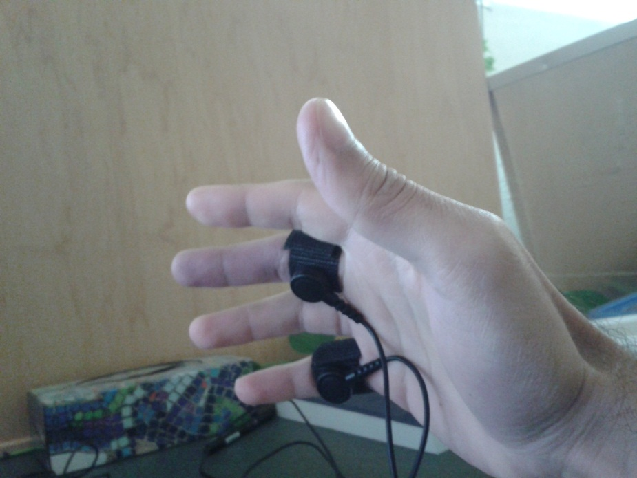

The sensors are attached to the hand that is going to handle the mouse. As based on the combination of keys that the player needs to work with on keyboard, it would be much shakier than the hand which would hold the mouse; however the fingers that the sensors are attached to are decided based on the way the player works with mouse. Some players were pressing left and right buttons of the mouse using their index and third finger, but some others were using their index and fourth finger to do that. For these two different cases the sensors where attached either to fourth and fifth finger or to third and fifth finger.

**Affect Engine**

This component is in charge of collecting raw physiological inputs and transforming them into different emotional states of the gamer. Generated emotional states on the other hand is inserted into the play technology in this case using a proxy layer, and on that side, the play technology decides how to use these emotional states to enhance the play experience.

In this study with use of the GSR sensor to acquire an estimation of gamer’s excitement level. The affect engine is basically implemented as a stand-alone desktop application which provides fuzzification and signal filtering and monitoring toolsets. Applications such as games can easily integrate the system where emotion recognition can offer adaptive control to maintain user interest and engagement. Once connected via sensors to the emotion recognition system, the affective state of the user can be captured continuously and in real-time.

**FPS Game**

The FPS game used for this study is a modification of Half Life 2, using the Valve’s open source engine and MOD toolset, it has been a quick process to create a one map survival mode zombie game. In this FPS the gamer is supposed to survive as long as she/he can. During the game waves of zombies would attach the player for all directions. Zombies’ only can damage the player when reach to a distance of close contact, they essentially run and use their claws to kill or damage the player. While their health is at a minuscule level, sometimes the mystical creature on their head which is like a huge parasite is released and jumps towards the player’s head. During of these attacks taking place by zombies the player need to run around the map and quickly check every direction to find out newly spawned zombies and try to kill or escape them. The player uses infinite ammunition of a single kind, which is a kind of submachine gun to kill zombies. Added to that the player can throw grenades and use health packs to restore his health.

The component of the FPS Game in charge for application of the emotional state is a logical game entity called Director. Director is a basically a piece of code that can be configured to use the gamer’s emotional state, in this case excitement, to augment game’s logic in three different modes: Player, NPC and Environment.

**Player Mode**

In this mode the system use the gamer’s excitement level to decide to whether increase or decrease the movement speed of the player. For the design of this study, we chose to increase the player’s speed and grenade creation rate whenever we found his excitement at a high level; and on the other hand we decrease the speed and grenade creation rate when a low level of excitement from player is captured. The fact that speed value is changed like this is based on the idea to uphold game’s challenge at a level that enables the player to engage best with it. A gamer at a low level of excitement usually is not experiencing enough challenge, therefore decreasing the speed value, would increase the amount of challenge for him to escape the zombies and survive. On the other hand a player with a high level of challenge is usually engaging with game mechanics, and enjoys to be awarded extra speed; this policy is also applied to the grenades.

**Zombie Mode**

In this mode the Director uses the player’s excitement level to adjust the zombie crowd and also the movement speed of zombies. When the player is experiencing a high level of excitement the number of zombies and the movement ability would be at a moderate level, but when the player is showing a lower level of excitement, or in other word is bored, the Directory tries to make the game more challenging by increasing the number of zombies and also their movement abilities.

**Environment Mode**

In this mode neither the player nor the zombies would be adjusted, but rather, the environmental parameters, like the fog distance, and the rate of health packs the player is awarded is adapted. Like the other modes, the changes are set in a way to uphold the challenge factor of the game. When the player is at a high level of excitement, he would also be awarded health packs more frequently, and would have a more clear view of the scene with further fog distance. But when the player is bored showing a low level of excitement. He would confront an intense level of fog and less frequent health packs, which subsequently makes the game harder for him.

**Experiment Design**

5 to 10 pages talk about the experimentation adequacy, efficiency, productiveness, effectiveness (choose your criteria, state them clearly and justify them) be careful that you are using a fair measure, and that you are actually measuring what you claim to be measuring if comparing with previous techniques those techniques must be described in Chapter 2 be honest in evaluation admit weaknesses

This study has been run during three weeks, each session took about 45 minutes. 17 participants of moderate to expert FPS players were asked to play the game under four different conditions: No Adaptation, Player Adapted, NPC Adapted and Environment Adapted. The order of played conditions was circulated between different players.

Participants did not know what different conditions exists and which condition they are currently playing, at the start of the play session, they were required to press one of the four buttons on the entrance ramp labeled 1 to 4, and when any one of these buttons were pressed, the Affect engine started calibrating players signals for 60 seconds, during the calibration mode, no adjustment no any of game parameters is applied, no matter which condition is being played. After the one minute of calibration the system decides the standard range of signal for player’s excitement value. After that except for the condition number 1 which is the no adaptation mode, the captured excitement value is normalized in the calibrated player range of excitement into a value between 0 and 1, and this value is then used to adjust the game parameters, this process of capturing, adjusting and applying the signal value would continue for 3 minutes until the next cycle of calibrating and adjustment starts. The player is required to play every condition for at least 5 minutes to ensure capturing of a complete cycle of calibrating and adjustment.

After playing each condition, the player is asked to rest for 7 minutes, during this time the player is asked to fill out between condition questionnaires, which tries to ask the participant to self-estimate his affect level.

The Player Mode is labeled as condition number 2, the NPC mode is labeled as condition number 3 and the Environment mode is labeled as condition number 4. From the 17 participants in this study, one has been lacking adequate level of expertise and therefore was unable to continue doing the required tasks at the expected level and therefore his results was not usable for this study. The image of signal values for this participant is depicted at the following:

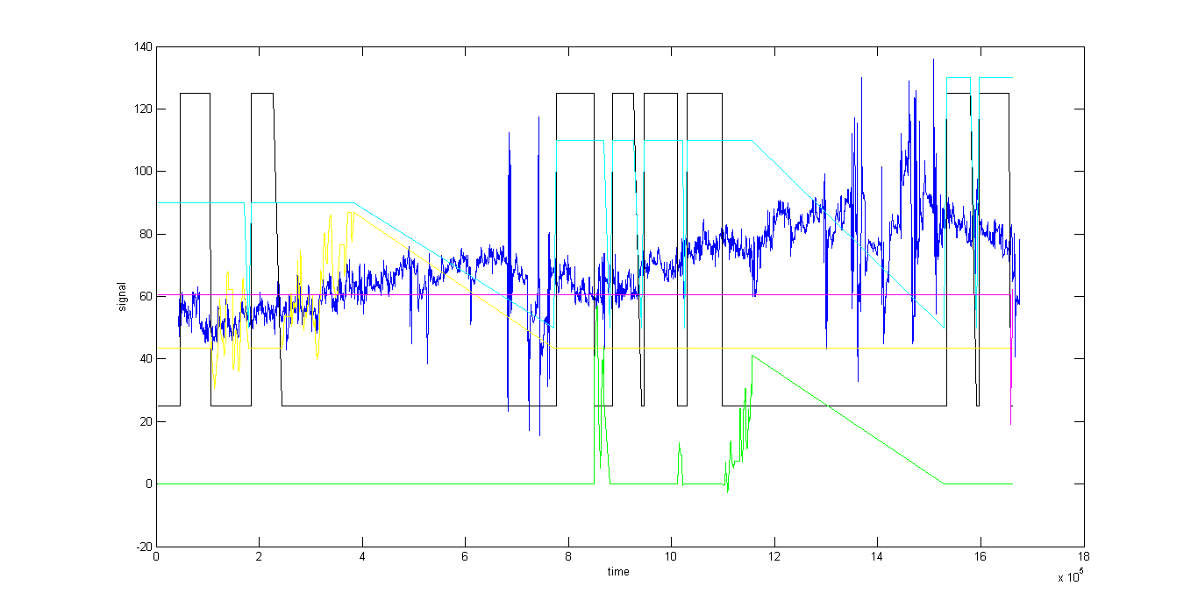

An image of a regular participant signal values is depicted at the following. In this image from left to right the light blue line shows different conditions being played, and when the light blue line is declining towards its base value, that is the period that participant is asked to stop playing and instead relaxing and filling out the questionnaires. The blue line is the normalized GSR signal value of the participants which is used as an estimation of his excitement level. The yellow green and pink lines are showing the three different modes of Player, NPC and Environment parameters being adapted

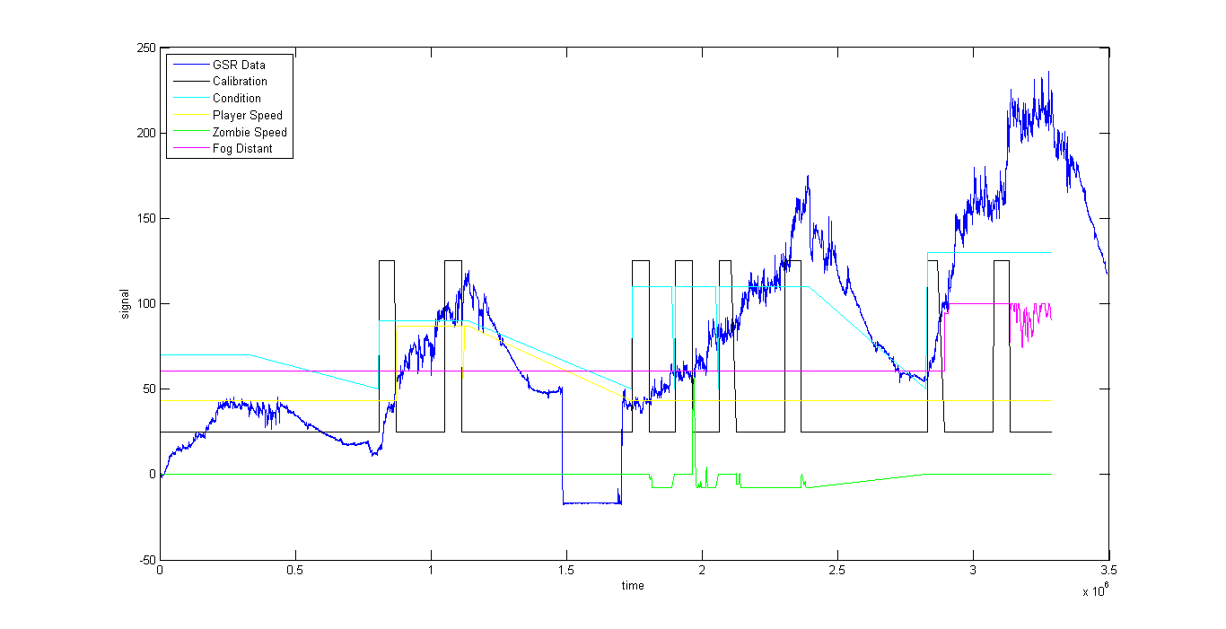

Following image is the GSR signal of players playing different conditions from 1 to 4. From left to right the conditions are the Default, Player, NPC and the Environment mode. This signals are all based to an initial start value of 100, during the play experience, some of them had gone bellow the start point and some other had risen above that. Also the start time for each different condition is shifted 500 seconds times the number of condition, from 0.

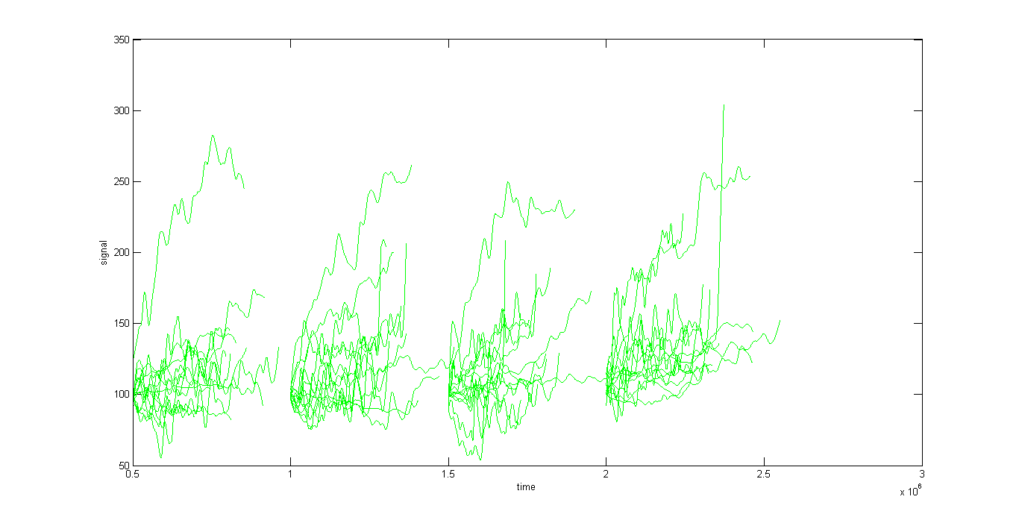

The following image is the average of GSR values for players in four different conditions from left to right: Default, Player, NPC and Environment modes

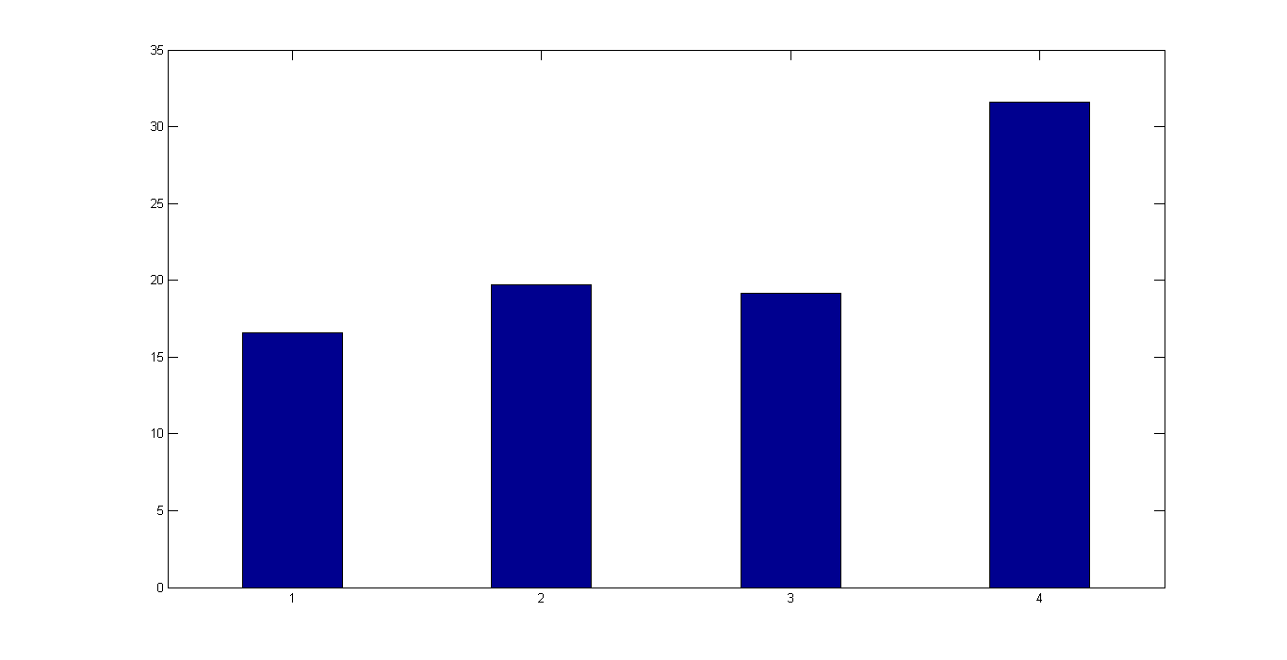

Experiment Script - BioFeedback FPS by Faham Negini

<Participants arrive>

- Greetings

<Participants sits>

- Consent form and a short description of the procedure and questionnaires

(make sure they put their email address)

- Ask him to turn his cell phone off­

- Tell him about the sensor and attach the sensors and make

sure s/he is comfortable with that

- Give him his participant ID

- Describe the SAM for him if he doesn't know

Self-Assessment Manikin questionnaire is a non-verbal pictorial

assessment technique that directly measures the pleasure, arousal

and dominance associated with a person's affective reaction.

It contains three simple judgments.

- Take him to fill the start questionnaire

<Run the first condition>

- Turn on the encoder

- Run the game

- Take him a tour in the map

- Headshot effect

- Infinite ammo plus automatic recoil

- Little monsters

- 30 seconds gameplay practice

- Make sure he is in good shape to play the game

<After each condition>

- Choose New Game from menu and pause the game

- Ask him to fill the 'between conditions' after each condition

- Inform him not to rush through questionnaires.

- Start timer

- Rest for 7 minutes

<After each condition questionnaire>

- Bring up signal window

- Let the game start

- player should play to round 5 for about 5 minutes at least

- Start timer

<After the four conditions finished>

- Answer participant's unasnwered questions

- Pay the $15

- Take them to sign the honorarium form

- Say good buy

- Move Logs to its directory

- Turn the encoder off