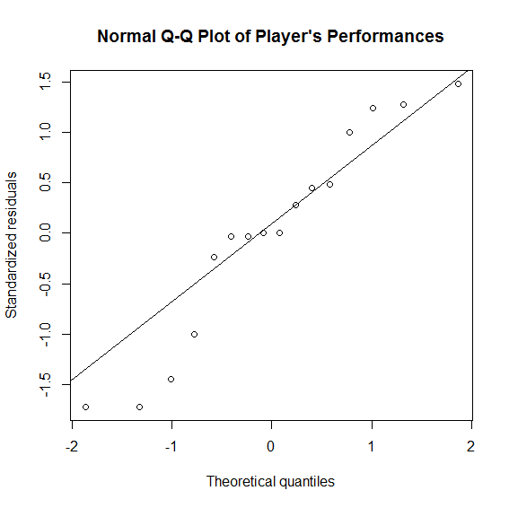

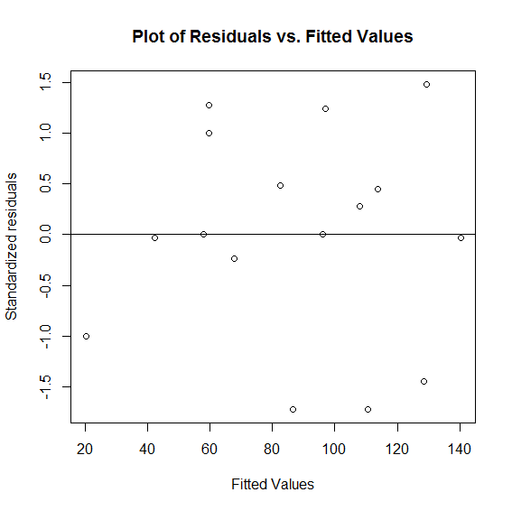

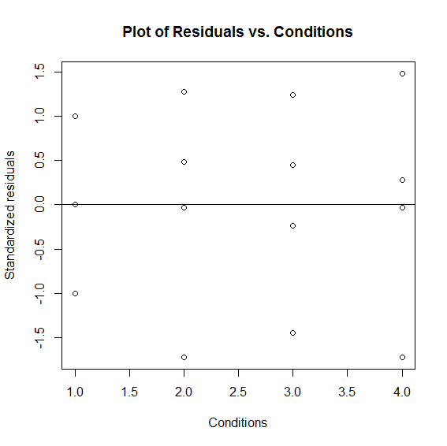

|  |  |  |  |
| --- | --- | --- | --- |
| condition | Mean estimation of performance | Lower bound | Upper bound |
| 1 | 58.50 | 45.60997 | 71.39003 |
| 2 | 98.25 | 85.35997 | 111.14003 |
| 3 | 101.75 | 88.85997 | 114.64003 |
| 4 | 91.50 | 78.60997 | 104.39003 |

In the above table we see that not all the means of performances of players across the conditions are equal. We use ANOVA to test whether the means are statistically equal. The p-value corresponding the hypothesis that all the means are equal is 0.01719944. Hence we come to realize that, at the level of 5%, not all the means are equal. This may mean that manipulating the games may have changed the performances of the players. To see whether this assumption is true, we use Tukey's multiple comparison test. The results are as following:

|  |  |  |  |  |
| --- | --- | --- | --- | --- |
| Conditions' difference | Mean difference | Lower bound | Upper bound | P-value |
| Condition 2- Condition 1 | 39.75 | 10.787245 | 68.71276 | 0.0124504 |
| 3-1 | 43.25 | 14.287245 | 72.21276 | 0.0082819 |
| 4-1 | 33.00 | 4.037245 | 61.96276 | 0.0290272 |
| 3-2 | 3.50 | -25.462755 | 32.46276 | 0.9732678 |
| 4-2 | -6.75 | -35.712755 | 22.21276 | 0.8492682 |
| 4-3 | -10.25 | -39.212755 | 18.71276 | 0.6351259 |

The first three rows of the above table state that the players have significantly lower performance in the default condition, while the performances increase in the other three condition. The lower three rows of the table state that all the three conditions have the same influence on the default such that the performers have similar performances.

In this experiment, as mentioned earlier, we used Latin Square method. The blockings were Individuals' experiences and time order which were suspected to be nuisiance factors of this experiment. After apply the method, we gained the values:

F-ratio of run order= 1.2083

F-ratio of experience= 29.0333.

The first value is small while the other is extremely large. We conclude that blocking the time order is not appropriate for such studies while experience had the potential to affect our results. In addition, we can say that different individuals' experiences resulted in different performances. This becomes more apparent when we note that if a player is more experienced than the other, s/he would have a better performance if the game is manipulated in order to make the game, sometimes, more challenging (condition 3) and sometimes of favour of the player (condition 2). The table below explains which condition is more suitable for different players with different game experiences:

|  |  |  |  |  |
| --- | --- | --- | --- | --- |
| experiences' difference | Mean difference | Lower bound | Upper bound | P-value |
| Experience 2-experience 1 | 33.5 | 4.537245 | 62.46276 | 0.0271883 |
| 3-1 | 50.5 | 21.537245 | 79.46276 | 0.0037921 |
| 4-1 | 76.0 | 47.037245 | 104.96276 | 0.0004163 |
| 3-2 | 17.0 | -11.962755 | 45.96276 | 0.2745976 |
| 4-2 | 42.5 | 13.537245 | 71.46276 | 0.0090222 |
| 4-3 | 25.5 | -3.462755 | 54.46276 | 0.0812661 |

#######################################################

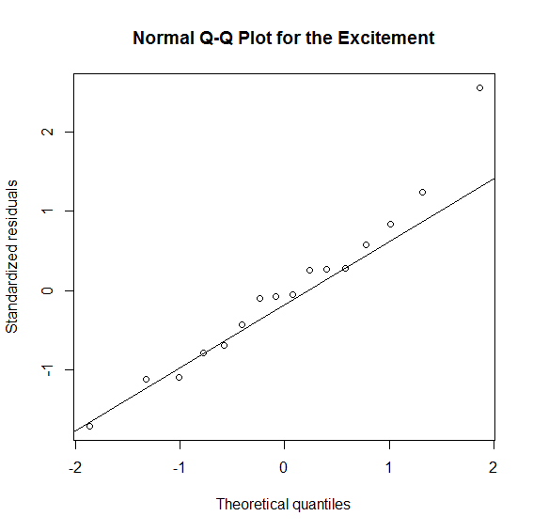

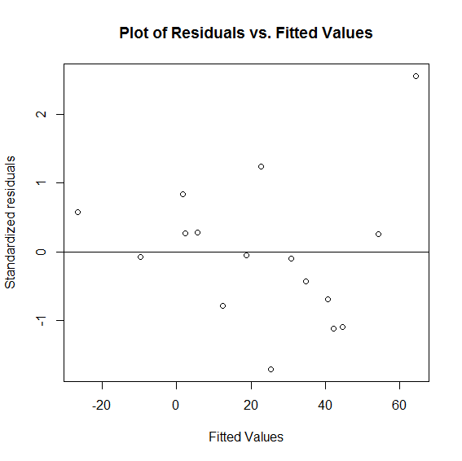

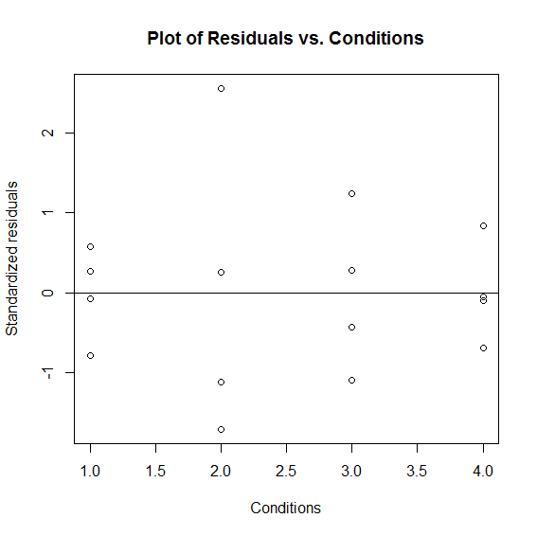

|  |  |  |  |
| --- | --- | --- | --- |
| Condition | Mean of GSR | Lower bound | Upper bound |
| Default | -5.29680 | -24.13608 | 13.54248 |
| Player | 46.48590 | 27.64662 | 65.32518 |
| Zombie | 26.95377 | 8.11450 | 45.79305 |
| Environment | 22.99617 | 4.15690 | 41.83545 |

p-value of the hypothesis that the excitement of players were the same across all the conditions= 0.06439932.

the ration for experience is 2.230153 which is small. So experience doesn't have an influence on players' excitement.