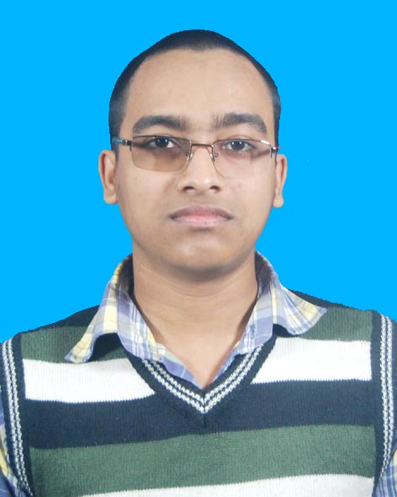
CURRICULUM VITAE
OF
FAHAMIN
H/R-11/9, Sector 11 Uttara - 1230
Contact No:-+8801639467698
E-mail: fahamin00@gmail.com

CAREER OBJECTIVE :

I aspire to build a long-term career in Android App development field in such an organization where there are vast opportunities for further career growth. I want to use my skills in the best way possible in a dynamic and stable work place.

ACADEMIC QUALIFICATION :
(B. Sc. Hon’s in CSE) : 2016_Runing
University : Uttara University, Dhaka-1230
Department : Computer Science & Engineering
Result (CGPA) : 3.72 (Avg) (out of 4)
H. S. C
Board : Dhaka
Group : Science
Year of Passing : 2015
Result (GPA) : 4.33 (out of 5)
S. S. C
Board : Dhaka
Group : Science
Year of Passing : 2012
Result (GPA) : 4.88 (out of 5)
PERSONAL STRENGTH:
- Leadership
- problem solving
- Decision Making
- Workaholic
- Teamwork
- Meeting deadlines
- Interpersonal
PROFESSIONAL SKILLS:
Language : C, C++, JAVA, SQL, HTML5, CSS, PHP
IDE : Android Studio, Eclipse, Net beans, Code Blocks
Learning Android App Development
Problem solve : https://www.urionlinejudge.com.br/judge/en/profile/137200
GitHub : https://github.com/Fahamin
Operating System : Windows7, 8, 8.1, 10, Linux
Office Management : Microsoft Word, Microsoft Excel,
Microsoft Power Point
Internet Browsing : E-mail & Internet Browsing
Digital & Communication System
Knowledge on Internet operations
LANGUAGE :
English & Bengali:
Proficiency in reading, writing, speaking & listening
TRANNING :
- Completed Top up IT training in Web Development under LICT project of Bangladesh Computer Council (BCC) under the ICT Ministry of Bangladesh.
- In this course I learn HTML5, CSS3, PHP, and Database.

- Completed Training in Android App Development under the ICT Ministry of Bangladesh.
- In this course I learn android application create and Design patterns UI.
PROJECT :

GitHub : https://github.com/Fahamin
My Play Store account : https://play.google.com/store/apps/dev?id=7556100466882241730
https://play.google.com/store/apps/details?id=us.dev.configaddons

PERSONAL INFORMATION :
Father’s Name : Md. Suruzzaman (Falu mia)
Mother’s Name : Mst. Fahima Begum
Permanent Address : C/O. Fahamin
Vill: Momin Nagar, (P.O: Rampur Bazzar-1973)
P.S.:Kalihati, Dist: Tangail
Date of birth : 19 December 1996
REFERENCES :
Professor Dr. Md. Mijanur Rahman
Chairman
Dept.of CSE
Uttara University
Phone: 01778949274
Email: mdmijanur1970@gmail.com

Signature
Fahamin
Date:

