**REPUBLIQUE ALGERIENNE DEMOCRATIQUE ET POPULAIRE**

**University Of Science And Technology Houari Boumediene**



**FINAL PROJECT OF**

**WEB & BUR**

**Done by :**

* **Fahd Djedi**

**Group : 54**

Table des matières

INTRODUCTION : 3

MICROSOFT TOOLS : 4

WORD : 4

EXCEL : 4

POWERPOINT : 4

LATEX AND HTML/CSS : 5

LATEX : 5

HTML/CSS : 5

GOOGLE SERVICES : 6

Google Sheets: 6

Purpose: 6

Key Features: 6

Google Docs: 6

Purpose: 6

Key Features: 6

Google Slides: 7

Purpose: 7

Key Features: 7

Resume des google apps/services 7

GIT AND GITHUB : 8

Key features of Git : 8

Distributed Version Control 8

Branching and Merging 8

History Tracking 8

Key features of GitHub : 8

Remote Repositories 8

Pull Requests 8

Issue Tracking 8

Collaboration Tools 8

In more simple terms : 9

used together : 9

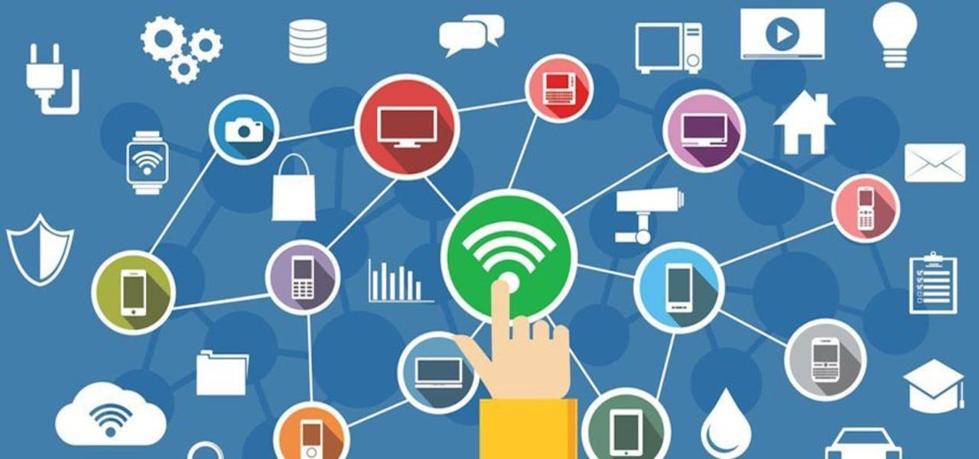

# INTRODUCTION :

during this first semester of our first year studying computer science we got introduced to TIC that stands for (information and communication technologies or in French technologies d'informations et de communication) in which we learned how to use different technologies, tools and programs related to that domain such as google services, Microsoft tools, git and github and two programing langages that are HTML and CSS, in addition to latex, and got familiar to them learning what they are used for, how to use them and why.

# MICROSOFT TOOLS :

Microsoft offers us in its operating system windows different tools to help us innovate, create, manage and manipulate large amounts of data and documents and for that we have in our hands different tools for different needs and during our semester we learned about the three most use and most famous one which are

## WORD :

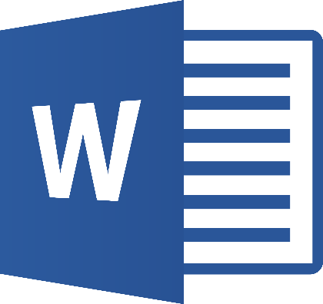Microsoft Word is a word processing program that is used for creating editing, formatting and sorting both simple and complex documents.

It allows to compose and type various types of written content with a user-friendly interface, it is easy to use and understand the interface is intuitive and most people can learn how to use it within a short period of time

It also benefits from really useful features such as automatic spelling and grammar checks, possibility to adjust the size colors shape and position of our written and personalize your documents however you want it

## EXCEL :

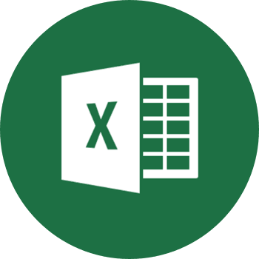Excel is a spreadsheet program from Microsoft and a component of its Office product group for business applications. Microsoft Excel enables users to format, organize and calculate data in a spreadsheet.

Like word, excel also benefits from the same easy to use and intuitive interface, features and options to help the user feel free in how he wants to organize, personalize and edit his documents to make them as easy, detailed and obvious as he would like to

## POWERPOINT :

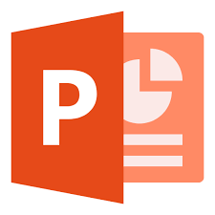Microsoft PowerPoint is a powerful slide show presentation program. It is a standard component of the company's Microsoft Office suite software, and is bundled together with Word, Excel, and other office productivity tools. The program uses slides to convey information

Rich in multimedia like its two brothers from above the interface intuition and the ease of use is still and allays here with PowerPoint and it allows use to create artworks of beauty by mixing its multiple options and the animations in addition to it

# LATEX AND HTML/CSS :

both of these two technologies are used to create websites from scratch by programing them typing our selves the different lines of codes the structures the website itself and although very similar there are some differences that we learned about

## LATEX :

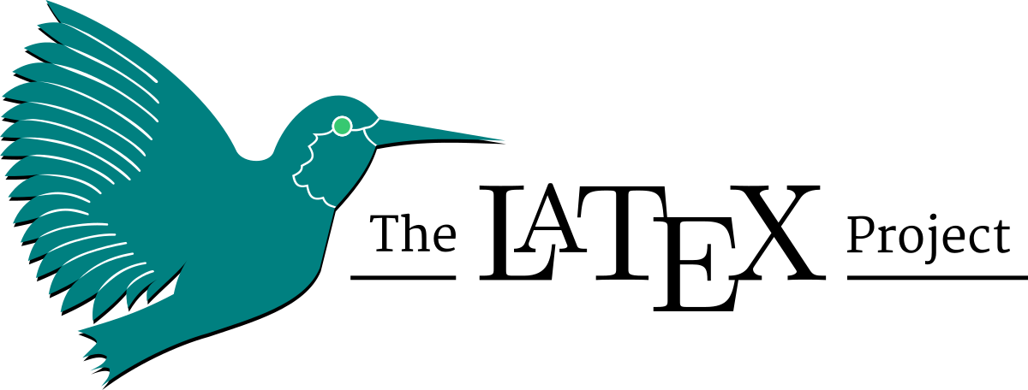LATEX was the first web design tool/technology we learned to use and we did so via OVERLEAF.com which is An online LaTeX editor that's easy to use No installation, real-time collaboration, version control, hundreds of LaTeX templates, and more.

LaTeX is a software system for typesetting documents. LaTeX markup describes the content and layout of the document, as opposed to the formatted text found

LATEX is a document preparation system for high-quality typesetting. It is most often used for medium-to-large technical or scientific documents but it can be used for almost any form of publishing oras mentioned earlier to create a sort of website

## HTML/CSS :

HTML and CSS are scripting languages used to create a web page and web applications. HTML provides web page structure, whereas CSS is mainly used to control web page styling

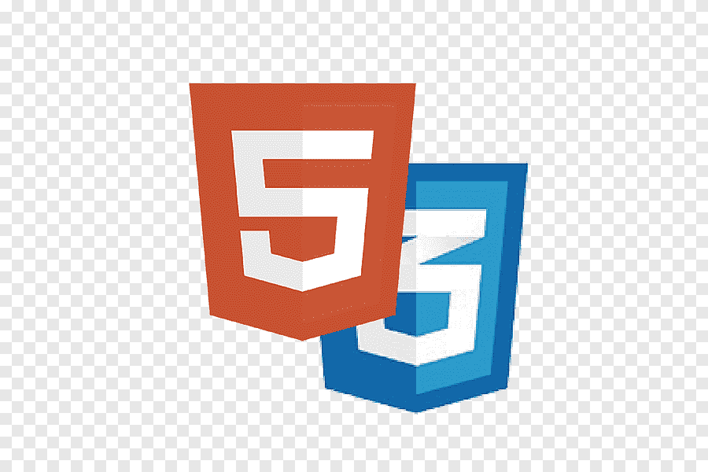HTML provides the raw tools needed to structure content on a website. CSS, on the other hand, helps to style this content so it appears to the user the way it was intended to be seen. These languages are kept separate to ensure websites are built correctly before they're reformatted

Learning HTML & CSS is essential for anyone hoping to work as a Web Developer or a Front End Developer. Most people who learn HTML learn it as a foundation for learning more complex coding languages such as JavaScript or React

# GOOGLE SERVICES :

Google Apps facilitates the provisioning of Google applications and user/enterprise management tools, including Gmail, Google Talk, Google Calendar, Google Docs, Google Videos and Google Cloud Connect and many many more

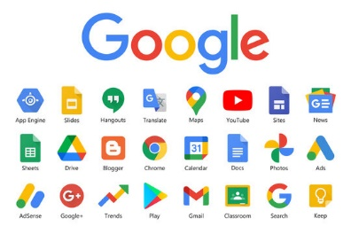we can name of them google sheets, google docs and google slides which operates the same and are use for the same purpose as excel, word and PowerPoint in that order but also introduces a new technologies which is the ability to work in a group and share the same documents being able to modify it type it or work on it in a group which we weren't able so far with the Microsoft tools

Google Sheets, Google Docs, and Google Slides are part of the Google Workspace (formerly G Suite) suite of productivity tools. Each of these applications serves a specific purpose:

## Google Sheets:

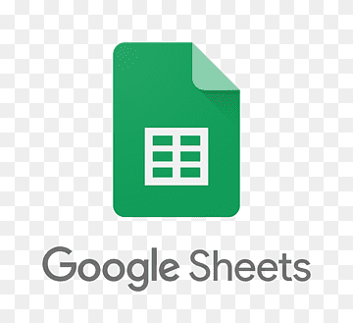Purpose: Google Sheets is a spreadsheet application. It is used for creating, editing, and sharing spreadsheets online.

### Key Features:

Cells and formulas: Users can input data into cells and use formulas to perform calculations.

Collaboration: Multiple users can work on the same spreadsheet simultaneously, making it a powerful tool for collaborative data analysis.

Charts and graphs: Google Sheets allows users to create various types of charts and graphs to visualize data.

## Google Docs:

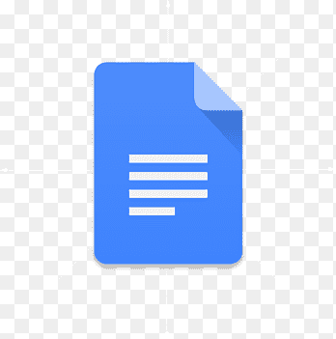Purpose: Google Docs is a word processing application. It is used for creating and editing documents online.

### Key Features:

Text editing: Users can create, format, and edit text documents.

Collaboration: Multiple users can collaborate in real-time on the same document, making it easy to work together on writing projects.

Commenting and suggestion tools: Users can leave comments and suggestions for others, facilitating communication during the editing process.

## Google Slides:

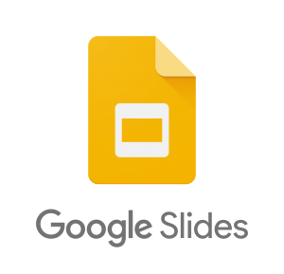Purpose: Google Slides is a presentation application. It is used for creating, editing, and delivering presentations online.

### Key Features:

Slides creation: Users can create slides containing text, images, and multimedia elements.

Collaboration: Multiple users can collaborate on the same presentation in real-time.

Presentation mode: Google Slides includes a presentation mode for delivering slideshows to an audience.

These Google Workspace applications are cloud-based, meaning that users can access their documents, spreadsheets, and presentations from any device with an internet connection.

The real-time collaboration features make them particularly useful for teams working on projects together, as changes are automatically saved and visible to all collaborators.

Additionally, users can easily share documents with others and control access permissions.

### Resume des google apps/services

|  |  |  |
| --- | --- | --- |
| GOOGLE APPS | PURPOSE | FEATURES |
| GOOGLE SHEETS | creating, editing, and sharing spreadsheets online | * Input data into cells and performs calculations * Create charts and graphs * Can work in groups |
| GOOGLE DOCS | creating and editing documents online | * create, format, and edit text documents * can work in groups * can leave comments and suggestions for other to facilitate communications and understanding |
| GOOGLE SLIDES | creating, editing, and delivering presentations online | * can create slides containing images text and multimedia elements * includes a presentation mode * can work in groups |

# GIT AND GITHUB :

Git is a distributed version control system (DVCS) that allows multiple developers to collaborate on a project, track changes to source code, and manage different versions of files. It was created by Linus Torvalds in 2005 and has become the standard version control system for software development.

## Key features of Git :

Distributed Version Control**:** Every developer has their own copy of the entire project repository, including its complete history. This allows for offline work and easy collaboration.

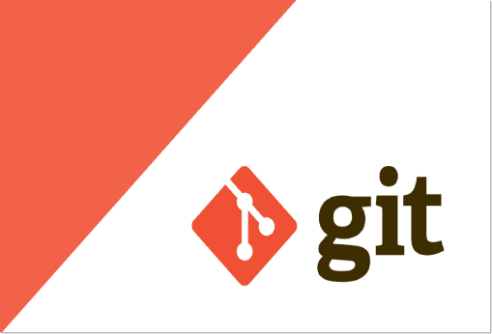Branching and Merging**:** Git allows developers to create branches to work on specific features or fixes independently. These branches can later be merged back into the main codebase.

History Tracking**:** Git keeps a complete history of changes made to the codebase. Developers can view the history, revert to previous versions, and track who made specific changes.

GitHub, on the other hand, is a web-based platform that provides hosting for Git repositories. It adds a layer of collaboration features on top of Git and facilitates social coding. GitHub allows multiple developers to work together on projects, making it easier to coordinate and manage changes.

## Key features of GitHub :

Remote Repositories**:** GitHub hosts Git repositories in the cloud, allowing developers to collaborate on projects without having to share physical copies of the code.

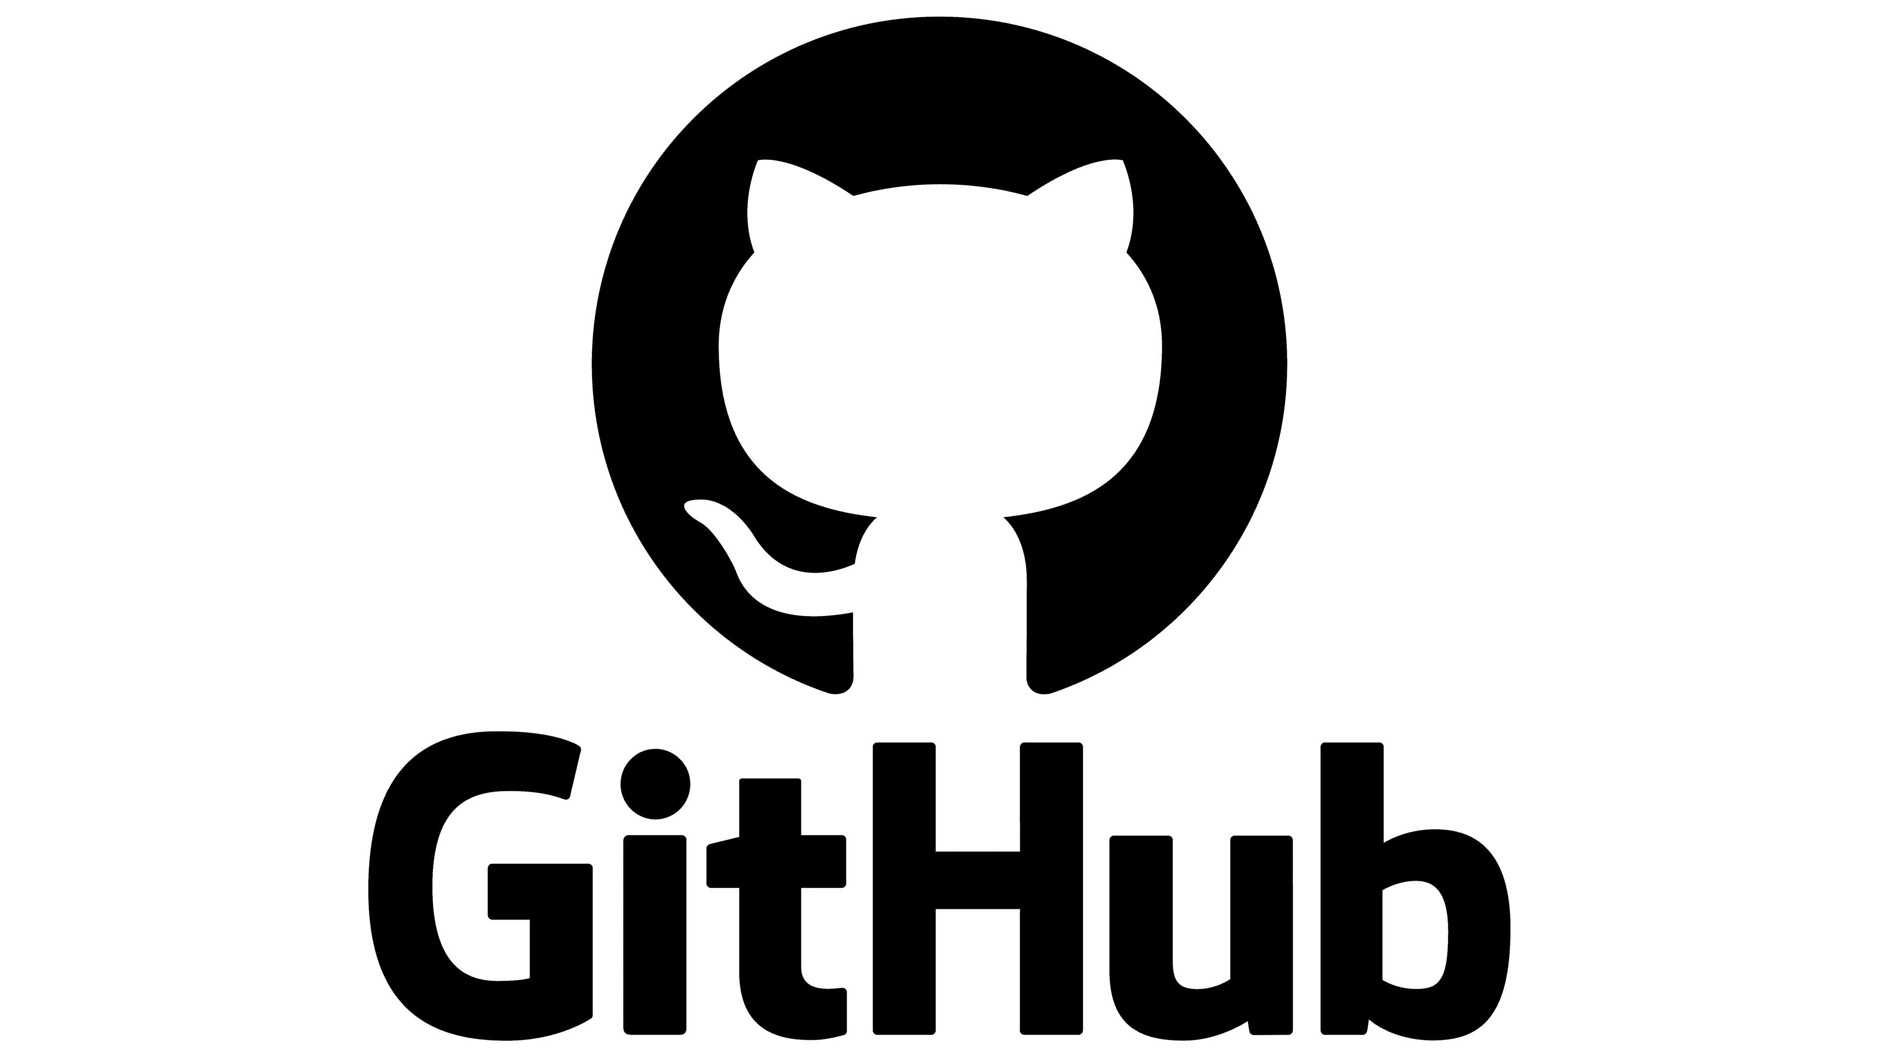Pull Requests**:** Developers can propose changes to a project by creating a pull request. This allows others to review the changes before they are merged into the main codebase.

Issue Tracking**:** GitHub provides tools for issue tracking and project management, making it easier to coordinate tasks and communicate about specific features or bugs.

Collaboration Tools**:** GitHub offers features like wikis, project boards, and discussions to facilitate collaboration and communication among team members.

In summary, Git is the version control system that manages the source code, while GitHub is a platform that uses Git for version control and adds collaboration and project management features. Developers use Git and GitHub to work on projects collaboratively, track changes, and manage the development workflow efficiently. Other similar platforms include GitLab and Bitbucket.

## In more simple terms :

Git is a DevOps tool used for source code management. It is a free and open-source version control system used to handle small to very large projects efficiently. Git is used to tracking changes in the source code, enabling multiple developers to work together on non-linear development

and GitHub is a code hosting platform for version control and collaboration. It lets you and others work together on projects from anywhere. This tutorial teaches you GitHub essentials like repositories, branches, commits, and pull requests

## used together :

those two combined allows multiple users to work on the same file and documents directly on their personal laptop or pc or platform in general