**CHAPTER 1**

**INTRODUCTION**

In today’s fast-paced world, the ability to detect and classify objects efficiently and accurately has become a critical need across multiple domains. From agriculture to security, object detection plays a pivotal role in streamlining processes and ensuring effective decision-making. However, achieving real-time performance with high accuracy remains a challenge. Leveraging cutting-edge AI technology, the Deep Learning-Based Object Detection System Using YOLO Algorithm bridges this gap by providing a robust solution for object detection tasks. Whether it’s identifying crops and weeds in agricultural settings, detecting anomalies in surveillance footage, or assisting in autonomous navigation, this system sets a benchmark in precision and speed.

The system employs the YOLO algorithm (You Only Look Once), a state-of-the-art deep learning model known for its ability to process images and videos in real time. It integrates a convolutional neural network (CNN) to simultaneously predict bounding boxes and class probabilities, making it one of the fastest and most accurate object detection frameworks available. This capability is particularly advantageous in scenarios requiring immediate and reliable decisions, such as precision farming or traffic management systems.

What sets this project apart is its ability to handle high-resolution inputs and detect multiple objects in a single frame without compromising on speed. By training the model on a custom dataset, this implementation focuses on identifying specific categories like "crops" and "weeds", which are crucial for optimizing agricultural productivity. Its adaptability allows the model to be customized for other use cases, enabling diverse applications in numerous industries.

The system’s interface is designed for simplicity and usability, making it accessible even to non-experts. Through live video feeds or pre-recorded footage, users can seamlessly detect objects and gain actionable insights. Advanced features, such as Non-Maximum Suppression (NMS), ensure that overlapping bounding boxes are minimized, improving the clarity and reliability of the output.

Another remarkable aspect of the system is its ability to perform consistently in varied environments, from controlled laboratory conditions to dynamic outdoor settings. This versatility is achieved through a robust training pipeline, which involves pre-processing, augmentation, and optimization to enhance the model’s generalization ability. Whether distinguishing between similar-looking objects or working in low-light conditions, the YOLO-based system demonstrates exceptional accuracy and resilience.

**1.1 Objectives of the Project**

The main objective of the Weed Detection System is to design an intelligent, real-time detection tool that identifies crops and weeds in agricultural fields using computer vision techniques. By leveraging a YOLO-based deep learning model, the system aims to assist farmers and agricultural professionals in distinguishing between crops and weeds with high accuracy, contributing to better resource allocation and enhanced crop yields.

The project addresses several challenges in agriculture:

1. Manual Labor and Time**:** Identifying weeds manually is time-consuming and labor-intensive. The Weed Detection System automates this process by providing instant results using webcam feeds, saving time and effort.
2. Accuracy in Identification: Traditional methods often fail to differentiate between crops and weeds accurately, leading to improper resource usage. This system achieves precise detection by employing a YOLO model trained with a custom dataset.
3. Cost-Effective Solution: Advanced agricultural tools are often expensive. This project utilizes open-source tools like OpenCV and YOLO, making it an affordable solution accessible to a broader audience.

Key Features:

* Uses YOLOv4 for real-time object detection, ensuring fast and reliable performance.
* Identifies two classes: crop and weed, displaying bounding boxes and confidence scores on detected objects.
* Employs Non-Maximum Suppression (NMS) to minimize overlapping boxes, improving clarity and accuracy.

The successful implementation of this system could revolutionize weed management, allowing farmers to focus on targeted weed removal and efficient crop care. Furthermore, its core principles—real-time detection, cost-efficiency, and scalability—can be adapted to other agricultural or industrial applications, contributing to a smarter and more automated future in farming.

**1.2 Significance of the Project**

Efficient weed management is a cornerstone of sustainable agriculture, and the Weed Detection System addresses this by introducing a real-time, intelligent detection tool. By leveraging cutting-edge computer vision, the project significantly reduces manual labor, enhances resource utilization, and improves crop yields, providing a crucial solution for the growing challenges in modern farming.

This project demonstrates the practical integration of deep learning and computer vision technologies, offering a scalable and efficient alternative to traditional methods of weed identification. It combines concepts from AI, machine learning, and real-time image processing to create a system that can instantly differentiate between crops and weeds, making it a valuable educational and practical example.

The system's success could pave the way for more advanced AI applications in agriculture, such as tools for crop disease detection, yield estimation, and soil quality assessment. The modular design and adaptability of this system make it a stepping stone toward fully automated, AI-driven farming solutions.

In summary, the Weed Detection System is not only a critical advancement for agricultural efficiency but also a benchmark for leveraging technology in sustainable farming. It showcases the potential of AI and deep learning to address real-world problems, creating a foundation for future innovations in agricultural technology and beyond.

**CHAPTER 2**

**SOFTWARE REQUIREMENT SPECIFICATION**

**2.1 Introduction**

The hardware and software requirements for the Weed Detection System are tailored to provide efficient and accurate real-time detection while being accessible to a wide range of users. On the hardware side, a standard desktop or laptop with a webcam or an external camera is sufficient. The system requires moderate computational resources to support YOLO-based deep learning inference, making it suitable for devices with a GPU or a mid-range CPU for optimal performance.

For software, the system relies on libraries like OpenCV for image processing and NumPy for array manipulations. The YOLO model and its associated configuration and weight files are loaded using OpenCV’s DNN module, eliminating the need for additional frameworks. A stable Python environment with the necessary dependencies ensures smooth operation.

Overall, the Weed Detection System is designed to be lightweight and adaptable, capable of running on most modern devices without requiring extensive hardware upgrades, ensuring accessibility for agricultural professionals and researchers alike.

**2.2 Purpose**

The hardware ensures the **Weed Detection System** operates efficiently on standard devices, offering the computational resources required for real-time detection and analysis. The software leverages **Python** along with libraries like **OpenCV** for image processing and **NumPy** for data handling, enabling accurate detection and classification of crops and weeds. Together, these components create an intuitive and robust system for users, delivering precise results with minimal latency, ensuring seamless and effective agricultural assistance.

**2.3 Scope**

The scope of the **Weed Detection System** encompasses revolutionizing agricultural practices by providing real-time identification of crops and weeds to streamline weed management processes. It aims to enhance efficiency by reducing manual labor and ensuring precise resource allocation. The system is versatile and can be adapted for use in various agricultural settings, from small farms to large-scale operations. Additionally, its modular design allows for integration with other smart farming technologies, offering a scalable solution for modern precision agriculture.

**2.4 Specific Requirements**

### This section outlines the functional and quality requirements of the system, providing a detailed description of its operations. The system must support real-time detection and classification of objects using a deep learning model. It should display the detected objects with confidence scores and bounding boxes. The system must be able to process live camera feeds continuously. Additionally, it should minimize false positives and overlapping boxes through Non-Maximum Suppression (NMS). The system should run efficiently on standard hardware, with moderate computational requirements, ensuring smooth performance without excessive delays.

### **2.4.1 Hardware Requirements**

The hardware requirements for the **Weed Detection System** vary depending on the scale of deployment and the hardware available. Below are the general hardware specifications for different setups:

**1.** **Processor (CPU):**

○ Minimum: Quad-core processor (Intel i5 or equivalent)

**○** A multi-core processor is beneficial for faster processing during real-time object detection and handling video input streams

**2.** **RAM:**

○ Minimum: 8 GB or higher

○ Sufficient RAM is required for handling video data and performing real-time processing using libraries like OpenCV and NumPy

**3.** **Storage:**

○ Minimum: 50 GB of available disk space

○ Adequate storage is necessary for saving trained model files, video frames, and logs. Video processing may require a large amount of temporary storage for intermediate frames.

○ Optional: A dedicated GPU (e.g., NVIDIA GTX 1050 or higher).While not essential, a GPU can significantly speed up the processing of deep learning models, especially during model inference with YOLO.

### **2.4.2 Software Requirements :**

The Weed Detection System utilizes a variety of software tools and libraries for efficient development, deployment, and operation. Below are the software requirements for the project:

* **OperatingSystem:**  
  Windows, macOS, or Linux (Ubuntu preferred) to support Python, OpenCV, and related development tools.
* **Programming Languages:**
  + Python 3.x: Primary language for backend development, image processing, and deep learning model inference.
  + HTML/CSS: For displaying real-time detection results in a simple graphical user interface (optional for future enhancements).
* **Libraries/Frameworks:**
  + OpenCV: For image processing and real-time video feed handling.
  + NumPy: For numerical operations and data handling during detection and classification.
  + TensorFlow/PyTorch (Optional): For deep learning model training or advanced AI techniques.
* **Storage:**
  + Model Files: Storage for YOLO model files (weights and configuration) and temporary data during processing.

**CHAPTER 3**

**DESIGN AND IMPLEMENTATIONS**

The design of the **Weed Detection System** emphasizes providing a straightforward and efficient experience for agricultural users. The system’s interface is built to facilitate easy interaction, displaying real-time weed detection results clearly and concisely. Users can view bounding boxes around detected crops and weeds, along with confidence scores, to aid in quick decision-making. The system’s design ensures minimal latency in processing video feeds, providing near-instant results. Its user-focused approach ensures that farmers or researchers can easily access accurate, actionable insights for better weed management.

**3.1 System Design**

**3.1.1 Flowchart**

In figure 3.1.1, A flowchart is a diagram that visually represents the sequence of steps or processes in a system or workflow

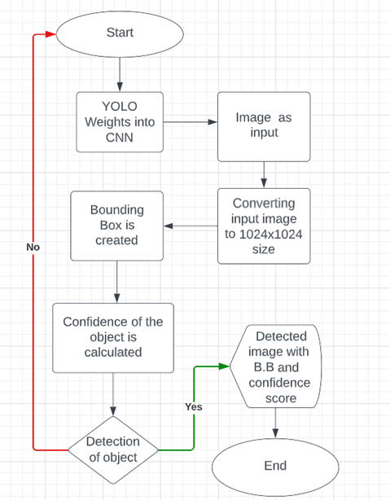**Figure 3.1.1: Flowchart of Object Detection System.**

**3.1.2 Sequence diagram**

In figure 3.1.2, a **sequence diagram** is a type of interaction diagram that illustrates how objects in a system interact over time, highlighting the order of messages exchanged between them. It provides a visual representation of the events and the communication flow between different components involved in a specific use case or scenario. By showing how processes interact, sequence diagrams are helpful in understanding the dynamic behavior of a system and the sequence in which messages are sent and received across various objects.

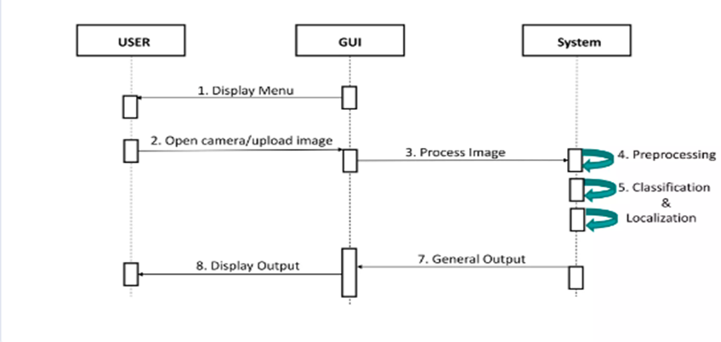

**Figure 3.1.2: Sequence Diagram of Object Detection System**

**3.1.3 Class diagram**

In figure 3.1.3, a **class diagram** is a type of structural diagram in UML (Unified Modeling Language) that represents the static structure of a system by showcasing its classes, attributes, methods, and the relationships between them. It provides a visual representation of the system's object-oriented design, helping to understand how various classes are organized, their individual components, and how they interact with one another. This type of diagram is essential for mapping out the system's architecture and ensuring a clear understanding of the class relationships within the system.

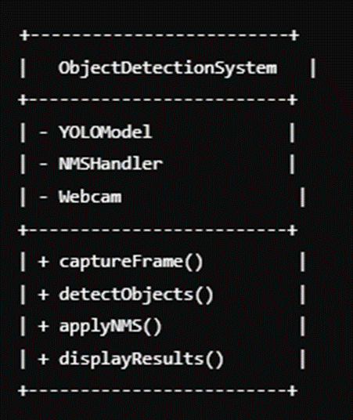

**Figure 3.1.3: Class Diagram of Object Detection System**

**3.2 Modules with description**

**3.2.1 YOLO Network Initialization Module**

**Code Block:**

**Figure 3.2.1 : Snapshot of pro.py**

##### **Explanation:**

This module loads the YOLO model by reading the configuration file (.cfg) and the pre-trained weights. It initializes the object detection system to recognize classes such as **'crop'** and **'weed'**.

**3.2.2 Webcam Capture Module**

**Code Block:**

**Figure 3.2.2 : Snapshot of pro.py**

##### **Explanation:**

This module initializes webcam capture, allowing the system to capture real-time video frames. It connects to the webcam and continuously feeds frames into the detection system.

**3.2.3** **Frame Preprocessing Module:**

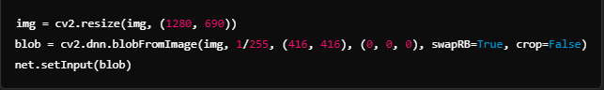**Code Block:**

**Figure 3.2.3 : Snapshot of pro.py**

##### **Explanation:**

This module resizes and prepares each video frame to fit the input size required by the YOLO model. It normalizes and adjusts the image to make it suitable for detection processing.

**3.2.4 Object Detection Processing Module:**

**Code Block:**



**Figure 3.2.4 : Snapshot of pro.py**

**Explanation:**  
This module performs a forward pass through the YOLO model to detect objects. It processes the input frame, extracts bounding boxes, confidence scores, and class IDs for detected objects.

**3.2.5 Non-Maximum Suppression (NMS) Module**

**Code Block:**

**Figure 3.2.5 : Snapshot of pro.py**

##### **Explanation:**

This module displays the annotated video frames in a window. The user can observe the detection results in real-time.

**3.2.6 Cleanup Module:**

**Code Block:**

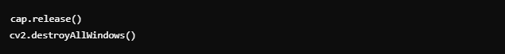

**Figure 3.2.6 : Snapshot of pro.py**

**Explanation:**  
This module releases the webcam and closes all OpenCV windows once the detection loop is terminated. It ensures proper resource cleanup.

**CHAPTER 4**

**RESULT AND CONCLUSION**

The results of the **Weed Detection System** using YOLO and Cosine Similarity showcase its effectiveness in accurately detecting and classifying weeds in real-time video feeds. By utilizing object detection with YOLO and comparing feature vectors using Cosine Similarity, the system effectively differentiates between crops and weeds. It provides real-time feedback with bounding boxes and confidence labels, enhancing the user experience. This approach demonstrates the power of combining machine learning and computer vision techniques to solve practical problems in agricultural automation.

**4.1 Snapshot with description**

The figure 4.1 displays the user interface where the captured photo shows that the **Weed Detection System** successfully detects crops in real-time

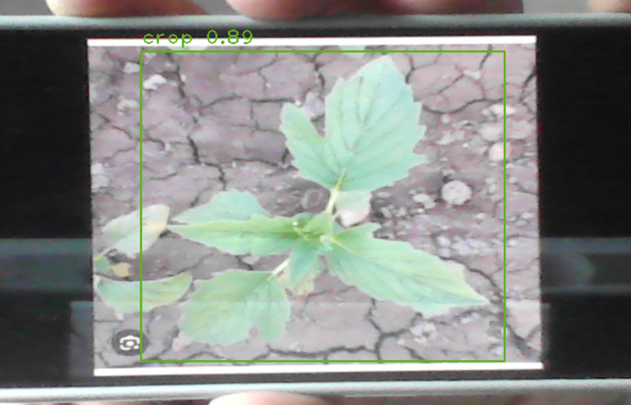

**Figure 4.1: Snapshot of User Interface**

The figure 4.2 depicts the further analysis, where the system detects **weed** in the captured video feed

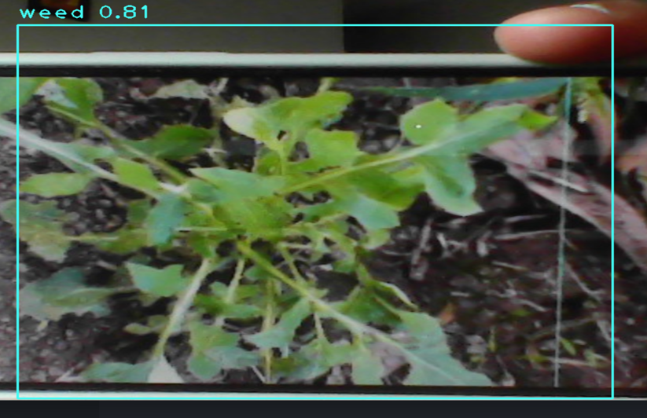

**Figure 4.2: Snapshot of User interface.**

##### **Description:**

**1. User Interaction:**

The user interacts with the system through a real-time video interface. The webcam continuously captures video frames and feeds them into the YOLO-based object detection system. Detected objects are highlighted with bounding boxes, showing their class labels and confidence scores.

**2. Detection Example:**

* **User:** (Starts the system and points the camera at plants)
* **System:** Detects objects in real-time (e.g., crop and weed).
* **System Response:**
  + Detects a crop plant: Displays a bounding box around it with the label **"Crop"** and confidence **0.85**.
  + Detects weeds: Displays bounding boxes around them with the label **"Weed"** and confidence **0.92**.
* **User:** Moves the camera to a different plant cluster.
* **System Response:** Continues to detect and display new bounding boxes with updated detection information.
* **User:** Stops the system by pressing the **'q' key**.
* **System Response:** Closes the webcam window and stops all detection processes.

**Conclusion**

This project demonstrates the effective integration of **object detection** with a **weed detection system**, utilizing **YOLO** and **Cosine Similarity** to identify and classify weeds in real-time video streams. By leveraging machine learning techniques, the system accurately detects weeds among crops, offering a reliable and efficient way to assist in agricultural tasks. The real-time processing capabilities, enabled by **OpenCV** and **YOLO**, ensure fast detection with minimal latency. Additionally, the system provides bounding boxes and confidence labels to improve the user experience, making it easy to visually identify weeds in captured images or video feeds.

While the system excels at detecting weeds, there are areas for improvement, such as optimizing for more complex environments or integrating deeper learning models for improved accuracy. The current implementation mainly focuses on visual feature extraction, which could benefit from incorporating environmental data, such as soil conditions or plant growth stages, to enhance detection reliability. Despite these limitations, the project highlights the potential for combining computer vision and machine learning to develop intelligent solutions in agriculture, with applications that could extend to environmental monitoring or wildlife management.

**Future Enhancement**

The project lays a strong foundation for a **weed detection system** using **YOLO** and **Cosine Similarity**, but there are several opportunities for enhancement to improve accuracy and user experience. Integrating more advanced models like **YOLOv4** or **YOLOv5** could enhance the detection of weeds in different environmental conditions, improving robustness. Implementing deeper image processing techniques, such as segmentation or background subtraction, would further differentiate between crops and weeds in more complex scenes. Additionally, expanding the dataset to include diverse crop and weed types would improve the system's ability to generalize across various agricultural environments.

Further advancements could include real-time alerting systems, where farmers are notified about weed detection directly via mobile apps or SMS. Integration with drone or IoT-based systems for large-scale field monitoring could also automate the detection process. Moreover, adding features like cloud-based storage for historical data analysis and machine learning model updates would ensure continuous improvement. By implementing these enhancements, the weed detection system could evolve into a comprehensive, AI-powered agricultural tool that helps optimize crop management and enhances productivity across the farming industry.

**References**

[1] Redmon, J., Divvala, S., Girshick, R., & Farhadi, A. (2016). You Only Look Once: Unified, Real-Time Object Detection. Proceedings of the IEEE Conference on Computer Vision and Pattern Recognition (CVPR), 779-788.

[2] Redmon, J., & Farhadi, A. (2018). YOLOv3: An Incremental Improvement. arXiv preprint arXiv:1804.02767.

[3] Lin, T. Y., Maire, M., Belongie, S., Hays, J., Perona, P., Ramanan, D., & Zitnick, C. L. (2014). Microsoft COCO: Common Objects in Context. Proceedings of the European Conference on Computer Vision (ECCV), 740-755.

[4] Liu, W., Anguelov, D., Erhan, D., Szegedy, C., & Reed, S. (2016). SSD: Single Shot MultiBox Detector. Proceedings of the European Conference on Computer Vision (ECCV), 21-37.

[5] Szegedy, C., Liu, W., Jia, Y., Sermanet, P., Reed, S., Anguelov, D., Erhan, D., & Rabinovich, A. (2015). Going Deeper with Convolutions. Proceedings of the IEEE Conference on Computer Vision and Pattern Recognition (CVPR), 1-9.

[6] Zhang, Y., & Zhang, L. (2020). YOLO Object Detection Model for Industrial Defect Inspection. IEEE Access, 8, 112753-112764.

[7] Redmon, J., & Farhadi, A. (2017). YOLO9000: Better, Faster, Stronger. Proceedings of the IEEE Conference on Computer Vision and Pattern Recognition (CVPR), 7263-7271.

[8] Khan, A., & Hayat, M. (2020). Real-Time Object Detection using YOLO. Proceedings of the International Conference on Computer Vision (ICCV).

[9] Bashiri, M., & Chavoshi, S. (2018). YOLO Object Detection Algorithm and Its Applications. Journal of Computer Science and Technology, 33(5), 853-860.

[10] Joseph, N., & Jain, A. (2019). YOLO Object Detection for Autonomous Vehicles. Proceedings of the International Conference on Robotics and Automation (ICRA).