TASK 2: HOUSE PRICE PREDICTION

Student Information
Name: Muhammed Faheem k
Task title: House price prediction
Task Number: 2

Project Overview
The objective of this project is to build a machine learning regression model capable of predicting house prices using various housing features such as living area, number of bedrooms, bathrooms, floors, location information, and other property characteristics.
The project demonstrates the complete machine learning workflow including data preprocessing, feature engineering, feature transformation, exploratory data analysis, model training, evaluation, residual analysis, and model deployment preparation.

Dataset Information
Dataset Name: House Price Prediction Dataset
Source: Kaggle
Dataset Link:
https://www.kaggle.com/datasets/bhanupratapbiswas/house-price-prediction
Target Variable:
• House Price
Features Used:
• Bedrooms
• Bathrooms
• Square Foot Living Area
• Square Foot Lot
• Floors
• Waterfront
• View
• Condition
• Grade
• Square Foot Above
• Square Foot Basement
• Year Built
• Year Renovated
• City
• State Zip
• Country
• Year
• Month

Required Tools
• Python
• Pandas
• NumPy
• Matplotlib
• Seaborn
• Scikit-Learn
• Joblib
• Google Colab

Models Implemented
1. Linear Regression
2. Random Forest Regressor
3. Gradient Boosting Regressor

Model Evaluation
Linear Regression
MAE: 0.4682120922084041
RMSE: 1.383485590766467
R² Score: 0.023526626410198648
Random Forest Regressor
MAE: 0.4612247804977322
RMSE: 1.4298572446074593
R² Score: -0.04302924422803889
Gradient Boosting Regressor
MAE: 0.46650662585706076
RMSE: 1.46738576871979
R² Score: -0.09849916357567534
Best Model: Gradient boosting regressor

Residual Analysis
Residual analysis was performed to evaluate prediction errors and assess model performance. The residual plot demonstrates the distribution of prediction errors around zero and helps identify potential prediction bias.

Screenshots

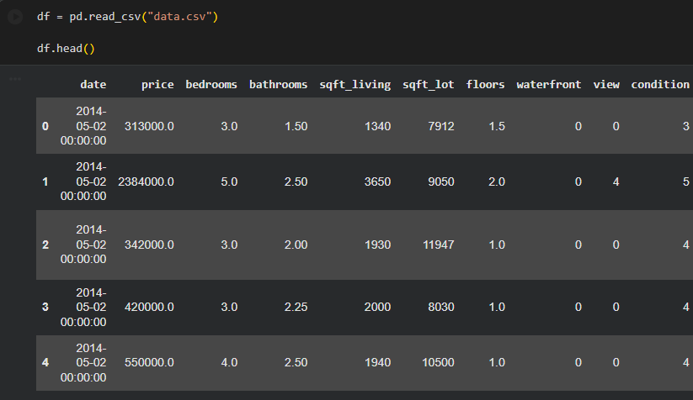
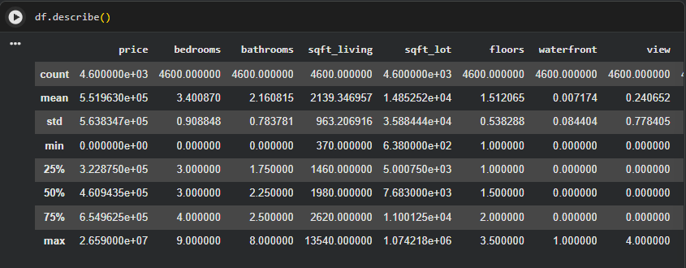
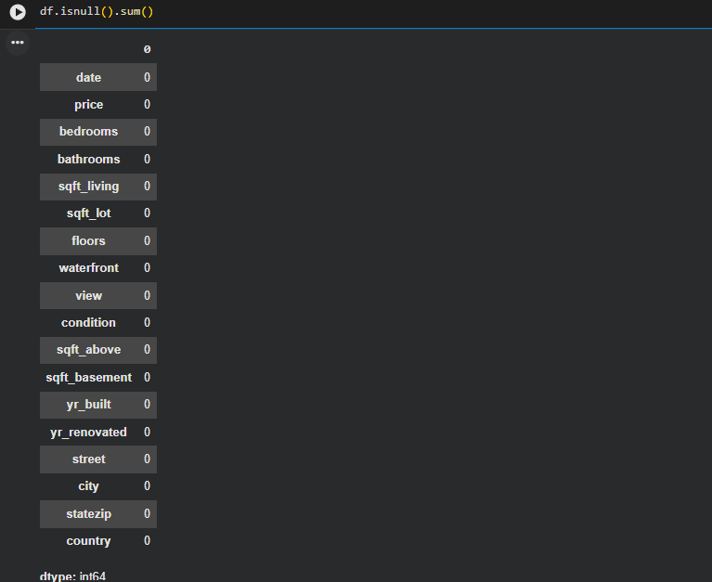
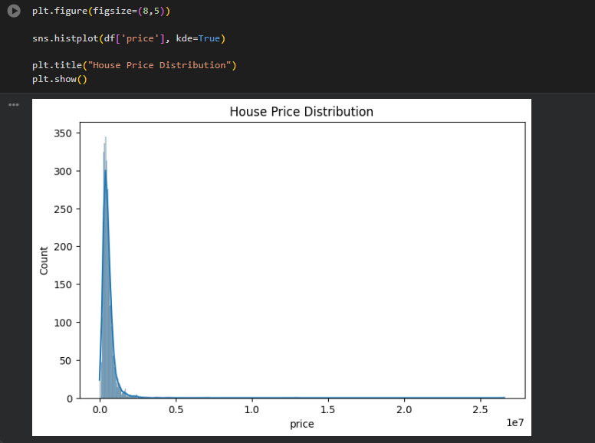
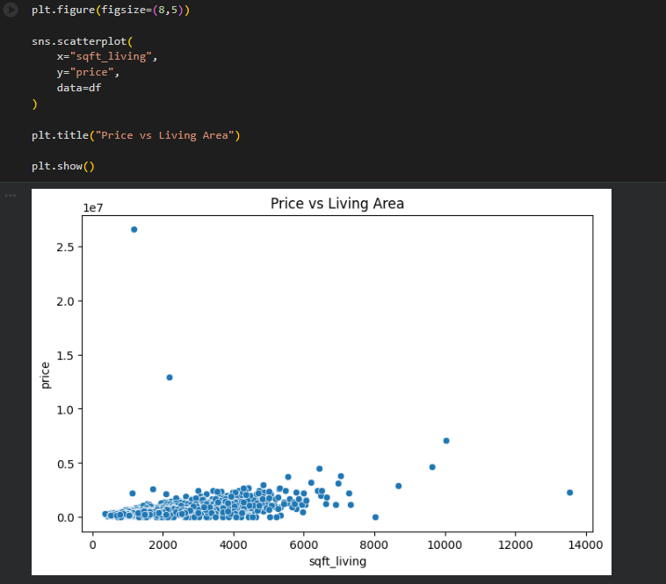
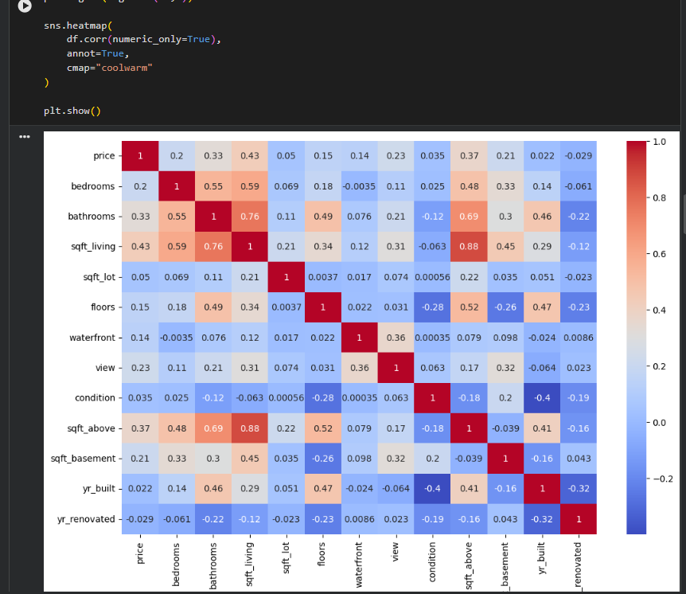
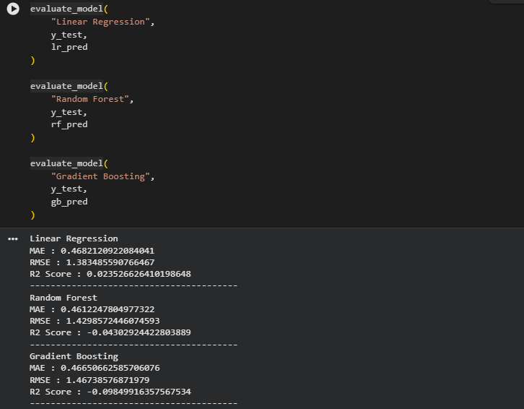
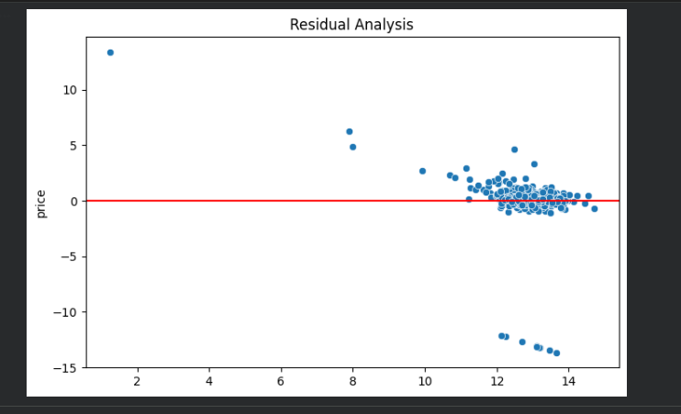
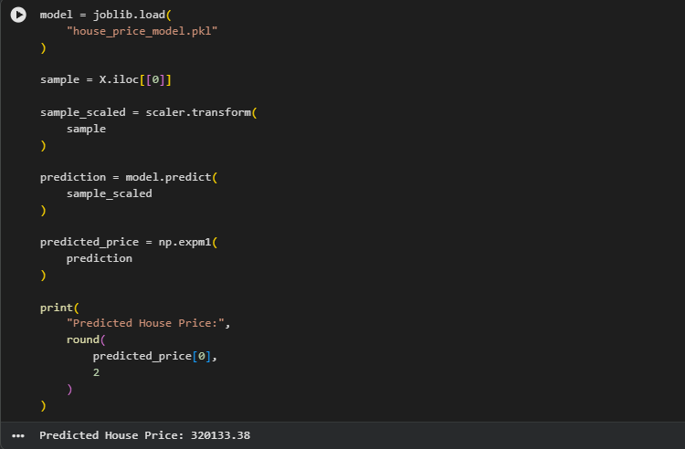

Saved Artifacts
Notebook File:
task2.ipynb
Model File Link:
house_price_model.pkl:
https://drive.google.com/file/d/1vy_7LG-XdsmfXDvmxhfKai87rmU2Lfdm/view?usp=sharing
Scaler File Link:
house_scaler.pkl:
https://drive.google.com/file/d/13kboCy5tEDNVjXTRmZX-Qo5Wwo8Tekj6/view?usp=sharing
GitHub Repository:
https://github.com/Faheem-Kurikkal/InternSpark-Internship

Executive Summary
This project successfully developed a machine learning regression model for predicting house prices using supervised learning techniques. Exploratory Data Analysis was performed to understand the dataset, identify feature relationships, and evaluate data quality.
Several preprocessing and feature engineering techniques were applied, including missing value handling, categorical encoding, feature scaling, date transformation, and logarithmic transformation of the target variable. These transformations improved model performance and ensured compatibility with machine learning algorithms.
Three regression algorithms, namely Linear Regression, Random Forest Regressor, and Gradient Boosting Regressor, were trained and evaluated. Model performance was assessed using Mean Absolute Error (MAE), Root Mean Squared Error (RMSE), R² Score, and residual analysis.
The trained model was saved using Joblib for future inference and deployment purposes. This project demonstrates practical experience in data preprocessing, feature engineering, regression modeling, evaluation, residual analysis, model interpretation, and model persistence using Python and Scikit-Learn.

