INTERNSPARK MACHINE LEARNING INTERNSHIP

TASK 1: IRIS CLASSIFICATION

Candidate Details
Name: Muhammed Faheem K
Task title: Iris Classification
Task Number: 1

Project Overview
Objective:
The objective of this project is to build a machine learning classification model capable of predicting Iris flower species using sepal and petal measurements.
The project demonstrates the complete machine learning workflow including data preprocessing, exploratory data analysis, model training, evaluation, and model deployment preparation.

Dataset Information
Dataset Name: Iris Classification Dataset
Source: Kaggle
Features:
• Sepal Length
• Sepal Width
• Petal Length
• Petal Width
Target Variable:
• Iris Setosa
• Iris Versicolor
• Iris Virginica

Required Tools
- Python
- Pandas
- NumPy
- Matplotlib
- Seaborn
- Sckit-Learn
- Joblib
- Google Colab

Models Implemented

1. K-Nearest Neighbors (KNN)
2. Logistic Regression
3. Decision Tree Classifier

Model Evaluation
Model | Accuracy
KNN | 0.933333
Logistic Regression | 0.933333
Decision Tree | 0.900000
Best Model: KNN
Accuracy: 0.933333 or 93%
Additional Metrics:
• Precision: 0.94
• Recall: 0.93
• F1 Score: 0.93

Screenshots

- Dataset Preview

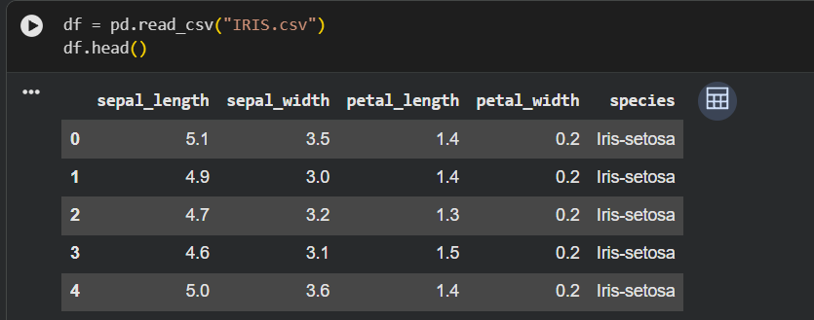

- Dataset Information

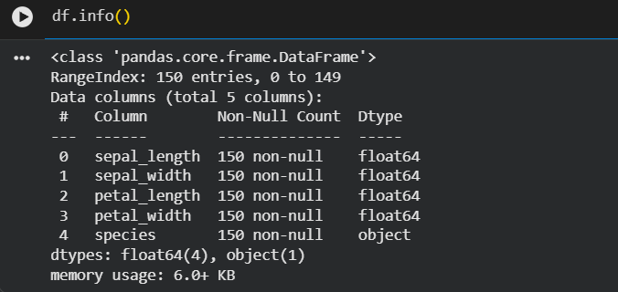
- Dataset Statistic

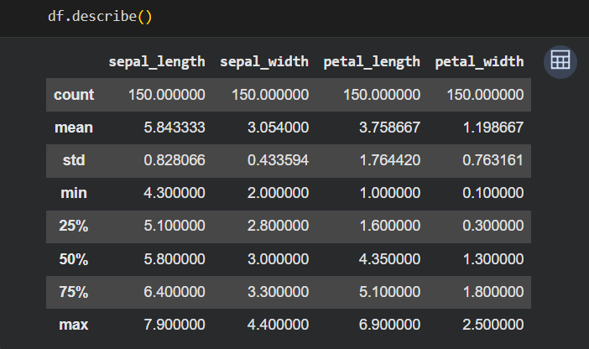

- Scatter plot

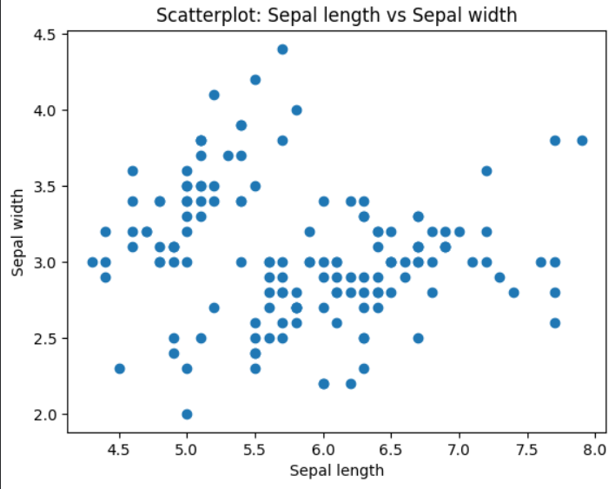
- Box plot

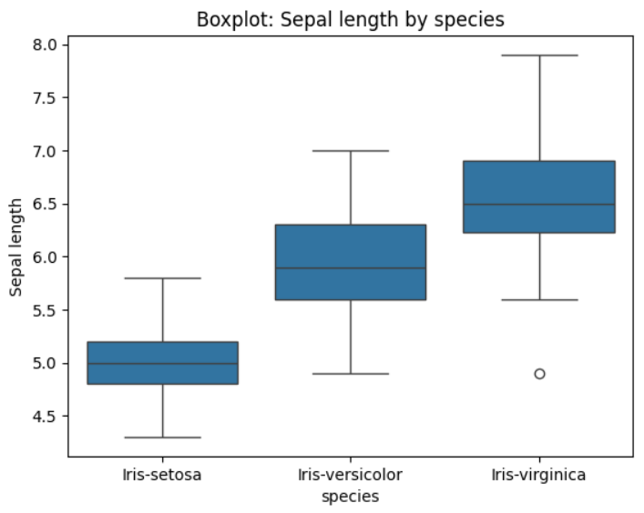

- Histogram
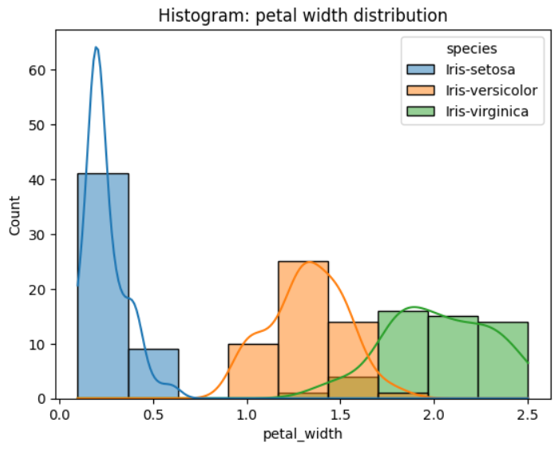
- Pair plot

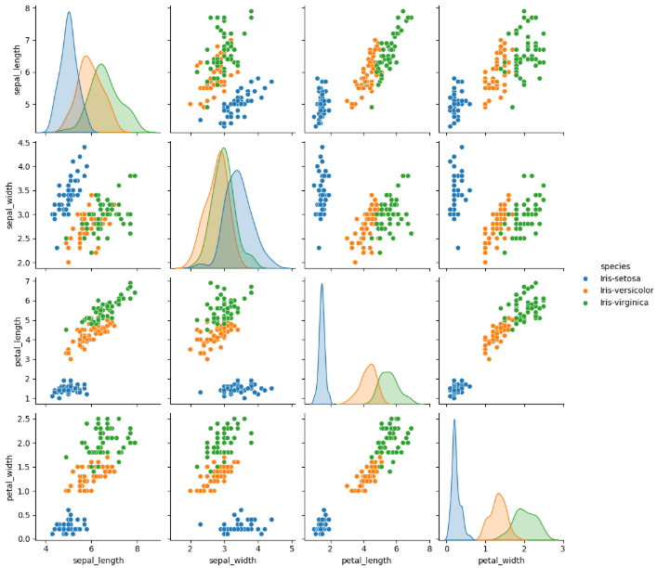

- Model comparison table

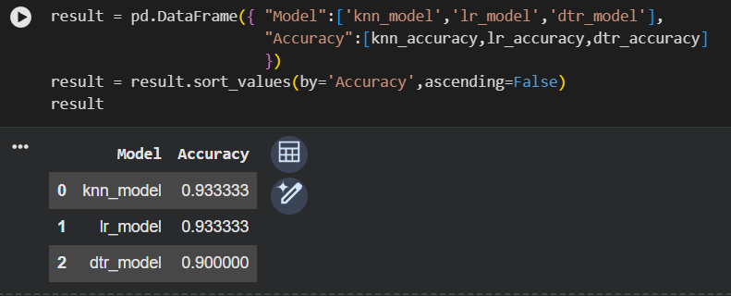

- Confusion matrix

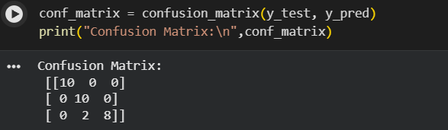

- Classification report

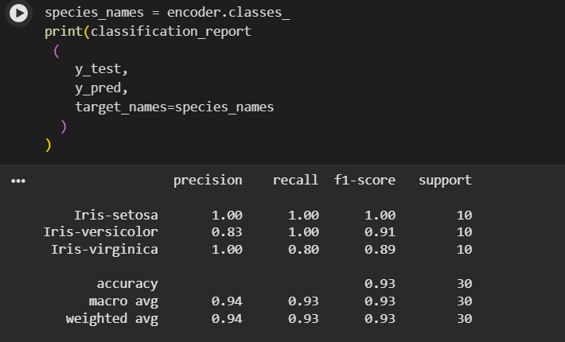

- Inference output

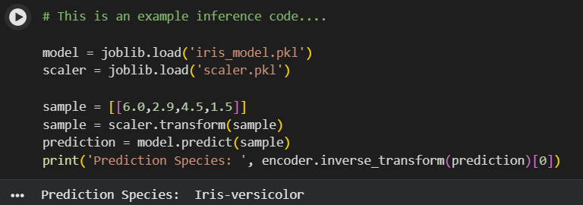

Saved Artifacts

Notebook File:
task1.ipynb
Model File Link:
Iris_model.pkl: https://drive.google.com/file/d/1xqo0KKjbbgTkJTPITu2-170ph_lwphH5/view?usp=sharing
Scaler.pkl: https://drive.google.com/file/d/1JugO-YiJmzz0qI5Ds1l4ekKex_8YcKwc/view?usp=sharing
GitHub Repository:
https://github.com/Faheem-Kurikkal/InternSpark-Internship

Executive Summary

This project successfully developed a machine learning model for Iris flower classification using supervised learning techniques. Exploratory Data Analysis was performed to understand the dataset and identify important feature relationships. Three classification algorithms, namely K-Nearest Neighbors, Logistic Regression, and Decision Tree Classifier, were trained and compared.
The models were evaluated using accuracy, precision, recall, F1-score, and confusion matrix. Among the tested models, KNN model achieved the highest classification accuracy of 93% and was selected as the final model.
The trained model was saved using Joblib for future inference and deployment purposes. The project demonstrates practical experience in data preprocessing, feature analysis, model training, evaluation, and model persistence using Python and Scikit-learn.

