THE UNIVERSITY OF AZAD JAMMU & KASHMIR, MUZAFFARABAD
DEPARTMENT OF SOFTWARE ENGINEERING
=================================================================

ASSIGNMENT 01
Google Maps Redesign HCI Analysis & Cognitive Load Evaluation

Student Name | Faheem Rasool
Roll Number | 2023-SE-17
Course Title | Human-Computer Interaction (HCI) | SE-3204
Semester & Session | 6th Semester | Session 2023-2027
Department | Department of Software Engineering
Date of Submission | sept 2026
Submitted To | Mam Sidra Rafique

Question A) Evaluate which design changes are most effective in reducing cognitive load for users.
The Google Maps redesign effectively reduced extraneous cognitive load by focusing on simplicity and timing, specifically through the following changes:
• Simplified Turn-by-Turn Interface: The redesigned turn-by-turn view strips non-essential UI elements, reducing extraneous cognitive load at the exact moment a driver's attention is most constrained.
• Visual Hierarchy and Clarity: The design uses a priority-based information display to structure data logically. The visual hierarchy is set so that the primary focus is the next turn, secondary is the distance and ETA, and tertiary is the route overview. Coupled with larger fonts, a simplified color palette, and reduced visual clutter, this hierarchy supports quick perception.
• Progressive Disclosure: Instead of overwhelming the user with all available data, the app is designed to reveal depth on demand. For example, Points of Interest (POI) details appear in a card only when actively tapped.
• Bottom Sheet Navigation: By replacing the hidden navigation drawer (hamburger menu) with a persistent, thumb-friendly bottom sheet containing 4 tabs, users no longer have to bury through multiple taps to find features.
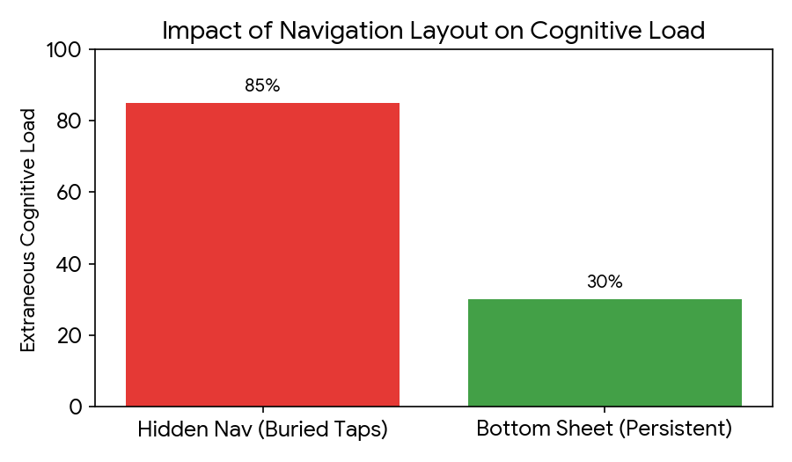
Impact Metrics Comparison Matrix

Layout Paradigm | Extraneous Cognitive Load % | User Interaction Performance
Hidden Nav (Buried Taps) | 85% | High friction, deep navigation trees
Bottom Sheet (Persistent) | 30% | Low friction, instant access via 4 tabs
Question B) Discuss how the redesigned system maintains a balance between user safety and information presentation.
Driving is a safety-critical context that requires high attention, fast decision-making, and minimal distraction. The redesigned system balances this need for safety with vital information delivery through:
• Glance able Interfaces: The interface is engineered to minimize glance time, ensuring drivers keep their eyes on the road. High-contrast visuals and prominent next-turn instructions make the screen easily readable and clear.
• Multimodal Interaction: To reduce the need for visual processing, the app heavily utilizes auditory feedback, which can allow users to avoid looking at the screen for up to 20% of the time. It also supports voice interaction and gesture-based controls to reduce manual interaction.
• Application of Fitts' Law: The persistent bottom tabs sit at the thumb's natural resting zone on a phone, making them faster to hit. The interface also utilizes large touch targets.
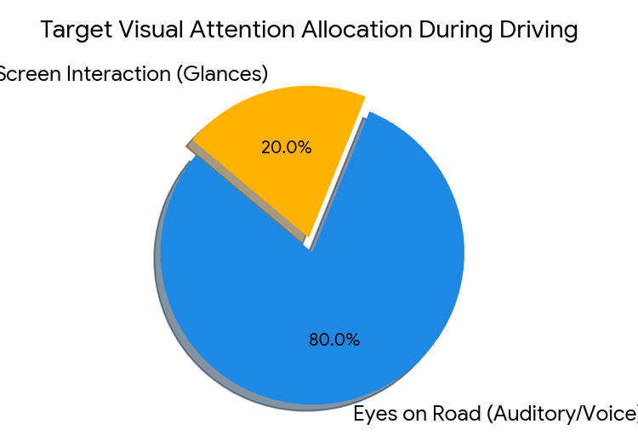
• Context-Aware Automation: The system reduces the user's manual workload by dynamically rerouting, providing incident alerts, and adapting to real-time traffic.

Question C) Examine whether the use of 3D visualization enhances user understanding or leads to increased distraction. Provide justification.
The use of 3D visualization, specifically Google Maps' Live View Augmented Reality (AR), presents a careful trade-off between spatial understanding and potential distraction:
• Enhanced Understanding in Specific Contexts: AR visualization can significantly enhance spatial reasoning by overlaying digital directions onto the physical world, but Google wove it strictly into the active walking navigation flow.
• Preventing Distraction via Progressive Disclosure: To ensure 3D elements do not increase cognitive load or distraction for drivers, the Live View AR surfaces only during active walking navigation. It does not clutter the default driving view.
• The Trade-off: The justification for hiding the 3D AR view is user safety. However, a direct consequence of this seamless integration is that the discoverability of the AR feature is incredibly low, as there is no strong visual signifier to indicate its presence to the average user.
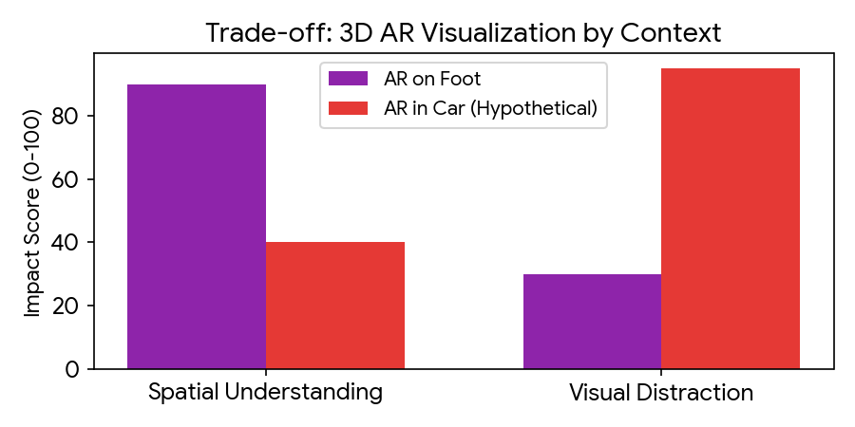
Question D) Propose suitable improvements to further enhance usability, efficiency, and user experience.
Based on the design trade-offs identified in the redesign, the following improvements could bridge the gap between aesthetic simplicity and functional efficiency:
• Customizable Navigation Bar for Power Users: The shift to a simplified bottom sheet resulted in power users losing their quick-access shortcuts. Allowing users to customize slots on the bottom bar would restore efficiency.
• Clearer Signifiers for Hidden Features: Because the AR Live View suffers from low discoverability, introducing a subtle visual cue (a signifier) when a user is navigating on foot could guide them to the feature without cluttering the screen.
• Accessible Icon Labeling: Removing text labels from navigation icons can disadvantage certain users. Implementing a user setting to toggle text labels on would improve accessibility and adhere more closely to universal design principles.

• Dynamic Screen Optimization: The new bottom bar consumes approximately 10% of the screen space, taking away from the map view. Introducing a dynamic feature that minimizes the bottom bar when the user begins actively panning the map would balance Fitts' Law thumb reachability with a cleaner exploration experience.
Conclusion:
In conclusion, the case study shows that good interface design makes systems easier and safer to use. By reducing unnecessary information, using simple layouts, and applying HCI principles like Cognitive Load Theory and Fitts' Law, the system improves user experience.
However, some features like 3D visualization can both help and distract, so they must be used carefully. Overall, the design is effective but can be further improved with better accessibility and personalization.

