THE UNIVERSITY OF AZAD JAMMU & KASHMIR, MUZAFFARABAD
DEPARTMENT OF SOFTWARE ENGINEERING
=================================================================

LAB REPORT 08-09
Human-Computer Interaction (HCI) Analysis of Canva & Web Developer Hiring Poster Case Study

Student Name | Faheem Rasool
Roll Number | 2023-SE-17
Course Title | Human-Computer Interaction (HCI) | SE-3204
Semester & Session | 6th Semester | Session 2023-2027
Department | Department of Software Engineering
Date of Submission | Sept 18, 2026
Submitted To | Mam Sidra Rafique

1. Introduction
This lab report presents an in-depth analysis of Canva, a widely-used cloud-based graphic design tool, through the lens of Human-Computer Interaction (HCI). Canva was used to create a 'WE ARE HIRING! WEB DEVELOPERS' poster (Softnexa Solutions), and the interface was examined to identify and document key HCI concepts including paradigms, WIMP elements, multimedia features, collaboration tools, and direct manipulation techniques.
Canva is an excellent case study for HCI analysis because it is designed for non-expert users, relies heavily on visual and direct manipulation, and incorporates a rich set of interactive features that align closely with foundational HCI paradigms.
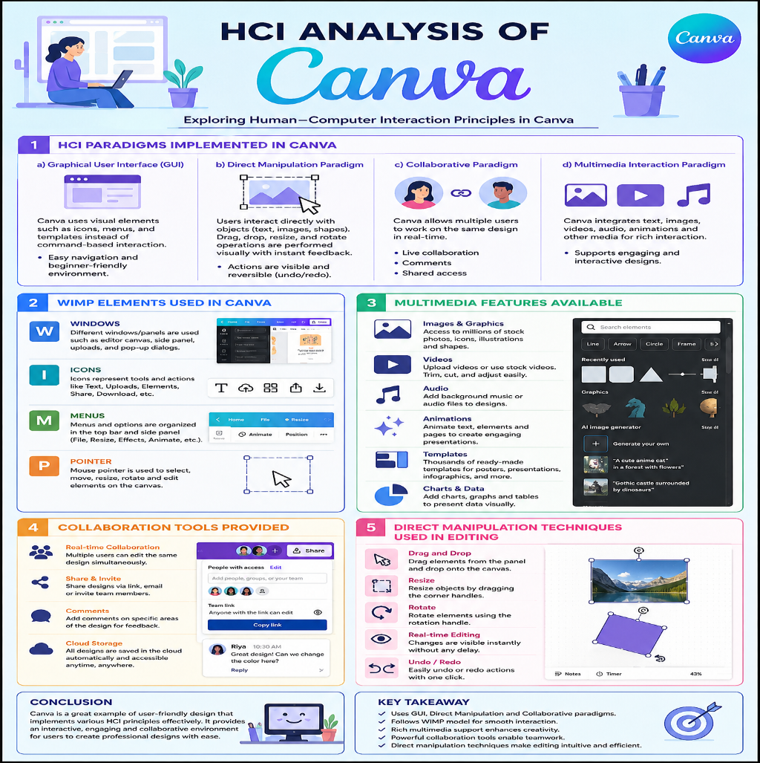
2. Objective
- Identify and explain HCI paradigms implemented in Canva.
- Recognize and categorize WIMP (Windows, Icons, Menus, Pointers) elements in the interface.
- Explore and document multimedia features available in Canva.
- Understand the collaboration tools provided by Canva.
- Analyze direct manipulation techniques used in the editing environment.
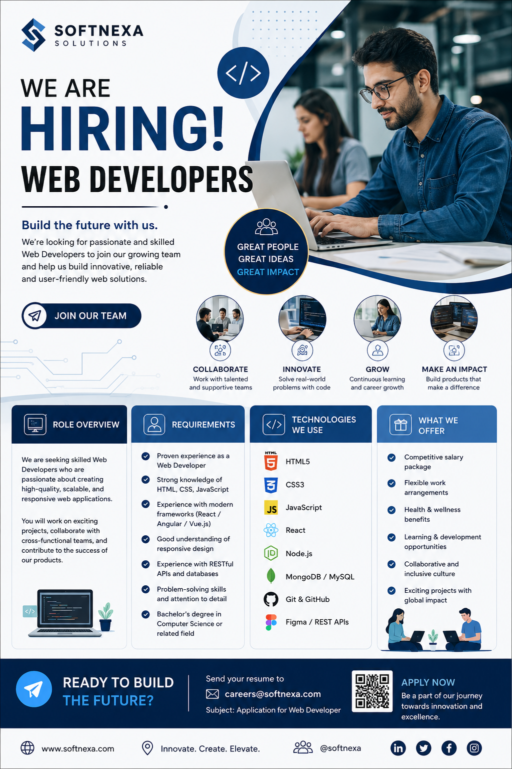
3. Comprehensive HCI Paradigms in Canva
HCI paradigms are overarching conceptual models that guide the design of interactive systems. Canva implements multiple paradigms simultaneously, making it a rich multi-paradigm platform:
Paradigm | Description | Canva Practical Example
Direct Manipulation | Users interact directly with visual objects on-screen, receiving immediate feedback. | Dragging elements, resizing images with handles, rotating text boxes.
GUI / WIMP Paradigm | Interaction via Windows, Icons, Menus, and Pointers rather than command-line input. | Toolbar icons, dropdown menus, canvas windows, cursor-based selection.
WYSIWYG Paradigm | What You See Is What You Get — the on-screen view mirrors the final printed output. | The canvas shows exactly how the exported poster or slide will appear.
Collaborative Computing | Multiple users can access and modify shared content simultaneously. | Real-time collaboration: share a link and multiple users edit together.
Cloud Computing | Data and processing are handled on remote servers, accessible from any browser. | Designs auto-save to Canva's cloud; no local installation required.
Template-Based Interaction | Pre-built designs scaffold user creativity and reduce cognitive load. | Hundreds of poster, infographic, and presentation templates available.
Mobile Paradigm | Interfaces adapted for touch and gesture-based interaction on handheld devices. | Canva mobile app uses pinch-to-zoom, tap-to-select, and swipe gestures.
3.1 Key Paradigm Deep-Dive: Direct Manipulation & WYSIWYG
Ben Shneiderman's Direct Manipulation model relies on continuous visual representation, physical/incremental actions (drag, resize, rotate) with immediate visual feedback, and reversible operations (Ctrl+Z instant undo). Combined with WYSIWYG accuracy, non-expert users eliminate command syntax errors.
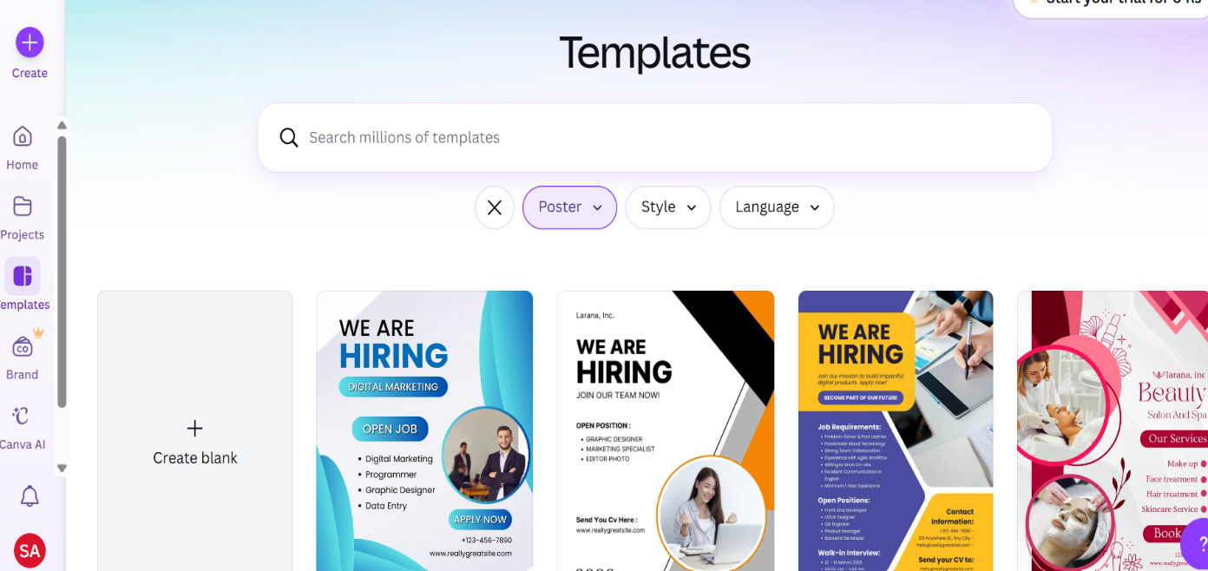
4. WIMP Elements Audit in Canva
WIMP stands for Windows, Icons, Menus, and Pointers:
4.1 Windows (Spatial Panels)
Main Canvas Window, Left Panel (Elements/Templates), Right Properties Panel, Template Gallery Modal Overlay, Export/Download Dialog, and Collaborative Comments Panel.
• Observation / Note: Windows organize tools into distinct cognitive spatial zones, preventing interface clutter.
4.2 Icons
Toolbar icons (Bold, Italic, Underline), element category icons (square, circle, line), action icons (undo, redo, duplicate, delete, lock, flip), navigation icons (home, search, cloud upload), sharing/comment avatars, and presentation play mode.
• Observation / Note: Icons provide high visual affordance and faster recognition speed than text labels.
4.3 Menus
Top Navigation Menu (File/Home, Resize, Share, Download), Right-Click Contextual Menu (Copy, Paste, Group, Lock, Bring Forward/Send Backward), Dropdown Selectors (fonts, sizes, line spacing, color palettes), Element Contextual Toolbar, and Pages Menu at bottom.
• Observation / Note: Hierarchical menus systematically expose secondary and infrequently used options.
4.4 Pointers
Default Arrow Pointer, Four-Headed Move Cursor, Double-Headed Resize Cursors, Circular Rotation Cursor, Text I-Beam Cursor, Crosshair Cursor, and Hand/Grab Pan Cursor (Space + Drag).
• Observation / Note: Dynamic pointer shape morphing communicates legal state affordances contextually.

5. Multimedia Features Inventory
Visual Media: Stock photos & images, vector illustrations/stickers, image filters/shadows/duotone, AI background remover (Pro), frames & photo collages.
Text & Typography: Rich text editing, 1,000+ font library (Google Fonts + custom), text effects (shadow, lift, echo, glitch, outline, curve, neon), animated text.
Audio & Video: MP4 video clip embedding, audio track library/background music, native video trimming/cropping, animated MP4/GIF export.
Charts & Data Visualization: Built-in Chart Editor (bar, line, pie), grid-based data tables, dynamic editable infographics.
Interactive & Presentation Features: Full-screen presentation mode with speaker notes, clickable hyperlinks for PDFs/presentations, QR code generator.
6. Collaboration Tools & CSCW Analysis
Real-Time Collaboration: Shareable URLs, multiple simultaneous editors with color-coded cursors, live presence avatar indicators.
Commenting System: Inline element-pinned comments, threaded replies, resolved status tracking, @mention notifications.
Permission & Access Control: View-only link restrictions, full editor access grants, shared team brand folders.
Version History & Brand Kit: Pro version audit trail restore logs, Brand Kit logo/color/font locking, approved template publishing.
7. Direct Manipulation & Hiring Poster Case Study Analysis
Case Study Artifact Audited: Softnexa Solutions 'WE ARE HIRING! WEB DEVELOPERS' recruitment poster.
Drag-and-Drop Placement: Developer laptop illustration, brand badge icons, feature columns dragged directly onto canvas.
Handle-Based Resizing: Corner and edge scaling anchors used on recruitment hero images and icon cards.
Rotation & Alignment: Circular rotation handles and smart blue guide snapping used for skill badge alignment.
Inline Editing & Micro-Nudging: Double-click text editing on job headings and 1px/10px arrow key spatial micro-adjustments.
8. Critical Observations & Conclusion
• Observation / Note: Low learning curve (under 5 minutes for basic poster composition), deterministic error prevention (canvas boundary constraints + undo/redo), high visual/spatial consistency, and scaffolded cognitive load reduction via structured templates.
Conclusion: Canva exemplifies modern HCI theory in practice, seamlessly blending Direct Manipulation, WIMP structures, cloud computing, multi-user CSCW collaboration, and rich multimedia integration into a frictionless design experience.

