

The University of Azad Jammu and Kashmir, Muzaffarabad
Department of Software Engineering
____________________________________________________

Course Title: Human Computer Intereaction
Submitted to: Engr. Sidra Rafique
Submitted by: Faheem Rasool
Roll no: 2023-SE-17
Session: (2023-2027)

OPEN-ENDED LAB REPORT
Usability evaluation and redesign study of comsats university islamabad website

ABSTRACT
Usability is one of the most important factors in determining the effectiveness of an interactive system. University websites are widely used by students, faculty members, parents, and researchers to access academic and administrative information. This report presents a usability evaluation and redesign study of the COMSATS University Islamabad website. Data was collected through a questionnaire survey and usability testing. The website was evaluated using Nielsen's Heuristic Evaluation principles and interface design analysis. Several usability issues related to navigation, visual hierarchy, information overload, and mobile accessibility were identified. Based on the findings, a redesign proposal was developed to improve user experience, accessibility, and overall usability.
Keywords: Human Computer Interaction, Usability Evaluation, User Experience, Website Design, Heuristic Evaluation, Interface Redesign

Contents
ABSTRACT 1
INTRODUCTION 3
OBJECTIVES 3
SYSTEM SELECTION AND CONTEXT SETUP 4
3.1 Selected System 4
3.2 Purpose of the System 4
3.3 Target Users 4
3.4 Usage Environment 4
DATA GATHERING 5
4.1 Method Used 5
4.2 Participants 5
4.3 Survey Questions 5
4.4 Survey Results 5
4.5 User Observation Summary 5
DATA ANALYSIS AND INTERPRETATION 6
5.1 Major Findings 6
5.2 User Behavioral Patterns 6
5.3 Interpretation 6
USABILITY EVALUATION 6
6.1 Heuristic Evaluation 6
Table 6.2: Heuristic Rating Summary 7
6.2 Usability Testing 7
INTERFACE ANALYSIS 8
7.1 Typography Analysis 8
7.2 Icon Analysis 8
7.3 Layout Analysis 8
7.4 Consistency Analysis 9
INTERACTION TECHNOLOGY PERSPECTIVE 9
REDESIGN PROPOSAL 9
9.1 Proposed Homepage Structure 9
REFLECTION 15
CONCLUSION 15

INTRODUCTION
Human-Computer Interaction (HCI) focuses on designing systems that are efficient, effective, and satisfying for users. Educational websites serve as an important communication medium between universities and their stakeholders. A well-designed university website allows users to easily find information related to admissions, academic programs, research activities, and student services.
This study evaluates the usability of the COMSATS University Islamabad website and identifies areas where improvements can be made. The study follows usability engineering methods including data gathering, usability testing, heuristic evaluation, and redesign recommendations.

OBJECTIVES
The objectives of this study are:
• To evaluate the usability of the COMSATS University Islamabad website.
• To identify usability problems affecting users.
• To analyze user behavior and interaction patterns.
• To apply heuristic evaluation principles.
• To assess interface design elements.
• To propose an improved website design.
• To explore future enhancements using modern technologies.

SYSTEM SELECTION AND CONTEXT SETUP

3.1 Selected System
COMSATS University Islamabad Website

3.2 Purpose of the System
Table 3.1: Purpose of the Website
Function Area | Purpose
Admissions | Provide admission schedules and application procedures
Academic Programs | Display undergraduate and graduate programs
Faculty Information | Present faculty profiles
Student Services | Provide academic notices and services
Research Activities | Showcase research projects and publications
News & Events | Display university announcements
Campus Information | Provide information about campuses and facilities

3.3 Target Users
Table 3.2: Target Users
User Group | Purpose
Prospective Students | Search admissions and degree programs
Current Students | Access academic information
Parents | Learn about university facilities
Faculty Members | Access academic resources
Researchers | Explore research activities
International Students | Obtain admission information

3.4 Usage Environment
Table 3.3: Usage Environment
Device | Usage
Desktop Computer | Detailed browsing and applications
Laptop | Academic tasks
Tablet | Portable information access
Smartphone | Quick access to information

DATA GATHERING

4.1 Method Used
Questionnaire Survey

4.2 Participants
A questionnaire survey was conducted with 10 university students.

4.3 Survey Questions
- Is the website easy to navigate?
- Can admission information be found quickly?
- Is the homepage visually attractive?
- Is the website mobile-friendly?
- Are menus logically organized?

4.4 Survey Results
Table 4.1: Questionnaire Survey Results
Question | Yes | No | Yes (%) | No (%)
Easy Navigation | 4 | 6 | 40% | 60%
Admission Information Easy to Find | 5 | 5 | 50% | 50%
Attractive Homepage Design | 3 | 7 | 30% | 70%
Mobile Friendly | 4 | 6 | 40% | 60%
Organized Menus | 5 | 5 | 50% | 50%

4.5 User Observation Summary
Table 4.2: User Observations
Observation | Frequency
Difficulty locating admission information | High
Frequent scrolling | High
Dependence on search feature | Medium
Mobile navigation issues | Medium
Revisiting homepage repeatedly | High

DATA ANALYSIS AND INTERPRETATION

5.1 Major Findings
Table 5.1: Identified Usability Issues
Issue | Severity Level | Impact on Users
Difficult Navigation | High | Increased task completion time
Information Overload | High | User confusion
Outdated Visual Design | High | Reduced engagement
Mobile Usability Issues | Medium | Poor mobile experience
Search Limitations | Medium | Difficulty finding information

5.2 User Behavioral Patterns
Table 5.2: User Behavior Analysis
User Behavior | Observation
Searching for admissions information | Most common task
Revisiting homepage | Frequent
Mobile usability difficulties | Common
Longer task completion for new users | Observed

5.3 Interpretation
The survey results indicate that users face challenges when locating important information. The homepage contains a large amount of information, which creates cognitive overload. The website structure is functional but lacks an effective visual hierarchy that guides users toward key tasks.

USABILITY EVALUATION

6.1 Heuristic Evaluation
Nielsen's Ten Usability Heuristics were applied.
Table 6.1: Heuristic Evaluation Results
Heuristic Principle | Rating | Remarks
Visibility of System Status | Good | Feedback available
Match Between System and Real World | Good | Familiar terminology
User Control and Freedom | Moderate | Navigation can improve
Consistency and Standards | Moderate | Minor inconsistencies
Error Prevention | Moderate | Limited preventive measures
Recognition Rather than Recall | Poor | Users remember navigation paths
Flexibility and Efficiency | Moderate | Better for experienced users
Aesthetic and Minimalist Design | Poor | Homepage crowded
Error Recovery | Moderate | Limited guidance
Help and Documentation | Good | Information available

Table 6.2: Heuristic Rating Summary

Rating Category | Count
Good | 3
Moderate | 5
Poor | 2

6.2 Usability Testing
Participants:
5 Students
Tasks Performed:
• Find Admission Criteria
• Locate BS Software Engineering Program
• Find Fee Structure
• Find Contact Information
Table 6.3: Task Performance Results
Task | Success Rate | Average Completion Time
Find Admission Criteria | 60% | 2.5 Minutes
Locate BS Software Engineering Program | 80% | 1.5 Minutes
Find Fee Structure | 50% | 3 Minutes
Find Contact Information | 90% | 1 Minute
Average Task Success Rate = 70%
Table 6.4: Common User Errors
Error | Frequency
Clicking wrong menu options | High
Difficulty finding fee structure | High
Excessive scrolling | Medium
Missing important links | Medium
Table 6.5: User Feedback Summary
Feedback | Frequency
Homepage appears crowded | High
Search feature needs improvement | High
Admissions should be highlighted | Medium
Mobile navigation is confusing | High

INTERFACE ANALYSIS

7.1 Typography Analysis
Table 7.1: Typography Evaluation
Problem | Impact | Recommendation
Small text size | Reduced readability | Increase font size
Weak visual hierarchy | Difficult scanning | Larger headings
Inconsistent emphasis | User confusion | Standardized typography

7.2 Icon Analysis
Table 7.2: Icon Evaluation
Problem | Impact | Recommendation
Limited icon usage | Poor visual guidance | Add meaningful icons
Missing visual cues | Reduced discoverability | Use icons with labels

7.3 Layout Analysis
Table 7.3: Layout Evaluation
Problem | Impact | Recommendation
Dense content blocks | Information overload | Increase whitespace
Important information below fold | Poor visibility | Reorganize content

7.4 Consistency Analysis
Table 7.4: Consistency Evaluation
Problem | Impact | Recommendation
Different page structures | User confusion | Standard templates
Inconsistent spacing | Visual imbalance | Consistent spacing system

INTERACTION TECHNOLOGY PERSPECTIVE
Table 8.1: Future Technologies and Benefits
Technology | Proposed Feature | Expected Benefit
Augmented Reality (AR) | Virtual Campus Tour | Improved engagement
Augmented Reality (AR) | Interactive Navigation | Easier campus exploration
Virtual Reality (VR) | 3D Campus Experience | Immersive exploration
Virtual Reality (VR) | Virtual Admission Counseling | Better accessibility
Ubiquitous Computing | Smart Notifications | Timely information
Ubiquitous Computing | Personalized Dashboard | Faster information access
Discussion:
AR technology can help prospective students explore campus facilities remotely. VR can provide immersive campus tours and virtual admission sessions. Ubiquitous computing can improve usability through personalized dashboards and intelligent notifications.

REDESIGN PROPOSAL

9.1 Proposed Homepage Structure
HEADER
• University Logo
• Search Bar
• Login Button
• Notifications
NAVIGATION MENU
• Home
• Admissions
• Programs
• Research
• Students
• Faculty
• Contact
HERO SECTION
Apply Now for Fall Admissions 2026
Buttons:
• Apply Now
• Explore Programs
QUICK ACCESS CARDS
□ Admissions
□ Programs
□ Scholarships
□ Fee Structure
□ Research
□ Contact Information
FEATURED NEWS SECTION
Latest university announcements displayed in card format.
Table 9.1: Existing vs Proposed Design
Existing Design | Proposed Design
Crowded Homepage | Clean Homepage Layout
Complex Navigation | Simplified Navigation
Weak Visual Hierarchy | Strong Visual Hierarchy
Limited Search Visibility | Prominent Search Bar
Dense Information Blocks | Card-Based Design
Average Mobile Experience | Fully Responsive Design
Table 9.2: Expected Improvements
Improvement Area | Expected Outcome
Navigation | Faster task completion
Visual Design | Better user satisfaction
Search Functionality | Improved discoverability
Mobile Interface | Better accessibility
Information Organization | Reduced cognitive load
Figure 1: Existing Homepage Screenshot
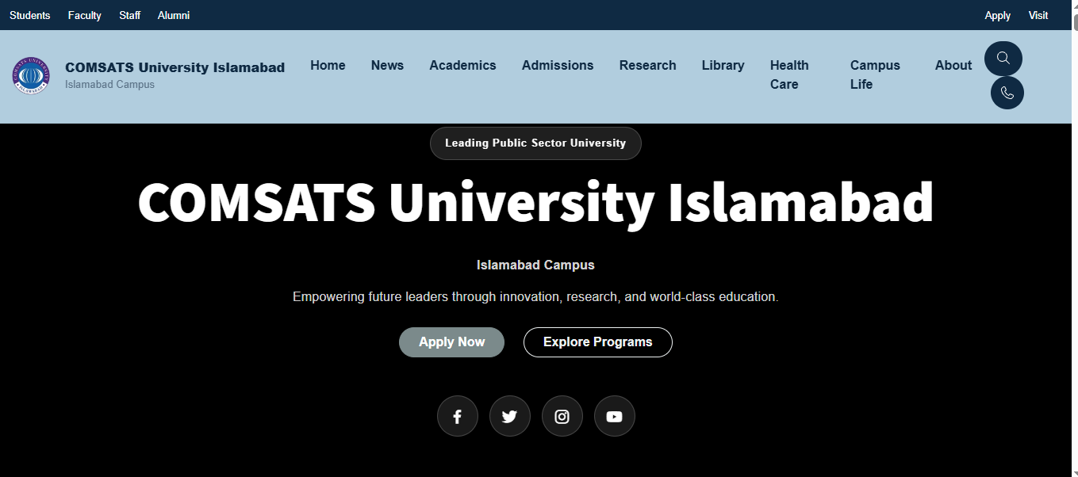
Figure 2: Admissions Page Screenshot
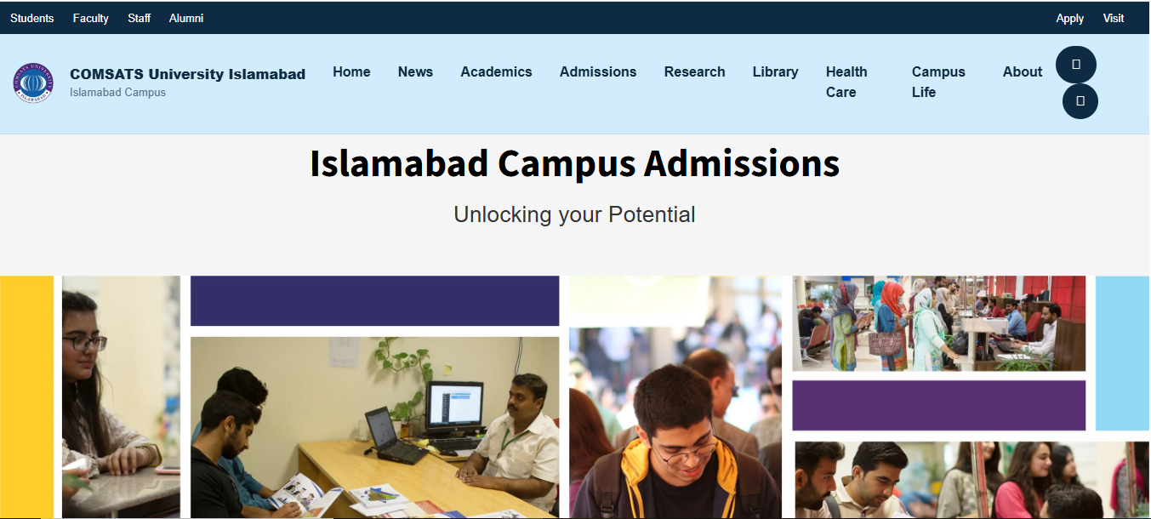
Figure 3: Academic Programs Page Screenshot
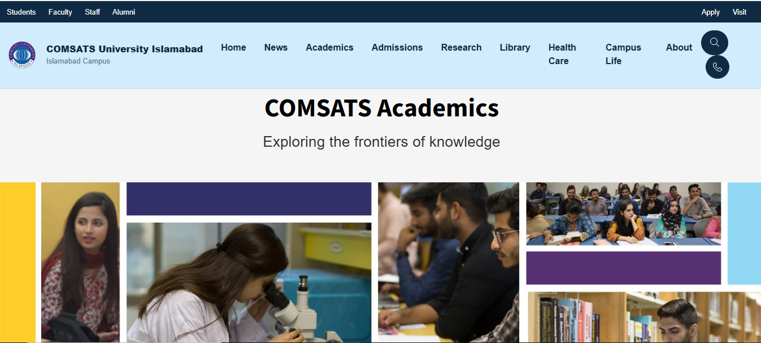
Figure 4: Mobile View Screenshot
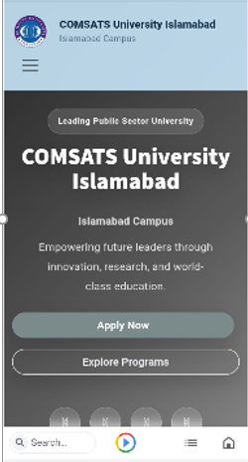
Figure 5: Existing Navigation Structure

Figure 6: Proposed Homepage Wireframe
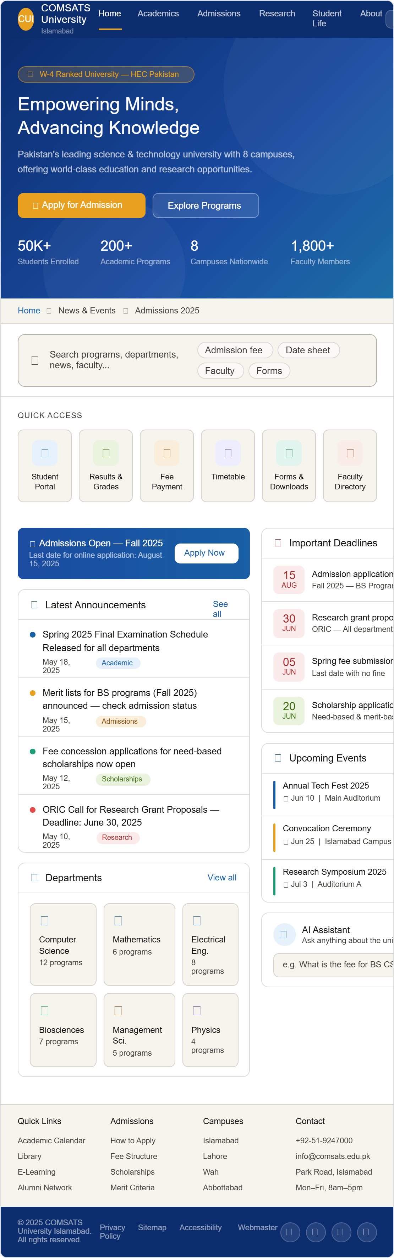

REFLECTION
This project provided practical experience in applying usability engineering techniques to a real-world website. Through surveys, usability testing, and heuristic evaluation, several usability problems were identified. The study demonstrated the importance of user-centered design and how usability improvements can enhance overall user satisfaction and efficiency.

CONCLUSION
The usability evaluation of the COMSATS University Islamabad website identified issues related to navigation, visual hierarchy, information overload, and mobile accessibility. User feedback and usability testing showed that important information such as admissions and fee structures can be difficult to locate.
The proposed redesign addresses these issues by simplifying navigation, improving visual hierarchy, introducing quick-access features, and enhancing mobile responsiveness.
Expected Benefits:
✔ Improved Navigation Efficiency
✔ Better User Satisfaction
✔ Enhanced Mobile Accessibility
✔ Faster Information Discovery
✔ Reduced Cognitive Load
The study concludes that applying usability engineering principles can significantly improve the effectiveness and usability of university websites.

THE END

