THE UNIVERSITY OF AZAD JAMMU AND KASHMIR, MUZAFFARABAD

2023-2027
DEPARTMENT OF SOFTWARE ENGINEERING


LAB_TASK: 04
Course Code: SE-3204
Course Title: Human Computer Interface
Semester: 6th
Session: 2023-2027
Submitted to: Mam Sidra Rafique
Submitted By:
Group Members
- Faheem Rasool (2023-SE-17)
- Sabaat Ali (2023-SE-22)
- Aman Tariq (2023-SE-29)
- Aina Yousaf Khan (2023-SE-32)

Table of Contents
Section 1: Description of Chosen System 7
Description: 7
Why Choose: 7
Section 2: Jakob Nielsen’s 10 Heuristics 7
Section 3: Severity Rating Scale 8
Section 4: Issues Identified by Each Group Member 8
Member 1: Aman Tariq 8
Issue 1.1 8
Images: 9
Issue 1.2 10
Image: 10
Issue 1.3 10
Image: 11
Member 2: Faheem Rasool 11
Issue 2.1 11
Image: 11
Issue 2.2 12
Image: 12
Issue 2.3 13
Image: 13
Member 3: Sabaat Ali 14
Issue 3.1 14
Image: 14
Issue 3.2 15
Image: 15
Issue 3.3 16
Image: 16
Member 4: Aina yousaf khan 17
Issue 4.1 17
Image: 17
Issue 4.2 18
Image: 18
Issue 4.3 19
Image: 19
Section 5: List of All Unique Issues 20
Section 6: Issues-Evaluators Matrix 20
Section 7: Summary of Findings 21
Section 8: Conclusion & Recommendations 21
Recommendations: 21

List of Figures
Figure 1: Product search results with filters applied on Daraz website. 7
Figure 2: Same search results page after clicking back; all filters are clear. 7
Figure 3: Product listing page loading slowly with no spinner or progress bar visible. 8
Figure 4: OTP input error showing only “Invalid”, unclear to the user. 9
Figure 5: Homepage showing multiple pop-ups and banners, distracting the user. 10
Figure 6: Shopping cart page with “Remove” button; deletion occurs without confirmation. 11
Figure 7: Search results for typo query “samsunf” showing “No results found”. 12
Figure 8: Product detail page with zoomed-in image appearing blurry. 13
Figure 9: Multi-step checkout process (Address → Shipping → Payment → Review). 14
Figure 10: End of a long product page with no “Back to top” button visible. 15
Figure 11: Comparison of Electronics vs Fashion category filters; inconsistent formatting causes confusion. 16
Figure 12: Footer showing a small “Help” link; difficult for new users to locate. 17
Figure 13: : Product page showing no option to compare multiple products. 18

TASK_ REPORT – USABILITY EVALUATION OF DARAZ WEBSITE

Using Jakob Nielsen’s 10 Heuristics

Section 1: Description of Chosen System
System Name: Daraz (www.daraz.pk)
Type: E-commerce / Online Marketplace
Description:
Daraz is the largest online shopping platform in Pakistan and a subsidiary of the Alibaba Group. Users can purchase electronics, fashion, groceries, home appliances, and thousands of other products. Major features include a search bar, category filters, product reviews, seller ratings, wish list, shopping cart, and multiple payment options (Cash on Delivery, credit/debit cards, Daraz wallet, installment plans).
Why Choose:
Daraz is a real-world e-commerce system where usability issues can identified easily. It is relevant for FYP and e-commerce research.

Section 2: Jakob Nielsen’s 10 Heuristics
# | Heuristic | Description
1 | Visibility of system status | The system should always inform the user about what is happening.
2 | Match between system and real world | The system should use language familiar to the user and avoid technical jargon.
3 | User control and freedom | Users should have options to undo or exit actions.
4 | Consistency and standardsChoose | Similar functions and elements should be consistent across the system.
5 | Error prevention | Prevent errors before they happen.
6 | Recognition rather than recall | Users should not have to memorize information.
7 | Flexibility and efficiency of use | System should be efficient for both new and experienced users.
8 | Aesthetic and minimalist design | Avoid showing unnecessary information.
9 | Help users recognize, diagnose, recover from errors | Error messages should be clear and informative.
10 | Help and documentation | A proper help section should be available.

Section 3: Severity Rating Scale
Rating | Meaning
Critical | System is unusable; user task cannot proceed
High | Major problem; user gets frustrated
Medium | Problem exists but task can be completed
Low | Minor issue; user can ignore it

Section 4: Issues Identified by Each Group Member

Member 1: Aman Tariq

Issue 1.1
Field | Answer
Issue | Search filters reset after using the back button
Severity | Medium
Heuristic violated | User control and freedom (#3)
Description | When a user clicks the back button from a product page, applied filters are clear, forcing the user to reapply them.
Images:
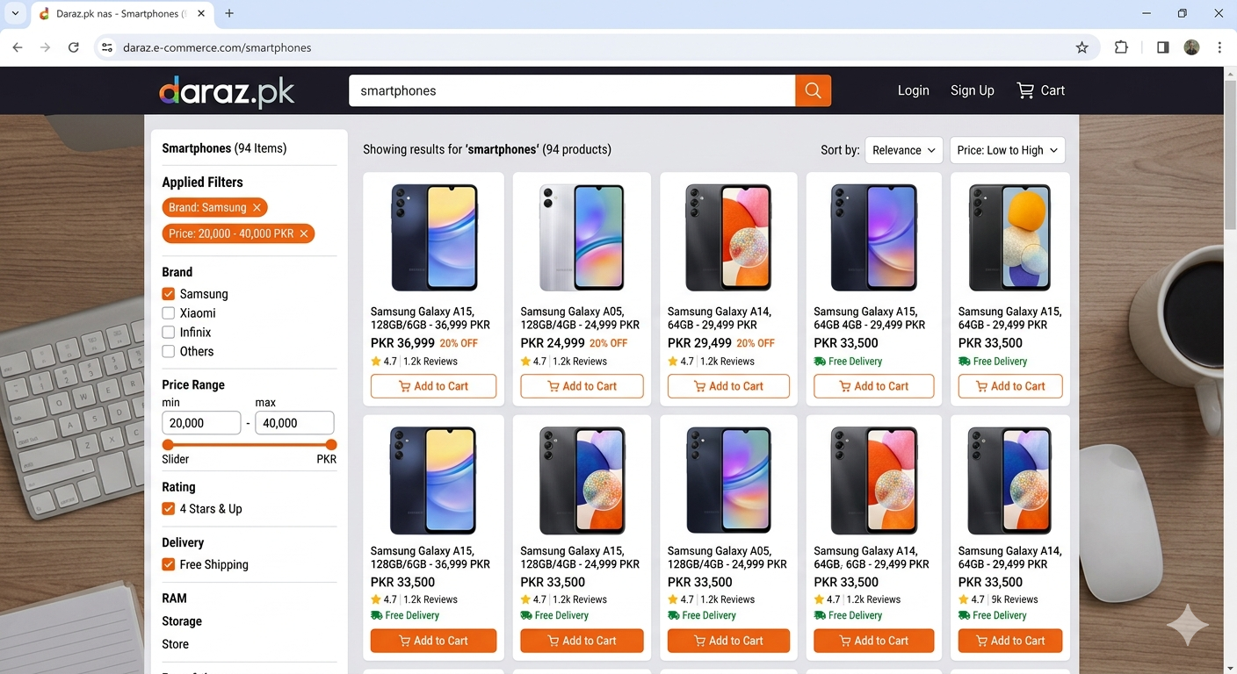
Figure 1: Product search results with filters applied on Daraz website.
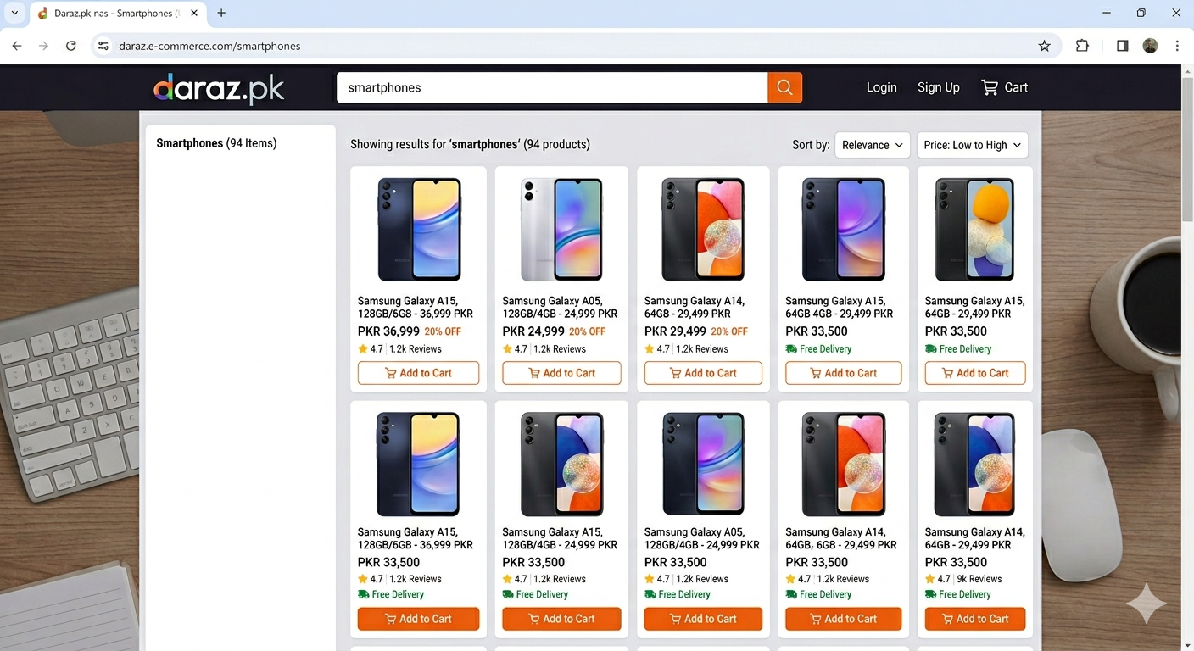
Figure 2: Same search results page after clicking back; all filters are clear.

Issue 1.2
Field | Answer
Issue | No loading indicator during slow page load
Severity | Medium
Heuristic violated | Visibility of system status (#1)
Description | Product lists take a few seconds to load, but no spinner or progress bar is visible, so users may think the site is frozen.

Image:
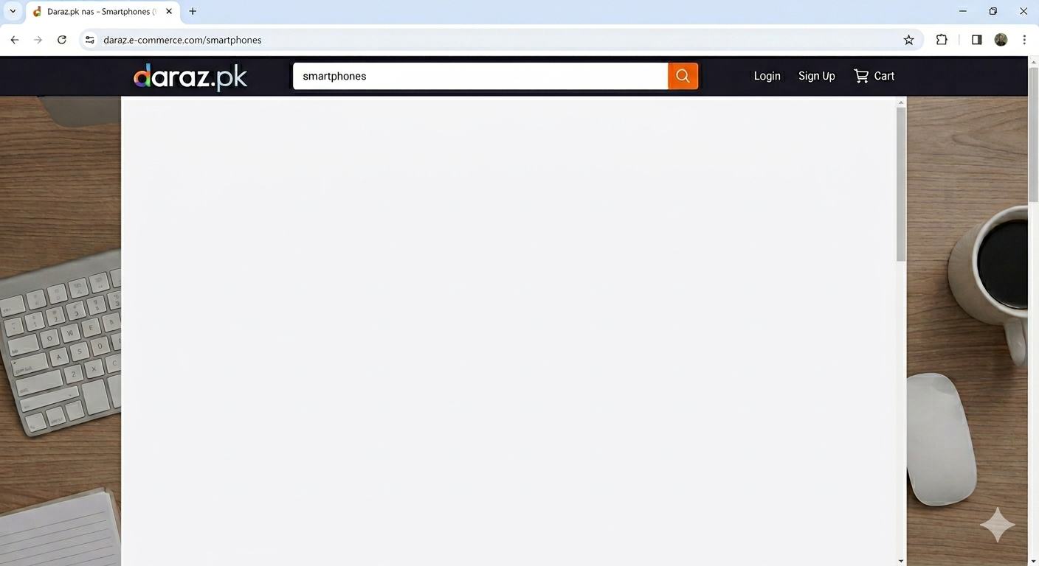
Figure 3: Product listing page loading slowly with no spinner or progress bar visible.

Issue 1.3
Field | Answer
Issue | Confusing error message for incorrect OTP
Severity | High
Heuristic violated | Help users recognize, diagnose, recover from errors (#9)
Description | When entering the wrong OTP, only “Invalid” is display. It is unclear if the OTP expired, was wrong, or if the user needs to resend.

Image:
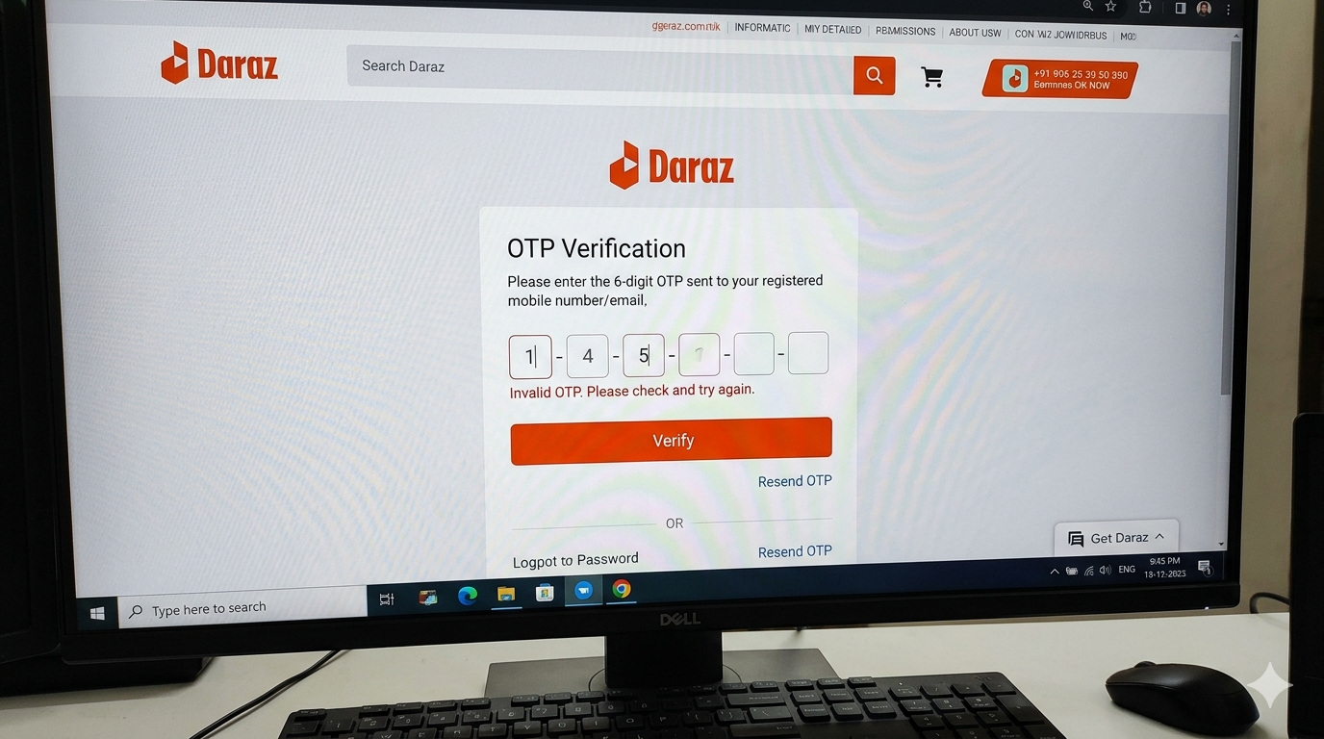
Figure 4: OTP input error showing only “Invalid”, unclear to the user.

Member 2: Faheem Rasool

Issue 2.1
Field | Answer
Issue | Too many pop-ups and banners
Severity | Low
Heuristic violated | Aesthetic and minimalist design (#8)
Description | Upon opening the site, multiple pop-ups appear (sale alerts, app download, newsletter), which the user must close first.

Image:
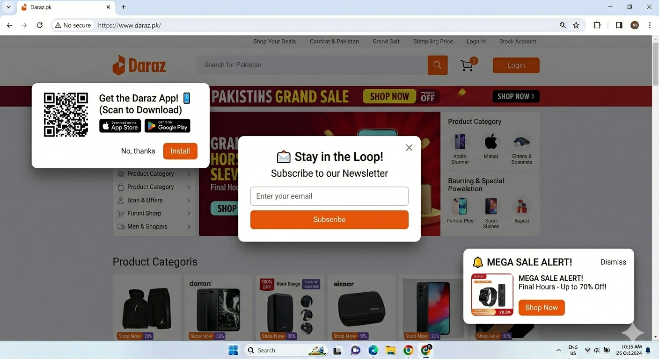
Figure 5: Homepage showing multiple pop-ups and banners, distracting the user.

Issue 2.2
Field | Answer
Issue | No confirmation before removing items from the cart
Severity | Medium
Heuristic violated | Error prevention (#5)
Description | Clicking "Remove" in the cart immediately deletes the item without confirmation.

Image:
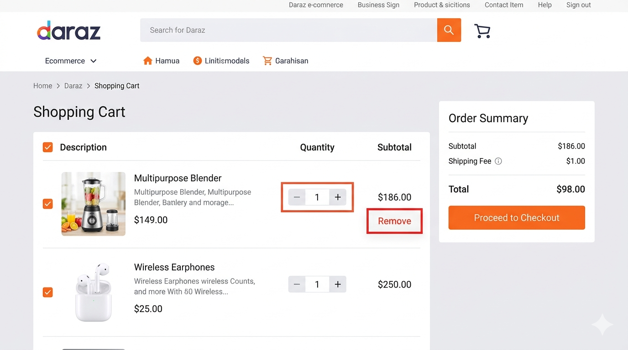
Figure 6: Shopping cart page with “Remove” button; deletion occurs without confirmation.

Issue 2.3
Field | Answer
Issue | Search bar does not suggest spelling corrections
Severity | Low
Heuristic violated | Error prevention (#5)
Description | Typing “samsunf” instead of “samsung” shows “No results” with no suggestions.

Image:
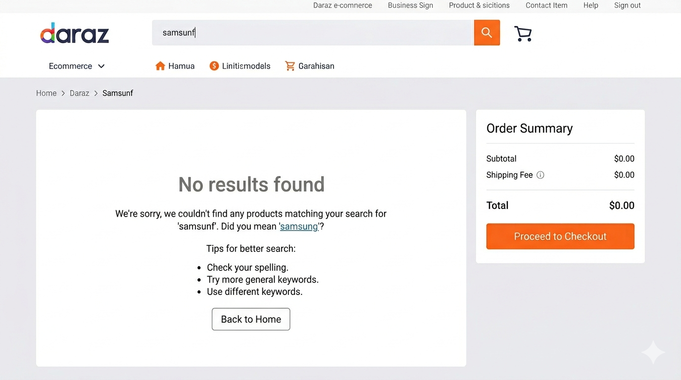
Figure 7: Search results for typo query “samsunf” showing “No results found”.

Member 3: Sabaat Ali

Issue 3.1
Field | Answer
Issue | Poor zoom quality on product images
Severity | Low
Heuristic violated | Match between system and real world (#2)
Description | Zooming product images makes them blurry. Users want a clear view, as in real life.

Image:
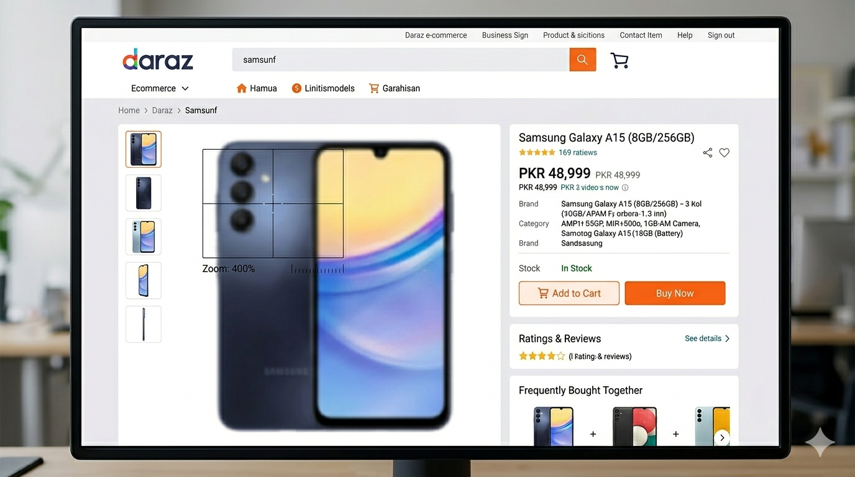
Figure 8: Product detail page with zoomed-in image appearing blurry.

Issue 3.2
Field | Answer
Issue | Checkout process has too many steps
Severity | Medium
Heuristic violated | Flexibility and efficiency of use (#7)
Description | The checkout involves 5–6 steps (address, shipping, payment, review, confirm). Even registered users go through the same steps.

Image:
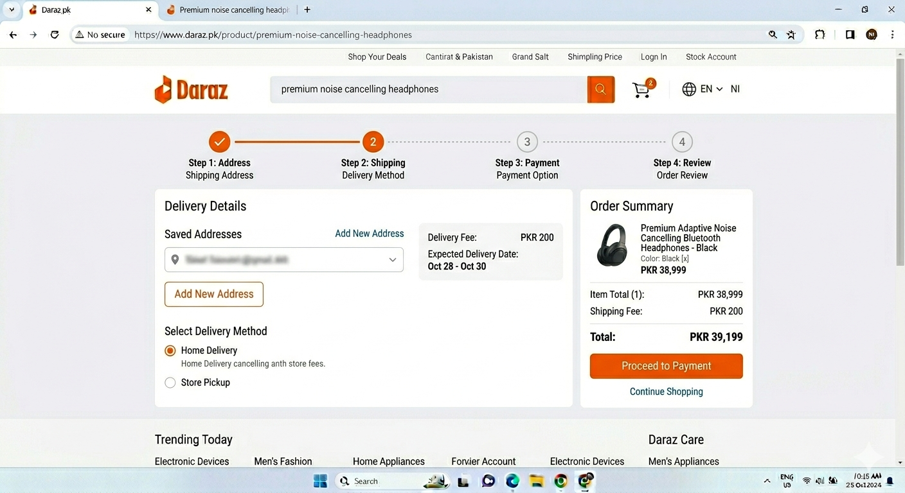
Figure 9: Multi-step checkout process (Address → Shipping → Payment → Review).

Issue 3.3
Field | Answer
Issue | No “Back to top” button on long product pages
Severity | Low
Heuristic violated | User control and freedom (#3)
Description | On long product pages, users must scroll manually to return to the top.

Image:
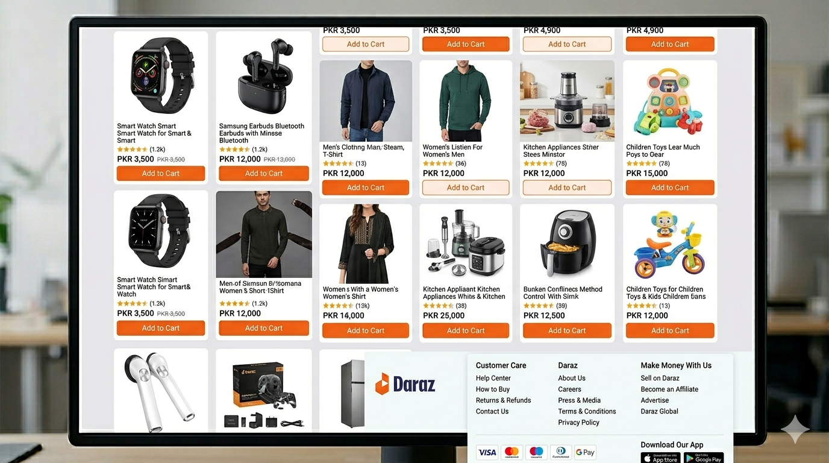
Figure 10: End of a long product page with no “Back to top” button visible.

Member 4: Aina yousaf khan

Issue 4.1
Field | Answer
Issue | Inconsistent filter options across categories
Severity | Medium
Heuristic violated | Consistency and standards (#4)
Description | Electronics category has a price filter, but the fashion category shows a differently formatted filter, causing confusion.

Image:
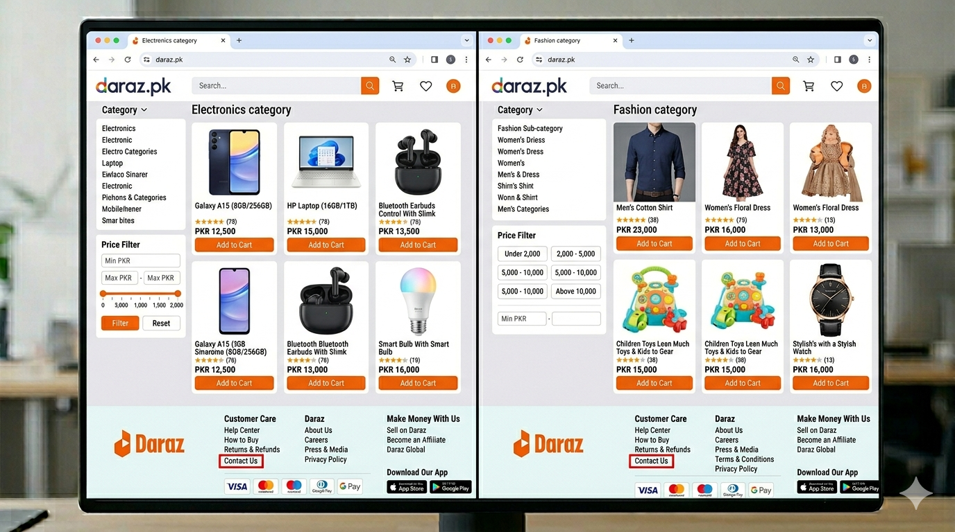
Figure 11: Comparison of Electronics vs Fashion category filters; inconsistent formatting causes confusion.

Issue 4.2
Field | Answer
Issue | Help section difficult to find
Severity | Medium
Heuristic violated | Help and documentation (#10)
Description | The help page is hide in the footer with a very small link. New users struggle to locate it.

Image:
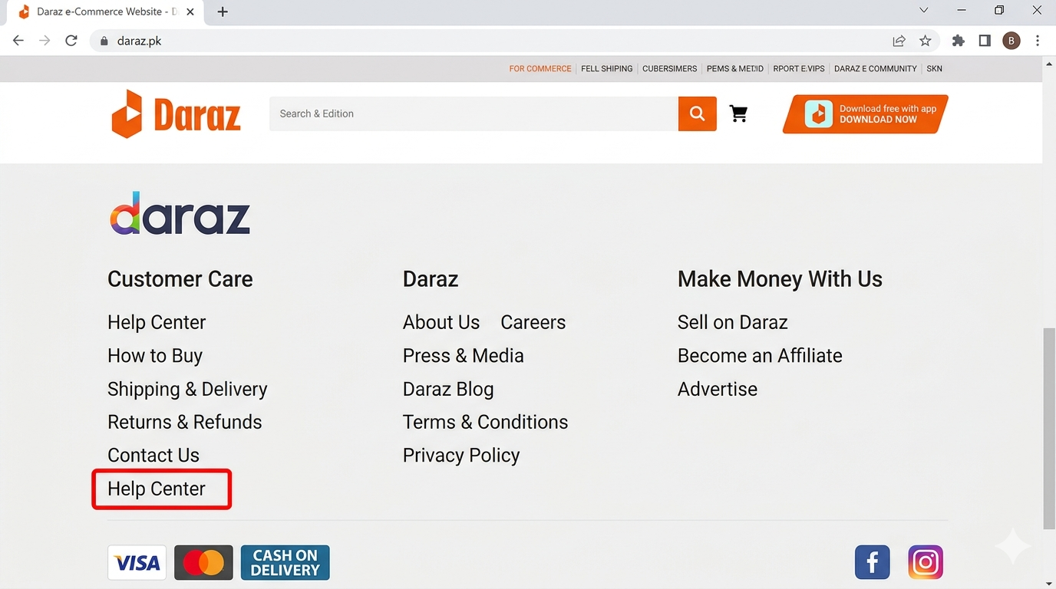
Figure 12: Footer showing a small “Help” link; difficult for new users to locate.

Issue 4.3
Field | Answer
Issue | Product comparison feature missing
Severity | Low
Heuristic violated | Flexibility and efficiency of use (#7)
Description | Users cannot compare two products within the site; they must open multiple tabs.

Image:
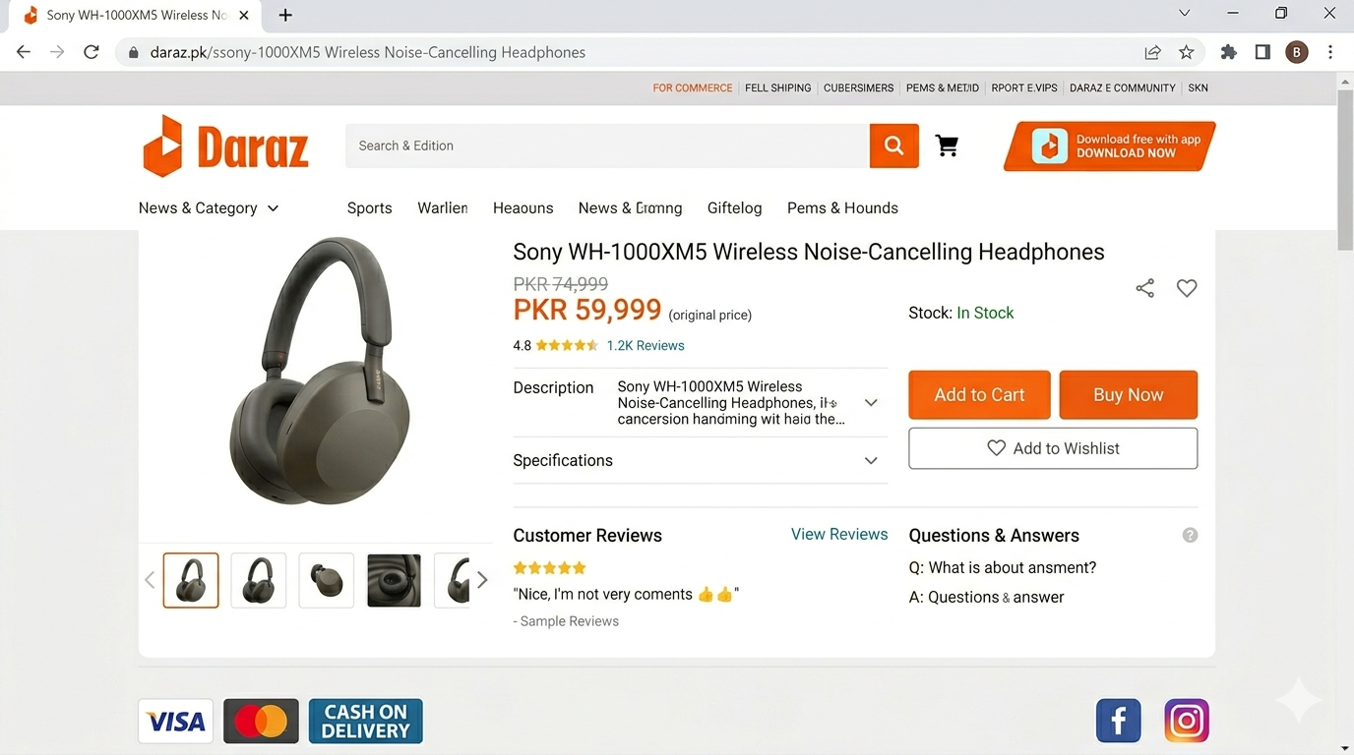
Figure 13: : Product page showing no option to compare multiple products.

Section 5: List of All Unique Issues
Issue ID | Issue Name | Reported By
U1 | Search filters reset after using back button | Aman Tariq
U2 | No loading indicator during slow page load | Aman Tariq
U3 | Confusing error message for incorrect OTP | Aman Tariq
U4 | Too many pop-ups and banners | Faheem Rasool
U5 | No confirmation before removing items from cart | Faheem Rasool
U6 | Search bar does not suggest spelling corrections | Faheem Rasool
U7 | Poor zoom quality on product images | Sabaat Ali
U8 | Checkout process has too many steps | Sabaat Ali
U9 | No “Back to top” button on long product pages | Sabaat Ali
U10 | Inconsistent filter options across categories | Aina yousaf
U11 | Help section difficult to find | Aina yousaf
U12 | Product comparison feature missing | Aina yousaf

Section 6: Issues-Evaluators Matrix
Evaluator | U1 | U2 | U3 | U4 | U5 | U6 | U7 | U8 | U9 | U10 | U11 | U12
Aman Tariq | ✅ | ✅ | ✅ | ❌ | ❌ | ❌ | ❌ | ❌ | ❌ | ❌ | ❌ | ❌
Faheem Rasool | ❌ | ❌ | ❌ | ✅ | ✅ | ✅ | ❌ | ❌ | ❌ | ❌ | ❌ | ❌
Sabaat Ali | ❌ | ❌ | ❌ | ❌ | ❌ | ❌ | ✅ | ✅ | ✅ | ❌ | ❌ | ❌
Aina yousaf | ❌ | ❌ | ❌ | ❌ | ❌ | ❌ | ❌ | ❌ | ❌ | ✅ | ✅ | ✅

Section 7: Summary of Findings
Heuristic Violated | Number of Issues
- Visibility of system status | 1
- Match between system and real world | 1
- User control and freedom | 2
- Consistency and standards | 1
- Error prevention | 2
- Flexibility and efficiency of use | 2
- Aesthetic and minimalist design | 1
- Help users recognize, diagnose, recover | 1
- Help and documentation | 1

Section 8: Conclusion & Recommendations
- Total 12 distinct usability issues identified.
- Top problems:
  - User control and freedom (#3) – 2 issues
  - Error prevention (#5) – 2 issues
  - Flexibility and efficiency of use (#7) – 2 issues

Recommendations:
- Add confirmation dialogs – When user clicks "Remove" in cart, a popup should ask "Are you sure you want to remove this item?" with Yes/No options. This prevents accidental deletion.
- Add loading indicators – On slow-loading pages, a spinner or progress bar should appear so users know the system is working.
- Improve error messages – Instead of just "Invalid", OTP error messages should say: "Wrong OTP. Please try again or click 'Resend Code'."
- Add "Back to Top" button – On long product pages, a floating button should appear when user scrolls down, allowing one-click return to top.
- Make help section visible – Move the Help/Support link from footer to top navigation bar or add a floating help icon.
Thanks!

