**Laptop Harbor**



CONTENTS

Introduction …………………………………………………………………………………………

Acknowledgment………………………………………………………………………………….

Requirements……………………………………………………………………………………….

E-Project Analysis…………………………………………………………………………………..

User Guide……………………………………………………………………………………………

Coding………………………………………………………………………………………………….

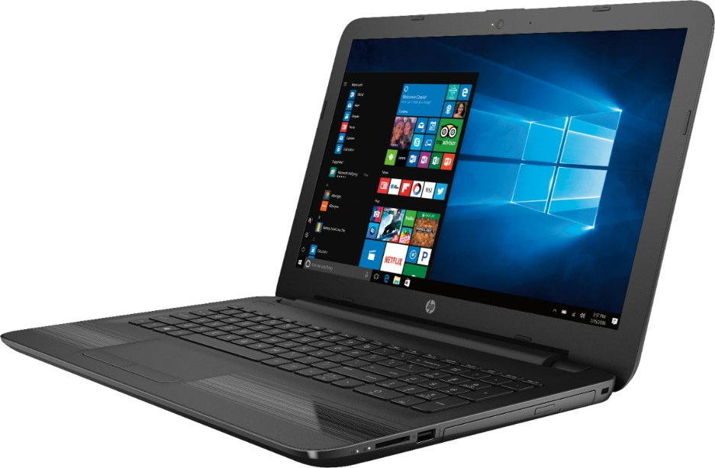

**SUBMITED BY**

* **FAHEEM ANIS**
* **MUHAMMAD HASSAN**
* **MASOOD MEHMOOD**
* **SHALIM KEITH**
* **KHALID ASHRAF**

Of batch **PR202205+06G** have successfully completed the given task for the topic

**FACULTY: SIR HUZAIFA**

SEMESTER HDSI II

APTECH LEARNING SHAHRAH-E-FAISAL

**INTRODUCTION**

The **LaptopHarbor** app is designed to provide a convenient and efficient platform for users to browse, compare, and purchase laptops and related accessories.

**ACKNOWLEDGMENT**

The thirst for learning, upgrading technical skills and applying the concepts in real life environment at a fast pace is what the industry demands from IT professionals today. However busy work schedules, far-flung locations, unavailability of convenient time-slots pose as major barriers when it comes to applying the concepts into realism. And hence the need to look out for alternative means of implementation in the form of laddered approach. The above truly pose as constraints especially for our students too! With their busy schedules, it is indeed difficult for our students to keep up with the genuine and constant need for integrated application which can be seen live especially so in the field of IT education where technology can change on the spur of a moment. Well, technology does come to our rescue at such times!! Keeping the above in mind and in tune with our constant endeavor to use technology in our training model, we at Aptech have thought of revolutionizing the way our students learn and implement the concepts using tools themselves by providing a live and synchronous e-Project learning environment!



**WHAT IS THIS E-PROJECT?**

e-Project is a step-by-step learning environment that closely simulates the classroom and Lab based learning environment into actual implementation. It is a project implementation at your fingertips!! An electronic, live juncture on the machine that allows you to

* Practice step by step i.e. laddered approach.
* Build a larger more robust application.
* Usage of certain utilities in applications designed by user.
* Single program to unified code leading to a complete application.
* Learn implementation of concepts in a phased manner.
* Enhance skills and add value.
* Work on real life projects.
* Give a real life scenario and help to create applications more complicated and useful.
* Mentoring through email support.

**REQUIRMENTS**

**User Registration and Authentication:**

a. Users must be able to create an account.

b. The app must provide a secure login mechanism.

**Product Listings:**

a. Users must be able to browse laptop products by category, brand, price, and specifications.

b. The app should support product filtering and sorting options.

c. Product listings should display essential information such as product name, image, price, and ratings.

**Product Details and Reviews:**

a. Users should be able to view detailed product descriptions, specifications, and high-quality images.

b. Product pages must display user reviews and ratings.

c. Users should have the ability to leave reviews and rate products.

**Shopping Cart:**

a. Users must be able to add products to their shopping cart.

b. The cart should display a summary of selected products and their quantities.

c. Users should have the option to modify or remove items from the cart.

**Checkout:**

a. Users should be able to enter shipping and billing information.

b. The checkout process must calculate the total order amount, including taxes and shipping fees.

c. Users must receive order confirmation emails upon successful payment.

**Order Tracking:**

a. Users should be able to view their order history and track the status of their current orders.

b. The app must provide real-time order tracking with shipping details.

c. Users should receive notifications for order status updates.

**User Profile and Settings:**

a. Users should have a profile section to manage their personal information and preferences.

b. The app should allow users to update their profile picture and contact information.

c. Users must have the option to change account password.

**Search Functionality:**

a. Users should be able to search for specific laptop models or brands.

b. The app must provide filters to enhance the search experience.

**Wish List:**

a. Users should be able to add products to a wish list for future reference.

b. The wish list should be accessible from the user's profile.

**Feedback and Support:**

a. Users should have the ability to contact customer support within the app.

1. b. The app should include a feedback or contact form for user inquiries and issues.

**LAPTOP HARBOR**

Laptop Harbor

The **LaptopHarbor** app is designed to provide a convenient and efficient platform for users to browse, compare, and purchase laptops and related accessories.

USER MANUAL

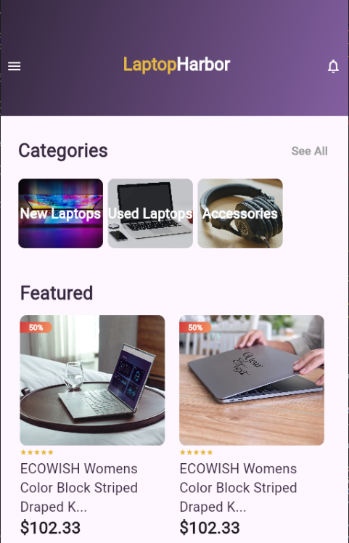

* This is the home page when user open the app.

**How to use home page:**

Basically, home page has one main section:

1. Gallery section

Gallery Section:

Gallery section contains all the top products and buttons to go to the perfume page.

Click the name of any product to open its page with detailed information. Click the **See All** buttontoview more products. Press the Details button to download its details.

**Checkout Page**

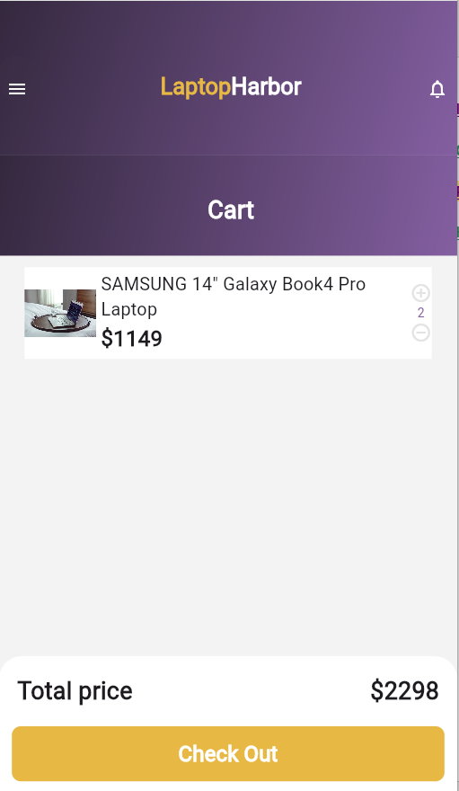

* This page contains the information about all products added to cart

