Academic Year -: 26 – 27 |  | Date: 01/10/2026


SYMBIOSIS INSTITUTE
OF TECHNOLOGY (SIT)
Constituent of SYMBIOSIS INTERNATIONAL (DEEMED UNIVERSITY)
DevOps
CA2 - DevOps Implementation & Deployment Report
Title: “ForgeFlow on Oracle Cloud: CI/CD, Configuration Management, Containerisation, Orchestration and Monitoring”
Problem Statement: Build and operate a complete, automated delivery pipeline for ForgeFlow, an AI-native web-app development platform, so that every change is tested, packaged, deployed to a 3-OCPU / 16 GB Oracle Cloud Ampere VM with automatic rollback, provisioned as code, orchestrated with zero-downtime rolling updates, and monitored for uptime, latency and errors.
Name | PRN
Raghav Sonchhatra | 23070122172
Faheemuddin Sayyed | 23070122196
Sanidhya Awasthi | 23070122192

Contents
1. Introduction 3
1.1 About ForgeFlow 3
1.2 Objectives and assignment mapping 3
1.3 Deployment at a glance 4
2. Infrastructure: The Oracle Cloud VM 5
2.1 Virtual machine specification 5
2.2 Capacity plan for 3 OCPU / 16 GB 5
2.3 Domain, DNS and TLS 6
2.4 Two firewalls 6
3. System Architecture 7
3.1 Overview 7
3.2 Why two runtimes: Compose for production, k3s for orchestration 8
3.3 Request path and security layers 9
4. Task 1 — Deployment Strategy: CI/CD with GitHub Actions 10
4.1 Tool selection 10
4.2 Continuous Integration (ci.yml) 10
4.3 Continuous Delivery (cd.yml) 10
4.4 Kubernetes rollout workflow (k8s-rollout.yml) 12
4.5 Pipeline design decisions 12
4.6 Secrets and variables 13
5. Task 2 — Configuration Management with Ansible 14
5.1 Why Ansible, and how it is organised 14
5.2 Inventory and variables 14
5.3 Roles, in order 14
5.4 Mapping to the assignment: packages, users, files 16
5.5 Idempotency and secret handling 16
5.6 The Oracle firewall trap 16
5.7 Running the playbook 17
6. Task 3 — Containerisation and Orchestration 18
6.1 The production Dockerfile 18
6.2 The production Compose stack 19
6.3 Sandbox containers 19
6.4 Kubernetes manifests (k3s) 19
6.5 Rolling update 20
6.6 Rollback, and the measured demonstration 21
7. Task 4 — Monitoring and Logging 23
7.1 Monitoring architecture 23
7.2 Application metrics 23
7.3 Scrape targets 24
7.4 Grafana dashboard 24
7.5 Alert rules 25
7.6 Logging 25
8. How Each ForgeFlow Stage Runs in Production 27
9. Security Hardening Summary 28
10. Verification and Results 29
10.1 The WebSocket test, including the negative control 29
11. Task 5 — Reflection: Challenges and Lessons Learned 30
11.1 Challenges 30
11.2 Lessons learned 30
12. Operations Runbook 32
12.1 First-time setup 32
12.2 Everyday commands 32
12.3 Moving to a new VM or domain 32
13. Known Limitations and Future Work 33
14. Conclusion 33
15. Bonus — External Challenge: IBM Bob 2.0 Hackathon 34
Appendix A — DevOps Artefacts in the Repository 35
Appendix B — Production Environment Variables 35

1. Introduction

1.1 About ForgeFlow
ForgeFlow is our B.Tech project: an AI-native, human-in-the-loop Progressive Web App that takes a web-application idea, given as screenshots or a structured specification, through six stages: requirements → design → build → test with self-healing repair → deploy → live validation. The user can refine, revisit or skip any stage. The apps it generates always use one fixed stack (React + Vite + TypeScript, Node/Express, MongoDB), and they are built and tested inside isolated Docker sandboxes before being deployed.
ForgeFlow itself has two parts. The control plane is a FastAPI service (Python 3.11) with MongoDB, a WebSocket hub for live progress, a Docker-based sandbox manager and the AI agents. The frontend is a React 18 + Vite + Tailwind PWA. This report covers how both are built, tested, shipped, run and monitored in production, which is what the CA-II DevOps assignment asks for.

1.2 Objectives and assignment mapping
The CA-II task sheet asks for five deliverables plus an optional bonus. Each one is implemented in the repository and described in its own section:
Table 1: CA-II tasks, what was built, and where it lives
Task | Requirement | What we built | Section
1 — Deployment strategy | Working pipeline with one tool; workflow file + pipeline diagram | GitHub Actions: ci.yml (6 jobs), cd.yml (build → GHCR → Oracle VM + Vercel, automatic rollback), k8s-rollout.yml | 4
2 — Configuration management & IaC | Ansible/Puppet: install packages, create users, manage files; playbook + inventory | Ansible site.yml with 7 roles, inventory, group vars, optional vault; idempotent | 5
3 — Containerisation & orchestration | Dockerfile, Kubernetes Deployment + Service, rolling update and rollback | Multi-arch production image, production compose stack, k3s manifests (Deployment, Service, StatefulSet, PDB, Ingress), rollout/rollback scripts | 6
4 — Monitoring & logging | Prometheus + Grafana, app metrics, dashboard (uptime, latency, error rate) | /metrics endpoint, Prometheus + 4 exporters, 16-panel Grafana dashboard, 10 alert rules, structured logs | 7
5 — Reflection & report | Slides + documentation: architecture, pipeline, challenges, lessons | This report + the CA-2 presentation deck | 11
Bonus | Participate in an external challenge | IBM Bob 2.0 Hackathon (lablab.ai, 25–27 Sep 2026): ForgeFlow submitted | 15

1.3 Deployment at a glance
Table 2: Key facts of the production deployment
Item | Value
Backend host | Oracle Cloud Infrastructure (OCI) — Ampere A1 Flex VM, 3 OCPU, 16 GB RAM, arm64 (aarch64)
Operating system | Ubuntu 24.04 LTS (nginx 1.24 from the Ubuntu archive)
Public API endpoint | https://forgeflow-backend.ddnsfree.com (Dynu dynamic DNS, Let’s Encrypt TLS)
Frontend | Vercel — https://forgeflow-ecru.vercel.app (React + Vite PWA)
Source control & CI/CD | GitHub + GitHub Actions (CI, CD, K8s rollout workflows)
Container registry | GitHub Container Registry — ghcr.io/faheem219/forgeflow-api (linux/arm64 + linux/amd64)
Configuration management | Ansible (7 roles), run from macOS or WSL against the VM over SSH
Production runtime | Docker Engine + Compose v2: api, mongo, appdb, caddy, plus per-project sandbox containers
Orchestration | k3s v1.31.4 (single node) on the same VM: rolling update and rollback demonstration
Monitoring | Prometheus 2.54, Grafana 11.2, node-exporter, cAdvisor, blackbox-exporter
Generated apps (deploy target) | Vercel (frontend + backend function) and MongoDB Atlas

2. Infrastructure: The Oracle Cloud VM

2.1 Virtual machine specification
The whole backend runs on one Oracle Cloud virtual machine. We chose OCI’s Ampere A1 (ARM) shape because it offers the most memory per core in Oracle’s free allowance, and ForgeFlow is memory-hungry: every project gets its own sandbox container running pnpm, Vite, a Node server and sometimes a headless browser.
Table 3: Oracle VM specification
Property | Value | Why it matters
Shape | VM.Standard.A1.Flex (Ampere Altra) | Flexible OCPU/RAM sizing; fits within OCI’s Always Free Ampere allowance
OCPUs | 3 | One OCPU is one physical Ampere core; budgeted below
Memory | 16 GB | Holds the control plane, two MongoDB instances, the monitoring stack, k3s and several sandboxes
Architecture | arm64 / aarch64 | Every image must be built for arm64 (Section 4.3); amd64-only images fail with exec format error
OS image | Canonical Ubuntu 24.04 LTS | Debian family, which the Ansible roles assert; long-term support
Boot volume | ~50 GB | Small: log rotation, image pruning and a disk alert all exist because of this
Swap | 2 GB swap file (Ansible common role) | Protects against OOM during large image pulls
Networking | Public IPv4; OCI Security List opens TCP 22/80/443 | Second firewall outside the VM (Section 2.4)
Shared host | An existing nginx with TLS already served another project | All automation had to be additive and never touch the other site

2.2 Capacity plan for 3 OCPU / 16 GB
Running production, a Kubernetes cluster and a monitoring stack on one 3-core machine needs an explicit budget. The limits below come from the configuration files; the right-hand column shows the worst case if every container used its full limit at once.
Table 4: Configured resource limits on the VM
Workload | Configured limit / request | Source | Notes
Control plane (api) | 2.0 CPU, 4 GB memory (limit) | docker-compose.prod.yml | Single uvicorn worker by design (state is in process memory)
Each project sandbox | 1 CPU, 1 GB memory, 256 pids | app config sandbox_*_limit | Reaped after 15 min idle, so only active projects use resources
mongo + appdb | No hard limit; small working set | compose | Two separate mongo:7 instances (control plane vs generated apps)
caddy (preview proxy) | No limit; negligible | compose | Routes preview traffic only
k3s API pods (demo) | request 200m CPU / 512 Mi; limit 2 Gi | 30-api.yaml | 2 replicas during the demo
k3s mongo (demo) | request 100m / 256 Mi; limit 1 Gi | 20-mongo.yaml | No CPU limit on purpose (throttling a DB causes latency spikes)
Prometheus | 15-day / 2 GB retention cap | monitoring compose | Bounded disk use on a small volume
OS, nginx, Docker, k3s server | ~1–1.5 GB typical | — | Plus 2 GB swap as a safety margin

With the API at its 4 GB ceiling and four sandboxes active (4 GB), about 8 GB remains for the databases, monitoring, the k3s demo and the operating system. CPU is the tighter resource: three cores are shared, so sandboxes are capped at one core each and the API at two, which means a burst of builds slows down but cannot starve the control plane. The HostHighCPU and HighMemoryPressure alerts (Section 7.5) watch exactly this.

2.3 Domain, DNS and TLS
- DNS: the API subdomain forgeflow-backend.ddnsfree.com is a Dynu dynamic-DNS hostname with an A record pointing at the VM’s public IP. A wildcard record (*.preview.…) is used for live sandbox previews.
- TLS: certificates come from Let’s Encrypt. certbot --nginx issued the API certificate (renewed automatically by certbot.timer). The wildcard preview certificate is issued over DNS-01 with acme.sh and the Dynu API, so it also renews unattended.
- Frontend: Vercel serves the PWA on its own domain over HTTPS; the API base URL is injected at build time (VITE_API_BASE_URL).

2.4 Two firewalls
Oracle Cloud traffic passes two independent firewalls, and both must allow it:
- OCI Security List / NSG (in the cloud console, outside the VM). Ingress is opened for TCP 22, 80 and 443 only. Ansible cannot manage this, so the playbook prints a reminder at the end of every run.
- Host firewall (ufw) on the VM, default-deny inbound, allowing 22, 80 and 443. Oracle’s Ubuntu images also ship a pre-baked iptables REJECT rule that silently overrides ufw; the Ansible firewall role removes it (Section 5.6).
Everything else listens on 127.0.0.1 only (Section 3.3). A service that "looks safe" only because the Security List blocks it would be one console click from exposure.

3. System Architecture

3.1 Overview
Figure 1 shows the complete deployment. Developers push to GitHub; GitHub Actions tests the code, builds a multi-architecture image into GHCR and deploys it to the VM over SSH, then deploys the frontend to Vercel. On the VM, nginx terminates TLS and forwards to the Docker Compose production stack. The k3s cluster and the monitoring stack run alongside it.
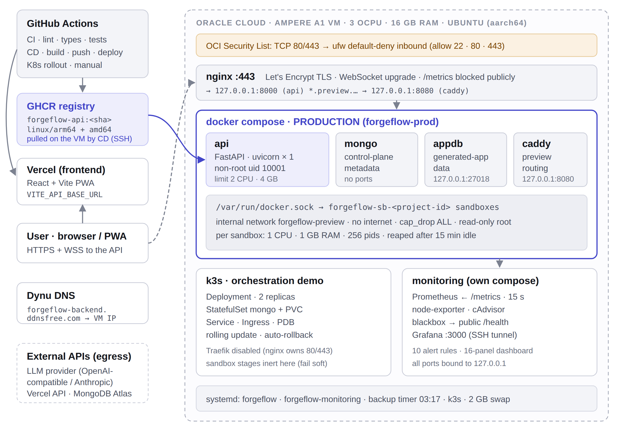
Figure 1: Deployment architecture: GitHub Actions, GHCR and Vercel, and the Oracle Cloud VM (3 OCPU / 16 GB) running production, k3s and monitoring
Table 5: Production components and their responsibilities
Component | Technology | Responsibility | Exposure
nginx | nginx 1.24 (host package) | TLS termination, HTTP→HTTPS redirect, WebSocket upgrade, 64 MB upload limit | Public :80/:443
api | FastAPI on uvicorn (custom image) | REST + WebSocket control plane, agents, sandbox manager, /health, /metrics | 127.0.0.1:8000
mongo | mongo:7 | Control-plane metadata: users, projects, versioned artifacts, runs | No published port
appdb | mongo:7 | Databases for generated apps while they run in sandboxes | 127.0.0.1:27018
proxy | caddy:2 | Routes <project>.preview.<domain> to the right sandbox by container name | 127.0.0.1:8080
sandboxes | forgeflow-sandbox image (Node 20, pnpm, Playwright, git, test mongod) | Build, run and test untrusted generated code | Internal network only
k3s | k3s v1.31.4 | Orchestration demo: Deployment, StatefulSet, rolling update, rollback | kubectl via SSH tunnel
monitoring | Prometheus, Grafana, exporters | Metrics, dashboard, alerts | 127.0.0.1 (SSH tunnel)

3.2 Why two runtimes: Compose for production, k3s for orchestration
The one architectural decision that needs explaining is why production runs on Docker Compose while Kubernetes runs alongside it as a demonstration. ForgeFlow creates a Docker container per project to run untrusted generated code, and its preview proxy reaches those containers by name (forgeflow-sb-<project-id>) through Docker’s embedded DNS on a dedicated bridge network. Generated apps reach their database (forgeflow-appdb) the same way.
Running the control plane as a Kubernetes pod breaks this. Mounting the Docker socket into a pod solves sandbox creation, but not sandbox routing: a pod on the cluster network cannot resolve Docker container names. Fixing that would mean rewriting preview discovery to use IP addresses, which changes how the application works, not how it is deployed. So:
Table 6: Feature availability in each runtime
Capability | Compose (production) | k3s (demo)
Auth, projects, requirements, artifacts, config, realtime WebSocket | Yes | Yes
/health, /metrics | Yes | Yes
Build / preview / test / deploy (sandbox-backed stages) | Yes | No: fails soft and logs "sandbox reconcile skipped"

Keeping them separate also means a failed orchestration demo can never take production down. The k3s cluster still demonstrates everything Task 3 asks for, with real pods running the real production image.

3.3 Request path and security layers
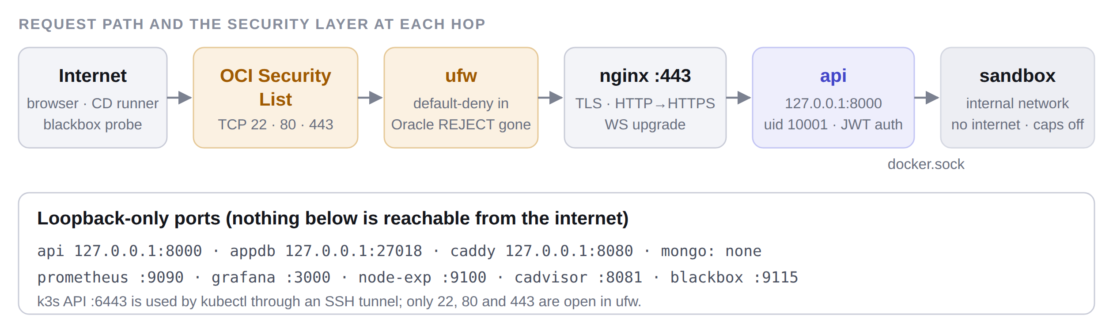
Figure 2: Path of a request through the VM, with the protection applied at each hop
A browser request crosses the OCI Security List, ufw and nginx (TLS) before reaching the API on the loopback interface. The API reaches sandboxes through the Docker socket; sandboxes live on an internal network with no route to the host or the internet. All databases, the preview proxy and every monitoring UI bind to 127.0.0.1, so only ports 22, 80 and 443 are reachable from outside.

4. Task 1 — Deployment Strategy: CI/CD with GitHub Actions

4.1 Tool selection
We chose GitHub Actions from the tools suggested (GitHub Actions, Codefresh, Harness, Spinnaker). The code already lives on GitHub; Actions provides hosted runners, encrypted secrets, environments and a built-in token that can push to the GitHub Container Registry without a personal access token. Spinnaker and Harness are aimed at large multi-cluster organisations and would need their own servers, more than our 3-core VM can spare. Three workflows split the work:
Table 7: The three workflows
Workflow | Trigger | Purpose
.github/workflows/ci.yml | Every push to main and every pull request | Prove the code is good: lint, type-check, test, build, scan
.github/workflows/cd.yml | workflow_run when CI completes successfully on main; or manual | Ship it: build image → GHCR → Oracle VM (with automatic rollback) → Vercel
.github/workflows/k8s-rollout.yml | Manual (workflow_dispatch) | Drive the k3s cluster: rollout, rollback, status, or the full demo

4.2 Continuous Integration (ci.yml)
CI runs six independent jobs in parallel. A newer push to the same branch cancels the run in progress (concurrency: cancel-in-progress: true), so runners are never wasted on outdated commits.
Table 8: CI jobs and the checks each one runs
Job | Steps | What it protects against
Backend (lint + type + tests) | uv sync (Python 3.11, --extra openai) → ruff → black --check → mypy → pytest, with a mongo:7 service container; 30-minute timeout | Style drift, type errors and regressions; 1,648 backend tests
Config layering guard | check_no_os_environ.sh | Code reading environment variables outside the config layer
Sandbox image | Build the sandbox image and run a Node + Playwright smoke test | A broken sandbox image that would stop every project build
Security | gitleaks over the full git history → committed-secret guard → pip-audit → pnpm audit (high) | Leaked credentials (even ones deleted later) and vulnerable dependencies
Frontend | pnpm install → ESLint → Prettier check → tsc → Vitest → production build → PWA installability/caching check | UI regressions, type errors and a broken service worker
App skeleton | install → lint → typecheck → build FE + BE → Vitest + Jest → Playwright E2E | A broken template, which would break every generated app

4.3 Continuous Delivery (cd.yml)
CD has four jobs that run in sequence. Figure 2 shows the full flow, including the failure paths.
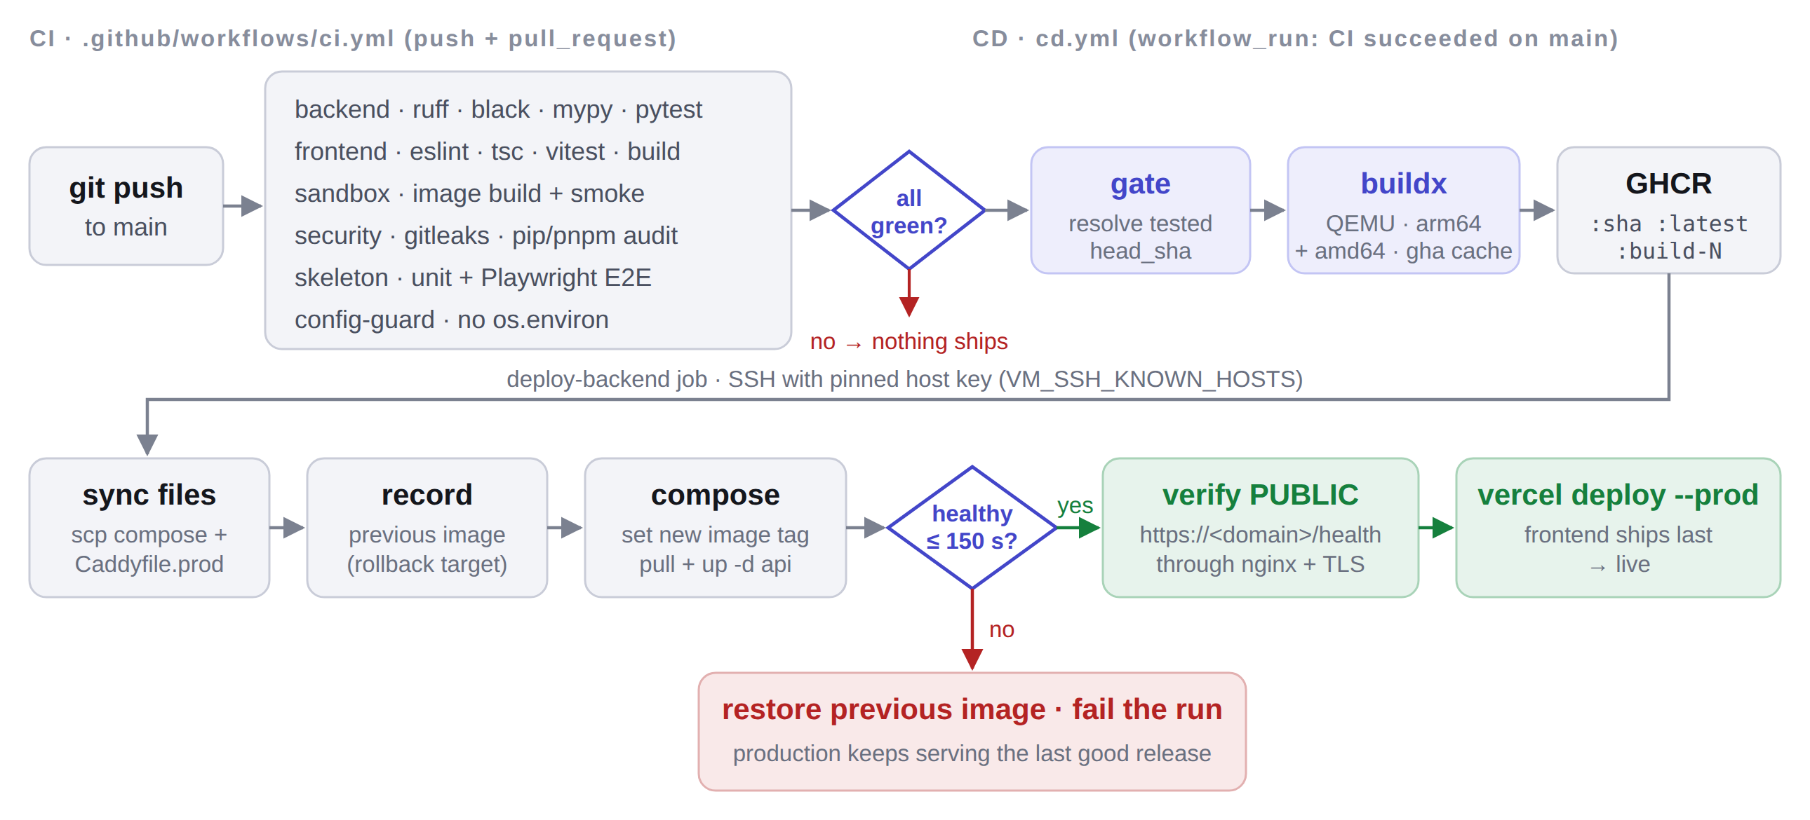
Figure 3: CI/CD pipeline: CI must be fully green before CD builds, pushes, deploys, verifies and finally ships the frontend; an unhealthy release is rolled back automatically

Job 1 — gate
Runs only if CI concluded success (or for a manual run). It resolves the exact commit CI tested, workflow_run.head_sha, rather than github.sha, which would be whatever main points at now and might be a newer, untested commit. It also computes the image tag: the 7-character short SHA, unless a manual run pins one.

Job 2 — build (multi-arch image to GHCR)
- Checks out the tested SHA, sets up QEMU (for arm64 emulation on GitHub’s amd64 runners) and Docker Buildx.
- Builds backend/Dockerfile.prod from the repository root for linux/amd64 and linux/arm64 in one manifest. The Oracle VM is aarch64; an amd64-only image would pull successfully and then crash with exec format error.
- Pushes three tags: :<sha> (immutable, the one actually deployed), :latest (convenience) and :build-<run number> (monotonic ordering).
- Uses the GitHub Actions layer cache (cache-from/to: type=gha), because re-running uv sync under QEMU emulation is otherwise by far the slowest step.
- Adds OCI labels (org.opencontainers.image.revision, .source) so every image can be traced back to its commit.

Job 3 — deploy-backend (Oracle VM, with automatic rollback)
- Install SSH key and pin the host key from the VM_SSH_KNOWN_HOSTS secret. StrictHostKeyChecking=no is never used, because disabling the check would make every deploy open to man-in-the-middle attacks.
- Sync deployment files: scp the current docker-compose.prod.yml and Caddyfile.prod to /opt/forgeflow, so infrastructure changes ship with the code.
- Record the rollback target: read the currently running FORGEFLOW_IMAGE from /opt/forgeflow/.env before changing anything.
- Switch the image: rewrite FORGEFLOW_IMAGE to the new SHA tag, then docker compose pull api and up -d --no-deps api.
- Poll health: check the container’s Docker HEALTHCHECK status every 5 s for up to 30 attempts (150 s), stopping early if it reports unhealthy.
- On success: print the /health response and prune images older than 7 days, so the 50 GB disk does not fill up.
- On failure: print the last 50 log lines, restore the recorded previous image, restart it and fail the run. Production keeps serving the last good release.
- Verify the public endpoint: from the runner, call https://<domain>/health through DNS, the firewalls, nginx and TLS (10 attempts). This catches a healthy container behind a misconfigured proxy.

Job 4 — deploy-frontend (Vercel)
Runs after the backend job succeeds, because the frontend is compiled against VITE_API_BASE_URL; shipping it first could point a new UI at an old API. It installs the Vercel CLI and runs vercel deploy --prod from the repository root, letting Vercel build the frontend directory in the cloud with VITE_API_BASE_URL=https://${FORGEFLOW_DOMAIN} passed as a build variable.
# cd.yml, deploy-backend job: "Deploy (with automatic rollback)", run on the VM via SSH
PREVIOUS="$(grep -E '^FORGEFLOW_IMAGE=' .env | cut -d= -f2- || true)"
sed -i "s|^FORGEFLOW_IMAGE=.*|FORGEFLOW_IMAGE=${IMAGE}|" .env
docker compose --env-file .env -f docker-compose.prod.yml pull api
docker compose --env-file .env -f docker-compose.prod.yml up -d --no-deps api
for _ in $(seq 1 30); do
state="$(docker inspect -f '{{.State.Health.Status}}' forgeflow-api)"
[ "$state" = "healthy" ] && { docker image prune -af --filter until=168h; exit 0; }
[ "$state" = "unhealthy" ] && break
sleep 5
done
sed -i "s|^FORGEFLOW_IMAGE=.*|FORGEFLOW_IMAGE=${PREVIOUS}|" .env # roll back
docker compose --env-file .env -f docker-compose.prod.yml up -d --no-deps api
exit 1
Listing 1: The deploy-and-rollback logic (simplified from .github/workflows/cd.yml)

4.4 Kubernetes rollout workflow (k8s-rollout.yml)
A separate, manually triggered workflow drives the k3s cluster, so a demo can never interfere with production deploys. It first validates every manifest with kubeconform in -strict mode against the Kubernetes 1.31 schema. Strict mode rejects unknown fields, which catches typos like replica: for replicas: that would otherwise apply silently and do nothing. It then performs one of four actions chosen from a drop-down: rollout (to a given image tag), rollback (to the previous or a named revision), status, or demo (the measured zero-downtime + broken-release + auto-rollback sequence in Section 6.6). Cluster access comes from a base64-encoded kubeconfig secret.

4.5 Pipeline design decisions
Table 9: Why the pipeline is built the way it is
Decision | Reason
CD triggered by workflow_run, not push | A push-triggered deploy starts at the same time as CI and can be serving traffic while the test that would have failed it is still running. workflow_run + conclusion == success makes "CI passed" a real precondition.
Deploy immutable SHA tags, never latest | Rollback has to mean something: after a bad deploy, latest points at the bad build.
Record the previous image before changing anything | The rollback target is a known-good value, not a guess.
Poll the health check instead of sleeping | A fixed sleep is either too short (false success) or too long (slow deploys). The timeout is what makes automatic rollback possible.
Two health checks | Loopback proves the container is up; the public HTTPS check proves a user can reach it.
Frontend deploys after backend | Avoids a new UI calling an API that does not exist yet.
concurrency: cd-production, never cancel | Two deploys must never interleave on one VM, and cancelling a half-finished deploy leaves the VM in an unknown state.
Secrets passed via env, not inlined into shell | Interpolating ${{ }} directly into a script is the standard script-injection hole in Actions.

4.6 Secrets and variables
Table 10: GitHub Actions configuration (values are never committed)
Name | Type | Purpose
VM_HOST, VM_USER | Secret | SSH target (VM public IP, ubuntu)
VM_SSH_KEY | Secret | Private deploy key (full PEM)
VM_SSH_KNOWN_HOSTS | Secret | Output of ssh-keyscan; pins the VM’s host key
VERCEL_TOKEN, VERCEL_ORG_ID, VERCEL_PROJECT_ID | Secret | Vercel CLI authentication and project link
KUBECONFIG_B64 | Secret (optional) | Cluster access for the k8s workflow
FORGEFLOW_DOMAIN | Variable | API hostname; used for the public health check and VITE_API_BASE_URL
VM_SSH_PORT | Variable (optional) | Defaults to 22
GITHUB_TOKEN | Built-in | Pushes images to GHCR; no personal token needed

5. Task 2 — Configuration Management with Ansible

5.1 Why Ansible, and how it is organised
Ansible is agentless: it needs only SSH and Python on the VM, so nothing extra runs on our small machine. The playbook is plain POSIX and runs from macOS or from WSL on Windows (Ansible has no native Windows control node). Everything lives in infra/ansible/:
infra/ansible/
├── ansible.cfg inventory, pipelining, SSH reuse, host-key checks on
├── inventory.example.ini copy to inventory.ini (gitignored), set the VM IP
├── requirements.yml community.general, community.docker, ansible.posix
├── site.yml the playbook: pre_tasks + 7 roles + summary
├── group_vars/all.yml every tunable: domain, ports, packages, firewall, k3s
├── group_vars/vault.yml optional secrets (gitignored, ansible-vault encryptable)
└── roles/
├── common/ packages, timezone, forgeflow user, swap, unattended upgrades
├── docker/ Docker CE + Compose v2, daemon.json, docker gid, preview network
├── forgeflow/ /opt/forgeflow, .env, compose + Caddyfile, systemd units, backups
├── nginx/ one additive site with WebSocket support
├── k3s/ single-node Kubernetes + manifests
├── monitoring/ Prometheus, Grafana, exporters
└── firewall/ ufw + removal of Oracle’s REJECT rules
Listing 2: Layout of the Ansible project

5.2 Inventory and variables
[forgeflow]
oracle-vm ansible_host=<VM public IP>

[forgeflow:vars]
ansible_user=ubuntu
ansible_ssh_private_key_file=~/.ssh/<oracle key>
ansible_python_interpreter=/usr/bin/python3
Listing 3: inventory.ini (the real file is gitignored: an inventory in a public repository is a target list)
group_vars/all.yml holds every setting, including forgeflow_domain: forgeflow-backend.ddnsfree.com, forgeflow_api_port: 8000, forgeflow_cors_origins (the Vercel URL), the package list, the timezone (Asia/Kolkata), the 2 GB swap size, firewall ports (22, 80, 443), the k3s version (v1.31.4+k3s1, Traefik disabled) and the monitoring ports and retention. Nothing secret is in this file.

5.3 Roles, in order
Role order is a dependency chain: common creates the user that docker adds to the docker group; docker discovers the docker group id that forgeflow writes into .env; forgeflow creates /opt/forgeflow, under which k3s and monitoring place files. firewall runs last, so a mistake in it cannot lock us out in the middle of a run.
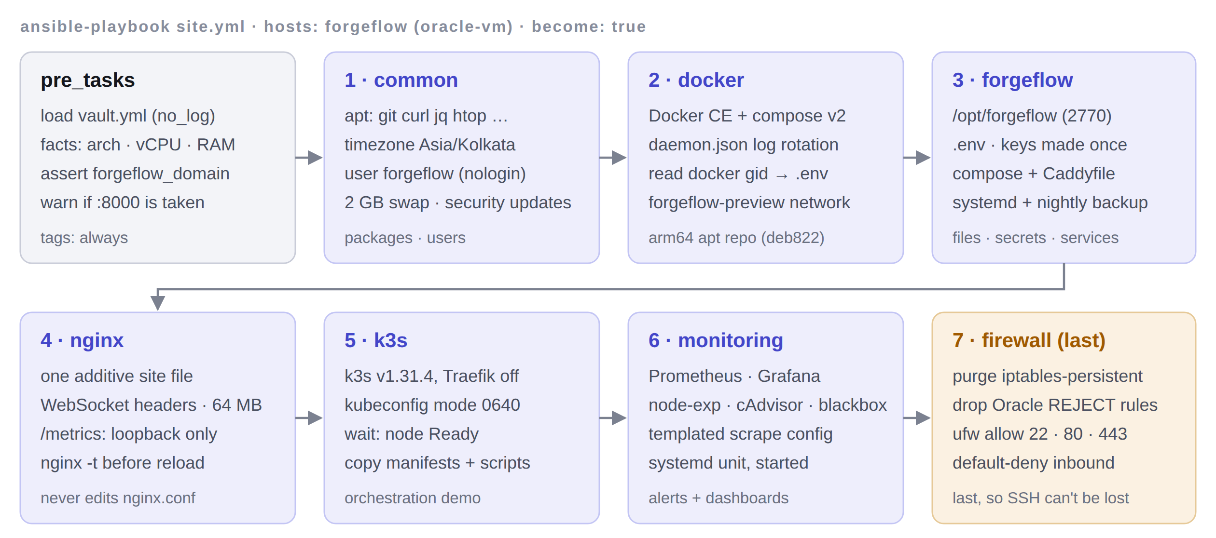
Figure 4: Execution order of the playbook: pre-flight checks, then seven roles, with the firewall deliberately last
Table 11: What each role does on the VM
Role | Tasks performed
pre_tasks | Load vault.yml if present (no_log); gather facts and print distro, architecture, vCPU count and RAM; refuse to run if forgeflow_domain is a placeholder; warn if port 8000 is already taken
common | Assert a Debian-family OS; refresh the apt cache (1-hour validity); install base packages (ca-certificates curl git gnupg htop jq unzip python3-pip python3-docker); set the timezone; create the forgeflow group and system user (no login shell, home /opt/forgeflow); create, secure (0600), format, enable and persist a 2 GB swap file; enable unattended security upgrades with no automatic reboot
docker | Add Docker’s GPG key and apt repository for the host’s real architecture (arm64), in deb822 format; install docker-ce, CLI, containerd, Buildx and the Compose v2 plugin; write daemon.json (json-file logs 10 MB × 3, live-restore, a private address pool); add forgeflow and ubuntu to the docker group; read the docker group id for .env; create the forgeflow-preview network as internal (no internet)
forgeflow | Add the login user to the forgeflow group; create /opt/forgeflow, caddy/ and backups/ (mode 2770, setgid); generate SECRET_KEY and FERNET_KEY on first run only, then read them back on later runs; render .env (0660, no_log, with backup); install the production compose file and Caddyfile; install and enable forgeflow.service; install a nightly mongodump backup timer (03:17, 14-day retention)
nginx | Install nginx if missing; warn if another file already claims the domain; write one site file with WebSocket headers, a 64 MB body limit, 1-hour proxy timeouts, no buffering, and /metrics restricted to localhost; validate with nginx -t before any reload; never touch nginx.conf or the other project’s site
k3s | Install k3s v1.31.4 with Traefik disabled and kubeconfig mode 0640; wait for the node to be Ready; give the login user a kubeconfig rewritten to the VM’s address; copy the manifests and rollout scripts to /opt/forgeflow/k8s
monitoring | Create /opt/forgeflow/monitoring; install the compose file, a templated Prometheus config (probes our real domain), alert rules, blackbox config, Grafana provisioning and the dashboard JSON; write a 0640 env file with the Grafana admin credentials; install and start forgeflow-monitoring.service
firewall | Install ufw; purge iptables-persistent/netfilter-persistent; detect Oracle’s blanket REJECT rules and delete them by specification; allow SSH first, then 80/443; default-deny inbound, allow outbound; enable ufw; print the final state and a reminder about the OCI Security List

5.4 Mapping to the assignment: packages, users, files
Table 12: How the playbook meets each Task 2 requirement
Requirement | Implemented by
Install packages | common (base tools, unattended-upgrades), docker (Docker CE, containerd, Buildx, Compose), nginx, firewall (ufw), k3s (installer)
Create users | forgeflow system user and group (/usr/sbin/nologin); ubuntu added to the docker and forgeflow groups; the container itself runs as uid 10001
Manage files | /opt/forgeflow tree with setgid permissions; .env from a Jinja2 template; compose file, Caddyfile and k8s manifests copied; /etc/docker/daemon.json; nginx site; systemd units (forgeflow, forgeflow-backup service + timer, forgeflow-monitoring); /etc/apt/apt.conf.d/20auto-upgrades; swap entry in /etc/fstab
Manage services | Docker enabled + started; forgeflow.service enabled (started later by CD); backup timer started; monitoring started; nginx reloaded only after validation; ufw enabled

5.5 Idempotency and secret handling
The defining property of configuration management is that running it twice changes nothing the second time. The playbook is written so that a second run of site.yml reports changed=0; any task that reports a change on a no-op run is treated as a bug. Three details make this work:
- Secrets are generated once and read back. FERNET_KEY encrypts the stored LLM-provider credentials. Regenerating it would make every stored token undecryptable, an unrecoverable loss. The role therefore creates the keys only when .env does not exist, and on later runs reads the existing values back before re-rendering the file.
- Guards on one-time actions: creates: on the swap file and k3s installer, stat checks before creation, and changed_when on commands that only read state.
- no_log: true on every task that handles secret material, so keys never appear in Ansible output or CI logs.
Provider API keys are deliberately left blank in .env and entered later in ForgeFlow’s /admin panel, where they are Fernet-encrypted at rest and can never be read back. If preferred, group_vars/vault.yml (encrypted with ansible-vault) can supply the seed admin login and the MongoDB Atlas URI used by deployed generated apps.

5.6 The Oracle firewall trap
This was the most time-consuming issue of the deployment. Oracle’s Ubuntu images ship an iptables ruleset whose INPUT chain ends in a blanket REJECT, persisted in /etc/iptables/rules.v4. ufw writes its rules into a different chain, so ufw allow 443 succeeds, ufw status shows the port as open, and packets are still rejected by the earlier rule. The firewall role fixes this properly:
- Purge iptables-persistent and netfilter-persistent so the Oracle rules are never reloaded at boot (ufw declares Breaks: on them anyway).
- Find -A INPUT -j REJECT rules and delete each one by its full specification (iptables -D …), never by index. Deleting by index while the chain shifts removes the wrong rule, and the wrong rule is the one keeping SSH open.
- Allow SSH before enabling the default-deny policy, then 80 and 443, then enable ufw, which persists its own rules.

5.7 Running the playbook
cd infra/ansible
cp inventory.example.ini inventory.ini # set ansible_host to the VM IP
ansible-galaxy collection install -r requirements.yml
ansible forgeflow -m ping # check SSH first
ansible-playbook site.yml --check --diff # dry run: shows what WOULD change
ansible-playbook site.yml # provision
ansible-playbook site.yml # second run must report changed=0
ansible-playbook site.yml --tags nginx # or just one part
Listing 4: Provisioning commands

6. Task 3 — Containerisation and Orchestration

6.1 The production Dockerfile
backend/Dockerfile.prod is kept separate from the development Dockerfile, which is bind-mounted with hot reload for local work. The production image is multi-stage, so the build toolchain never reaches the runtime layer:
Table 13: Production image features
Feature | Implementation | Benefit
Multi-stage build | builder stage runs uv sync --frozen --no-dev --extra openai into /opt/venv; runtime copies only the venv and source | Small image; no compilers or caches in production
Reproducible dependencies | --frozen fails on a stale lockfile; dependencies copied before source | Exactly what CI tested; source-only changes reuse cached layers
Non-root user | useradd --uid 10001 forgeflow; USER forgeflow | A compromised process has no root inside the container
Real PID 1 | tini as entrypoint | SIGTERM reaches uvicorn, so rolling updates drain cleanly
Health check | HEALTHCHECK curls http://127.0.0.1:8000/health every 15 s (30 s start period, 3 retries) | Docker, CD and Kubernetes can tell "process up" from "actually serving"
App skeleton baked in | Build context is the repo root; templates/app-skeleton copied in | The Build stage always has the generated-app template
Single worker | uvicorn --workers 1 --proxy-headers | WebSocket subscribers and rate limiters live in process memory; a second worker would split them

FROM python:3.11-slim AS builder
COPY --from=ghcr.io/astral-sh/uv:0.5.11 /uv /usr/local/bin/uv
COPY backend/pyproject.toml backend/uv.lock ./
RUN uv sync --frozen --no-install-project --no-dev --extra openai
COPY backend/ .
RUN uv sync --frozen --no-dev --extra openai

FROM python:3.11-slim AS runtime
RUN apt-get update \
&& apt-get install -y --no-install-recommends ca-certificates curl tini \
&& rm -rf /var/lib/apt/lists/* \
&& useradd --create-home --uid 10001 forgeflow
COPY --from=builder /opt/venv /opt/venv
COPY --from=builder --chown=forgeflow:forgeflow /build /app
COPY --chown=forgeflow:forgeflow templates/app-skeleton /app/templates/app-skeleton
USER forgeflow
HEALTHCHECK --interval=15s --timeout=5s --start-period=30s --retries=3 \
CMD curl -fsS http://127.0.0.1:8000/health || exit 1
ENTRYPOINT ["/usr/bin/tini", "--"]
CMD ["uvicorn", "app.api.app:app", "--host", "0.0.0.0", "--port", "8000", \
"--workers", "1", "--proxy-headers"]
Listing 5: backend/Dockerfile.prod (comments removed)

6.2 The production Compose stack
infra/docker-compose.prod.yml defines the four long-running services on the VM. Every service gets bounded logs (json-file, 10 MB × 3 files) and restart: always, and every published port binds to 127.0.0.1.
Table 14: Services in the production Compose file
Service | Image | Key settings
mongo | mongo:7 | No published port at all; named volume mongo-data; mongosh ping health check
appdb | mongo:7 | 127.0.0.1:27018; joins the preview network so sandboxes can reach it by name; volume appdb-data
api | ${FORGEFLOW_IMAGE} (SHA tag from CD) | env_file: .env; waits for both databases to be healthy; mounts /var/run/docker.sock to manage sandboxes; group_add: ${DOCKER_GID} for socket access as non-root; limits 2 CPU / 4 GB; 127.0.0.1:8000
proxy | caddy:2 | 127.0.0.1:8080; routes <id>.preview.<domain> to forgeflow-sb-<id>:5173 and <id>.api.preview.<domain> to port 3001; TLS off (nginx terminates)

A systemd unit, forgeflow.service (Type=oneshot, RemainAfterExit=true), runs docker compose pull and up -d at boot, so the stack comes back after a VM restart with whatever image tag CD last wrote to .env.

6.3 Sandbox containers
Generated code is untrusted, so it never runs in the control plane. For each project the API creates a container from the forgeflow-sandbox image (Node 20, pnpm 9, Playwright Chromium, git and a test-only MongoDB, running as a non-root user) with a strict posture applied at docker run time: its own internal network (no internet, no host access), cap_drop: ALL, no-new-privileges, a read-only root filesystem with writable workspace volumes and a /tmp tmpfs, and limits of 1 CPU, 1 GB memory and 256 processes. Idle sandboxes are reaped after 15 minutes. The sandbox image is built once on the VM (docker build -t forgeflow-sandbox:latest sandbox/).

6.4 Kubernetes manifests (k3s)
k3s was chosen over kubeadm because it is a single ~60 MB binary with first-class arm64 support and bundles containerd, CoreDNS, a CNI and the local-path storage class. A kubeadm control plane would use much of a 3-OCPU machine for a demo cluster. Traefik is disabled because its LoadBalancer would try to bind host ports 80/443, which nginx already owns; the demo reaches the cluster through kubectl port-forward.
Table 15: Kubernetes objects in infra/k8s/base
File | Objects | Purpose
00-namespace.yaml | Namespace forgeflow | Everything is cleaned up by deleting one namespace
10-config.yaml | ConfigMap, Secret (template only) | Non-secret settings; the real Secret is created out of band with kubectl create secret
20-mongo.yaml | Headless Service, StatefulSet, PVC template (5 Gi) | Stable identity forgeflow-mongo-0 and its own volume
30-api.yaml | Service (ClusterIP), Deployment (2 replicas), PodDisruptionBudget | The rolling-update target
40-ingress.yaml | Ingress | Standard networking.k8s.io/v1 Ingress for clusters that run an ingress controller

Table 16: Deployment settings and why they were chosen
Setting | Value | Reason
Strategy | RollingUpdate, maxSurge: 1, maxUnavailable: 0 | A new pod must be Ready before an old one stops; capacity never drops below 2
replicas | 2 | With one replica, "zero dropped requests" cannot be tested
minReadySeconds | 10 | A pod that passes one probe and then crashes cannot let the rollout continue
progressDeadlineSeconds | 180 (the recorded demo used 60) | Makes rollout status fail instead of waiting forever; the rollback is triggered by that failure
revisionHistoryLimit | 10 | Keeps old ReplicaSets so rollout undo --to-revision has a target
Probes | startup (30 × 5 s), readiness (5 s), liveness (20 s, slack) | Three questions: booted? should get traffic? wedged? Liveness is looser than readiness so a brief slowdown never kills a healthy pod
initContainer | wait-for-mongo (busybox nc -z) | The API blocks at startup without Mongo; waiting avoids crash-loop noise
Security context | runAsNonRoot (10001), read-only root FS, drop ALL capabilities, seccomp RuntimeDefault | Least privilege for the pod
Downward API | APP_VERSION from the pod label | Grafana shows which version serves; a half-finished rollout is visible

6.5 Rolling update
infra/k8s/scripts/rolling-update.sh <image> "<reason>" records the current revision, runs kubectl set image, annotates the Deployment with a change-cause (so rollout history is readable) and then waits on kubectl rollout status. set image returns as soon as the API server accepts the change, long before anything is running, so a script that stopped there would report success for a deploy about to crash-loop. rollout status blocks until the progress deadline and exits non-zero if the new pods never become Ready. That exit code triggers the automatic rollback.
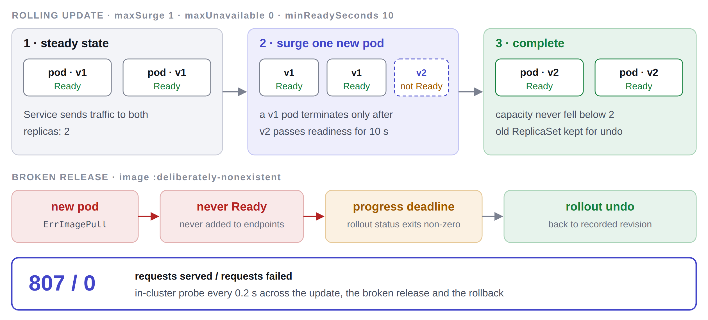
Figure 5: Rolling update with maxSurge 1 / maxUnavailable 0, and the broken-release path that ends in an automatic rollback

6.6 Rollback, and the measured demonstration
Rollback is available in three ways: automatically from rolling-update.sh when a rollout does not converge; manually with rollback.sh (previous revision) or rollback.sh <n> (a specific revision); and from GitHub Actions via the rollback action of k8s-rollout.yml.
demo-rolling-update.sh proves the behaviour on a real single-node k3s v1.31.4 cluster running the actual production image. An in-cluster probe pod requests /health every 0.2 seconds for the entire sequence: (1) a rolling update from v1 to v2; (2) a deliberately broken release pointing at a nonexistent image tag; (3) the automatic rollback.
### kubectl get all -n forgeflow
pod/forgeflow-api-5cbc6c4774-psp4r 1/1 Running 0 2m34s
pod/forgeflow-api-5cbc6c4774-wkhs9 1/1 Running 0 2m18s
pod/forgeflow-mongo-0 1/1 Running 0 5m56s
deployment.apps/forgeflow-api 2/2 2 2 5m57s
statefulset.apps/forgeflow-mongo 1/1 5m57s

### broken release (nonexistent tag)
forgeflow-api-6ff44cfbc7-42kpt 0/1 ErrImagePull
error: deployment "forgeflow-api" exceeded its progress deadline
-> rolling back
deployment.apps/forgeflow-api rolled back

### rollout history
REVISION CHANGE-CAUSE
4 demo: deliberately broken release
5 rolling update to v2

### availability tally (in-cluster probe, 0.2s interval, whole demo)
ok=807 fail=0

### deployment strategy in effect
{"rollingUpdate":{"maxSurge":1,"maxUnavailable":0},"type":"RollingUpdate"}
Listing 6: Evidence from docs/devops/evidence/k3s-rolling-update-verification.txt (abridged)
Result
807 requests, 0 failures across the rolling update, the failed release and the rollback. The broken pod never became Ready, so it was never added to the Service endpoints and never received a single request.

7. Task 4 — Monitoring and Logging

7.1 Monitoring architecture
Monitoring runs as its own Compose project (infra/monitoring/docker-compose.monitoring.yml), separate from the application. A monitoring stack that restarts with every deploy would be blind exactly when a deploy needs watching, and the thing that reports the app is down must not share the app’s lifecycle. Ansible starts it through forgeflow-monitoring.service.
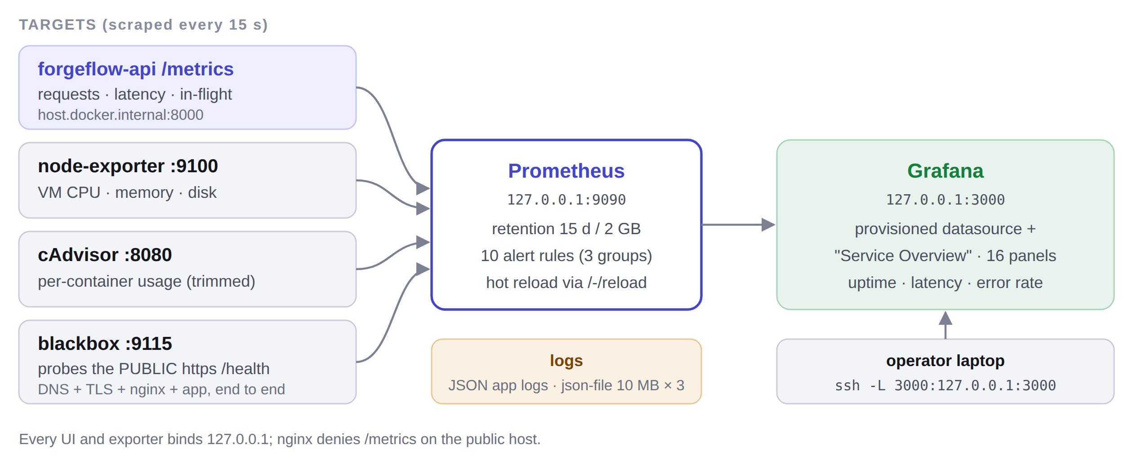
Figure 6: Monitoring data flow: four targets scraped by Prometheus, visualised in Grafana and reached over an SSH tunnel

7.2 Application metrics
backend/app/core/metrics.py adds a Starlette middleware that times every request and records its outcome, and a /metrics endpoint that serves the Prometheus text format. Three rules shaped it:
- Read-only observer: recording a metric can never fail a request; errors in recording are logged and swallowed.
- Bounded label cardinality: the path label is the route template (/projects/{project_id}/artifacts), read after routing, never the raw URL. Requests that match no route, such as scanners probing a public VM, collapse into one <unmatched> series. Otherwise every project id or probed URL would create a new time series.
- No secrets in output: only method, route template and status code are labelled; no query strings, bodies, headers, user ids or project ids.
Table 17: Metrics exported by the control plane
Metric | Type | Labels | Used for
forgeflow_http_requests_total | Counter | method, path, status | Throughput, error rate (5xx ratio)
forgeflow_http_request_duration_seconds | Histogram (5 ms … 60 s buckets) | method, path | Latency percentiles (p50/p95/p99)
forgeflow_http_requests_in_flight | Gauge | — | Concurrency / saturation
forgeflow_http_unhandled_exceptions_total | Counter | method, path | Exceptions that escaped the error handlers
forgeflow_build_info | Gauge (always 1) | version, env | Which version is serving; detects half-finished rollouts
process / platform / GC collectors | Various | — | RSS memory, CPU time, open file descriptors

/metrics is enabled by two keys registered in the layered configuration (METRICS_ENABLED, METRICS_PATH), and was added deliberately to the test that lists unauthenticated routes. nginx denies /metrics to everyone except localhost, so the scrape works on the loopback while the public cannot read the route table or traffic shape.

7.3 Scrape targets
Table 18: Prometheus scrape jobs (15-second interval)
Job | Target | Question it answers
forgeflow-api | host.docker.internal:8000/metrics (loopback, not the public URL) | What is the application doing? Keeps working even if the public path is broken
node | node-exporter :9100 (host /proc, /sys, /) | Is the VM itself the problem? CPU, memory, disk, load
cadvisor | cAdvisor :8080 (relabelled to a few series) | Which container is using resources, for example a runaway sandbox
blackbox-http | blackbox :9115 probing https://forgeflow-backend.ddnsfree.com/health | Can a user reach it? Covers DNS, Security List, nginx, TLS and the app
prometheus | itself | Is monitoring healthy?

cAdvisor needed special care: ForgeFlow creates and destroys sandbox containers constantly, and each would leave its own set of time series. The scrape keeps only the seven container metrics the dashboard uses, drops aggregate cgroup series without a container name, and drops the per-restart id label.

7.4 Grafana dashboard
Grafana’s datasource and the "ForgeFlow — Service Overview" dashboard are provisioned from files, so a rebuilt Grafana comes back identical. The dashboard has 16 panels in three rows and covers the three signals the task requires (uptime, latency, error rate):
Table 19: Dashboard panels
Row | Panels
Health at a glance | Uptime (24 h, from the blackbox probe) · Current status · Error rate (5 m) · p95 latency (5 m) · Version
Golden signals | Latency percentiles · Request rate by status class · Error ratio · Slowest routes (p95) · Requests in flight · Unhandled exceptions · Probe duration (public URL)
The VM | CPU utilisation · Memory used · Root disk used (gauge) · Memory by container

Testing the queries against a live Prometheus found one real bug: the error-rate panel showed "No data" on a perfectly healthy service, because sum(rate(…{status=~"5.."})) returns an empty vector when no 5xx has ever occurred. Appending or vector(0) fixed it.

7.5 Alert rules
Table 20: The ten alert rules, in three groups
Alert | Condition | For | Severity
ForgeFlowDown | Blackbox probe of the public /health fails | 2 m | critical
ForgeFlowScrapeTargetDown | API /metrics scrape fails on loopback | 2 m | critical
TLSCertificateExpiringSoon | Certificate expires in < 21 days (certbot renewal has failed) | 1 h | warning
HighErrorRate | 5xx ratio > 5% of requests | 5 m | critical
HighLatencyP95 | p95 latency > 2 s (from histogram buckets) | 10 m | warning
UnhandledExceptions | > 5 unhandled exceptions in 10 minutes | — | warning
DiskFillingUp | Root filesystem < 15% free | 10 m | warning
DiskCritical | Root filesystem < 5% free | 5 m | critical
HighMemoryPressure | Memory used > 90% | 10 m | warning
HostHighCPU | CPU > 85% (sustained; builds are expected to be busy) | 15 m | warning

Every rule has a for: duration so one slow scrape cannot raise an alert. Alerts that fire on momentary spikes get ignored within a week. The two "down" alerts together show which layer failed: if only the public probe fails, the problem is DNS, the firewall, nginx or TLS; if the loopback scrape fails too, it is the container.

7.6 Logging
- Application logs are structured JSON (LOG_JSON=true, LOG_LEVEL=INFO), one event per line, ready for any log shipper. Secrets are never logged (a project rule, enforced in review).
- Container logs use Docker’s json-file driver with rotation at 10 MB × 3 files, set per service in Compose and daemon-wide in daemon.json so that sandboxes created through the SDK are covered too. Unrotated logs on a small boot volume are a common way such VMs fail.
- nginx writes separate forgeflow.access.log and forgeflow.error.log files.
- systemd units (forgeflow, forgeflow-monitoring, forgeflow-backup) log to journald: journalctl -u forgeflow.
- Backups: a nightly mongodump --archive --gzip of the control-plane database to /opt/forgeflow/backups, 14-day retention, timer with Persistent=true so a missed run happens at next boot.
### Prometheus targets (all up)
blackbox-http up
cadvisor up
forgeflow-api up
node up
prometheus up

### Alert rules loaded: 10, in groups forgeflow-availability / -performance / -host
### Grafana dashboard: 16 panels provisioned
Listing 7: Evidence from docs/devops/evidence/monitoring-stack-verification.txt (abridged)

8. How Each ForgeFlow Stage Runs in Production
ForgeFlow’s six product stages need different infrastructure. The deployment had to support all of them without making any stage mandatory: a user can skip straight to Build, and the only hard prerequisites are deploy ⇐ build and validate ⇐ deploy.
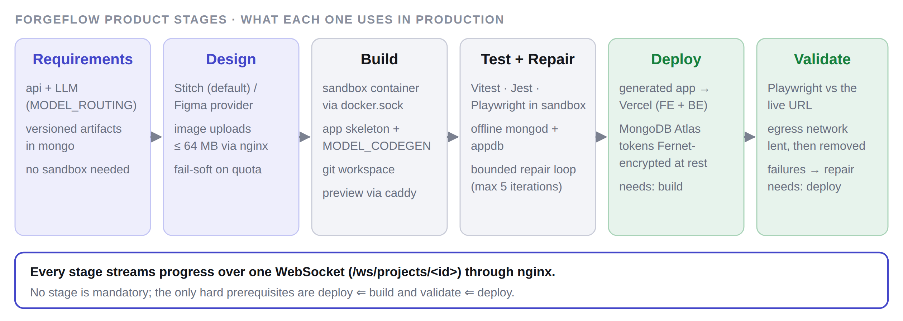
Figure 7: Infrastructure used by each ForgeFlow stage in production
Table 21: Stage-by-stage production behaviour
Stage | What happens | Infrastructure involved
Requirements | Turns screenshots or a spec into structured, versioned requirements | API + LLM provider (role MODEL_ROUTING, egress over HTTPS); artifacts versioned in mongo
Design | Generates or imports UI designs (Stitch by default, Figma alternative) | Image uploads up to 64 MB (nginx client_max_body_size); provider quota errors fail soft with a fallback
Build | Copies the fixed app skeleton into a git-backed workspace and generates code | A sandbox container created through docker.sock; MODEL_CODEGEN; live preview via Caddy at <id>.preview.<domain>
Test + Repair | Runs Vitest/Jest unit tests and Playwright E2E; failures go to a bounded, diff-aware repair loop | Inside the sandbox, offline; tests use a sandbox-local mongod and appdb; maximum 5 repair iterations
Deploy | Ships the generated app | Vercel (frontend + backend function) and MongoDB Atlas; provider tokens decrypted only at call time
Validate | Re-runs the smoke/critical E2E suite against the live URL | The sandbox is lent an egress network for the run only; failures feed back into repair

Every stage streams its progress to the browser over a single WebSocket, /ws/projects/<id>, which is why the nginx WebSocket configuration (Section 10) matters so much. Without it every REST call still works, but live progress never connects.

9. Security Hardening Summary
Table 22: Security controls across the deployment
Layer | Control
Network perimeter | OCI Security List + ufw default-deny; only 22/80/443 open; Oracle REJECT rules removed safely
Service exposure | Every internal service bound to 127.0.0.1; control-plane Mongo has no port at all; /metrics denied publicly
Transport | Let’s Encrypt TLS on all public hostnames; HTTP→HTTPS redirect; certificate-expiry alert
Containers | Non-root (uid 10001); minimal runtime image; k8s pods with read-only root, dropped capabilities, seccomp
Untrusted code | Sandboxes on an internal network with no internet, cap_drop: ALL, no-new-privileges, read-only root, CPU/memory/pid limits
Secrets | GitHub encrypted secrets; SECRET_KEY/FERNET_KEY generated on the VM, never committed; provider tokens Fernet-encrypted at rest and never returned to the client; no_log in Ansible; .env mode 0660
Supply chain | gitleaks over full history; committed-secret guard; pip-audit and pnpm audit; frozen lockfiles; images tagged by commit SHA with source labels
Deploy channel | SSH key authentication with a pinned host key; no StrictHostKeyChecking=no
Host maintenance | Unattended security upgrades without automatic reboot; nightly database backups
Admin surfaces | Grafana and Prometheus loopback-only (SSH tunnel), anonymous access and sign-up disabled; kubeconfig mode 0640

10. Verification and Results
Every configuration was executed, not just inspected. Raw outputs are committed under docs/devops/evidence/.
Table 23: Verification performed and results
Check | Tool | Result
Workflow syntax + embedded shell | actionlint (with shellcheck) | 3 workflows, 0 findings
Kubernetes manifests | kubeconform -strict (k8s 1.31) | 9/9 valid
Ansible | ansible-lint, production profile | 0 failures, 0 warnings (30 files)
Prometheus config + rules | promtool check | valid, 10 rules
nginx configuration | nginx -t | valid (with and without preview block)
WebSocket upgrade through nginx | live handshake | 101 Switching Protocols
Production image | docker build + run | healthy, non-root uid 10001
/metrics content | live scrape | route templates only, no secrets
Rolling update on real k3s | in-cluster probe | 807 requests, 0 failures
Broken release | real k3s | detected, auto-rolled back, served 0 requests
Monitoring stack | live Prometheus/Grafana | 5/5 targets up, 16 panels, 10 alerts
Backend test suite | pytest | 1,648 passed

10.1 The WebSocket test, including the negative control
ForgeFlow’s live progress depends on a WebSocket, and a standard nginx proxy_pass block does not forward the upgrade handshake. We tested the exact same request against a real nginx with and without the three required lines:
### WITH proxy_http_version 1.1 + Upgrade + Connection headers
$ curl -k -i -H 'Connection: Upgrade' -H 'Upgrade: websocket' \
-H 'Sec-WebSocket-Version: 13' -H 'Sec-WebSocket-Key: <random>' \
https://localhost/ws/projects/test
HTTP/1.1 101 Switching Protocols
Upgrade: websocket

### NEGATIVE CONTROL: identical config with those three lines removed
HTTP/1.1 200 OK <- upgrade silently swallowed, nothing in any error log

### /metrics from outside -> 403
### http:// -> 301 https://...
Listing 8: Evidence from docs/devops/evidence/nginx-websocket-verification.txt (abridged)
Showing that the headers work is half the evidence. Removing them and watching the handshake quietly fall back to 200 OK proves they are actually needed.

11. Task 5 — Reflection: Challenges and Lessons Learned

11.1 Challenges
Table 24: Problems met during the deployment and how they were solved
Challenge | What went wrong | Resolution
Kubernetes could not host the real runtime | Pods cannot resolve Docker container names, so sandbox preview routing breaks | Compose for production, k3s for the orchestration deliverable; stated openly instead of shipping a cluster where a third of the product fails
Two firewalls on Oracle Cloud | ufw allow 443 reported success but Oracle’s pre-baked iptables REJECT still dropped packets | Firewall role removes the REJECT rules by specification and purges iptables-persistent; OCI Security List opened manually
arm64 vs amd64 | GitHub runners are amd64; the VM is aarch64; an amd64 image dies with exec format error | QEMU + Buildx multi-platform builds with a registry layer cache
Caddy preview routing broke twice | (1) Host labels are indexed right-to-left, so a fixed index pointed at the TLD on a real domain; (2) a bare hostname made Caddy listen on :443 even with auto_https off | Left-anchored regex for the project id; site addresses pinned to http://. Both found by sending real requests
Metric cardinality | Raw URL paths would create a series per project, or per scanner probe | Route-template labels plus an <unmatched> bucket; cAdvisor series trimmed
Error panel blank when healthy | Empty vector ÷ anything = empty, so "No data" | or vector(0)
Adding metrics without breaking architecture rules | The app forbids os.environ outside its config layer and tests the list of public routes | Registered two config keys properly and declared /metrics public in a reviewable change
nginx 1.24 on Ubuntu 24.04 | The http2 on; directive is unknown to nginx 1.24 | Removed the directive so the site validates on the stock Ubuntu nginx (WebSocket upstreams use HTTP/1.1 anyway)

11.2 Lessons learned
- Validate by execution, not inspection. Every configuration here parsed correctly while being wrong. The Caddy label bug, the :443 bind, the missing WebSocket headers and the blank error panel were invisible to linters and obvious within seconds of a real request. A throwaway k3s cluster and a real Prometheus took about an hour to set up and found five genuine bugs.
- Test the negative case. Removing the WebSocket headers and watching the handshake fail is what proved they were needed.
- "Zero downtime" is a measurement. 807 requests and 0 failures across an update, a failed release and a rollback is evidence; watching pods change colour is not.
- A deploy command that returns is not a deploy that worked. kubectl set image and docker compose up -d both return before anything serves. Every deploy path waits on a real health signal, and that timeout is what makes automatic rollback possible.
- Make dangerous operations hard to do by accident. Regenerating FERNET_KEY would destroy every stored credential, so the playbook reads the existing key back and documents why in three places.
- Automation on a shared machine must not disturb its neighbours. The VM already served another project, so the nginx role writes exactly one file, never touches nginx.conf, validates before reloading and reloads rather than restarts.

12. Operations Runbook

12.1 First-time setup
- OCI console: open ingress TCP 80 and 443 on the instance’s Security List.
- DNS + TLS: point the Dynu hostname at the VM; on the VM run sudo certbot --nginx -d forgeflow-backend.ddnsfree.com.
- Provision: run the Ansible playbook (Listing 4); run it twice and confirm changed=0.
- GHCR: make the forgeflow-api package public (or add a pull secret) so the VM can pull it.
- Vercel: create the project from frontend/, run vercel link, and store the org and project ids as secrets.
- Sandbox image (CD does not build it): tar czC sandbox . | ssh forgeflow-vm 'docker build -t forgeflow-sandbox:latest -'.
- Deploy: push to main and watch Actions → CD turn green.
- Seed admin: docker compose … exec -T api python -m scripts.seed, then log in, open /admin and enter the LLM provider key.

12.2 Everyday commands
# deploy
git push origin main # CI -> CD -> VM + Vercel
# or: Actions -> CD -> Run workflow (image_tag=<sha> redeploys a known-good build)

# check health
curl https://forgeflow-backend.ddnsfree.com/health
ssh forgeflow-vm 'systemctl status forgeflow; docker ps'

# monitoring (loopback-only, through an SSH tunnel)
ssh -N -L 3000:127.0.0.1:3000 -L 9090:127.0.0.1:9090 forgeflow-vm
# Grafana -> http://localhost:3000 Prometheus -> http://localhost:9090

# kubernetes demo
make k8s-validate && make k8s-apply
make k8s-rollout IMAGE=ghcr.io/faheem219/forgeflow-api:<sha>
make k8s-rollback # or REVISION=<n>
make k8s-demo V1=<img>:v1 V2=<img>:v2

# lint every DevOps artefact (actionlint, kubeconform, promtool, ansible-lint)
make devops-lint
Listing 9: Day-to-day operations

12.3 Moving to a new VM or domain
Because the whole host is described in code, moving is a checklist (docs/devops/moving-vm-or-domain.md): update the Dynu A record, open 80/443 on the new instance, change ansible_host and the GitHub VM_HOST / VM_SSH_KNOWN_HOSTS secrets, re-run the playbook, rebuild the sandbox image, push to main, and re-seed the admin user. Only the database contents need restoring, from the nightly mongodump archives.

13. Known Limitations and Future Work
Table 25: Limitations, stated plainly, and the next step for each
Limitation | Why | Next step
Sandbox stages do not work in k3s | Docker-DNS routing (Section 3.2) | IP-based preview discovery, or a Kubernetes-native sandbox runtime
Single MongoDB instance in both runtimes | A replica set needs three members and an initiator job | Three-member replica set or MongoDB Atlas
One API replica in production | WebSocket subscribers, replay ring and rate limiters live in process memory | Move that state to Redis, then scale horizontally
No Alertmanager | Rules evaluate and fire in Prometheus but are not routed | Add Alertmanager with email/Slack receivers
Sandbox image built manually | CD ships only the API image | Add a CD job that builds the sandbox image when sandbox/ changes
Single VM is a single point of failure | Cost: fits the free allowance | A second VM or managed Kubernetes behind a load balancer

14. Conclusion
ForgeFlow’s backend runs in production on a single 3-OCPU / 16 GB Oracle Cloud Ampere VM, and its frontend on Vercel, with every step from commit to running service automated and checked. Task 1: GitHub Actions runs six CI jobs on every change and, only when all pass, builds a multi-architecture image, deploys it with an automatic health-checked rollback and then ships the frontend. Task 2: a seven-role Ansible playbook provisions the VM idempotently, including packages, users, files, services and a firewall that works around Oracle’s hidden iptables rules. Task 3: a hardened multi-stage image runs under Docker Compose in production, and the same image on k3s demonstrated a rolling update and automatic rollback with 807 requests and 0 failures. Task 4: Prometheus, four exporters, a 16-panel Grafana dashboard and ten alert rules cover uptime, latency, error rate and host health. Task 5: the challenges and lessons are recorded in Section 11 and in the accompanying slides.
The main lesson is that a deployment is only as trustworthy as the evidence behind it. Each claim in this report, from the WebSocket handshake to zero dropped requests, was demonstrated by running it, and the raw output is committed with the code.

15. Bonus — External Challenge: IBM Bob 2.0 Hackathon
For the bonus task our team took ForgeFlow to an external competition: the IBM Bob 2.0 Hackathon, hosted on lablab.ai, and submitted the project.
Table 26: Hackathon participation details
Field | Details
Event | IBM Bob 2.0 Hackathon — "Your code meets your new AI dev partner."
Organiser / platform | lablab.ai, with IBM (IBM Bob)
URL | https://lablab.ai/ai-hackathons/ibm-bob-2-hackathon
Format | Online hackathon · 48-hour build
Dates | 25–27 September 2026 (kick-off Friday 25 September 2026, 8:30 PM IST)
Prize pool | US $12,000
Team members | Faheemuddin Sayyed (faheem219) · Sanidhya Awasthi (sanidhya_awasthi) · Raghav Sonchhatra (raghav18)
Submission | Forgeflow: "ForgeFlow turns a web-app idea into a verified live URL. It writes tests from your acceptance criteria, fixes failures in a bounded, diff-aware repair loop …"
Status | Project submitted; event has finished

Proof of participation: the team page lists the three members above with the submitted project Forgeflow, and the event page confirms the dates, format and prize pool. Both pages are viewable at the URL above.

Appendix A — DevOps Artefacts in the Repository
Table 27: Where every DevOps file lives
Path | Contents
.github/workflows/ci.yml | Continuous integration (6 jobs)
.github/workflows/cd.yml | Continuous delivery to GHCR, the Oracle VM and Vercel, with rollback
.github/workflows/k8s-rollout.yml | Manual k3s rollout / rollback / status / demo
backend/Dockerfile.prod | Multi-stage, multi-arch production image
backend/app/core/metrics.py | Prometheus middleware and /metrics
infra/docker-compose.prod.yml | Production Compose stack
infra/caddy/Caddyfile.prod | Preview routing to sandboxes
infra/nginx/forgeflow.conf.example | Reference nginx server blocks (API + previews)
infra/ansible/ | Playbook, inventory template, group vars, 7 roles
infra/k8s/base/, infra/k8s/scripts/ | Kubernetes manifests; rolling-update, rollback and demo scripts
infra/monitoring/ | Monitoring Compose file, Prometheus config + alerts, blackbox config, Grafana provisioning + dashboard
infra/scripts/ | CI guards: no direct os.environ; no committed secrets
docs/devops/evidence/ | Raw verification output (k3s, monitoring, nginx)
DEPLOYMENT.md, docs/devops/moving-vm-or-domain.md | Step-by-step deployment and migration guides

Appendix B — Production Environment Variables
Rendered into /opt/forgeflow/.env by Ansible (values shown are non-secret defaults; secrets are generated on the VM). Precedence inside the app is: admin panel (database) > environment > code default.
Variable | Value / source | Purpose
FORGEFLOW_ENV | prod | Selects production behaviour
SECRET_KEY, FERNET_KEY | Generated once on the VM | Session signing; encryption of the credential vault
CORS_ORIGINS | https://forgeflow-ecru.vercel.app | The only browser origin allowed (credentialed CORS)
LOG_LEVEL, LOG_JSON | INFO, true | Structured logging
METRICS_ENABLED, METRICS_PATH | true, /metrics | Prometheus endpoint
FORGEFLOW_IMAGE | Rewritten by CD per release | Immutable SHA-tagged image to run
FORGEFLOW_API_PORT | 8000 | Loopback port nginx proxies to
DOCKER_GID | Discovered by Ansible | Lets uid 10001 use the Docker socket
PREVIEW_BASE_DOMAIN | preview.forgeflow-backend.ddnsfree.com | Wildcard domain for sandbox previews
MONGODB_URI, FORGEFLOW_META_DB | mongodb://mongo:27017, forgeflow_meta | Control-plane database
APP_DB_CLUSTER_URI | Atlas URI from the vault | Database for deployed generated apps
APP_DB_SANDBOX_URI | mongodb://forgeflow-appdb:27017 | Database for generated apps inside sandboxes
SANDBOX_IMAGE, PREVIEW_NETWORK_NAME | forgeflow-sandbox:latest, forgeflow-preview | Sandbox runtime
LLM_PROVIDER, MODEL_CODEGEN, MODEL_ROUTING, MODEL_CLASSIFY | Configurable; keys set in /admin | Role-based model routing

