A PROJECT REPORT

ON

“ForgeFlow: An AI-Native End-to-End Software Development Lifecycle Automation Platform”

A project report submitted in partial fulfillment of the requirements for the degree of Bachelor of Technology in Computer Science & Engineering

BACHELOR OF TECHNOLOGY
IN
COMPUTER SCIENCE & ENGINEERING

Submitted By
Faheemuddin Sayyed (PRN: 23070122196)
Sanidhya Awasthi (PRN: 23070122192)
Raghav Sonchhatra (PRN: 23070122172)

UNDER THE GUIDANCE OF

Dr. Payal Kadam
Professor


Pune – 412115, Maharashtra State, India
https://www.sitpune.edu.in/

DEPARTMENT OF COMPUTER SCIENCE & ENGINEERING
AY 2026-27

Pune – 412115, Maharashtra State, India
https://www.sitpune.edu.in/

DEPARTMENT OF COMPUTER SCIENCE & ENGINEERING
CERTIFICATE
This is to certify that the Project work entitled “ForgeFlow: An AI-Native End-to-End Software Development Lifecycle Automation Platform” is carried out by Faheemuddin Sayyed (23070122196), Sanidhya Awasthi (23070122192) and Raghav Sonchhatra (23070122172), in partial fulfillment for the award of the degree of Bachelor of Technology in Computer Science & Engineering, Symbiosis International (Deemed University), Pune during the academic year 2026-2027.

Dr. Payal Kadam | Dr. Sonali Kothari
Project Guide | Head, Department of CSE

DECLARATION
We hereby declare that the project titled “ForgeFlow: An AI-Native End-to-End Software Development Lifecycle Automation Platform” submitted to Symbiosis Institute of Technology, Constituent of Symbiosis International (Deemed University) Pune for the award of the degree of Bachelor of Technology in Computer Science & Engineering is a result of original research carried out by us. We understand that the report may be made electronically available to the public. It is further declared that the project report or any part thereof has not been previously submitted to any University or Institute for the award of any degree or diploma.
Name(s) of Student(s) : Faheemuddin Sayyed, Sanidhya Awasthi, Raghav Sonchhatra
PRN : 23070122196, 23070122192, 23070122172
Degree : Bachelor of Technology in CSE
Department : Computer Science & Engineering
Title of the project : ForgeFlow: An AI-Native End-to-End Software Development Lifecycle Automation Platform

_________________________________
(Signatures of all the Students of the project group)
Date:

ACKNOWLEDGEMENT
We want to express our sincere gratitude to everyone who supported us throughout this project. First and foremost, we thank our project guide, Dr. Payal Kadam, for valuable guidance, encouragement and feedback at every review. Dr. Kadam's questions about what the system could actually demonstrate shaped both the design of ForgeFlow and the way we report its results.
We would also like to thank the Head of the Department, Dr. Sonali Kothari, for providing the facilities and resources needed for this project, and for constant support and advice.
We thank the faculty members who reviewed our progress and our invention disclosure; their comments made our claims more precise. We also thank our families and friends for their care and support, and for their patience during the many evenings spent debugging deployments.
Lastly, we thank Symbiosis Institute of Technology, Pune for giving us the opportunity to work on this project and to enhance our skills and knowledge. We are proud to be a part of this institution.

ABSTRACT
AI coding assistants and prompt-to-app builders have made it easy to generate a web application, but verifying it is still hard. Recent studies show that AI-generated code has maintainability and security flaws, that repeatedly asking a model to fix its own code can make it less secure, that fewer than one in three model-generated infrastructure deployments succeed on the first attempt, and that unbounded repair loops keep spending budget long after they stop helping.
ForgeFlow is an AI-native, human-in-the-loop Progressive Web App that takes a web-app idea, given as screenshots or a structured specification, through requirements capture, UI design, full-stack code generation on a fixed React, Express and MongoDB stack, unit and end-to-end tests generated from the requirements, a self-healing repair loop, cloud deployment that adapts to the app's infrastructure needs, and validation against the live URL. The repair loop is diff-aware and bounded: it sees only the failing tests, the code they exercise and the changes since the last passing run, and it stops at an iteration cap, a budget cap, a regression or a lack of progress, handing the user a clear summary of where it is stuck. No stage is mandatory; users can enter, refine, skip or revisit any stage. Generated code runs only in isolated per-project Docker sandboxes, and an in-browser IDE keeps that code visible and editable.
The prototype comprises about 50,000 lines of production code built over 65 phases and more than 2,000 automated tests. It is delivered through a six-job CI pipeline and a health-checked continuous deployment to Oracle Cloud and Vercel, and it includes a benchmark harness that measures first-pass versus post-repair success, repair convergence and cost; through its own model interface it reaches 97.0% pass@1 on HumanEval (99.4% with bounded repair) and 92.7% on the BFCL function-calling benchmark. The project has produced an IEEE conference paper (under review), an invention disclosure submitted for filing and a submission to the IBM Bob 2.0 Hackathon.
Keywords: AI-native software engineering; large language model agents; automated program repair; self-healing software; human-in-the-loop systems; requirements-driven test generation; DevOps; progressive web application

TABLE OF CONTENTS
 |  | Page
Certificate |  | i
Declaration |  | ii
Acknowledgement |  | iii
Abstract |  | iv
Table of Contents |  | v
List of Tables |  | vii
List of Figures |  | viii
List of Abbreviations |  | x
CHAPTER 1: INTRODUCTION |  | 1
1.1 | Introduction | 1
1.2 | Problem Statement | 3
1.3 | Scope of the Project | 4
1.4 | Research Hypothesis | 6
1.5 | Objectives | 6
1.6 | Mapping to Sustainable Development Goals | 7
1.7 | Project Team and Work Distribution | 8
1.8 | Organization of the Report | 9
CHAPTER 2: LITERATURE REVIEW |  | 10
2.1 | Background | 10
2.2 | Summary of Literature Review and Research Gap | 16
CHAPTER 3: SOFTWARE REQUIREMENTS SPECIFICATION |  | 20
3.1 | Software Tools, Platform and Frameworks Used | 20
3.2 | Hardware Requirements | 22
3.3 | Work Breakdown Structure | 23
3.4 | Functional Requirements | 24
3.5 | Non-Functional Requirements | 26
3.6 | Project Cost Estimation | 27
3.7 | Project Plan and Schedule | 28
CHAPTER 4: METHODOLOGY |  | 31
4.1 | Overview of the Proposed Solution | 31
4.2 | System Architecture | 32
4.3 | Non-Linear Orchestration | 35
4.4 | Data Design | 38
4.5 | Class Design | 40
4.6 | Requirements and Design Stages | 42
4.7 | Build Stage | 44
4.8 | Requirements-Driven Test Generation and Execution | 47
4.9 | The Bounded, Diff-Aware Self-Healing Repair Loop | 48
4.10 | Deployment and Live Validation | 52
4.11 | Sandbox, Security and Threat Model | 54
4.12 | LLM Transport, Cost Discipline and Configuration | 56
4.13 | User Interface | 57
4.14 | Platform Delivery: CI/CD, Containerisation, Orchestration and Monitoring | 62
4.15 | End-to-End Hero Path | 65
CHAPTER 5: RESULTS AND DISCUSSION |  | 67
5.1 | Testing Strategy | 67
5.2 | Test Cases and Results | 68
5.3 | Automated Test-Suite Results | 69
5.4 | Debugging: Defects Found by End-to-End Validation | 72
5.5 | Platform Delivery Verification | 73
5.6 | Performance and Bounds | 74
5.7 | Evaluation Harness and Benchmark Protocol | 74
5.8 | Benchmark Results | 76
5.9 | Project Outcomes | 82
5.10 | Summary of Results and Discussion | 83
CHAPTER 6: CONCLUSION AND FUTURE SCOPE |  | 85
6.1 | Conclusion | 85
6.2 | Limitations | 86
6.3 | Future Scope | 87
REFERENCES (APA FORMAT) |  | 88
APPENDICES
A | AIC Form | 93
B | Similarity Report | 94
C | AI Plagiarism Report | 95
D | Research Paper | 96
E | Project Competition: IBM Bob 2.0 Hackathon | 97
F | Other Project Outcomes | 98

LIST OF TABLES
 |  | Page
Table 1.1 | Mapping of ForgeFlow to the Sustainable Development Goals | 7
Table 1.2 | Mapping of the project to the Programme Outcomes | 8
Table 1.3 | Group members and their contributions | 9
Table 2.1 | Summary of the literature review | 16
Table 2.2 | Capability comparison across classes of systems | 18
Table 2.3 | Identified gaps and the corresponding ForgeFlow design response | 18
Table 3.1 | Platform software stack and the specific use of each tool | 20
Table 3.2 | Fixed stack of every generated application | 21
Table 3.3 | External services and DevOps tooling | 22
Table 3.4 | Hardware requirements | 22
Table 3.5 | Functional requirements | 25
Table 3.6 | Non-functional requirements | 26
Table 3.7 | Project cost estimation | 27
Table 3.8 | Planned versus achieved milestones | 29
Table 4.1 | Data dictionary of the main control-plane collections | 39
Table 4.2 | Default bounds of the repair loop and the build (all admin-tunable) | 52
Table 4.3 | Main threats and mitigations from the threat model | 55
Table 5.1 | Levels of testing used in the project | 67
Table 5.2 | Representative test cases and results | 68
Table 5.3 | Automated test-suite results | 69
Table 5.4 | Defects found in live use, their root causes and fixes | 72
Table 5.5 | Verification of the delivery pipeline and infrastructure | 73
Table 5.6 | Worst-case bounds and measured performance | 74
Table 5.7 | Benchmark specifications | 75
Table 5.8 | Code-generation benchmark results, pass@1 and after bounded repair | 77
Table 5.9 | BFCL v3 non-live (Python) accuracy, scored by the official AST checker | 79
Table 5.10 | End-to-end results on the benchmark applications completed (one run each) | 80
Table 5.11 | Planned and achieved project outcomes | 82
Table D.1 | Details of the submitted research paper | 96
Table E.1 | IBM Bob 2.0 Hackathon participation details | 97

LIST OF FIGURES
 |  | Page
Figure 1.1 | The six ForgeFlow stages from an idea to a live, validated URL | 3
Figure 3.1 | Work breakdown structure of ForgeFlow | 23
Figure 3.2 | Use case diagram of ForgeFlow | 25
Figure 3.3 | Gantt chart of the project, July to October 2026 | 29
Figure 4.1 | System architecture: the presentation, control and execution planes and the external provider boundary | 32
Figure 4.2 | Level 0 data flow diagram (context diagram) | 34
Figure 4.3 | Level 1 data flow diagram | 35
Figure 4.4 | The non-linear stage model | 36
Figure 4.5 | State diagram of a pipeline stage (StageState.status) | 37
Figure 4.6 | Entity-relationship diagram of the control-plane database (forgeflow_meta) | 39
Figure 4.7 | Class diagram of the orchestration and repair core | 41
Figure 4.8 | Class diagram of the provider abstractions and deployment services | 42
Figure 4.9 | Activity diagram of the build stage | 45
Figure 4.10 | Requirement-to-repair traceability through criterion_id | 47
Figure 4.11 | The bounded self-healing repair loop: minimal context assembly, targeted patching, re-execution, termination guards in precedence order, and escalation as a terminal state | 48
Figure 4.12 | Infrastructure analysis, dual-mode credentials, ordered deployment and live validation with its repair path | 53
Figure 4.13 | Landing page of the ForgeFlow PWA | 57
Figure 4.14 | Projects dashboard with per-stage progress | 57
Figure 4.15 | Project workspace showing the stage navigator and captured requirements | 58
Figure 4.16 | Guided requirements form with the optional AI draft from a description | 59
Figure 4.17 | Design stage with text, screenshot and own-design intake | 60
Figure 4.18 | Deploy stage with dual-mode selection and the deployment topology | 60
Figure 4.19 | Provider credential vault in Settings | 61
Figure 4.20 | Admin dashboard: repair-loop bounds with their sources and allowed ranges | 61
Figure 4.21 | Production deployment of the platform: GitHub Actions, GHCR and Vercel, and the Oracle Cloud VM running the production Compose stack, the k3s demonstration and the monitoring stack | 62
Figure 4.22 | CI/CD pipeline: CI must be fully green before CD builds, pushes, deploys, verifies and ships the frontend; an unhealthy release is rolled back automatically | 63
Figure 4.23 | Rolling update with maxSurge 1 and maxUnavailable 0, and the broken-release path that ends in an automatic rollback | 64
Figure 4.24 | Monitoring data flow: targets scraped by Prometheus and visualised in Grafana | 65
Figure 4.25 | Sequence diagram of the hero path | 66
Figure 5.1 | Distribution of automated test definitions by module (2 October 2026) | 71
Figure 5.2 | Growth of the automated test suite (test definitions) | 71
Figure 5.3 | Industry benchmark results: code generation with and without bounded repair (top) and BFCL tool-calling accuracy by category (bottom) | 78

LIST OF ABBREVIATIONS
AI | Artificial Intelligence
API | Application Programming Interface
APA | American Psychological Association
AST | Abstract Syntax Tree
BFCL | Berkeley Function-Calling Leaderboard
BYO | Bring Your Own (credentials)
CD | Continuous Deployment / Delivery
CI | Continuous Integration
CPU | Central Processing Unit
CRUD | Create, Read, Update, Delete
CSS | Cascading Style Sheets
DB | Database
DFD | Data Flow Diagram
DNS | Domain Name System
DORA | DevOps Research and Assessment
E2E | End-to-End
ER | Entity-Relationship
FE / BE | Frontend / Backend
FR | Functional Requirement
GHCR | GitHub Container Registry
HTML | HyperText Markup Language
HTTP(S) | HyperText Transfer Protocol (Secure)
IaC | Infrastructure as Code
IDE | Integrated Development Environment
IEEE | Institute of Electrical and Electronics Engineers
JSON | JavaScript Object Notation
JWT | JSON Web Token
K8s | Kubernetes
LLM | Large Language Model
MBPP | Mostly Basic Programming Problems (benchmark)
MCP | Model Context Protocol
MSR | Mining Software Repositories
NFR | Non-Functional Requirement
OCI | Oracle Cloud Infrastructure
OCPU | Oracle CPU
ODM | Object Document Mapper
PO | Programme Outcome
pp | Percentage points
PRN | Permanent Registration Number
PWA | Progressive Web App
RAM | Random Access Memory
REST | Representational State Transfer
SDG | Sustainable Development Goal
SDK | Software Development Kit
SDLC | Software Development Life Cycle
SPA | Single-Page Application
TLS | Transport Layer Security
UI | User Interface
UML | Unified Modeling Language
URI / URL | Uniform Resource Identifier / Locator
VM | Virtual Machine
WBS | Work Breakdown Structure

Chapter 1

Introduction

1.1 Introduction
Large language models (LLMs) have moved from autocompleting single lines of code to writing whole applications. A recent survey of LLMs in software engineering systematises 926 studies covering 112 tasks across all five phases of the software development lifecycle (Q. Zhang et al., 2026), and a survey of “vibe coding” describes a growing class of tools in which a natural-language request is turned directly into a running application (Ge et al., 2025). Commercial prompt-to-app builders now let a person with no programming background describe an idea and receive a deployed website within minutes.
Adoption has followed. In the 2025 Stack Overflow Developer Survey, 84% of more than 49,000 respondents said they use or plan to use AI tools in their development process, up from 76% a year earlier, and 51% of professional developers use them every day (Stack Overflow, 2025). The DORA 2025 report finds that 90% of about 5,000 technology professionals now use AI at work (DORA, 2025). Trust has not kept pace with this adoption. In the same Stack Overflow survey, 46% of developers distrust the accuracy of AI output while only 33% trust it and just 3% trust it highly; 66% name “almost right, but not quite” as their biggest frustration, and 45% say that debugging AI-generated code takes longer than writing it themselves. In a randomised controlled trial, experienced open-source developers took 19% longer to finish tasks when AI was allowed, while believing they had been about 20% faster (Becker et al., 2025).
The cost of this gap now shows up after code is shipped. In an industry survey, 81% of enterprise technology leaders reported more production incidents caused by AI-generated code, and 70% said that maintaining test suites had become a bigger burden than writing the code (CloudBees, 2026). When frontier models were asked to generate cloud infrastructure for 153 real-world scenarios, only 20.8% to 30.2% of their outputs deployed successfully on the first attempt (T. Zhang et al., 2026). A benchmark of agent-written solutions to real feature requests found that 57% worked but only 11.8% were secure (Zhao et al., 2026), and asking a model repeatedly to make its code more secure can weaken security rather than improve it (Shukla et al., 2025).
Two observations follow from this evidence. First, generating an application is no longer the hard part; knowing whether the generated application actually works, before and after it is deployed, is. Second, the obvious remedy, letting the model keep fixing its own output until the tests pass, has its own failure mode. Empirical studies of LLM repair loops show that most of the achievable gain arrives in the first few iterations and that later iterations mostly consume tokens (Kiecker et al., 2026; Arimbur, 2026). An unbounded “keep fixing it” loop wastes budget and, as noted above, can make the code worse.
ForgeFlow is the system built in this project to address both observations. It is an AI-native, human-in-the-loop Progressive Web App (PWA) that takes a web-application idea, given as screenshots or a structured specification, through six stages: requirements, design, build, test with self-healing repair, deployment, and validation of the live site (Figure 1.1). Every generated application uses one fixed, well-understood stack: React with Vite and TypeScript for the frontend, Node.js with Express and TypeScript for the backend, and MongoDB through Mongoose for data. Tests are generated from the user's own acceptance criteria, failures are repaired by a loop that is deliberately bounded and fed only the context it needs, and the same end-to-end tests are run again against the deployed URL.
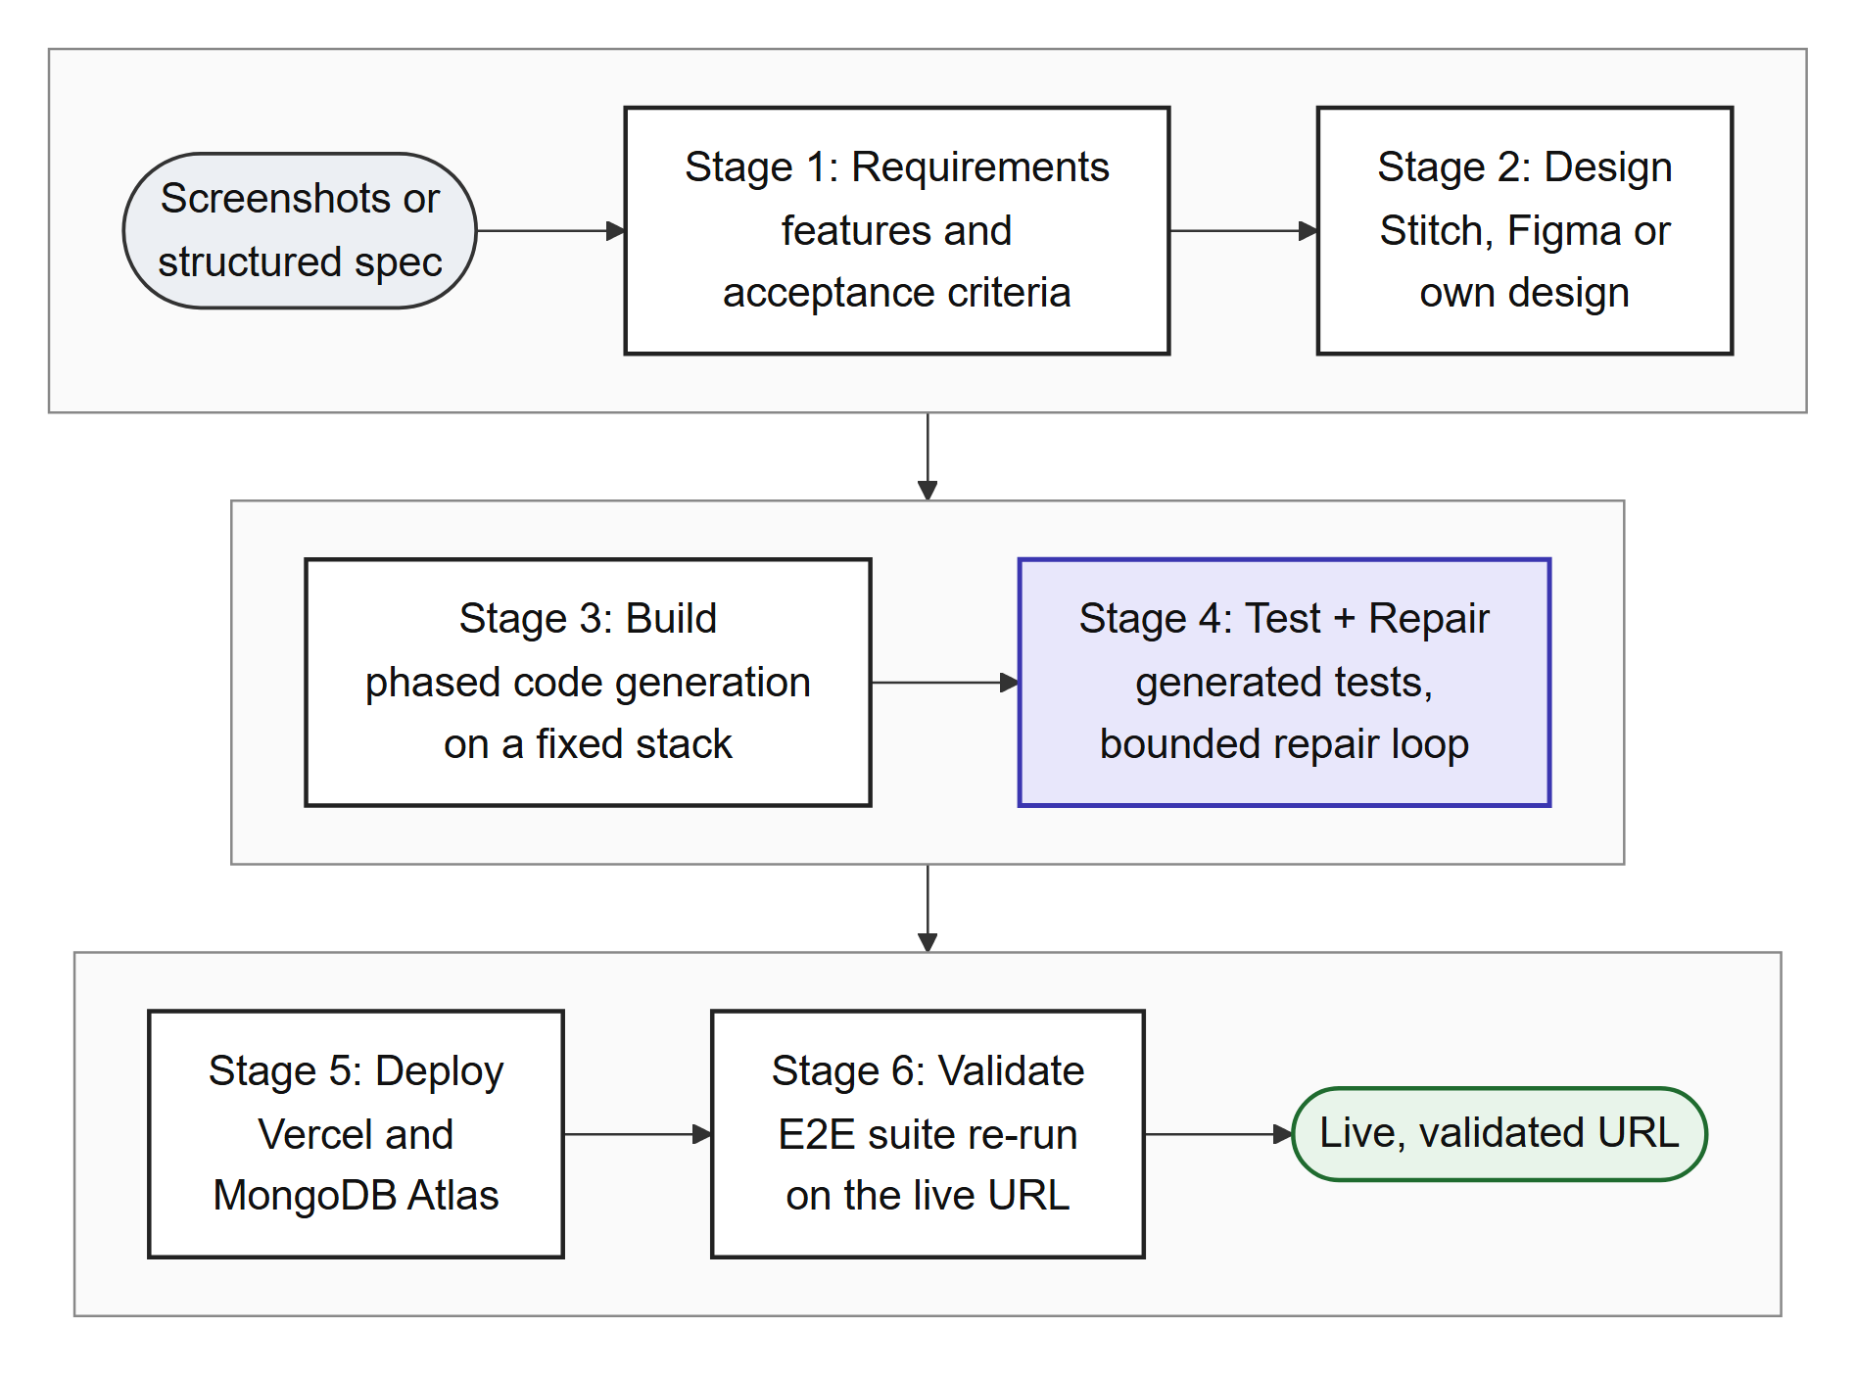
Figure 1.1: The six ForgeFlow stages from an idea to a live, validated URL. Every stage can be refined, skipped or revisited; only deploy after build and validate after deploy are enforced
The human stays in control throughout. No stage is mandatory: a user can start at any stage, refine any output through conversation, skip a stage (and undo the skip), or jump back to an earlier stage, in which case later stages are marked stale rather than deleted. Generated code runs only inside an isolated Docker sandbox created for each project, and an in-browser IDE with an editor, a terminal and a live preview keeps that code visible and editable instead of hiding it behind a chat window.
The project was carried out between July and October 2026 as 65 independently shippable phases grouped into 14 epics, each with a written specification and acceptance criteria. The platform itself is delivered through a six-job continuous integration pipeline and a health-checked continuous deployment to an Oracle Cloud virtual machine and Vercel.

1.2 Problem Statement
Current AI app-builders can generate and deploy web applications, but they cannot reliably verify them. Users get stuck in costly bug-fix loops with no end, nobody checks whether the deployed site actually works, and beginners have no safe way through cloud infrastructure. The problem addressed by this project is to design and build a human-in-the-loop platform that takes a web-app idea (from screenshots or a structured specification) through six stages, namely requirements, design, build, testing with bounded self-healing repair, deployment, and validation of the live site, while letting the user refine, revisit or skip any stage.
Four sub-problems make this statement concrete:
- Verification, not just generation. Requirements must compile into executable tests, and test failures must drive a repair process, so that “done” means “the acceptance criteria pass” rather than “the model stopped writing”.
- A repair process that terminates. Repair must be bounded by an iteration cap, a budget cap and explicit detection of regressions and stalls, and it must hand the problem back to a human with a clear explanation when it cannot converge.
- Truth after deployment. Passing tests in a development sandbox is not evidence that the deployed site works, so the same tests must be run again against the live URL, and live failures must re-enter the same repair process.
- Human control and beginner-safe infrastructure. Every stage must be optional and revisitable, and the platform must work out what infrastructure an application needs (static frontend, backend, database) and deploy it without the user having to understand cloud configuration.

1.3 Scope of the Project
The scope was fixed early through a set of locked design decisions (recorded in the project's implementation plan) so that the work stayed tractable within one academic term and a development budget of ₹6,000.

1.3.1 In scope
- User authentication, a projects dashboard and a per-project workspace delivered as an installable PWA.
- Six optional pipeline stages: requirements, design, build, test with repair, deploy and live validation.
- A web IDE (Monaco editor, xterm.js terminal and live preview) running against per-project Docker sandboxes.
- Pluggable UI design from screenshots or text through Google Stitch (default) or Figma.
- Agentic generation of the fixed React, Express and MongoDB stack, with conversational change requests.
- Structured requirements compiled into unit and Playwright end-to-end tests, with bounded self-healing repair.
- Infrastructure analysis, dual-mode deployment (platform-owned or bring-your-own credentials) and a visual deployment topology.
- Post-deployment validation against the live URL, with a repair path for live failures.
- A per-project database with an in-app data browser, an evaluation harness, an admin configuration dashboard and cost tracking.

1.3.2 Out of scope
- Non-web targets such as mobile, native or desktop applications, and progressive web apps as generated output.
- More than one generated-application stack.
- Payments in generated applications, team collaboration or multiplayer editing, enterprise single sign-on and compliance, and a template marketplace.
Restricting generated applications to one stack is a deliberate trade-off. A single, opinionated target raises first-pass generation success, reduces the number of repair iterations and makes rigorous verification achievable within the project's time and budget.

1.4 Research Hypothesis
The project is built around three hypotheses. They are stated here as claims to be tested; Section 5.7 describes the evaluation protocol designed to test them, and Section 5.8 reports what has been measured so far.
- H1 (bounded repair). A repair loop with an iteration cap, a stall guard, a regression guard and a budget guard reaches most of the pass-rate improvement of an unbounded loop at a substantially lower token cost, because most repair gains occur in the first few iterations.
- H2 (diff-aware context). Giving the repair model only the failing tests, the source files those tests reach and the diff since the last passing run yields a higher repair success rate per token than giving it broader repository context.
- H3 (live validation). Re-running the generated end-to-end suite against the deployed URL detects failures that sandbox testing alone does not, so post-deployment validation is necessary rather than redundant.

1.5 Objectives
The objectives below were set at the first review and guided the phase roadmap:
- Non-linear orchestration. Build a human-in-the-loop workflow in which no lifecycle stage is mandatory and every artifact is versioned and can be revisited.
- Agentic generation. Turn screenshots, prompts or user-supplied designs into a working full-stack web application on the fixed stack.
- Requirements to tests. Capture requirements in a structured form that compiles deterministically into unit and end-to-end tests traceable to individual acceptance criteria.
- Bounded self-healing repair (core contribution). Develop a diff-aware repair loop with retry caps, no-progress detection and human escalation.
- Infrastructure reasoning. Classify each project's deployment needs and carry out dual-mode deployment with a live component topology.
- Post-deployment closure. Validate the live URL after every deployment and repair and redeploy on failure.
- Quantitative evaluation. Measure first-pass versus post-repair success, repair convergence, cost and latency on a reproducible benchmark.
- Isolation and safety. Run untrusted generated code only in per-project sandboxes with per-project databases, so that it never executes in the control plane.

1.6 Mapping to Sustainable Development Goals

1.6.1 Sustainable Development Goals
Table 1.1 maps the project to the United Nations Sustainable Development Goals (SDGs). SDG 9 is the primary goal; SDG 8 is a strong secondary goal; SDG 4 and SDG 12 are supporting goals.
Table 1.1: Mapping of ForgeFlow to the Sustainable Development Goals
Sustainable Development Goal | Strength | Justification
SDG 9: Industry, Innovation and Infrastructure | Primary | Automates the software development lifecycle with AI while keeping it verifiable, and gives beginners a safe, guided path to cloud infrastructure through infrastructure analysis and managed deployment.
SDG 8: Decent Work and Economic Growth | Secondary | Lets startups, small businesses and non-experts ship verified web applications with lower cost and effort, and keeps the human in charge of the work rather than replacing them.
SDG 4: Quality Education | Supporting | Generated code stays visible and editable in an in-browser IDE, so users can see how a full-stack application is built, tested and deployed rather than receiving a black box.
SDG 12: Responsible Consumption and Production | Supporting | Bounded repair, per-project and global budget caps, and role-based model routing reduce wasted compute and avoid runaway token spending.

1.6.2 Programme Outcomes
Table 1.2 maps the project to the twelve Programme Outcomes (POs) of the National Board of Accreditation. PO7 (Environment and Sustainability) is not claimed because the link is weak.
Table 1.2: Mapping of the project to the Programme Outcomes
Programme Outcome | Justification
PO1 Engineering Knowledge | Applies software engineering, databases, distributed systems and AI/LLMs.
PO2 Problem Analysis | The literature survey found that AI app-builders do not verify what they build.
PO3 Design/Development of Solutions | Three-plane architecture: FastAPI control plane, Docker sandboxes and a React PWA.
PO4 Investigation of Complex Problems | Benchmark harness measuring pass rates, repair convergence and cost.
PO5 Modern Tool Usage | LLM APIs, Docker, Playwright, Vercel, MongoDB Atlas, GitHub Actions, Ansible, Kubernetes, Prometheus.
PO6 The Engineer and Society | Makes building software easier for non-experts while the human stays in control.
PO8 Ethics | Sandboxed untrusted code, encrypted secrets, a written threat model and no runaway spending.
PO9 Individual and Team Work | Three-member team with branch, review and merge workflow.
PO10 Communication | IEEE conference paper, three review presentations and this report.
PO11 Project Management and Finance | Phased roadmap, ₹6,000 budget and per-project token cost tracking.
PO12 Life-long Learning | Built on 2025–26 research and new tooling, revisited at every review.

1.7 Project Team and Work Distribution
The project was carried out by a team of three under the guidance of Dr. Payal Kadam. Every change was developed on its own branch, reviewed by another member and then merged. Table 1.3 lists each member's primary contributions, taken from the repository history (11 July to 2 October 2026) and the review presentations; all three members contributed to testing, documentation and the reviews.
Table 1.3: Group members and their contributions
Name | PRN | Primary contributions
Faheemuddin Sayyed | 23070122196 | Repository tooling, data layer, authentication, PWA shell and realtime hub (01–05); sandbox manager, workspace files, terminal, Monaco IDE, live preview and DesignProvider interface (11–16); test generation and test runner (27–28); DB provisioning, deploy orchestration, topology, live validation, data browser, evaluation harness and observability (36–46); phased build, provider compatibility, Vercel backend, preview lifecycle, scope-aware build and layout (56–61); deploy truthfulness, repair reachability and truthful phase completion (62–64); platform CI/CD, Ansible, Kubernetes and monitoring.
Sanidhya Awasthi | 23070122192 | Stage state machine, conversation and artifact model, conductor, workspace UI and sandbox image (06–10); Stitch and Figma design providers, design stage, LLM client and agent tools (17–21); requirements schema and UI (25–26); credential vault and deploy adapters (34–35); security hardening, resilience, PWA, demo and layered configuration (47–51); design clarifying questions; offline test database (65); CI fixes and the DevOps reports.
Raghav Sonchhatra | 23070122172 | Fixed-stack app skeleton, codegen agent loop and build stage (phases 22–24); the self-healing repair core: failure analyzer, diff-aware repair agent, bounded loop controller and repair UI (29–32); infrastructure analyzer (33); admin dashboard UI (52); skeleton clean-up and build verification with self-heal (54–55); patent-disclosure revision and the paper's figures.

1.8 Organization of the Report
The rest of this report is organised as follows. Chapter 2 reviews the literature on LLM-based code generation, program repair, test generation, human-in-the-loop control, design-to-code and deployment, and identifies the research gap. Chapter 3 specifies the software requirements: tools and technologies, hardware, work breakdown, functional and non-functional requirements, cost and schedule. Chapter 4 describes the methodology, covering the architecture, design diagrams and the implementation of each subsystem, with the bounded repair loop treated in most detail. Chapter 5 presents the testing strategy, test cases and results, the defects found during end-to-end validation, the platform's delivery pipeline and the project outcomes. Chapter 6 concludes and outlines future work. References and appendices follow.
Chapter 2

Literature Review

2.1 Background
The literature relevant to ForgeFlow spans several research threads that have, until recently, been studied separately: LLMs across the software lifecycle, agentic code generation, automated program repair, test generation and traceability, human control of AI agents, multimodal design-to-code, and the delivery of agent-written code through CI/CD and deployment. This chapter reviews each thread, concentrating on 2024–26 work, and then identifies the gap that ForgeFlow addresses. Where a cited source is a preprint or an industry survey rather than a peer-reviewed publication, the text says so.

2.1.1 LLMs across the software lifecycle and the adoption–trust gap
Q. Zhang et al. (2026) survey LLMs for software engineering and systematise 926 studies covering 112 tasks across the requirements, design, development, testing and maintenance phases, showing that LLMs are now used throughout the lifecycle rather than only for code completion. Ge et al. (2025), in a preprint survey of vibe coding, describe the user-centric category in which a natural-language request becomes a deployable application, and they distinguish planning-driven and test-driven forms of the practice. These two surveys establish that generation is mature; the question this project takes up is what happens after generation.
Industry surveys show that adoption is high and rising while trust is low. The Stack Overflow 2025 Developer Survey reports that 84% of developers use or plan to use AI tools, up from 76% a year earlier, yet 46% distrust the accuracy of AI output against 33% who trust it (Stack Overflow, 2025). The DORA 2025 report finds that AI adoption now improves delivery throughput but is still associated with lower delivery stability, and that AI amplifies existing practice: teams with fast feedback loops and strong safety nets gain, while weak pipelines ship poor work faster (DORA, 2025). Becker et al. (2025), in a randomised controlled trial with experienced open-source developers, found that tasks took 19% longer when AI tools were allowed, even though the developers believed they had been faster. The CloudBees (2026) industry survey reports that 81% of enterprise technology leaders see more production incidents caused by AI-generated code.

2.1.2 Agentic code generation and issue resolution
Benchmarks such as SWE-bench, which evaluates whether models can resolve real GitHub issues from popular Python repositories, pushed research from function-level generation to repository-level tasks (Jimenez et al., 2024). SWE-agent showed that the interface between an agent and the computer, meaning the commands, file views and test runners the agent can use, strongly affects how well it performs (J. Yang et al., 2024). Multi-agent frameworks followed: MAGIS divides GitHub issue resolution among collaborating agents (Tao et al., 2024), and AgentCoder separates programmer, test-designer and test-executor agents so that generated code is checked against generated tests (D. Huang et al., 2024). Jiang et al. (2025) survey more than 150 primary studies on agentic issue resolution and classify them into benchmarks, techniques and empirical studies.
An influential counter-result is Agentless (Xia et al., 2025). It showed that a simple, fixed three-phase pipeline of localisation, repair and patch validation can match or outperform complex autonomous agents on issue resolution at a much lower cost. ForgeFlow follows this lesson: its pipeline is fixed and deterministic, the project skeleton is copied rather than generated, and the model is called only where real synthesis is needed.

2.1.3 Automated program repair and the economics of iteration
LLM-based program repair is an active field. RepairAgent is an autonomous agent that plans and calls repair tools and fixes real-world defects at competitive rates (Bouzenia et al., 2025). K. Huang et al. (2025), in IEEE Transactions on Software Engineering, show through extensive fine-tuning experiments that repair quality depends heavily on how the repair task is framed and on the context supplied to the model. Olausson et al. (2024) asked whether self-repair is a silver bullet and found that, once the cost of repair is accounted for, the gains are often modest and vary widely, because self-repair is limited by the quality of the model's own feedback. Self-debugging improves results, but only to the extent that execution feedback is informative (X. Chen et al., 2024).
Work from 2026 adds the economic question of how many repair attempts are worth making. Kiecker et al. (2026), in a preprint evaluating LLM-based repair loops, report that the first three to four iterations account for most of the achievable gain while later iterations add little. Arimbur (2026), studying iterative self-repair across seven models and several benchmarks, finds most gains in the first two rounds. Shukla et al. (2025) provide the safety argument: when a model is repeatedly asked to make generated code more secure, security can degrade with further iterations. Taken together, these results argue that a repair loop should be bounded by design, not merely measured after the fact.

2.1.4 Repair context and fault localisation
Several studies show that what the repair model is shown matters more than how much it is shown. Sepidband et al. (2026), in a preprint covering 500 SWE-bench Verified tasks and 61 context configurations, find a 15 to 17 times gain from file-level localisation over a no-file baseline, with the best results at roughly six to ten relevant files, and they observe that expanding context to more lines often adds noise. RepoGraph represents a repository as a line-level code graph and retrieves k-hop ego-graphs as context, which improves software-engineering agents (Ouyang et al., 2025). LocAgent uses dependency graphs and multi-hop search to reach 92.7% file-level localisation accuracy (Z. Chen et al., 2025). These results support ForgeFlow's import-graph walk, which follows the failing test's imports to the file that holds the bug.

2.1.5 Test generation and requirements traceability
LLM-based unit-test generation has been studied at scale. Schäfer et al. (2024) gave an early empirical evaluation of LLM-based unit-test generation for JavaScript. Ouédraogo et al. (2026) compare prompt-engineering strategies for class-level unit tests over a very large number of generated tests, and Shang et al. (2025) fine-tune 37 models across three unit-testing scenarios and five benchmarks. Closer to ForgeFlow's goal, Alian et al. (2025) generate end-to-end tests from application features, and Gu et al. (2025) use hybrid program analysis to guide iterative test generation and improve the validity of generated suites.
A key negative result comes from Haroon et al. (2026), a preprint that evaluates eight LLMs on 22,374 program variants. When the program under test changes, generated tests lose validity, and more than 99% of the new failing tests still pass on the original program: the model tests the code it remembers rather than the code it was given. The authors recommend computing a code diff and highlighting the changed regions to direct the model's attention. This is exactly what ForgeFlow's repair context does. On the requirements side, TraceLLM shows that prompt-engineered LLMs can recover links between requirements and artifacts after the fact (Alturayeif et al., 2026); ForgeFlow instead builds the link in from the start through a criterion identifier that travels from each acceptance criterion to its tests, results and repair context.

2.1.6 Human-in-the-loop control and ambiguity
Industrial practice favours keeping engineers in control. HULA, deployed in Atlassian Jira, lets engineers approve both the coding plan and the resulting code (Takerngsaksiri et al., 2025). Its follow-up names the high cost of correctness testing and the variability of LLM-based evaluation as the main open challenges (Pasuksmit et al., 2025). Observational work finds that professional developers do not simply delegate to agents but continually restrain, monitor and redirect them (R. Huang et al., 2025), and a large-scale preprint analysis of 20,574 real coding-agent sessions finds widespread misalignment between what developers intend and what agents do, with 91.49% of visible misalignment resolutions requiring explicit user correction (Tang et al., 2026).
Ambiguity in requirements is a related problem. ClarifyCodeBench shows that strong code generators are not necessarily good at asking clarifying questions, and clarification quality degrades as ambiguity increases (Fang et al., 2026). The agentic software-engineering roadmap of Hassan et al. (2025) calls for agents that initiate callbacks to humans when they meet ambiguity. ForgeFlow applies this by routing a design provider's question to the user instead of silently falling back to another provider.

2.1.7 Multimodal design-to-code
Design2Code benchmarks multimodal models on converting 484 real web pages into code and shows that models still lag in recalling visual elements and reproducing layout (Si et al., 2025). For this reason ForgeFlow treats design as a pluggable, human-refinable stage with versioned artifacts and an explicit skip path, rather than a one-shot conversion whose output is passed downstream unchecked.

2.1.8 Deployment, CI/CD and the delivery of agent-written code
Deployment is a separate failure mode from code quality. T. Zhang et al. (2026), in work accepted at FSE 2026, evaluate LLM-generated infrastructure-as-code across 153 real-world scenarios and 58 cloud services and report first-attempt deployment success of only 20.8% to 30.2%. Ghammam and Almukhtar (2026) mine AI-generated build code and find that agents systematically introduce maintainability and security smells.
Mining-software-repositories research from 2026 shows that continuous integration is now where an agent's work is judged. Li et al. (2025) built the AIDev dataset of more than 456,000 agent-authored pull requests from five agents across 61,000 repositories and found that agents are faster than humans but have their pull requests accepted less often. Ehsani et al. (2026) analyse 33,000 agentic pull requests and find that rejected ones are larger, touch more files and often fail the project's CI/CD checks. Ghaleb (2026) reports that changes to CI/CD configuration make up only 3.25% of agent changes and are merged less often than other changes. Fixing what CI rejects remains hard: on CI-Repair-Bench, which validates every candidate fix by re-running the full CI workflow on 567 real failures from 103 repositories, the best model fixes only 18.9%, and environment, dependency and configuration failures are the hardest classes (Muna et al., 2026).

2.1.9 Sandboxing, cost and model routing
Running untrusted, model-generated code needs strong isolation. SandboxEval documents how wide the attack surface of naively configured execution environments is (Rabin et al., 2025), which is why ForgeFlow treats the sandbox boundary, rather than the model's behaviour, as the security control. On cost, RouteLLM learns to route each request between a stronger and a weaker model using preference data and reduces cost by more than half without losing quality (Ong et al., 2025). ForgeFlow applies a simpler, role-based version of the same idea, sending classification and routing work to a cheap model and only real code work to the code-generation model, which directly addresses the cost-of-correctness-testing challenge named by Pasuksmit et al. (2025).

2.2 Summary of Literature Review and Research Gap

2.2.1 Summary of the reviewed literature
Table 2.1 summarises the most relevant sources, their main findings and how each one shaped ForgeFlow.
Table 2.1: Summary of the literature review
Source | Key finding | Relevance to ForgeFlow
Q. Zhang et al. (2026) | Survey of 926 studies on 112 SE tasks across five lifecycle phases. | Generation across the lifecycle is mature; verification is the open problem.
Ge et al. (2025) | Survey formalising vibe coding, including test-driven variants. | Defines the prompt-to-app category ForgeFlow belongs to.
Stack Overflow (2025) | 84% adoption, 46% distrust vs 33% trust of AI output. | Motivates verification and visibility of generated code.
DORA (2025) | AI raises throughput but correlates with lower delivery stability. | Motivates gated delivery and live validation.
Becker et al. (2025) | RCT: experienced developers 19% slower with AI while feeling faster. | Perceived and real productivity differ; outcomes must be measured.
CloudBees (2026) | 81% of leaders report more AI-caused production incidents. | Failures reach production; validate after deployment.
Jimenez et al. (2024) | SWE-bench: real GitHub issues as a benchmark. | Repository-level, test-validated evaluation.
J. Yang et al. (2024) | Agent-computer interface strongly affects agent success. | Strict, sandbox-bound tool surface for agents.
Xia et al. (2025) | Simple fixed pipeline matches complex agents at lower cost. | Deterministic pipeline; skeleton copied, not generated.
Bouzenia et al. (2025) | Autonomous repair agent with tool planning. | Contrast: ForgeFlow bounds the agent inside a controller.
K. Huang et al. (2025) | Repair quality depends on task framing and context. | Minimal, structured repair context.
Olausson et al. (2024) | Self-repair gains are modest once cost is counted. | Repair must be costed and bounded.
Kiecker et al. (2026) | Most repair gain in the first three to four iterations. | Default iteration cap of 5 and stall guard of 2.
Arimbur (2026) | Most gains in the first two rounds across seven models. | Supports early stopping.
Shukla et al. (2025) | Iterative “make it secure” prompting can degrade security. | Unbounded loops are unsafe, not just wasteful.
Sepidband et al. (2026) | File-level localisation gives 15–17x gain; 6–10 files is best. | Per-file and whole-context character caps.
Ouyang et al. (2025) | Repository code graph improves SE agents. | Graph-shaped repair context.
Z. Chen et al. (2025) | Graph-guided localisation reaches 92.7% file accuracy. | Import-graph walk from the failing test.
Haroon et al. (2026) | >99% of failing generated tests pass on the old program; highlight diffs. | Diff since last passing run in repair context.
Alian et al. (2025) | Feature-driven end-to-end test generation. | Acceptance criteria compiled to Playwright tests.
Alturayeif et al. (2026) | LLMs recover requirement-artifact links. | ForgeFlow builds traceability in via criterion_id.
Takerngsaksiri et al. (2025) | HULA keeps engineers in control in Jira. | Every stage is refinable, skippable and revisitable.
Pasuksmit et al. (2025) | Open challenge: cost of correctness testing. | Role-based model routing and budget caps.
Tang et al. (2026) | Agent-developer misalignment in 20,574 sessions. | Human approval and reversible skips.
Fang et al. (2026) | Code generators are poor clarifiers. | Provider questions routed to the user.
Si et al. (2025) | Design-to-code still lags on layout fidelity. | Design is a pluggable, human-refinable stage.
T. Zhang et al. (2026) | 20.8–30.2% first-attempt IaC deployment success. | Infrastructure analyzer and truthful deployment.
Muna et al. (2026) | Best LLM fixes 18.9% of real CI failures. | Environment failures never reach the repair agent.
Rabin et al. (2025) | Naive execution sandboxes are easy to escape. | Hardened per-project Docker sandboxes.
Ong et al. (2025) | Learned routing halves cost without quality loss. | Cheap model for routing, capable model for code.

2.2.2 Research gap
The reviewed work falls into three groups. Research agents and benchmarks (for example SWE-agent, Agentless and RepairAgent) generate and repair code but stop before deployment. LLM test-generation and repair tools improve individual steps but are not part of a delivery system. Commercial prompt-to-app builders generate and deploy applications but do not verify them against the user's requirements, do not validate the deployed site, and offer no principled stopping rule when fixes fail. Table 2.2 compares these groups with ForgeFlow.
Table 2.2: Capability comparison across classes of systems
Capability | Research agents | LLM test / repair tools | Commercial builders | ForgeFlow
Multimodal design intake (screenshot to UI) | No | No | Yes | Yes (pluggable)
Full-stack application generation | Partial | No | Yes | Yes (fixed stack)
Requirements to executable, traceable tests | No | Partial | No | Yes
Bounded repair: iteration cap and stall detection | No | No | No | Yes
Diff-aware minimal repair context | No | Partial | No | Yes
Human escalation on non-convergence | No | No | No | Yes
Automated cloud deployment | No | No | Yes (locked-in) | Yes (dual-mode)
Post-deployment live validation | No | No | No | Yes
Non-linear, skip-any-stage control | No | No | Partial | Yes
Per-run cost accounting and budget caps | No | No | No | Yes

The gap can therefore be stated precisely: no existing system combines requirement-derived verification, a repair loop that is bounded by construction and escalates to a human, deployment, and validation of the live artifact, within a workflow where the human can enter, skip or revisit any stage. Research systems verify but do not deploy; commercial builders deploy but do not verify; neither validates the live site, and none bounds the repair loop.
Table 2.3 lists the specific gaps identified in the literature and the ForgeFlow mechanism designed in response to each.
Table 2.3: Identified gaps and the corresponding ForgeFlow design response
Gap identified | Evidence | ForgeFlow response
AI-generated code has systematic quality and security flaws | Ghammam & Almukhtar (2026); Zhao et al. (2026) | Verification over generation: requirements compile into executable tests
Repair gains stop after a few iterations; iterating can degrade security | Kiecker et al. (2026); Arimbur (2026); Shukla et al. (2025) | Iteration cap 5, stall guard 2, regression guard 2, no-op guard 2, budget guard
The right file matters more than more context | Sepidband et al. (2026); Ouyang et al. (2025); Z. Chen et al. (2025) | Import-graph repair context with character caps and a bounded file request
Generated tests lose validity when code changes | Haroon et al. (2026) | Diff since the last passing run included in every repair context
Deployment fails separately from code quality | T. Zhang et al. (2026) | Infrastructure analyzer, mirrored environment variables, real provider logs, database pre-flight check
Environment and configuration failures are the hardest CI class | Muna et al. (2026) | Environment failures classified first and escalated with zero repair iterations
Users must correct and override agents | Tang et al. (2026); R. Huang et al. (2025) | Reversible skips, human approval of a build, conductor-owned transitions
Models guess when a brief is ambiguous | Fang et al. (2026); Hassan et al. (2025) | Design-provider questions parked and routed to the user
Cost of correctness testing is an open challenge | Pasuksmit et al. (2025); Ong et al. (2025) | Role-based model routing, per-run cost accounting, budget caps

Chapter 3

Software Requirements Specification
This chapter specifies what ForgeFlow must do and the conditions under which it must do it. It lists the software and hardware used, the work breakdown, the functional and non-functional requirements, the cost estimate and the project schedule.

3.1 Software Tools, Platform and Frameworks Used
ForgeFlow involves two distinct software stacks: the stack of the platform itself, and the fixed stack of every application it generates. Keeping them separate is a design decision. The platform is written in Python because Python suits the agent loop, Docker orchestration and asynchronous I/O, while generated applications are always Node.js and React. Table 3.1 lists the platform's tools and their specific use.
Table 3.1: Platform software stack and the specific use of each tool
Tool or framework | Version | Specific use in ForgeFlow
Python | 3.11 | Language of the control plane (agents, orchestration, sandbox management).
FastAPI and Uvicorn | 0.115+ | REST API and WebSocket server; asynchronous request handling for long agent, Docker and provider calls.
Pydantic v2 and pydantic-settings | 2.7+ | Typed schemas at every boundary; rejects malformed LLM output; layered configuration.
Motor and Beanie | 3.5+ / 1.26+ | Asynchronous MongoDB driver and typed ODM for the control-plane database forgeflow_meta.
docker (Python SDK) | 7.1+ | Creates, limits, executes in and reaps per-project sandbox containers.
anthropic and openai SDKs | 0.39+ / 1.40+ | Two LLM transports behind one seam: Anthropic Messages and any OpenAI-compatible Chat Completions endpoint.
httpx | 0.27+ | HTTP calls to design and deployment providers (Stitch, Figma, Vercel, Render).
cryptography (Fernet) | 43+ | Encrypts provider tokens and secret settings at rest.
python-jose and passlib (bcrypt) | 3.3+ / 1.7+ | JWT session tokens and bcrypt password hashing.
prometheus-client | 0.20+ | Exposes /metrics with request counts, latency histograms and build information.
pytest and pytest-asyncio | 8.2+ | Backend unit and integration tests (1,592 test functions).
ruff, black, mypy | current | Linting, formatting and static type checking of the control plane.
React and React Router | 18.3 / 6.28 | Platform PWA: dashboard, workspace, stage panels, admin dashboard.
Vite and TypeScript (strict) | 5.4 / 5.5 | Frontend build tooling and type safety.
Tailwind CSS | 3.4 | Semantic design tokens with light and dark themes.
Zustand and TanStack Query | 4.5 / 5.59 | Client UI state and server-state caching with automatic refetch on stage transitions.
Monaco Editor and xterm.js | 0.52 / 5.5 | In-browser IDE editor and terminal bridged to the sandbox shell.
@xyflow/react (React Flow) | 12 | Interactive deployment topology with per-node status, logs and redeploy controls.
vite-plugin-pwa (Workbox) | 0.20 | Installable PWA with an offline application shell.
framer-motion, react-resizable-panels, lucide-react | current | Micro-interactions, resizable and collapsible workspace panels, icons.
Vitest and Testing Library | 2.1 / 16 | Frontend unit tests (449 test cases).
ESLint and Prettier | 8.57 / 3.3 | Frontend linting and formatting.

Every application that ForgeFlow generates uses the fixed stack in Table 3.2. It is shipped as an opinionated skeleton in templates/app-skeleton that is copied, never generated, into each project's workspace.
Table 3.2: Fixed stack of every generated application
Tool | Version | Specific use in generated applications
React, React Router, Vite, TypeScript | 18.3 / 6.26 / 5.4 / 5.6 | Single-page frontend with a typed API client.
Tailwind CSS | 3.4 | Styling of generated pages from the design artifact.
Node.js, Express, TypeScript | 20 / 4.21 / 5.6 | REST backend with health route, error middleware and configuration.
MongoDB and Mongoose | 8.7 | Persistence through generated Mongoose schemas; connection cached for serverless functions.
Zod | 3.23 | Request validation on the backend.
Vitest and Testing Library | 2.1 / 16 | Frontend unit tests generated from acceptance criteria.
Jest, supertest, ts-jest | 29 / 7 / 29 | Backend unit tests that exercise the Express app in-process.
mongodb-memory-server-core | 11.2 | Real in-memory MongoDB for tests inside the offline sandbox.
Playwright | 1.48.2 | End-to-end tests run against the sandbox preview and again against the live URL.

Table 3.3 lists the external services and the tools used to deliver, run and monitor the platform itself.
Table 3.3: External services and DevOps tooling
Service or tool | Specific use
MongoDB Atlas | Shared cluster that hosts one isolated database per deployed generated application.
Vercel | Hosts the platform PWA and the generated applications (static frontend plus an Express function backend).
Render (optional) | Alternative backend host for a persistent process, behind DEPLOY_BE_PROVIDER=render.
Google Stitch and Figma (MCP) | Design providers: image-to-UI and text-to-UI, with Figma as the alternative.
Docker Engine, Colima, Docker Compose | Local development runtime and the production stack (api, mongo, appdb, caddy).
Caddy | Reverse proxy that routes each project's preview subdomain to its sandbox container.
nginx and Let's Encrypt | TLS termination and WebSocket upgrade on the production virtual machine.
GitHub Actions and GHCR | Six-job CI on every push; CD that builds a multi-architecture image and deploys it with rollback.
Ansible | Idempotent provisioning of the Oracle Cloud VM with seven roles.
k3s (Kubernetes) | Orchestration demonstration: Deployment, StatefulSet, rolling update and rollback.
Prometheus, Grafana, exporters | Metrics scraping, a 16-panel dashboard and ten alert rules.
gitleaks, pip-audit, pnpm audit | Secret scanning over full history and dependency vulnerability audits in CI.

3.2 Hardware Requirements
Table 3.4 lists the hardware used for development and production. Because generated code runs in containers with fixed limits, the server's capacity determines how many projects can build or test at the same time.
Table 3.4: Hardware requirements
Component | Specification
Development workstation | Windows 11 or macOS laptop, 4 or more CPU cores, 16 GB RAM recommended, 30 GB free disk; Docker Desktop or Colima, Node.js 20, Python 3.11.
Production server | Oracle Cloud Infrastructure VM.Standard.A1.Flex (Ampere Altra, arm64): 3 OCPU, 16 GB RAM, about 50 GB boot volume, Ubuntu 24.04 LTS, 2 GB swap.
Control-plane container | Limited to 2 CPU and 4 GB memory; one Uvicorn worker by design.
Per-project sandbox | 1 CPU, 1 GB memory, at most 256 processes; reaped after 15 minutes idle.
Client | Any modern browser (Chrome, Edge or Firefox); ForgeFlow can be installed as a PWA.

3.3 Work Breakdown Structure
The work was decomposed into 65 phases grouped into 14 epics (numbered 0 to 13) and five milestones. Each phase has its own specification in the repository's plans folder with a goal, dependencies, file-level tasks, an out-of-scope list and testable acceptance criteria, and a phase was marked done only when all of its acceptance criteria passed. Epics 12 and 13 and the later phases were added in response to issues found during live use. Figure 3.1 shows the breakdown.
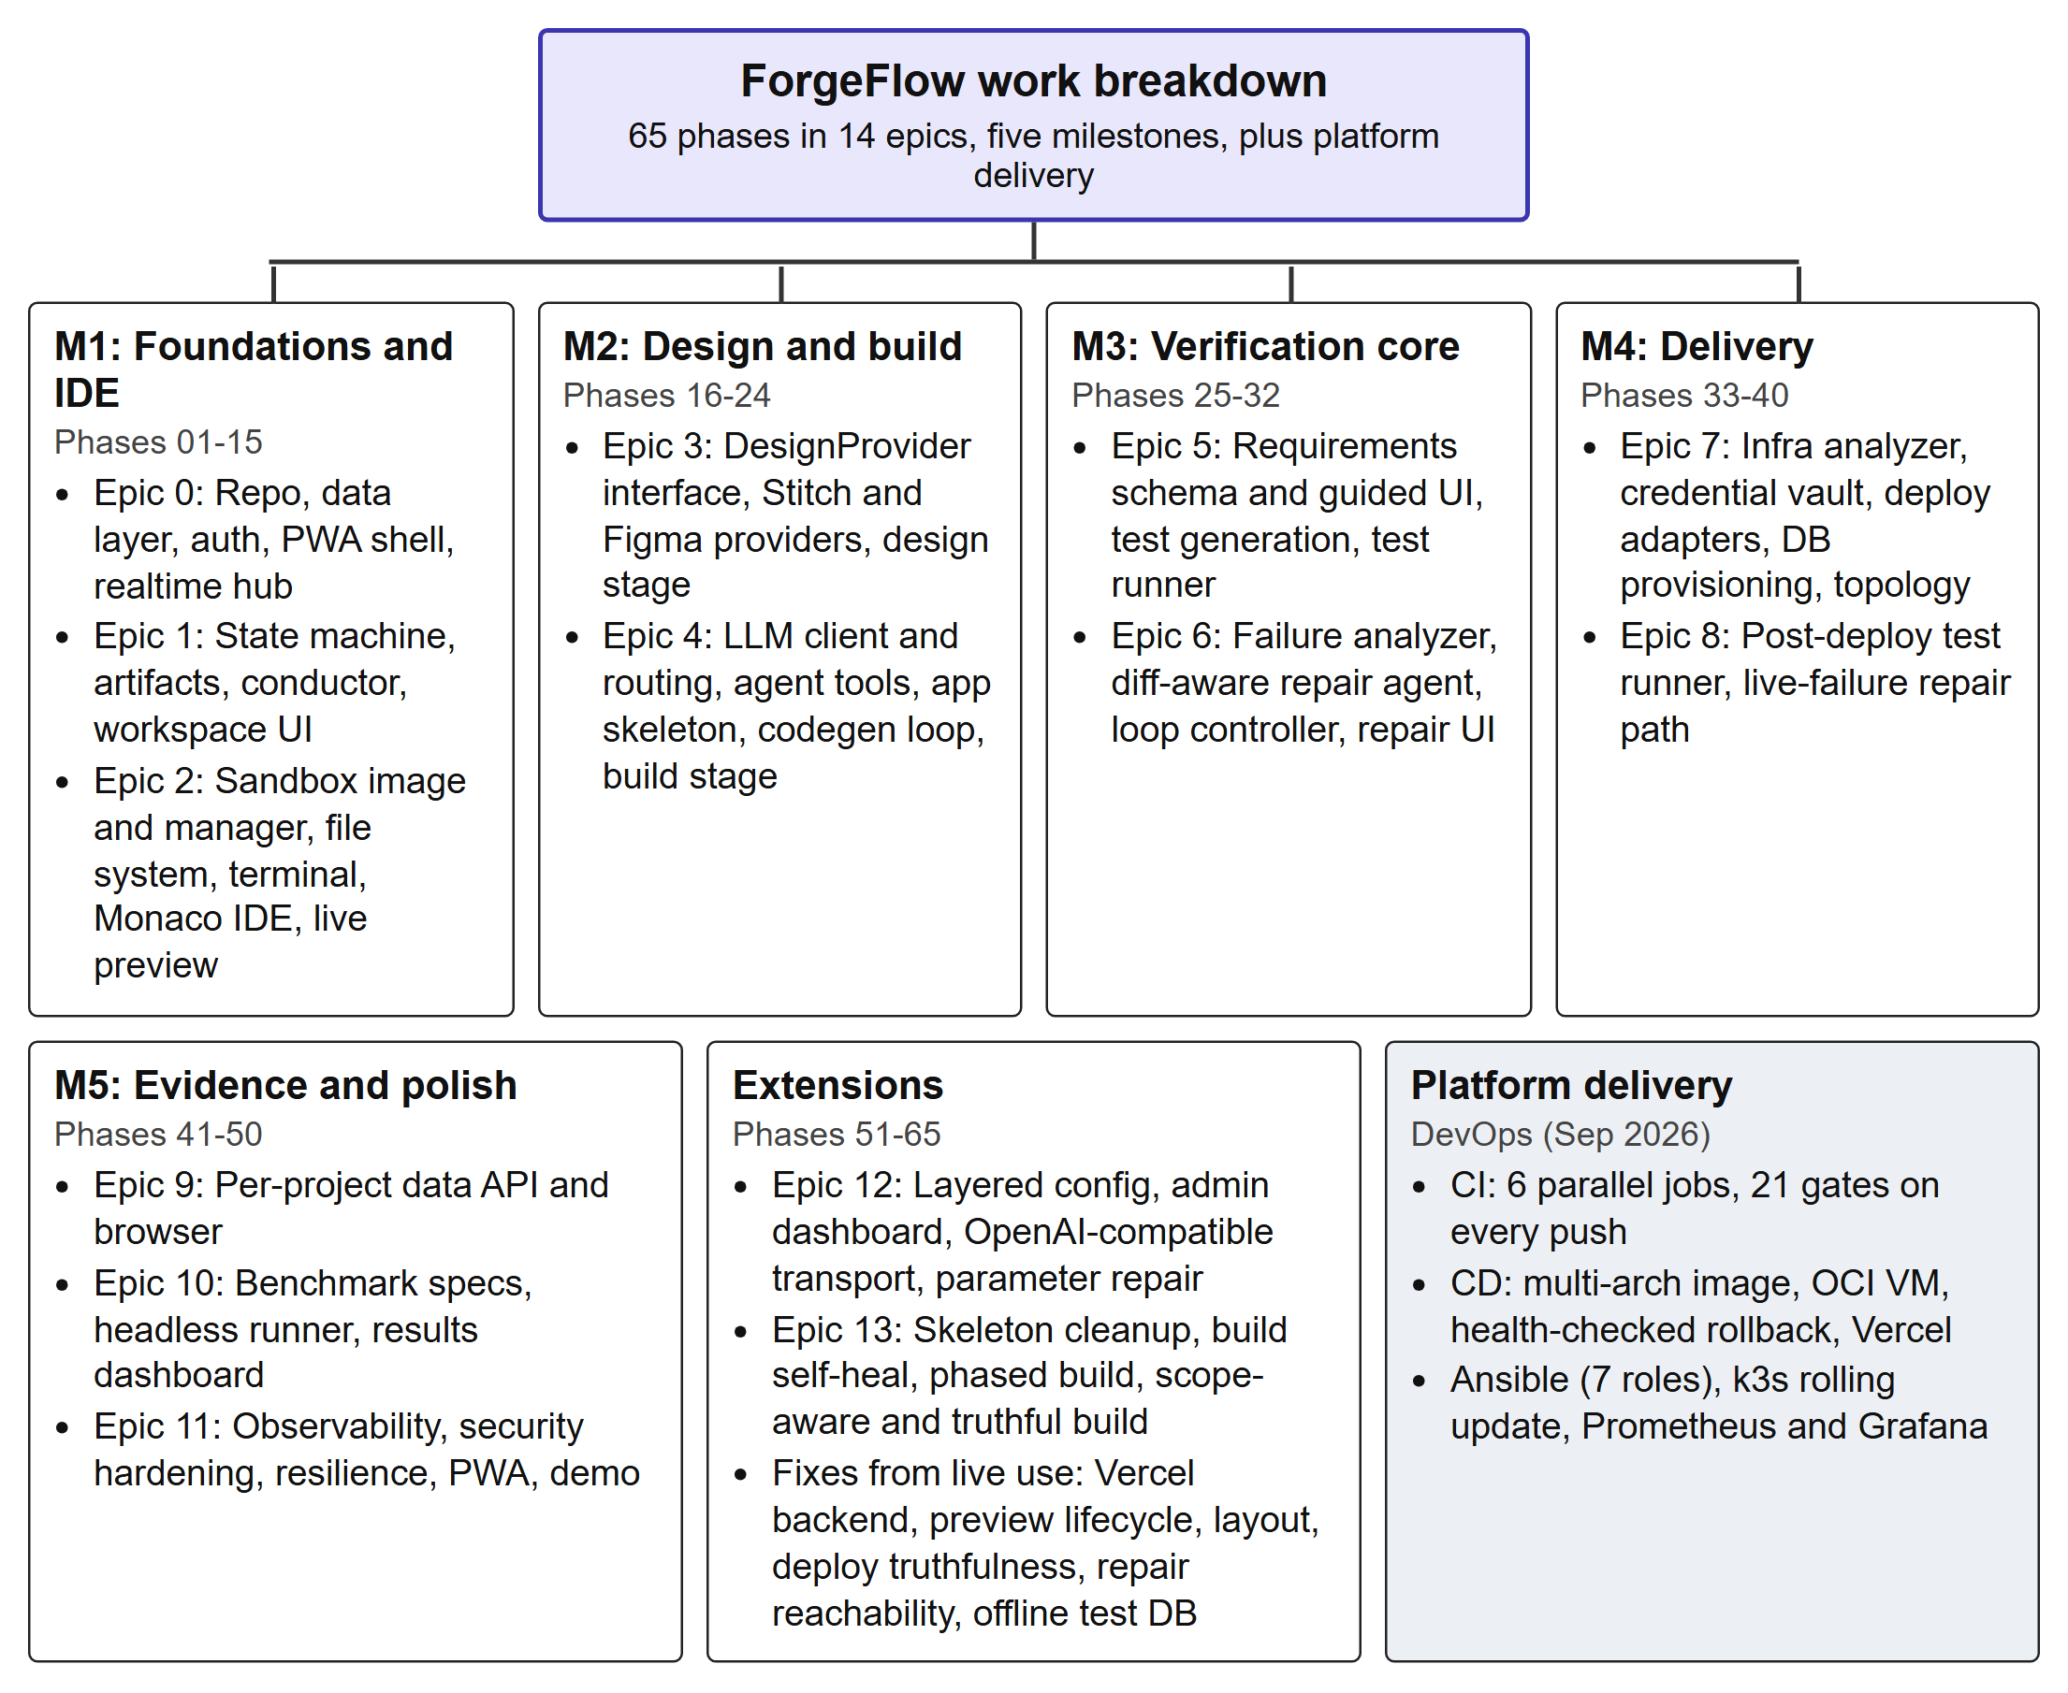
Figure 3.1: Work breakdown structure of ForgeFlow
The milestones were defined so that each one leaves a runnable system. M1 delivered an authenticated workspace with a working web IDE, terminal and preview over sandboxes; M2 turned screenshots or text into a design and a generated, running application; M3 delivered requirements-to-tests and the bounded repair loop; M4 delivered deployment, the topology view and live validation; and M5 added the data browser, the evaluation harness, hardening, PWA polish and the demonstration scenario.

3.4 Functional Requirements
Figure 3.2 shows the actors and the main use cases. The user drives the pipeline; the administrator configures the platform and monitors cost; external providers supply language models, designs and hosting.
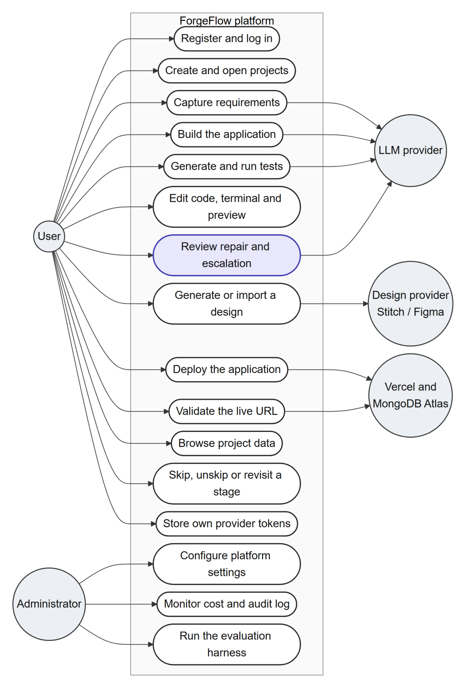
Figure 3.2: Use case diagram of ForgeFlow
Table 3.5 lists the functional requirements and the subsystem that realises each one.
Table 3.5: Functional requirements
ID | Requirement | Realised by
FR-1 | Register, log in and manage projects; each project has its own workspace, sandbox and database. | Auth, project service
FR-2 | Accept an app idea as screenshots or a structured specification. | Requirements and design stages
FR-3 | Capture requirements as features with inputs, expected behaviours and acceptance criteria, through a guided form or an AI draft that is never auto-saved. | RequirementSpec, requirements UI
FR-4 | Generate a UI design from text or screenshots, refine it conversationally, import an own design or skip the stage. | DesignProvider (Stitch, Figma)
FR-5 | Generate a working full-stack application on the fixed stack and stream the code live into the IDE. | Codegen agent, build stage
FR-6 | Accept conversational change requests and route small changes to an incremental pass. | Scope classifier, build stage
FR-7 | Compile acceptance criteria into unit and end-to-end tests, each tagged with its criterion_id. | Test-generation agent
FR-8 | Run tests in the sandbox and report structured per-test results. | Test runner and parsers
FR-9 | Repair failures with a bounded, diff-aware loop and escalate to the user when it cannot converge. | Repair loop controller
FR-10 | Analyse the application's infrastructure needs and deploy the frontend, backend and database in order. | Infra analyzer, deploy orchestrator
FR-11 | Support platform-owned (seamless) and bring-your-own credentials, stored encrypted. | Secret vault
FR-12 | Show a live deployment topology with status, provider logs, redeploy and teardown. | Topology UI
FR-13 | Re-run the end-to-end suite against the live URL and send live failures to repair and redeploy. | Live validation controller
FR-14 | Let the user enter, refine, skip, unskip or revisit any stage, and approve a build. | Conductor, state machine
FR-15 | Provide an in-browser editor, terminal, live preview and a per-project data browser. | Web IDE, data browser
FR-16 | Let an administrator configure every platform setting, monitor cost and review an audit log. | Admin dashboard
FR-17 | Run benchmark specifications headlessly and report pass rates, iterations, cost and time. | Evaluation harness

3.5 Non-Functional Requirements
Table 3.6: Non-functional requirements
ID | Quality attribute | Requirement
NFR-1 | Non-linearity | No stage is mandatory; the only hard prerequisites are deploy after build and validate after deploy. Refining a stage marks later stages stale but never deletes them.
NFR-2 | Isolation and security | Untrusted generated code runs only in sandboxes: non-root, all capabilities dropped, no new privileges, read-only root, no host network, CPU, memory and process limits.
NFR-3 | Data isolation and secrets | One database per project; provider tokens encrypted at rest, decrypted only at call time, never logged or returned to the client.
NFR-4 | Boundedness | Every loop has a hard bound: repair iterations, stalls, regressions, empty attempts, tool turns, build phases and wall-clock time.
NFR-5 | Cost discipline | Models are chosen by role; token usage and rupee cost are recorded per run; per-project and global budget caps halt work with a warning at 80%.
NFR-6 | Reliability | Provider failures degrade gracefully; long tasks are event-driven and resumable from a sequence number after a disconnect.
NFR-7 | Auditability | Artifacts are versioned, never overwritten; every repair attempt and configuration change is recorded.
NFR-8 | Usability | Installable PWA with light and dark themes, resizable panels, a focus mode and generated code that stays visible and editable.
NFR-9 | Maintainability | Full type hints and strict TypeScript; ruff, black, mypy, ESLint and Prettier clean; one specification per phase.
NFR-10 | Portability | No code above the LLM transport assumes a vendor's request shape, model names or error format.
NFR-11 | Observability | Structured JSON logs, per-run traces, a cost dashboard and Prometheus metrics with bounded label cardinality.

3.6 Project Cost Estimation
The project was planned against a development and demonstration budget of ₹6,000, almost all of it for language-model API usage. Hosting and tooling were kept within free tiers. Table 3.7 gives the estimate. Actual model spending is recorded per project and per run by the platform's own cost tracking, and the budget caps in the admin dashboard prevent it from exceeding the allocation.
Table 3.7: Project cost estimation
Item | Basis | Estimated cost (₹)
LLM API usage (development, demonstration, evaluation) | Planned allocation, enforced by budget caps | 6,000
Production server | Oracle Cloud Always Free Ampere A1 allowance | 0
Frontend and generated-app hosting | Vercel Hobby tier | 0
Generated-app databases | MongoDB Atlas M0 shared cluster | 0
Design generation | Google Stitch free quota (about 350 generations per month) | 0
Source control, CI/CD and container registry | GitHub, GitHub Actions and GHCR free tiers | 0
Domain name and TLS certificates | Dynu dynamic DNS and Let's Encrypt | 0
Development hardware | Team members' existing laptops | 0
Software tools and libraries | Open-source | 0
Total planned cash outlay |  | 6,000

3.7 Project Plan and Schedule
Development ran from 11 July 2026, when the repository and the implementation plan were created, to the final review at the end of October 2026. The first prototype covering all five milestones was built quickly, between 12 and 22 July, because the phase specifications had been written in advance. The following months were spent hardening the system against problems found in live use, writing the paper and the invention disclosure, automating the platform's own delivery, and preparing the evaluation. Figure 3.3 shows the schedule. Dates for development work come from the repository history; review dates come from the review presentations.
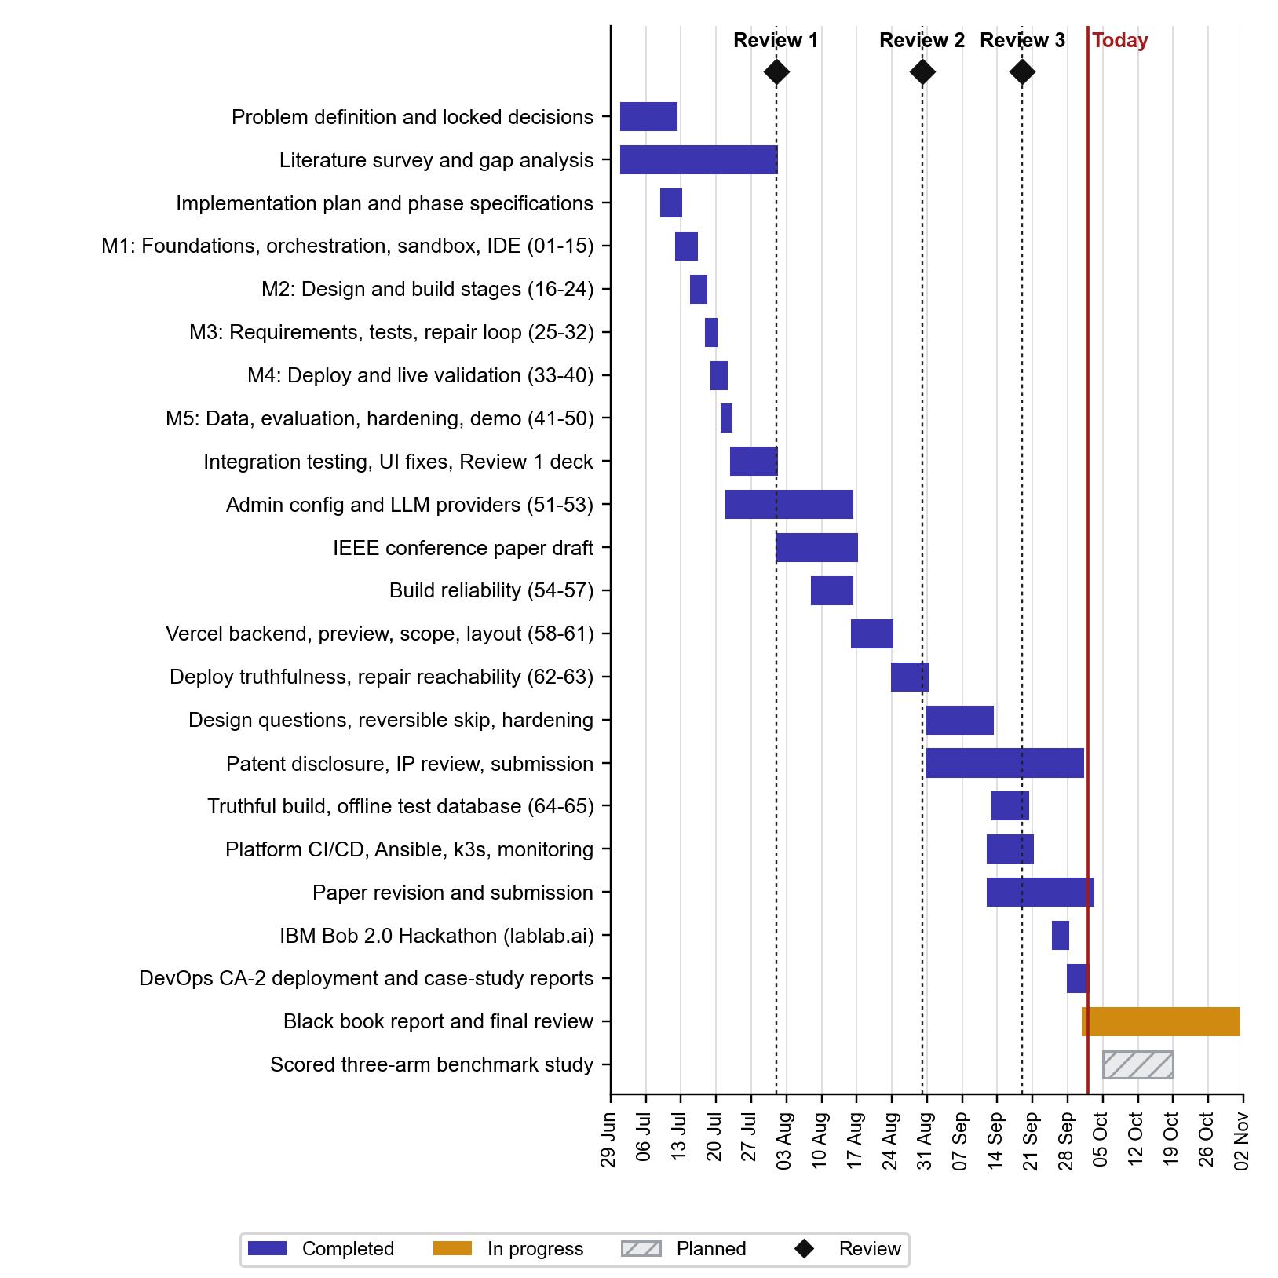
Figure 3.3: Gantt chart of the project, July to October 2026
Table 3.8: Planned versus achieved milestones
Milestone | Planned | Status (2 October 2026)
M1 to M5: first end-to-end prototype (phases 01–50) | July 2026 | Achieved 22 July
Review 1: working prototype and literature survey | 1 August | Achieved
Admin configuration and multi-provider LLM support (51–53) | August | Achieved
IEEE conference paper draft | Mid-August | Draft 16 August; submitted, under review
Build reliability and live-use fixes (54–63) | August | Achieved by 30 August
Review 2: research gaps, design mapping, tools | 30 August | Achieved
Truthful build and offline test database (64–65) | September | Achieved 19 September
Review 3: end-to-end verification on real deployments | 19 September | Achieved
Platform CI/CD, configuration management, orchestration, monitoring | September | Achieved 20 September
Invention disclosure | September | Submitted for filing
IBM Bob 2.0 Hackathon submission | 25–27 September | Submitted
Scored three-arm benchmark study | Weeks 8–10 | Industry benchmarks done; application corpus partial (Section 5.8)
Final report and review | October | In progress

Chapter 4

Methodology
This chapter describes how ForgeFlow was designed and built. It begins with the principles behind the design and the overall architecture, presents the design diagrams (data flow, state, entity-relationship, class and activity diagrams), and then describes the implementation of each subsystem, with the bounded repair loop treated in most detail because it is the project's core contribution. The chapter ends with the user interface and with the pipeline that delivers the platform itself.

4.1 Overview of the Proposed Solution
ForgeFlow carries a web-application idea from intake to a live, validated URL. The user supplies screenshots or a written specification; ForgeFlow helps capture structured requirements, produces a UI design, generates the application, generates tests from the requirements, repairs failures within strict bounds, deploys the application and checks that the deployed site behaves as the requirements say. Six design principles, fixed at the start of the project, govern every subsystem:
- P1: Verification over generation. The defensible contribution is knowing when the system is finished, not how quickly it emits code.
- P2: One fixed generated-app stack. Every generated application is React with Vite and TypeScript, Express with TypeScript, and MongoDB through Mongoose, tested with Vitest, Jest with supertest, and Playwright. A hand-written skeleton is copied rather than generated, which removes scaffolding tokens entirely and follows the lesson of Agentless (Xia et al., 2025).
- P3: Cost discipline as an architectural concern. Models are selected by role: a cheap model for classification, summaries and routing, and the code-generation model only for real code, test and repair work. Every call is costed and checked against budget caps.
- P4: Never overwrite; always version. Designs, code changes, requirements, test suites, test runs, repair attempts, deployments and infrastructure plans are stored as new versions, which makes revisiting a stage safe.
- P5: Untrusted code runs only in sandboxes. The control plane never executes generated code. The sandbox boundary, not the model's good behaviour, is the security control (Rabin et al., 2025).
- P6: Non-linearity is an invariant. No stage is mandatory, and every downstream stage tolerates missing or stale upstream artifacts.

4.2 System Architecture
ForgeFlow is organised into three planes and an external provider boundary (Figure 4.1).
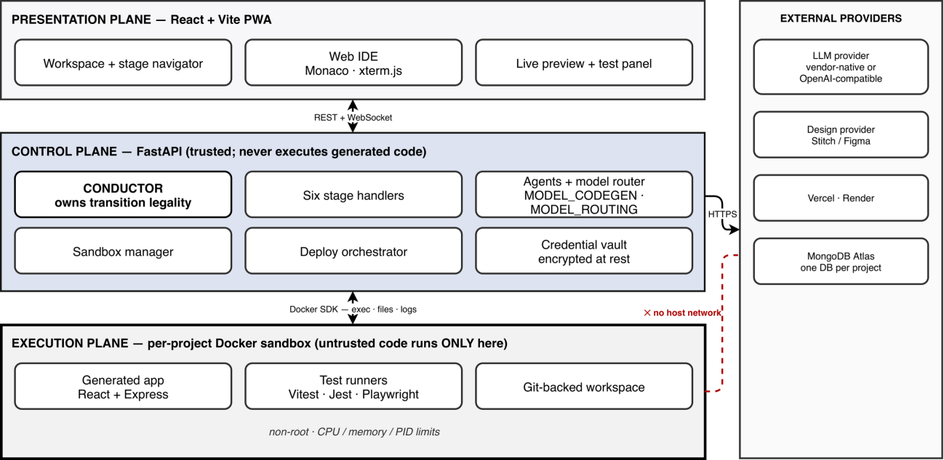
Figure 4.1: System architecture: the presentation, control and execution planes and the external provider boundary. Untrusted generated code executes only inside the per-project sandbox, which has no host network
- Control plane. A FastAPI service in Python 3.11 with Pydantic v2 schemas at every boundary and Motor and Beanie over MongoDB. It contains authentication, the project lifecycle and stage state, the conductor, the stage handlers, the agent layer and model router, the sandbox manager, the deployment orchestrator, the encrypted credential vault, the evaluation harness, the layered configuration service and a WebSocket hub. Control-plane metadata lives in the forgeflow_meta database.
- Execution plane. One Docker container per active project, holding a git-backed workspace, the generated application, its development servers (proxied as a live preview) and the test runners. Git is not incidental: the diff since the last passing run, which the repair loop depends on, is computed from it.
- Presentation plane. An installable React 18 PWA: dashboard, workspace with a clickable stage navigator, Monaco IDE that renders code as the agent writes it, xterm.js terminal, live preview, test and repair panel, React Flow deployment topology, project data browser and admin dashboard.
- External providers. LLM providers (Anthropic or any OpenAI-compatible endpoint), design providers (Stitch or Figma), hosting (Vercel, with Render as an option) and MongoDB Atlas.
All long-running work is event-driven. Each realtime event carries the fields event, project_id, stage, payload and seq. The browser subscribes per project over one WebSocket and, after a disconnect, resumes from the last sequence number it saw, so a page reload does not lose an in-flight build or repair loop. Build runs are detached from the request that started them, so they survive a closed tab or a proxy timeout.

4.2.1 Data flow diagrams
Figure 4.2 is the context-level data flow diagram. ForgeFlow exchanges requirements, guidance and approvals with the user, settings and cost information with the administrator, minimal-context prompts and generated code with the LLM provider, briefs and screens with the design provider, and build output, URLs and logs with the hosting provider; it also provisions a per-project database on MongoDB Atlas and receives its connection URI and status.
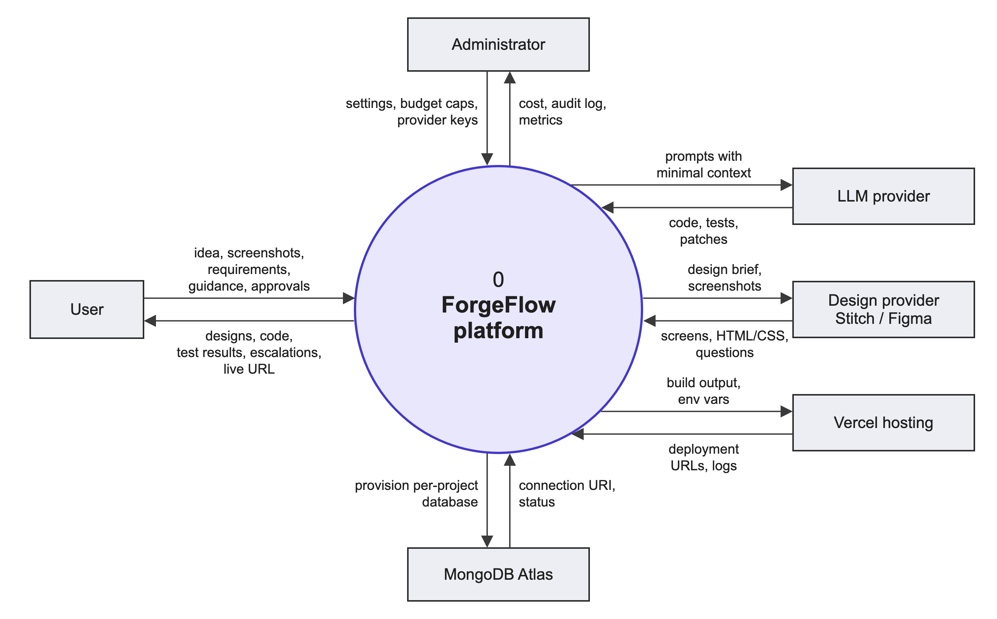
Figure 4.2: Level 0 data flow diagram (context diagram)
Figure 4.3 decomposes the platform into eight processes and four data stores. The control-plane database (D1) holds projects, stage states, versioned artifacts and runs; the sandbox workspace (D2) holds the git-backed source; the credential vault (D3) holds encrypted tokens; and each deployed application gets its own database (D4). The repair process (6.0) reads failing tests from D1 and the diff since the last pass from D2, and writes patches back to D2. Live failures from validation (8.0) flow back into the same repair process.
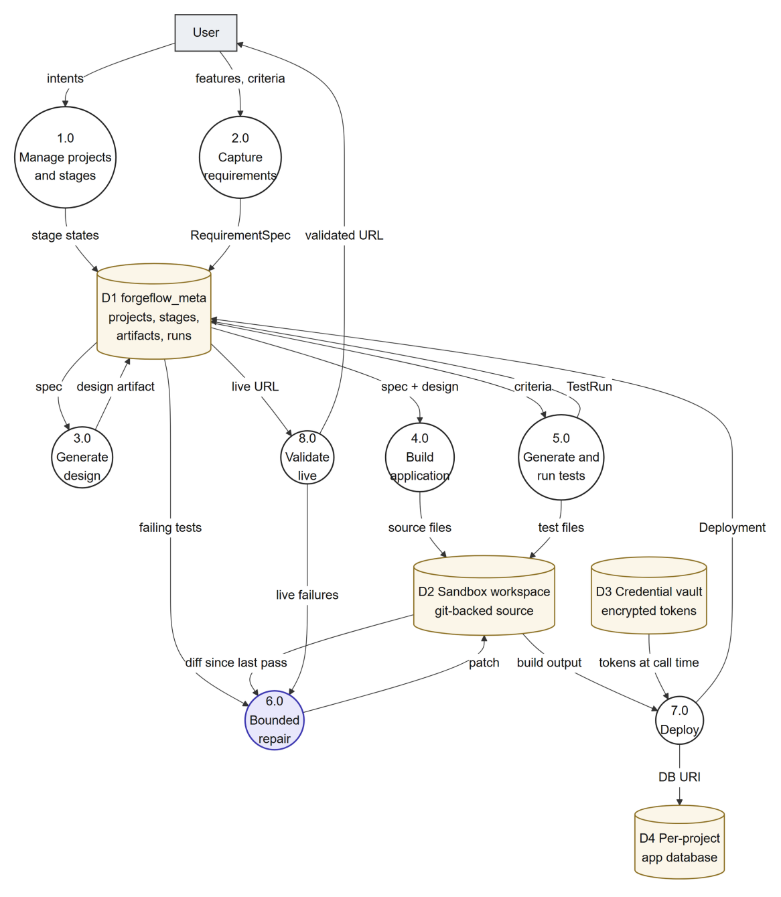
Figure 4.3: Level 1 data flow diagram

4.3 Non-Linear Orchestration
The product order of the stages is requirements, design, build, test, deploy and validate. This order drives the navigator, the default entry stage of a new project and the staleness cascade, but it gates nothing (Figure 4.4). Requirements come before design because a UI should not be designed before it is known what the application has to do; when a requirement specification exists it is added to the design provider's prompt, but design also works without one.
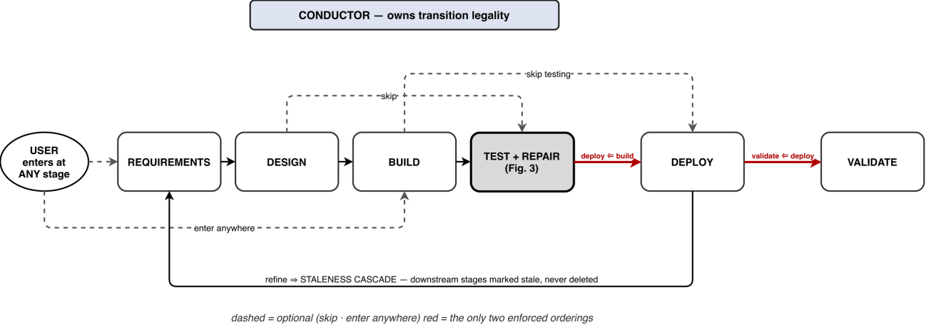
Figure 4.4: The non-linear stage model. Dashed edges are optional (enter anywhere, skip); the two red edges are the only enforced orderings; refining a stage marks later stages stale without deleting them

4.3.1 Stage state machine
Each project keeps an independent StageState for every stage, with one of six statuses: empty, in_progress, awaiting_user, complete, skipped and stale. Figure 4.5 shows the state diagram. The rules are implemented in a pure module with no input or output, which makes every rule exhaustively testable:
- enter moves an empty stage to in_progress and is legal regardless of other stages, except for the two hard prerequisites.
- skip moves any stage to skipped and records the status it held as a restore point.
- unskip restores the recorded status (in_progress is restored as awaiting_user, because whatever was running is gone). This makes skips reversible without a paid rebuild.
- complete marks a stage complete; a human can approve a build directly, bypassing the agent's verification gate when the user judges the build good.
- refine reopens a complete, skipped or stale stage and marks every later non-empty stage stale; artifacts are never deleted.
- Hard prerequisites: entering or completing deploy requires build to be complete, and entering or completing validate requires deploy to be complete. These are the only mandatory orderings; skip, refine and unskip are never blocked.
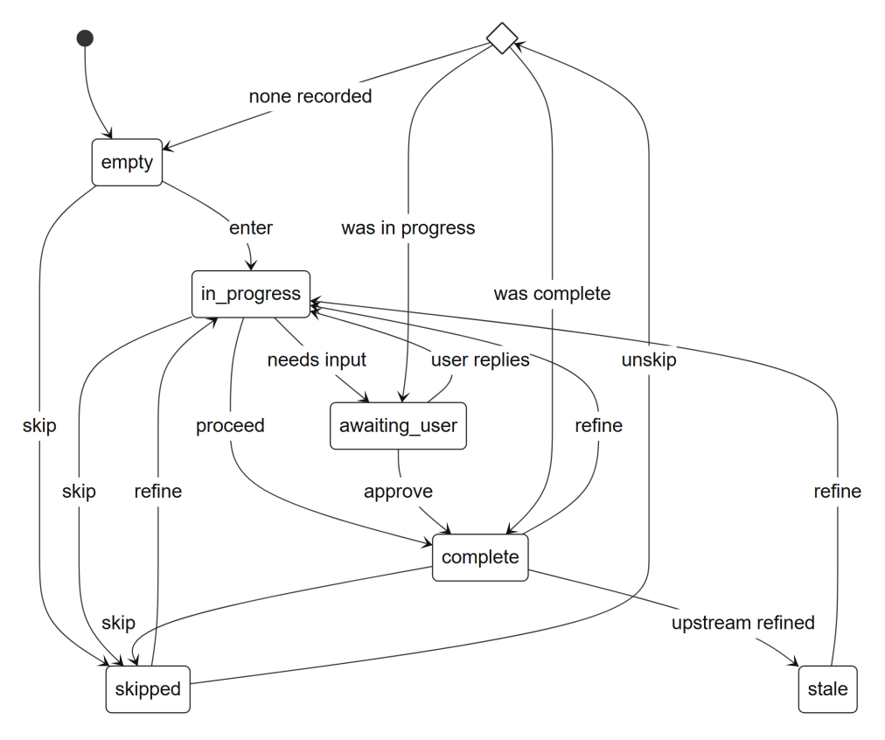
Figure 4.5: State diagram of a pipeline stage (StageState.status)

def apply_transition(states, stage, action, *, restore_point=None):
result = can_transition(states, stage, action)
if not result.allowed:
raise ValueError(result.reason)
from_status = states.get(stage, StageStatus.empty)
new_states, stale, next_restore = dict(states), (), None
if action is Action.enter:
to_status = from_status if from_status is not StageStatus.empty else StageStatus.in_progress
elif action is Action.skip:
to_status = StageStatus.skipped
next_restore = restore_point if from_status is StageStatus.skipped else from_status
elif action is Action.complete:
to_status = StageStatus.complete
elif action is Action.unskip:
to_status = restore_target(restore_point)
else: # refine: reopen this stage, mark every non-empty later stage stale
to_status = StageStatus.in_progress
stale = tuple(s for s in downstream_of(stage) if states.get(s) is not StageStatus.empty)
for s in stale:
new_states[s] = StageStatus.stale
new_states[stage] = to_status
return ApplyResult(new_states, stage, from_status, to_status, stale, next_restore)
Listing 4.1: Core of the pure stage state machine (backend/app/projects/state_machine.py, abridged)

4.3.2 The conductor
The conductor is the single owner of transition legality; the user interface only expresses intent. An intent carries a message, a target stage and an action (refine, proceed, skip or unskip). The conductor handles each intent in seven steps:
- Resolve project ownership and take a snapshot of the stage statuses.
- Map the user action to a state-machine action (proceed becomes complete; refine becomes refine for a finished stage and enter otherwise) and reject an illegal transition before any side effect.
- Persist the user's message.
- Open a costed Run for the work.
- Dispatch to the stage handler and persist its messages and versioned artifacts.
- Apply the state transition, which also emits a stage.transition event.
- Close the Run with its cost and outcome.
Centralising legality in one component keeps non-linearity a property of the system rather than of one screen. An unskip is answered by step 6 alone, because restoring a status requires no handler and produces no artifact.

4.4 Data Design
The control plane stores its state in MongoDB. A document database fits because artifacts are heterogeneous and change shape by design (designs, diffs, test runs, repair attempts, deployments), and because one database per project gives isolation for generated-application data without extra machinery. Figure 4.6 shows the entities and relationships of the control-plane database, and Table 4.1 lists the main attributes.
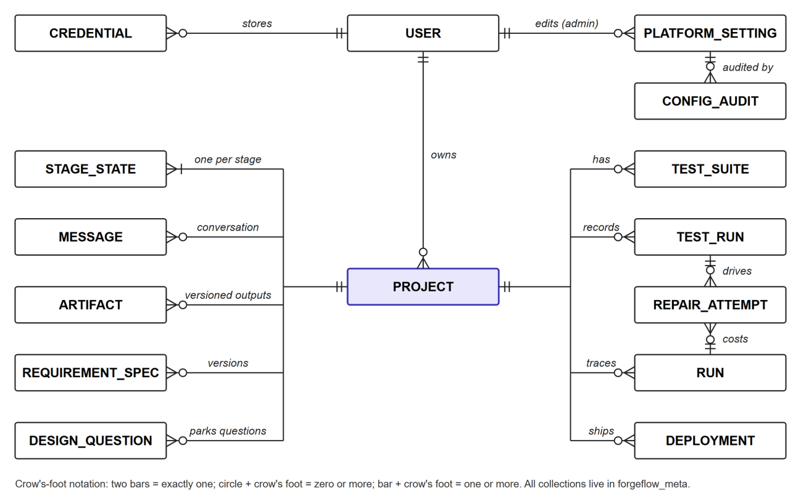
Figure 4.6: Entity-relationship diagram of the control-plane database (forgeflow_meta)
Table 4.1: Data dictionary of the main control-plane collections
Collection | Key attributes | Purpose
users | email, hashed_password (bcrypt), role (user or admin), settings | Accounts and roles
credentials | user_id, kind (vercel, render, mongo_uri, stitch, figma), encrypted_secret, scope (platform or byo) | Encrypted provider tokens
projects | user_id, name, current_stage, stack (fixed-mern-ts), sandbox_id, design_provider, app_db_name | A user's application in progress
stage_states | project_id, stage, status, previous_status (restore point), artifacts | Independent state per stage
messages | project_id, stage, role, content, artifacts, token_usage | Per-stage conversation
artifacts | project_id, stage, type, version, ref (blob pointer), meta | Versioned outputs of every stage
requirement_specs | project_id, app_name, features [name, description, inputs, expected_behaviors, acceptance_criteria (id, text, kind)], version, inferred | Structured requirements
test_suites | project_id, kind (unit or e2e), files, generated_from (criterion ids), version | Generated tests
test_runs | project_id, suite_refs, results, failures, stdout_ref, repair_context_ref, env (sandbox or live) | Normalised test results
repair_attempts | project_id, run_id, iteration, target_files, diff_ref, resulting_run_id, outcome, reverted | One patch iteration
runs | project_id, kind, cost (tokens, inr, reasoning_tokens), progress, tool_calls, outcome, started_at, finished_at | Costed unit of agent work
deployments | project_id, mode (seamless or byo), fe/be/db targets, urls, refs (provider ids), status, topology_snapshot, logs_ref | Deployment records
design_questions | project_id, provider, question, suggestions, status, answer | Questions parked for the user
platform_settings, config_audit | key, value (encrypted if secret), category; before and after values per change | Admin configuration and its audit trail

4.5 Class Design
The backend is organised around a small number of interfaces with interchangeable implementations. Figure 4.7 shows the orchestration and repair classes. The Conductor checks legality through the state machine and dispatches intents to stage handlers. The build and validation controllers both reuse a single RepairLoopController rather than implementing their own loops, so every repair in the system, whether triggered by a failing test, a failed build check or a live failure, obeys the same bounds.
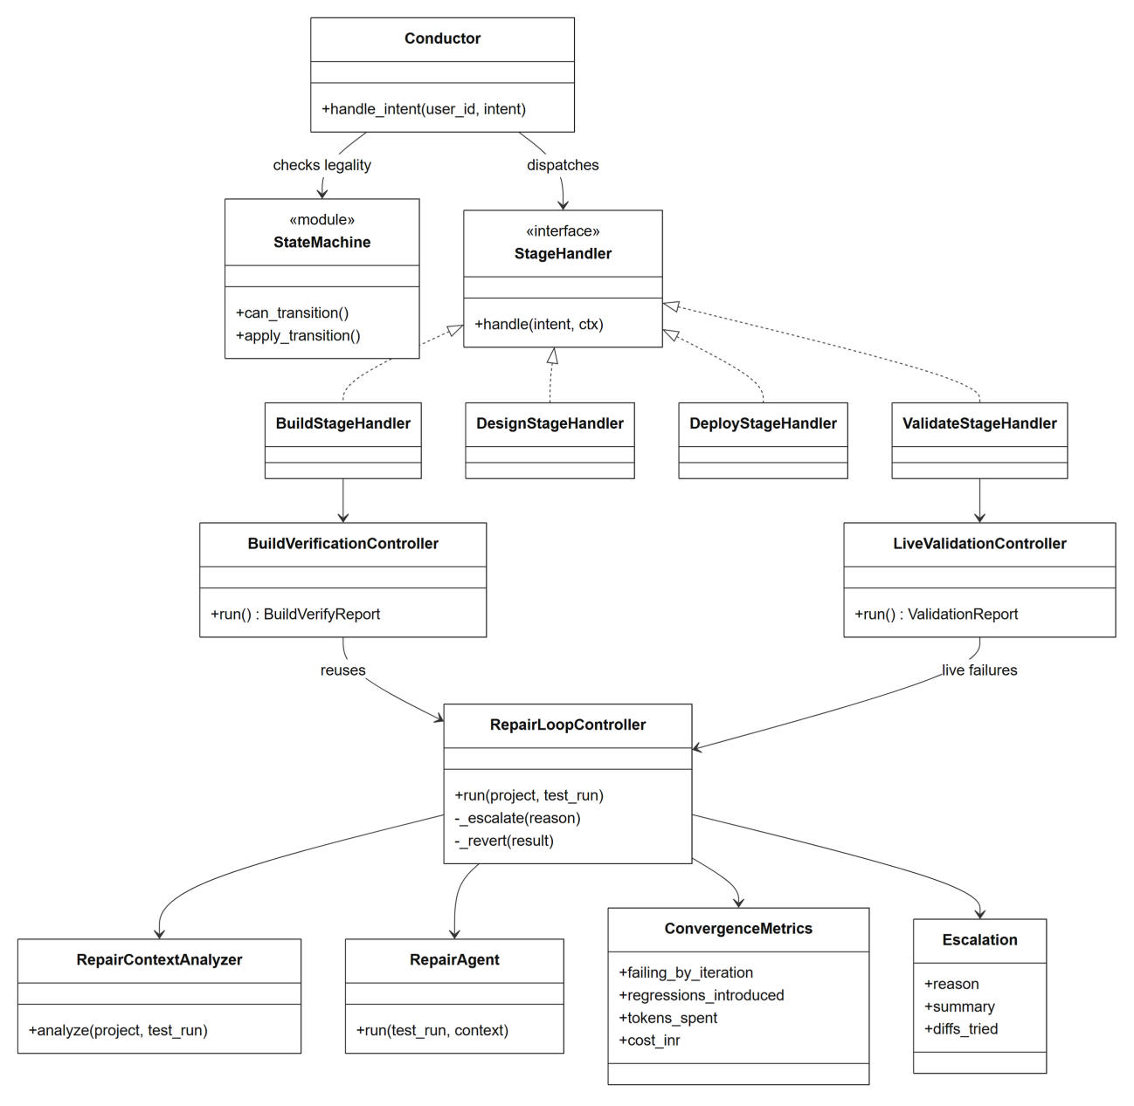
Figure 4.7: Class diagram of the orchestration and repair core
Figure 4.8 shows the provider abstractions. DesignProvider has Stitch, Figma and fake implementations, so switching providers needs no change to the design stage. DeployProvider has Vercel and Render implementations that share a base class. The Transport protocol hides whether a model call goes to the Anthropic SDK or to an OpenAI-compatible endpoint, so no agent, tool or cost code depends on a vendor.
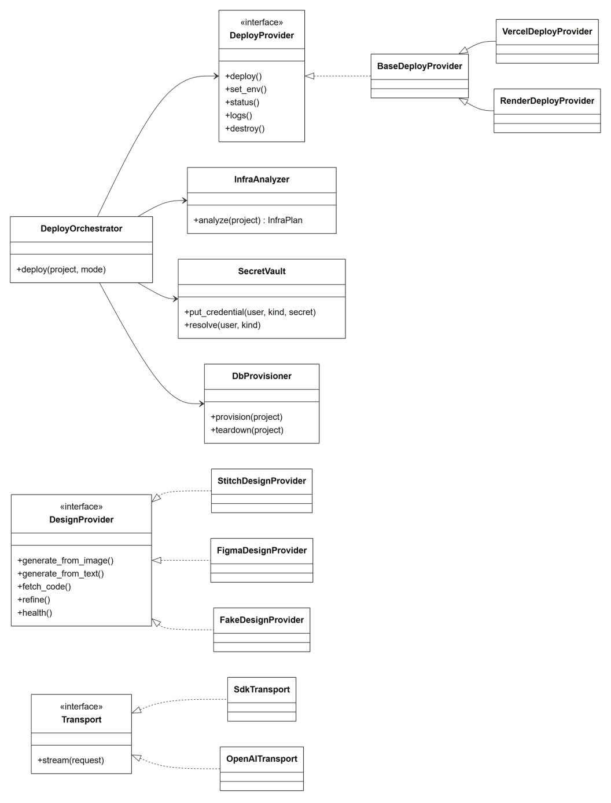
Figure 4.8: Class diagram of the provider abstractions and deployment services

4.6 Requirements and Design Stages

4.6.1 Structured requirements capture
Requirements are captured as a RequirementSpec: a list of features, each with a name, a description, inputs, expected behaviours and acceptance criteria. Every acceptance criterion has an identifier and a kind (unit, end-to-end or either) that tells the test generator how to verify it. Capture is deliberately structured rather than free prose, because structured input makes test generation deterministic and evaluable. There are two entry points: a guided form that adds features one at a time, and an AI draft that turns a free-text description of the whole application into a proposed feature list using the cheap routing model. The draft is never saved automatically; it is shown for editing, in keeping with the human-control principle. Listing 4.2 shows part of the specification used for the demonstration application.

requirements:
features:
- name: Clear completed
description: A single action that removes every completed todo at once, leaving the rest.
expected_behaviors:
- Clicking "Clear completed" removes all done todos in one step.
- Incomplete todos are never touched by "Clear completed".
acceptance_criteria:
- text: Clear completed removes every completed todo from the list and from storage.
kind: e2e
- text: Clear completed leaves all incomplete todos untouched, even when some are complete.
kind: unit
Listing 4.2: Part of the hero demonstration specification (eval/specs/hero-todo.yaml)
Because no stage is mandatory, a user may skip requirements entirely. In that case the test generator warns and offers either to capture requirements or to infer a minimal set from the code; it never refuses to run.

4.6.2 Pluggable design stage
The design stage is built on a DesignProvider interface with five operations: generate from images, generate from text, fetch the generated HTML and CSS, refine an existing design, and report health and capabilities. Google Stitch is the default provider and Figma is the alternative; a fake provider supports testing. Switching providers requires no change to the stage handler. Credentials are held centrally, short-lived access tokens are refreshed automatically, and monthly quota use is tracked per provider. Each ForgeFlow project generates into its own Stitch project, named after the application, so designs never leak between projects.
Two behaviours deserve mention. First, provider failures such as quota exhaustion fail soft: a resilient wrapper falls back to the next provider with a clear message instead of ending the pipeline. Second, a provider's question is treated as a question, not a failure. Stitch often answers a broad brief with a proposal such as “shall I proceed with these five screens?”. A plain scope proposal is accepted automatically up to a configured number of replies; anything else is stored as a DesignQuestion, the stage moves to awaiting_user, and the user's next message is sent back to the provider that asked. Earlier, a question had been treated as an error and the fallback produced a design nobody had asked for; routing the question to the human fixed this, in line with the evidence that code generators guess rather than ask when a brief is ambiguous (Fang et al., 2026).

4.7 Build Stage
The build stage turns the requirements and design into a working application in the project's sandbox. One press of Build is meant to produce a verified, working application without the user repeatedly telling the agent what is broken. Figure 4.9 shows the activity diagram.
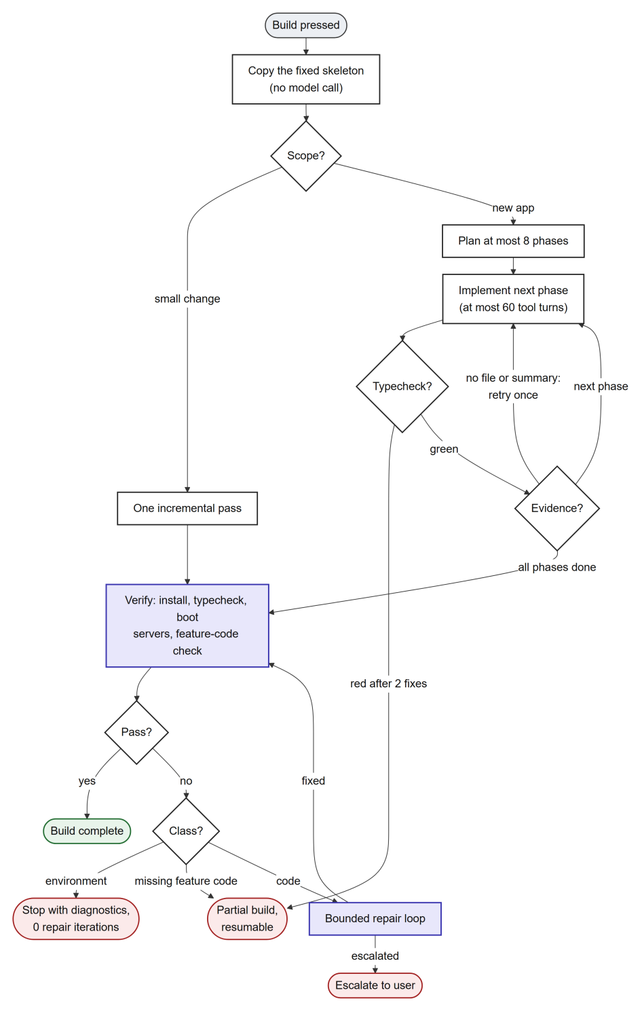
Figure 4.9: Activity diagram of the build stage
- Skeleton instantiation. The fixed-stack skeleton (frontend, backend, test configurations and a test-database helper) is copied into the git-backed workspace. No model call is involved, so no tokens are spent on scaffolding.
- Scope classification. A change request is first classified by the cheap MODEL_CLASSIFY role (with a heuristic fallback). A small change is handled in a single incremental pass instead of a full re-plan.
- Phased plan. For a new application, a planner produces at most eight phases, saved as a plan in the workspace. A deterministic fallback plan is used when there are no requirements or no design, so build always runs.
- Phase-by-phase implementation. Each phase is implemented by the code-generation agent through a tool loop of at most 60 turns, using a small context that summarises earlier phases. Each phase has its own typecheck gate with at most two fix attempts.
- Evidence-gated completion. A phase counts as done only if it wrote at least one file, ended with a non-empty summary and passed the typecheck; a phase that wrote nothing gets one retry with explicit feedback. The tool loop is reasoning-aware: a turn cut off by the output-token limit is nudged and continued, at most twice, instead of being mistaken for a finished turn.
- Verification. The build is verified by installing dependencies, typechecking, booting both development servers and checking their health, and then running a structural check that feature code really replaced the skeleton (feature files on both sides, a feature router mounted, and the index route rendering feature code).
- Failure classification and self-heal. A failure is classified before anything else. Environment failures (for example an unreachable package registry, process-limit exhaustion or an unresolvable database host) stop the build with diagnostics after zero repair iterations, because no code patch can fix them. Missing feature code marks the build partial and resumable. Only code-class failures reach the shared repair loop, capped at three iterations for a build, and the whole build is bounded at 3,600 seconds.
Every step streams progress events, and the code appears in the Monaco editor as the agent writes it. The user can approve a build directly, mark it complete without paying for another run, or send a change request.

4.8 Requirements-Driven Test Generation and Execution
A single identifier, criterion_id, links a user's acceptance criterion to its tests, their results, the failure analysis and the repair context (Figure 4.10). The link is built in from the start rather than recovered afterwards.
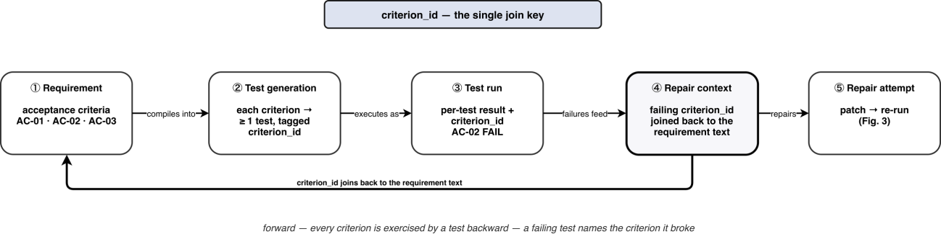
Figure 4.10: Requirement-to-repair traceability through criterion_id
- Generation. The test-generation agent maps each acceptance criterion to at least one executable test tagged with its criterion_id: Vitest with Testing Library for frontend units, Jest with supertest for backend units, and Playwright for end-to-end behaviour against the sandbox preview.
- Offline test database. Sandboxes have no internet access while tests run. The sandbox image therefore bakes in a checksum-verified mongod 8.0 binary, and the skeleton provides a useTestDb() helper and a Jest global setup, so every test reaches a real in-memory MongoDB without downloading anything. A missing test database is recognised deterministically and stops repair at zero attempts.
- Execution and normalisation. Suites run inside the sandbox. JUnit and JSON reporter output is normalised into one per-test record with status, assertion, stack, referenced files and criterion_id. A failing criterion is reported as unmet rather than hidden inside an aggregate pass count, and live validation produces the same shape, so the repair path does not depend on which framework or environment produced the failure.
- Last-passing reference. A git reference is moved forward on every green run. The diff from this reference to the current code answers the question “what changed since it last worked”.

4.9 The Bounded, Diff-Aware Self-Healing Repair Loop
The repair loop is the core contribution of the project. Its input is a test run with at least one failure, the current workspace and the requirements behind the failing tests. Its design follows four invariants: never feed the whole repository when a diff suffices; never loop without a bound; always leave an auditable trail; and always prefer escalation to a silent failure. Figure 4.11 shows the loop.
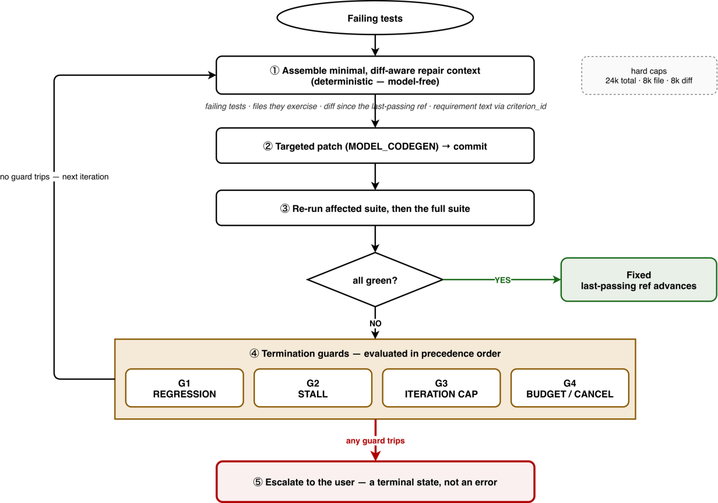
Figure 4.11: The bounded self-healing repair loop: minimal context assembly, targeted patching, re-execution, termination guards in precedence order, and escalation as a terminal state

4.9.1 Minimal, diff-aware repair context
Context assembly is deterministic and does not call a model, which makes it exhaustively testable and cheap. It admits only four kinds of content:
- The failing tests: name, framework, assertion, stack, referenced files and criterion_id.
- The source files those tests reach. The starting set is the failing test and the files named in its stack. It is widened along the failing test's import graph by a breadth-first walk bounded at depth 3 and 24 files, in which bare package specifiers never resolve (so node_modules cannot enter the context) and test files are filtered out. Direct imports rank above folder neighbours. If the subject of a test is registered rather than imported, the agent may request up to three additional non-test files per attempt.
- The diff since the last passing run, scoped to the implicated files.
- The requirement text for each failing criterion, joined through criterion_id, so the agent repairs against the acceptance criterion and not only against the assertion.
Everything else, including the rest of the repository, passing tests and untouched modules, is excluded. The context is capped at 24,000 characters in total, 8,000 per file and 8,000 for the diff. Oversized parts are trimmed in priority order and every dropped part is recorded, so a trimmed context is never silently lossy. The import-graph walk was added after a live session in which repair was handed main.tsx while the bug lived in a page component one directory away; the model correctly refused to patch the wrong file. Following the test's own imports, as graph-based localisation research recommends (Ouyang et al., 2025; Z. Chen et al., 2025), fixed the problem while keeping the context minimal.

4.9.2 Loop controller
The controller runs one attempt per iteration: assemble the context, call the repair agent with that context and a strict instruction to fix the failing behaviour without breaking passing tests, commit the patch, and re-run the affected suite followed by the full suite. Algorithm 4.1 gives the complete procedure.
Algorithm 4.1: Bounded, diff-aware repair loop (RepairLoopController.run)
Input: project P, failing test run R; bounds N (iterations, default 5), S (stall, 2), G (regressions, 2), Z (empty attempts, 2)
Output: outcome in {fixed, escalated}, convergence metrics, list of attempts
1: F ← failing(R); if F is empty then return fixed
2: stall ← 0; reg ← 0; noop ← 0
3: for i ← 1 to N do
4: if the run was cancelled then return escalate(cancelled)
5: C ← assemble_context(P, R) ▷ deterministic, no model call
6: if C names a broken environment then return escalate(environment) ▷ zero tokens spent
7: A ← repair_agent(C) ▷ a budget halt returns escalate(budget)
8: if A had nothing safe to patch then return escalate(blocked)
9: R′ ← test run after A; F′ ← failing(R′)
10: shrank ← |F′| < |F|; regressed ← A broke a previously passing test
11: if regressed then reg ← reg + 1
12: if A wrote no file then noop ← noop + 1 else noop ← 0
13: record attempt i with outcome regressed, fixed or no_progress; emit repair.iteration
14: if regressed and not shrank and R′ is not green then revert to the pre-attempt commit
15: else R ← R′; F ← F′
16: if R′ is green then return fixed
17: if reg ≥ G then return escalate(regressed)
18: if noop ≥ Z then return escalate(no_patch)
19: if shrank then stall ← 0 else stall ← stall + 1
20: if stall ≥ S then return escalate(stalled)
21: end for
22: return escalate(cap_reached)

The guards are evaluated in a deliberate order. The regression guard comes first because “my patches keep breaking working code” is a more precise and more actionable diagnosis than “no progress”; a single regression is tolerated because a legitimate patch can briefly break one test. The empty-attempt guard comes next: the context is assembled deterministically from the failing run, so an attempt that wrote nothing would be asked the identical question again, and the agent's own explanation of what it needed is more useful to the user than a generic stall. The stall guard trips when the failing set has not shrunk for two consecutive iterations; a set that oscillates at the same size counts as no progress. The iteration cap of five sits just above the range of three to four iterations in which the literature finds most of the achievable gain (Kiecker et al., 2026; Arimbur, 2026). An attempt that broke something and fixed nothing is reverted, so the loop may spend iterations but never hands back an application worse than it found.
Every attempt is judged as regressed, fixed or no_progress, with regression dominating: an attempt that fixes one test and breaks another is still treated as the dangerous kind. All thresholds are resolved from the layered configuration (admin panel, then environment, then default), so they can be tuned from the admin dashboard and swept by the evaluation harness without redeploying.

4.9.3 Escalation as a terminal state
Any ending other than green is an escalation, and an escalation is a normal outcome rather than an error. The stage moves to awaiting_user and a repair.escalation event carries the reason, a short “here is where I am stuck” summary, the failing tests with their criterion ids, the diffs already tried, the convergence metrics and a resume contract (refine the build stage with guidance; the build regenerates and repair can run again). A summary is generated from a fixed template of the form: “I stopped after N attempt(s) because <reason>. K test(s) are still failing: <names>. I patched: <files>. Failing count per attempt: <trail>. Tell me what to change and I'll rebuild from your guidance.” For an environment failure the closing sentence instead asks the user to fix the environment and run the tests again.

4.9.4 Audit trail and convergence metrics
Each iteration is stored as a RepairAttempt with its target files, a reference to its diff, the resulting run and whether it was reverted. The whole loop is one costed Run, and a versioned repair report records the initial and final failing counts, the failing count after every iteration, regressions introduced, empty attempts, iterations, tokens, rupee cost and wall-clock time. These are exactly the quantities the evaluation harness consumes. Table 4.2 summarises the bounds that keep repair and build finite.
Table 4.2: Default bounds of the repair loop and the build (all admin-tunable)
Setting | Default | Effect
repair_max_iterations | 5 | Hard cap on repair iterations per loop
repair_stall_threshold | 2 | Consecutive iterations without the failing set shrinking
repair_max_regressions | 2 | Attempts that broke passing tests before escalation
repair_max_noop_attempts | 2 | Consecutive attempts that wrote nothing
repair_context_max_chars / file / diff | 24,000 / 8,000 / 8,000 | Character budgets for the repair context
repair_import_max_depth / max_files | 3 / 24 | Bounds on the import-graph walk
repair_request_file_max | 3 | Extra files the agent may request per attempt
build_max_phases | 8 | Maximum phases in a build plan
build_phase_max_tool_turns | 60 | Tool-loop bound per phase
build_phase_max_fix_attempts | 2 | Typecheck fixes per phase
build_integration_max_iterations | 3 | Repair cap for build verification
build_max_wall_clock_s | 3,600 | Outermost bound on a whole build
validate_max_cycles | 2 | Repair, redeploy and re-validate cycles for live failures
llm_max_truncated_turns | 2 | Continuations after a turn hits the output-token limit

4.10 Deployment and Live Validation
Deployment and live validation follow the flow in Figure 4.12.
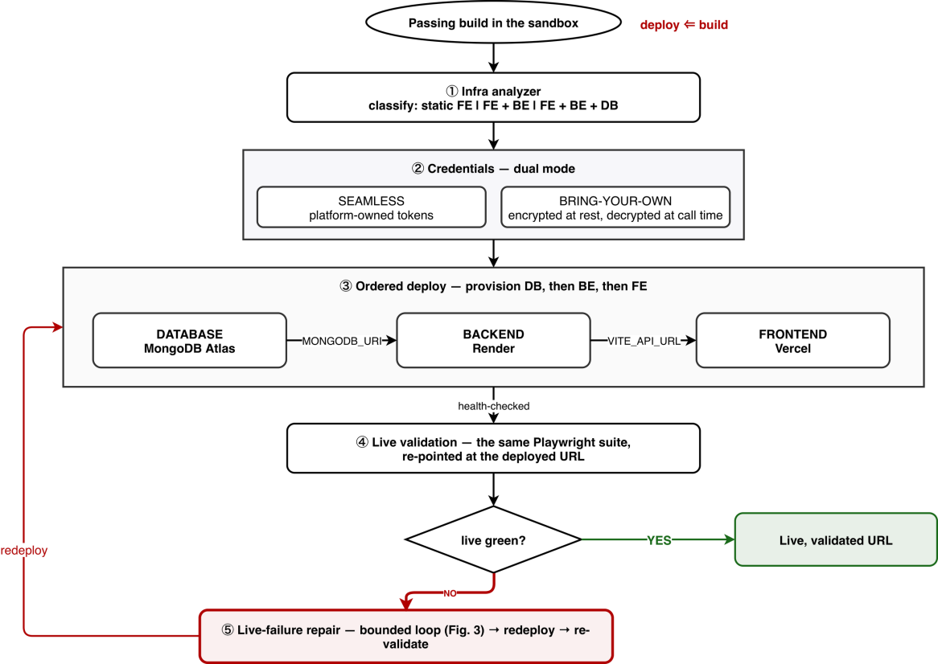
Figure 4.12: Infrastructure analysis, dual-mode credentials, ordered deployment and live validation with its repair path. The figure shows the original Render backend; since phase 58 the backend deploys to Vercel by default, with Render available as an option

4.10.1 Infrastructure analysis
An infrastructure analyzer reads the workspace and classifies the application as a static frontend, a frontend with a backend, or a frontend with a backend and a database. It detects the frontend build target, whether a server framework, start script and port are present, whether Mongoose or a connection string is used, and every environment variable referenced in code. The analysis is static and model-free, so it is cheap and reproducible. Where the evidence conflicts, the analyzer flags it with a lower confidence instead of guessing. One rule protects security: any variable prefixed with VITE_ is compiled into the browser bundle, so it is never treated as a secret, and a secret-looking VITE_ name is flagged as a leak.

4.10.2 Dual-mode, ordered deployment
ForgeFlow deploys either in seamless mode, on platform-owned accounts, or in bring-your-own mode with the user's tokens. All tokens are encrypted at rest with Fernet, decrypted only in process at call time, never logged and never returned to the client. Deployment is ordered: provision the project's database; deploy the backend as a Vercel function with the database URI injected; deploy the frontend with the backend's public URL injected; and health-check every node. A dead backend can never ship behind a live frontend. Both tiers are delivered by the same inline file upload, so no git host is needed, and what ships is exactly what the repair loop validated.
Deployment is also truthful about what it did. Environment variables are mirrored into the provider project rather than living only on one immutable deployment; provider deployment identifiers are recorded so that the topology shows the provider's real build and runtime logs; a pre-flight check refuses a localhost database URI before anything is deployed; and a deployment can be torn down, which returns the deploy stage to empty and so restores the rule that validation requires a deployment. These behaviours were added after a live session exposed each gap, as reported in Section 5.4.

4.10.3 Post-deployment validation
After deployment, the same Playwright suite is pointed at the live URL. The suite can be narrowed to tests tagged smoke or critical. The sandbox is lent an egress network only for the duration of the run, and it is always detached in a finally block; a cold site is warmed before the suite starts. Live results have the same normalised shape as sandbox results, so a live failure enters the same repair loop: diagnose, repair, redeploy and re-validate, for at most two cycles. On success, the final link is recorded and delivered to the user.

4.11 Sandbox, Security and Threat Model
The sandbox is the most important trust boundary. Each project gets its own container created by the sandbox manager with the specification in Listing 4.3.

def build_run_kwargs(project_id, *, image, cpu_limit, mem_limit, pids_limit, read_only):
return {
"image": image,
"name": container_name(project_id),
"network_mode": sandbox_network_name(project_id), # per-project internal network: no host, no internet
"cap_drop": ["ALL"],
"security_opt": ["no-new-privileges"],
"read_only": read_only, # read-only root filesystem
"pids_limit": pids_limit, # default 256
"mem_limit": mem_limit, # default 1g
"nano_cpus": int(cpu_limit * 1_000_000_000), # default 1 CPU
"tmpfs": {"/tmp": ""},
"volumes": {volume_name(project_id): {"bind": WORKSPACE, "mode": "rw"},
home_volume_name(project_id): {"bind": SANDBOX_HOME, "mode": "rw"}},
}
Listing 4.3: Isolation posture of a project sandbox (backend/app/sandbox/manager.py, abridged)
The container runs as a non-root user from an image containing Node.js 20, a pinned pnpm, Playwright with Chromium, git and a test-only mongod. Its default network is internal and per project. Only two relaxations exist, both deliberate and narrow: the preview network, which is also internal, and an egress network attached only for dependency installation and live validation and then detached. Idle sandboxes are reaped after 15 minutes. Table 4.3 summarises the written threat model.
Table 4.3: Main threats and mitigations from the threat model
Threat | Mitigation | Verified by
Generated code reaches the host or the internet | Sealed per-project internal network; preview and egress attached deliberately and temporarily | Sandbox isolation tests
Privilege escalation in the container | All capabilities dropped, no-new-privileges, non-root user | Sandbox isolation tests
Resource exhaustion (fork bomb, memory, CPU) | PID, memory and CPU limits; execution timeouts; idle reaping | Sandbox and execution tests
Docker-socket escape | The socket is never mounted into a sandbox (checked by a source-wide scan) | Security test suite
Path traversal out of the workspace | Single safe-path checkpoint plus symlink resolution at call time | Path-safety tests
Cross-project data access | Authorisation on every route; one database per project; no endpoint accepts a database name | Data-browser isolation tests
Secret disclosure | Fernet encryption at rest, decryption at call time, no read-back endpoint, log redaction | Vault no-leak tests
Denial of wallet | Per-project and global budget caps; bounded loops everywhere | Budget-cap tests

4.12 LLM Transport, Cost Discipline and Configuration
All model access goes through one Transport seam with two implementations: the Anthropic SDK and a pure OpenAI-compatible Chat Completions adapter, which is the primary interface because most providers implement it. Above the seam, no code depends on a vendor's request shape, model names or error format. Providers spell parameters differently; for example, one model rejected max_tokens and required max_completion_tokens. Rather than hard-coding such cases, the transport reads the provider's own 400 error, repairs the request (renaming or dropping a parameter, changing the system role, or falling back to non-streaming), retries, and remembers the working shape for that endpoint and model. The repair ladder is bounded, each repair must be new, and it never silently removes an output cap.
Cost discipline is enforced by role. MODEL_CODEGEN is used only for code, test and repair work; MODEL_ROUTING for summaries and routing; and MODEL_CLASSIFY (which defaults to the routing model) for classification such as build scope. Model identifiers are configuration, not identity, and are priced through a pricing table. Every call records tokens and rupee cost against its Run; per-project and global budget caps warn at 80% and then halt work with a clear message, which the repair loop turns into a budget escalation. On OpenRouter, where one model can be served by several upstream providers at different prices, requests ask for the cheapest upstream first while keeping fallbacks.
Configuration is layered with the precedence admin panel, then environment, then code default. Every setting (more than 100, in 15 sections) can be viewed and edited from the admin dashboard. Secrets entered there are write-only and encrypted; only the encryption key and the control-plane database settings remain environment-only, because they are needed before the configuration layer exists. A CI guard forbids reading environment variables outside the configuration layer, and every change is written to an audit log.

4.13 User Interface
The following screenshots were captured from the running application. The landing page (Figure 4.13) introduces the six stages. The dashboard (Figure 4.14) lists projects with their progress across the stages.
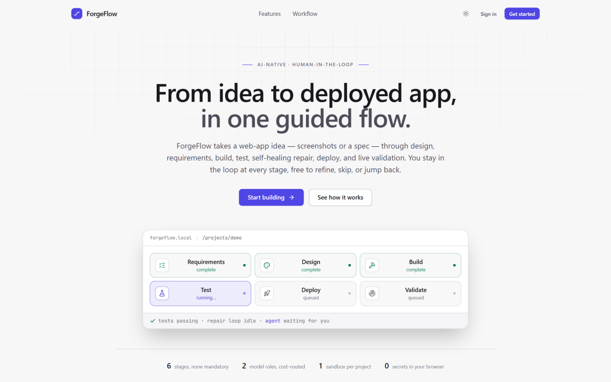
Figure 4.13: Landing page of the ForgeFlow PWA
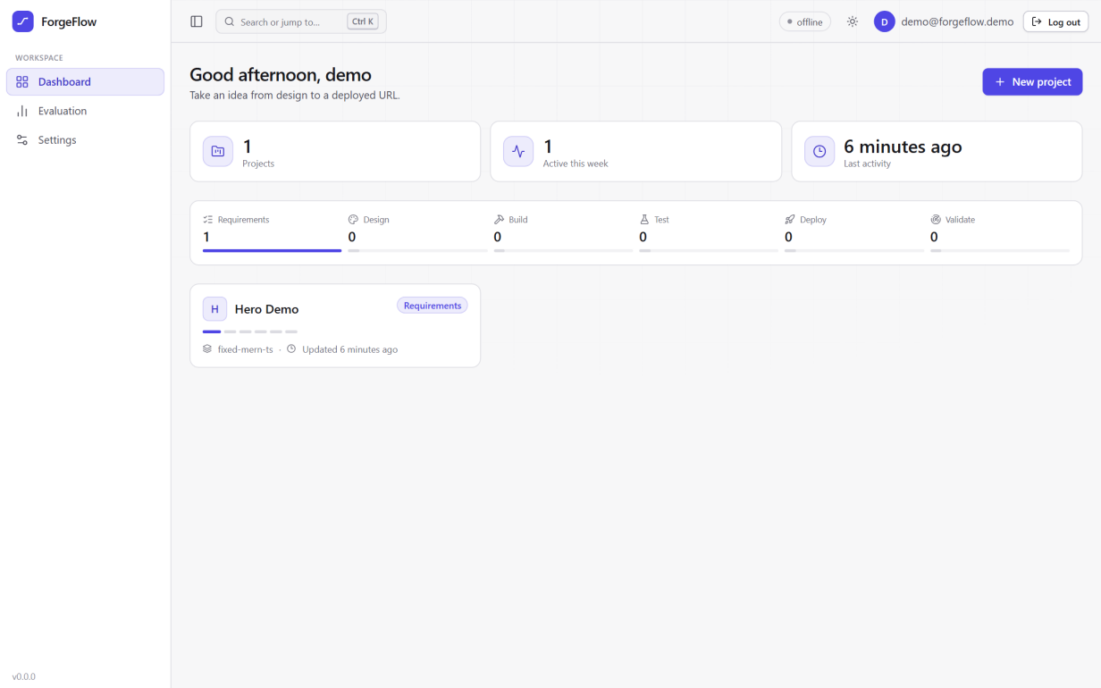
Figure 4.14: Projects dashboard with per-stage progress
The workspace (Figure 4.15) has the clickable stage navigator on the left with each stage's status and the hard-prerequisite locks on deploy and validate, the cost panel below it, the active stage panel in the centre and the stage's conversation on the right. Panels can be resized, collapsed or focused. Here the requirements of the hero demonstration are complete, with each acceptance criterion labelled by its kind.
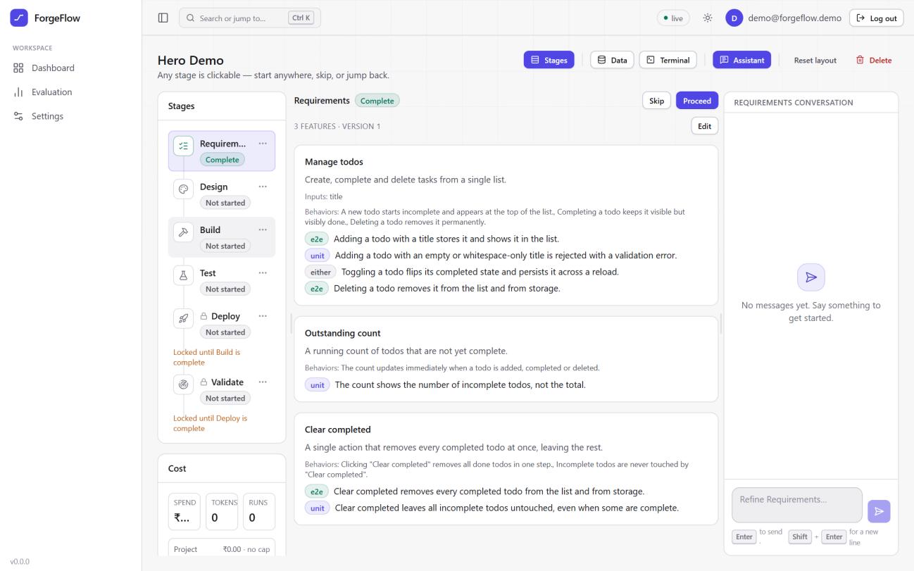
Figure 4.15: Project workspace showing the stage navigator and captured requirements
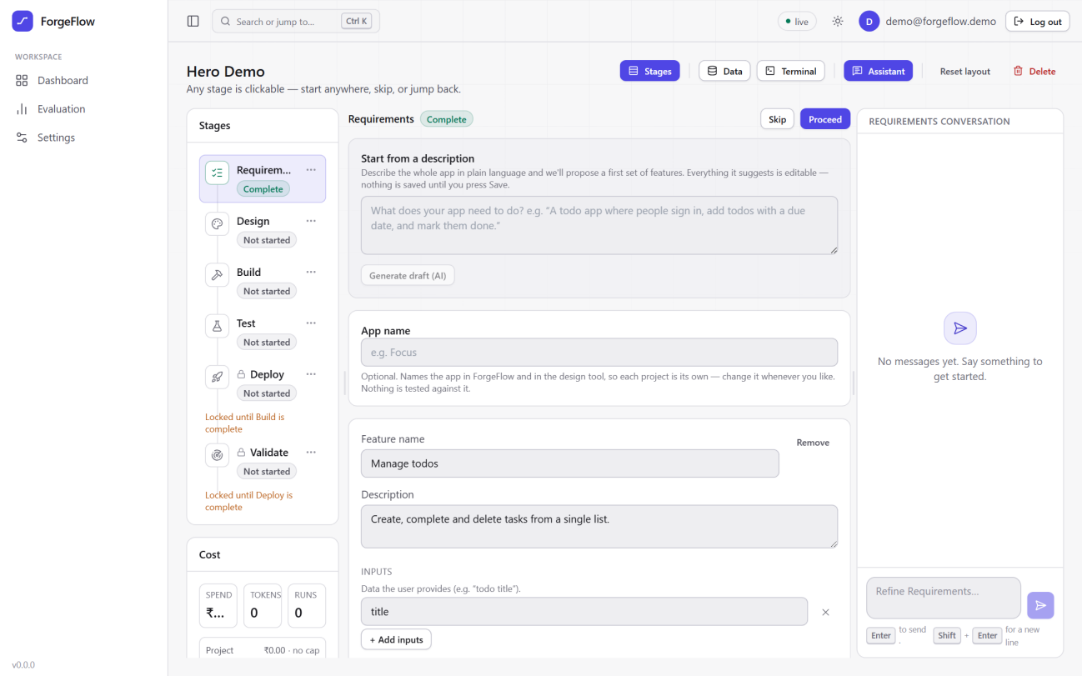
Figure 4.16: Guided requirements form with the optional AI draft from a description
The design stage (Figure 4.17) offers generation from text, upload of screenshots and import of an own design, with a version list and a refinement box; the badge next to the title shows the provider's health. The deploy stage (Figure 4.18) offers seamless and bring-your-own modes, shows the frontend, backend and database topology, and explains that deploy is locked until a build is complete.
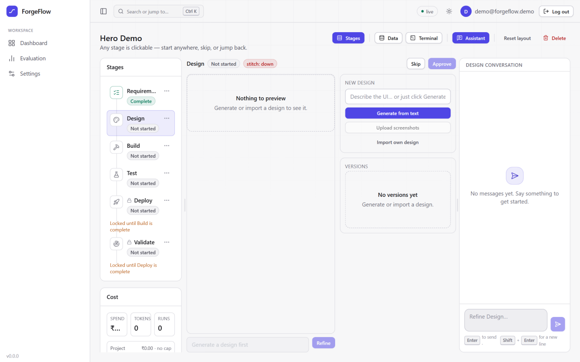
Figure 4.17: Design stage with text, screenshot and own-design intake
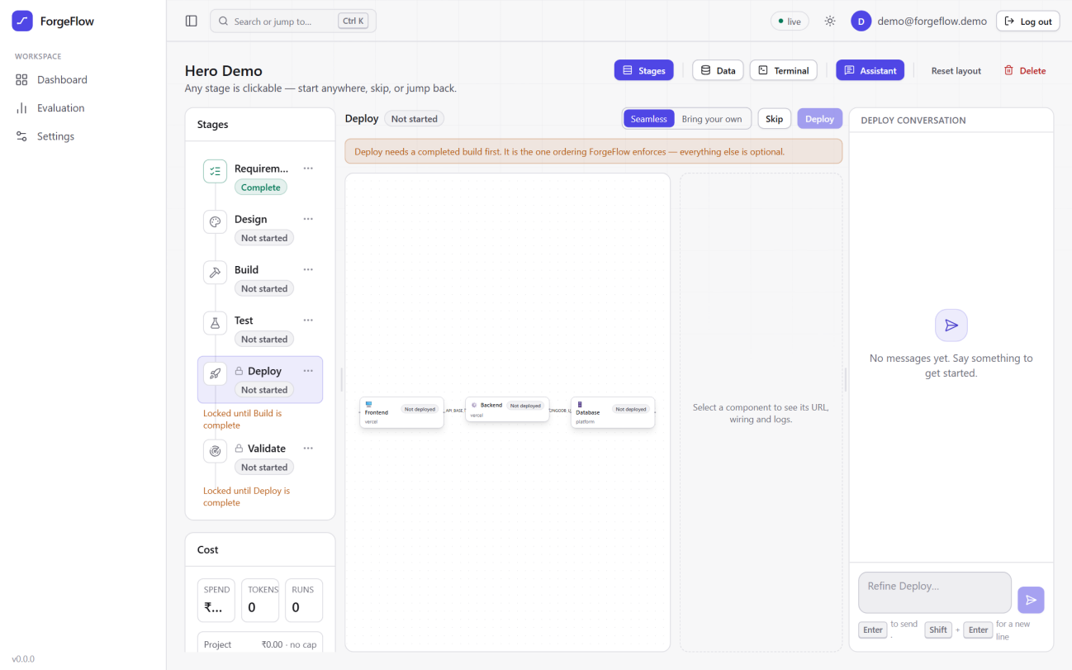
Figure 4.18: Deploy stage with dual-mode selection and the deployment topology
Users store their own provider tokens in Settings (Figure 4.19); tokens are encrypted and never shown again. Administrators tune the platform from the admin dashboard; Figure 4.20 shows the repair-loop section with the iteration cap, stall threshold, regression limit and context budgets, each showing its source (default, environment or admin) and allowed range.
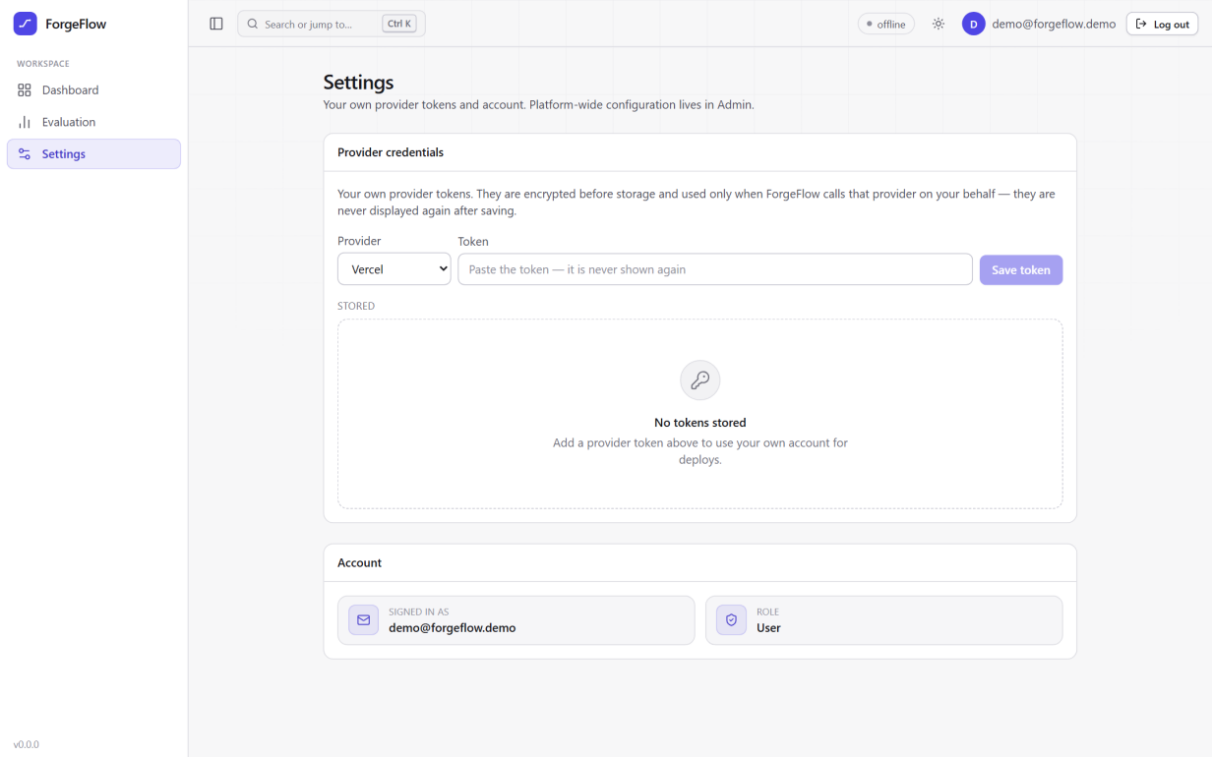
Figure 4.19: Provider credential vault in Settings
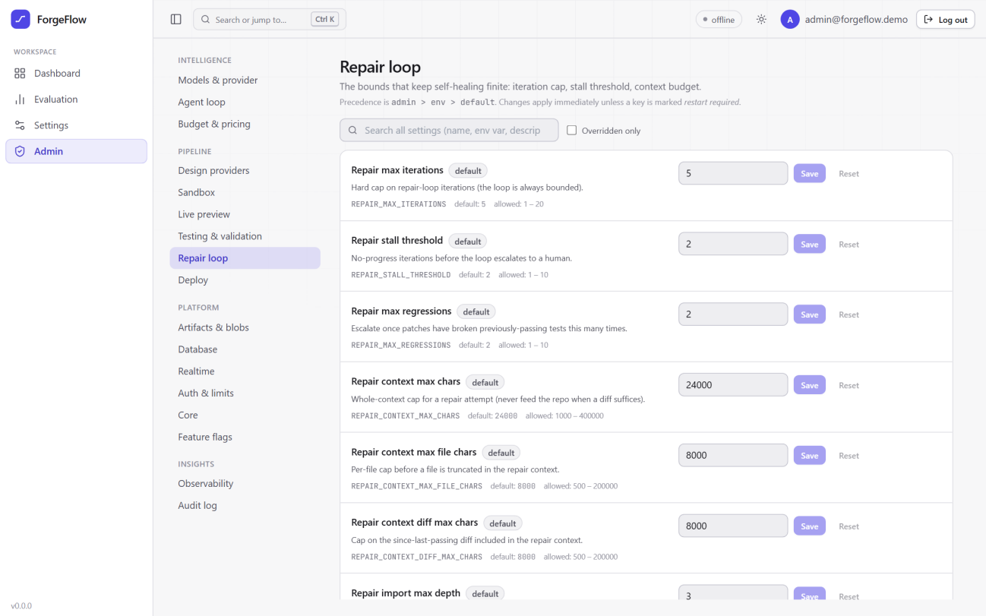
Figure 4.20: Admin dashboard: repair-loop bounds with their sources and allowed ranges

4.14 Platform Delivery: CI/CD, Containerisation, Orchestration and Monitoring
ForgeFlow holds generated applications to their tests in the sandbox and again on the live URL. The platform's own releases are held to the same rule. Its backend runs on an Oracle Cloud Ampere A1 virtual machine (3 OCPU, 16 GB, arm64, Ubuntu 24.04) and its frontend on Vercel (Figure 4.21).
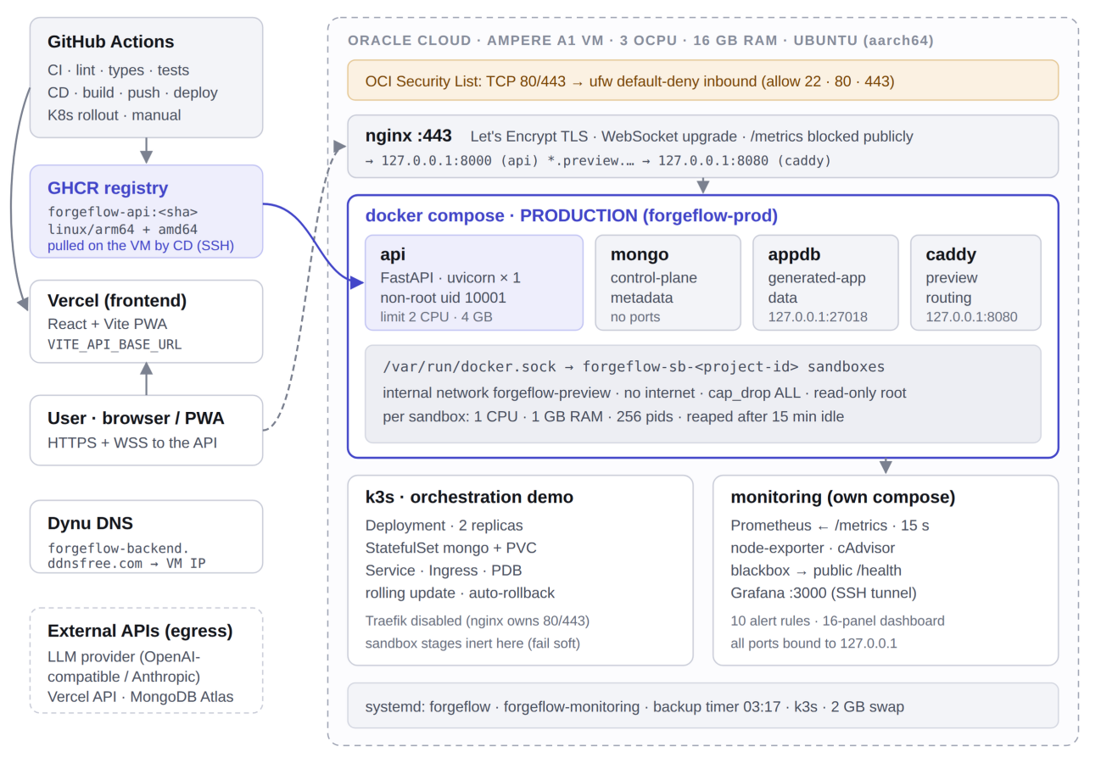
Figure 4.21: Production deployment of the platform: GitHub Actions, GHCR and Vercel, and the Oracle Cloud VM running the production Compose stack, the k3s demonstration and the monitoring stack

4.14.1 Continuous integration and delivery
Continuous integration runs six independent jobs on every push and pull request: the backend job (ruff, black, mypy and pytest with a MongoDB service container), a configuration-layering guard, the sandbox-image build with a Node and Playwright smoke test, a security job (gitleaks over the full history, a committed-secret guard, pip-audit and pnpm audit), the frontend job (ESLint, Prettier, tsc, Vitest, production build and a PWA check), and an app-skeleton job that builds the generated-app template and runs its unit and Playwright tests.
Continuous delivery is triggered by a successful CI run rather than by the push, so CI passing is a real precondition and not a race (Figure 4.22). A gate job resolves the exact commit that CI tested; a build job produces a multi-architecture (arm64 and amd64) image tagged with the commit SHA and pushes it to GHCR; a deploy job records the currently running image as the rollback target, switches to the new image, polls the container's health check for up to 150 seconds, restores the previous image and fails the run if the new one is unhealthy, and finally checks the public HTTPS health endpoint; the frontend is deployed to Vercel last, so a new interface never points at an old API.
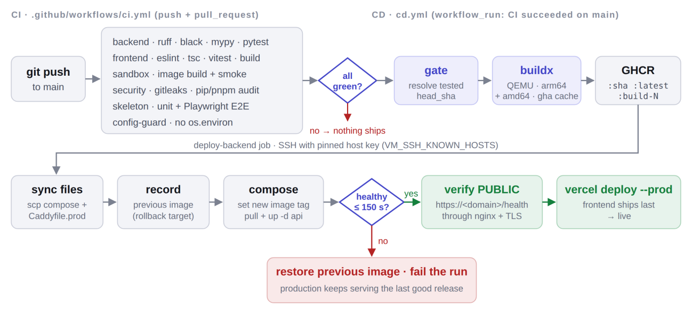
Figure 4.22: CI/CD pipeline: CI must be fully green before CD builds, pushes, deploys, verifies and ships the frontend; an unhealthy release is rolled back automatically

4.14.2 Configuration management, containers and orchestration
An Ansible playbook with seven roles (common, docker, forgeflow, nginx, k3s, monitoring and firewall) provisions the virtual machine idempotently; a second run reports no changes. Secrets such as the encryption key are generated once and read back on later runs, because regenerating the key would make every stored credential unreadable. The firewall role removes Oracle's pre-installed iptables reject rules by specification, which otherwise silently override ufw. The production image is multi-stage, runs as a non-root user under tini with a health check, and uses a single Uvicorn worker because WebSocket subscribers and rate limiters live in process memory.
Production runs on Docker Compose (api, mongo, appdb and a Caddy preview proxy), while a single-node k3s cluster on the same machine demonstrates Kubernetes orchestration. The split is deliberate: the preview proxy reaches sandboxes by container name through Docker's embedded DNS, which a Kubernetes pod cannot resolve, so moving production to Kubernetes would require changing how the application discovers sandboxes. The k3s deployment runs the real production image with two replicas and a rolling-update strategy of one surge and zero unavailable pods (Figure 4.23).
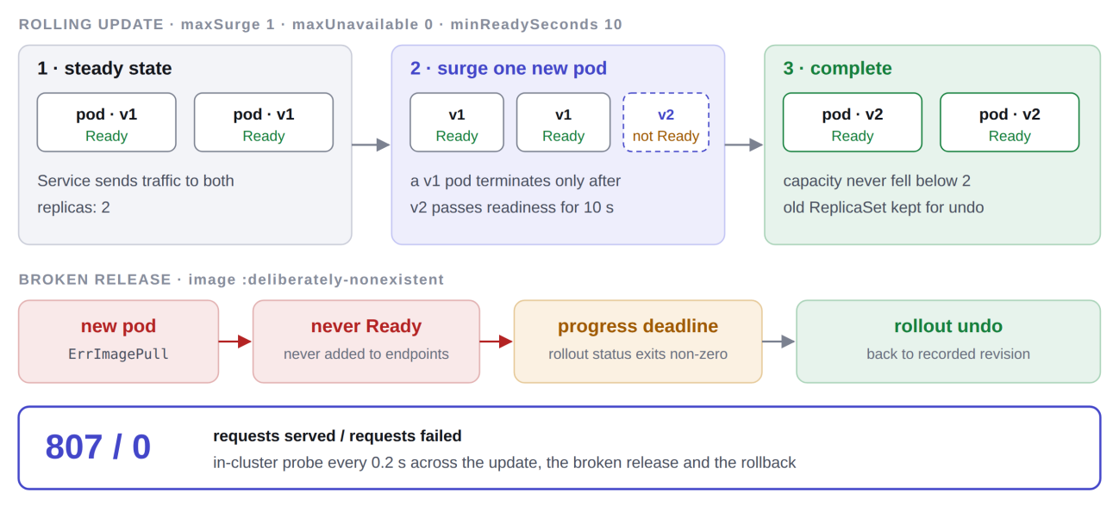
Figure 4.23: Rolling update with maxSurge 1 and maxUnavailable 0, and the broken-release path that ends in an automatic rollback

4.14.3 Monitoring
A separate monitoring stack (Figure 4.24) runs Prometheus with node-exporter, cAdvisor and a blackbox probe of the public health endpoint, a provisioned 16-panel Grafana dashboard covering uptime, latency and error rate, and ten alert rules. The application's /metrics endpoint labels requests by route template rather than raw path, so scanners or project identifiers cannot create unbounded time series, and the endpoint is blocked from the public internet.
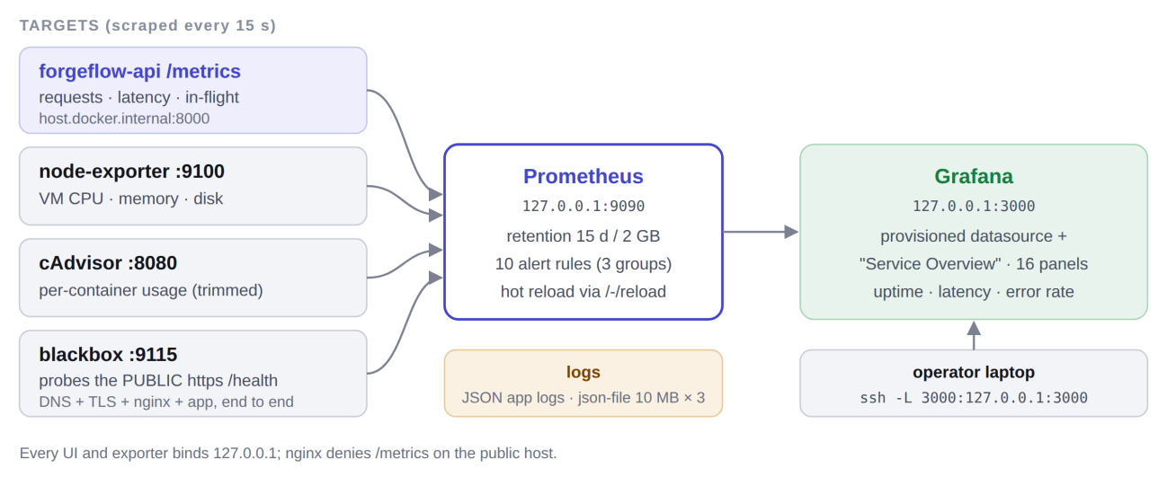
Figure 4.24: Monitoring data flow: targets scraped by Prometheus and visualised in Grafana

4.15 End-to-End Hero Path
Figure 4.25 shows the complete path that the demonstration follows, from screenshots or a specification to a validated live URL. The demonstration application is a todo list with a “Clear completed” bulk action. This action was chosen because first-pass generation often gets it subtly wrong, for example by clearing the whole list or only hiding completed rows, which makes the two “Clear completed” acceptance criteria the moment the bounded repair loop visibly earns its keep.
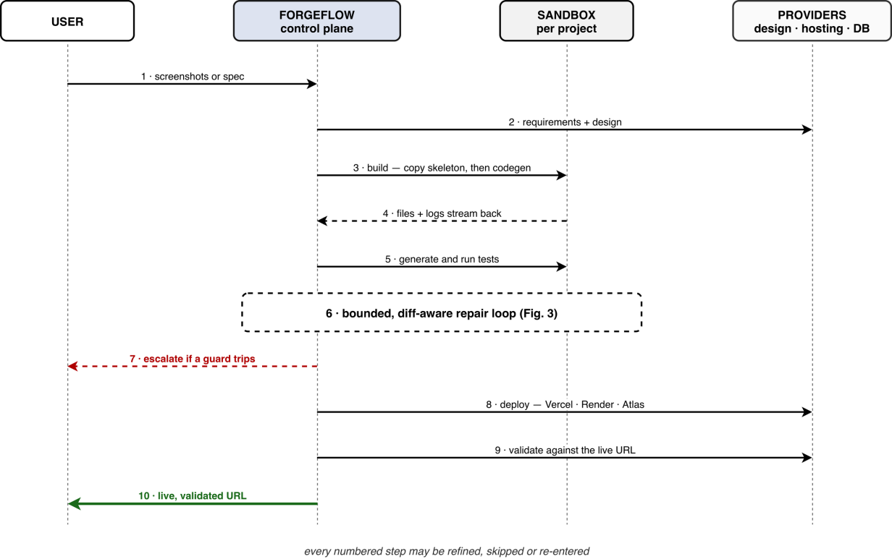
Figure 4.25: Sequence diagram of the hero path. Every numbered step can be refined, skipped or re-entered; the figure shows the original Render backend, which is now an option behind Vercel
Chapter 5

Results and Discussion
This chapter reports how ForgeFlow was tested and what the tests and the project produced. It covers the testing strategy, specific test cases and their results, the automated suite results, the defects found by running the full pipeline on real deployments, the verification of the platform's own delivery pipeline, performance and bounds, the evaluation protocol, the benchmark results, and the project outcomes. Only measured results are reported; where a measurement has not yet been made, the text says so.

5.1 Testing Strategy
Testing was part of every phase: a phase was marked done only when its acceptance criteria passed as automated tests, and every defect found in live use was fixed together with a regression test. External providers (LLM transports, Stitch, Figma, Vercel and Render) are mocked in automated tests, a disposable MongoDB database is used for persistence tests, and wherever the two LLM transports could behave differently, both are tested. Table 5.1 lists the levels of testing.
Table 5.1: Levels of testing used in the project
Level | What is tested | Tools
Unit (pure logic) | State machine, repair-context assembly, import-graph walk, result parsers, infrastructure analyzer, scope classifier, cost accounting | pytest
Integration (API and database) | Conductor legality, authentication, credential vault, data-browser isolation, configuration layering, deploy orchestration with mocked providers | pytest, httpx, test MongoDB
Provider contract | Anthropic and OpenAI-compatible transports, parameter-repair ladder, Stitch question handling, Vercel and Render adapters | pytest with mocked transports
Sandbox and system | Container isolation flags, lifecycle, execution, preview, offline test database (needs a Docker daemon) | pytest, Docker
Frontend component | Stage navigator, build streaming, IDE, deploy topology, data browser, admin settings | Vitest, Testing Library, jsdom
Generated-app template | Skeleton lint, typecheck, build, unit tests and Playwright E2E against the preview | Vitest, Jest, Playwright (CI job)
Security | Sandbox posture, no Docker socket, secret non-disclosure, cross-project access | pytest security suite, gitleaks, audits
End-to-end on real deployments | Full hero path from requirements to a live URL on Vercel and MongoDB Atlas, validated by Playwright | Manual sessions with live providers
Delivery pipeline | Workflows, manifests, playbooks, alert rules, rolling update and rollback, WebSocket proxying | actionlint, kubeconform, ansible-lint, promtool, k3s, nginx

5.2 Test Cases and Results
Table 5.2 lists representative test cases from the backend suite, chosen to cover each requirement area. Each row names the actual test function in the repository. All of them passed in the full-suite run reported in Section 5.3.
Table 5.2: Representative test cases and results
ID | Module | Test case (function) | Expected result | Result
TC-01 | State machine | test_‌skip_‌any_‌stage_‌sets_‌skipped | Any stage can be skipped | Pass
TC-02 | Conductor | test_‌deploy_‌proceed_‌rejected_‌before_‌build_‌complete | Deploy refused until build is complete | Pass
TC-03 | Conductor | test_‌skip_‌is_‌never_‌blocked_‌by_‌hard_‌prereqs | Skip is always legal | Pass
TC-04 | Conductor | test_‌rejection_‌leaves_‌no_‌message_‌or_‌run_‌side_‌effects | Illegal intent leaves no trace | Pass
TC-05 | Auth | test_‌password_‌stored_‌as_‌bcrypt_‌hash | Passwords stored only as bcrypt hashes | Pass
TC-06 | Realtime | test_‌replay_‌returns_‌events_‌after_‌last_‌seq | Reconnect resumes from the last sequence number | Pass
TC-07 | Repair context | test_‌context_‌holds_‌only_‌the_‌implicated_‌files | Context excludes unrelated files | Pass
TC-08 | Repair context | test_‌diff_‌runs_‌from_‌last_‌passing_‌to_‌head_‌scoped_‌to_‌implicated_‌files | Diff measured from last green run | Pass
TC-09 | Repair context | test_‌requirement_‌snippets_‌join_‌on_‌criterion_‌id | Acceptance text joined by criterion_id | Pass
TC-10 | Repair context | test_‌lowest_‌priority_‌file_‌is_‌dropped_‌and_‌recorded | Budget trims are recorded, never silent | Pass
TC-11 | Import graph | test_‌the_‌reported_‌case_‌the_‌spec_‌names_‌the_‌component_‌it_‌renders | Walk reaches the component under test | Pass
TC-12 | Import graph | test_‌a_‌node_‌modules_‌path_‌is_‌unreachable_‌because_‌bare_‌specifiers_‌never_‌resolve | Packages never enter the context | Pass
TC-13 | Repair loop | test_‌never_‌exceeds_‌max_‌iterations | Loop stops at the iteration cap | Pass
TC-14 | Repair loop | test_‌stalls_‌at_‌the_‌threshold_‌not_‌the_‌cap | Stall guard trips before the cap | Pass
TC-15 | Repair loop | test_‌two_‌regressions_‌stop_‌the_‌loop | Regression guard escalates | Pass
TC-16 | Repair loop | test_‌two_‌no_‌op_‌attempts_‌escalate_‌with_‌the_‌agents_‌own_‌explanation | Empty attempts escalate as no_patch | Pass
TC-17 | Repair loop | test_‌a_‌missing_‌test_‌database_‌escalates_‌before_‌any_‌attempt | Environment failure costs zero attempts | Pass
TC-18 | Repair loop | test_‌every_‌iteration_‌is_‌recorded_‌as_‌an_‌attempt | Full audit trail persisted | Pass
TC-19 | Build | test_‌environment_‌failures_‌never_‌reach_‌the_‌repair_‌loop | Sandbox failures short-circuit | Pass
TC-20 | Build | test_‌red_‌typecheck_‌is_‌repaired_‌then_‌reverified_‌to_‌complete | Self-heal then re-verify | Pass
TC-21 | Infra analyzer | test_‌full_‌stack_‌plan_‌covers_‌all_‌three_‌tiers | FE, BE and DB tiers detected | Pass
TC-22 | Infra analyzer | test_‌a_‌secret_‌shaped_‌frontend_‌var_‌is_‌flagged_‌as_‌a_‌leak | VITE_ secret flagged | Pass
TC-23 | Vault | test_‌value_‌is_‌ciphertext_‌at_‌rest | Tokens stored encrypted | Pass
TC-24 | Vault | test_‌there_‌is_‌no_‌endpoint_‌that_‌reads_‌a_‌secret_‌back | No secret read-back | Pass
TC-25 | Data browser | test_‌two_‌projects_‌cannot_‌see_‌each_‌other_‌s_‌data | Per-project isolation | Pass
TC-26 | Sandbox security | test_‌the_‌docker_‌socket_‌is_‌never_‌mounted | No Docker socket in sandboxes | Pass
TC-27 | Live validation | test_‌egress_‌is_‌handed_‌back_‌even_‌when_‌the_‌suite_‌explodes | Egress always detached | Pass
TC-28 | LLM transport | test_‌a_‌model_‌that_‌rejects_‌max_‌tokens_‌completes_‌after_‌one_‌repair | Parameter repaired, call succeeds | Pass
TC-29 | Budget | test_‌project_‌cap_‌halts_‌with_‌error_‌and_‌event | Spending halts at the cap | Pass
TC-30 | Evaluation | test_‌one_‌specs_‌requirements_‌never_‌leak_‌into_‌another | Benchmark specs isolated | Pass

5.3 Automated Test-Suite Results
Both automated suites were run in full on 2 October 2026 on a Windows 11 development machine, with a local MongoDB server providing the backend's disposable test databases and the Docker daemon stopped. Table 5.3 gives the results next to the run reported at Review 3 on 19 September 2026.
Table 5.3: Automated test-suite results
Suite | Collected | Passed | Failed | Skipped | Wall time
Backend (pytest), 2 Oct 2026 | 1,815 | 1,745 | 0 | 70 | 653 s
Frontend (Vitest, 61 files), 2 Oct 2026 | 508 | 508 | 0 | 0 | 167 s
Total, 2 Oct 2026 | 2,323 | 2,253 | 0 | 70 | –
Backend (pytest), 19 Sep 2026 | 1,713 | 1,642 | 2 | 69 | 674 s
Frontend (Vitest), 19 Sep 2026 | 506 | 506 | 0 | 0 | 331 s

All 2,253 executed tests passed and none failed. The 70 skipped backend tests are skipped by design on this host: 66 exercise POSIX-only behaviour (pseudo-terminals, process groups and pgrep) and run on the Linux CI runners, and 4 are opt-in tests that need a Docker daemon with the sandbox image or the real pnpm toolchain, which the CI sandbox-image and app-skeleton jobs cover. In the Review 3 run two tests had failed because the Docker daemon was off; in the current run, also without Docker, no test failed. Collected counts are higher than the number of test definitions because parametrised cases are counted individually.
Figure 5.1 shows how the test definitions are distributed across the code. The agents (code generation, test generation, repair and their context builders), deployment, orchestration and sandbox modules carry the most tests, matching where the system's risk lies. Figure 5.2 shows how the suite grew as defects found in live use were fixed together with regression tests; test definitions are counted the same way at every point (each def test_ in Python and each it( or test( in TypeScript), so parametrised cases make the runner's collected count higher.
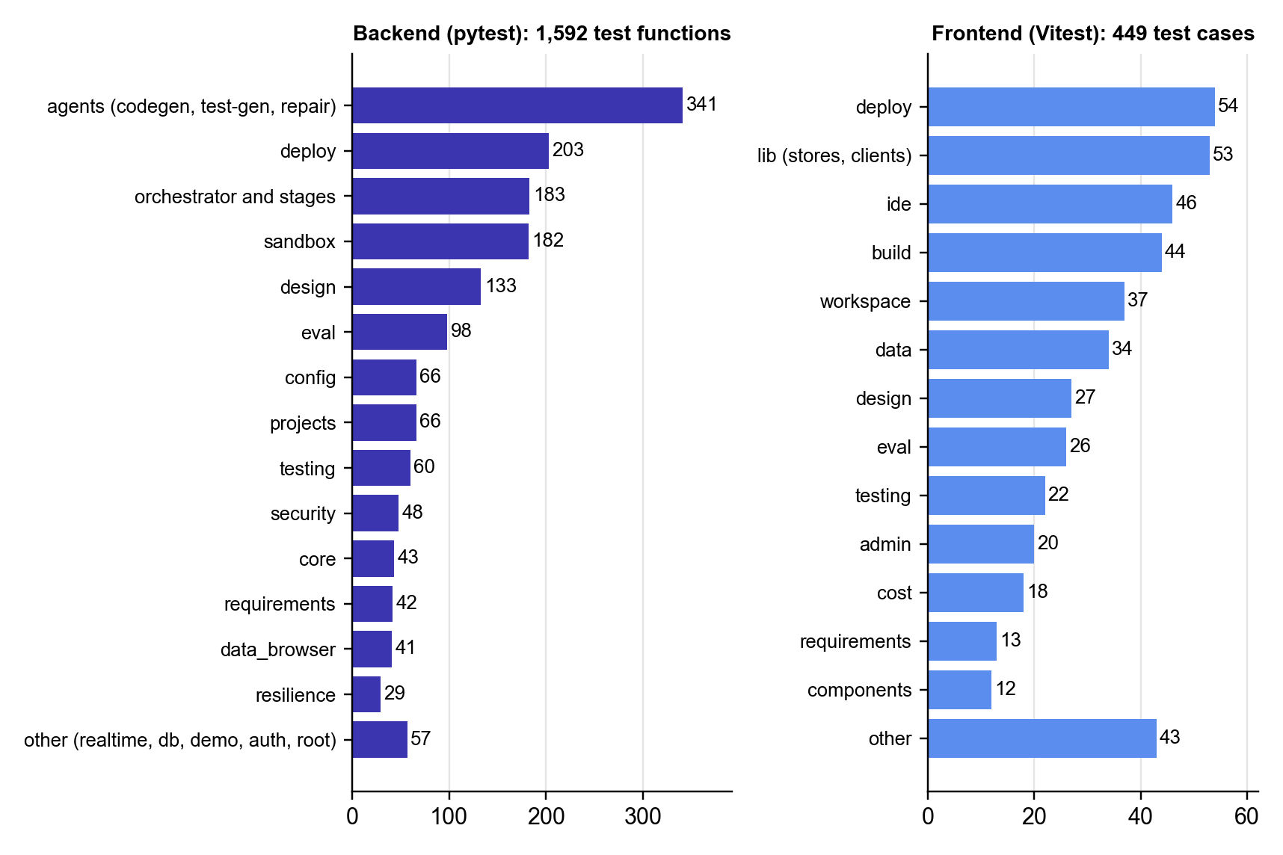
Figure 5.1: Distribution of automated test definitions by module (2 October 2026)
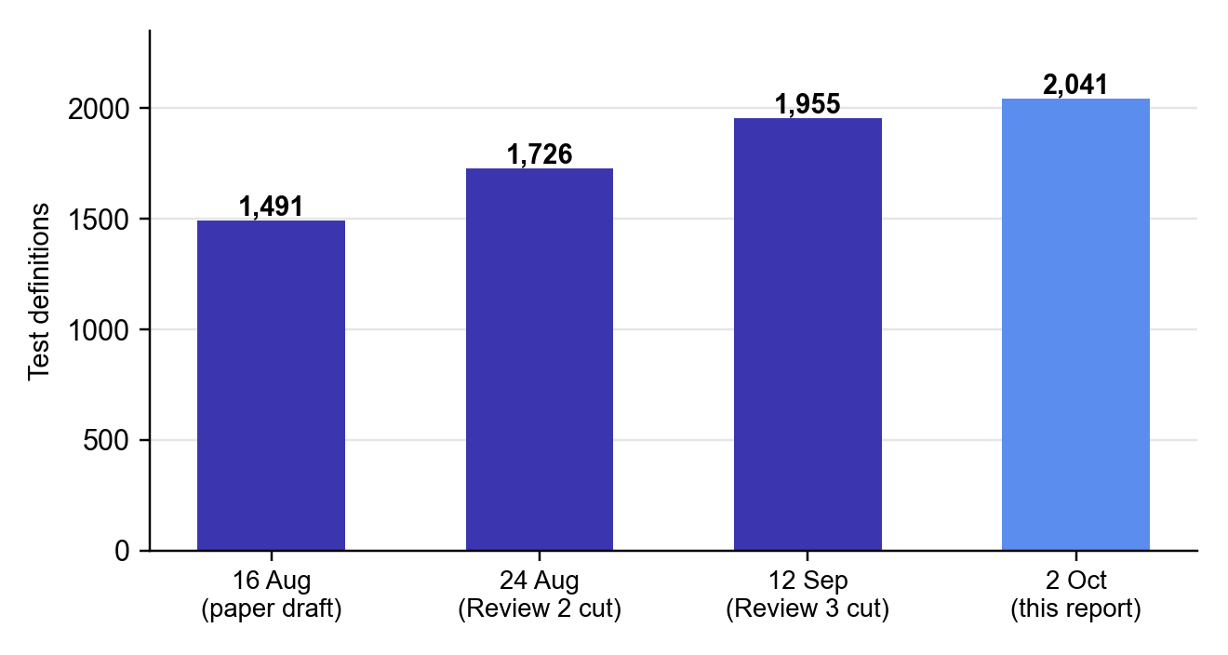
Figure 5.2: Growth of the automated test suite (test definitions)
Static quality gates were run alongside the tests: ruff and black for Python formatting and linting, strict TypeScript compilation, ESLint with zero warnings and Prettier for the frontend, and mypy for Python types. At Review 3 (19 September) mypy reported four type errors in two new test files; the CI gate caught them, and they were fixed the same day, before continuous deployment was enabled.

5.4 Debugging: Defects Found by End-to-End Validation
The most valuable debugging came from running the full pipeline on real deployments, with the frontend and backend on Vercel and data on MongoDB Atlas. Each defect found was traced to a root cause, fixed, and covered by regression tests; several led to whole new phases. Table 5.4 lists them.
Table 5.4: Defects found in live use, their root causes and fixes
Observed symptom | Root cause | Fix now in place | Phase
Backend could never deploy to Render | Render clones a git repository, but nothing pushed the sandbox workspace anywhere | Backend moved to Vercel using the same inline file upload as the frontend | 58
Model call failed with “max_tokens is not supported” | Request shape assumed one vendor's parameter names | Transport reads the provider's 400, repairs the request and remembers the working shape | 57
Environment variables shown as set but absent on Vercel | set_env was built and unit-tested but never wired | Variables mirrored to the provider project; readiness strip shows presence and last 4 characters | 62
“Logs” tab showed ForgeFlow's own step log | Provider deployment ids were never recorded | Ids recorded; real provider build and runtime logs shown | 62
No way to delete a deployment | destroy was never wired | Teardown returns deploy to empty, restoring validate after deploy | 62
Localhost database URI shipped to a function that timed out every query | No pre-flight reachability check | Database step refuses a localhost cluster URI before deploying | 62
Repair wrote nothing, twice, then stalled | Directory-shaped context missed the component under test | Import-graph walk, per-test coverage, bounded file request, no_patch escalation | 63
Report said 8 of 8 phases complete but the preview showed a placeholder | Output-token cap cut off reasoning; empty phases passed a trivial typecheck | Reasoning-aware loop, evidence-gated phases, structural feature-code check | 64
Model concluded it could not download mongod with no network | Test database downloaded its binary on first use | mongod baked into the sandbox image; useTestDb() helper; offline failures detected | 65
Build loop spent its budget and still failed | Skeleton demo tests asserted text the build gate forbids; tests are read-only to repair | Zero-iteration stop that names the stale test files | –
Preview failed with EAI_AGAIN after a Docker restart | Database and proxy did not restart with the sandbox | Unresolvable host detected, diagnosed and dependencies restarted | –
A design nobody asked for appeared after the provider asked a question | Question treated as an error, so fallback ran | Question parked; stage awaiting_user; answer resumes the same provider | –
A live-validation run appeared as the Test stage's latest result | Shared collection with an unscoped listing | Sandbox runs shown by default; explicit environment filter | –

Two patterns stand out. First, several defects were features that had been built and unit-tested but never connected to the rest of the system (set_env, destroy); only an end-to-end run against a real provider exposed them. Second, several defects were cases of the system reporting success it had not earned (phases marked done without writing code, environment variables shown as set). The fixes consistently replaced an optimistic signal with evidence, which is the same principle the project applies to generated applications.

5.5 Platform Delivery Verification
Every DevOps configuration was verified by executing it, not only by inspecting it, and the raw output is kept in the repository under docs/devops/evidence. Table 5.5 summarises the results.
Table 5.5: Verification of the delivery pipeline and infrastructure
Check | Tool | Result
Workflow syntax and embedded shell | actionlint with shellcheck | 3 workflows, 0 findings
Kubernetes manifests | kubeconform -strict (Kubernetes 1.31) | 9 of 9 valid
Ansible playbook | ansible-lint, production profile | 0 failures, 0 warnings (30 files)
Prometheus configuration and rules | promtool check | Valid, 10 rules
nginx configuration | nginx -t | Valid, with and without the preview block
WebSocket upgrade through nginx | Live handshake | 101 Switching Protocols (negative control: 200 OK)
Production image | docker build and run | Healthy, non-root uid 10001
/metrics content | Live scrape | Route templates only, no secrets
Rolling update on real k3s | In-cluster probe every 0.2 s | 807 requests, 0 failures
Deliberately broken release | Real k3s | Detected and automatically rolled back; served 0 requests
Monitoring stack | Live Prometheus and Grafana | 5 of 5 targets up, 16 panels, 10 alert rules
Backend test suite in CI | pytest | 1,648 passed

The WebSocket test illustrates why execution matters. A standard nginx proxy block does not forward the upgrade handshake; with the three required directives the handshake returns 101 Switching Protocols, and without them it silently returns 200 OK. Every REST call still works in the broken case, so the only symptom would be that live build and test streaming never connects. Running the negative control is what proves the directives are needed.

5.6 Performance and Bounds
ForgeFlow's worst-case behaviour is bounded by construction, independently of how well the model performs. Table 5.6 lists the guaranteed bounds and the measurements made so far.
Table 5.6: Worst-case bounds and measured performance
Scope | Bound or measurement | Basis
Repair loop | At most 5 iterations; stops at 2 stalls, 2 regressions or 2 empty attempts | Gains concentrate in iterations 1 to 4
Repair context | At most 24,000 characters (8,000 per file, 8,000 of diff); every drop recorded | Context quality over quantity
Import walk | Depth at most 3, at most 24 files; at most 3 requested files per attempt | Right file, bounded reach
Build | At most 8 phases, 60 tool turns per phase, 2 typecheck fixes per phase, 3,600 s per build | No unbounded loop anywhere
Environment failures | 0 repair iterations and 0 tokens; classified before the loop | Environment failures are the hard class
Live validation | At most 2 repair, redeploy and re-validate cycles | Bounded delivery loop
Cost | Per-project and global caps, warning at 80% | Cost of verification
Backend suite | 1,815 tests collected and run in 653 s on the development host (about 0.36 s per test) | Measured
Frontend suite | 508 tests across 61 files in 167 s | Measured
Rolling update | 807 requests, 0 failures across update, broken release and rollback | Measured on k3s

5.7 Evaluation Harness and Benchmark Protocol
A headless evaluation harness runs the whole pipeline without the user interface on a corpus of benchmark specifications and records, for each specification, the first-pass success rate, the pass rate after repair, the repair delta, the number of repair iterations, regressions introduced, tokens and rupee cost, per-stage and total wall-clock time, and the time from intake to a live URL. Each specification gets its own project and database, and costly legs such as deployment are opt-in. Ten specifications are seeded, from a simple todo list to an issue tracker and an event scheduler, with 93 acceptance criteria in total (Table 5.7).
Table 5.7: Benchmark specifications
Specification | Difficulty | Features | Criteria | Focus
todo-list | Simple | 2 | 5 | CRUD on a single entity
notes-crud | Simple | 2 | 7 | CRUD with search
url-shortener | Simple | 2 | 6 | Redirects and uniqueness
hero-todo | Moderate | 3 | 7 | Bulk action (demonstration)
bookmark-manager | Moderate | 3 | 9 | Tags and many-to-many filtering
expense-tracker | Moderate | 3 | 10 | Aggregation, categories, dates
kanban-board | Moderate | 3 | 10 | Ordering, drag and drop, screenshot input
recipe-box | Moderate | 3 | 9 | Nested data, scaling, filtering
issue-tracker | Complex | 4 | 15 | Relations, workflow, comments, permissions
event-scheduler | Complex | 4 | 15 | Dates, conflict detection, capacity

The planned study has three arms run on the same specifications with repeated runs to report variance: (i) no repair, (ii) the proposed bounded, diff-aware repair, and (iii) bounded repair with the diff-aware context removed. Arm (i) against arm (ii) tests the value of repair; arm (ii) against arm (iii) tests hypothesis H2. Secondary sweeps over the iteration cap and stall threshold will locate the empirical point of diminishing returns and check whether the one-to-four-iteration range reported for function-level benchmarks (Kiecker et al., 2026; Arimbur, 2026) also holds for whole-application generation, which tests H1.
Status. The harness, the specifications and the metric pipeline are implemented and tested (130 evaluation tests). Section 5.8 reports the first scored run: four industry-standard benchmarks in full, and the first two of the ten benchmark applications, after which the run was stopped to stay within budget. The no-repair and context-ablated arms with repeated runs have not yet been run, so this report gives no variance and does not yet separate the effect of diff-aware context. Three threats to validity are acknowledged. Generated-test pass rates measure agreement between generated code and generated tests, not necessarily the user's intent; the criterion_id chain reduces but does not remove this risk. Model non-determinism requires repeated runs. And results will be specific to one stack and to small and medium CRUD-style applications.

5.8 Benchmark Results
ForgeFlow was evaluated at two levels on 2 October 2026, using a single command (make eval) so that every number in this section can be reproduced from the repository. The first level uses four industry-standard benchmarks that are widely reported for language models that write code and call tools; they run through ForgeFlow's own model interface and its bounded repair policy. The second level runs the benchmark applications of Table 5.7 through the complete pipeline; that run was stopped after the first two applications to stay within the evaluation budget. All runs used the model z-ai/glm-5.3-flash, accessed through OpenRouter and pinned to the model developer's own endpoint, so that every call was served by the same deployment of the model.

5.8.1 Evaluation set-up
The pass@1 metric is the share of problems solved by one greedy sample (temperature 0), graded only by the benchmark's own tests; it is the figure reported on public leaderboards. The second figure applies ForgeFlow's repair policy to each failure: the failing test output is returned to the model for at most five attempts, and repair stops after two attempts that make no progress, which are the defaults of the product's repair loop (Table 4.2). Each attempt sees only the task, the current code and the failure, mirroring the loop's minimal context. As in the self-repair literature (Chen et al., 2024; Olausson et al., 2024), the feedback comes from the benchmark's tests, so the second figure measures what repair adds and is not a pass@1 result.
Model-written code is executed only inside a container with no network access, all Linux capabilities dropped, a read-only root file system and limits on memory, CPU and processes. Before any model output is scored, the grader itself is checked: 426 of 426 reference solutions pass and 580 of 580 deliberately wrong solutions are rejected, so every pass rate below comes from a grader that accepts correct code and rejects incorrect code. Each dataset is fixed to an upstream commit and verified by a SHA-256 checksum before use. The industry benchmarks made 1,853 model calls costing ₹64.58. All costs in this section are computed from token counts at the provider's list price and ignore prompt-cache discounts, so they are upper bounds.

5.8.2 Code generation: HumanEval, MBPP and HumanEval-TS
HumanEval (Chen et al., 2021) contains 164 Python problems, and MBPP (Austin et al., 2021) contains 257 hand-verified problems in its sanitised test split. HumanEval-TS is the TypeScript translation of HumanEval from MultiPL-E (Cassano et al., 2023); it matches the language of the applications that ForgeFlow generates. Table 5.8 and Figure 5.3 give the results.
Table 5.8: Code-generation benchmark results, pass@1 and after bounded repair
Benchmark | Problems | pass@1 | After repair | Gain (pp) | Repaired | Mean attempts | Cost (₹)
HumanEval (Python) | 164 | 97.0% | 99.4% | +2.4 | 4 | 1.2 | 14.74
MBPP sanitized (Python) | 257 | 96.1% | 98.8% | +2.7 | 7 | 1.3 | 19.82
HumanEval-TS (TypeScript) | 159 | 97.5% | 98.7% | +1.3 | 2 | 1.0 | 13.59

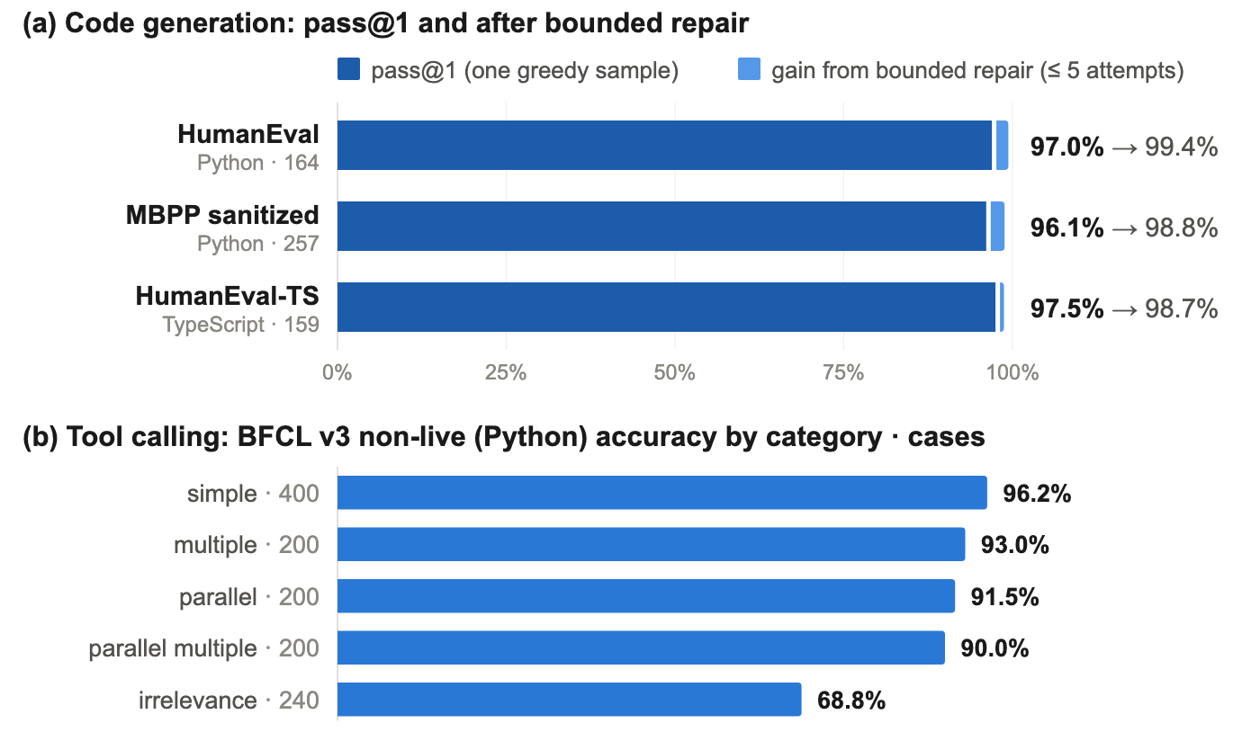
Figure 5.3: Industry benchmark results: code generation with and without bounded repair (top) and BFCL tool-calling accuracy by category (bottom)
The model solved 97.0% of HumanEval, 96.1% of MBPP and 97.5% of HumanEval-TS at the first attempt. Of the 19 problems that failed first time, bounded repair solved 13, with a mean of 1.2 attempts per repaired problem, raising the pass rates by between 1.3 and 2.7 percentage points. Of the remaining failures, six stopped early because two attempts made no progress and none reached the five-attempt cap, so no problem consumed more than the configured budget. No item was lost to a provider error. Because these function-level problems are short and self-contained, the absolute numbers say more about the model than about ForgeFlow. The contribution measured here is the repair policy, which turned 13 of 19 first-attempt failures (68%) into passes and stopped on its own on the rest.

5.8.3 Tool calling: Berkeley Function-Calling Leaderboard
The Berkeley Function-Calling Leaderboard (Patil et al., 2025) measures whether a model calls the right function with correctly typed arguments, which is what ForgeFlow's agents do in every build and repair turn. Its four non-live abstract syntax tree (AST) categories cover a single function, a choice among several functions, several calls in parallel, and both together; the irrelevance category checks that the model calls nothing when no function fits. The functions are offered as tools through the same transport that the build agents use, the request follows the official harness, and the calls are graded by a port of the official AST checker (Table 5.9).
Table 5.9: BFCL v3 non-live (Python) accuracy, scored by the official AST checker
Category | Cases | Correct | Accuracy
simple | 400 | 385 | 96.2%
multiple | 200 | 186 | 93.0%
parallel | 200 | 183 | 91.5%
parallel multiple | 200 | 180 | 90.0%
Mean of the four AST categories | 1,000 | – | 92.7%
Irrelevance (correctly calls nothing) | 240 | 165 | 68.8%

Across the 1,000 AST cases the mean accuracy was 92.7%; the weakest category was parallel multiple (90.0%), and the model correctly declined to call a function in 68.8% of the irrelevance cases. This is the clearest weakness the benchmark shows: when no offered function fits, the model still calls one in about 31% of cases, which for an agent means acting where it should ask. ForgeFlow's approval gates and human-in-the-loop stages are the mitigation, and a tool-use prompt that rewards abstaining is a cheap follow-up. The mean covers only the Python non-live categories and is therefore not comparable with the leaderboard's overall score, which also includes Java, JavaScript, live and multi-turn categories.

5.8.4 End-to-end application generation
Each specification in Table 5.7 is run once through requirements, build, test generation, testing and the bounded repair loop, each in its own project, sandbox and database. The evaluation runs the product's own test-generation agent after the build, so that every acceptance criterion has tests tagged with its identifier. A criterion counts as met only when at least one of its tests ran and none failed; a criterion without a test counts as unmet. An application counts as delivered only when all of its tests pass and every acceptance criterion is met. The run was stopped after two of the ten applications had completed, to keep the evaluation within its budget; Table 5.10 reports those applications, and the discussion below does not generalise from them.
Table 5.10: End-to-end results on the benchmark applications completed (one run each)
Specification | Difficulty | Criteria met: first → repaired | Repair attempts | Tokens | Cost (₹) | Time (min) | Outcome
notes-crud | Simple | 5/7 → 5/7 | 0 | 1.4M | 20.8 | 34 | Escalated
bookmark-manager | Moderate | 7/9 → 7/9 | 0 | 1.6M | 24.9 | 44 | Escalated

The generated tests covered all 16 acceptance criteria of the two applications, and 12 criteria (75%) were met at the first test run. Every unit test passed (78 of 78), while only 2 of 13 Playwright end-to-end tests did, so every unmet criterion was an end-to-end one. The bounded repair loop made no attempt on either application, and this is by design rather than a failure of the loop: an end-to-end test drives the browser and imports none of the application's source, so the minimal repair context (Section 4.9) contains no editable file and the loop escalates instead of guessing. Repair therefore helps where a failing test reaches the code it exercises, and mapping an end-to-end failure to the pages and routes it visits is the clearest next improvement. One caution applies to the end-to-end numbers themselves: in an isolated re-run of a third application's end-to-end suite, both of its tests passed in 2.3 seconds, so some of these failures may come from building four applications at once on one machine rather than from the generated code. Each application took between 34 and 44 minutes and about 1.5 million tokens.

5.8.5 Defects found by running the evaluation
Running the evaluation end to end exposed five defects that no unit test had caught. Each was fixed and is covered by a regression test:
Test generation was not wired in. The test-generation agent was implemented and tested but never called by the pipeline, so test pass rates measured only the skeleton's placeholder tests, which pass whatever is built. The evaluation now runs it before the first test run and scores acceptance criteria rather than tests.
Detached builds were not awaited. The build stage returns as soon as a build is accepted and finishes in the background, so the harness measured a half-built workspace and raced the build for its sandbox. It now waits for the build to finish.
Cheapest-first routing chose a slow, 4-bit host. Sorting OpenRouter's upstream providers by price sent requests to a host serving a 4-bit quantised copy of the model at about three tokens per second, so a single planning call ran for over half an hour. A new setting pins requests to named upstreams without fallback, and every benchmark run uses it.
End-to-end browsers crashed inside the sandbox. Playwright sizes its worker pool from the host's processor count rather than the sandbox's single-CPU limit, and each Chromium instance needs about a hundred threads, which count against the sandbox's 256-process limit. With two workers the sandbox peaked at 247 processes; with three, every browser failed at launch, so every end-to-end criterion failed for a reason the generated code never caused. The application skeleton now runs one browser at a time, which peaked at 142 processes.
Network timeouts inside a stream were not retried. A read timeout raised while a response was streaming escaped the retry logic and failed the whole build. It is now retried like any other transient error, or reported as a provider error once output has been produced.
All results in this section are reproduced with make eval, which also writes a report of the latest run (eval/results/REPORT.md) and a JSON record of every item. The developer guide lists what must be in place first: Docker, MongoDB, the sandbox image, the model settings in the environment file, and the agents' loop bounds at their documented defaults. The last condition matters: with the tool-turn cap left at 16 instead of 250, test generation stopped while still reading the code and wrote no tests, so every acceptance criterion scored as unmet.

5.9 Project Outcomes
Table 5.11 compares the outcomes planned at the start of the project with what had been achieved by 2 October 2026. The supporting evidence is collected in the appendices.
Table 5.11: Planned and achieved project outcomes
Planned outcome | Achieved | Evidence
Working end-to-end platform | All 65 phases shipped; hero path verified on real Vercel and Atlas deployments | Chapter 4; Section 5.4
Bounded, diff-aware repair loop | Implemented with five guards, revert of harmful attempts, escalation and full audit trail | Section 4.9; TC-13 to TC-18
Live deployment of the platform | Backend on Oracle Cloud with health-checked CD and rollback; frontend on Vercel | Section 4.14; Table 5.5
Automated quality gates | Six-job CI with 21 gates on every push and pull request | Section 4.14
Research publication | IEEE conference paper submitted; under review | Appendix D
Intellectual property | Invention disclosure revised after six-point IP review and submitted for filing | Appendix F
Competition participation | ForgeFlow submitted to the IBM Bob 2.0 Hackathon (lablab.ai, 25–27 September 2026) | Appendix E
Quantitative evaluation | Industry benchmarks complete: 97.0% pass@1 on HumanEval, 99.4% with bounded repair; BFCL 92.7%. 2 of 10 applications run; ablation arms pending | Sections 5.7–5.8

The research paper, titled “ForgeFlow: A Human-in-the-Loop AI Platform for End-to-End Web Application Delivery with a Bounded, Diff-Aware Self-Healing Repair Loop”, is authored by Faheemuddin Sayyed, Sanidhya Awasthi, Raghav Sonchhatra and Dr. Payal Kadam. The invention disclosure is titled “System and Method for Bounded Diff-Aware Self-Healing Software Application Delivery”; in response to the IP review its claims were narrowed to what the system demonstrably does, for example replacing “provable termination” with “deterministically bounded termination under configured guard conditions”.

5.10 Summary of Results and Discussion
The results support three conclusions. First, the system works end to end: all 65 phases were delivered against written acceptance criteria, the full path from requirements to a validated live URL was exercised on real deployments, and all 2,253 automated tests executed on the development host pass, with the remaining 70 POSIX-only or opt-in tests covered by the Linux CI runners. Second, the bounds that make the repair loop safe are enforced by construction and verified by tests: the loop stops at its cap, at a stall, after repeated regressions or empty attempts, and spends no tokens on environment failures. Third, the platform holds itself to the standard it applies to generated applications, with gated CI, health-checked deployment, automatic rollback and monitoring, all verified by execution.
With respect to the hypotheses, the scored run in Section 5.8 gives first evidence for H1: on the code benchmarks, bounded repair added between 1.3 and 2.7 percentage points to pass@1 within at most five attempts and stopped by itself when it made no progress. On the two applications completed, every remaining failure was an end-to-end test outside the repair context, so the loop escalated without an attempt. H1 at the level of whole applications, and H2, still need the full corpus and the context-ablated arm, which remain the main open items. The live-use defects in Table 5.4 give qualitative support for H3: problems such as a database URI that worked in the sandbox but timed out every query on the deployed function, or environment variables that existed only on one immutable deployment, are invisible to sandbox tests and appear only when the deployed site is exercised. A quantitative test of H3 will compare sandbox and live pass rates in the benchmark study.
Chapter 6

Conclusion and Future Scope

6.1 Conclusion
Generating a web application with AI is no longer the hard part; knowing whether it works is. The literature from 2025 and 2026 points to the same problem from five directions: AI-generated code carries systematic quality and security defects, iterative self-improvement can make code worse, generated infrastructure often fails to deploy, generated tests lose validity when code changes, and developers do not want to give up control. ForgeFlow is a complete response to this problem: a human-in-the-loop, non-linear platform that takes an idea from screenshots or a specification to a live, validated URL, with a bounded, diff-aware, escalating repair loop at its centre.
The project met its objectives. A non-linear orchestration model lets the user enter, refine, skip, unskip or revisit any stage, with only two enforced orderings. Agentic generation produces applications on a fixed stack from a copied skeleton, with phase-by-phase construction and evidence-gated verification. Structured requirements compile into unit and end-to-end tests linked to their acceptance criteria. The repair loop assembles a minimal context from the failing tests, the files they import and the diff since the last passing run, and it stops at the first of five guards, reverts harmful attempts, and hands the user an auditable summary when it cannot converge. Deployment analyses infrastructure needs, deploys in order, reports truthfully and is followed by validation on the live URL. Untrusted code runs only in hardened per-project sandboxes, and every model call is costed and capped.
The prototype consists of about 50,000 lines of production code and more than 2,000 automated tests, built over 65 specified phases. The platform is itself delivered by a gated CI/CD pipeline to Oracle Cloud and Vercel, with automatic rollback and monitoring. The work produced an IEEE conference paper now under review, an invention disclosure submitted for filing and a hackathon submission. On industry benchmarks run through its own model interface it reached 97.0% pass@1 on HumanEval (99.4% with bounded repair) and 92.7% on the BFCL function-calling categories. The distinguishing commitment of ForgeFlow is a negative one: rather than promising that it can always fix an application, the system knows when to stop, and it returns the problem to the human together with an account of what it tried.

6.2 Limitations
- Partial, single-run evaluation. The industry benchmarks in Section 5.8 are complete, but only two of the ten benchmark applications were run, once each and with one model, so the application results report no variance; the context-ablated arm needed to test H2 has not been run, and the repair loop cannot yet act on end-to-end failures.
- One generated-app stack. Restricting output to React, Express and MongoDB makes verification tractable but limits applicability.
- Design fidelity. Design intake inherits the visual-fidelity limits of current multimodal models, which is why the design stage is refinable and skippable.
- Oracle quality. Generated tests check agreement with generated code; a test can satisfy the letter of an acceptance criterion but not its intent.
- Single-node production. The control plane runs as one worker on one virtual machine because WebSocket subscribers and rate limiters are held in process memory, and sandbox-backed stages do not run on the Kubernetes demonstration cluster.
- Scope. Mobile, desktop and native targets, team collaboration, payments in generated applications and enterprise compliance are outside the scope of this version.

6.3 Future Scope
- Complete the ablation study. Run all ten applications in the no-repair, bounded diff-aware and context-ablated arms, with repeated runs and more than one model, and report convergence, cost per success and latency with variance. Give the repair loop end-to-end context by mapping a failing browser test to the pages and routes it visits.
- Expand the corpus. Grow the benchmark from 10 to 20–30 specifications of increasing difficulty and sweep the iteration cap and stall threshold to find the empirical point of diminishing returns for whole applications.
- Learned stopping. Replace the fixed iteration cap with a stopping criterion learned from the trajectory of the failing set, while keeping a hard upper bound.
- Repository-level maintenance. Test whether the bounded loop transfers to existing codebases, where the diff signal is richer but a regression has a larger blast radius.
- Horizontal scaling. Move realtime subscribers and rate-limiter state to a shared store such as Redis, run multiple control-plane replicas, and add a Kubernetes-native sandbox runtime.
- More stacks and providers. Add further generated-app stacks behind the same skeleton-and-verification pattern, and further deployment providers behind the existing DeployProvider interface.
- Alert routing and release automation. Route Prometheus alerts to e-mail or chat, and build the sandbox image automatically in continuous deployment.

References
Alian, P., Nashid, N., Shahbandeh, M., Shabani, T., & Mesbah, A. (2025). Feature-driven end-to-end test generation. In Proceedings of the IEEE/ACM 47th International Conference on Software Engineering (ICSE) (pp. 450–462). IEEE. https://doi.org/10.1109/ICSE55347.2025.00141
Alturayeif, N., Ahmad, I., & Hassine, J. (2026). TraceLLM: Leveraging large language models with prompt engineering for enhanced requirements traceability. Requirements Engineering, 31(1), Article 6. https://doi.org/10.1007/s00766-026-00460-1
Arimbur, J. J. (2026). How many tries does it take? Iterative self-repair in LLM code generation across model scales and benchmarks (arXiv:2604.10508). arXiv.
Austin, J., Odena, A., Nye, M., Bosma, M., Michalewski, H., Dohan, D., Jiang, E., Cai, C., Terry, M., Le, Q., & Sutton, C. (2021). Program synthesis with large language models (arXiv:2108.07732). arXiv. https://doi.org/10.48550/arXiv.2108.07732
Becker, J., Rush, N., Barnes, E., & Rein, D. (2025). Measuring the impact of early-2025 AI on experienced open-source developer productivity (arXiv:2507.09089). arXiv.
Bouzenia, I., Devanbu, P. T., & Pradel, M. (2025). RepairAgent: An autonomous, LLM-based agent for program repair. In Proceedings of the IEEE/ACM 47th International Conference on Software Engineering (ICSE) (pp. 2188–2200). IEEE. https://doi.org/10.1109/ICSE55347.2025.00157
Cassano, F., Gouwar, J., Nguyen, D., Nguyen, S., Phipps-Costin, L., Pinckney, D., Yee, M.-H., Zi, Y., Anderson, C. J., Feldman, M. Q., Guha, A., Greenberg, M., & Jangda, A. (2023). MultiPL-E: A scalable and polyglot approach to benchmarking neural code generation. IEEE Transactions on Software Engineering, 49(7), 3675–3691. https://doi.org/10.1109/TSE.2023.3267446
Chen, M., Tworek, J., Jun, H., Yuan, Q., Pinto, H. P. de O., Kaplan, J., Edwards, H., Burda, Y., Joseph, N., Brockman, G., Ray, A., Puri, R., Krueger, G., Petrov, M., Khlaaf, H., Sastry, G., Mishkin, P., Chan, B., Gray, S., … Zaremba, W. (2021). Evaluating large language models trained on code (arXiv:2107.03374). arXiv. https://doi.org/10.48550/arXiv.2107.03374
Chen, X., Lin, M., Schärli, N., & Zhou, D. (2024). Teaching large language models to self-debug. In Proceedings of the 12th International Conference on Learning Representations (ICLR).
Chen, Z., Tang, R., Deng, G., Wu, F., Wu, J., Jiang, Z., Prasanna, V., Cohan, A., & Wang, X. (2025). LocAgent: Graph-guided LLM agents for code localization. In Proceedings of the 63rd Annual Meeting of the Association for Computational Linguistics (Volume 1: Long Papers) (pp. 8697–8727). Association for Computational Linguistics.
CloudBees. (2026). The state of code abundance 2026. CloudBees, Inc. https://www.cloudbees.com/lp/2026-state-of-code-abundance-report
DORA. (2025). State of AI-assisted software development 2025. Google Cloud. https://dora.dev/dora-report-2025/
Ehsani, R., Pathak, S., Rawal, S., Mujahid, A. A., Imran, M. M., & Chatterjee, P. (2026). Where do AI coding agents fail? An empirical study of failed agentic pull requests in GitHub. In Proceedings of the 23rd International Conference on Mining Software Repositories (MSR). arXiv:2601.15195
Fang, Z., Jin, D., Dong, Y., Li, Y., Zhang, K., Jin, Z., & Li, G. (2026). ClarifyCodeBench: Evaluating LLMs on clarifying ambiguous requirements for code generation (arXiv:2607.00711). arXiv.
Ge, Y., Mei, L., Duan, Z., Li, T., Zheng, Y., Wang, Y., Wang, L., Yao, J., Liu, T., Cai, Y., Bi, B., Guo, F., Guo, J., Liu, S., & Cheng, X. (2025). A survey of vibe coding with large language models (arXiv:2510.12399). arXiv.
Ghaleb, T. A. (2026). When AI agents touch CI/CD configurations: Frequency and success. In Proceedings of the 23rd International Conference on Mining Software Repositories (MSR). arXiv:2601.17413
Ghammam, A., & Almukhtar, M. (2026). AI builds, we analyze: An empirical study of AI-generated build code quality. In Proceedings of the 23rd International Conference on Mining Software Repositories (MSR) (pp. 727–731). ACM. https://doi.org/10.1145/3793302.3793563
Gu, S., Nashid, N., & Mesbah, A. (2025). LLM test generation via iterative hybrid program analysis (arXiv:2503.13580). arXiv.
Haroon, S., Khan, M. T., & Gulzar, M. A. (2026). Evaluating LLM-based test generation under software evolution (arXiv:2603.23443). arXiv.
Hassan, A. E., Li, H., Lin, D., Adams, B., Chen, T.-H., Kashiwa, Y., & Qiu, D. (2025). Agentic software engineering: Foundational pillars and a research roadmap (arXiv:2509.06216). arXiv.
Huang, D., Zhang, J. M., Luck, M., Bu, Q., Qing, Y., & Cui, H. (2024). AgentCoder: Multi-agent-based code generation with iterative testing and optimisation (arXiv:2312.13010). arXiv.
Huang, K., Zhang, J., Bao, X., Wang, X., & Liu, Y. (2025). Comprehensive fine-tuning large language models of code for automated program repair. IEEE Transactions on Software Engineering, 51(4), 904–928. https://doi.org/10.1109/TSE.2025.3532759
Huang, R., Reyna, A., Lerner, S., Xia, H., & Hempel, B. (2025). Professional software developers don't vibe, they control: AI agent use for coding in 2025 (arXiv:2512.14012). arXiv.
Jiang, Z., Lo, D., & Liu, Z. (2025). Agentic software issue resolution with large language models: A survey (arXiv:2512.22256). arXiv.
Jimenez, C. E., Yang, J., Wettig, A., Yao, S., Pei, K., Press, O., & Narasimhan, K. (2024). SWE-bench: Can language models resolve real-world GitHub issues? In Proceedings of the 12th International Conference on Learning Representations (ICLR).
Kiecker, T., Reichmann, E., Kang, H., An, G., & Grunske, L. (2026). Is three the magic number? An empirical evaluation of LLM-based repair loops (arXiv:2607.05197). arXiv.
Li, H., Zhang, H., & Hassan, A. E. (2025). The rise of AI teammates in software engineering (SE) 3.0: How autonomous coding agents are reshaping software engineering (arXiv:2507.15003). arXiv.
Muna, R. K., Rafi, M. N., & Chen, T.-H. (2026). CI-Repair-Bench: A repository-aware benchmark for automated patch validation via CI workflows (arXiv:2604.27148). arXiv.
Olausson, T. X., Inala, J. P., Wang, C., Gao, J., & Solar-Lezama, A. (2024). Is self-repair a silver bullet for code generation? In Proceedings of the 12th International Conference on Learning Representations (ICLR).
Ong, I., Almahairi, A., Wu, V., Chiang, W.-L., Wu, T., Gonzalez, J. E., Kadous, M. W., & Stoica, I. (2025). RouteLLM: Learning to route LLMs from preference data. In Proceedings of the 13th International Conference on Learning Representations (ICLR).
Ouédraogo, W. C., Kaboré, A. K., Li, Y., Tian, H., Koyuncu, A., Klein, J., Lo, D., & Bissyandé, T. F. (2026). Prompt engineering in LLMs for automated unit test generation: A large-scale study. Empirical Software Engineering, 31(4), Article 103. https://doi.org/10.1007/s10664-026-10840-4
Ouyang, S., Yu, W., Ma, K., Xiao, Z., Zhang, Z., Jia, M., Han, J., Zhang, H., & Yu, D. (2025). RepoGraph: Enhancing AI software engineering with repository-level code graph. In Proceedings of the 13th International Conference on Learning Representations (ICLR).
Pasuksmit, J., Takerngsaksiri, W., Thongtanunam, P., Tantithamthavorn, C., Zhang, R., Wang, S., Jiang, F., Li, J., Cook, E., Chen, K., & Wu, M. (2025). Human-in-the-loop software development agents: Challenges and future directions. In Proceedings of the IEEE/ACM 22nd International Conference on Mining Software Repositories (MSR) (pp. 756–757). IEEE. https://doi.org/10.1109/MSR66628.2025.00112
Patil, S. G., Mao, H., Yan, F., Ji, C. C.-J., Suresh, V., Stoica, I., & Gonzalez, J. E. (2025). The Berkeley Function Calling Leaderboard (BFCL): From tool use to agentic evaluation of large language models. In Proceedings of the 42nd International Conference on Machine Learning (Proceedings of Machine Learning Research, Vol. 267). PMLR. https://proceedings.mlr.press/v267/patil25a.html
Rabin, R., Hostetler, J., McGregor, S., Weir, B., & Judd, J. (2025). SandboxEval: Towards securing test environment for untrusted code (arXiv:2504.00018). arXiv.
Schäfer, M., Nadi, S., Eghbali, A., & Tip, F. (2024). An empirical evaluation of using large language models for automated unit test generation. IEEE Transactions on Software Engineering, 50(1), 85–105.
Sepidband, M., Pham, H. V., & Hemmati, H. (2026). On the role of fault localization context for LLM-based program repair (arXiv:2604.05481). arXiv.
Shang, Y., Zhang, Q., Fang, C., Gu, S., Zhou, J., & Chen, Z. (2025). A large-scale empirical study on fine-tuning large language models for unit testing. Proceedings of the ACM on Software Engineering, 2(ISSTA), 1678–1700. https://doi.org/10.1145/3728951
Shukla, S., Joshi, H., & Syed, R. (2025). Security degradation in iterative AI code generation: A systematic analysis of the paradox. In Proceedings of the 2025 IEEE International Symposium on Technology and Society (ISTAS) (pp. 1–8). IEEE. https://doi.org/10.1109/ISTAS65609.2025.11269659
Si, C., Zhang, Y., Li, R., Yang, Z., Liu, R., & Yang, D. (2025). Design2Code: Benchmarking multimodal code generation for automated front-end engineering. In Proceedings of the 2025 Conference of the Nations of the Americas Chapter of the Association for Computational Linguistics: Human Language Technologies (NAACL) (pp. 3956–3974). https://doi.org/10.18653/v1/2025.naacl-long.199
Stack Overflow. (2025). 2025 Developer Survey: AI. https://survey.stackoverflow.co/2025/ai
Takerngsaksiri, W., Pasuksmit, J., Thongtanunam, P., Tantithamthavorn, C., Zhang, R., Jiang, F., Li, J., Cook, E., Chen, K., & Wu, M. (2025). Human-in-the-loop software development agents. In Proceedings of the IEEE/ACM 47th International Conference on Software Engineering: Software Engineering in Practice (ICSE-SEIP) (pp. 342–352). IEEE. https://doi.org/10.1109/ICSE-SEIP66354.2025.00036
Tang, N., Chen, C., Xu, G., Shi, Y., Huang, Y., McMillan, C., Dong, T., & Li, T. J.-J. (2026). How coding agents fail their users: A large-scale analysis of developer-agent misalignment in 20,574 real-world sessions (arXiv:2605.29442). arXiv.
Tao, W., Zhou, Y., Wang, Y., Zhang, W., Zhang, H., & Cheng, Y. (2024). MAGIS: LLM-based multi-agent framework for GitHub issue resolution. In Advances in Neural Information Processing Systems 37 (NeurIPS 2024) (pp. 51963–51993).
Xia, C. S., Deng, Y., Dunn, S., & Zhang, L. (2025). Demystifying LLM-based software engineering agents. Proceedings of the ACM on Software Engineering, 2(FSE), 801–824. https://doi.org/10.1145/3715754
Yang, J., Jimenez, C. E., Wettig, A., Lieret, K., Yao, S., Narasimhan, K., & Press, O. (2024). SWE-agent: Agent-computer interfaces enable automated software engineering. In Advances in Neural Information Processing Systems 37 (NeurIPS 2024).
Zhang, Q., Fang, C., Xie, Y., Zhang, Y., Yu, S., Sun, W., Yang, Y., & Chen, Z. (2026). A survey on large language models for software engineering. Science China Information Sciences, 69(4), Article 141102. https://doi.org/10.1007/s11432-025-4670-0
Zhang, T., Pan, S., Zhang, Z., Xing, Z., & Sun, X. (2026). Deployability-centric infrastructure-as-code generation: Fail, learn, refine, and succeed through LLM-empowered DevOps simulation. In Proceedings of the ACM International Conference on the Foundations of Software Engineering (FSE). arXiv:2506.05623
Zhao, S., Wang, D., Zhang, K., Luo, J., Li, Z., & Li, L. (2026). Is vibe coding safe? Benchmarking vulnerability of agent-generated code in real-world tasks. In Proceedings of the 43rd International Conference on Machine Learning (ICML). arXiv:2512.03262

Appendix A: AIC Form
The completed AIC form for this project is attached on the following page, as required for every group.

Attach the completed and signed AIC form here (mandatory).

Appendix B: Similarity Report
The summary page of the Turnitin similarity report, reviewed by the project guide, is attached below. The similarity index must be less than 10%.

Attach the summary page of the Turnitin similarity report here (mandatory).

Appendix C: AI Plagiarism Report
The summary page of the Turnitin AI-writing report, reviewed by the project guide, is attached below.

Attach the summary page of the Turnitin AI plagiarism report here (mandatory).

Appendix D: Research Paper
A research paper describing ForgeFlow and its bounded repair loop has been submitted to an IEEE conference and is under review.
Table D.1: Details of the submitted research paper
Field | Details
Title | ForgeFlow: A Human-in-the-Loop AI Platform for End-to-End Web Application Delivery with a Bounded, Diff-Aware Self-Healing Repair Loop
Authors | Faheemuddin Sayyed, Sanidhya Awasthi, Raghav Sonchhatra and Dr. Payal Kadam (Department of CSE, Symbiosis Institute of Technology, Pune)
Type | IEEE conference paper
Status | Submitted; under review

Attach the first page of the paper here once it is accepted or published.

Appendix E: Project Competition: IBM Bob 2.0 Hackathon
The team took ForgeFlow to an external competition, the IBM Bob 2.0 Hackathon hosted on lablab.ai, and submitted the project.
Table E.1: IBM Bob 2.0 Hackathon participation details
Field | Details
Event | IBM Bob 2.0 Hackathon: “Your code meets your new AI dev partner.”
Organiser and platform | lablab.ai, with IBM (IBM Bob)
URL | https://lablab.ai/ai-hackathons/ibm-bob-2-hackathon
Format | Online hackathon, 48-hour build
Dates | 25–27 September 2026 (kick-off Friday 25 September 2026, 8:30 PM IST)
Prize pool | US $12,000
Team members | Faheemuddin Sayyed (faheem219), Sanidhya Awasthi (sanidhya_awasthi), Raghav Sonchhatra (raghav18)
Submission | Forgeflow: “ForgeFlow turns a web-app idea into a verified live URL. It writes tests from your acceptance criteria, fixes failures in a bounded, diff-aware repair loop ...”
Status | Project submitted; event finished

Attach the hackathon participation certificate or a screenshot of the team and submission page here.

Appendix F: Other Project Outcomes
Invention disclosure. An invention disclosure titled “System and Method for Bounded Diff-Aware Self-Healing Software Application Delivery”, naming the three students and Dr. Payal Kadam, was revised in response to a six-point intellectual-property review and submitted for filing. The review led to narrower claims that foreground the technical effects of the invention: sandbox isolation, bounded context construction, diff-based repair, regression detection, deployment validation and credential isolation.

Attach the acknowledgement of the invention disclosure submission here.

Live deployment of the platform. The platform's API is served from https://forgeflow-backend.ddnsfree.com on an Oracle Cloud virtual machine, and its frontend from https://forgeflow-ecru.vercel.app on Vercel, both deployed by the CI/CD pipeline described in Chapter 4.
Certificate from industry. Not applicable: the project was carried out without an industry mentor or industry collaboration.

