CS341 – Assignment 1

Read Me

**IDE:** NetBeans

**GitHub Repo**: <https://github.com/Faheem4468/CS341-Assignment-1>

Opening and Runing Java File

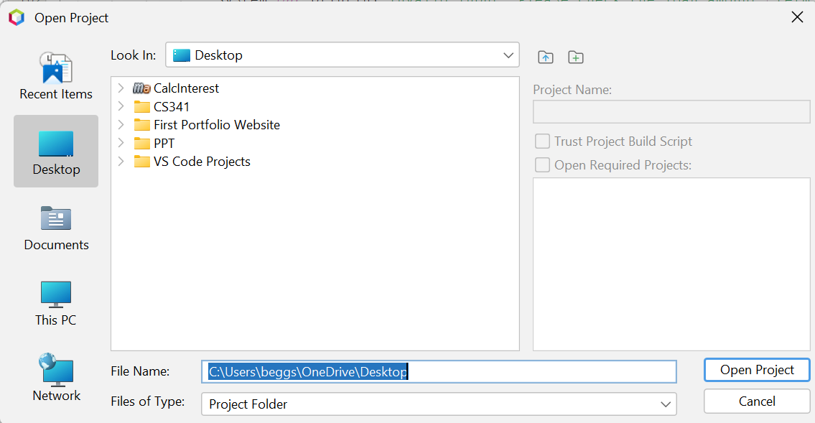

Locate project name **CalcInterest.java**

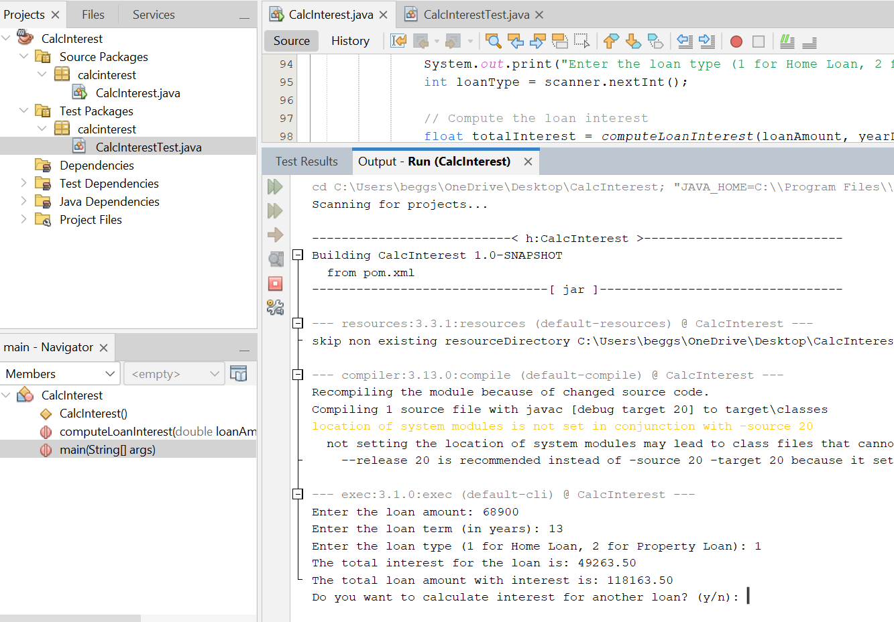

Run the project. Once the program is executed user can enter the loan amount and terms to calculate the interest. The program runs in loop until the user wishes to terminate.

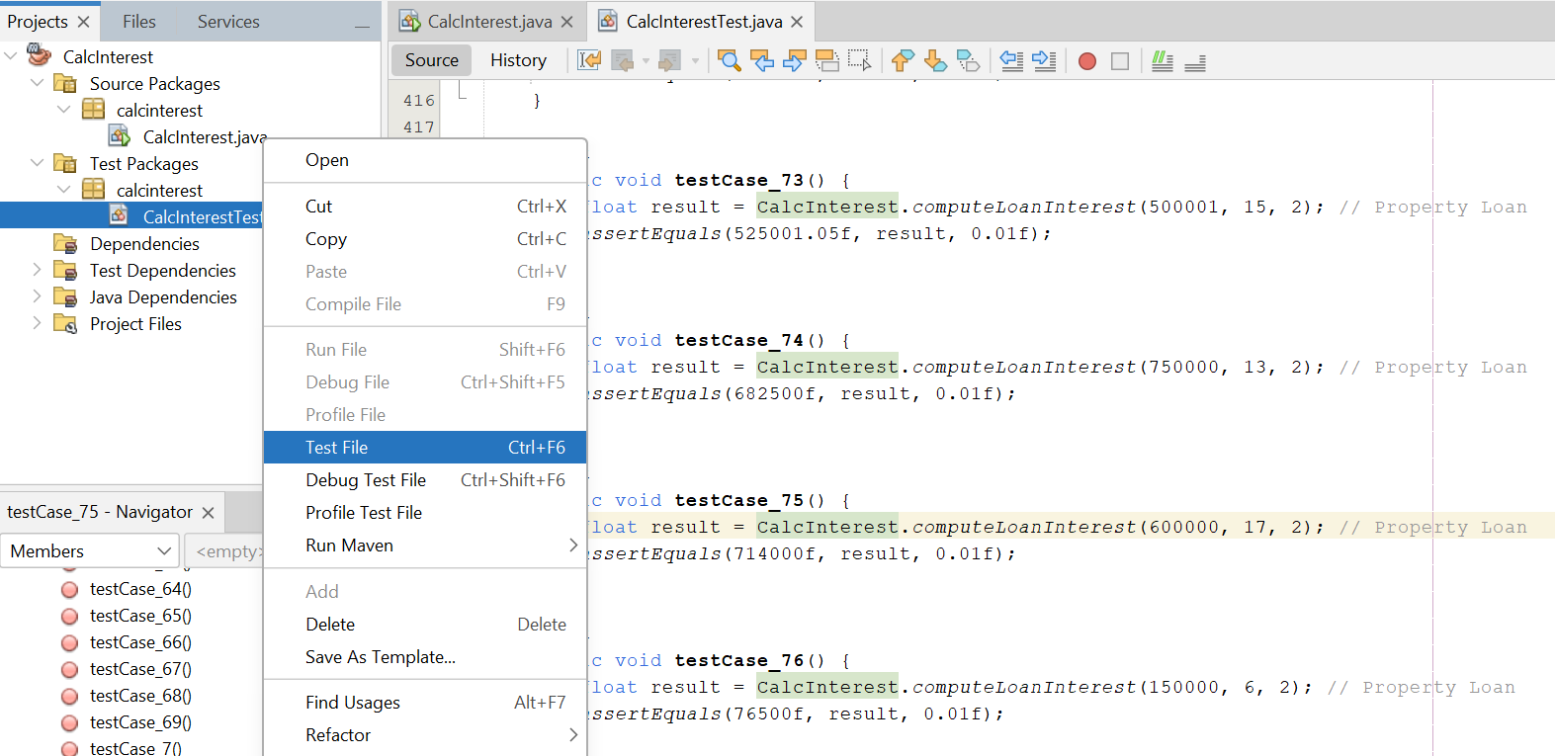Running the Junit Test on the above code

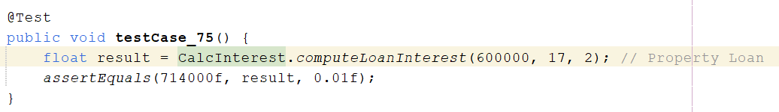the values 600000 – 17 – 2 represents the input for that particular test case

1. Amount
2. Years
3. Type (Home/Property)

And the expected result is within the assertEquals parenthesis.

**All our test were passed therefore we did not create defect tracker**