Lab 1: Simple Circuit Design

Professor Gertner

Faheem Kamal

2019

**Table of Contents**

**Objective 2**

**Functionality and Specifications 3 – 6**

**Simulation 6 – 12**

**Conclusion 12**

**Appendix 12 - 36**

**Objective:**

The goal of this lab is to understand and design basic essential tools in digital electronics. Using Quartus and ModelSim, our task is to create and generate several types of circuits. In addition, we are also response to test and analyze each circuit.

* Part 2: We create a 2-to-1 Multiplexer using the Board Diagram Schematic file and we create a waveform file. In addition, we create a vhdl code and testbench file.
* Part 3: We create a 2-to-1 Multiplexer using LPM and we create a waveform file.
* Part 4: We create each circuit: 2-to-1 Mux, 1-bit Half Adder, 1-bit Full Adder using Half Adder, 3-to-8 Decoder and 8-to-3 Encoder.
  + We create each Board Diagram Schematic File.
  + We then add our own vhdl code and testbench file.
  + We also create a waveform file for simulation for each file.
* Part 5: We create each circuit using LPM except for Decoder and 2-to-1 Multiplexer(covered in Part 3)

**Functionality and Specifications:**

1. **2-to-1 Multiplexer**

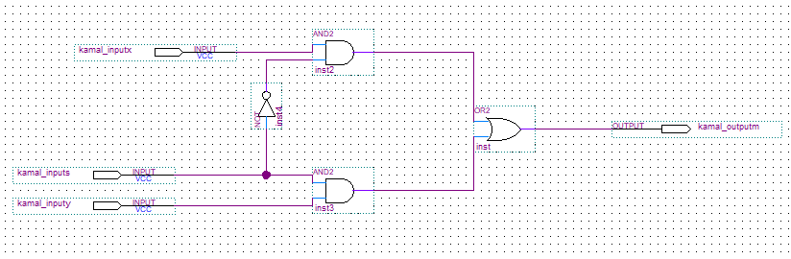

Inputs: kamal_inputs, kamal_inputx and kamal_inputy

Outputs: kamal_outputm

Pin Assignments (DE2-115): -

* kamal_inputs: PIN_AC27
* kamal_inputx: PIN_AB28
* kamal_inputy: PIN_AC28
* kamal_outputm, PIN_G19

1. **Half-Adder**

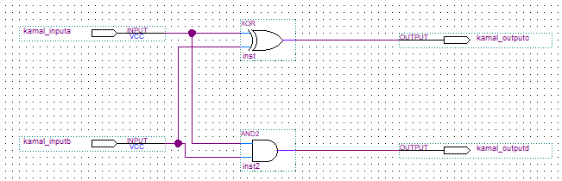

Inputs: kamal_inputa and kamal_inputb

Outputs: kamal_outputc and kamal_outputd

Pin Assignments (DE2-115): -

* kamal_inputa: PIN_AB28
* kamal_inputb: PIN_AC28
* kamal_outputc: PIN_G19
* kamal_outputd: PIN_F19

1. **Full-Adder**

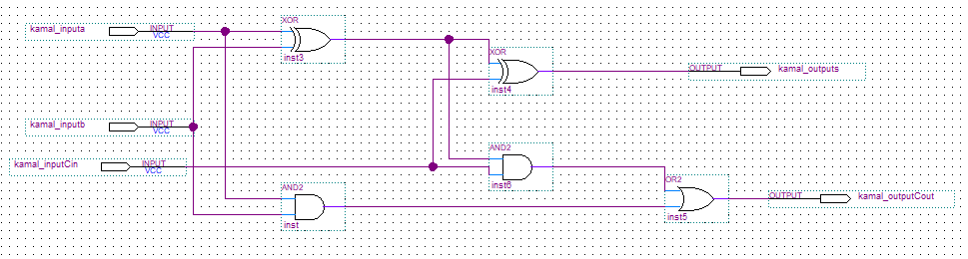

Inputs: kamal_inputa, kamal_inputb and kamal_inputCin

Outputs: kamal_outputs and kamal_outputCout

Pin Assignments (DE2-115): -

* kamal_inputa: PIN_AB28
* kamal_inputb: PIN_AC28
* kamal_inputCin: PIN_AC27
* kamal_outputs: PIN_G19
* kamal_outputCout: PIN_F19

1. **3-to-8 Decoder**

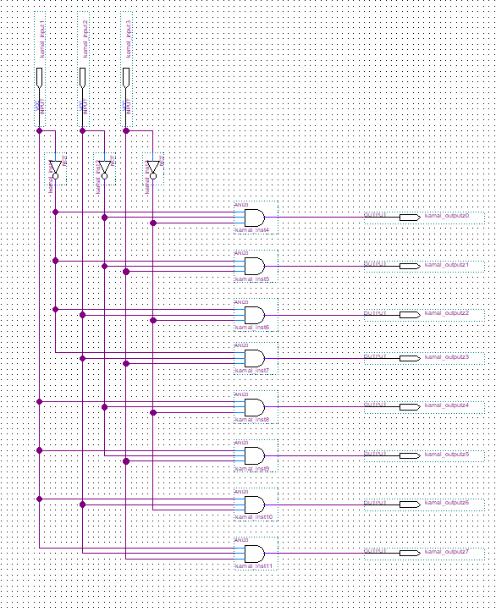

Inputs: kamal_input1, kamal_input2 and kamal_input3

Outputs: kamal_outputz0, kamal_outputz1, kamal_outputz2, kamal_outputz3, kamal_outputz4, kamal_outputz5, kamal_outputz6 and kamal_outputz7

Pin Assignments (DE2-115): -

* kamal_input1: PIN_AB28
* kamal_input2: PIN_AC28
* kamal_input3: PIN_AC27
* kamal_outputz0: PIN_G19
* kamal_outputz1: PIN_F19
* kamal_outputz2: PIN_E19
* kamal_outputz3: PIN_F21
* kamal_outputz4: PIN_F18
* kamal_outputz5: PIN_E18
* kamal_outputz6: PIN_J19
* kamal_outputz7: PIN_H19

1. **8-to-3 Encoder**

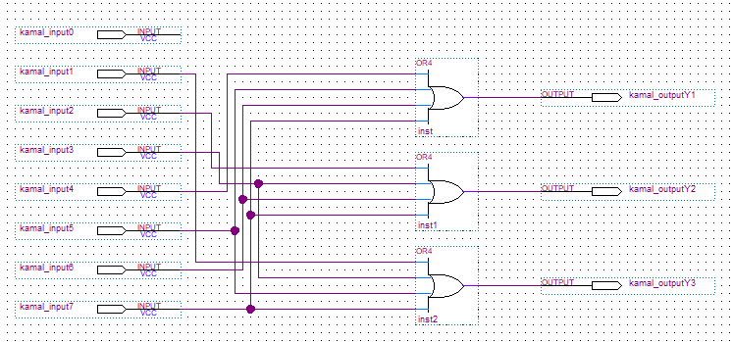

Input: kamal_input1, kamal_input2, kamal_input3, kamal_input4, kamal_input5, kamal_input6 and kamal_input7

Output: kamal_outputY1, kamal_outputY2 and kamal_outputY3

Pin Assignments (DE2-115): -

* kamal_input1: PIN_AB28
* kamal_input2: PIN_AC28
* kamal_input3: PIN_AC27
* kamal_input4: PIN_AD27
* kamal_input5: PIN_AB27
* kamal_input6: PIN_AC26
* kamal_input7: PIN_AD26
* kamal_outputY1: PIN_G19
* kamal_outputY2: PIN_F19
* kamal_outputY3: PIN_E19

**Simulation:**

1. **2-to-1 Multiplexer**

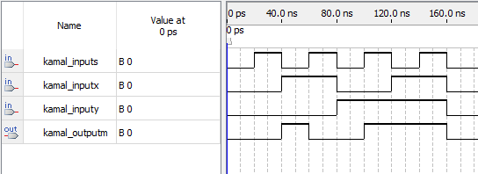

**(LPM Simulation Below)**

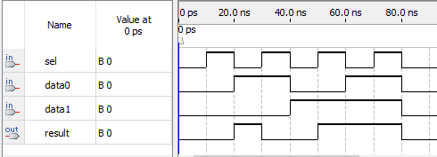

A 2-to-1 Multiplexer is a combinational logic circuit designed to switch one of the inputs to a single output line using a control signal. It’s also a digital switch where the select line is the throw on the switch, it chooses which of the many inputs get to be the output.

1. **Half-Adder**

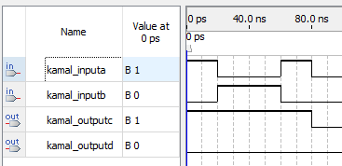

**(LPM Simulation Below)**

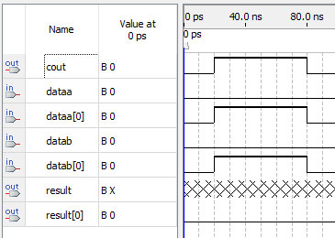

A Half-Adder is a type of adder that performs the addition of numbers. It can add two single binary digits and provide the output. It has two inputs, in this case, kamal_inputa and kamal_inputb. It also has two outputs, kamal_outputc and kamal_outputd. We can observe based on the simulation diagram that kamal_outputc gets its signal values based on the addition of kamal_inputa and kamal_inputb.

1. **Full-Adder**

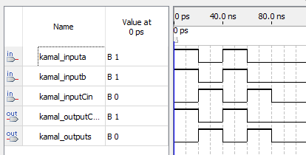

**(LPM Simulation Below)**

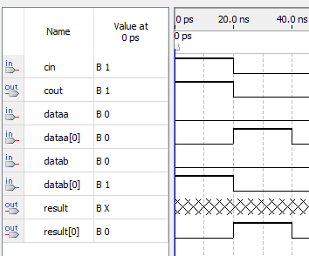

Full Adder is the adder that adds three inputs and produces two outputs. For this case, our three inputs are kamal_inputa, kamal_inputb and kamal_inputCin. And our two outputs are kamal_outputCout and kamal_outputs. The output carry is kamal_outputCout and the normal output sum is kamal_outputs. We can analyze each output signal based on the logical expressions. The logical expression for the output sum is **kamal_inputCin XOR (kamal_inputa XOR kamal_inputb)**. The logical expression for the output carry is **(kamal_inputb AND kamal_inputb) OR (kamal_inputb AND kamal_inputCin) OR (kamal_inputa AND kamal_inputCin).**

1. **3-to-8 Decoder**

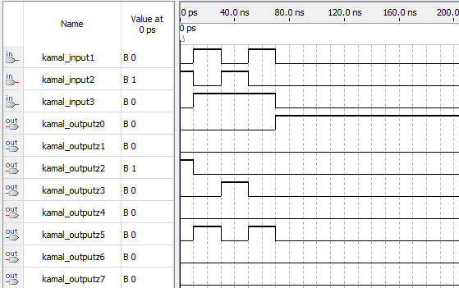

**(LPM Simulation Below)**

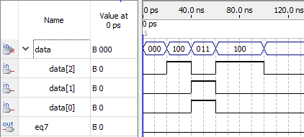

A Decoder translates or decodes information from one format into another. In this case, a Binary Decoder transforms n binary input signals into an equivalent $2^{n}$ outputs. A 3-to-8 Decoder has 8 logic outputs for 3 logic inputs. The inputs are kamal_input1, kamal_input2 and kamal_input3. The outputs are kamal_outputz0, kamal_outputz1, kamal_outputz2, kamal_outputz3, kamal_outputz4, kamal_outputz5, kamal_outputz6 and kamal_outputz7. The logical expression for the outputs are:

1. **kamal_outputz0 = (NOT kamal_input1) AND (NOT kamal_input2) AND (NOT kamal_input3)**

2. **kamal_outputz1 = (NOT kamal_input1) AND (NOT kamal_input2) AND (kamal_input3)**

3. **kamal_outputz2 = (NOT kamal_input1) AND (kamal_input2) AND (NOT kamal_input3)**

4. **kamal_outputz3 = (NOT kamal_input1) AND (kamal_input2) AND (kamal_input3)**

5. **kamal_outputz4 = (kamal_input1) AND (not kamal_input2) AND (not kamal_input3)**

6. **kamal_outputz5 = (kamal_input1) AND (not kamal_input2) AND (kamal_input1)**

7. **kamal_outputz6 = (kamal_input1) AND (kamal_input2) AND (not kamal_input3)**

8. **kamal_outputz7 = (kamal_input1) AND (kamal_input2) AND (kamal_input3)**

1. **8-to-3 Encoder**

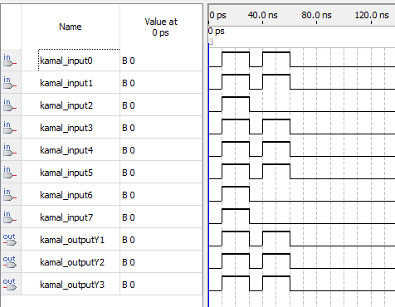

An encoder takes all of the data inputs one at a time and converts them into a single equivalent binary code as an output. We have 8 inputs denoted by kamal_input0 through kamal_input7 in the circuit. And we also have 3 outputs denoted by kamal_outputY1 through kamal_outputY3. The input kamal_input0 is generally ignored since it is not connected to any of the OR gates in the circuit.

**Conclusion:**

I learned various circuit designs such as the 2-to-1 MUX, Half-Adder, Full-Adder, 3-to-8 Decoder and 8-to-3 Encoder using Quartus II. I learned to also make block diagrams, code in VHDL and create Waveform files. In addition, I also learned the properties and functionalities of each circuits and to verify each one through simulation. Furthermore, I also learned to utilize Quartus II and Modelsim in future labs.

**Appendix:**

1. **2-to-1 Multiplexer VHDL code**

library ieee;

use ieee.std_logic_1164.all;

entity kamal_mux2to1code is

port(

kamal_inputx: in std_logic;

kamal_inputy: in std_logic;

kamal_inputs: in std_logic;

kamal_outputm: out std_logic

);

end kamal_mux2to1code;

architecture arch of kamal_mux2to1code is

begin

kamal_outputm <= (kamal_inputs and kamal_inputy) or ((not kamal_inputs) and kamal_inputx);

end arch;

1. **2-to-1 Multiplexer Testbench VHDL code**

library ieee;

use ieee.std_logic_1164.all;

entity kamal_mux2to1_tb is

end kamal_mux2to1_tb;

architecture tb of kamal_mux2to1_tb is

signal kamal2_inputx: std_logic := '0';

signal kamal2_inputy: std_logic := '0';

signal kamal2_inputs: std_logic := '0';

signal kamal2_outputm: std_logic;

begin

UUT: entity work.kamal_mux2to1code

port map(

kamal_inputs => kamal2_inputs,

kamal_inputx => kamal2_inputx,

kamal_inputy => kamal2_inputy,

kamal_outputm => kamal2_outputm

);

process is

begin

kamal2_inputs <= '0';

kamal2_inputx <= '0';

kamal2_inputy <= '0';

wait for 10 ns;

kamal2_inputs <= '0';

kamal2_inputx <= '0';

kamal2_inputy <= '1';

wait for 10 ns;

kamal2_inputs <= '0';

kamal2_inputx <= '1';

kamal2_inputy <= '1';

wait for 10 ns;

kamal2_inputs <= '1';

kamal2_inputx <= '1';

kamal2_inputy <= '1';

wait for 10 ns;

end process;

end tb;

1. **PIN ASSIGNMENT for 2-to-1 Multiplexer**

To, Location

kamal_inputx,PIN_AB28

kamal_inputy,PIN_AC28

kamal_inputs,PIN_AC27

kamal_outputm,PIN_G19

1. **2-to-1 MUX LPM VHDL code**

LIBRARY ieee;

USE ieee.std_logic_1164.all;

LIBRARY lpm;

USE lpm.lpm_components.all;

ENTITY kamal_muxLPM IS

PORT

(

data0 : IN STD_LOGIC ;

data1 : IN STD_LOGIC ;

sel : IN STD_LOGIC ;

result : OUT STD_LOGIC

);

END kamal_muxLPM;

ARCHITECTURE SYN OF kamal_muxlpm IS

-- type STD_LOGIC_2D is array (NATURAL RANGE <>, NATURAL RANGE <>) of STD_LOGIC;

SIGNAL sub_wire0 : STD_LOGIC_VECTOR (0 DOWNTO 0);

SIGNAL sub_wire1 : STD_LOGIC ;

SIGNAL sub_wire2 : STD_LOGIC ;

SIGNAL sub_wire3 : STD_LOGIC_2D (1 DOWNTO 0, 0 DOWNTO 0);

SIGNAL sub_wire4 : STD_LOGIC ;

SIGNAL sub_wire5 : STD_LOGIC ;

SIGNAL sub_wire6 : STD_LOGIC_VECTOR (0 DOWNTO 0);

BEGIN

sub_wire4 <= data0;

sub_wire1 <= sub_wire0(0);

result <= sub_wire1;

sub_wire2 <= data1;

sub_wire3(1, 0) <= sub_wire2;

sub_wire3(0, 0) <= sub_wire4;

sub_wire5 <= sel;

sub_wire6(0) <= sub_wire5;

LPM_MUX_component : LPM_MUX

GENERIC MAP (

lpm_size => 2,

lpm_type => "LPM_MUX",

lpm_width => 1,

lpm_widths => 1

)

PORT MAP (

data => sub_wire3,

sel => sub_wire6,

result => sub_wire0

);

END SYN;

1. **PIN ASSIGNMENT for 2-to-1 Multiplexer LPM**

To, Location

data0,PIN_AB28

data1,PIN_AC28

sel,PIN_AC27

result,PIN_G19

1. **Half-Adder VHDL code**

library ieee;

use ieee.std_logic_1164.all;

use ieee.numeric_std.all;

entity kamal_lab1halfaddercode is

port(

kamal_inputa : in std_logic;

kamal_inputb : in std_logic;

--

kamal_outputc : out std_logic;

kamal_outputd : out std_logic

);

end kamal_lab1halfaddercode;

architecture arch of kamal_lab1halfaddercode is

begin

kamal_outputc <= kamal_inputa xor kamal_inputb;

kamal_outputd <= kamal_inputa and kamal_inputb;

end arch;

1. **Half-Adder Testbench VHDL code**

library ieee;

use ieee.std_logic_1164.all;

use ieee.numeric_std.all;

entity kamal_lab1halfadder_tb is

end kamal_lab1halfadder_tb;

architecture tb of kamal_lab1halfadder_tb is

signal kamal2_inputa: std_logic := '0';

signal kamal2_inputb: std_logic := '0';

signal kamal2_outputc: std_logic;

signal kamal2_outputd: std_logic;

begin

UUT : entity work.kamal_lab1halfaddercode

port map(

kamal_inputa => kamal2_inputa,

kamal_inputb => kamal2_inputb,

kamal_outputc => kamal2_outputc,

kamal_outputd => kamal2_outputd

);

process is

begin

kamal2_inputa <= '0';

kamal2_inputb <= '0';

wait for 10 ns;

kamal2_inputa <= '0';

kamal2_inputb <= '1';

wait for 10 ns;

kamal2_inputa <= '1';

kamal2_inputb <= '0';

wait for 10 ns;

kamal2_inputa <= '1';

kamal2_inputb <= '1';

wait for 10 ns;

end process;

end tb;

1. **PIN ASSIGNMENTS for Half-Adder**

To, Location

kamal_inputa,PIN_AB28

kamal_inputb,PIN_AC28

kamal_outputc,PIN_G19

kamal_outputd,PIN_F19

1. **Half-Adder LPM VHDL code**

LIBRARY ieee;

USE ieee.std_logic_1164.all;

LIBRARY lpm;

USE lpm.all;

ENTITY kamal_lab1_AdderLPM IS

PORT

(

dataa : IN STD_LOGIC_VECTOR (0 DOWNTO 0);

datab : IN STD_LOGIC_VECTOR (0 DOWNTO 0);

cout : OUT STD_LOGIC ;

result : OUT STD_LOGIC_VECTOR (0 DOWNTO 0)

);

END kamal_lab1_AdderLPM;

ARCHITECTURE SYN OF kamal_lab1_adderlpm IS

SIGNAL sub_wire0 : STD_LOGIC ;

SIGNAL sub_wire1 : STD_LOGIC_VECTOR (0 DOWNTO 0);

COMPONENT lpm_add_sub

GENERIC (

lpm_direction : STRING;

lpm_hint : STRING;

lpm_representation : STRING;

lpm_type : STRING;

lpm_width : NATURAL

);

PORT (

cout : OUT STD_LOGIC ;

dataa : IN STD_LOGIC_VECTOR (0 DOWNTO 0);

datab : IN STD_LOGIC_VECTOR (0 DOWNTO 0);

result : OUT STD_LOGIC_VECTOR (0 DOWNTO 0)

);

END COMPONENT;

BEGIN

cout <= sub_wire0;

result <= sub_wire1(0 DOWNTO 0);

LPM_ADD_SUB_component : LPM_ADD_SUB

GENERIC MAP (

lpm_direction => "ADD",

lpm_hint => "ONE_INPUT_IS_CONSTANT=NO,CIN_USED=NO",

lpm_representation => "SIGNED",

lpm_type => "LPM_ADD_SUB",

lpm_width => 1

)

PORT MAP (

dataa => dataa,

datab => datab,

cout => sub_wire0,

result => sub_wire1

);

END SYN;

1. **PIN ASSIGNMENTS for Half-Adder LPM**

To, Location

dataa,PIN_AB28

datab,PIN_AC28

cout,PIN_G19

result,PIN_F19

1. **Full-Adder VHDL code**

library ieee;

use ieee.std_logic_1164.all;

entity kamal_lab1fulladdercode is

port(

kamal_inputa : in std_logic;

kamal_inputb : in std_logic;

kamal_inputCin : in std_logic;

kamal_outputs : out std_logic;

kamal_outputCout : out std_logic

);

end kamal_lab1fulladdercode;

architecture arch of kamal_lab1fulladdercode is

begin

kamal_outputs <= kamal_inputa xor kamal_inputb xor kamal_inputCin;

kamal_outputCout <= (kamal_inputa and kamal_inputb) or (kamal_inputCin and kamal_inputa) or (kamal_inputCin and kamal_inputb);

end arch;

1. **Full-Adder Testbench VHDL code**

library ieee;

use ieee.std_logic_1164.all;

entity kamal_lab1fulladder_tb is

end kamal_lab1fulladder_tb;

architecture tb of kamal_lab1fulladder_tb is

signal kamal2_inputa: std_logic := '0';

signal kamal2_inputb: std_logic := '0';

signal kamal2_inputCin: std_logic := '0';

signal kamal2_outputs: std_logic;

signal kamal2_outputCout: std_logic;

BEGIN

UUT: entity work.kamal_lab1fulladdercode

port map(

kamal_inputa => kamal2_inputa,

kamal_inputb => kamal2_inputb,

kamal_inputCin => kamal2_inputCin,

kamal_outputs => kamal2_outputs,

kamal_outputCout => kamal2_outputCout

);

process is

begin

wait for 10 ns;

kamal2_inputa <= '0';

kamal2_inputb <= '0';

kamal2_inputCin <= '0';

wait for 10 ns;

kamal2_inputa <= '0';

kamal2_inputb <= '0';

kamal2_inputCin <= '1';

wait for 10 ns;

kamal2_inputa <= '0';

kamal2_inputb <= '1';

kamal2_inputCin <= '0';

wait for 10 ns;

kamal2_inputa <= '0';

kamal2_inputb <= '1';

kamal2_inputCin <= '1';

wait for 10 ns;

kamal2_inputa <= '1';

kamal2_inputb <= '0';

kamal2_inputCin <= '0';

wait for 10 ns;

kamal2_inputa <= '1';

kamal2_inputb <= '0';

kamal2_inputCin <= '1';

wait for 10 ns;

kamal2_inputa <= '1';

kamal2_inputb <= '1';

kamal2_inputCin <= '0';

wait for 10 ns;

kamal2_inputa <= '1';

kamal2_inputb <= '1';

kamal2_inputCin <= '1';

wait for 10 ns;

end process;

END;

1. **PIN ASSIGNMENTS for Full-Adder**

To, Location

kamal_inputa,PIN_AB28

kamal_inputb,PIN_AC28

kamal_inputCin,PIN_AC27

kamal_outputs,PIN_G19

kamal_outputCout,PIN_F19

1. **Full-Adder LPM VHDL code**

LIBRARY ieee;

USE ieee.std_logic_1164.all;

LIBRARY lpm;

USE lpm.all;

ENTITY kamal_lab1_fulladderlpm IS

PORT

(

cin : IN STD_LOGIC ;

dataa : IN STD_LOGIC_VECTOR (0 DOWNTO 0);

datab : IN STD_LOGIC_VECTOR (0 DOWNTO 0);

cout : OUT STD_LOGIC ;

result : OUT STD_LOGIC_VECTOR (0 DOWNTO 0)

);

END kamal_lab1_fulladderlpm;

ARCHITECTURE SYN OF kamal_lab1_fulladderlpm IS

SIGNAL sub_wire0 : STD_LOGIC ;

SIGNAL sub_wire1 : STD_LOGIC_VECTOR (0 DOWNTO 0);

COMPONENT lpm_add_sub

GENERIC (

lpm_direction : STRING;

lpm_hint : STRING;

lpm_representation : STRING;

lpm_type : STRING;

lpm_width : NATURAL

);

PORT (

cin : IN STD_LOGIC ;

datab : IN STD_LOGIC_VECTOR (0 DOWNTO 0);

cout : OUT STD_LOGIC ;

dataa : IN STD_LOGIC_VECTOR (0 DOWNTO 0);

result : OUT STD_LOGIC_VECTOR (0 DOWNTO 0)

);

END COMPONENT;

BEGIN

cout <= sub_wire0;

result <= sub_wire1(0 DOWNTO 0);

LPM_ADD_SUB_component : LPM_ADD_SUB

GENERIC MAP (

lpm_direction => "ADD",

lpm_hint => "ONE_INPUT_IS_CONSTANT=NO,CIN_USED=YES",

lpm_representation => "UNSIGNED",

lpm_type => "LPM_ADD_SUB",

lpm_width => 1

)

PORT MAP (

cin => cin,

datab => datab,

dataa => dataa,

cout => sub_wire0,

result => sub_wire1

);

END SYN;

1. **PIN ASSIGNMENTS for Full-Adder LPM**

To, Location

cin,PIN_AB28

dataa,PIN_AC28

datab,PIN_AC27

cout,PIN_G19

result,PIN_F19

1. **3-to-8 Decoder VHDL code**

library ieee;

use ieee.std_logic_1164.all;

entity kamal_lab1_3to8Decodercode is

Port(

kamal_input1 : in std_logic;

kamal_input2 : in std_logic;

kamal_input3 : in std_logic;

kamal_outputz0 : out std_logic;

kamal_outputz1 : out std_logic;

kamal_outputz2 : out std_logic;

kamal_outputz3 : out std_logic;

kamal_outputz4 : out std_logic;

kamal_outputz5 : out std_logic;

kamal_outputz6 : out std_logic;

kamal_outputz7 : out std_logic

);

end kamal_lab1_3to8Decodercode;

architecture gate of kamal_lab1_3to8Decodercode is

begin

kamal_outputz0 <= (not kamal_input1) and (not kamal_input2) and (not kamal_input3);

kamal_outputz1 <= (not kamal_input1) and (not kamal_input2) and (kamal_input3);

kamal_outputz2 <= (not kamal_input1) and (kamal_input2) and (not kamal_input3);

kamal_outputz3 <= (not kamal_input1) and (kamal_input2) and (kamal_input3);

kamal_outputz4 <= (kamal_input1) and (not kamal_input2) and (not kamal_input3);

kamal_outputz5 <= (kamal_input1) and (not kamal_input2) and (kamal_input1);

kamal_outputz6 <= (kamal_input1) and (kamal_input2) and (not kamal_input3);

kamal_outputz7 <= (kamal_input1) and (kamal_input2) and (kamal_input3);

end gate;

1. **3-to-8 Decoder Testbench VHDL code**

library ieee;

use ieee.std_logic_1164.all;

entity kamal_lab1_3to8Decoder_tb is

end kamal_lab1_3to8Decoder_tb;

architecture tb of kamal_lab1_3to8Decoder_tb is

signal kamal2_input1: std_logic := '0';

signal kamal2_input2: std_logic := '0';

signal kamal2_input3: std_logic := '0';

signal kamal2_outputz0: std_logic;

signal kamal2_outputz1: std_logic;

signal kamal2_outputz2: std_logic;

signal kamal2_outputz3: std_logic;

signal kamal2_outputz4: std_logic;

signal kamal2_outputz5: std_logic;

signal kamal2_outputz6: std_logic;

signal kamal2_outputz7: std_logic;

begin

UUT: entity work.kamal_lab1_3to8Decodercode

port map(

kamal_input1 => kamal2_input1,

kamal_input2 => kamal2_input2,

kamal_input3 => kamal2_input3,

kamal_outputz0 => kamal2_outputz0,

kamal_outputz1 => kamal2_outputz1,

kamal_outputz2 => kamal2_outputz2,

kamal_outputz3 => kamal2_outputz3,

kamal_outputz4 => kamal2_outputz4,

kamal_outputz5 => kamal2_outputz5,

kamal_outputz6 => kamal2_outputz6,

kamal_outputz7 => kamal2_outputz7

);

process is

begin

kamal2_input1 <= '0';

kamal2_input2 <= '0';

kamal2_input3 <= '0';

wait for 10 ns;

kamal2_input1 <= '0';

kamal2_input2 <= '0';

kamal2_input3 <= '1';

wait for 10 ns;

kamal2_input1 <= '0';

kamal2_input2 <= '1';

kamal2_input3 <= '0';

wait for 10 ns;

kamal2_input1 <= '0';

kamal2_input2 <= '1';

kamal2_input3 <= '1';

wait for 10 ns;

kamal2_input1 <= '1';

kamal2_input2 <= '0';

kamal2_input3 <= '0';

wait for 10 ns;

kamal2_input1 <= '1';

kamal2_input2 <= '0';

kamal2_input3 <= '1';

wait for 10 ns;

kamal2_input1 <= '1';

kamal2_input2 <= '1';

kamal2_input3 <= '0';

wait for 10 ns;

kamal2_input1 <= '1';

kamal2_input2 <= '1';

kamal2_input3 <= '1';

end process;

end tb;

1. **PIN ASSIGNMENT for 3-to-8 Decoder**

To, Location

kamal_input1,PIN_AB28

kamal_input2,PIN_AC28

kamal_input3,PIN_AC27

kamal_outputz0,PIN_G19

kamal_outputz1,PIN_F19

kamal_outputz2,PIN_E19

kamal_outputz3,PIN_F21

kamal_outputz4,PIN_F18

kamal_outputz5,PIN_E18

kamal_outputz6,PIN_J19

kamal_outputz7,PIN_H19

1. **3-to-8 Decoder LPM VHDL code**

LIBRARY ieee;

USE ieee.std_logic_1164.all;

LIBRARY lpm;

USE lpm.all;

ENTITY kamal_Lab1_Decoder IS

PORT

(

data : IN STD_LOGIC_VECTOR (2 DOWNTO 0);

eq7 : OUT STD_LOGIC

);

END kamal_Lab1_Decoder;

ARCHITECTURE SYN OF kamal_lab1_decoder IS

SIGNAL sub_wire0 : STD_LOGIC_VECTOR (7 DOWNTO 0);

SIGNAL sub_wire1 : STD_LOGIC ;

COMPONENT lpm_decode

GENERIC (

lpm_decodes : NATURAL;

lpm_type : STRING;

lpm_width : NATURAL

);

PORT (

data : IN STD_LOGIC_VECTOR (2 DOWNTO 0);

eq : OUT STD_LOGIC_VECTOR (7 DOWNTO 0)

);

END COMPONENT;

BEGIN

sub_wire1 <= sub_wire0(7);

eq7 <= sub_wire1;

LPM_DECODE_component : LPM_DECODE

GENERIC MAP (

lpm_decodes => 8,

lpm_type => "LPM_DECODE",

lpm_width => 3

)

PORT MAP (

data => data,

eq => sub_wire0

);

END SYN;

1. **PIN ASSIGNMENT for 3-to-8 Decoder LPM**

To, Location

data[2],PIN_AB28

data[1],PIN_AC28

data[0],PIN_AC27

eq7,PIN_G19

1. **8-to-3 Encoder VHDL code**

library ieee;

use ieee.std_logic_1164.all;

entity kamal_lab1_8to3Encodercode is

port(

kamal_input0 : in std_logic;

kamal_input1 : in std_logic;

kamal_input2 : in std_logic;

kamal_input3 : in std_logic;

kamal_input4 : in std_logic;

kamal_input5 : in std_logic;

kamal_input6 : in std_logic;

kamal_input7 : in std_logic;

kamal_outputY1 : out std_logic;

kamal_outputY2 : out std_logic;

kamal_outputY3 : out std_logic

);

end kamal_lab1_8to3Encodercode;

architecture gate of kamal_lab1_8to3Encodercode is

begin

kamal_outputY1 <= (kamal_input7) or (kamal_input4) or (kamal_input5) or (kamal_input6);

kamal_outputY2 <= (kamal_input3) or (kamal_input2) or (kamal_input6) or (kamal_input7);

kamal_outputY3 <= (kamal_input7) or (kamal_input5) or (kamal_input3) or (kamal_input1);

end gate;

1. **8-to-3 Encoder Testbench VHDL code**

library ieee;

use ieee.std_logic_1164.all;

entity kamal_lab1_8to3Encoder_tb is

end kamal_lab1_8to3Encoder_tb;

architecture tb of kamal_lab1_8to3Encoder_tb is

signal kamal2_input0: std_logic := '0';

signal kamal2_input1: std_logic := '0';

signal kamal2_input2: std_logic := '0';

signal kamal2_input3: std_logic := '0';

signal kamal2_input4: std_logic := '0';

signal kamal2_input5: std_logic := '0';

signal kamal2_input6: std_logic := '0';

signal kamal2_input7: std_logic := '0';

signal kamal2_outputY1: std_logic;

signal kamal2_outputY2: std_logic;

signal kamal2_outputY3: std_logic;

begin

UUT: entity work.kamal_lab1_8to3Encodercode

port map(

kamal_input0 => kamal2_input0,

kamal_input1 => kamal2_input1,

kamal_input2 => kamal2_input2,

kamal_input3 => kamal2_input3,

kamal_input4 => kamal2_input4,

kamal_input5 => kamal2_input5,

kamal_input6 => kamal2_input6,

kamal_input7 => kamal2_input7,

kamal_outputY1 => kamal2_outputY1,

kamal_outputY2 => kamal2_outputY2,

kamal_outputY3 => kamal2_outputY3

);

process is

begin

kamal2_input0 <= '1';

kamal2_input1 <= '0';

kamal2_input2 <= '0';

kamal2_input3 <= '0';

kamal2_input4 <= '0';

kamal2_input5 <= '0';

kamal2_input6 <= '0';

kamal2_input7 <= '0';

wait for 10 ns;

kamal2_input0 <= '0';

kamal2_input1 <= '1';

kamal2_input2 <= '0';

kamal2_input3 <= '0';

kamal2_input4 <= '0';

kamal2_input5 <= '0';

kamal2_input6 <= '0';

kamal2_input7 <= '0';

wait for 10 ns;

kamal2_input0 <= '0';

kamal2_input1 <= '0';

kamal2_input2 <= '1';

kamal2_input3 <= '0';

kamal2_input4 <= '0';

kamal2_input5 <= '0';

kamal2_input6 <= '0';

kamal2_input7 <= '0';

wait for 10 ns;

kamal2_input0 <= '0';

kamal2_input1 <= '0';

kamal2_input2 <= '0';

kamal2_input3 <= '1';

kamal2_input4 <= '0';

kamal2_input5 <= '0';

kamal2_input6 <= '0';

kamal2_input7 <= '0';

wait for 10 ns;

kamal2_input0 <= '0';

kamal2_input1 <= '0';

kamal2_input2 <= '0';

kamal2_input3 <= '0';

kamal2_input4 <= '1';

kamal2_input5 <= '0';

kamal2_input6 <= '0';

kamal2_input7 <= '0';

wait for 10 ns;

kamal2_input0 <= '0';

kamal2_input1 <= '0';

kamal2_input2 <= '0';

kamal2_input3 <= '0';

kamal2_input4 <= '0';

kamal2_input5 <= '1';

kamal2_input6 <= '0';

kamal2_input7 <= '0';

wait for 10 ns;

kamal2_input0 <= '0';

kamal2_input1 <= '0';

kamal2_input2 <= '0';

kamal2_input3 <= '0';

kamal2_input4 <= '0';

kamal2_input5 <= '0';

kamal2_input6 <= '1';

kamal2_input7 <= '0';

wait for 10 ns;

kamal2_input0 <= '0';

kamal2_input1 <= '0';

kamal2_input2 <= '0';

kamal2_input3 <= '0';

kamal2_input4 <= '0';

kamal2_input5 <= '0';

kamal2_input6 <= '0';

kamal2_input7 <= '1';

wait for 10 ns;

end process;

end tb;

1. **PIN ASSIGNMENT for 8-to-3 Encoder**

To, Location

kamal_input1,PIN_AB28

kamal_input2,PIN_AC28

kamal_input3,PIN_AC27

kamal_input4,PIN_AD27

kamal_input5,PIN_AB27

kamal_input6,PIN_AC26

kamal_input7,PIN_AD26

kamal_outputY1,PIN_G19

kamal_outputY2,PIN_F19

kamal_outputY3,PIN_E19