LAB Logbook

Lab 1

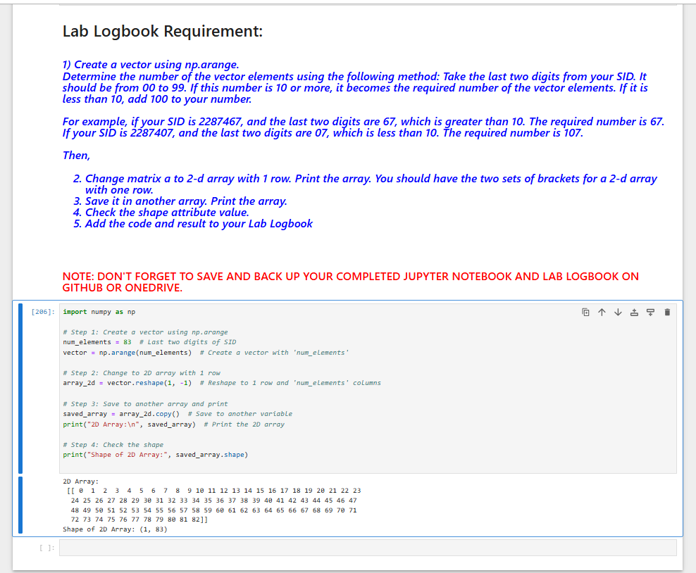

Lab 2

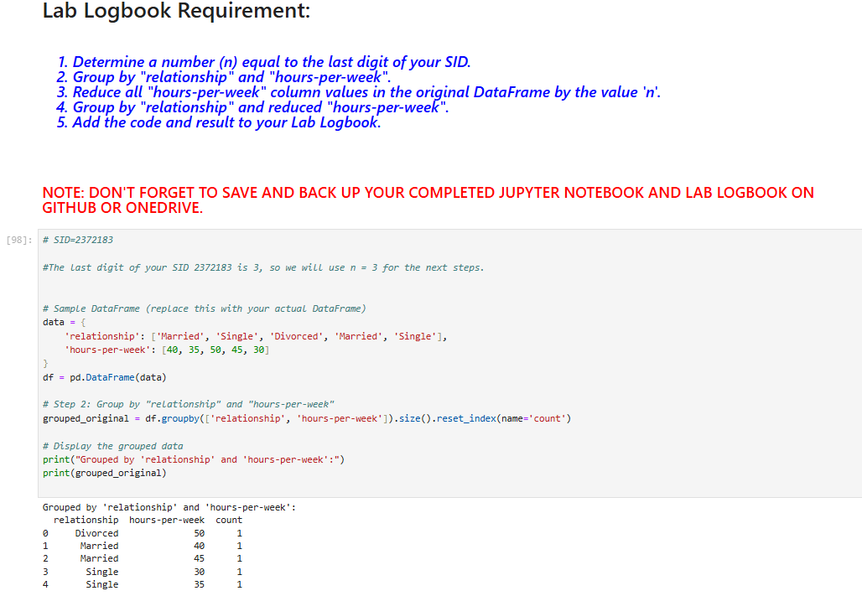

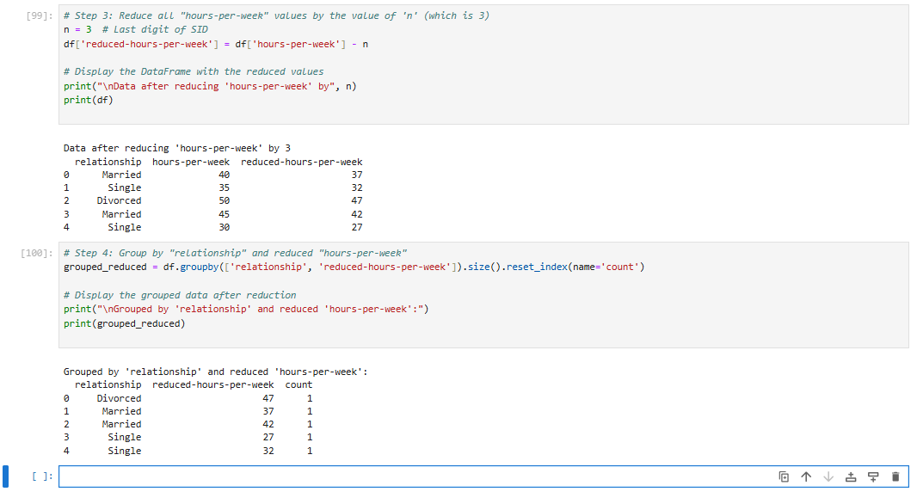

Lab 3

Lab 4

Lab 5

Lab 6

Lab 7b

Lab 8

Lab 9

Lab 10

Lab 11

Lab 12