**Capstone Project — The Battle of Neighbourhoods**

**Introduction**

Introduction

Kochi is a major city of India. It is a part of Ernakulam district. The city itself has a population of more than a million.

Called the "Queen of the Arabian Sea", Kochi was an important spice trading centre on the west coast of India from the 14th century onward, and maintained a trade network with Arab merchants from the pre-Islamic era. Occupied by the Portuguese in 1503, Kochi was the first of the European colonies in colonial India.

The official language of Malayalam. However, English is also spoken as a formal language within businesses and government agencies. Over last decades it is continuously grow because of the city’s important role in government and commercial business.

With it’s diverse culture , comes diverse food items. There are many restaurants in Kochi, each belonging to different categories like Chinese , Italian , French etc. So as part of this project , we will list and visualise all major parts of Kochi .

Questions that can be asked using the above mentioned datasets

->What is best location in Kochi for Chinese Cuisine ?

->Which areas have large number of Chinese Resturant Market ?

->Which all areas have less number of resturant ?

->Which is the best place to stay if I prefer Chinese Cuisine ?

->What places are have best restaurant in Kochi?

**Data**

For this project we need the following data :

* Kochi Resturants data that contains list Locality, Resturant name,Rating along with their latitude and longitude.
  + Data source : [Zomato kaggel dataset](https://www.kaggle.com/shrutimehta/zomato-restaurants-data)
  + Description : This data set contains the required information. And we will use this data set to explore various locality of kochi city.
* Nearby places in each locality of new delhi city.
  + Data source : [Fousquare API](https://developer.foursquare.com/)
  + Description : By using this api we will get all the venues in each neighborhood.

**Approach**

->Collect the Kochi city data from Zomato kaggel dataset

->Using FourSquare API we will find all venues for each neighborhood.

->Filter out all venues that are nearby by locality.

->Using aggregative rating for each resturant to find the best places.

->Visualize the Ranking of neighborhoods using folium library(python)

**3. Methodology section**

The Methodology section will describe the main components of our analysis and predication system. The Methodology section comprises four stages:

1. **Collect Inspection Data**
2. **Explore and Understand Data**
3. **Data preparation and preprocessing**
4. **Modeling**

**3.1 Collect Inspection Data**

I collected the data from Zomato Kaggle dataset. I imported the file in .csv format to the notebook and save it to a dataframe.

**3.2 Explore and Understand the data**

We read the dataset which we have from Zomato into a pandas dataframe and display the first five rows.

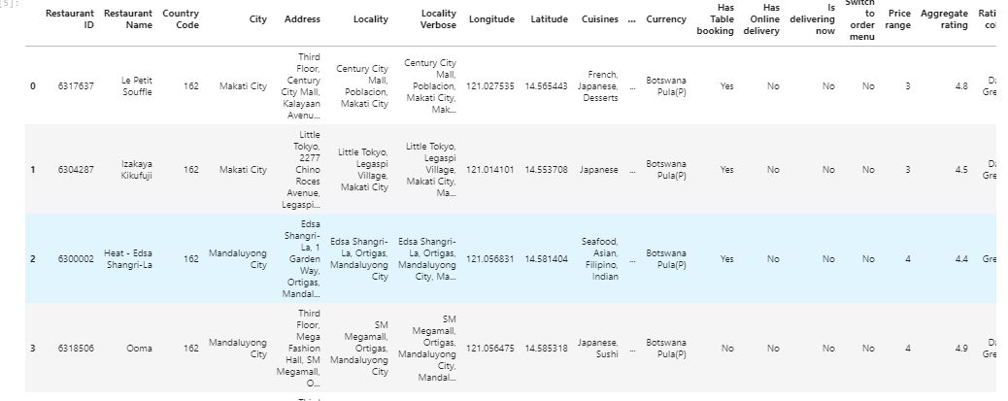

Then we delete unwanted column titles and only keep the ones that we want.

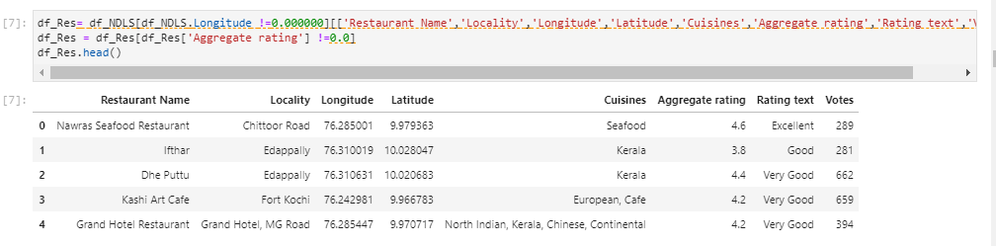

**3.3 Data Preparation and preprocessing**

We create a map to show the restaurant clusters

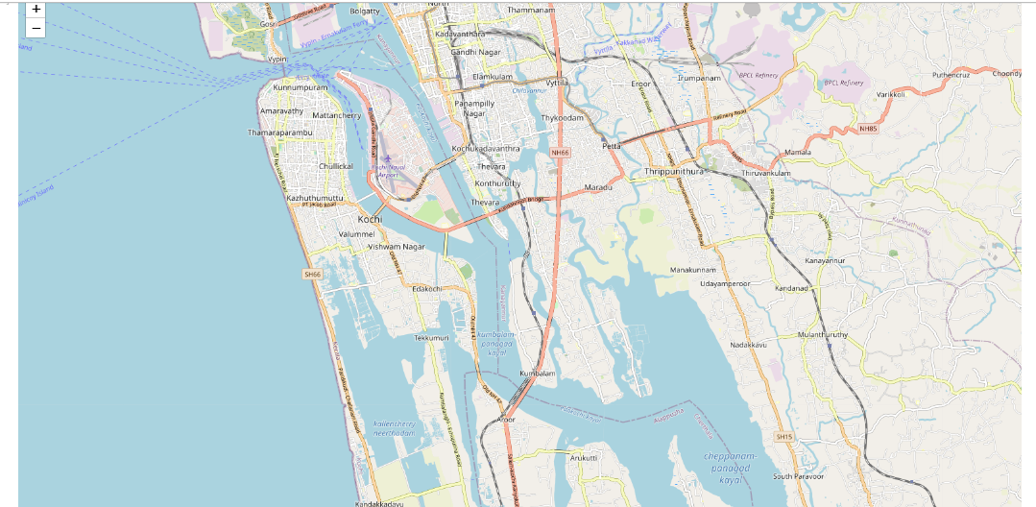

We then transform the data based on locality grouping data and combine the longitutes and latitudes into a single dataframe.

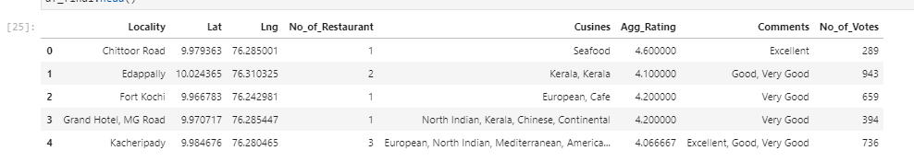

Using K means, we cluster the locality into 5 clusters and combine both grouped and the Chinese restaurants and then we plot the map

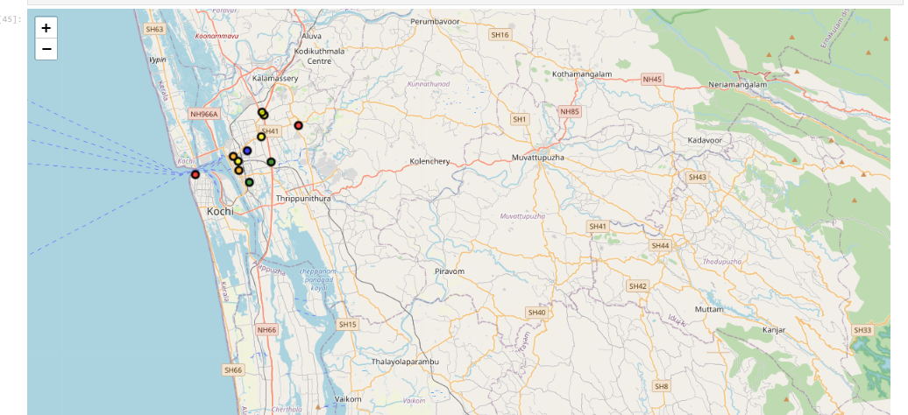

**3.4 Modeling**

After exploring the dataset and gaining insights into it, we are ready to use the clustering methodology to analyze real estates. We will use the k-means clustering technique as it is fast and efficient in terms of computational cost

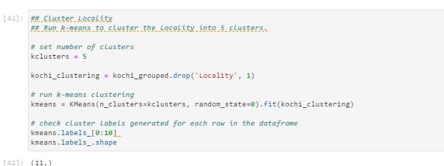



Cluster 1:

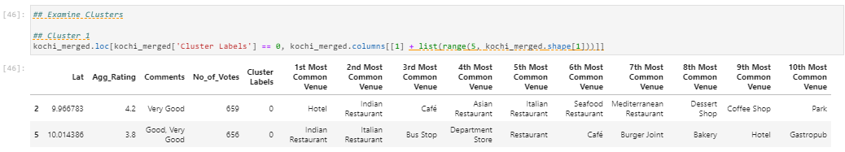

Cluster 2:

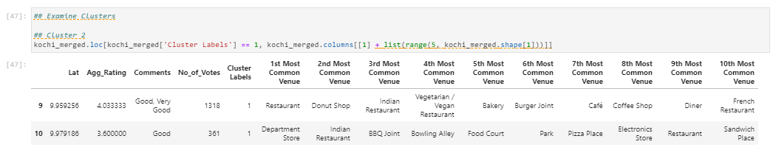

Cluster 3:

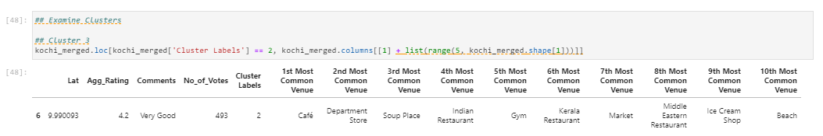

Cluster 4:

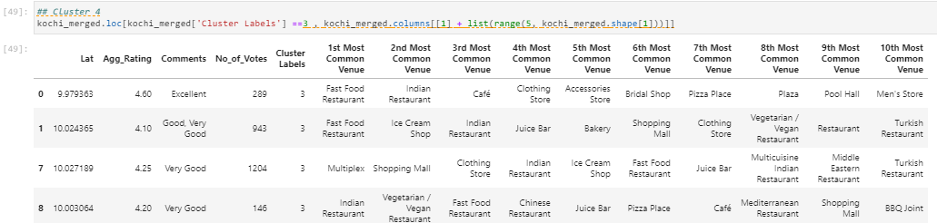

Cluster 5:

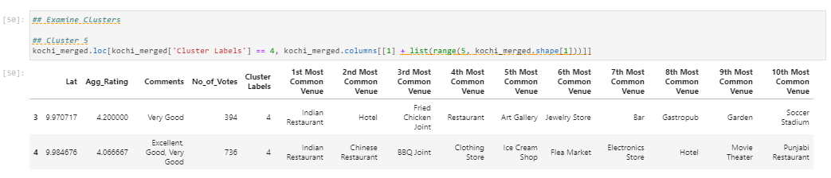

**Conclusion and Result:**

We analysed the data and found the best Chinese restaurants in Kochi. We also found the worst restaurants in Kochi. With the data, we were also able to find most edible restauarants and worst edible restaurants in Kochi. We also analysed which localities or neighbourhood have the best Chinese restaurants. We also found the worst Chinese restaurants.

**Conclusion**

Palarivottom, Kacheripady and Kakkanad are some of the best neighborhoods for Chinese cuisine.

Palarivottom and Kacheripady have the best Chinese Resturant.

Kacheripady Kakkanad and Panampilly Nagar are the best places for edible person.

Chittoor Road, Lulu Mall,Edapally and Fort Kochi have best resturants in Kochi.

**Cluster 1: It is most recommended for Indian Restaurants. #### Cluster 2: It is most recommended for Hotels. #### Cluster 3 and Cluster 5: It is most recommended for Fast food. #### Cluster 4: It is most recommended for the cafe and fast food.**