Introduction 2

1. Requirement Analysis 2

1.1. Member Management 2

1.2. Workout Zones 2

1.3. Members Profile 2

1.4. Payments and Subscriptions 3

1.5. Attendance Tracking 3

1.6. Staff Management Dashboard 3

1.7. Scalability 3

Design and Implementation 4

2. Diagrams 4

2.1. Use Case Diagram of St Mary’s Fitness 4

2.2. Class Diagram of St Mary’s Fitness 5

Implementation 6

3. Outputs of St Marry’s Fitness 6

3.1. Add Attendance 6

3.2. View Attendance 6

3.3. Add Member 7

3.4. View Member 7

3.5. Add Appointment 8

3.6. View Appointment 8

3.7. Add Payments 9

3.8. View Payments 9

3.9. Add Workout Zone 10

3.10. View Workout Zone 10

3.11. Generate Reports 11

# **Introduction**

St. Mary’s Fitness, a rapidly expanding citywide gym chain, encountered problems due to its reliance on manual processes to manage membership, appointments, and payments. As memberships grew and programs expanded, the existing system proved inefficient, prone and unable to meet business needs. Given these limitations, the gym began developing software systems to meet its operational needs, increase capacity, and improve the member experience.

## **Requirement Analysis**

### **Member Management**

Each gym location operates independently with a unique identity and diverse facilities, including workout zones, equipment, and amenities. A gym manager oversees operations, ensuring smooth functionality and acting as the primary contact for members and staff. Given the geographical spread of gym locations across cities, the system must:

* Maintain detailed records of each location.
* Facilitate inter-location communication and collaboration.
* Support managerial oversight through intuitive dashboards.

### **Workout Zones**

Workout zones are categorized by the type of exercise or equipment, such as cardio, strength training, or yoga. Each zone is managed by an attendant responsible for equipment maintenance and member assistance. To enhance functionality, the system must:

* Communicate updates, schedules, and promotions specific to each zone.
* Allow attendants to log maintenance activities and report issues.
* Display class schedules and availability to members in real-time.

### **Members Profile**

The gym’s diverse membership includes regular, premium, and trial members, each with unique needs and privileges. Member profiles include:

* Personal details such as name, age, and contact information.
* Health information relevant to fitness goals.

The system must enable seamless differentiation and management of these categories to ensure tailored services.

### **Payments and Subscriptions**

The gym offers flexible subscription plans, including monthly, quarterly, and annual options, with support for various payment methods. To optimize revenue management, the system must:

* Calculate fees and session charges based on predefined rates.
* Manage discounts, promotions, and loyalty rewards.
* Generate detailed invoices and payment receipts.

### **Attendance Tracking**

Attendance tracking ensures operational transparency and helps gauge member engagement. The system must:

* Log attendance for classes and gym facility usage.
* Generate reports on attendance trends, class popularity, and peak hours.
* Use the data for resource allocation and schedule optimization.

### **Staff Management Dashboard**

The gym manager’s dashboard will provide insights and tools to oversee daily operations effectively. Key features include:

* Membership growth and revenue trend analysis.
* Trainer schedules and equipment maintenance tracking.
* Real-time updates on operational metrics

### **Scalability**

As St Mary’s Fitness expands, the system must accommodate new locations and services seamlessly. Scalability considerations include:

* Modular architecture to integrate additional functionalities.
* Support for a larger member base and increased data volume.
* Future enhancements in fitness offerings.

# **Design and Implementation**

The design of this assignment focuses on creating a robust, user-friendly, and scalable software solution for St. Mary’s Fitness. Key considerations include a modular architecture to ensure maintainability, intuitive interfaces for seamless user interaction, and comprehensive functionalities to address gym operations such as member management, workout zones, appointments, payments, and attendance tracking. The use of UML diagrams like use-case and class diagrams ensures clarity in system planning and communication. Tools like Python, Draw.io, and Tkinter are utilized to build an efficient and visually appealing system that aligns with the fitness center's growing needs.

## **Diagrams**

### **Use Case Diagram of St Mary’s Fitness**

### 

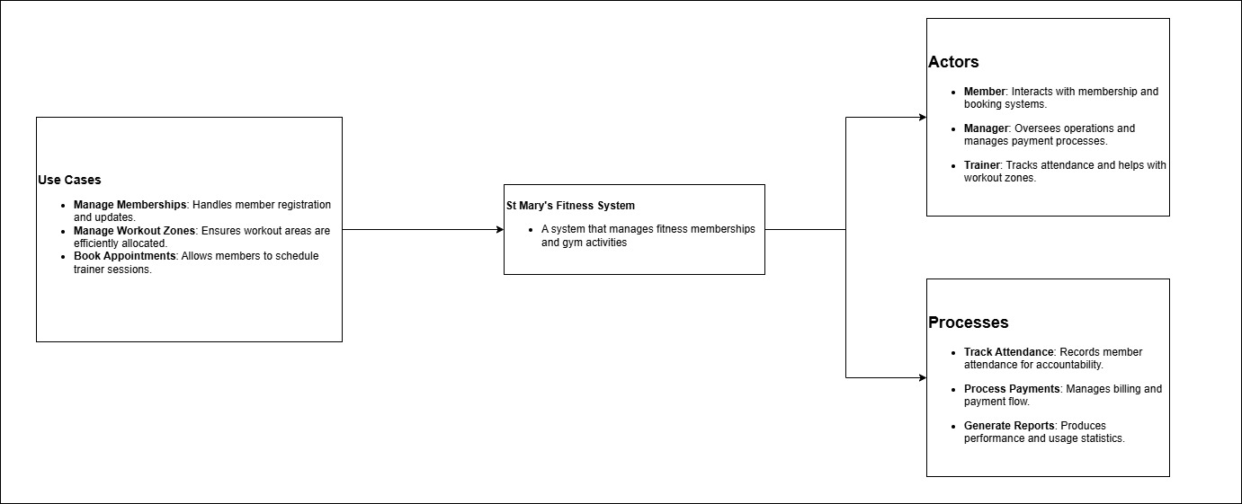

**UseCase Diagram of St Marry Fitness**

### **Class Diagram of St Mary’s Fitness**

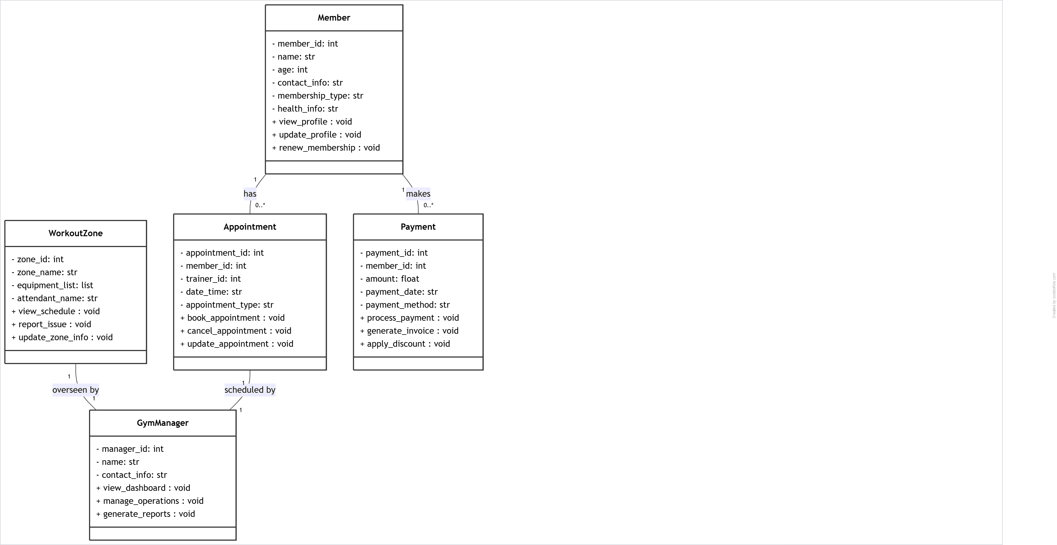

**Class Diagram of St Mary Fitness**

# **Implementation**

## **Outputs of St Marry’s Fitness**

### **Add Attendance**

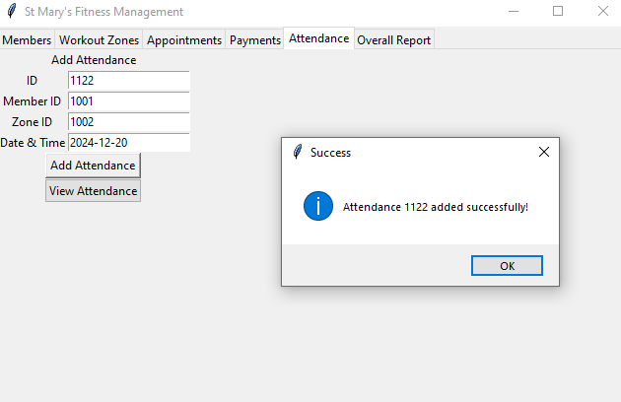

### **View Attendance**

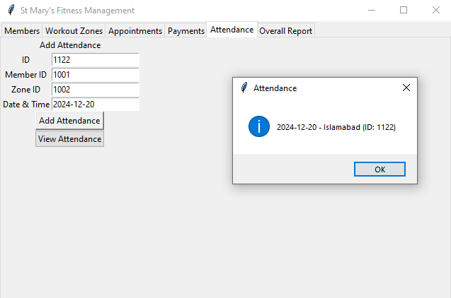

### **Add Member**

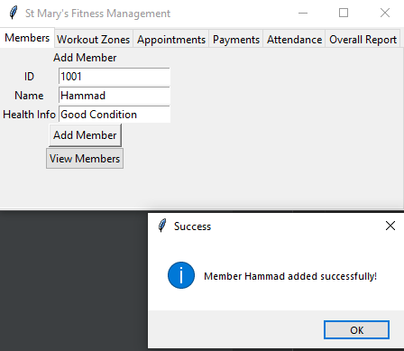

### **View Member**

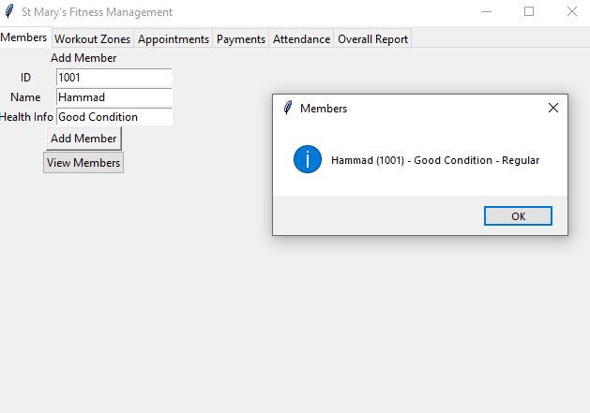

### **Add Appointment**

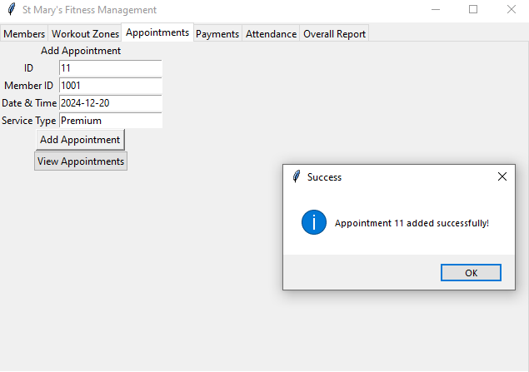

### **View Appointment**

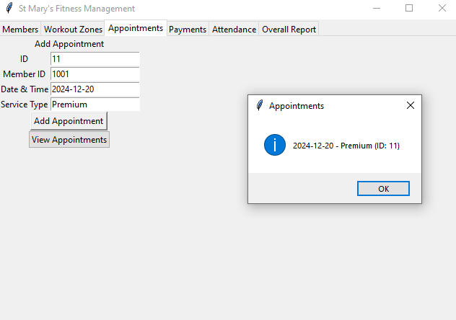

### **Add Payments**

### **View Payments**

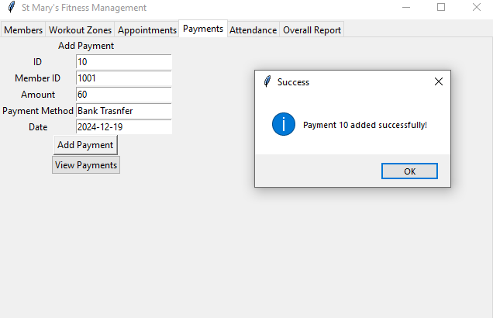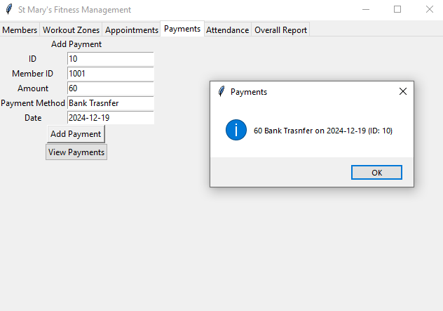

### **Add Workout Zone**

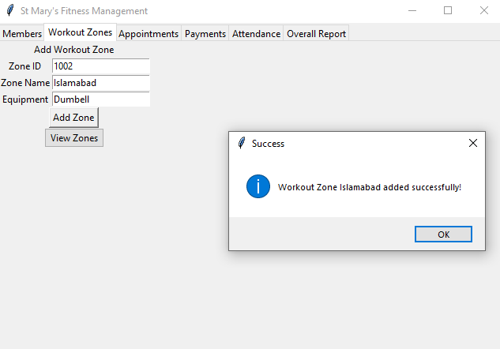

### **View Workout Zone**

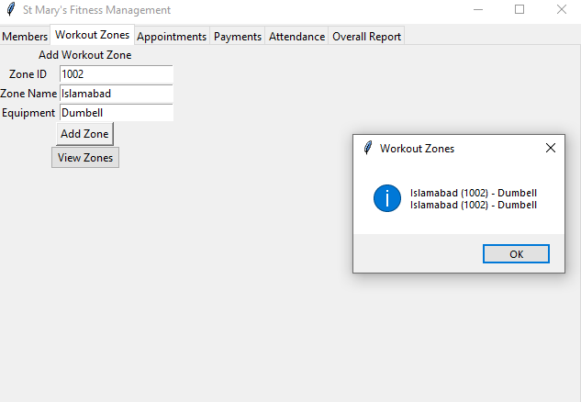

### **Generate Reports**

