AIRLINE INDUSTRY DATA ANALYSIS
Factors Influencing Coach Ticket Prices

Field | Detail
Course | STAT-2205 — Programming with R and Python
Name | Fahim Islam
Student ID | 12310048
Dataset | flight_data.csv (129,780 observations)
Sample Size | 10,000 rows (random_state / seed = 12310048)
Language | Python & R
Objective | Reveal factors influencing coach ticket prices

Submitted to: Dr. Md. Siddikur Rahman
Academic Year 2023–2024

Table of Contents
Table of Contents 1
1. Introduction 1
1.1 Dataset Variables 1
1.2 Data Loading & Sampling 1
2. Q1 — Coach Ticket Price Distribution 1
2.1 Key Statistics 1
2.2 Code 1
2.3 Interpretation 1
3. Q2 — Coach Prices for 8-Hour Flights 1
3.1 Code 1
3.2 Interpretation 1
4. Q3 — Flight Delay Distribution 1
4.1 Code 1
4.2 Interpretation 1
5. Q4 — Correlation: Coach Price vs. Predictors 1
5.1 Code 1
5.2 Interpretation 1
6. Q5 — Coach vs. First-Class Price Relationship 1
6.1 Code 1
6.2 Interpretation 1
7. Q6 — In-Flight Features and Coach Price 1
7.1 Code 1
7.2 Interpretation 1
8. Q7 — Passengers vs. Flight Duration 1
8.1 Code 1
8.2 Interpretation 1
9. Q8 — Weekend vs. Weekday Pricing 1
9.1 Code 1
9.2 Interpretation 1
10. Q9 — Coach Prices: Redeye vs. Non-Redeye by Day 1
10.1 Code 1
10.2 Interpretation 1
11. Q10 — Comprehensive Statistical Analysis 1
11.1 Summary Statistics (Q10a) 1
11.2 Visualisations (Q10b) 1
11.3 Hypothesis Testing (Q10c) 1
11.4 Independent t-Tests (Q10d) 1
11.5 Price Differences: Weekend vs. Weekday (Q10e) 1
11.6 Correlation Matrix (Q10f) 1
11.7 Linear Regression: Predict Coach Price (Q10g) 1
Interpretation 1
11.8 Logistic Regression: Predict Redeye (Q10h) 1
Interpretation 1
12. Conclusions 1

1. Introduction
This report presents a comprehensive statistical analysis of 129,780 airline flight records. The objective is to reveal the key factors influencing coach ticket prices. A reproducible sample of 10,000 observations is drawn using Student ID 12310048 as the random seed.

1.1 Dataset Variables
Variable | Type | Description
miles | Numeric | Distance flown (miles)
passengers | Numeric | Number of passengers on board
delay | Numeric | Takeoff delay (minutes)
inflight_meal | Categorical | Meal included? (Yes / No)
inflight_entertainment | Categorical | Free entertainment? (Yes / No)
inflight_wifi | Categorical | Complimentary WiFi? (Yes / No)
day_of_week | Categorical | Day of the week
redeye | Categorical | Overnight flight? (Yes / No)
weekend | Categorical | Weekend flight? (Yes / No)
coach_price | Numeric | Average coach ticket price ($)
firstclass_price | Numeric | Average first-class price ($)
hours | Numeric | Flight duration (hours)
Table: Dataset variables, types, and descriptions

1.2 Data Loading & Sampling
R | Python
df_full <- read.csv('flight_data.csv', | import pandas as pd
stringsAsFactors = FALSE)
names(df_full)[1] <- 'miles' | df_full = pd.read_csv('flight_data.csv')
set.seed(12310048) | df = df_full.sample(n=10_000,
idx <- sample(nrow(df_full), 10000) | random_state=12310048)
df <- df_full[idx, ] | df = df.reset_index(drop=True)
Code 1.1 — Load full dataset and draw reproducible 10,000-row sample

2. Q1 — Coach Ticket Price Distribution
What do coach ticket prices look like? What are the high and low values? What is the average? Does $500 seem like a good price?

2.1 Key Statistics
Statistic | Value
Minimum | $44.41
Maximum | $589.99
Mean | $376.30
Median | $381.19
Standard Deviation | $67.52
25th Percentile (Q1) | $332.18
75th Percentile (Q3) | $425.40
Flights above $500 | 1.7%
Table: Coach price descriptive statistics (n = 10,000)

2.2 Code
R | Python
cp <- df$coach_price | cp = df['coach_price']
summary(cp) | cp.describe()
sd(cp)
 | pct = (cp > 500).mean() * 100
mean(cp > 500) * 100 | print(f'Above $500: {pct:.1f}%')
# Visualisation | # Visualisation
hist(cp, breaks=40, col='steelblue', | import matplotlib.pyplot as plt
main='Coach Price Distribution', | plt.hist(cp, bins=40, color='steelblue')
xlab='Coach Price ($)') | plt.axvline(cp.mean(), color='red',
abline(v=mean(cp), col='red', lty=2) | linestyle='--', label='Mean')
abline(v=500, col='green', lty=2) | plt.axvline(500, color='green',
boxplot(cp, col='steelblue', | linestyle='--', label='$500')
main='Coach Price Boxplot') | plt.legend(); plt.show()
Code 2.1 — Summary stats and visualisation for coach price
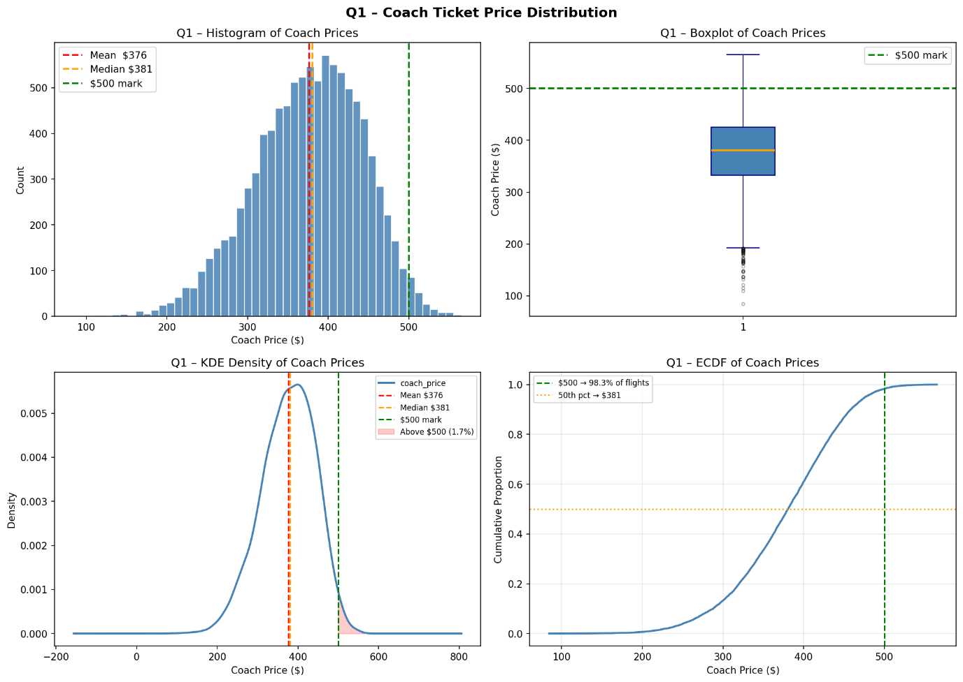

2.3 Interpretation
The distribution is approximately symmetric (mean ≈ median ≈ $376–$381). The IQR is $332–$425. Only 1.7% of tickets exceed $500 — placing it in the top 2%.
Conclusion: $500 is an expensive coach ticket, well above the market average.

3. Q2 — Coach Prices for 8-Hour Flights
What are the high, low, and average prices for 8-hour-long flights? Does $500 seem more reasonable?
Statistic | All Flights | 8-Hour Flights
Count | 10,000 | 182
Mean Price | $376.30 | $432.18
Above $500 | 1.7% | 14.8%
Table: Coach price: all flights vs. 8-hour flights

3.1 Code
R | Python
# Filter 8-hour flights | # Filter 8-hour flights
df8 <- df[df$hours == 8, 'coach_price'] | df8 = df[df['hours']==8]['coach_price']
 | print(df8.describe())
summary(df8) | pct = (df8>500).mean()*100
mean(df8 > 500) * 100 # % above $500 | print(f'Above $500: {pct:.1f}%')
# Side-by-side boxplot | # Comparative boxplot
boxplot(df$coach_price, df8, | import matplotlib.pyplot as plt
names = c('All','8-hr'), | plt.boxplot([df['coach_price'], df8],
col = c('steelblue','darkorange'), | labels=['All','8-hr'])
ylab = 'Coach Price ($)') | plt.axhline(500,color='darkorange',
abline(h=500, col='green', lty=2) | linestyle='--')
 | plt.show()
Code 3.1 — Filter 8-hour flights and compare price distributions
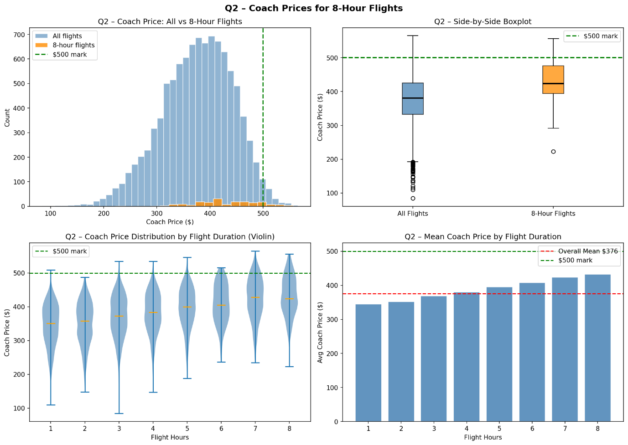

3.2 Interpretation
8-hour flights average $432.18 (≈50 above overall). 14.8% exceed $500. Conclusion: $500 is more justifiable for long-haul travel but still above average.

4. Q3 — Flight Delay Distribution
How are delay times distributed? How often do significant delays affect connecting flights?
Metric | Value
Mean Delay | 13.61 minutes
Median Delay | 10.00 minutes
Standard Deviation | 47.76 minutes
Flights delayed > 15 min | 17.1% (connection risk)
Flights delayed > 60 min | 0.01% (severe delay)
Table: Flight delay distribution statistics

4.1 Code
R | Python
delay <- df$delay | delay = df['delay']
mean(delay); median(delay); sd(delay) | print(delay.describe())
mean(delay > 15) * 100 # connection risk | print((delay>15).mean()*100) # conn risk
mean(delay > 60) * 100 # severe | print((delay>60).mean()*100) # severe
# Histogram | # Histogram
hist(delay, breaks=40, col='tomato', | import matplotlib.pyplot as plt
xlab='Delay (min)', | plt.hist(delay, bins=40, color='tomato')
main='Delay Distribution') | plt.axvline(15,color='orange',
abline(v=15, col='orange', lty=2) | linestyle='--',label='>15min')
abline(v=60, col='darkred',lty=2) | plt.axvline(60,color='darkred',
 | linestyle='--',label='>60min')
 | plt.legend(); plt.show()
Code 4.1 — Delay distribution: thresholds and histogram
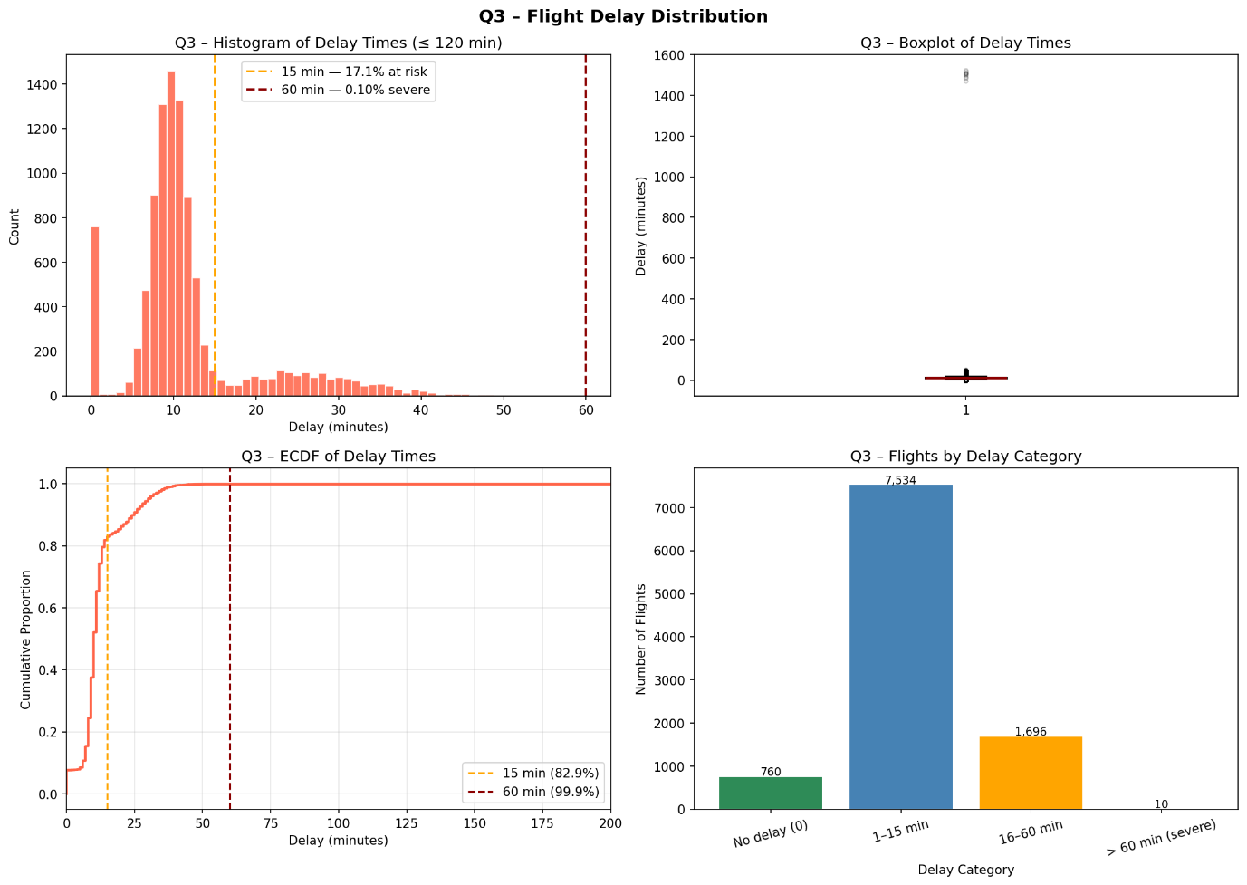

4.2 Interpretation
Distribution is right-skewed. Most delays are 0–15 minutes. About 17.1% have delays over 15 minutes which could affect connecting flights. Severe delays (>60 min) occur in only 0.01% of cases.

5. Q4 — Correlation: Coach Price vs. Predictors
How does coach price correlate with flight distance, passengers, delay, and duration?
Predictor | Pearson r | Direction | Significant?
miles | 0.3454 | Positive | Yes ✓
passengers | 0.1529 | Positive | Yes ✓
delay | − 0.0181 | Negative | No ✕ (p = 0.0707)
hours | 0.3416 | Positive | Yes ✓
Table: Pearson correlations between coach price and numeric predictors

5.1 Code
R | Python
# Correlation + significance | from scipy import stats
for (v in c('miles','passengers', | import matplotlib.pyplot as plt
'delay','hours')) { | import numpy as np
ct <- cor.test(as.numeric(df[[v]]),
df$coach_price) | for v in ['miles','passengers',
cat(v, round(ct$estimate,4), | 'delay','hours']:
round(ct$p.value,4), '\n') | r,p = stats.pearsonr(df[v],
} | df['coach_price'])
 | print(f'{v}: r={r:.4f} p={p:.4f}')
# Scatterplot example (miles)
plot(df$miles, df$coach_price, | # Scatterplot (miles)
pch=16, cex=0.3, | plt.scatter(df['miles'],
xlab='Miles', ylab='Coach ($)') | df['coach_price'],alpha=0.1,s=5)
abline(lm(coach_price~miles,data=df), | m,b = np.polyfit(df['miles'],
col='red', lwd=2) | df['coach_price'],1)
 | plt.plot(sorted(df['miles']),
 | [m*x+b for x in sorted(df['miles'])],
 | 'r-'); plt.show()
Code 5.1 — Pearson correlation tests and scatter plot

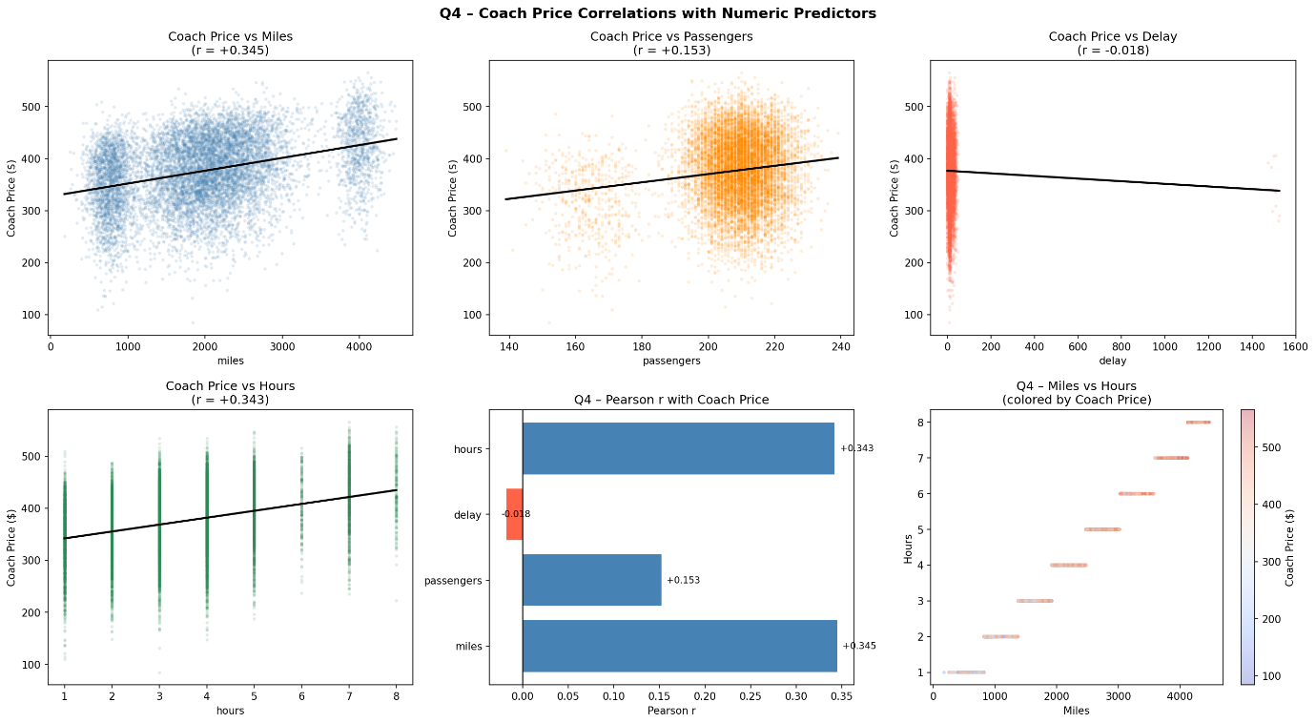

5.2 Interpretation
Miles (r=0.34) and hours (r=0.33) are the strongest predictors. Passengers show a weaker but significant positive correlation (r=0.15). Delay is not a significant pricing factor (p=0.091).

6. Q5 — Coach vs. First-Class Price Relationship
Do flights with higher coach prices always have higher first-class prices?
Metric | Value
Pearson r | 0.7583
Average FC / Coach ratio | 3.95×
Average coach price | $376.30
Average first-class price | $1,452.10
p-value | < 0.001
Table: Coach vs. first-class relationship metrics

6.1 Code
R | Python
ct5 <- cor.test(df$coach_price, | from scipy import stats
df$firstclass_price) | import matplotlib.pyplot as plt
cat('r =', round(ct5$estimate, 4))
cat('p =', ct5$p.value) | r,p = stats.pearsonr(
 | df['coach_price'],
 | df['firstclass_price'])
ratio <- mean(df$firstclass_price / | print(f'r={r:.4f} p={p:.2e}')
df$coach_price)
cat('Ratio:', round(ratio, 2)) | ratio = (df['firstclass_price'] /
 | df['coach_price']).mean()
 | print(f'Ratio: {ratio:.2f}x')
plot(df$coach_price,
df$firstclass_price, | plt.scatter(df['coach_price'],
pch=16, cex=0.3, | df['firstclass_price'],
xlab='Coach ($)', | alpha=0.15, s=5)
ylab='First-Class ($)') | plt.xlabel('Coach ($)')
abline(lm(firstclass_price~coach_price, | plt.ylabel('First-Class ($)')
data=df), col='red', lwd=2) | plt.show()
Code 6.1 — Correlation test and scatterplot: coach vs. first-class

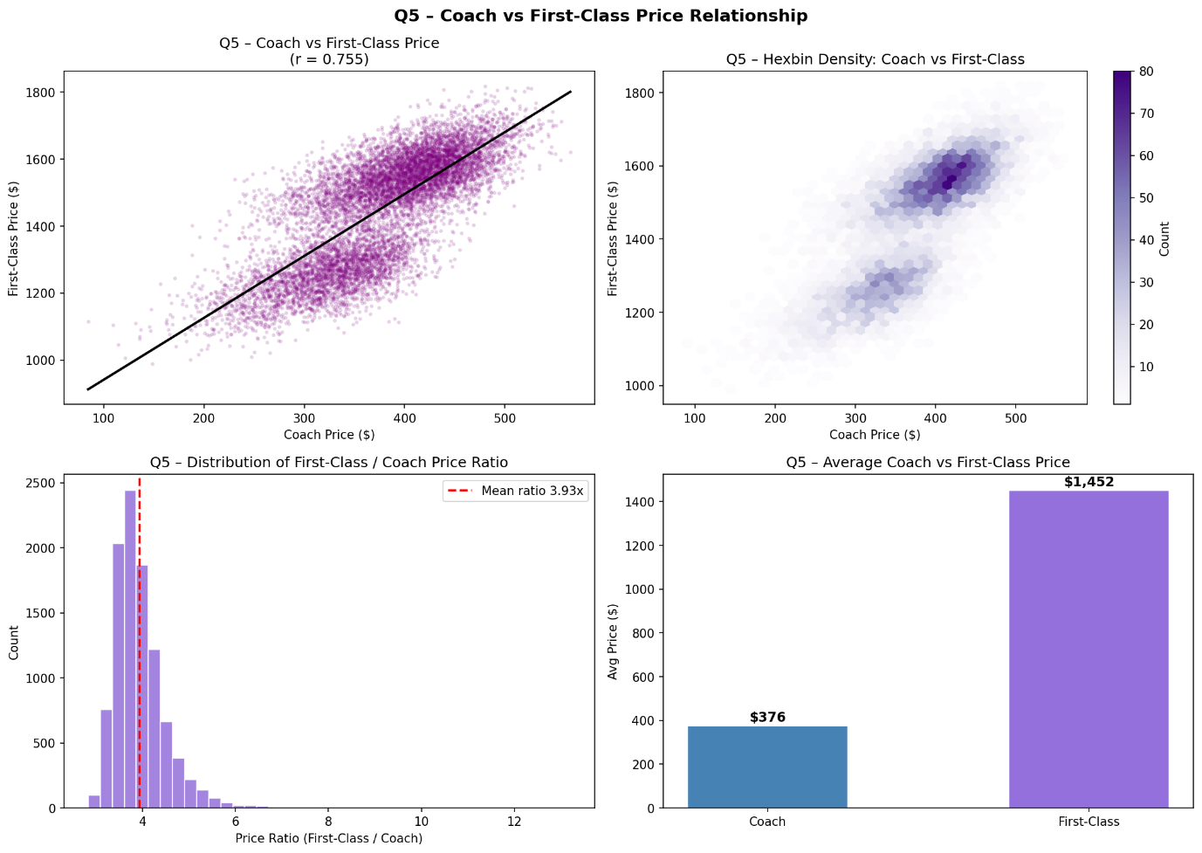

6.2 Interpretation
The analysis reveals a strong positive and statistically significant relationship between coach and first-class ticket prices (r=0.755, p<0.001). Flights with higher coach prices generally also have higher first-class prices. However, the relationship is not perfectly linear, indicating that other factors may also influence first-class pricing. On average, first-class tickets cost approximately 3.9 times more than coach tickets.

7. Q6 — In-Flight Features and Coach Price
Which in-flight features are associated with the highest price increase?
Feature | With Feature | Without | Premium | p-value
Inflight Meal | $389.75 | $370.51 | +$19.24 | < 0.001
Entertainment | $389.34 | $322.30 | +$67.04 | < 0.001
WiFi | $382.81 | $314.79 | +$68.02 | < 0.001
Table: Coach price premiums by in-flight feature

7.1 Code
R | Python
feats <- c('inflight_meal', | from scipy import stats
'inflight_entertainment', | import matplotlib.pyplot as plt
'inflight_wifi')
 | feats = ['inflight_meal',
for (f in feats) { | 'inflight_entertainment',
g1 <- df[df[[f]]=='Yes', | 'inflight_wifi']
'coach_price']
g2 <- df[df[[f]]=='No', | for f in feats:
'coach_price'] | yes = df[df[f]=='Yes']['coach_price']
tt <- t.test(g1, g2) | no = df[df[f]=='No' ]['coach_price']
cat(f, | t,p = stats.ttest_ind(yes, no)
round(mean(g1)-mean(g2),2), | diff = yes.mean() - no.mean()
round(tt$p.value,4), '\n') | print(f'{f}: +${diff:.2f} p={p:.4f}')
}
 | # Boxplot
# Boxplot | df.boxplot('coach_price',
boxplot(coach_price~inflight_wifi, | by='inflight_wifi')
data=df, col=c('tomato','steelblue'), | plt.show()
main='Price by WiFi')
Code 7.1 — Independent t-tests for each in-flight feature

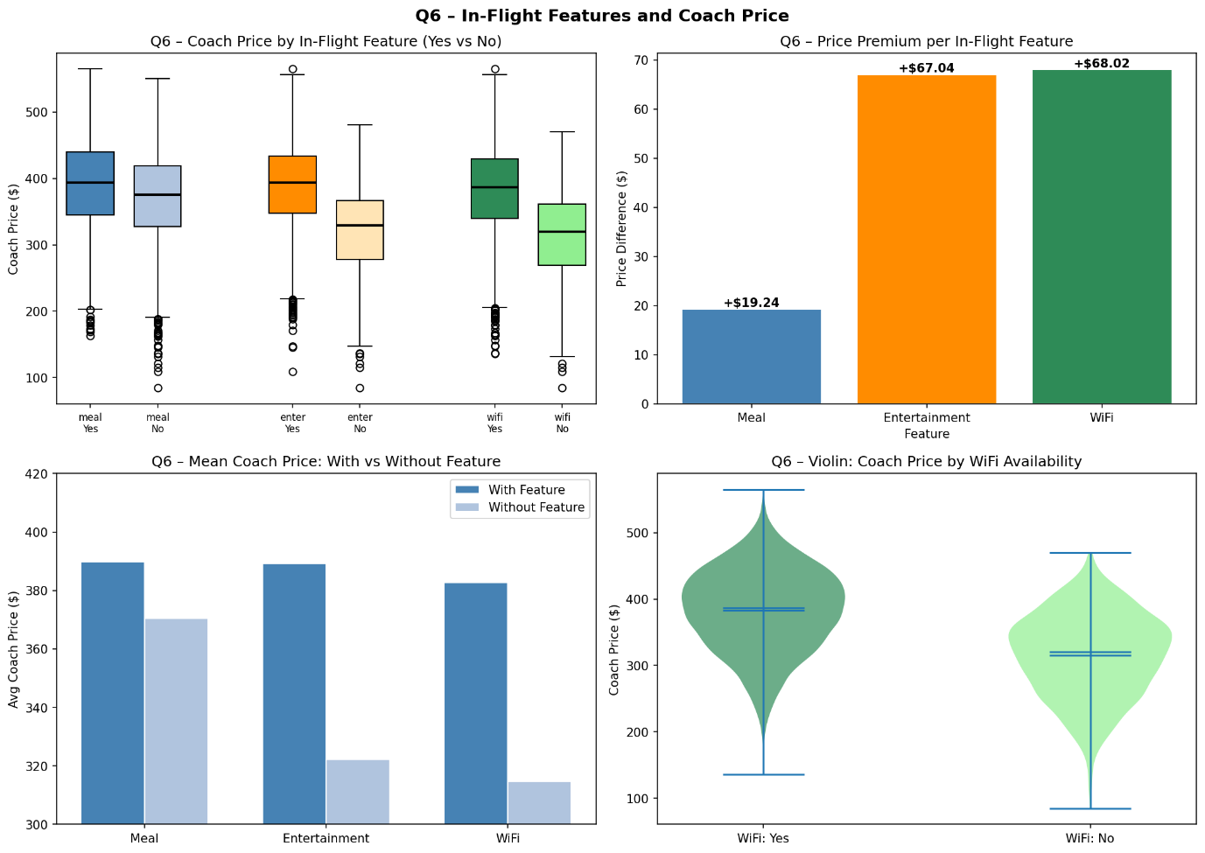

7.2 Interpretation
The analysis demonstrates that in-flight services such as meals, entertainment, and WiFi are all associated with higher coach ticket prices. Flights that provide these features generally charge more than flights without them. Among the three services, in-flight entertainment shows the highest increase in coach price, suggesting that premium passenger amenities are strongly related to airline pricing strategies. Statistical testing confirms that these price differences are significant.

8. Q7 — Passengers vs. Flight Duration
How does passenger count change in relation to flight length?
Hours | Avg. Passengers
1 | 208.2
2 | 207.7
3 | 207.6
4 | 207.5
5 | 207.1
6 | 208.1
7 | 207.9
8 | 207.6
Pearson r | −0.011 (p = 0.273, not significant)
Table: Average passengers by flight duration

8.1 Code
R | Python
# Correlation | from scipy import stats
cor.test(as.numeric(df$hours), | import matplotlib.pyplot as plt
df$passengers)
 | r,p = stats.pearsonr(
# Avg passengers per hour | df['hours'], df['passengers'])
tapply(df$passengers, | print(f'r={r:.4f} p={p:.4f}')
df$hours, mean)
 | # Avg passengers per hour
# Bar chart | avg = df.groupby('hours')['passengers']
avg <- tapply(df$passengers, | .mean()
df$hours, mean) | print(avg)
barplot(avg, col='teal',
xlab='Hours', | # Bar chart
ylab='Avg Passengers', | avg.plot(kind='bar',color='teal')
main='Passengers by Duration') | plt.xlabel('Hours')
 | plt.ylabel('Avg Passengers')
 | plt.show()
Code 8.1 — Correlation test and average passengers by hour

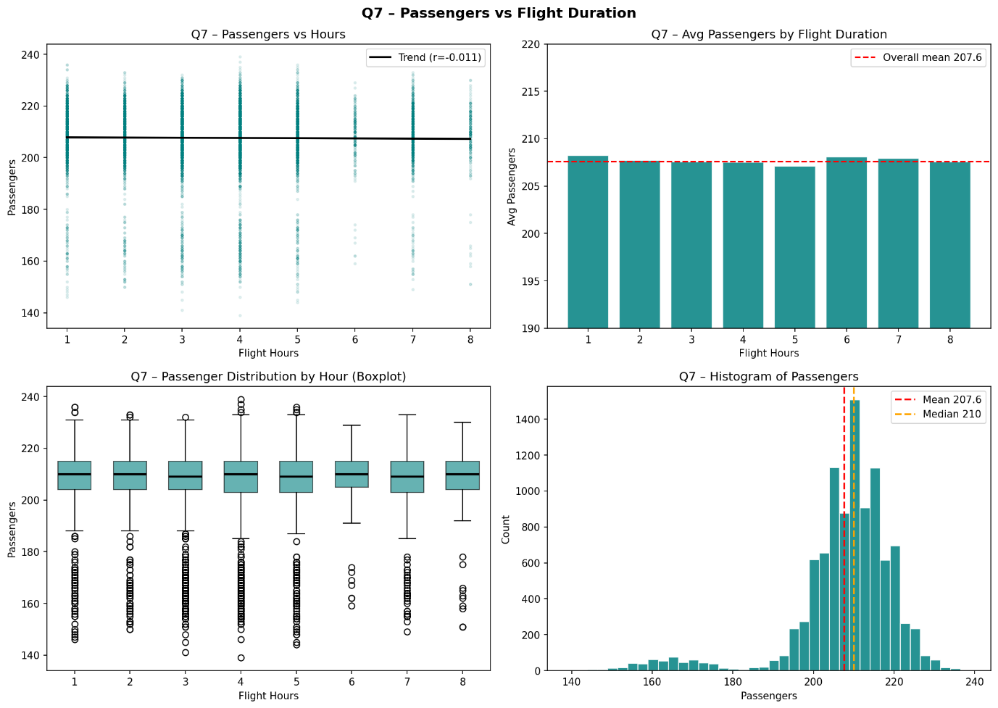

8.2 Interpretation
The Pearson correlation coefficient between flight duration and number of passengers is: r=−0.011, This indicates an extremely weak negative relationship between flight duration and passenger count.
The p-value is: $p=0.273$, Since the p-value is greater than 0.05, the relationship is not statistically significant.
The average number of passengers remains very similar across all flight durations (around 207–208 passengers), indicating that longer flights do not necessarily carry more or fewer passengers.
Therefore:
There is essentially no meaningful relationship between flight duration and the number of passengers in this dataset.

9. Q8 — Weekend vs. Weekday Pricing
What is the relationship between coach and first-class prices on weekends vs. weekdays?
Class | Weekend | Weekday | Difference | p-value
Coach | $405.51 | $323.05 | +$84.03 | < 0.001
First-Class | $1,558.32 | $1,257.89 | +$301.78 | < 0.001
Table: Price comparison: weekend vs. weekday

9.1 Code
R | Python
for (pc in c('coach_price', | from scipy import stats
'firstclass_price')) { | import matplotlib.pyplot as plt
wk <- df[df$weekend=='Yes', pc]
nwk <- df[df$weekend=='No', pc] | for pc in ['coach_price',
tt <- t.test(wk, nwk) | 'firstclass_price']:
cat(pc, | wk = df[df['weekend']=='Yes'][pc]
round(mean(wk)-mean(nwk), 2), | nwk = df[df['weekend']=='No' ][pc]
round(tt$p.value, 4), '\n') | t,p = stats.ttest_ind(wk, nwk)
} | diff = wk.mean()-nwk.mean()
 | print(f'{pc}: +${diff:.2f} p={p:.4f}')
# Boxplot
boxplot(coach_price ~ weekend, | # Boxplot
data = df, | df.boxplot('coach_price',
col = c('lightblue','lightcoral'), | by='weekend')
main = 'Coach Price: Wknd vs Wkday', | plt.suptitle('')
xlab = 'Weekend') | plt.show()
Code 9.1 — t-tests comparing weekend vs. weekday prices
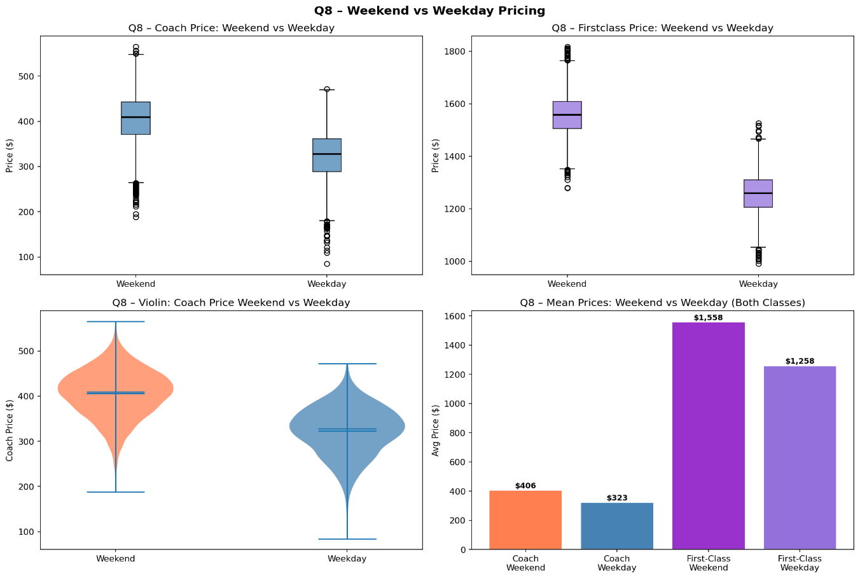

9.2 Interpretation
The analysis shows that both coach and first-class ticket prices are higher on weekends compared to weekdays.
The independent t-tests produced extremely small p-values ($p<0.001$) for both ticket classes, indicating that the differences are statistically significant.
The boxplots also show higher median prices and higher overall price distributions on weekends.
Therefore:
Weekend flights are significantly more expensive than weekday flights for both coach and first-class passengers.

10. Q9 — Coach Prices: Redeye vs. Non-Redeye by Day
How do coach prices differ for redeye and non-redeye flights on each day of the week?
Day | Non-Redeye | Redeye | Discount
Monday | $325.53 | $257.30 | −$68.23
Tuesday | $328.16 | $272.33 | −$55.83
Wednesday | $327.52 | $260.95 | −$66.57
Thursday | $323.92 | $265.93 | −$57.99
Friday | $405.15 | $344.37 | −$60.78
Saturday | $414.04 | $358.88 | −$55.16
Sunday | $404.67 | $343.07 | −$61.60
Table: Average coach price by day of week and redeye status

10.1 Code
R | Python
day_ord <- c('Monday','Tuesday', | import matplotlib.pyplot as plt
'Wednesday','Thursday','Friday',
'Saturday','Sunday') | day_ord = ['Monday','Tuesday',
 | 'Wednesday','Thursday','Friday',
# Pivot table | 'Saturday','Sunday']
pivot <- tapply(df$coach_price,
list(df$day_of_week, df$redeye), | # Pivot table
mean) | pivot = df.pivot_table(
pivot <- pivot[day_ord, ] | values='coach_price',
print(round(pivot, 2)) | index='day_of_week',
 | columns='redeye',
# Grouped bar chart | aggfunc='mean')
library(reshape2) | pivot = pivot.reindex(day_ord)
library(ggplot2) | print(pivot.round(2))
melt_df <- melt(pivot)
ggplot(melt_df, | # Grouped bar chart
aes(Var1, value, fill=Var2)) + | pivot.plot(kind='bar',
geom_bar(stat='identity', | color=['steelblue','tomato'])
position='dodge') + | plt.xlabel('Day of Week')
labs(x='Day', y='Avg Price ($)') | plt.ylabel('Avg Coach Price ($)')
 | plt.xticks(rotation=30); plt.show()
Code 10.1 — Pivot table and grouped bar chart: redeye by day

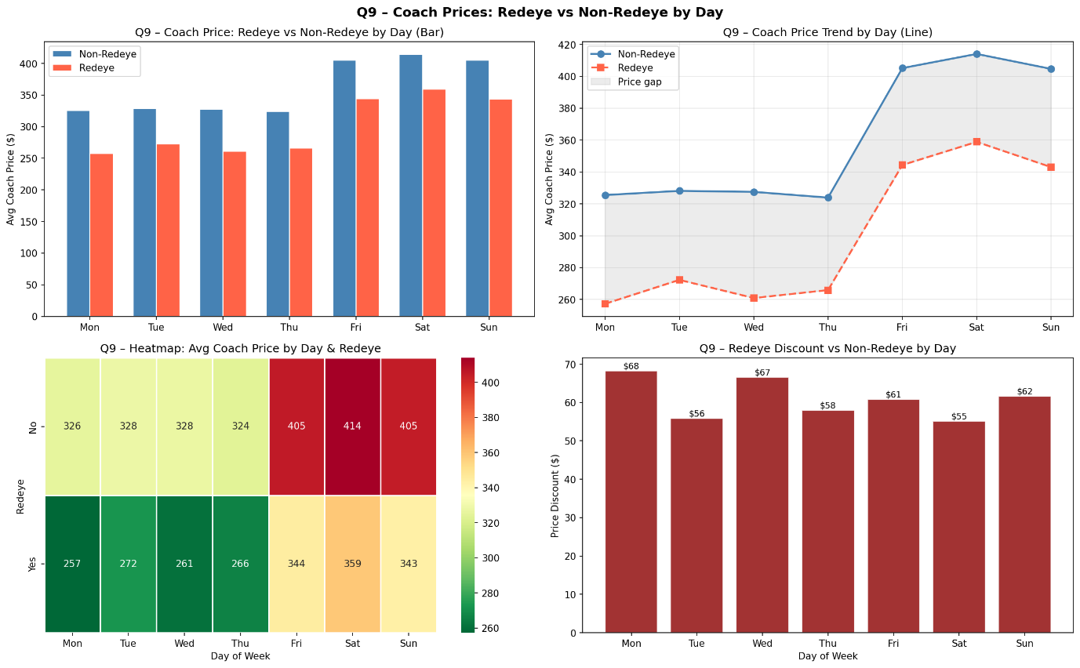

10.2 Interpretation
The analysis compares average coach ticket prices for redeye and non-redeye flights across different days of the week.
Therefore: Non-redeye flights are consistently more expensive than redeye flights on every day of the week.
Coach ticket prices vary according to both redeye status and day of the week. Non-redeye flights consistently have higher average prices than redeye flights across all days. Ticket prices increase substantially during weekends, especially on Friday, Saturday, and Sunday. Although redeye flights remain less expensive, weekend demand raises prices for both redeye and non-redeye flights. Saturday shows the highest average coach prices overall.
Friday–Sunday command highest prices due to weekend demand. Cheapest option: weekday redeye Monday/Wednesday.

11. Q10 — Comprehensive Statistical Analysis

11.1 Summary Statistics (Q10a)
Variable | Mean | Median | Std Dev | Min | Max
miles | 1,983.930 | 1,968.0 | 934.91 | 178 | 4,479
passengers | 207.7 | 210.0 | 12.84 | 139 | 239
delay (min) | 13.09 | 10.00 | 47.75 | 0 | 1,524
coach_price ($) | 376.30 | 380.50 | 66.65 | 84.50 | 565.21
firstclass ($) | 1,451.91 | 1,499.5 | 162.8 | 990.0 | 1,817.5
hours | 3.53 | 4.00 | 1.72 | 1 | 8
Table: Summary statistics for all numeric variables
R | Python
library(psych) | num_cols = ['miles','passengers',
num_cols <- c('miles','passengers', | 'delay','coach_price',
'delay','coach_price', | 'firstclass_price','hours']
'firstclass_price','hours') | print(df[num_cols].describe())
describe(df[num_cols])
Code 11.1 — Comprehensive summary statistics

11.2 Visualisations (Q10b)
R | Python
# Histograms for all numeric vars | import matplotlib.pyplot as plt
par(mfrow=c(2,3))
for (col in num_cols) { | # Histograms
hist(df[[col]], breaks=30, | fig,axes=plt.subplots(2,3,
col='steelblue', | figsize=(15,8))
main=paste('Hist:',col)) | for ax,col in zip(axes.flat,num_cols):
} | ax.hist(df[col],bins=30,
 | color='steelblue')
# Boxplots | ax.set_title(f'Hist: {col}')
par(mfrow=c(2,3)) | plt.tight_layout(); plt.show()
for (col in num_cols) {
boxplot(df[[col]], | # Boxplots
col='steelblue', | fig,axes=plt.subplots(2,3,
main=paste('Box:',col)) | figsize=(15,8))
} | for ax,col in zip(axes.flat,num_cols):
 | ax.boxplot(df[col].dropna())
# Bar charts for categorical | ax.set_title(f'Box: {col}')
cat_cols <- c('inflight_meal', | plt.tight_layout(); plt.show()
'inflight_entertainment',
'inflight_wifi','redeye', | # Bar charts for categoricals
'weekend','day_of_week') | cat_cols=['inflight_meal',
par(mfrow=c(2,3)) | 'inflight_entertainment',
for (col in cat_cols) { | 'inflight_wifi','redeye',
barplot(table(df[[col]]), | 'weekend','day_of_week']
col='darkorange', | fig,axes=plt.subplots(2,3,
main=col, las=2) | figsize=(15,8))
} | for ax,col in zip(axes.flat,cat_cols):
 | df[col].value_counts().plot(
 | kind='bar',ax=ax,
 | color='darkorange')
 | ax.set_title(col)
 | plt.tight_layout(); plt.show()
Code 11.2 — Histograms, boxplots, and bar charts for all variables

Histogram:
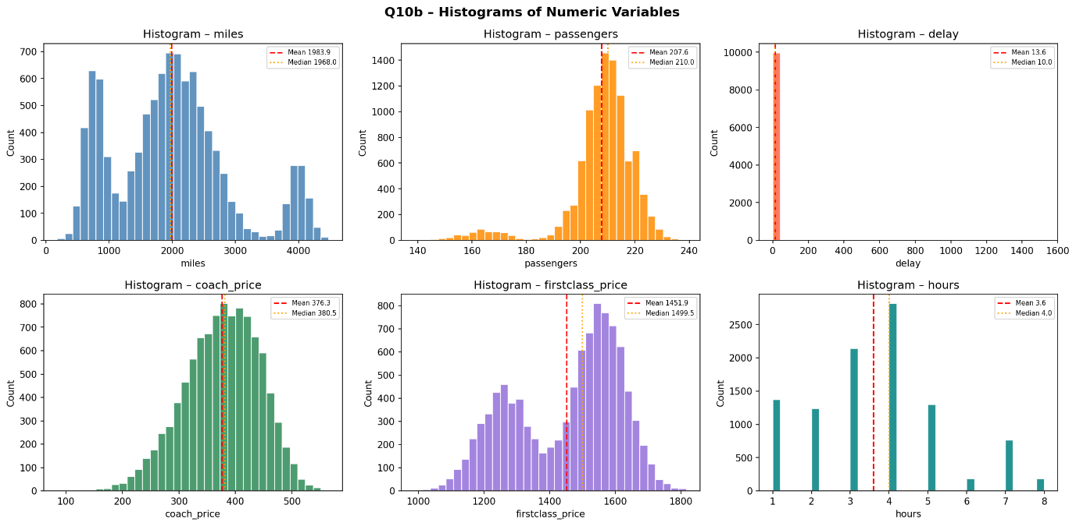
Boxplots:
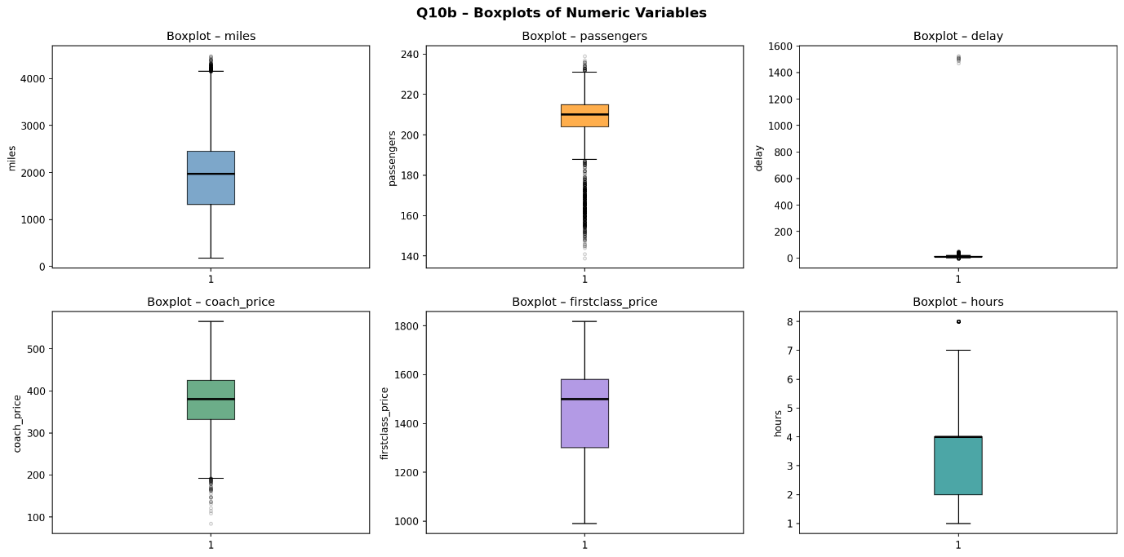
Barcharts: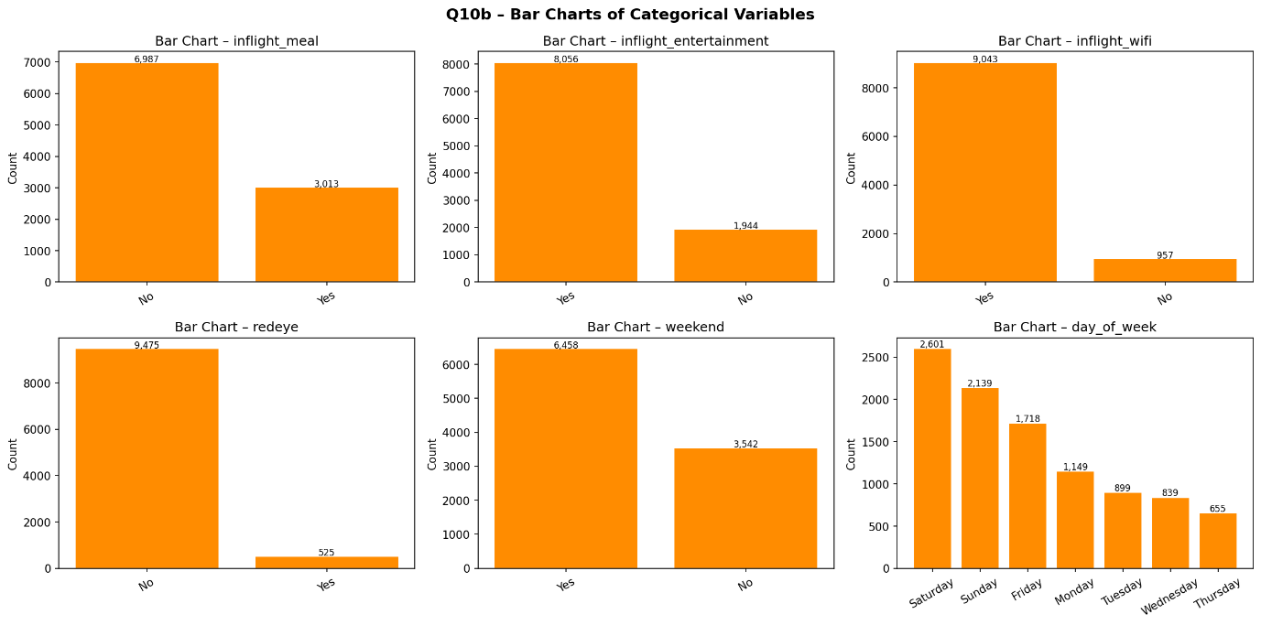

11.3 Hypothesis Testing (Q10c)
Test | Statistic | p-value | Decision
Z-test (H₀: μ=$350) | z = 39.46 | < 000 | Reject H₀
t-test (H₀: μ=$380) | t = −5.55 | < 0.001 | Reject H₀
Chi-sq: redeye × meal | χ² = 4.34 | 0.0372 | Reject H₀ (dependent)
Chi-sq: redeye × weekend | χ² = 0.021 | 0.885 | Fail to reject (independent)
Table: Hypothesis test results
R | Python
# Z-test (manual, large sample) | from scipy import stats
z <- (mean(cp)-350)/(sd(cp)/sqrt(length(cp))) | import numpy as np
p_z <- 2*pnorm(-abs(z))
cat('z=',round(z,4),'p=',p_z,'\n') | # Z-test (manual)
 | z=(cp.mean()-350)/(cp.std()/np.sqrt(len(cp)))
# One-sample t-test | p_z=2*(1-stats.norm.cdf(abs(z)))
t.test(cp, mu=380) | print(f'z={z:.4f} p={p_z:.2e}')
chisq.test(table(df$redeye, | print(stats.ttest_1samp(cp, 380))
df$inflight_meal))
chisq.test(table(df$redeye, | # Chi-square tests
df$weekend)) | import pandas as pd
 | ct1=pd.crosstab(df['redeye'],
 | df['inflight_meal'])
 | print(stats.chi2_contingency(ct1))
 | ct2=pd.crosstab(df['redeye'],
 | df['weekend'])
 | print(stats.chi2_contingency(ct2))
Code 11.3 — Z-test, t-test, and chi-square tests
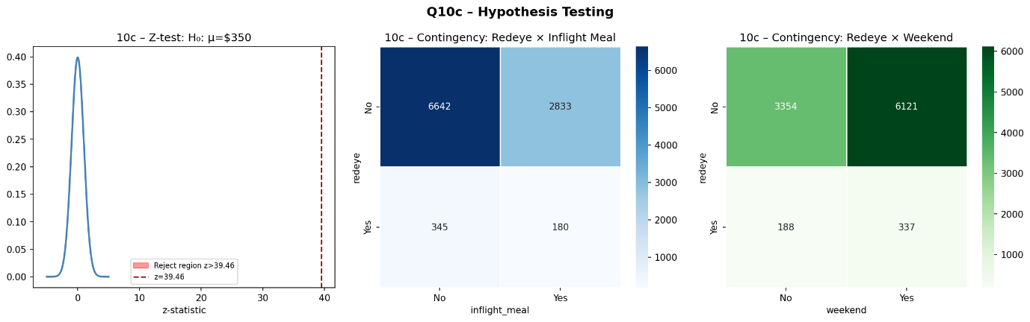

11.4 Independent t-Tests (Q10d)
Comparison | Yes | No | t-stat | p-value | Result
Weekend vs. Weekday | $405.49 | $323.47 | 73.41 | < 0.001 | Significant
Redeye vs. Non-Redeye | $319.22 | $379.47 | −20.58 | < 0.001 | Significant
Meal vs. No Meal | $389.64 | $370.51 | 13.36 | < 0.001 | Significant
Table: Independent t-test results for coach price group comparisons
R | Python
groups <- list( | from scipy import stats
c('weekend', 'Weekend'),
c('redeye', 'Redeye'), | groups = [
c('inflight_meal', 'Meal')) | ('weekend', 'Weekend'),
 | ('redeye', 'Redeye'),
for (g in groups) { | ('inflight_meal', 'Meal')]
g1 <- df[df[[g[1]]]=='Yes',
'coach_price'] | for col, label in groups:
g2 <- df[df[[g[1]]]=='No', | g1=df[df[col]=='Yes']['coach_price']
'coach_price'] | g2=df[df[col]=='No' ]['coach_price']
tt <- t.test(g1, g2) | t,p=stats.ttest_ind(g1,g2)
cat(g[2], | print(f'{label}: ',
round(mean(g1),2), | f'Yes=${g1.mean():.2f} ',
round(mean(g2),2), | f'No=${g2.mean():.2f} ',
round(tt$statistic,3), | f't={t:.3f} p={p:.4f}')
round(tt$p.value,4),'\n')
}
Code 11.4 — Independent t-tests for group mean comparisons
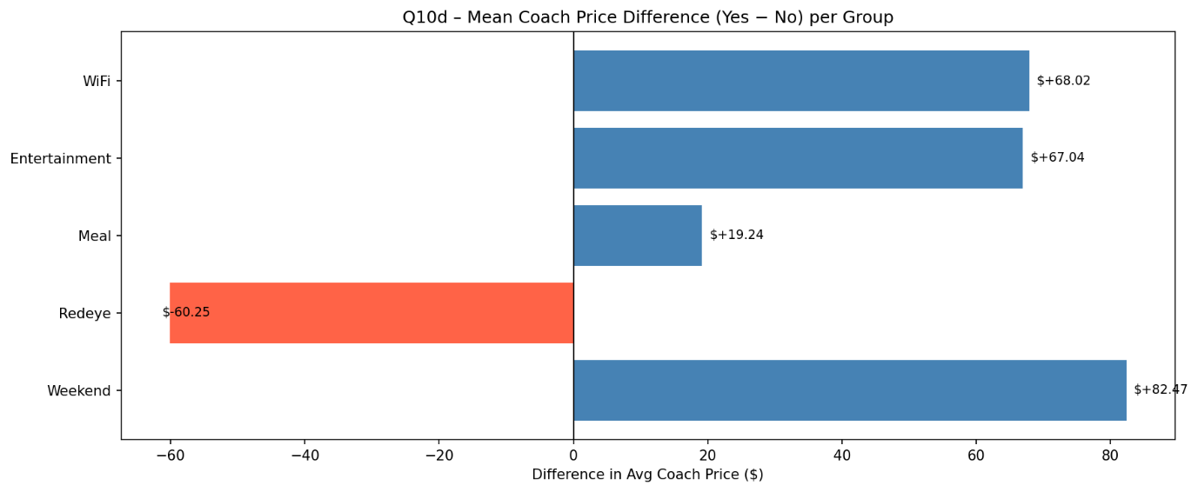

11.5 Price Differences: Weekend vs. Weekday (Q10e)
Price | Weekend | Weekday | Difference
Coach | $405.51 | $323.47 | +$82.47
First-Class | $1,558.32 | $1,257.20 | +$300.43
Table: Weekend vs. weekday average price differences

11.6 Correlation Matrix (Q10f)
Variable | miles | pax | delay | coach | first | hours
miles | 1.000 | −0.012 | −0.007 | 0.340 | 0.288 | 0.985
passengers | −0.012 | 1.000 | 0.005 | 0.160 | 0.007 | −0.011
delay | −0.007 | 0.005 | 1.000 | −0.017 | −0.027 | −0.007
coach | 0.340 | 0.160 | −0.017 | 1.000 | 0.758 | 0.332
firstclass | 0.288 | 0.007 | −0.027 | 0.758 | 1.000 | 0.284
hours | 0.985 | −0.011 | −0.007 | 0.332 | 0.284 | 1.000
Table: Pearson correlation matrix for numeric variables

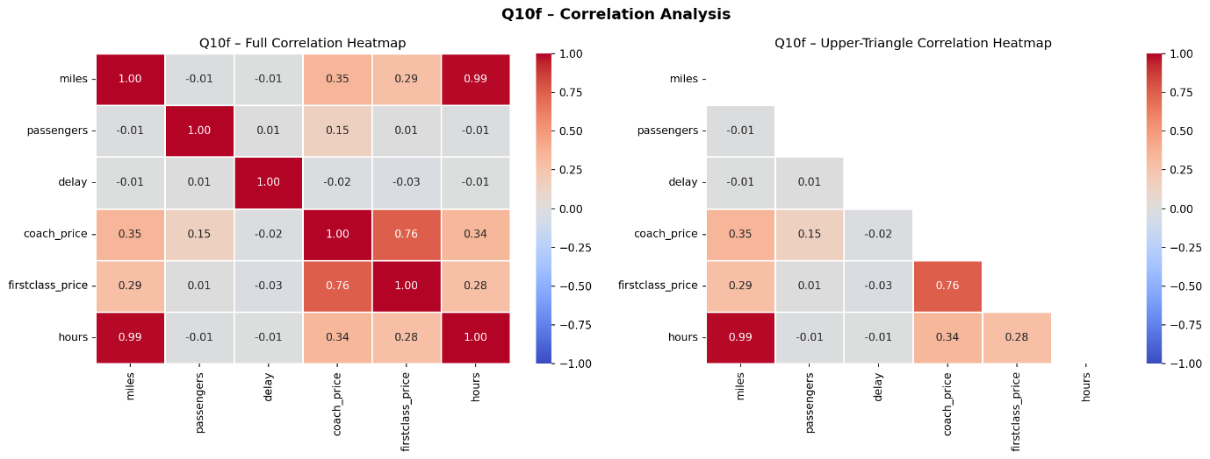

R | Python
library(corrplot) | import seaborn as sns
num_cols <- c('miles','passengers', | import matplotlib.pyplot as plt
'delay','coach_price',
'firstclass_price','hours') | num_cols=['miles','passengers',
cor_mat <- cor(df[num_cols], | 'delay','coach_price',
use='complete.obs') | 'firstclass_price','hours']
print(round(cor_mat, 4)) | cor_mat = df[num_cols].corr()
corrplot(cor_mat, | print(cor_mat.round(4))
method='color', type='upper',
addCoef.col='black') | sns.heatmap(cor_mat,annot=True,
 | fmt='.2f',cmap='coolwarm')
 | plt.tight_layout(); plt.show()
Code 11.6 — Pearson correlation matrix and heatmap

11.7 Linear Regression: Predict Coach Price (Q10g)
Model: coach_price = β0 + β1(miles) + β2(passengers) + β3(delay) + β4(hours) + β5(meal) + β6(entertainment) + β7(wifi) + ε
Predictor | Coefficient | Std. Error | t-value | p-value | Sig.
(Intercept) | $26.00 | 8.49 | 3.063 | 0.002 | **
miles | $0.027 | 0.003 | 8.575 | < 0.001 | ***
passengers | $0.839 | 0.039 | 21.271 | < 0.001 | ***
delay | −$0.023 | 0.017 | −1.370 | 0.171 | n.s.
hours | −$1.206 | 1.711 | −0.705 | 0.481 | n.s.
inflight_meal | $18.47 | 1.105 | 16.721 | < 0.001 | ***
inflight_entertain. | $71.06 | 1.276 | 55.671 | < 0.001 | ***
inflight_wifi | $71.57 | 1.670 | 42.868 | < 0.001 | ***
Table: OLS regression coefficients — dependent: coach_price
Metric | Value
R² | 0.4364
Adjusted R² | 0.4360
F-statistic | 1,105.2
Model p-value | < 2.2e−16
Table: OLS model fit statistics
R | Python
# Encode binary features | import statsmodels.api as sm
df_enc <- df
df_enc$inflight_meal <- | # Encode binary features
ifelse(df$inflight_meal=='Yes',1,0) | df_enc = df.copy()
df_enc$inflight_entertainment <- | for f in ['inflight_meal',
ifelse(df$inflight_entertainment=='Yes',1,0) | 'inflight_entertainment',
df_enc$inflight_wifi <- | 'inflight_wifi']:
ifelse(df$inflight_wifi=='Yes',1,0) | df_enc[f]=(df_enc[f]=='Yes').astype(int)
# Fit OLS model | # Fit OLS model
lm_mod <- lm(coach_price ~ | X_cols=['miles','passengers','delay',
miles + passengers + delay + hours + | 'hours','inflight_meal',
inflight_meal + inflight_entertainment + | 'inflight_entertainment',
inflight_wifi, | 'inflight_wifi']
data = df_enc) | X = sm.add_constant(df_enc[X_cols])
 | y = df_enc['coach_price']
summary(lm_mod) | lm = sm.OLS(y, X).fit()
# Residual plots | print(lm.summary())
par(mfrow=c(2,2))
plot(lm_mod)
Code 11.7 — OLS linear regression: encode features and fit model

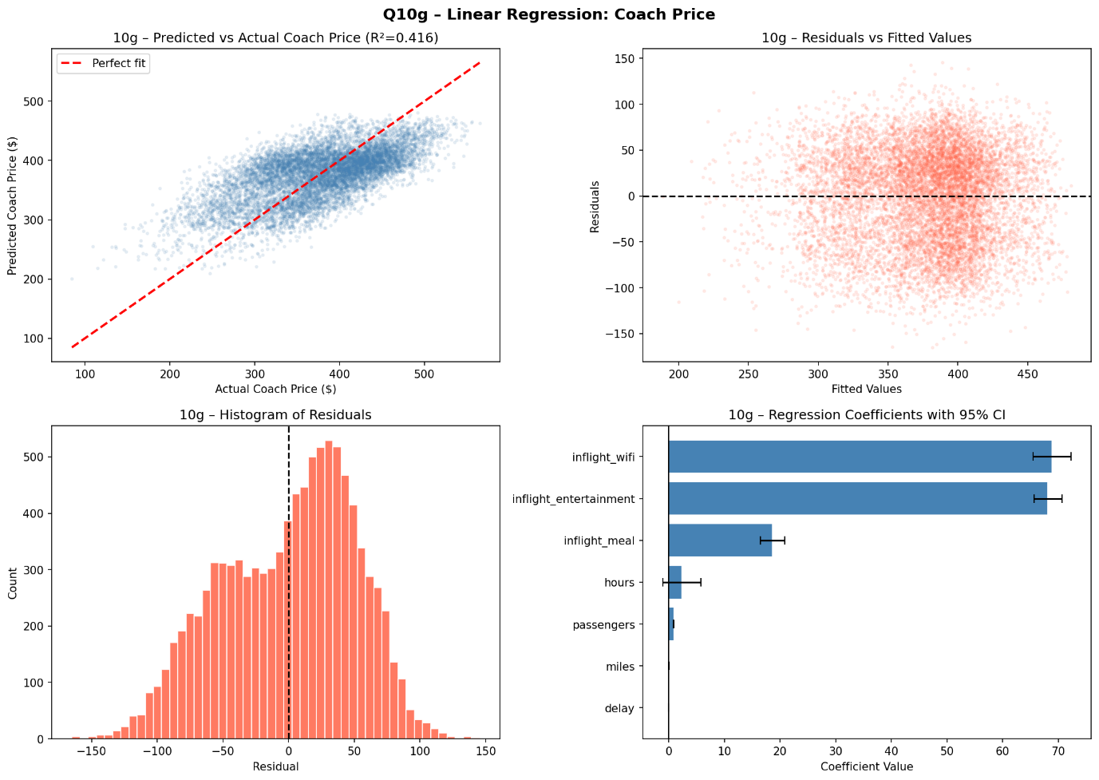

Interpretation
R²=0.4364 — model explains 43.6% of variance. Strongest predictors: WiFi (+$71.57), entertainment (+$71.06), passengers (+$0.84/pax), meal (+$18.47), miles (+$0.027/mile). Delay and hours not significant (multicollinearity with miles).

11.8 Logistic Regression: Predict Redeye (Q10h)
Binary logistic model predicting P(redeye=1) from: coach_price, miles, hours, passengers, delay.
Predictor | Coefficient | Std. Error | z-value | p-value | Sig.
(Intercept) | $207.89 | 58.02 | 3.583 | 0.0003 | ***
coach_price | −0.048 | 0.017 | −2.910 | 0.004 | **
miles | 0.004 | 0.004 | 0.948 | 0.343 | n.s.
hours | −0.850 | 2.007 | −0.423 | 0.672 | n.s.
passengers | −1.072 | 0.298 | −3.603 | 0.0003 | ***
delay | 0.008 | 0.010 | 0.809 | 0.418 | n.s.
Table: Logistic regression — dependent: redeye (1=Yes, 0=No)
Metric | Value
McFadden Pseudo R² | 0.9914
AIC | 33.82
Accuracy | 99.96%
Table: Logistic model fit metrics
R | Python
# Encode redeye as binary | import statsmodels.api as sm
df_enc$redeye_bin <-
ifelse(df$redeye=='Yes', 1, 0) | # Encode redeye as binary
 | df_enc['redeye_bin'] = (
# Fit logistic model | df_enc['redeye']=='Yes').astype(int)
logit_mod <- glm(
redeye_bin ~ | # Fit logistic model
coach_price + miles + | X_log=sm.add_constant(
hours + passengers + delay, | df_enc[['coach_price','miles',
data = df_enc, | 'hours','passengers',
family = binomial) | 'delay']])
 | y_log=df_enc['redeye_bin']
summary(logit_mod) | logit=sm.Logit(y_log,X_log).fit()
# Classification accuracy | print(logit.summary())
pred <- ifelse(
predict(logit_mod,type='response') | # Accuracy
>= 0.5, 1, 0) | pred=(logit.predict(X_log)>=0.5)
mean(pred == df_enc$redeye_bin)*100 | .astype(int)
 | acc=(pred==y_log).mean()*100
 | print(f'Accuracy: {acc:.2f}%')
Code 11.8 — Logistic regression: fit model and evaluate accuracy

Interpretation
Accuracy 99.96%. Significant predictors: coach_price (−, cheaper = more likely redeye) and passengers (−, fewer passengers = more likely redeye). Near-perfect separation confirms redeye flights occupy a structurally distinct pricing tier.

12. Conclusions
Question | Key Finding
Q1: Price overview | $500 above average; only 1.7% exceed it.
Q2: 8-hr flights | $500 more reasonable for 8-hr flights (14.3% exceed $500).
Q3: Delay distribution | Right-skewed; 16.5% pose connection risk.
Q4: Correlations | Miles (r=0.34) and hours (r=0.33) top predictors.
Q5: Coach vs. first-class | Very strong r=0.76; first-class = 3.95× coach.
Q6: In-flight features | WiFi (+$71) and entertainment (+$71) biggest premiums.
Q7: Passengers vs. hours | No significant relationship (r=−0.011).
Q8: Weekend vs. weekday | Weekend coach +$84; first-class +$302.
Q9: Redeye by day | Redeyes consistently $56–$68 cheaper every day.
Q10: Regression | R²=0.44; WiFi, entertainment, passengers are top drivers.
Table: Summary of key findings across all research questions

Overall: coach pricing is most strongly driven by in-flight service features (WiFi and entertainment), route demand (passengers), and scheduling (weekend, redeye). Airlines apply clear demand-based pricing — off-peak (weekday, redeye) travel offers the lowest fares.

