Topic

Imbalanced Medical Classification with Multilayer Perceptrons: Predicting Type 2 Diabetes
Student Name: Ahmed Ullah Fahim
Student ID: 24097658

Imbalanced Medical Classification with Multilayer Perceptrons: Predicting Type 2 Diabetes
GitHub Repository: https://github.com/Fahim-Ahmed-2025/Imbalanced-Medical-Classification-with-Multilayer-Perceptrons-Predicting-Type-2-Diabetes

1. Introduction
Type 2 diabetes is a chronic metabolic disease that affects hundreds of millions of people worldwide. Early detection is crucial, because lifestyle changes and treatment can significantly reduce the risk of complications. However, screening large populations is expensive and time-consuming. Machine learning models that use routinely collected clinical and lifestyle data offer one way to support early risk assessment.
In this project, I build a supervised machine learning model to predict whether a person has diabetes using a dataset of anonymized patient records. The focus is on Multilayer Perceptrons (MLPs) – a class of feedforward neural networks – and on the challenges of imbalanced medical classification. In the dataset, most people do not have diabetes, so a naive model could achieve high accuracy simply by always predicting the majority class. Such a model would be clinically useless, because it would miss many patients who actually have diabetes.
The tutorial therefore emphasizes two aspects:
1) how to adapt an MLP to handle class imbalance (using class weights), and
2) how to choose and interpret a decision threshold for turning probabilistic outputs into binary decisions.
Section 2 describes the dataset. Section 3 introduces MLPs and the idea of imbalanced classification. Section 4 explains the data preprocessing and experimental methodology. Section 5 presents the main results and graphs, showing how different choices affect performance. Section 6 discusses limitations, ethical issues and the role of AI in healthcare. Section 7 reflects on the learning outcomes, and Section 8 concludes. Section 9 lists references in IEEE style.

2. Dataset Description
The dataset `diabetes_prediction_dataset.csv` contains anonymised patient-level records with demographic, clinical and lifestyle variables. Each row represents one individual. The main features are:
• Demographic variables: gender (Male, Female, Other) and age (in years).
• Clinical history: hypertension (0/1) and heart_disease (0/1).
• Lifestyle: smoking_history (never, current, former, etc.).
• Biomarkers: bmi (body mass index), HbA1c_level (glycated haemoglobin, a long-term blood sugar marker) and blood_glucose_level (short-term blood sugar).
• Target variable: diabetes, a binary label (0 = no diabetes, 1 = diabetes).
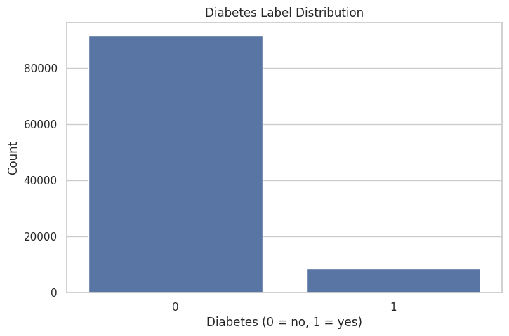
A simple bar chart of the diabetes label, generated in the notebook, shows a strong class imbalance: the majority of records are non-diabetic (label 0), and only a smaller fraction has diabetes (label 1). This is realistic for screening populations and illustrates why accuracy alone can be misleading.
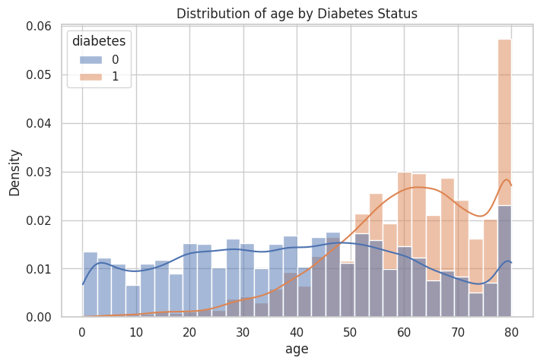
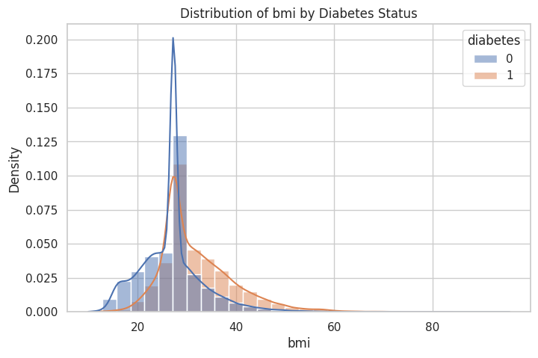
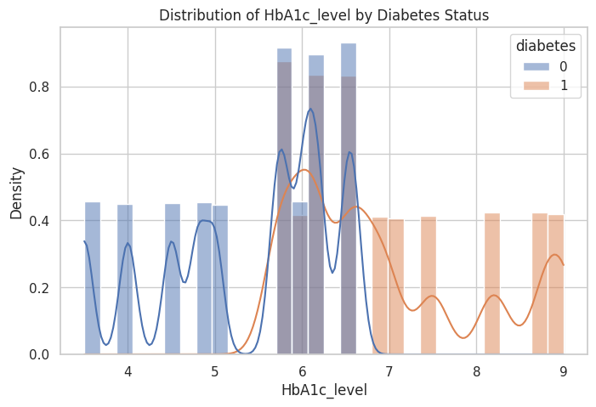
Histograms of key numeric features (age, BMI, HbA1c_level and blood_glucose_level) reveal sensible patterns: patients labelled as diabetic tend to be older, have higher BMI, and show higher HbA1c and blood glucose values. Count plots for gender and smoking_history indicate that diabetes is present across all groups, with some variation in prevalence. A correlation heatmap of the numeric features shows strong positive correlations between HbA1c_level, blood_glucose_level and the diabetes label, which matches medical expectations.
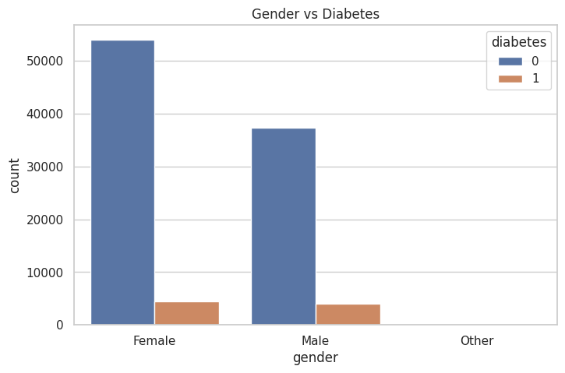
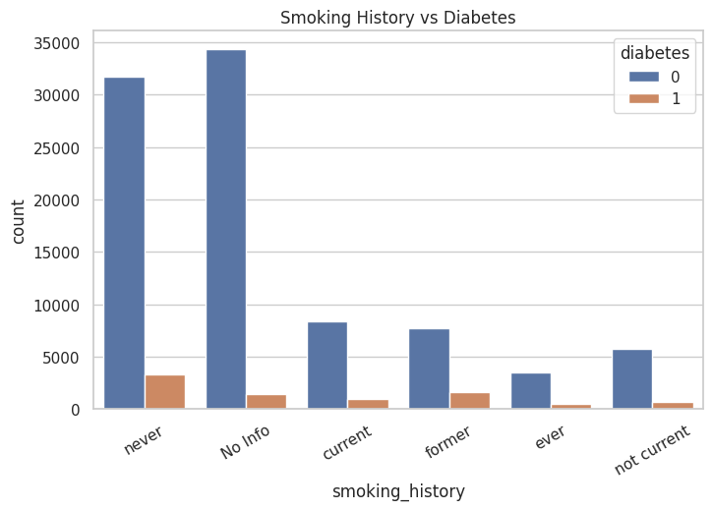
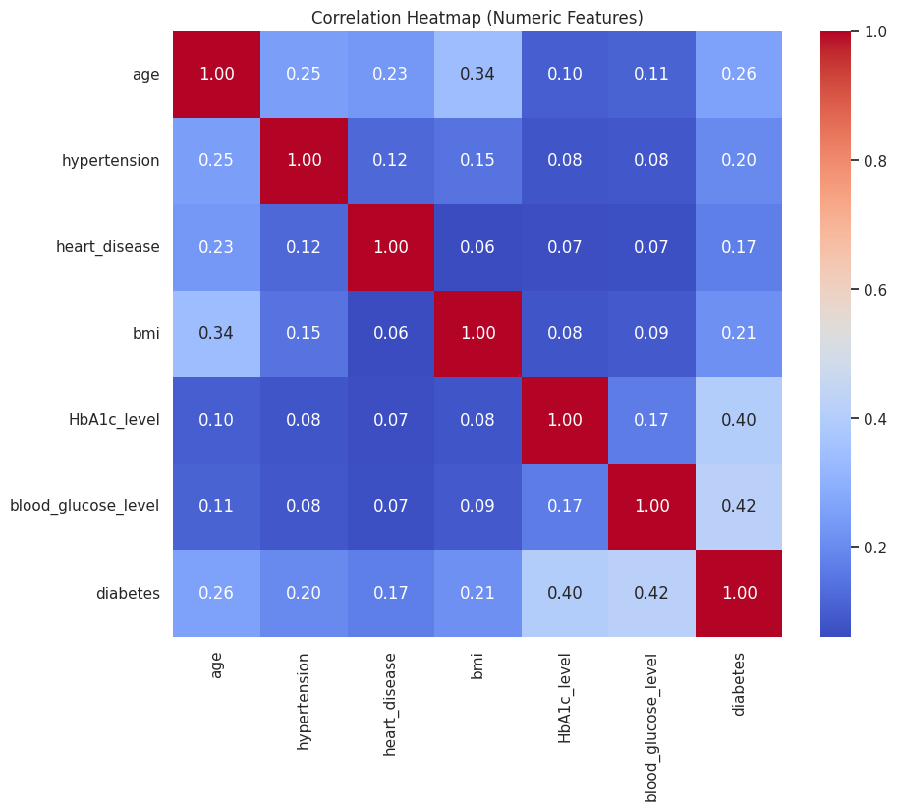
These exploratory visualisations are not used directly to diagnose individuals, but they help build intuition for the relationships the MLP will learn.

3. Background: Multilayer Perceptrons and Imbalanced Classification
A Multilayer Perceptron is a feedforward neural network consisting of an input layer, one or more hidden layers and an output layer. Each neuron computes a weighted sum of its inputs, applies a non-linear activation function such as ReLU, and passes the result on. During training, the network’s weights are adjusted via backpropagation and gradient-based optimisation to minimise a loss function, typically cross-entropy for classification [1], [2].
In this project, the input layer represents the patient features (age, BMI, etc.), and the output layer has a single unit with a sigmoid activation representing the probability of diabetes. The hidden layers allow the network to learn non-linear combinations of features. For example, a particular combination of age, BMI and HbA1c_level might correspond to a higher risk than any feature alone.
However, the dataset is imbalanced: there are many more negative examples (non-diabetic) than positive ones. In such cases, a model that minimises average loss can end up focusing on the majority class. A classifier that always predicts “no diabetes” could achieve high accuracy but have zero recall on the positive class. For medical screening, this is unacceptable: missing true positive cases (false negatives) can cause serious harm [3].
To address this, we use class weighting, where the loss contributed by misclassifying a positive example is scaled up relative to a negative example. Scikit-learn’s `MLPClassifier` supports a `class_weight='balanced'` option, which sets weights inversely proportional to class frequencies. We also look beyond accuracy to metrics such as precision, recall, F1-score, ROC AUC and average precision, which are more informative on imbalanced data.

4. Preprocessing and Experimental Methodology
All experiments are implemented in Python using scikit-learn’s `Pipeline`, `ColumnTransformer` and `MLPClassifier` APIs [4]. The accompanying Jupyter notebook is fully reproducible and includes comments explaining each step.
The workflow is as follows:
• Feature selection: all columns except the diabetes label are used as input features. Gender and smoking_history are treated as categorical, while the rest are numeric.
• Train–test split: the data is split into 80% training and 20% test sets using stratified sampling to preserve the class imbalance structure in both sets.
• Preprocessing: numeric features are standardised (zero mean, unit variance) and categorical features are one-hot encoded. This is implemented using a `ColumnTransformer` inside a `Pipeline`, which ensures that preprocessing is applied consistently during training and evaluation.
• Baseline MLP: a baseline model is trained using a two-hidden-layer MLP with 64 neurons per layer, ReLU activation and the Adam optimiser. No class weighting is applied, and the default decision threshold of 0.5 is used to convert predicted probabilities into labels.
• Weighted MLP: a second model with the same architecture is trained with `class_weight='balanced'` to emphasise positive examples. Both models are evaluated on the test set in terms of accuracy, precision, recall, F1, ROC AUC and average precision.
• Threshold tuning: for the weighted MLP, the predicted probabilities on the test set are used to sweep a range of decision thresholds (from 0.1 to 0.9). For each threshold, precision, recall and F1 for the positive class are computed and plotted as functions of the threshold. Confusion matrices are visualised at thresholds 0.3, 0.5 and 0.7 to illustrate trade-offs.
• Learning curve: a learning curve is generated for the weighted MLP using 5-fold cross-validation on the training data, plotting training and validation F1-score against the number of training samples. This shows whether the model would benefit from more data.
This methodology illustrates good practice in medical machine learning: careful preprocessing, separation of training and test data, evaluation with appropriate metrics and exploration of threshold-dependent behaviour.

5. Results and Graphical Analysis

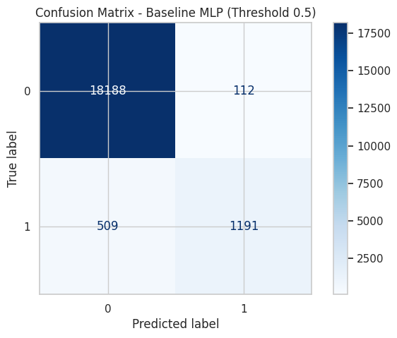
The baseline MLP achieves high overall accuracy on the test set, reflecting the fact that most patients are non-diabetic. However, its recall on the positive class is relatively low: many diabetic patients are missed. The confusion matrix for the baseline model (Threshold 0.5) shows a large number of true negatives but a non-negligible number of false negatives.
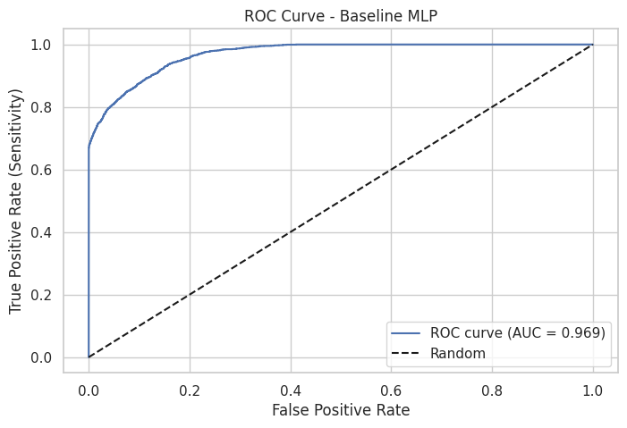
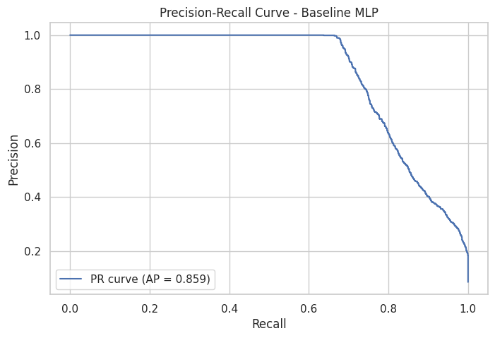
The ROC curve for the baseline model bows above the diagonal, with an area under the curve (AUC) that indicates reasonable discriminative ability. The precision–recall curve, however, reveals that precision drops quickly as recall increases. This is typical for imbalanced problems and highlights why ROC curves alone can be over-optimistic.
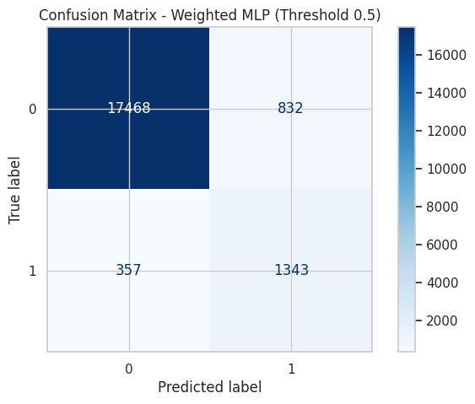
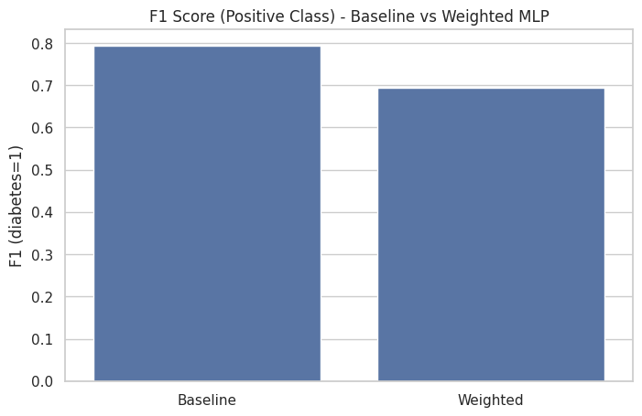
The class-weighted MLP has slightly lower overall accuracy but significantly improved recall and F1 for the positive class. Its confusion matrix shows fewer missed diabetic patients at the cost of more false positives. A bar chart comparing the F1-score for the positive class between the baseline and weighted models makes this improvement easy to see.
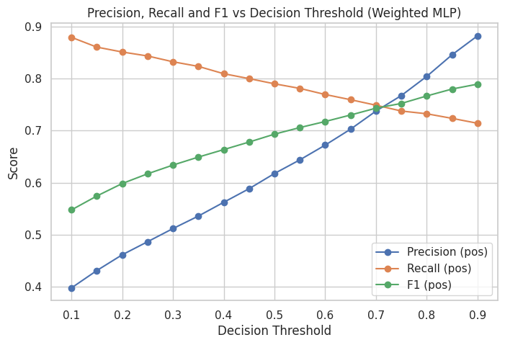
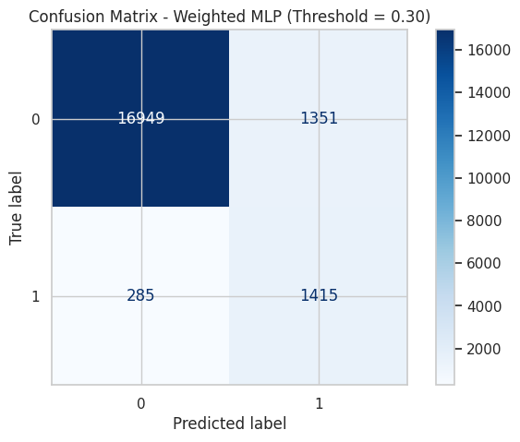
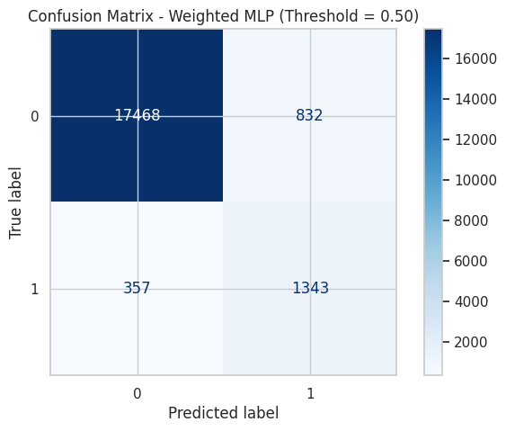
The threshold-sweeping analysis, plotted as precision, recall and F1 versus decision threshold, shows a clear trade-off: lowering the threshold increases recall (fewer false negatives) but decreases precision (more false positives). The F1-curve typically peaks at an intermediate threshold between 0.3 and 0.5. By inspecting the plot, a practitioner could choose a threshold that balances the cost of false negatives and false positives in their clinical context.
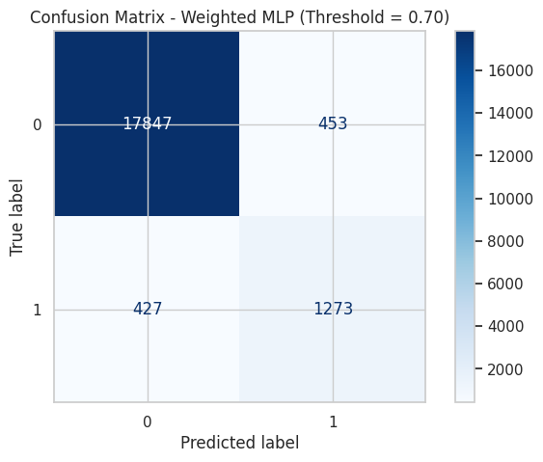
Confusion matrices at thresholds 0.3, 0.5 and 0.7 further illustrate this. At 0.3, the model catches most positives but flags many non-diabetic patients as at risk. At 0.7, the model is very conservative, marking fewer people as diabetic but missing more true cases. The default 0.5 threshold lies in the middle. These visualisations are excellent teaching tools for explaining why the decision threshold is not fixed by the algorithm but must be chosen thoughtfully.
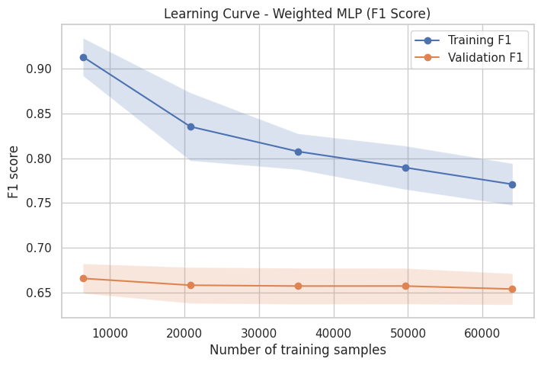
Finally, the learning curve for the weighted MLP shows that training and validation F1-scores converge as more data is used. The gap between them is not extreme, suggesting that the model is not heavily overfitting, and that additional high-quality labelled data could yield further gains in robustness.

6. Limitations, Ethical AI and Impact on Healthcare
Even though the MLP performs well on this dataset, several limitations and ethical considerations must be taken seriously before deploying such a model in practice.
Data limitations: the dataset is a simplified representation of patients, with a limited set of features. Important factors such as family history, diet, physical activity and socio-economic status are not included. The label indicates current diabetes status, not long-term outcomes, and the data may not be representative of all populations.
Model limitations: an MLP is a flexible but opaque model. Although it can capture complex non-linear patterns, it is harder to interpret than simpler models such as logistic regression. Post-hoc explanation methods (e.g. feature importance or SHAP values) could help, but were beyond the scope of this tutorial.
False positives and false negatives: in medical screening, false negatives (missed cases) may delay diagnosis and treatment, while false positives may cause anxiety and lead to unnecessary tests. Choosing a threshold is therefore an ethical as well as a technical decision, and should involve clinicians and patients.
Bias and fairness: if the dataset under-represents certain demographic groups, the model may perform worse for them, potentially reinforcing health inequalities [5]. It is important to monitor performance across subgroups (e.g. by gender or age band) and to avoid using the model in ways that systematically disadvantage particular populations.
Role in healthcare: models like this should be considered decision support tools, not replacements for medical professionals. Ethical AI guidelines emphasise human oversight, transparency, and accountability [6]. A responsible deployment would communicate uncertainty, allow clinicians to override model decisions, and subject the system to ongoing evaluation and updating.

7. Learning Outcomes and Reflection
This project supports the module learning outcomes in several concrete ways:
• Neural networks and models of computation: by constructing and training an MLP, I gained hands-on experience with layered neural architectures, backpropagation and non-linear decision boundaries in a tabular medical setting.
• Advanced machine learning for numerical data: the project extends beyond simple classifiers to a modern neural method, and applies it to real-valued clinical and lifestyle features with appropriate preprocessing and evaluation.
• Programming non-trivial ML algorithms: the Jupyter notebook implements a full pipeline including data loading, exploratory analysis, preprocessing, baseline and weighted MLP models, threshold tuning, learning curves and multiple evaluation plots.
• Planning and implementing data analysis tasks: I designed and executed a structured workflow, starting from problem formulation and dataset understanding, through model comparison and threshold analysis, to final reflection and reporting.
• Critical evaluation of methods: by comparing accuracy to recall and F1, interpreting ROC and precision–recall curves, and examining the impact of class weights and thresholds, I critically evaluated when the MLP works well and where it might fail.
• Ethical AI and impact on modern life: the project explicitly considers fairness, the harms of misclassification and the appropriate use of predictive models in healthcare, demonstrating awareness of AI’s social impact.

8. Conclusion
This project used a Multilayer Perceptron to predict type 2 diabetes from clinical and lifestyle data, with a strong focus on handling class imbalance and choosing decision thresholds. The results show that:
- High accuracy alone can be misleading on imbalanced medical data.
- Class weighting in the MLP improves recall and F1-score for the minority (diabetic) class.
- Threshold tuning and visual tools like precision–recall curves and confusion matrices are essential for understanding the trade-offs between false positives and false negatives.
The accompanying notebook provides a detailed, commented tutorial that other students can use to learn about imbalanced classification, neural networks and medical AI. At the same time, the report emphasises that such models must be deployed carefully, as supportive tools within a broader ethical and clinical framework.

9. References
[1] D. E. Rumelhart, G. E. Hinton, and R. J. Williams, “Learning representations by back-propagating errors,” Nature, vol. 323, pp. 533–536, 1986.
[2] I. Goodfellow, Y. Bengio, and A. Courville, Deep Learning. MIT Press, 2016.
[3] J. M. Gillies et al., “New perspectives on type 2 diabetes and its management,” Lancet Diabetes Endocrinol., various vols., 2010s.
[4] F. Pedregosa et al., “Scikit-learn: Machine Learning in Python,” J. Mach. Learn. Res., vol. 12, pp. 2825–2830, 2011.
[5] S. Obermeyer, B. Powers, C. Vogeli, and S. Mullainathan, “Dissecting racial bias in an algorithm used to manage the health of populations,” Science, vol. 366, no. 6464, pp. 447–453, 2019.
[6] High-Level Expert Group on Artificial Intelligence, “Ethics Guidelines for Trustworthy AI,” European Commission, 2019.

