**Eye tracking :**

**Please take off your glasses or sunglasses . Then just move your eye balls or you can move your head as well . it will move the mouse pointer and if you blink then it will perform a right click . you can click on whatever thing you line to click on any website or any file in your device , just make sure not to click on the button area . try to avoid the upper middle part of the screen while you are on the other screens rather than the project screen . press q button or you can take the pointer to the exit button and then blink to quit or you can switch mode .   
  
Hand Gesture Tracking :**

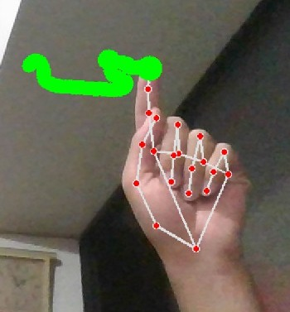

**Only raise your first finger to draw lines . you can change colors too .**

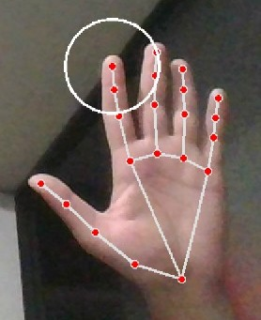

**To erase , just open five fingers and an eraser will appear then you can slide on the lines to erase those . you can also clear the whole thing by clicking on the button**

**get the thumb and first finger together**

**then you will be able to click on the buttons by taking tour fingers there**

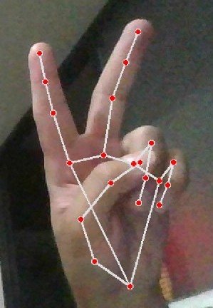

**To take a break or take up the marker just open two fingers and it wont draw anything .**