EdgeCache: Lightweight Result Caching for On-Device Neural Inference
Ada Example, Brian Sample
Department of Computer Science, Example University
ada@example.edu, brian@sample.org
Abstract: On-device neural inference is limited by latency and energy. We present EdgeCache, a lightweight cache that reuses intermediate results for near-duplicate inputs. This sample exists only to demonstrate Paper Forge.
Keywords: edge computing, caching, neural networks

Introduction
Mobile devices increasingly run neural networks locally [1]. Many inputs are near-duplicates, so recomputing the full network wastes time & energy (about 50% in our illustration).

Method
We hash early-layer activations and reuse cached outputs when the hash distance is small.

Admission Policy
Entries are admitted when their predicted reuse probability exceeds a threshold.

Evaluation
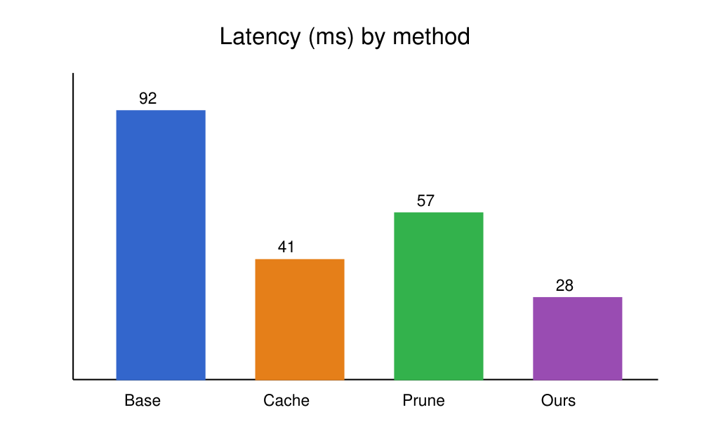
Figure 1: Mean inference latency per method (illustrative).
Table 1: Accuracy and latency (illustrative values).
Method | Top-1 (%) | Latency (ms)
Baseline | 76.1 | 92
EdgeCache | 75.8 | 28

Conclusion
EdgeCache shows that simple result caching can cut on-device latency.

References
[1] N. D. Lane and P. Georgiev, “Can deep learning revolutionize mobile sensing?” in Proc. HotMobile, 2015, pp. 117–122.
[2] D. Crankshaw et al., “Clipper: A low-latency online prediction serving system,” in Proc. NSDI, 2017.

