SAT-2
CLOUD COMPUTING TECHNOLOGIES

CI/CD PIPELINE:
STEP 1: Create the Lambda Function:
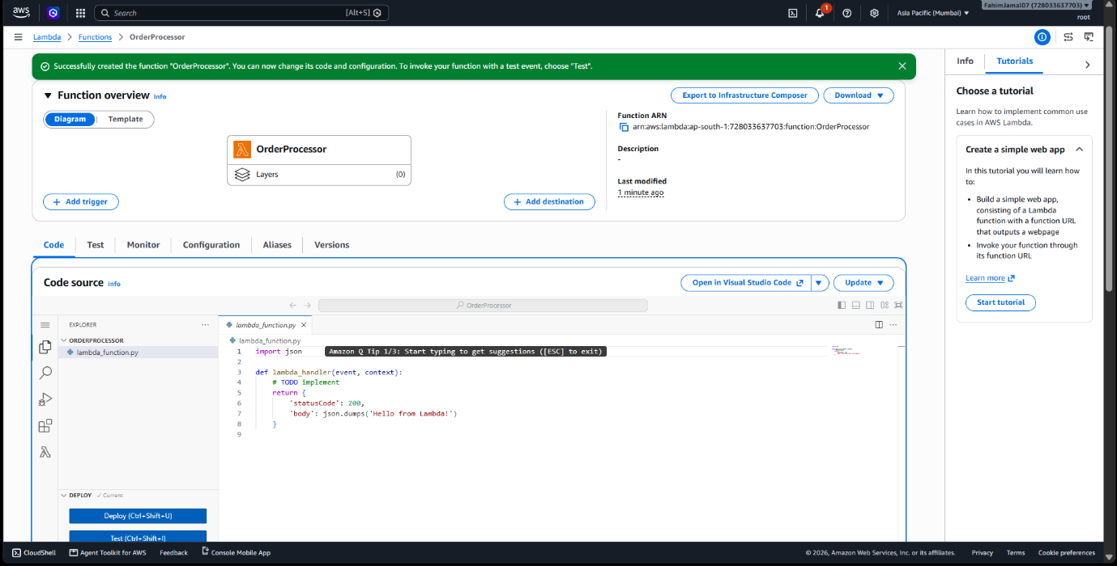

Step 2: Create the Source Repository:
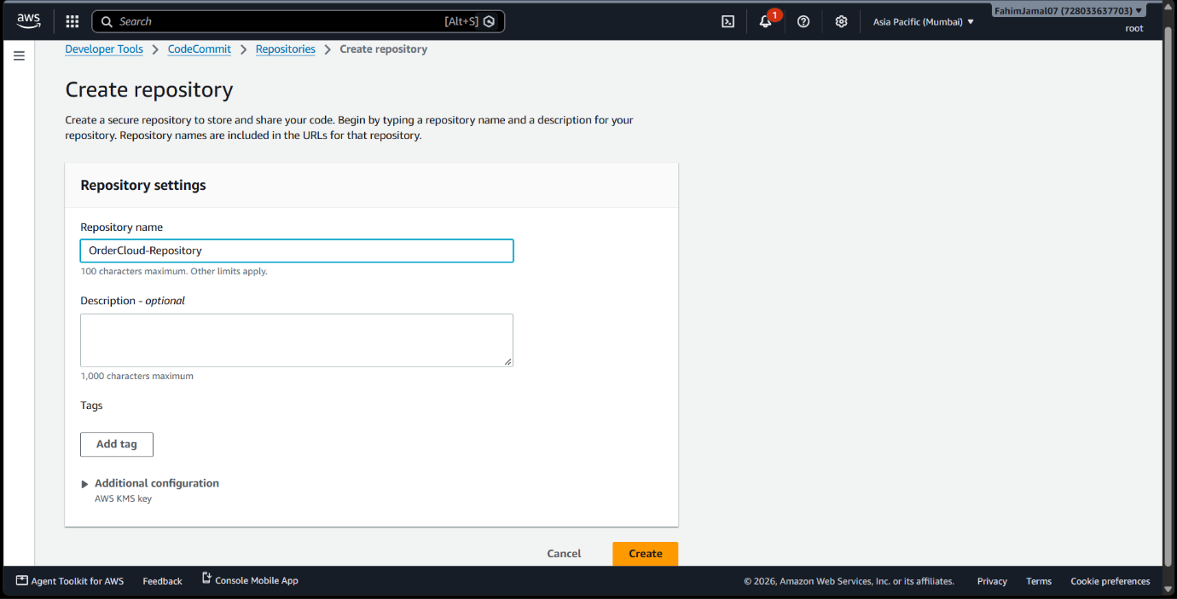
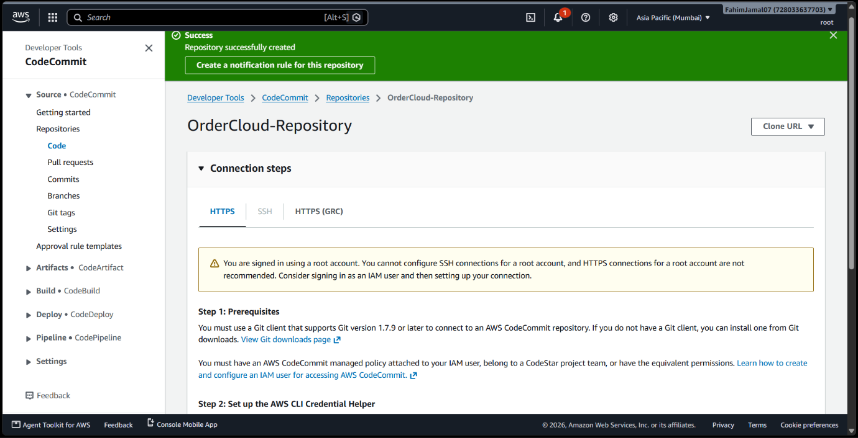
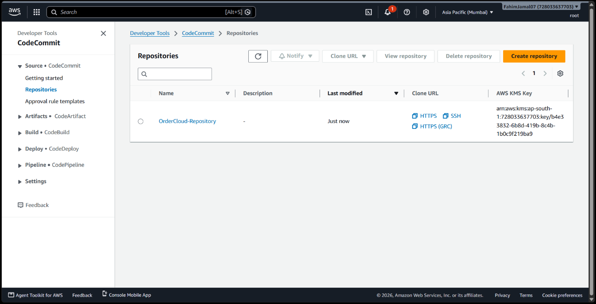

Step 3: Configure IAM:
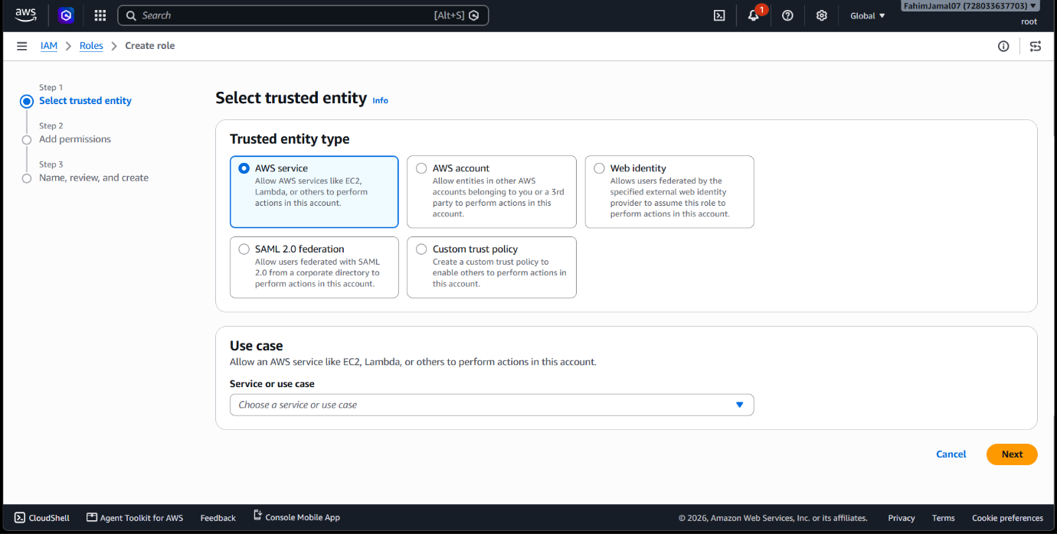

Step 4: Configure S3
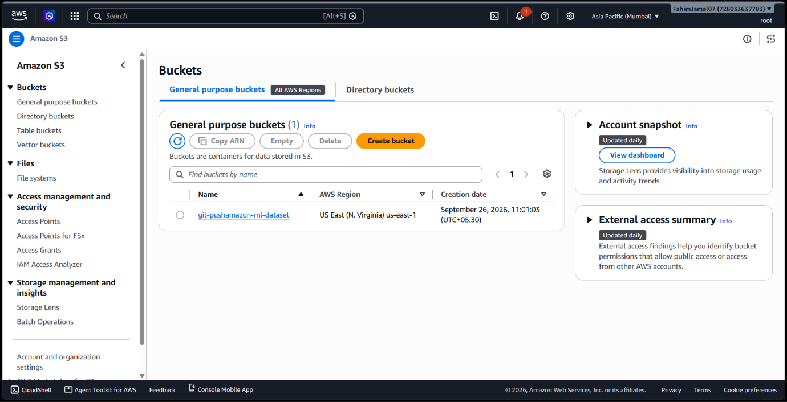

Step 5: Configure CodeBuild
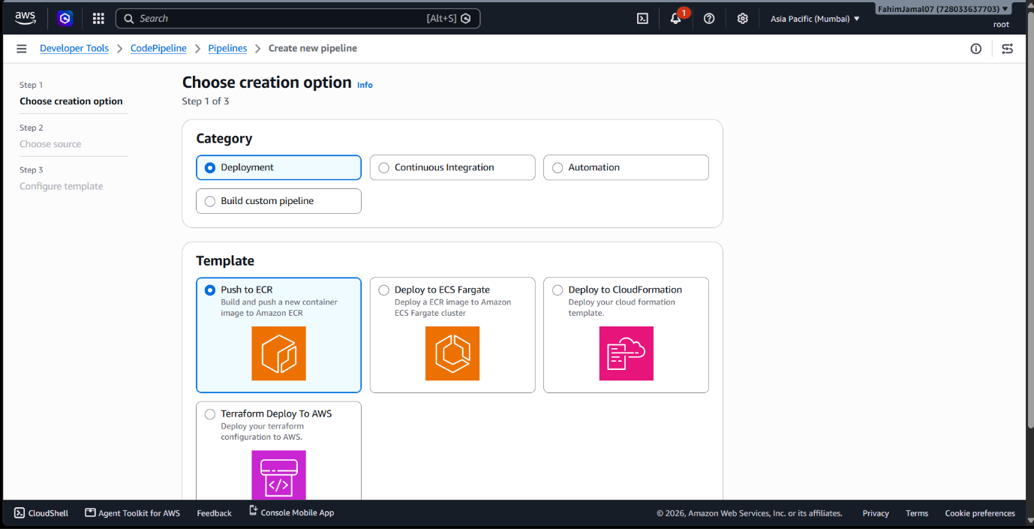

Step 6: Configure EventBridge
