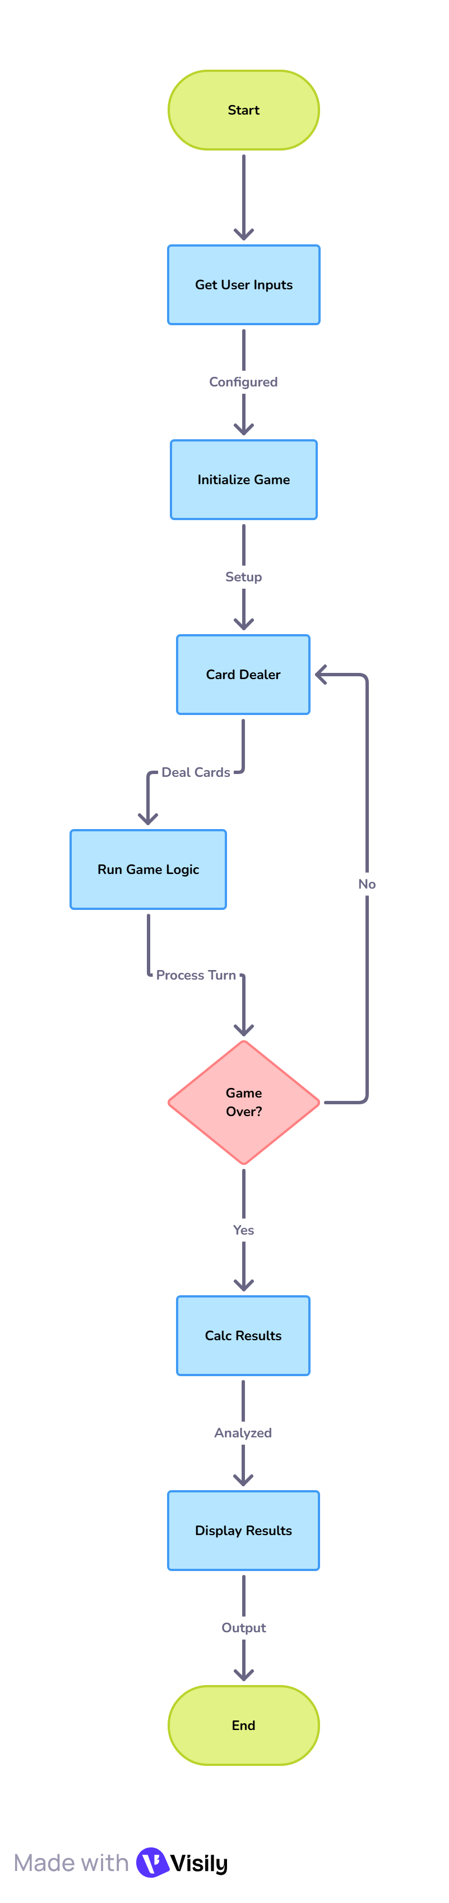
The DFD shows the poker simulator as a system that:
- Takes inputs from the user (like number of players or games to simulate).
- Runs the poker game logic using the Expectiminimax AI.
- Uses a card dealer to handle random card distributions.
- Calculates performance results (like who won, win rates, etc.).
- Gives those results back to the user.

