# *EXERCISE:*

# *Task 01*

## Write MATLAB Code for DSB Modulation

𝑦𝐷𝑆𝐵 = 𝐴𝑚 cos(2 𝑓𝑚𝑡) 𝑉𝑐 cos(2 𝑓𝑐𝑡)

Where 𝐴𝑚 = 1 and 𝑓𝑚 = 100𝐻𝑧, 𝑉𝑐 = 2 and 𝑓𝑐 = 10𝑘𝐻𝑧

* Plot 𝑚(𝑡), 𝑉c cos (2 𝑓c 𝑡) and 𝑦DSB in time domain for 𝑡 = 0 ∶ 1/fs:1, where 𝑓𝑠 = 1000𝐻𝑧
* Plot frequency spectrum of m(t), 𝑉𝑐𝑐𝑜𝑠(2 𝑓𝑐𝑡) and 𝑦𝐷𝑆𝐵 in frequency domain and reconstruct demodulated signal using filter.
* What can you analyze from the frequency components? Are they consistent with your theoretical knowledge?

% Parameters

Am = 1;

fm = 10; % in Hz

Vc = 2;

fc = 100; % in Hz

fs = 1000; % in Hz

t = 0:1/fs:1;

% Signals

mt = Am * cos(2 * pi * fm * t);

Vc_cos = Vc * cos(2 * pi * fc * t);

yDSB = Am * cos(2 * pi * fm * t) .* Vc_cos;

% Plot time domain signals

figure;

subplot(3,1,1);

plot(t, mt);

xlabel('Time (s)');

ylabel('m(t)');

title('Message Signal');

subplot(3,1,2);

plot(t, Vc_cos);

xlabel('Time (s)');

ylabel('Vc cos(2 * fc * t)');

%xlim([0 0.2])

title('Carrier Signal');

subplot(3,1,3);

plot(t, yDSB);

xlabel('Time (s)');

ylabel('yDSB');

title('DSB Modulated Signal');



%xlim([0 0.5])

% Plot frequency domain signals

f = -fs/2:fs/length(t):fs/2-fs/length(t);

MT = fftshift(fft(mt));

VC_COS = fftshift(fft(Vc_cos));

YDSB = fftshift(fft(yDSB));

figure;

subplot(3,1,1);

plot(f, abs(MT)/length(t));

xlabel('Frequency (Hz)');

ylabel('Magnitude');

title('Frequency Spectrum of m(t)');

xlim([-150 150])

grid("on")

ylim([-0.2 0.6])

subplot(3,1,2);

plot(f, abs(VC_COS)/length(t));

xlabel('Frequency (Hz)');

ylabel('Magnitude');

title('Frequency Spectrum of Vc cos(2 * fc * t)');

xlim([-150 150])

ylim([-0.2 1.2])

grid("on")

subplot(3,1,3);

plot(f, abs(YDSB)/length(t));

xlabel('Frequency (Hz)');

ylabel('Magnitude');

title('Frequency Spectrum of yDSB');

xlim([-150 150])

ylim([-0.1 0.6])

grid("on")



% Reconstruct demodulated signal using filter

y1=yDSB.*Vc_cos;

h = fir1(30, fc/(fs/2)); % Design a lowpass filter

y_demod =0.5* filter(h, 1, y1); % Demodulate using the filter

% Plot demodulated signal

figure;

subplot(2,1,1)

plot(t, y_demod);

xlabel('Time (s)');

ylabel('Demodulated Signal');

title('Demodulated Signal');

subplot(2,1,2)

plot(t, mt);

xlabel('Time (s)');

ylabel('Message Signal');

title('Message Signal');



***Explanation:***

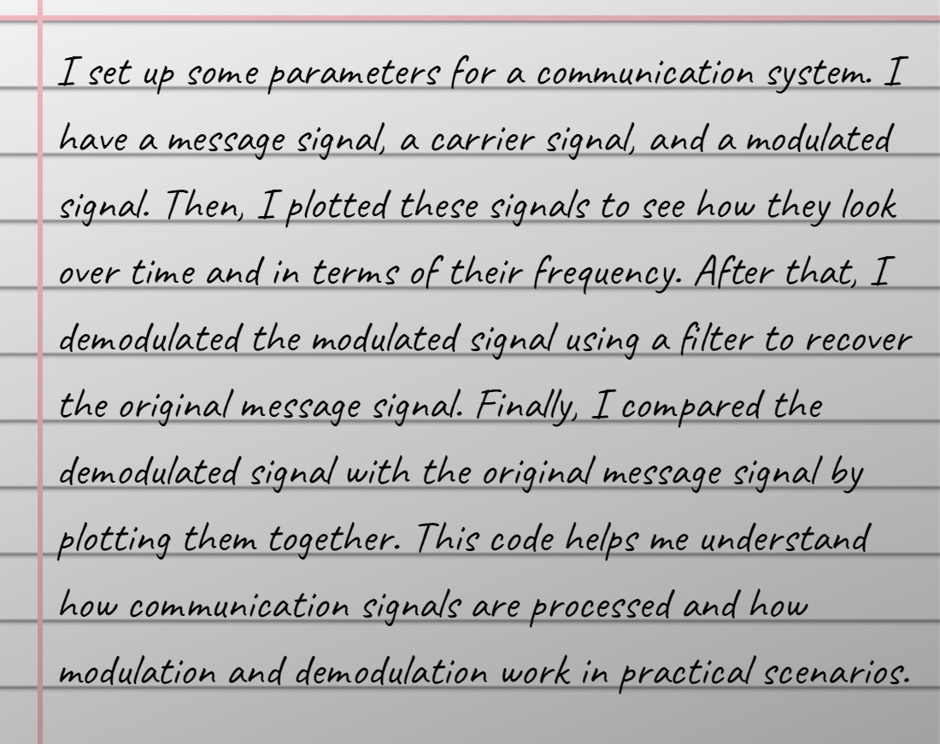

# *Task 02*

## Implement DSB-SC Modulation and De-modulation using Simulink, you can use the following blocks in Simulink to implement it.

Where 𝑓m = 10𝐻𝑧 and 𝑓c = 100𝐻𝑧

* Signal Generator (Carrier and Message Generation)
* Dot Product (for multiplication)
* Analog Filter Design (Butter-low pass)
* Gain (use at Demodulation side)
* Scope

***Block Diagram:***

***Output:***

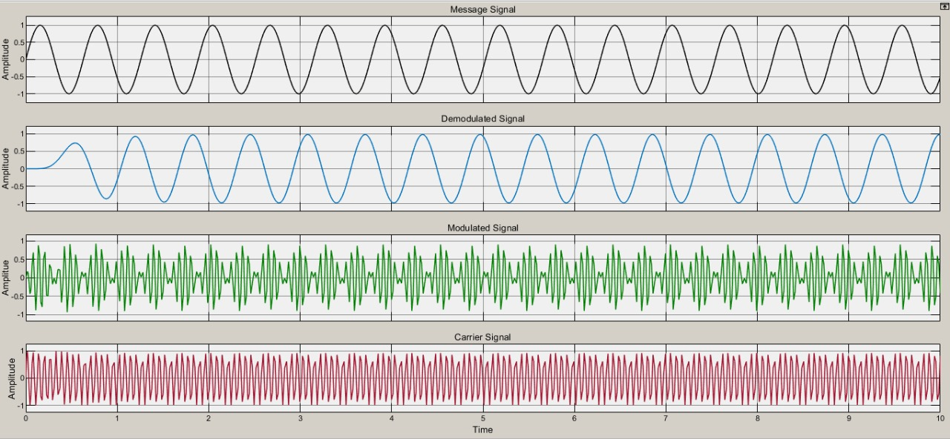

***Explanation:***

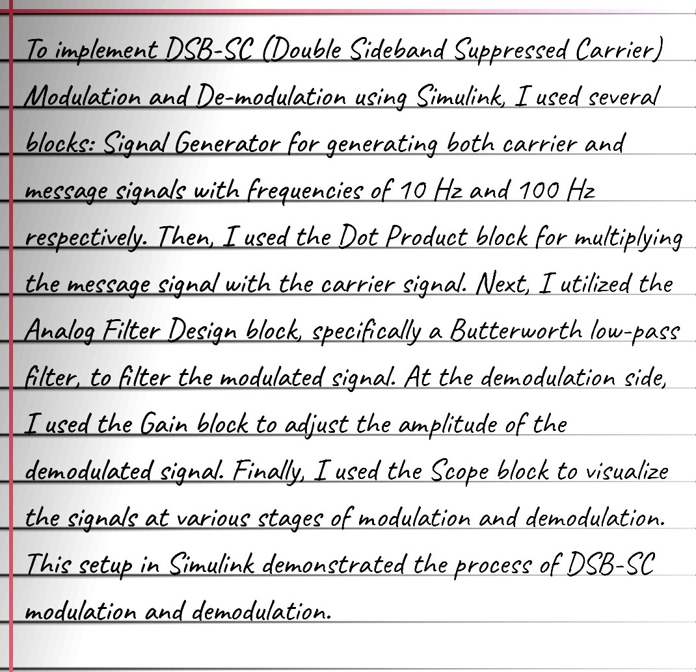

***Conclusion:***

