

***NAMAL UNIVERSITY MIANWALI***

***DEPARTMENT OF ELECTRICAL ENGINEERING***

***Communication Systems (Lab)LAB # 06***

***REPORT***

***Title :***

***Quadrature Amplitude Modulation (QAM) using MATLAB/Simulink***

|  |  |
| --- | --- |
| ***Name*** | ***Fahim Ur Rehman Shah*** |
| ***Roll No*** | ***NIM-BSEE-2021-24*** |
| ***Intructor*** | ***Dr. Sajjad Ur Rehman*** |
| ***Lab Engineer*** | ***Engr. Faizan Ahmad*** |
| ***Date Performed*** | ***15-April-2024*** |
| ***Marks*** |  |

# *Task 1 – Simple QAM and Demodulation using MATLAB*

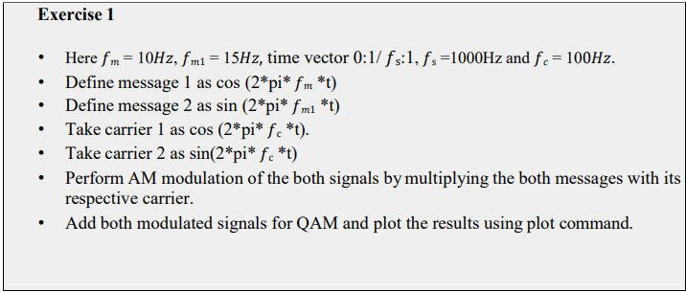

% Given parameters

fm = 10; % Hz

fm1 = 15; % Hz

fs = 1000; % Hz

fc = 100; % Hz

% Define time vector

t = 0:1/fs:1;

% Define message 1 as cos(2*pi*fm*t) and plot

message1 = cos(2*pi*fm*t);

subplot(3, 2, 1);

plot(t, message1);

title('Message 1');

xlabel('Time (s)');

ylabel('Amplitude');

% Define message 2 as sin(2*pi*fm1*t) and plot

message2 = sin(2*pi*fm1*t);

subplot(3, 2, 2);

plot(t, message2);

title('Message 2');

xlabel('Time (s)');

ylabel('Amplitude');

% Take carrier 1 as cos(2*pi*fc*t) and plot

carrier1 = cos(2*pi*fc*t);

subplot(3, 2, 3);

plot(t, carrier1);

title('Carrier 1');

xlabel('Time (s)');

ylabel('Amplitude');

% Take carrier 2 as sin(2*pi*fc*t) and plot

carrier2 = sin(2*pi*fc*t);

subplot(3, 2, 4);

plot(t, carrier2);

title('Carrier 2');

xlabel('Time (s)');

ylabel('Amplitude');

% Perform AM modulation of the both signals by multiplying the both messages with its respective carrier

modulated_signal1 = message1 .* carrier1;

modulated_signal2 = message2 .* carrier2;

% Plot modulated signals

subplot(3, 2, 5);

plot(t, modulated_signal1);

title('Modulated Signal 1');

xlabel('Time (s)');

ylabel('Amplitude');

subplot(3, 2, 6);

plot(t, modulated_signal2);

title('Modulated Signal 2');

xlabel('Time (s)');

ylabel('Amplitude');

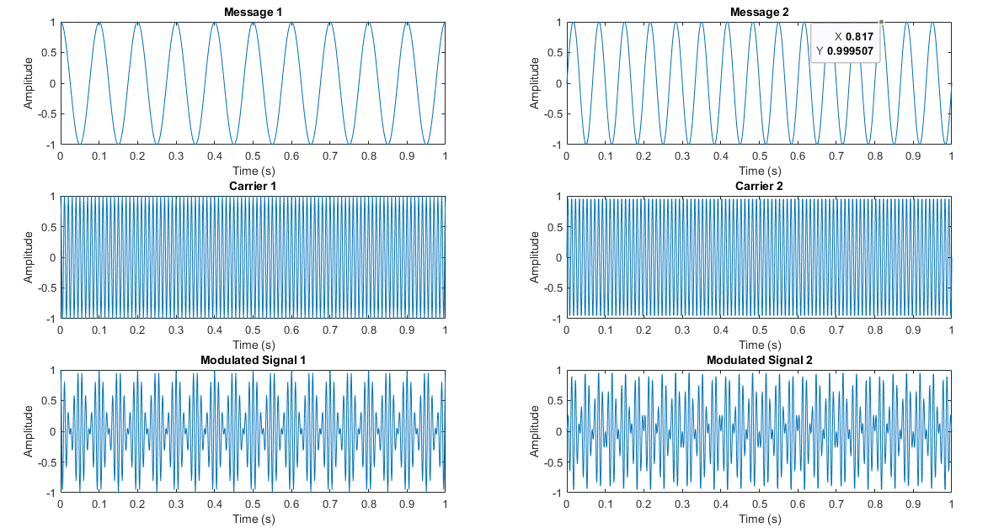

% Add both modulated signals for QAM

qam_signal = modulated_signal1 + modulated_signal2;

% Plot the result of QAM modulation

figure;

plot(t, qam_signal);

title('QAM Signal');

xlabel('Time (s)');

ylabel('Amplitude');

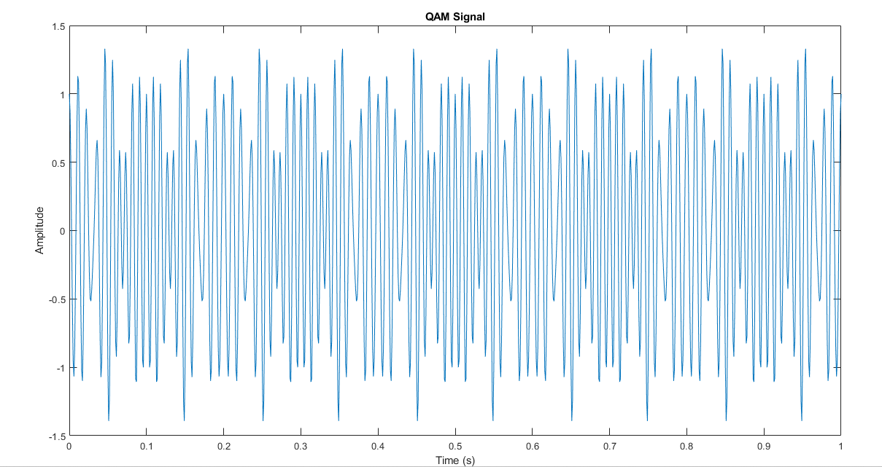

***Explanation:***

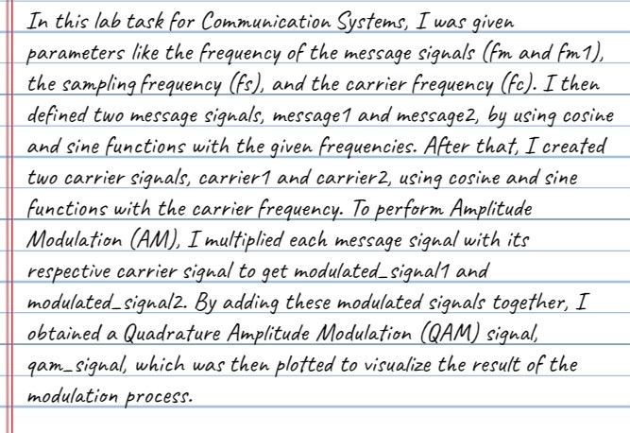

# 

% Given parameters

fm = 10; % Hz

fm1 = 15; % Hz

fs = 1000; % Hz

fc = 100; % Hz

% Define time vector

t = 0:1/fs:1;

% Define message 1 as cos(2*pi*fm*t) and plot

message1 = cos(2*pi*fm*t);

% Define message 2 as sin(2*pi*fm1*t) and plot

message2 = sin(2*pi*fm1*t);

% Take carrier 1 as cos(2*pi*fc*t) and plot

carrier1 = cos(2*pi*fc*t);

% Take carrier 2 as sin(2*pi*fc*t) and plot

carrier2 = sin(2*pi*fc*t);

% Perform AM modulation of the both signals by multiplying the both messages with its respective carrier

modulated_signal1 = message1 .* carrier1;

modulated_signal2 = message2 .* carrier2;

% Add both modulated signals for QAM

qam_signal = modulated_signal1 + modulated_signal2;

% Plot the result of QAM modulation

figure;

plot(t, qam_signal);

title('QAM Signal');

xlabel('Time (s)');

ylabel('Amplitude');



% Multiply QAM signal with respective carriers for QAM demodulation

demod_signal1 = qam_signal .* carrier1;

demod_signal2 = qam_signal .* carrier2;

% Plot demodulated signal 2

subplot(2, 2, 1);

plot(t, demod_signal1);

title('Demodulated Signal 1');

xlabel('Time (s)');

ylabel('Amplitude');

% Plot demodulated signal 2

subplot(2, 2, 2);

plot(t, demod_signal2);

title('Demodulated Signal 2');

xlabel('Time (s)');

ylabel('Amplitude');

% Design Low Pass Butterworth filter for message signals requirements

% Define filter parameters

cutoff_frequency = 20; % Hz

order = 5; % Filter order

[b, a] = butter(order, cutoff_frequency/(fs/2), 'low');

% Apply filter to message signals

filtered_message1 = filter(b, a, demod_signal1);

filtered_message2 = filter(b, a, demod_signal2);

% Plot filtered messages

subplot(2, 2, 3);

plot(t, filtered_message1);

title('Filtered Message 1');

xlabel('Time (s)');

ylabel('Amplitude');

subplot(2, 2, 4);

plot(t, filtered_message2);

title('Filtered Message 2');

xlabel('Time (s)');

ylabel('Amplitude');



***Explanation:***

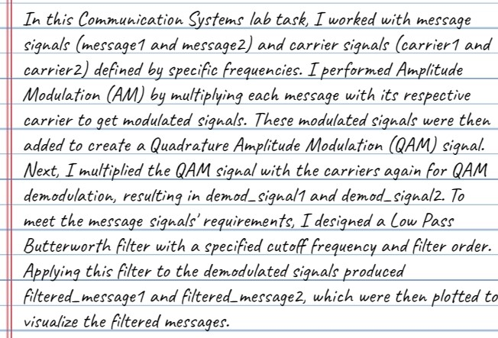

***Task 2 – QAM and Demodulation using Simulink***

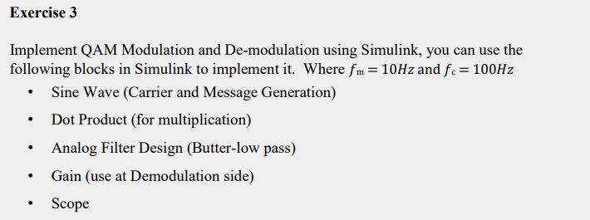

***Simulink Diagram:***

***Message and Carrier Signal Output:***

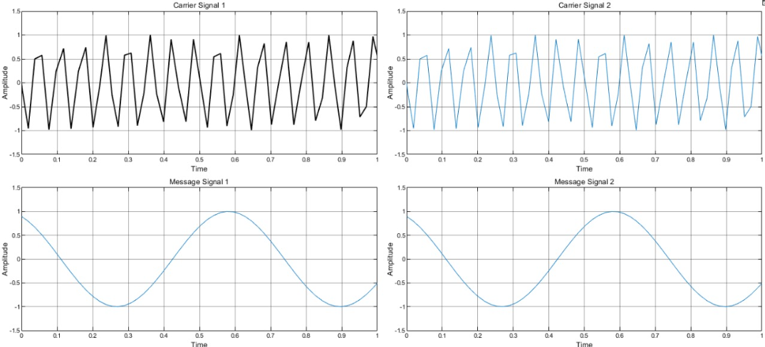

***QAM Modulated Signal Output:***

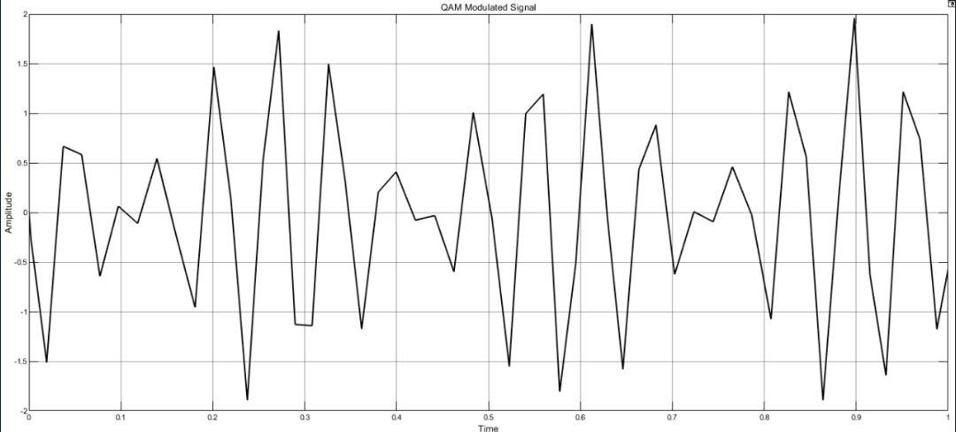

***Demodulated Signal Output:***

***Explanation:***

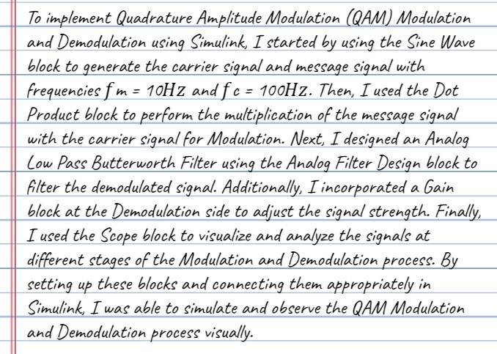

***Conclusion:***

