

***NAMAL UNIVERSITY MIANWALI***

***DEPARTMENT OF ELECTRICAL ENGINEERING***

***Communication Systems (Lab)LAB # 1 0***

***REPORT***

***Title :***

***Digital mapping (ASK, FSK, PSK) using MATLAB/Simulink***

|  |  |
| --- | --- |
| ***Name*** | ***Fahim Ur Rehman Shah*** |
| ***Roll No*** | ***NIM-BSEE-2021-24*** |
| ***Intructor*** | ***Dr. Sajjad Ur Rehman*** |
| ***Lab Engineer*** | ***Engr. Faizan Ahmad*** |
| ***Date Performed*** | ***May 27, 2024*** |
| ***Marks*** |  |

**Introduction**

The purpose of this lab is to enable the students to learn ASK, PSK and FSK using MATLAB.

# Course Learning Outcomes

CLO2: Develop software simulations to observe the performance of analog and digital communication systems.

CLO4: Report desired results proofs and calculations.

# Equipment

- Software

• MATLAB

# Instructions

* This is an individual lab. You will perform the tasks individually and submit the required files at the end of the lab.
* Plagiarism or any hint thereof will be dealt with strictly. Any incident where plagiarism is caught, both (or all) students involved will be given zero marks, regardless of who copied whom. Multiple such incidents will result in disciplinary action being taken.

# ASK Modulation

Amplitude Shift Keying ASK is a type of Amplitude Modulation which represents the binary data in the form of variations in the amplitude of a signal. Any modulated signal has a high frequency carrier. The binary signal when ASK modulated, gives a zero value for Low input while it gives the carrier output for High input. The following figure represents ASK modulated waveform along with its input.

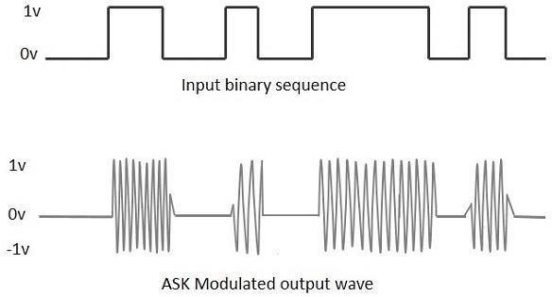

**Demodulation**

The modulated ASK signal is given to the half-wave rectifier, which delivers a positive half output. The low pass filter suppresses the higher frequencies and gives an envelope detected output from which the comparator delivers a digital output.

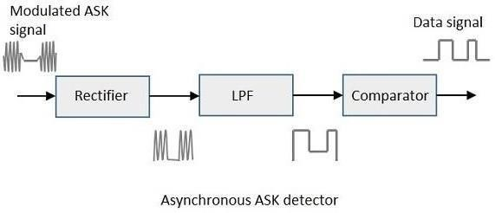

# PSK Modulation

Phase Shift Keying PSK is the digital modulation technique in which the phase of the carrier signal is changed by varying the sine and cosine inputs at a particular time. PSK technique is widely used for wireless LANs, bio-metric, contactless operations, along with RFID and Bluetooth communications.

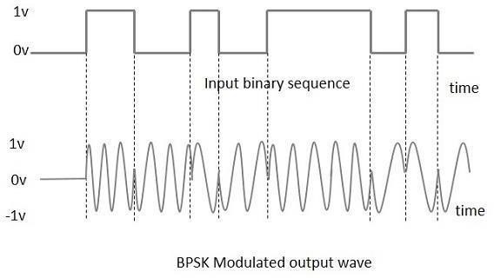

PSK is of two types, depending upon the phases the signal gets shifted.

1. *Binary Phase Shift Keying BPSK*

This is also called as 2-phase PSK or Phase Reversal Keying. In this technique, the sine wave carrier takes two phase reversals such as 0° and 180°.

1. *Quadrature Phase Shift Keying QPSK*

This is the phase shift keying technique, in which the sine wave carrier takes four phase reversals such as 0°, 90°, 180°, and 270°.

**Demodulation**

In demodulation of bpsk, multiply with carrier then use Low-Pass Filter.

# FSK Modulation

In Frequency Shift Keying (FSK), the instantaneous frequency of the carrier signal is switched between two (or more) values in response to the digital code (e.g. PCM code).

In binary FSK, the binary digital information is modulated to two different frequencies, say f1 and f2 = f1 + ∆f.

Thus binary ‘0’ can be expressed by a sinusoidal signal with frequency f1, as u1 = cos2*pi*f1*t. And, binary ‘1’ can be expressed as a sinusoidal signal with frequency f2), as u2

= cos2*pi*f2*t, where f2 = f1+ ∆f. Figure below shows a digital signal and the transmitted signal as Binary FSK.

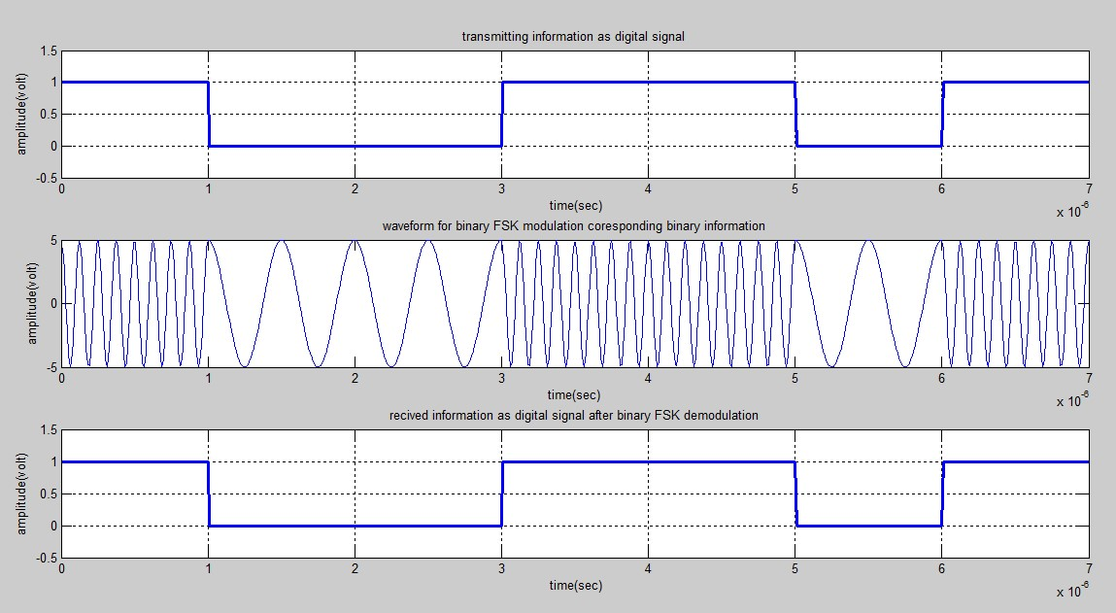

Digital signal and its corresponding FSK modulated signal.

Notice that binary ‘1’ is represented by a sinusoidal signal with frequency f1 and binary ‘0’ by signal with frequency f2.

# Demodulation

Demodulation of the binary FSK signal can be done by the non-coherent detection method as shown in the Figure

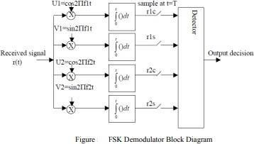

The detector decides the received signal by comparing r1 and r2. To be precise if r1> r2 then the detector decides that the received signal is of frequency f1 (which corresponds to binary

‘0’ at input) and vice versa.

**Exercise:**

**Task 1**

**Implement ASK Modulation and Demodulation using Simulink. You can use the following blocks for implementation.**

* **Bernoulli Binary**
* **Sine Wave (Set the Frequency of Sine wave 2*pi*4)**
* **Dot**
* **Sign**
* **Scope**

**Block Diagram:**

**Output:**

**Explanation:**

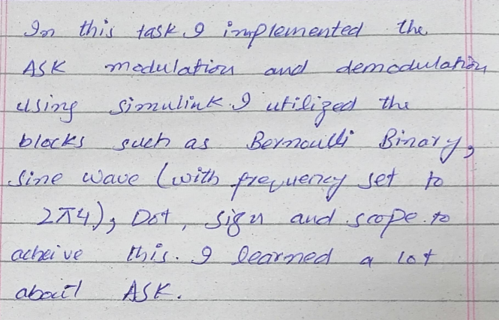

**Task 2**

**Implement FSK Modulation and Demodulation using Simulink. You can use the following blocks for implementation.**

* **Bernoulli Binary**
* **Sine Wave (Fc1=2*pi*4 and Fc2=2*pi*12)**
* **Dot**
* **Switch**
* **Relational Operator**
* **Charge Pump PLL** 
* **Constant**
* **Scope**

**Block Diagram:**

**Output:**

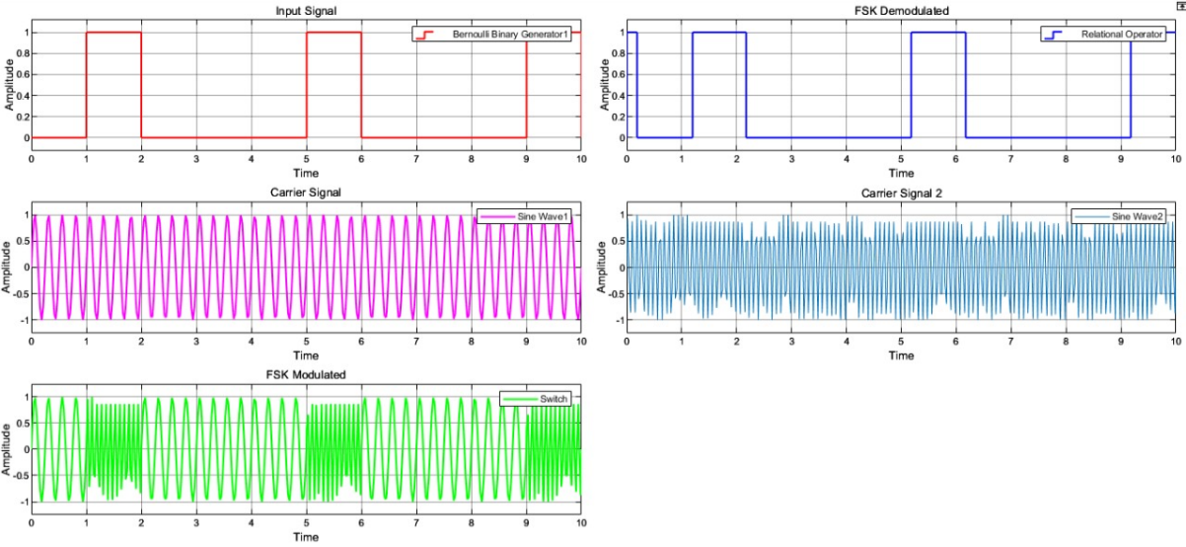

**Explanation:**

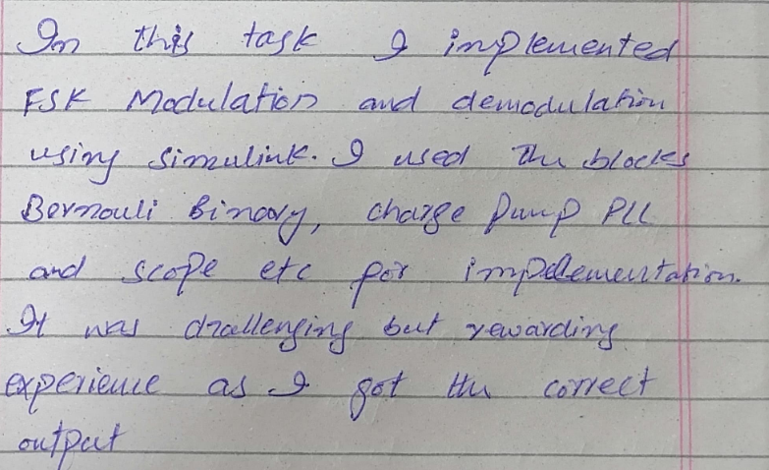**Task 3**

**Implement PSK Modulation using Simulink. You can use the following blocks for implementation.**

* **Bernoulli Binary**
* **Sine Wave**
* **Dot**
* **Scope**

**Block Diagram:**

**Output:**

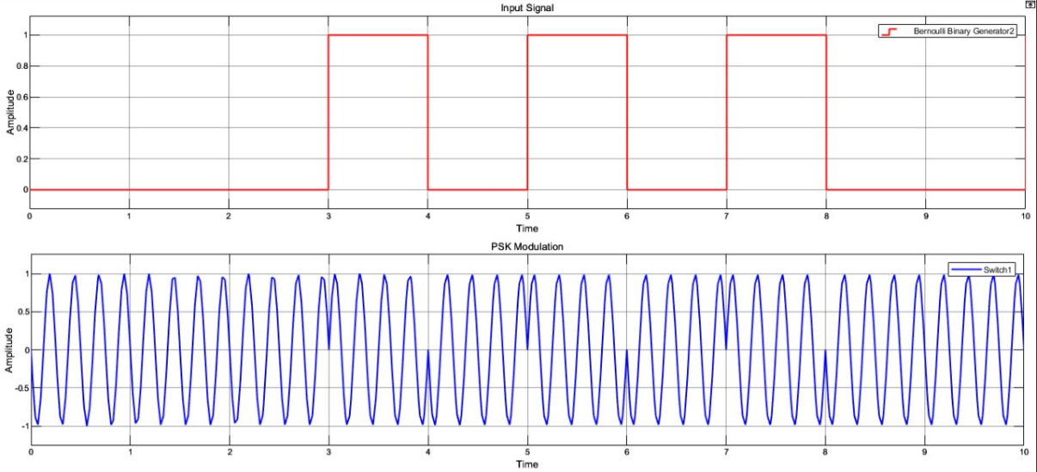

**Explanation:**

**Conclusion:**

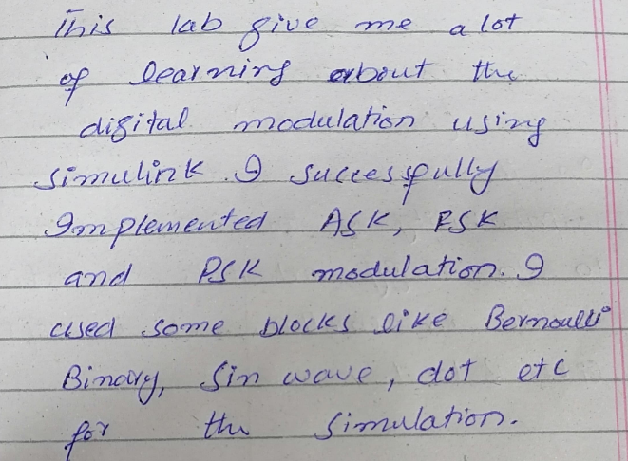

**Com. Sys. Lab 9 Rubric**

**Method of Evaluation**: Executable code, Report submitted by students **Measured Learning Outcomes**:

CLO2: Develop software simulations to observe the performance of analog and digital communications systems. CLO4: Report desired results proofs and calculations.

|  |  |  |  |  |  |  |
| --- | --- | --- | --- | --- | --- | --- |
|  | Excellent 10 | Good  9-7 | Satisfactory 6- 4 | Unsatisfactory 3-1 | Poor 0 | Marks Obtained |
| Code (CLO2) | Correct code, easily understandable with  comments where necessary | Correct code but without proper indentation or comments | Slightly incorrect code with proper comments | Incorrect code with improper format and no comments | Code not submitted |  |
| Output  (CLO2) | Output correctly shown with all Figures/ Plots displayed as required and properly labelled | Most Output/ Figures/ Plots displayed with proper  labels | Some Output/ Figures/ Plots displayed with proper labels OR Most Output/ Figures/  Plots displayed but without proper labels | Most of the required Output/  Figures/ Plots not displayed | Output/  Figures/ Plots not displayed |  |
| Answers  (CLO2) | Meaningful answers to all questions. Answers  show the understanding of the student. | Meaningful answers to most questions. | Some correct/ meaningful answers with some irrelevant  ones | Answers not understandable/ not relevant to questions | Wrong  Answers |  |
| Lab Report  (CLO4) | Report submitted with proper grammar and  punctuation with proper  conclusions drawn and good formatting | Report submitted with proper conclusions drawn with good formatting but some grammar mistakes  OR proper grammar but not very good formatting | Some correct/ meaningful conclusions. Some parts of the document not properly  formatted or some grammar  mistakes | Conclusions not based on results. Bad formatting with no proper grammar/ punctuation | Report not submitted |  |
| Total | | | |  |  |  |