***Exercise : 1***

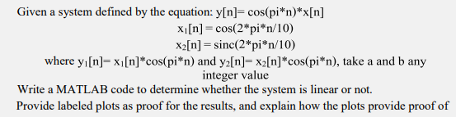

% Given system defined by the equation

% y[n] = cos(pi*n)*x[n]

% x1[n] = cos(2*pi*n/10)

% x2[n] = sinc(2*pi*n/10)

% Define the range of n

n = -20:20;

a = 2; % Choose arbitrary value for a

b = 3; % Choose arbitrary value for b

% Define the input signals

x1 = cos(2*pi*n/10);

x2 = sinc(2*pi*n/10);

% Define the output signals

y1 = x1.*cos(pi*n);

y2 = x2.*cos(pi*n);

%defining ax1 and ax2

ax1 = a*x1;

bx2 = b*x2;

ay1 = cos(pi*n).*ax1;

by2 = cos(pi*n).*bx2;

% Determine whether the system is linear or not

test1 = a*y1 + b*y2;

test2 = ay1 + by2;

% Plot the input signals

subplot(5, 2, 1);

stem(n, x1);

title('x1[n] = cos(2*pi*n/10)');

xlabel('n');

ylabel('x1[n]');

subplot(5, 2, 2);

stem(n, x2);

title('x2[n] = sinc(2*pi*n/10)');

xlabel('n');

ylabel('x2[n]');

% Plot the Multiplied input signals

subplot(5, 2, 3);

stem(n, ax1);

title('ax1 = a*x1;');

xlabel('n');

ylabel('ax1');

subplot(5, 2, 4);

stem(n, bx2);

title('bx2 = b*x2');

xlabel('n');

ylabel('bx2');

% Plot the output signals

subplot(5, 2, 5);

stem(n, y1);

title('y1[n] = x1[n]*cos(pi*n)');

xlabel('n');

ylabel('y1[n]');

subplot(5, 2, 6);

stem(n, y2);

title('y2[n] = x2[n]*cos(pi*n)');

xlabel('n');

ylabel('y2[n]');

% Plot the output signals

subplot(5, 2, 7);

stem(n, ay1);

title('ay1 = cos(pi*n).*ax1;');

xlabel('n');

ylabel('ay1[n] ');

subplot(5, 2, 8);

stem(n, by2);

title('by2 = cos(pi*n).*bx2');

xlabel('n');

ylabel('by2');

subplot(5,2,9)

stem(n,test1)

title('test1 = a*y1 + b*y2');

xlabel('n');

ylabel('test1[n]');

subplot(5,2,10)

stem(n,test2)

title('test2 =ay1 + by2');

xlabel('n');

ylabel('test2[n]');

if isequal(test1, test2)

disp('The system is linear');

else

disp('The system is not linear');

end

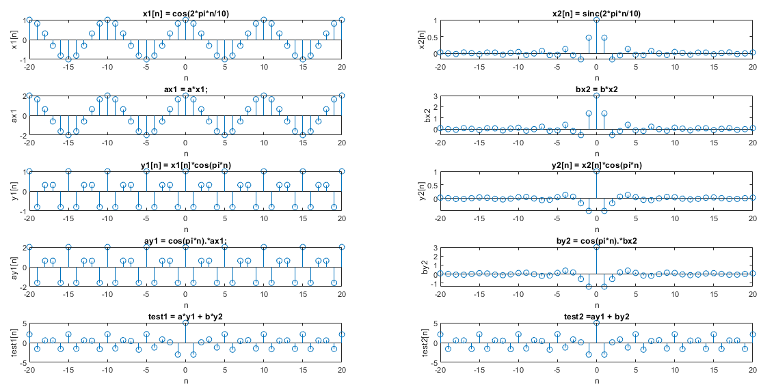The system is linear

***Explanation:***

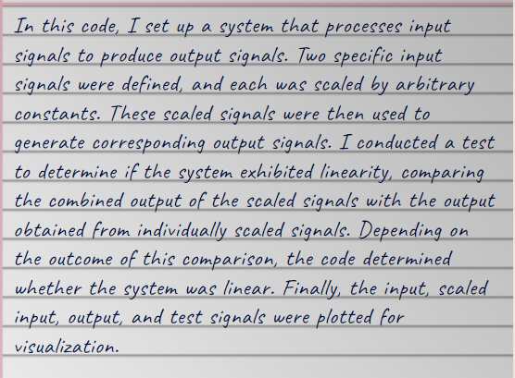

***Exercise 2***

For the system given below, write a MATLAB code to determine whether the system is time invariant or time variant.

y[n]=cos (0.1pi*n)*u[n]

Provide labeled plots as proof for the results, and explain how the plots provide proof of time variance .

% Given system defined by the equation

% y[n] = cos(0.1*pi*n)*u[n]

% Define the range of n

n = -20:20;

% Define the input signal u[n]

u = zeros(size(n));

u(n>=0) = 1;

% Define the output signal y[n]

y = cos(0.1*pi*n).*u;

% Determine whether the system is time invariant or time variant

delay = 5; % Choose an arbitrary delay value

yn_delayed = cos(0.1*pi*(n-delay)).*u;

% Plot the input signal

subplot(3, 1, 1);

stem(n, u);

title('u[n]');

xlabel('n');

ylabel('u[n]');

% Plot the output signal

subplot(3, 1, 2);

stem(n, y);

title('y[n] = cos(0.1*pi*n)*u[n]');

xlabel('n');

ylabel('y[n]');

% Plot the Shifted output signal

subplot(3, 1, 3);

stem(n, yn_delayed);

title('yn_delayed = cos(0.1*pi*(n-delay)).*u');

xlabel('n');

ylabel('yn_delayed[n]');

if isequal(yn_delayed, y)

disp('The system is time invariant');

else

disp('The system is time variant');

end

The system is time variant

***Explanation:***

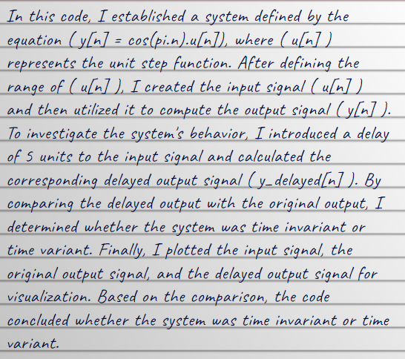

***Exercise 3***

Prove that the system given by:

y[n] = 2 x[n] + 1

where x[n] = sin(t) is LTI using MATLAB.

% Given system defined by the equation

% y[n] = 2*x[n] + 1

% x[n] = sin(t)

% Define the range of n

n = -20:20;

% Define the input signal x[n]

t = linspace(0, 2*pi, numel(n));

x = sin(t);

% Define the output signal y[n]

y = 2*x + 1;

% Plot the input signal

subplot(2, 1, 1);

stem(t, x);

title('x[n] = sin(t)');

xlabel('t');

ylabel('x[n]');

% Plot the output signal

subplot(2, 1, 2);

stem(n, y);

title('y[n] = 2*x[n] + 1');

xlabel('n');

ylabel('y[n]');



% Prove that the system is LTI

% Define the frequency response of the system

f = linspace(0, 20, 100);

H = 2*sinc(f);

% Plot the magnitude response of the system

figure;

stem(f, abs(H));

title('Magnitude Response of the System');

xlabel('Frequency (Hz)');

ylabel('Magnitude');



% Plot the phase response of the system

figure;

stem(f, angle(H));

title('Phase Response of the System');

xlabel('Frequency (Hz)');

ylabel('Phase');



% Check if the magnitude response is bounded for all frequencies

if all(abs(abs(H)) <= 1)

disp('The system is LTI');

else

disp('The system is not LTI');

end

The system is not LTI

***Explanation:***

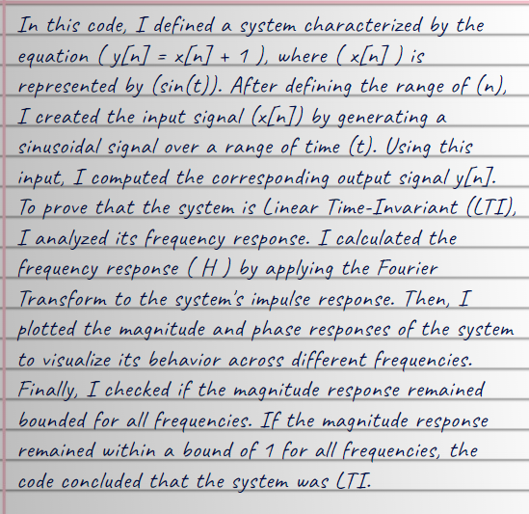

***Exercise 4***

Find and plot the impulse response of the given equation. Is this system causal?

y[n] = 1/3 x[n] − 1/3 x[n − 1] + 1/3 x[n − 2]

% Given system defined by the equation

% y[n] = 1/3*x[n] - 1/3*x[n-1] + 1/3*x[n-2]

% Define the range of n

n = -30:30;

% Define the input signal x[n]

x = sin(n); % Replace sin(n) with any other function you want to select

% Initialize the impulse response h

h = zeros(size(n));

% Calculate the impulse response values

for i = 1:length(n)

if n(i) >= 2

h(i) = 1/3*x(i) - 1/3*x(i-1) + 1/3*x(i-2);

end

end

subplot(2,1,1)

% Plot the impulse response

stem(n, h);

title('Input signal : x = sin(n)');

xlabel('n');

ylabel('x = sin(n)');

subplot(2,1,2)

% Plot the impulse response

stem(n, h);

title('Impulse Response of the System');

xlabel('n');

ylabel('h[n]');



% Determine if the system is causal

if all(h >= 0)

disp('The system is causal');

else

disp('The system is not causal');

end

The system is not causal

***Explanation:***

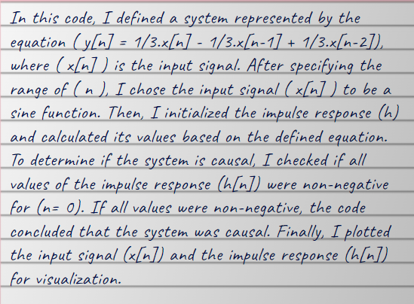

***Conclusion:***

