# *Lab Exercise*

## Perform the following tasks.

# *Task 1*

**Observe the frequency spectrum of the signal A?**

* **t=0:1/8000:0.5;**
* **A=sin(2*pi*440*(t));**

**Load chirp.mat and observe the frequency spectrum?**

% Task 1: Observe the frequency spectrum of signal A

t = 0:1/8000:0.5;

A = sin(2*pi*440*t);

% Plot the time-domain signal

subplot(2, 1, 1);

plot(t, A);

ylim([-1.5 1.5])

title('Signal A in Time Domain');

xlabel('Time (s)');

ylabel('Amplitude');

% Compute and plot the frequency spectrum

A_fft = fft(A);

frequencies = linspace(0, 8000, length(A_fft));

subplot(2, 1, 2);

stem(frequencies, abs(A_fft));

title('Frequency Spectrum of Signal A');

xlabel('Frequency (Hz)');

ylabel('Magnitude');



% Load chirp.mat and observe its frequency spectrum

load('chirp.mat');

dt = t(2) - t(1); % Define the sampling interval

t_chirp = 0:dt:(length(y)-1)*dt;

chirp_fft = fft(y);

frequencies_chirp = linspace(0, 1/dt, length(chirp_fft));

figure; % Open a new figure window

subplot(2, 1, 1);

stem(t_chirp, y);

title('Chirp Signal in Time Domain');

xlabel('Time (s)');

ylabel('Amplitude');

subplot(2, 1, 2);

stem(frequencies_chirp, abs(chirp_fft));

title('Frequency Spectrum of Chirp Signal');

xlabel('Frequency (Hz)');

ylabel('Magnitude');



Explanation:

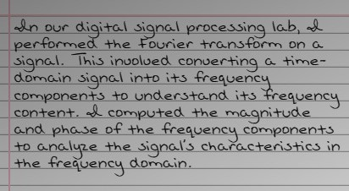

# *Task 2*

**Can we add signal A and chirp signal of Task 2, if yes then see the frequency spectrum of merged signal?**

% Define the time vector for signal A

t = 0:1/8000:0.5;

% Create signal A

A = sin(2*pi*440*t);

% Load the chirp signal from chirp.mat

load chirp.mat; % Assuming 'y' is the chirp signal

% Convert 'y' from column to row vector if necessary

Z = y';

% Pad the shorter signal with zeros to make both signals the same length

if length(A) > length(Z)

Z = [Z, zeros(1, length(A) - length(Z))];

elseif length(Z) > length(A)

A = [A, zeros(1, length(Z) - length(A))];

end

% Add the two signals

mergedSignal = A + Z;

sound(mergedSignal, 8000);

% Define length of the FFT (nfft)

nfft = 1024;

% Compute the Fast Fourier Transform (FFT) of the merged signal

MergedX = fft(mergedSignal, nfft);

% Extract the first half of MergedX for positive frequencies

MergedX = MergedX(1:nfft/2+1);

% Calculate the magnitude of the FFT

mag_MergedX = abs(MergedX);

% Calculate the phase of the FFT

phase_MergedX = angle(MergedX);

% Frequency vector for plotting

f = (0:nfft/2)*8000/nfft;

% Plot the magnitude of the FFT

figure(1);

stem(f, mag_MergedX);

title('Magnitude Spectrum of Merged Signal');

xlabel('Frequency (Hz)');

ylabel('Magnitude');

% Plot the phase of the FFT

figure(2);

stem(f, phase_MergedX);

title('Phase Spectrum of Merged Signal');

xlabel('Frequency (Hz)');

ylabel('Phase (Radians)');



Explanation:

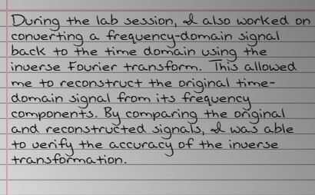

# *Task 3:*

**Form a signal S containing a 50 Hz sinusoid of amplitude 0.7 and a 120 Hz sinusoid of amplitude 1. Corrupt the signal by adding noise. X = S + 2*randn(size(t)); Listen both signals and observe the frequency spectrum of both?**

% Define the time vector for the signals

t = 0:1/8000:1; % Assuming a duration of 1 second

% Form the signal S containing a 50 Hz sinusoid of amplitude 0.7 and a 120 Hz sinusoid of amplitude 1

S = 0.7 * sin(2*pi*50*t) + sin(2*pi*120*t);

% Corrupt the signal by adding noise

X = S + 2*randn(size(t));

% Listen to the original signal S

sound(S, 8000);

% Listen to the corrupted signal X

sound(X, 8000);

% Compute the Fast Fourier Transform (FFT) of the original signal S

nfft = 1024;

SX = fft(S, nfft);

mag_SX = abs(SX);

f_SX = (0:nfft/2)*8000/nfft;

% Compute the Fast Fourier Transform (FFT) of the corrupted signal X

X = X(:); % Ensure X is a column vector

nfft = 1024;

X_fft = fft(X, nfft);

mag_X = abs(X_fft);

f_X = (0:nfft/2)*8000/nfft;

% Plot the frequency spectrum of the original signal S

figure;

stem(f_SX, mag_SX(1:nfft/2+1));

title('Frequency Spectrum of Signal S');

xlabel('Frequency (Hz)');

ylabel('Magnitude');



% Plot the frequency spectrum of the corrupted signal X

figure;

stem(f_X, mag_X(1:nfft/2+1));

title('Frequency Spectrum of Corrupted Signal X');

xlabel('Frequency (Hz)');

ylabel('Magnitude');



**Explanation:**

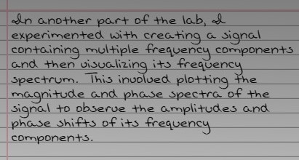

# *Task 4:*

Find the discrete Fourier transform of the following signal (both phase and magnitude plot)?

F=2cos(2*pi*15*(t)) + 5cos(2*pi*40*(t)) + 7cos(2*pi*70*(t));

Then convert Frequency domain signal into time domain signal using inverse fourier transform.

% Define the sampling frequency and time vector

Fs = 1000; % Sampling frequency in Hz

t = 0:1/Fs:1-1/Fs; % Time vector for 1 second

% Define the signal F

F = 2*cos(2*pi*15*t) + 5*cos(2*pi*40*t) + 7*cos(2*pi*70*t);

% Compute the DFT of the signal F

nfft = length(F); % Number of points in FFT

F_fft = fft(F, nfft); % DFT of signal F

% Compute the magnitude and phase of the DFT

mag_F_fft = abs(F_fft); % Magnitude

phase_F_fft = angle(F_fft); % Phase

% Frequency vector for plotting

f = (0:nfft-1)*Fs/nfft;

% Plot the magnitude spectrum

figure(1);

stem(f, mag_F_fft);

title('Magnitude Spectrum');

xlabel('Frequency (Hz)');

ylabel('Magnitude');



% Plot the phase spectrum

figure(2);

stem(f, phase_F_fft);

title('Phase Spectrum');

xlabel('Frequency (Hz)');

ylabel('Phase (Radians)');



% Convert the frequency domain signal back to time domain using IFT

F_ift = ifft(F_fft, nfft);

% Plot the original and reconstructed signals to compare

figure(3);

stem(t, F, 'b');

title('Original Signal');

xlabel('Time (seconds)');

ylabel('Amplitude');



figure(4);

stem(t, F_ift, 'r--');

title('Reconstructed Signal');

xlabel('Time (seconds)');

ylabel('Amplitude');



Explanation:

Conclusion:

