

***NAMAL UNIVERSITY MIANWALI***

***DEPARTMENT OF ELECTRICAL ENGINEERING***

***EE 345 (L) – Digital Signal Processing (Lab)***

***LAB # 06***

***REPORT***

***Title :***

***Analysis of Z- Transform, Inverse Z-Transform and Pole Zero Map for***

***Discrete Time systems***

|  |  |
| --- | --- |
| ***Name*** | ***Fahim Ur Rehman Shah*** |
| ***Roll No*** | ***NIM-BSEE-2021-24*** |
| ***Intructor*** | ***Zulaikha Kiran*** |
| ***Lab Engineer*** | ***Engr. Faizan Ahmad*** |
| ***Date Performed*** | ***03-April-2024*** |
| ***Marks*** |  |

# *Introduction*

The purpose of this lab is to revise some MATLAB concepts and implementations including ZTransform, Inverse Z-Transform and how poles and zeros are affected to the stability of the system.

# *Course Learning Outcomes*

CLO1: Develop algorithms to perform signal processing techniques on digital signals using MATLAB and DSP Kit DSK6713

CLO3: Deliver a report/lab notes/presentation/viva, effectively communicating the design and analysis of the given problem

# *Equipment*

• Software

o MATLAB

# *Instructions*

1. This is an individual lab. You will perform the tasks individually and submit a report.
2. Some of these tasks are for practice purposes only while others (marked as ‘Exercise’) have to be answered in the report.
3. When asked to display an image/ graph in the exercise either save it as jpeg or take a screenshot, in order to insert it in the report.
4. The report should be submitted on the given template, including:
   1. Code (copy and pasted, NOT a screenshot)
   2. Output values (from command window, can be a screenshot)
   3. Output figure/graph (as instructed in 3)
   4. Explanation where required
5. The report should be properly formatted, with easy to read code and easy to see figures.
6. Plagiarism or any hint thereof will be dealt with strictly. Any incident where plagiarism is caught, both (or all) students involved will be given zero marks, regardless of who copied whom. Multiple such incidents will result in disciplinary action being taken.

## *Z-Transform*

The z-transform of signal x[n] can be represented by the formula

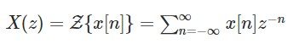

Where we will assume that z represents any complex number i.e., z is the independent (complex) variable of the z-transform X(z).

We suppose that x[n] is unit impulse sequence

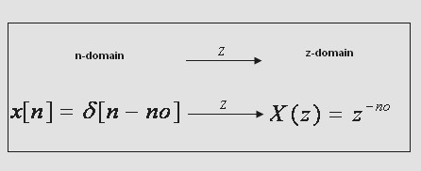

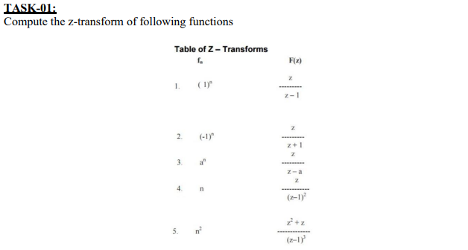

% Define symbolic variable

syms n z;

% Define functions

fn1 = 1^n;

fn2 = (-1)^n;

a = sym('a'); % Define symbolic variable 'a'

fn3 = a^n;

fn4 = n;

fn5 = n^2;

% Compute Z-transforms

F1 = ztrans(fn1, n, z);

F2 = ztrans(fn2, n, z);

F3 = ztrans(fn3, n, z);

F4 = ztrans(fn4, n, z);

F5 = ztrans(fn5, n, z);

% Display Z-transform results

disp('Z-transform of f1(n) = 1^n:')

Z-transform of f1(n) = 1^n:

disp(F1)



disp('Z-transform of f2(n) = (-1)^n:')

Z-transform of f2(n) = (-1)^n:

disp(F2)



disp('Z-transform of f3(n) = a^n:')

Z-transform of f3(n) = a^n:

disp(F3)



disp('Z-transform of f4(n) = n:')

Z-transform of f4(n) = n:

disp(F4)



disp('Z-transform of f5(n) = n^2:')

Z-transform of f5(n) = n^2:

disp(F5)



***Explanation:***

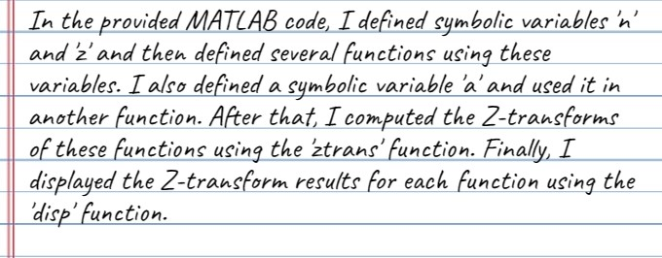

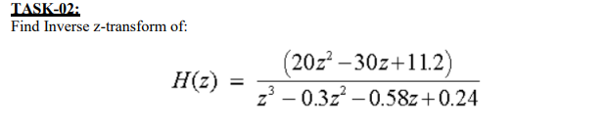

clc;

clear all;

% Define symbolic variable

syms z;

% Define transfer function H1

H1 = ((20*z^2) - (30*z) + 11.2) / (z^3 - 0.3*z^2 - 0.58*z + 0.24);

% Find inverse z-transform for H1

inv_H1 = iztrans(H1, z);

% Display the inverse z-transform result for H1

disp('Inverse z-transform of H1(z):');

Inverse z-transform of H1(z):

disp(inv_H1);



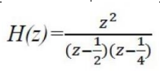

% Define transfer function H2

H2 = z^2 / ((z - 1/2)*(z - 1/4));

% Find inverse z-transform for H2

inv_H2 = iztrans(H2, z);

% Display the inverse z-transform result for H2

disp('Inverse z-transform of H2(z):');

Inverse z-transform of H2(z):

disp(inv_H2);



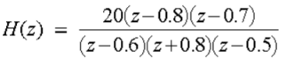

% Define transfer function H3

H3 = (20*(z - 0.8)*(z - 0.7)) / ((z - 0.6)*(z + 0.8)*(z - 0.5));

% Find inverse z-transform for H3

inv_H3 = iztrans(H3, z);

% Display the inverse z-transform result for H3

disp('Inverse z-transform of H3(z):');

Inverse z-transform of H3(z):

disp(inv_H3);



***Explanation:***

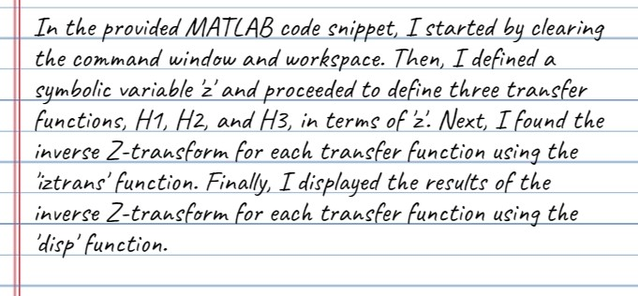

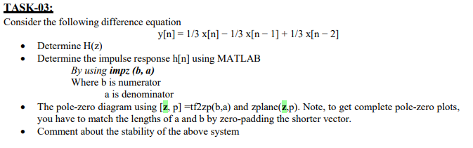

% Define the coefficients of the difference equation

b = [1/3, -1/3, 1/3];

a = [1, 0, 0]; % Denominator coefficients

% Determine H(z) from the difference equation coefficients

Hz = tf(b, a, 1); % Create transfer function

% Determine the impulse response h[n] using MATLAB

h = impz(b, a); % Get impulse response

% Zero-pad the shorter vector to match lengths

if length(b) < length(a)

b = [b, zeros(1, length(a) - length(b))];

elseif length(a) < length(b)

a = [a, zeros(1, length(b) - length(a))];

end

% Get the pole-zero diagram

[z, p] = tf2zp(b, a); % Get zeros and poles

figure;

zplane(z, p); % Plot pole-zero diagram



% Comment about the stability of the system

if all(abs(p) < 1) % Check if all poles are inside the unit circle

disp('The system is stable.');

else

disp('The system is unstable.');

end

The system is stable.

***Explanation:***

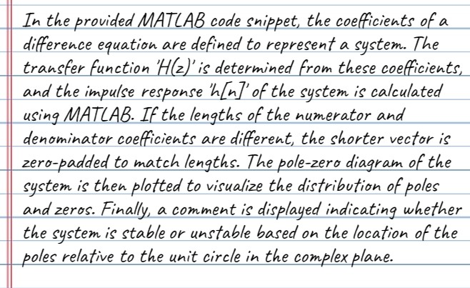

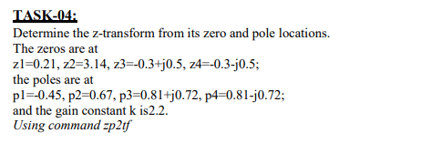

% Define the zero and pole locations as column vectors

zeros = [0.21; 3.14; -0.3+0.5i; -0.3-0.5i];

poles = [-0.45; 0.67; 0.81+0.72i; 0.81-0.72i];

k = 2.2; % Gain constant

% Convert zero-pole-gain representation to transfer function

[num, den] = zp2tf(zeros, poles, k);

% Display the transfer function

disp('The transfer function coefficients are:');

The transfer function coefficients are:

disp(['Numerator: ', num2str(num)]);

Numerator: 2.2 -6.05 -2.2233 -1.6354 0.49323

disp(['Denominator: ', num2str(den)]);

Denominator: 1 -1.84 1.2294 0.23004 -0.35411

***Explanation:***

***Conclusion:***

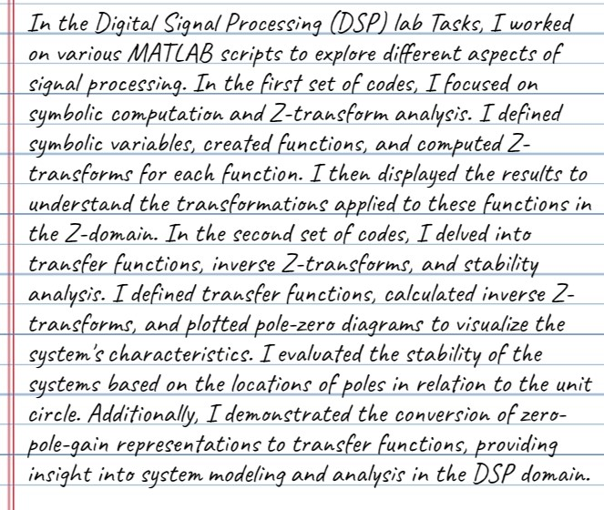

### Evaluation Rubric

* **Method of Evaluation**: In-lab marking by instructors, Report submitted by students
* **Measured Learning Outcomes**:

CLO1: Develop algorithms to perform signal processing techniques on digital signals using MATLAB and DSP Kit DSK6713 CLO3: Deliver a report/lab notes/presentation/viva, effectively communicating the design and analysis of the given problem

|  |  |  |  |  |  |  |
| --- | --- | --- | --- | --- | --- | --- |
|  | Excellent 10 | Good  9-7 | Satisfactory 6-4 | Unsatisfactory 3-1 | Poor 0 | Marks Obtained |
| Tasks (CLO1) | All tasks completed correctly. Correct code with proper comments. | Most tasks completed correctly. | Some tasks completed correctly. | Most tasks incomplete or incorrect. | All tasks incomplete or incorrect. |  |
| Output  (CLO1) | Output correctly shown with all Figures/Plots displayed  as required and properly  labelled | Most Output/Figures/Plots displayed with proper labels | Some Output/Figures/Plots displayed with proper labels  OR Most Output/Figures/Plots displayed but without proper  labels | Most of the required  Output/Figures/Plots not displayed | Output/Figures/Plots not displayed |  |
| Answers (CLO1) | Meaningful answers to all questions. Answers show the understanding of the student. | Meaningful answers to most questions. | Some correct/ meaningful answers with some irrelevant ones | Answers not understandable/ not relevant to questions | Not Written any Answer |  |
| Report  (CLO3) | Report submitted with proper grammar and  punctuation with proper  conclusions drawn and good  formatting | Report submitted with proper conclusions drawn with good formatting but  some grammar mistakes OR proper grammar but not very good formatting | Some correct/ meaningful conclusions. Some parts of the document not properly  formatted or some grammar  mistakes | Conclusions not based on results. Bad formatting with no proper grammar/punctuation | Report not submitted |  |
|  |  |  | Total | | |  |