

NAMAL UNIVERSITY MIANWALI

DEPARTMENT OF ELECTRICAL ENGINEERING

***EE 345 (L) – Digital Signal Processing (Lab)***

***LAB # 08***

***REPORT***

***Title :***

***Quantization of Discrete time Signals using MATLAB***

|  |  |
| --- | --- |
| ***Name*** | ***Fahim Ur Rehman Shah*** |
| ***Roll No*** | ***NIM-BSEE-2021-24*** |
| ***Intructor*** | ***Zulaikha Kiran*** |
| ***Lab Engineer*** | ***Engr. Faizan Ahmad*** |
| ***Date Performed*** | ***24-April-2024*** |
| ***Marks*** |  |

***Exercise 1:***

* ***Simulink Block Diagram:***

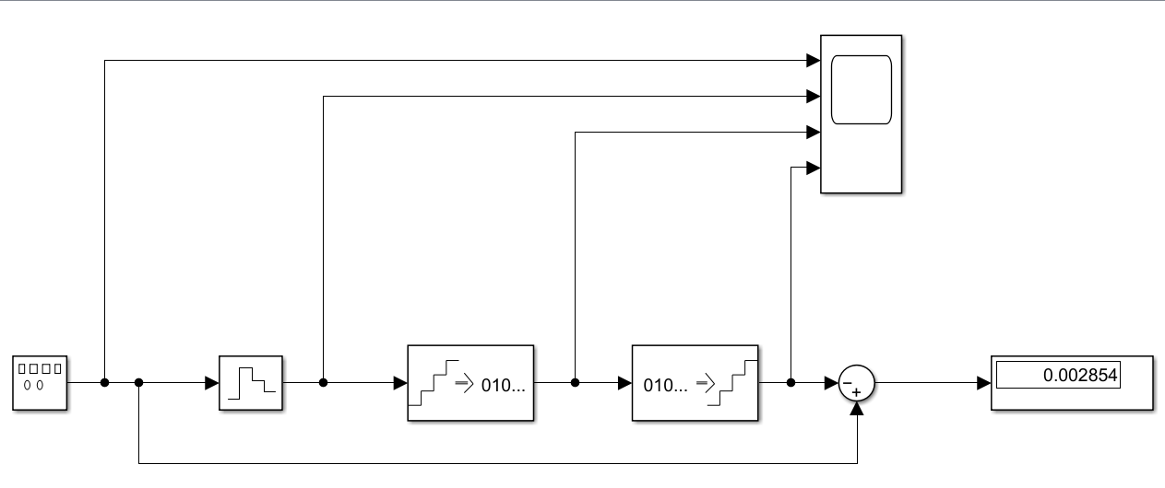

* ***1st Output When All the Parameters are same as given:***

* ***Effect of increasing the sampling frequency (in the zero order hold block) on the signals (Ts = 0.01 , fs = 100 Hz).***

* ***Effect of decreasing the sampling frequency (in the zero order hold block) on the signals (Ts = 0.1 , fs = 10 Hz).***

* ***Effect of increasing the number of bits in the Encoder and Decoder blocks (16 bits):***

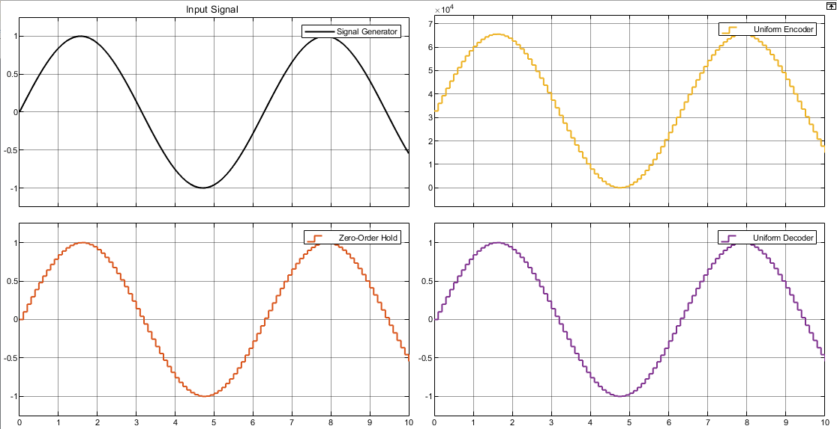

* ***Effect of decreasing the number of bits in the Encoder and Decoder blocks(4 bits):***

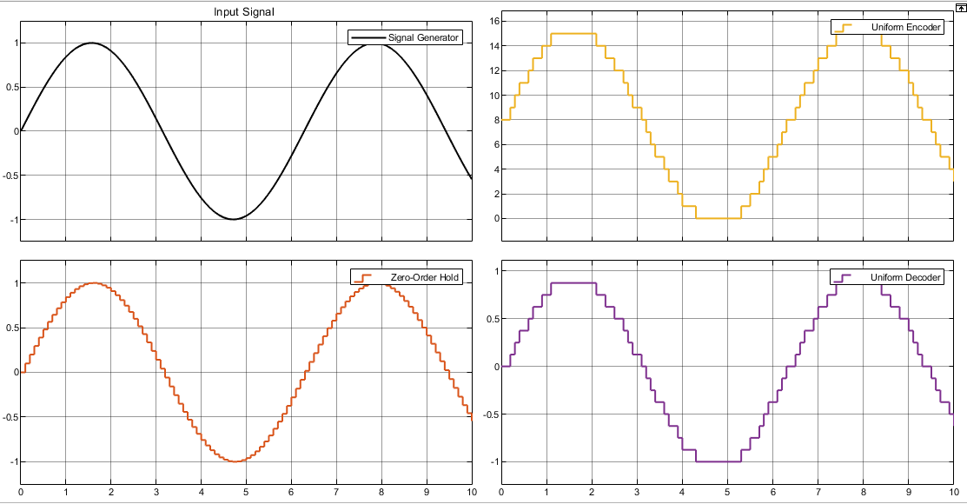

***Explanations and Answers:***

***What is the purpose of the Sum block?***

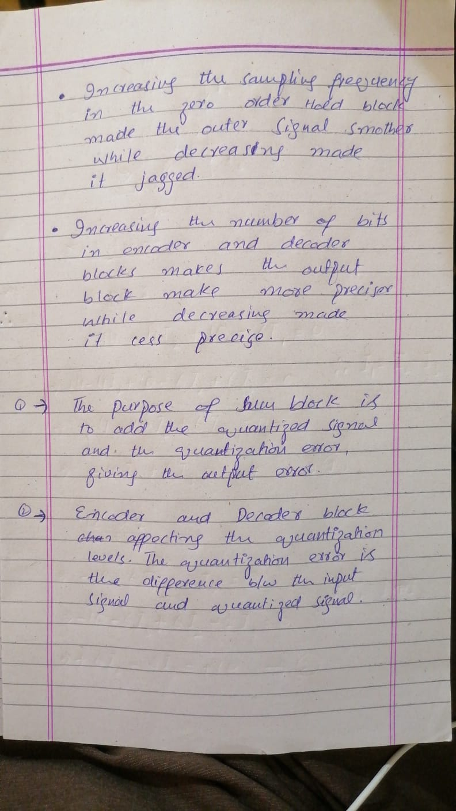

***Which blocks are affecting the quantization levels?***

***Exercise 2:***

*Generate saw-tooth wave for f=10 rad/sec to observe the effects of quantization? What happens, if frequency and sampling frequency increases and decreases?*

***Output:***

***Frequency increase (20 rad/sec ):***

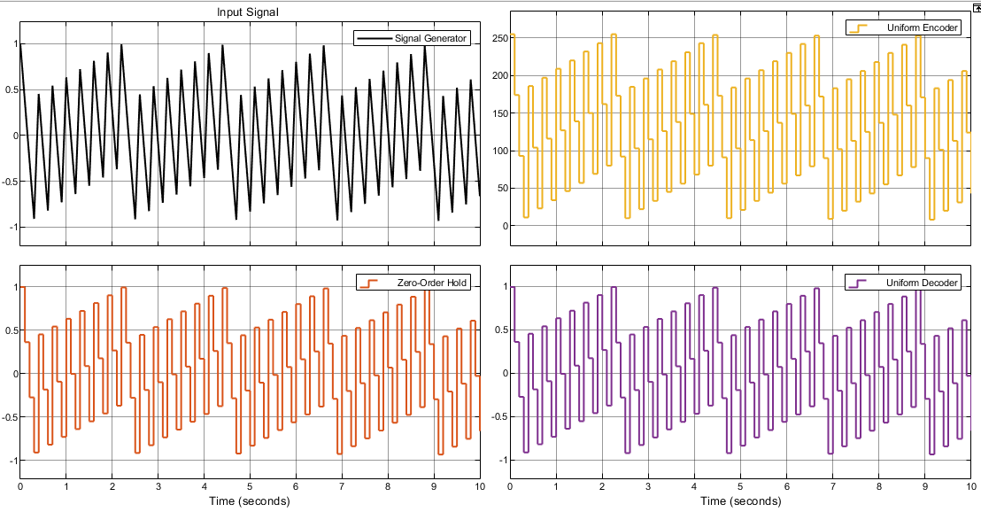

***Frequency decrease (2 rad /sec):***

***Sampling frequency increase (Ts = 0.01 , fs = 100Hz):***

***Sampling frequency decrease (Ts = 0.5 , fs = 2Hz):***

***Explanation:***

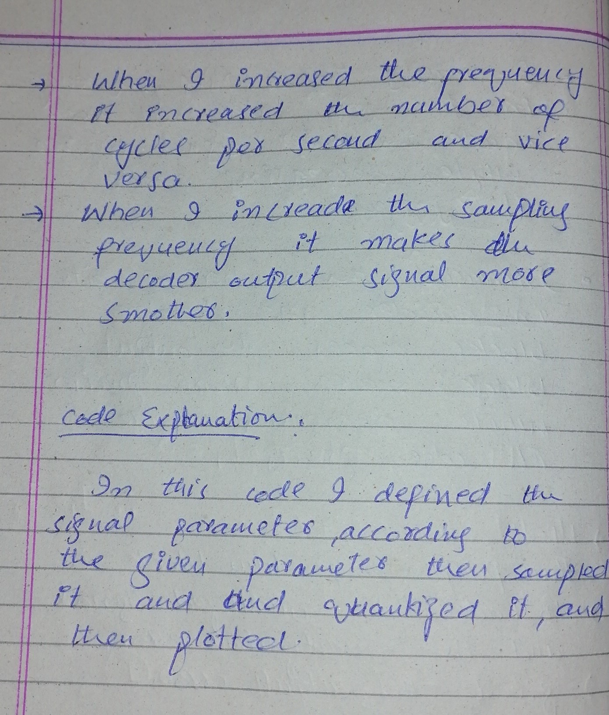

***Exercise 3:***

*Consider a continues signal S=a*cos(2*pi*f*t), plot this signal using MATLAB where*

*a=8, f=1Hz, Ts=0.001, and t=0:Ts:2. Take continues signal as a reference and plot the*

*following signals?*

*1. Sampled signal of S*

*2. Quantization Signal of S*

***Code :***

% Define the continuous signal parameters

a = 8;

f = 1;

Ts = 0.001;

t = 0:Ts:2;

% Calculate the continuous signal

S = a*cos(2*pi*f*t);

% Plot the continuous signal

plot(t, S);

xlabel('Time (s)');

ylabel('Amplitude');

title('Continuous Signal');

% Sample the signal

N = length(t);

dt = t(2) - t(1);

fs = 1/dt;

n = 0:N-1;

t_s = n*dt;

S_s = S(n+1);

% Plot the sampled signal

plot(t_s, S_s, 'o');

xlabel('Time (s)');

ylabel('Amplitude');

title('Sampled Signal');

% Quantize the signal

q = 2;

S_q = round(S*q)/q;

% Plot the quantized signal

plot(t, S_q);

xlabel('Time (s)');

ylabel('Amplitude');

title('Quantized Signal');

***Outputs:***

***Explanation:***

***Conclusion:***

