

***NAMAL UNIVERSITY MIANWALI***

***DEPARTMENT OF ELECTRICAL ENGINEERING***

***EE 345 (L) – Digital Signal Processing (Lab)***

***LAB # 08***

***REPORT***

***Title :***

***Quantization of Discrete time Signals using MATLAB***

|  |  |
| --- | --- |
| ***Name*** | ***Fahim Ur Rehman Shah*** |
| ***Roll No*** | ***NIM-BSEE-2021-24*** |
| ***Intructor*** | ***Zulaikha Kiran*** |
| ***Lab Engineer*** | ***Engr. Faizan Ahmad*** |
| ***Date Performed*** | ***24-April-2024*** |
| ***Marks*** |  |

# Introduction

The purpose of this lab is to enable the students to study the effect of quantization on signals using MATLAB.

# Course Learning Outcomes

CLO1: Develop algorithms to perform signal processing techniques on digital signals using MATLAB and DSP Kit DSK6713

CLO3: Deliver a report/lab notes/presentation/viva, effectively communicating the design and analysis of the given problem

# Equipment

• Software

o MATLAB

# Instructions

1. This is an individual lab. You will perform the tasks individually and submit a report.
2. Some of these tasks are for practice purposes only while others (marked as ‗Exercise‘) have to be answered in the report.
3. When asked to display an image/ graph in the exercise, either save it as jpeg or take a screenshot, in order to insert it in the report.
4. The report should be submitted on the given template, including:
   1. Code (copy and pasted, NOT a screenshot)
   2. Output values (from command window, can be a screenshot)
   3. Output figure/graph (as instructed in 3)
   4. Explanation where required
5. The report should be properly formatted, with easy to read code and easy to see figures.
6. Plagiarism or any hint thereof will be dealt with strictly. Any incident where plagiarism is caught, both (or all) students involved will be given zero marks, regardless of who copied whom. Multiple such incidents will result in disciplinary action being taken.

**Background:**

Everything stored on a computer is discrete time discrete valued signal. Because computer has finite number of registers and each register is a finite length register. We take too many samples to give the ‗effect‘ of continuous time signals. But actually they are discrete time. We also take very fine resolution of amplitude axis to give the effect of continuous valued signal but due to finite word length of the computer register, the stored variables are already quantized. This lab aims to explain the quantization effects in a computer. Regardless of the medium (audio or image), the digitization of real world analog signal usually involves two stages: sampling, i.e. the measurement of signal at discretely spaced time intervals, and quantization, i.e. the transformation of the measurements (amplitudes) into finite-precision numbers (allowed discrete levels), such that they can be represented in computer memory. Quantization is a matter of representing the amplitude of individual samples as integers expressed in binary. The fact that integers are used forces the samples to be measured in a finite number of bits (discrete levels). The range of the integers possible is determined by the bit depth, the number of bits used per sample. The bit depth limits the precision with which each sample can be represented.

Within digital hardware, numbers are represented by binary digits known as bits—in fact, the term bit originated from the words Binary digit. A single bit can be in only one of two possible states: either a one or a zero. When samples are taken, the amplitude at that moment in time must be converted to integers in binary representation. The number of bits used to represent each sample, called the bit depth (bits/sample) or sample size, determines the precision with which the sample amplitudes can be represented. Each bit in a binary number holds either a 1 or a 0. In digital sound, bit depth affects how much you have to round off the amplitude of the wave when it is sampled at various points in time.

The number of different values that can be represented with b-bit is 2bb.The largest decimal number that can be represented with a b-bit binary number is 2bb−1. For example, the decimal values that can be represented with an 8-bit binary number range from 0 to 255, so there are 256 different values (levels of ADC). A bit depth of 8 allows 28=256 different discrete levels at which samples can be approximated or recorded. Eight bits together constitute one byte. A bit depth of 16 allows 216= 65,536 discrete levels, which in turn provides much higher precision than a bit depth of 8.

## Simulink

―Simulink is a block diagram environment used to design systems with multi-domain models, simulate before moving to hardware, and deploy without writing code‖ (Copied from <https://www.mathworks.com/products/simulink.html>)

## Scope settings in Simulink

Go to Matlab Home > Simulink to open Simulink window.

In the Simulink window, open View > Library Browser

Search for scope in the Library Browser. Select and add it to your model.

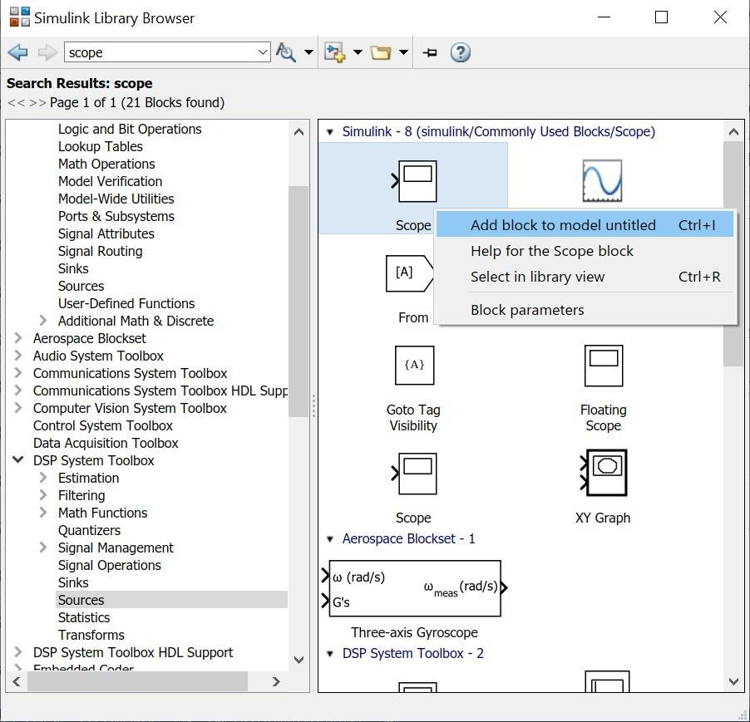

Double click on the scope to open its display window. The default window looks like the one shown below, with one display window (for the single input) and black background. You may increase the number of inputs to the scope by increasing the number of input ports.

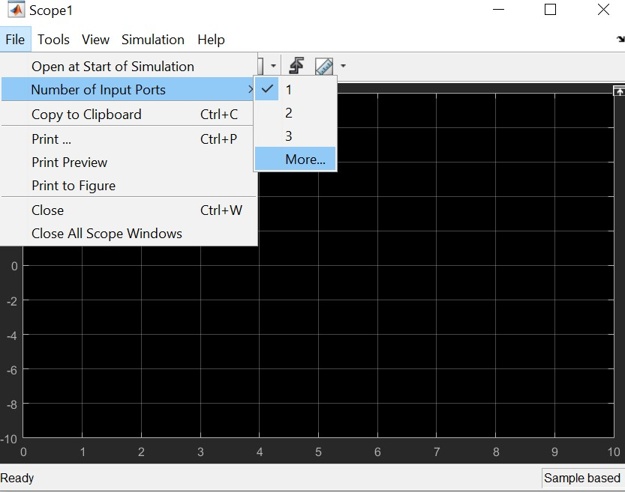

The default colour scheme for plots uses a lot of ink when printed. So change it to white background and dark curves by going to view > Style

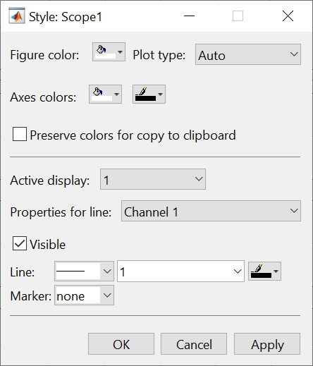

**You must use white background and black plot lines while using the scope.

Then open view > Layout to plot all inputs separately.

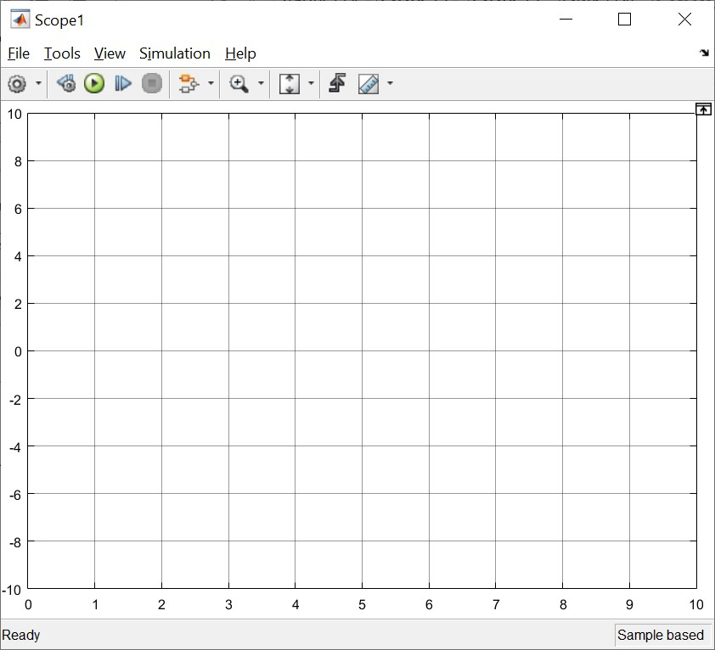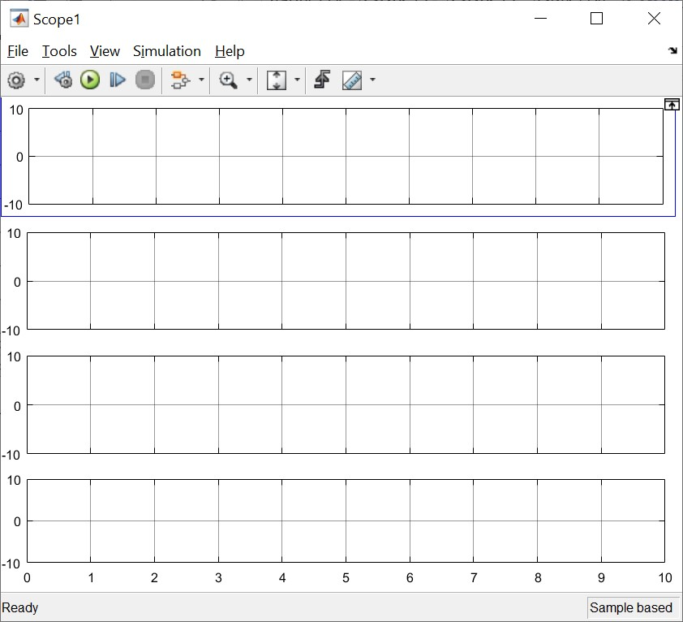

View > Legend will add the legend to the plots.

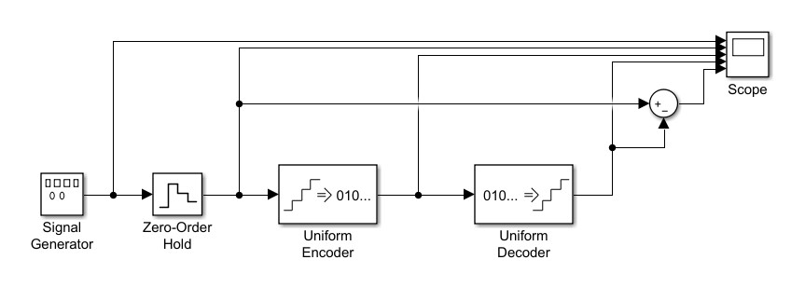

**Exercise**

**1**

Implement

the

following

system

on

MATLAB

simulink

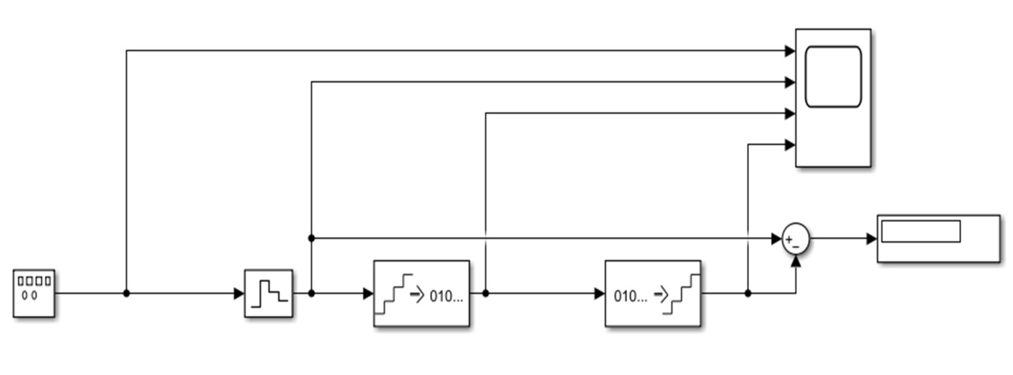

Ensure

your signal

generator is set to produce a sine wave with an amplitude of 1

and a frequency of 1 rad/sec.

Set

the

sampling

time in

your Zero

Order

Hold

block

to

be

0.1

sec.

The encoder applies uniform quantization to the sampled signal to give an output

between 0 and 2

n

-

1

where n is the number of bits.

Ensure that the number of output bits in the encoder and the number of input bits in

the decoder are the same (set to 8 initially for both).

Run the

simulation.

Analyse

the

effect

of

increasing/

decreasing

the

sampling

frequency

(

in

the

zero

order

hold

block) on the signals.

Analyse

the

effect

of

increasing/

decreasing

the

number

of

bits

in

the

Encoder

and

Decoder

blocks.

What

is the purpose

of the

Sum

block?

Which

blocks are

affecting

the quantization

levels?

***1st Output , With All the Given Parameters:***

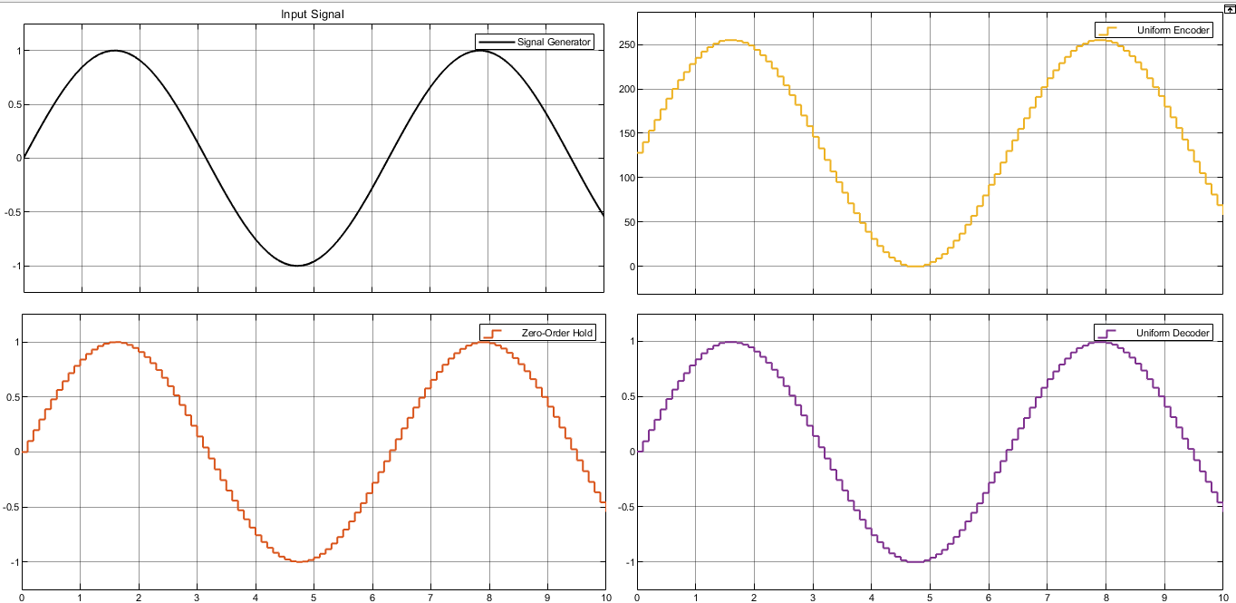



**Exercise**

**2**

Generate saw

-

tooth wave for f=10 rad/sec to observe the

effects of quantization? What

happens, if frequency and sampling frequency increases and decreases?



**Exercise**

**3**

Consider a continues signal

S

=

a

*

cos(

2

*pi*f*t

)

, plot

this signal using MATLAB where

a

, f=1Hz, Ts

=0.0

=8

01

, and t=0:Ts:2. Take continues signal as a reference and plot the

following signals

?

1.

S

ampled

signal

of S

2.

Quantization

Signal

of S

## Evaluation Rubric

* **Method of Evaluation**: In-lab marking by instructors, Report submitted by students
* **Measured Learning Outcomes**:

CLO1: Develop algorithms to perform signal processing techniques on digital signals using MATLAB and DSP Kit DSK6713 CLO3: Deliver a report/lab notes/presentation/viva, effectively communicating the design and analysis of the given problem

|  |  |  |  |  |  |  |
| --- | --- | --- | --- | --- | --- | --- |
|  | Excellent 10 | Good  9-7 | Satisfactory 6-4 | Unsatisfactory 3-1 | Poor 0 | Marks Obtained |
| Tasks (CLO1) | All tasks completed correctly. Correct code with proper comments. | Most tasks completed correctly. | Some tasks completed correctly. | Most tasks incomplete or incorrect. | All tasks incomplete or incorrect. |  |
| Output  (CLO1) | Output correctly shown with all Figures/Plots displayed  as required and properly  labelled | Most Output/Figures/Plots displayed with proper labels | Some Output/Figures/Plots displayed with proper labels  OR Most Output/Figures/Plots displayed but without proper  labels | Most of the required  Output/Figures/Plots not displayed | Output/Figures/Plots not displayed |  |
| Answers (CLO1) | Meaningful answers to all questions. Answers show the understanding of the student. | Meaningful answers to most questions. | Some correct/ meaningful answers with some irrelevant ones | Answers not understandable/ not relevant to questions | Not Written any Answer |  |
| Report  (CLO3) | Report submitted with proper grammar and  punctuation with proper  conclusions drawn and good  formatting | Report submitted with proper conclusions drawn with good formatting but  some grammar mistakes OR proper grammar but not very good formatting | Some correct/ meaningful conclusions. Some parts of the document not properly  formatted or some grammar  mistakes | Conclusions not based on results. Bad formatting with no proper grammar/punctuation | Report not submitted |  |
|  |  |  | Total | | |  |