

**Namal University, Mianwali**

Department of Electrical Engineering

EE 345 (L) – Digital Signal Processing (Lab)

Lab – 9

**Audio Signal Processing using MATLAB**

|  |  |
| --- | --- |
| Student Name | Student ID |
| Fahim Ur Rehman Shah | NIM-BSEE-2021-24 |

Instructor: Zulaikha Kiran

Lab Engineer: Faizan Ahmad

Version 1.0 – Muhammad Usman – 15/04/2021

Version 1.1 – Zulaikha Kiran – 05/04/2022

Version 1.2 – Husnain, Saiqa Dilawaiz – 06/04/2023

Version 1.3 – Faizan Ahmad – 26/02/2024

# Introduction

The purpose of this lab is to enable the students to study audio signal synthesis and analysis using MATLAB.

# Course Learning Outcomes

CLO1: Develop algorithms to perform signal processing techniques on digital signals using MATLAB and DSP Kit DSK6713

CLO3: Deliver a report/lab notes/presentation/viva, effectively communicating the design and analysis of the given problem

# Equipment

• Software

o MATLAB

# Instructions

1. This is an individual lab. You will perform the tasks individually and submit a report.
2. Some of these tasks are for practice purposes only while others (marked as ‘Exercise’) have to be answered in the report.
3. When asked to display an image/ graph in the exercise, either save it as jpeg or take a screenshot, in order to insert it in the report.
4. The report should be submitted on the given template, including:
   1. Code (copy and pasted, NOT a screenshot)
   2. Output values (from command window, can be a screenshot)
   3. Output figure/graph (as instructed in 3)
   4. Explanation where required
5. The report should be properly formatted, with easy to read code and easy to see figures.
6. Plagiarism or any hint thereof will be dealt with strictly. Any incident where plagiarism is caught, both (or all) students involved will be given zero marks, regardless of who copied whom. Multiple such incidents will result in disciplinary action being taken.

**Background**

Audio signal processing involves the manipulation, analysis, and enhancement of sound waves using digital techniques. Initially, analog audio signals are converted into digital format through analog-todigital converters (ADCs). Once digitized, various processing techniques can be applied, including filtering, equalization, compression, and reverberation, among others. Filtering can remove unwanted frequencies or enhance specific ones, while equalization adjusts the frequency balance of the signal. Compression reduces the dynamic range of the signal, making it more uniform in volume, often used in music production and broadcasting. Reverberation adds simulated acoustic reflections to create a sense of space or ambiance. These techniques can be implemented using algorithms in software or hardware, providing flexibility and control over audio content in applications ranging from music production and mixing to telecommunications and entertainment. Additionally, advancements in machine learning and artificial intelligence have further expanded the capabilities of audio signal processing, enabling tasks such as noise reduction, source separation, and automatic audio tagging.

**Exercise:**

**Task 1:**

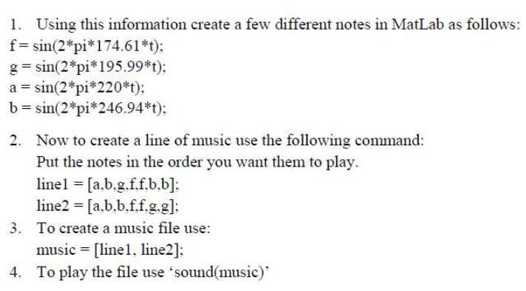

***Code:***

fs = 800; % Sampling frequency

t = 0:1/fs:1; % Time vector from 0 to 1 second with sampling rate 44100 Hz

f = sin(2*pi*174.61*t);

g = sin(2*pi*195.99*t);

a = sin(2*pi*220*t);

b = sin(2*pi*246.94*t);

line1 = [a, b, g, f, f, b, b];

line2 = [a, b, b, f, f, g, g];

music = [line1, line2];

sound(music)

***Explanation:***

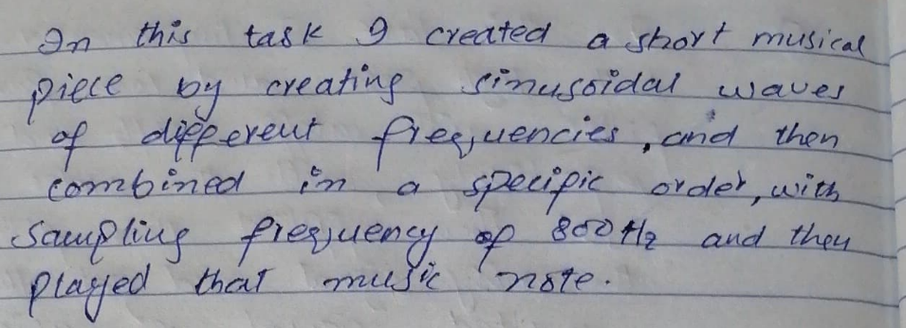

**Task 2:**

Add noise in the above music signal using 2*randn(size(t)) command, and take Fs=8000.

**Code:**

fs = 8000; % Sampling frequency

t = 0:1/fs:1; % Time vector from 0 to 1 second with sampling rate 8000 Hz

f = sin(2*pi*174.61*t);

g = sin(2*pi*195.99*t);

a = sin(2*pi*220*t);

b = sin(2*pi*246.94*t);

line1 = [a, b, g, f, f, b, b];

line2 = [a, b, b, f, f, g, g];

music = [line1, line2];

noise = 2*randn(size(music)); % Generate noise with the same size as music

noisy_music = music + noise; % Add noise to the music signal

sound(noisy_music, fs) % Play the noisy music signal

figure

stem(music)

xlim([0 100])

hold on

stem(noisy_music)

xlim([0 100])

xlabel('Sample Index') % Add x-axis label

ylabel('Amplitude') % Add y-axis label

legend('Music', 'Noisy Music') % Add legend

Graph:

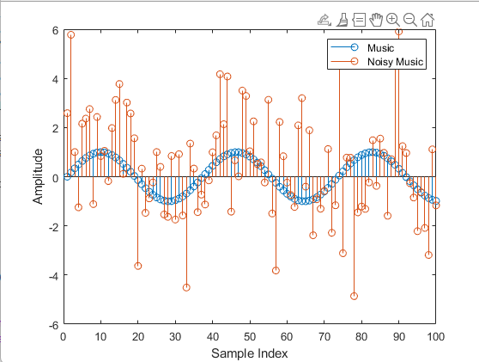

***Explanation:***

**Task 3:**

To remove noise, design a low-pass filter using commands below, and the cutoff frequency of filter should be 175Hz.

cutoff = f/(fs/2); order = 50;

d = designfilt('lowpassfir','CutoffFrequency',cutoff,'FilterOrder',order); output= filter(d,music);

**Code:**

fs = 8000; % Sampling frequency

t = 0:1/fs:1; % Time vector from 0 to 1 second with sampling rate 8000 Hz

f = sin(2*pi*174.61*t);

g = sin(2*pi*195.99*t);

a = sin(2*pi*220*t);

b = sin(2*pi*246.94*t);

line1 = [a, b, g, f, f, b, b];

line2 = [a, b, b, f, f, g, g];

music = [line1, line2];

noise = 2*randn(size(music)); % Generate noise with the same size as music

noisy_music = music + noise; % Add noise to the music signal

cutoff = 175/(fs/2); % Cutoff frequency of 175Hz

order = 50; % Filter order

d = designfilt('lowpassfir','CutoffFrequency',cutoff,'FilterOrder',order); % Design the low-pass filter

output = filter(d,music); % Apply the filter to the music signal

sound(output, fs) % Play the filtered music signal

figure

stem(music)

xlim([1000 1100])

hold on

stem(noisy_music)

xlim([1000 1100])

hold on

stem(output)

xlim([1000 1100])

xlabel('Sample Index') % Add x-axis label

ylabel('Amplitude') % Add y-axis label

legend('Music', 'Noisy Music','Filtered Music') % Add legend

Graph:

***Explanation:***

**Task 4:**

Design a high-pass filer having cutoff frequency 200Hz.

***Code:***

fs = 8000; % Sampling frequency

t = 0:1/fs:1; % Time vector from 0 to 1 second with sampling rate 8000 Hz

f = sin(2*pi*174.61*t);

g = sin(2*pi*195.99*t);

a = sin(2*pi*220*t);

b = sin(2*pi*246.94*t);

line1 = [a, b, g, f, f, b, b];

line2 = [a, b, b, f, f, g, g];

music = [line1, line2];

noise = 2*randn(size(music)); % Generate noise with the same size as music

noisy_music = music + noise; % Add noise to the music signal

cutoff = 200/(fs/2); % Cutoff frequency of 200Hz

order = 50; % Filter order

d = designfilt('highpassfir','CutoffFrequency',cutoff,'FilterOrder',order); % Design the high-pass filter

output = filter(d,music); % Apply the filter to the music signal

sound(output, fs) % Play the filtered music signal

figure

stem(music)

xlim([800 900])

hold on

stem(noisy_music)

xlim([800 900])

hold on

stem(output)

xlim([800 900])

xlabel('Sample Index') % Add x-axis label

ylabel('Amplitude') % Add y-axis label

legend('Music', 'Noisy Music','Filtered Music') % Add legend

***Graph:***

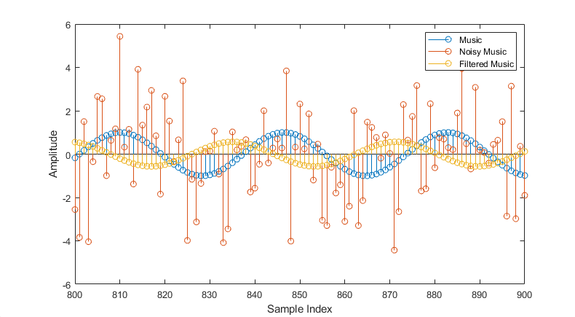

***Explanation:***

**Task 5:**

Design a band-pass filer which passes the range of frequency 200-300Hz.

**Code:**

fs = 8000; % Sampling frequency

t = 0:1/fs:1; % Time vector from 0 to 1 second with sampling rate 8000 Hz

f = sin(2*pi*174.61*t);

g = sin(2*pi*195.99*t);

a = sin(2*pi*220*t);

b = sin(2*pi*246.94*t);

line1 = [a, b, g, f, f, b, b];

line2 = [a, b, b, f, f, g, g];

music = [line1, line2];

noise = 2*randn(size(music)); % Generate noise with the same size as music

noisy_music = music + noise; % Add noise to the music signal

fcut1 = 200/(fs/2); % Lower cutoff frequency of 200Hz

fcut2 = 300/(fs/2); % Upper cutoff frequency of 300Hz

order = 50; % Filter order

d = designfilt('bandpassfir','FilterOrder',order,'CutoffFrequency1',fcut1,'CutoffFrequency2',fcut2); % Design the band-pass filter

output = filter(d,music); % Apply the filter to the music signal

sound(output, fs) % Play the filtered music signal

figure

stem(music)

xlim([800 900])

hold on

stem(noisy_music)

xlim([800 900])

hold on

stem(output)

xlim([800 900])

xlabel('Sample Index') % Add x-axis label

ylabel('Amplitude') % Add y-axis label

legend('Music', 'Noisy Music','Filtered Music') % Add legend

***Graph:***

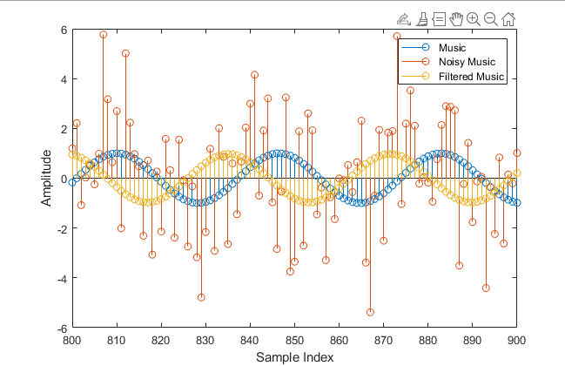

***Explanation:***

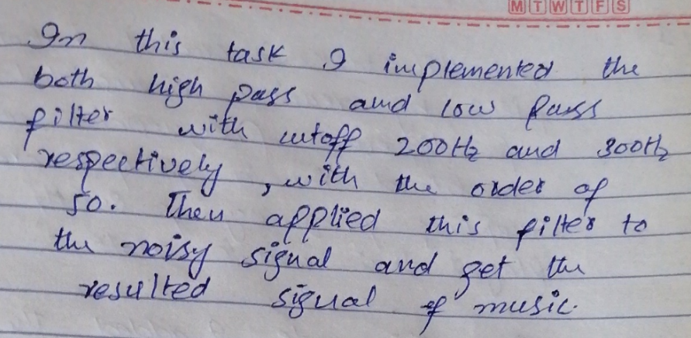

**Task 6:**

Record your own voice and observe the frequency spectrum?

myVoice = audiorecorder; disp('Start speaking.') recordblocking(myVoice, 5) disp('End of recording. Playing back ...') play(myVoice)

***Code:***

fs = 8000; % Sampling frequency

myVoice = audiorecorder(fs, 16, 1); % Create an audiorecorder object with the desired sampling frequency (fs), bit depth (16), and number of channels (1)

disp('Start speaking.')

recordblocking(myVoice, 5) % Record your voice for 5 seconds

disp('End of recording. Playing back ...')

play(myVoice) % Playback the recorded voice

voice = getaudiodata(myVoice); % Get the recorded voice data

fcut1 = 200/(fs/2); % Lower cutoff frequency of 200Hz

fcut2 = 300/(fs/2); % Upper cutoff frequency of 300Hz

order = 50; % Filter order

d=designfilt('bandpassfir','FilterOrder',order,'CutoffFrequency1',fcut1,'CutoffFrequency2',fcut2); % Design the band-pass filter

output = filter(d,voice); % Apply the filter to the voice signa

sound(output, fs) % Play the filtered voice signal

figure

subplot(3,1,1)

plot(voice) % Plot the original voice signal

title('Original Voice')

subplot(3,1,2)

plot(output) % Plot the filtered voice signal

title('Filtered Voice')

subplot(3,1,3)

spectrogram(output,[],[],[],fs,'yaxis') % Plot the spectrogram of the filtered voice

title('Spectrogram')

***Output:***

***Graph:***

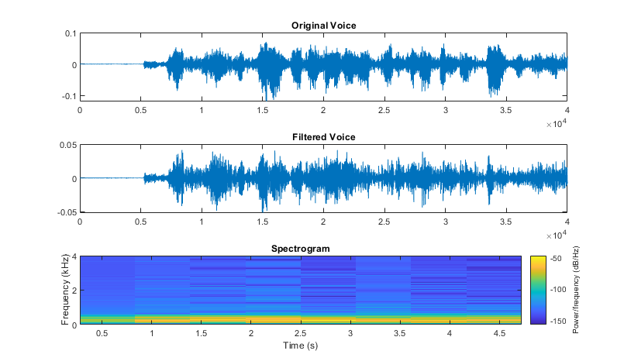

***Explanation:***

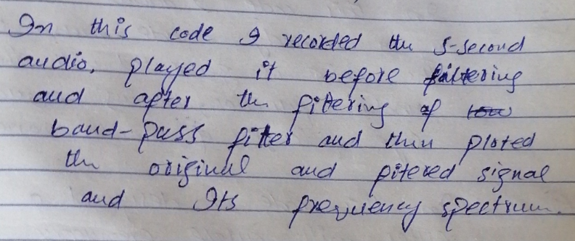.

***Conclusion:***

**Evaluation Rubric**

* **Method of Evaluation**: In-lab marking by instructors, Report submitted by students
* **Measured Learning Outcomes**:

CLO1: Develop algorithms to perform signal processing techniques on digital signals using MATLAB and DSP Kit DSK6713 CLO3: Deliver a report/lab notes/presentation/viva, effectively communicating the design and analysis of the given problem

|  |  |  |  |  |  |  |
| --- | --- | --- | --- | --- | --- | --- |
|  | Excellent 10 | Good  9-7 | Satisfactory 6-4 | Unsatisfactory 3-1 | Poor 0 | Marks Obtained |
| Tasks (CLO1) | All tasks completed correctly. Correct code with proper comments. | Most tasks completed correctly. | Some tasks completed correctly. | Most tasks incomplete or incorrect. | All tasks incomplete or incorrect. |  |
| Output  (CLO1) | Output correctly shown with all Figures/Plots displayed  as required and properly  labelled | Most Output/Figures/Plots displayed with proper labels | Some Output/Figures/Plots displayed with proper labels  OR Most Output/Figures/Plots displayed but without proper  labels | Most of the required  Output/Figures/Plots not displayed | Output/Figures/Plots not displayed |  |
| Answers (CLO1) | Meaningful answers to all questions. Answers show the understanding of the student. | Meaningful answers to most questions. | Some correct/ meaningful answers with some irrelevant ones | Answers not understandable/ not relevant to questions | Not Written any Answer |  |
| Report  (CLO3) | Report submitted with proper grammar and  punctuation with proper  conclusions drawn and good  formatting | Report submitted with proper conclusions drawn with good formatting but  some grammar mistakes OR proper grammar but not very good formatting | Some correct/ meaningful conclusions. Some parts of the document not properly  formatted or some grammar  mistakes | Conclusions not based on results. Bad formatting with no proper grammar/punctuation | Report not submitted |  |
|  |  |  | Total | | |  |