Course Code: EEE 4416
Course Name: Simulation Lab
Assignment : Mini-Project
Student ID: 220021326
Name: Shahriar Fahim
Section : C2

Introduction:
DataAnalyzer is an app that’s supposed to make plotting and EDA (Exploratory Data Analysis) Easier by letting the user select a excel or csv file and automatically reading the file as a table, assigning the columns their appropriate data types and plotting the appropriate plots for each data type (as example histogram and box plot for numeric column, pie and bar for categorical). Moreover, the user can also provide normal range for the columns as input (optional) so that the app can show it on the plot and provide insights on what percentile of the column is out of that range.
Basic Interface
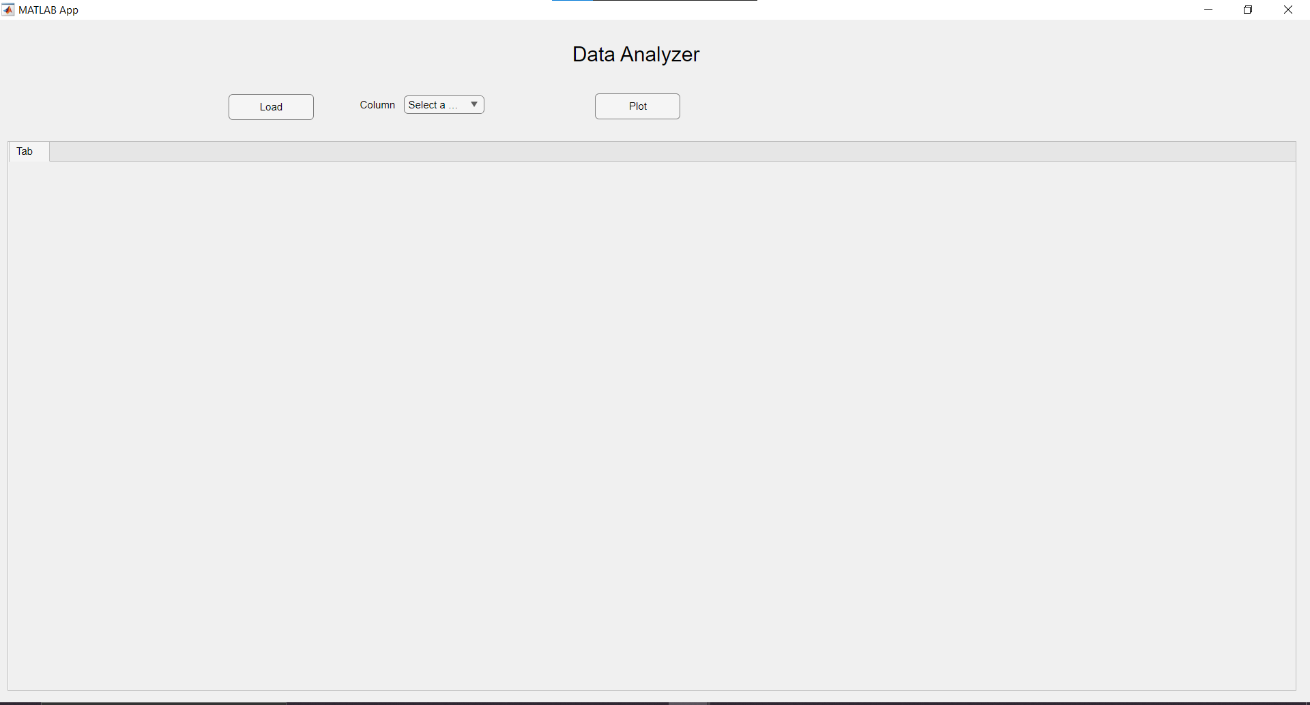
Load Button: Let’s you import any csv/excel of your choice and reads the file as table (using UIgetfile)
Column Dropdown: After a file has been read, all the column names will appear here as drop-down so the user can choose the column he wants to analyze. Additionally, there’s an ‘All’ option that lets the user plot all the columns with one click.
Plot Button: Plots the graphs upon clicking.
Bounds Table (Top Right): Table for taking optional input for taking normal range. If any particular column is selected, the table only takes upper and lower bound for that column, for ‘All’, it takes input for all the columns. All of these are Optional, of course.
Tab: For showing the plots once the user has pressed on ‘Plot’.

Outputs:
General Interface(No file read):

After reading a file using Load: (cirrhosis.csv as sample)
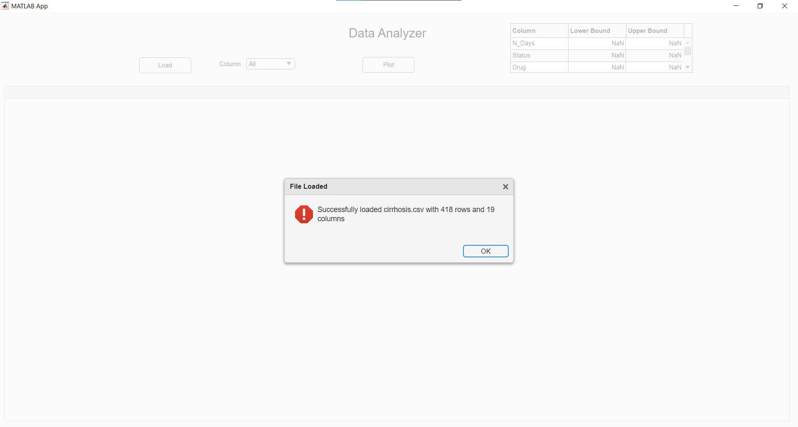
So file loading and reading successful!

The ‘Column Dropdown’ after successful loading:
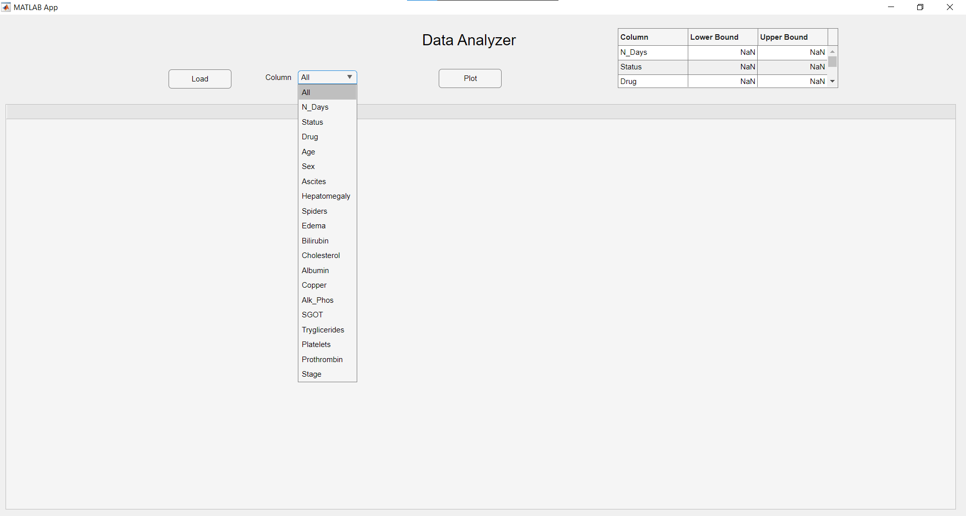
So the user can choose a particular column and give its normal range(optional) or just plot all the columns.
Select ‘All’ in the ‘Column Dropdown’ menu, giving the normal bilirubin range and Plotting:
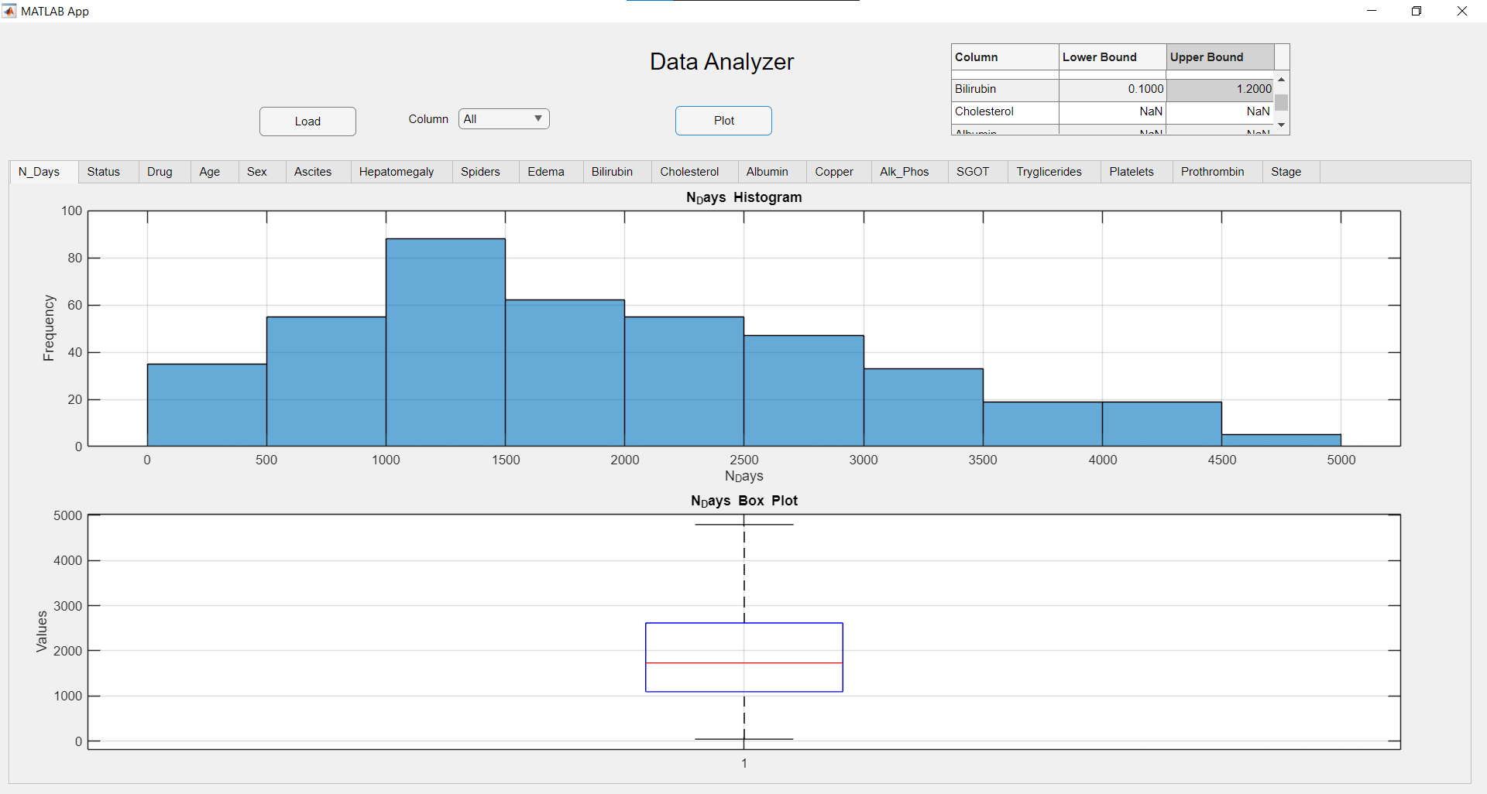
So we have appropriate plot for N_days, Since, it’s the first column it appeared first. Since we didn’t give any normal range for it, there’s no insight.

Bilirubin Plot:
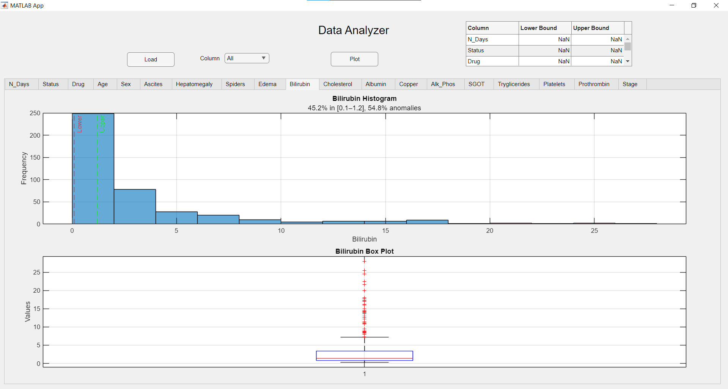
As we can see, the normal range is visible and more than half of the sample is out of range. So we have our insight
Drug Plot:
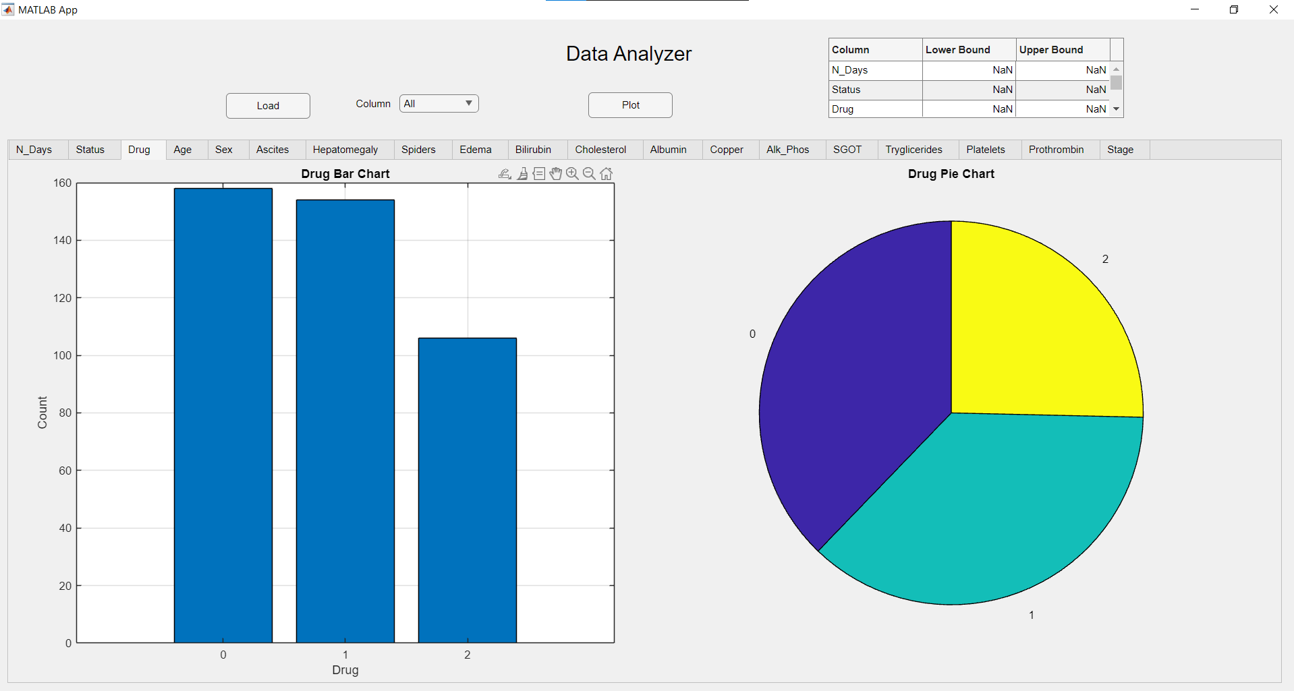
So we have the appropriate plots for categorical ones as well. Similarly, we can check for all the plots but I’m skipping that.

Let’s now plot for a single column.
Selecting ‘Cholesterol’ from the ‘Column Dropdown’ and providing normal range:
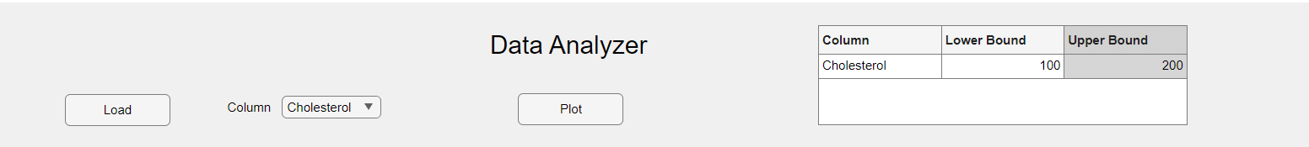
Plotting:
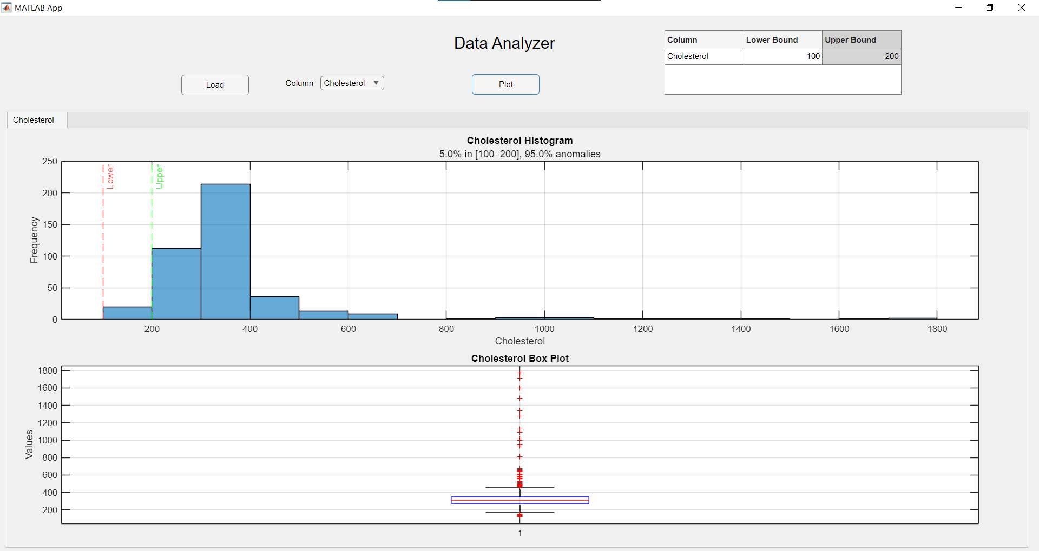
So, we can individually plot the columns with their normal range as well

Let’s check if it works on other datasets
Loading BigML dataset: (All)
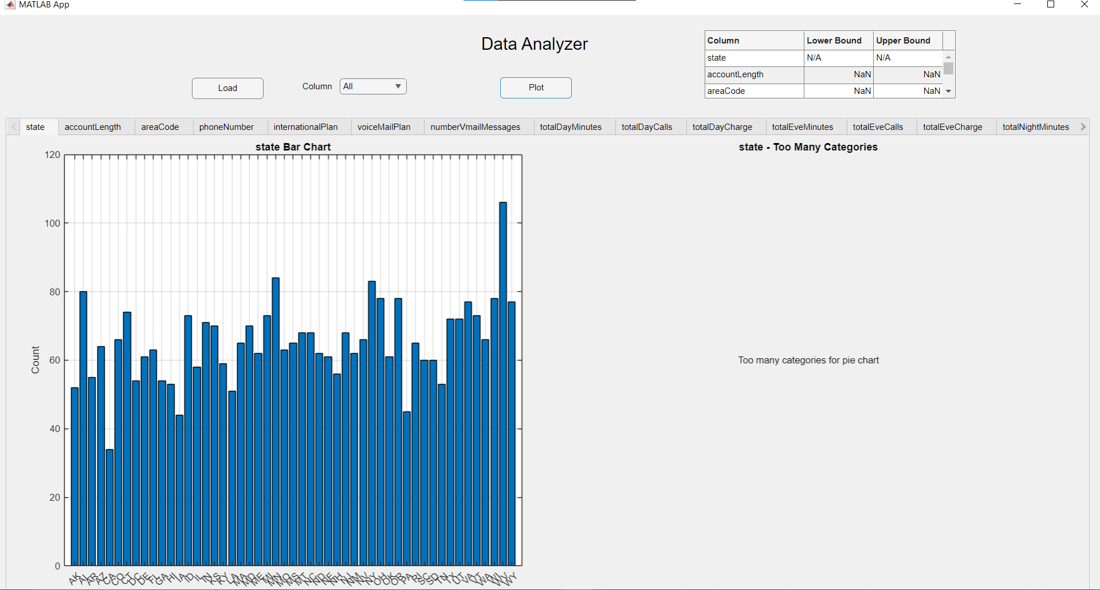
Police Killings dataset: (armed_with)
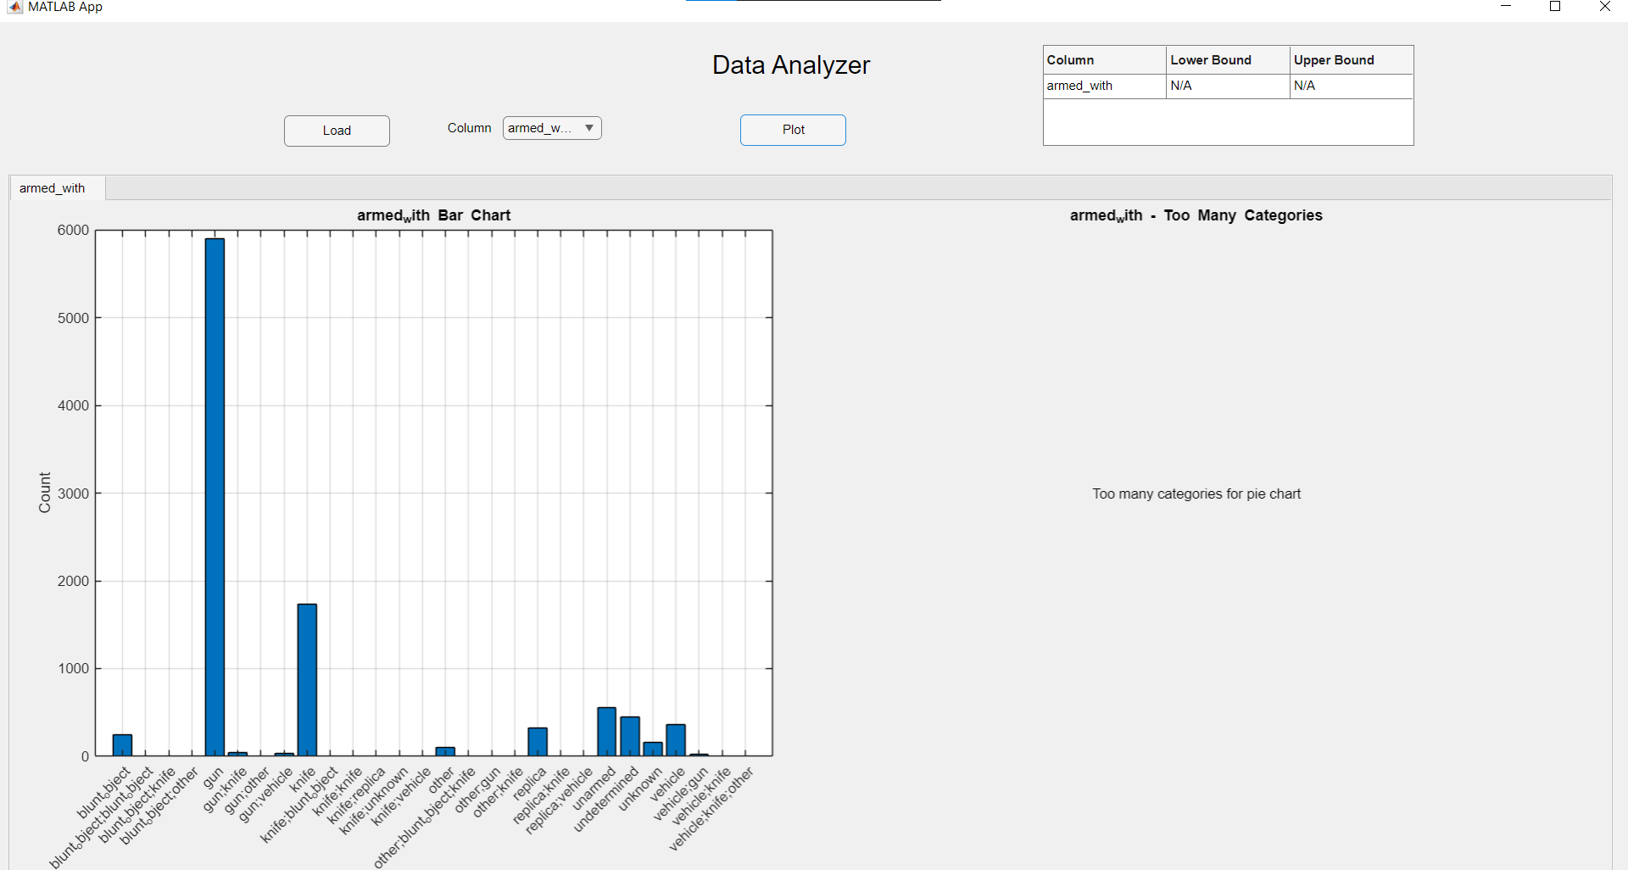

Diabetes dataset: (All)
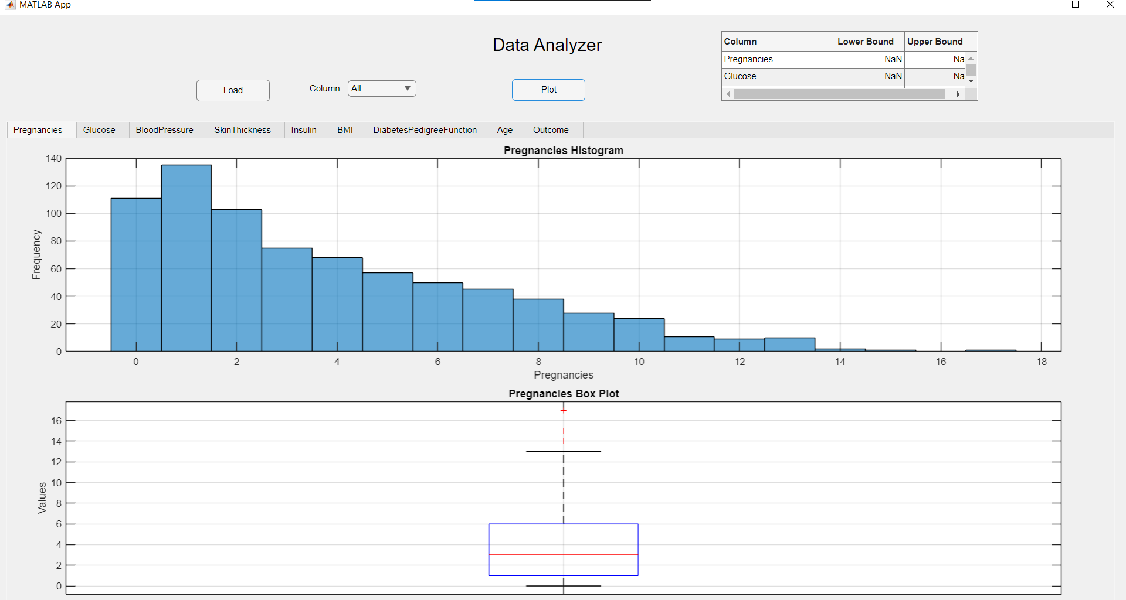

So, we can conclude the app is generalized.
Note: If the datasets are large, it might take some time to load and plot so some patience is required. If the plot isn’t appearing due to that, closing and running the app again helps.

