Fahimeh Tajarrod
Prof. Joseph Oakes
Internet of Things
17June 2026

Smart IoT Baby Monitor with Remote Surveillance
This project develops an intelligent baby monitor in the absence of a primary caregiver, using the M5Stack ecosystem to ensure child safety via real-time environmental monitoring and remote alerts. Programmed using UIFlow1.0 Blockly, the system operates on the M5Stack Core controller - utilizing its ESP32 processor, 320×240 display, and microSD slot - to manage local logic and stream telemetry data to the cloud.

Emergency Response: Using the environmental and motion sensors, the system detects hazards like wet bedding, extreme temperatures, or movement toward dangerous areas such as bed edges. It also monitors sound levels to detect baby crying. The system responds immediately by updating its visual indicators using specific RGB codes: green (0, 255, 0) for safe environments, orange (255, 165, 0) for environmental warnings such as elevated temperature or humidity, and red (255, 0, 0) for critical motion or sound alerts. Concurrently, it triggers audible alarms via the built-in speaker, sends instant notifications to the caregiver’s mobile device, and initiates an automated “soothing mode” that plays lullabies with a synchronized LED bar light dance to calm the child. Additionally, the integrated 6-axis IMU triggers a high-priority alert if the monitor device itself is accidentally knocked over or tilted.

Operations and Connectivity: The device features three operational modes - “Good Morning” (regular active monitoring), “Good Night” (lullabies and LED light dance), and “Standby” - which are accessible via physical hardware buttons or mobile integration. Specifically, Button A activates Good Morning mode, Button B activates Good Night mode, and Button C activates Standby mode, while an Angle Sensor provides intuitive analog control over the volume. Telemetry data is automatically synchronized with the EZ-data cloud database at regular 5-minute intervals via HTTP, ensuring caregivers always have access to the latest device status without manual intervention. This allows caregivers to monitor status and adjust safety thresholds remotely. To drive dynamic text labels on the screen, the system uses its Wi-Fi connection to fetch accurate network time from the WorldTimeAPI. Finally, all system events, errors, and sensor payloads are backed up locally on the Micro SD Card inside dedicated /LOGS/ and /JSON/ directories.

List of Components and Accessories

- M5Stack Core (Basic/Gray): The main controller equipped with an ESP32 processor (240 MHz), a 2-inch 320×240 TFT LCD screen for UI display, three hardware buttons (A, B, C), and a built-in Micro SD card slot.
- Integrated MPU6886 IMU: An internal 6-axis Inertial Measurement Unit used to detect device orientation, tilt angles, and accidental falls.
- Built-in Speaker: An integrated audio output component used to play emergency alert frequencies and automated lullabies.
- Unit ENV-III (SHT30/QMP6988): A high-precision I2C environmental sensor unit used to monitor ambient room temperature and relative humidity.
- Unit PIR (AS312): A passive infrared motion sensor unit used to detect unexpected baby displacement or movement near bed edges.
- Microphone Unit: An analog sound-level sensor calibrated to track high-decibel environmental noise and detect baby crying or distress.
- Unit RGB (SK6812): An expansion LED unit used alongside an RGB LED Bar to provide clear, color-coded visual safety statuses and soft, ambient nightlights.
- Unit Angle (Potentiometer): A rotary analog input unit used to provide precise, manual volume control for the speaker.
- Micro SD Card (TF Card): A local storage medium used for backing up text logs in the /LOGS/ directory and storing structured /JSON/ telemetry payloads.
- Wi-Fi & EZ-data Cloud Service: The built-in wireless networking stack and M5Stack cloud platform used for remote data persistence, threshold configuration, and dynamic API requests.
- UIFlow Remote Dashboard: A customized smartphone integration panel built via the UIFlow platform for real-time mobile tracking and wireless control.

Works Cited

“UiFlow1 Development Guide.” M5STACK, 2025, http://docs.m5stack.com/en/uiflow/uiflow1_layout, Accessed 24 Apr. 2026.

Oakes, Joseph. “Internet of Things.” IOT Course Slides and Lecture Series. Lecture, 2026, Hof, University of Applied Sciences.

APPENDIX A: User Interface (UI) Design Specifications

The paper prototype and layout designs for both the M5Stack Core display and the remote cloud/mobile dashboard (UIFlow Remote Panel) are illustrated below:
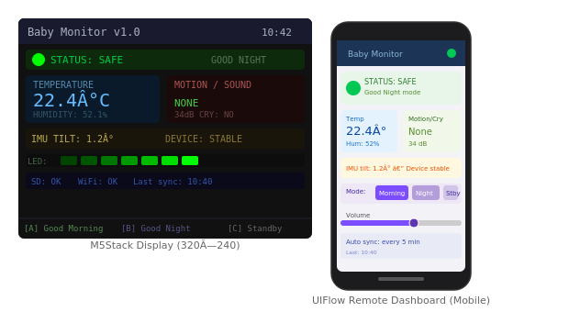

Figure 1: M5Stack and Mobile UI Prototypes

APPENDIX B: JSON Document Specifications for Logging

1. Sensor Data Capture Payloads (/JSON/telemetry_[timestamp].json)

This structured JSON object is generated locally at regular intervals and stored on the SD card, tracking the precise environment state and device stability metrics:

{
"timestamp": "2026-06-14T12:20:00Z",
"device_id": "M5_BABY_MONITOR_01",
"current_mode": "Good Night",
"telemetry": {
"ambient_temperature_c": 22.4,
"relative_humidity_pct": 52.1,
"motion_detected": false,
"sound_level_db": 34,
"crying_detected": false,
"imu_tilt_deg": 1.2
}
}

2. Error Logging Format (/LOGS/error.json)

This structure is used to capture hardware faults or communication issues, appending critical debugging data to the local SD card whenever a runtime failure occurs:

{
"timestamp": "2026-06-14T12:21:05Z",
"error_id": "ERR_CLOUD_SYNC_FAIL",
"severity": "Warning",
"hardware_component": "Wi-Fi / EZ-data Client",
"error_details": {
"error_code": 503,
"message": "Failed to push status data to EZ-data cloud database endpoint.",
"retry_attempt": 3
}
}

